This documentation begins on October 26, 2018. We decided to move forward with the 4 categories of asthma and atopy for the main analyses because the overall asthma results seem to be driven by the atopy/asthma and not the nonatopic/asthma group.

Univariate analyses with atopy/asthma and DNA methylation identified the following variables are significantly associated with either atopy/asthma or methylation:

(Details for the Asthma_Atopy4 are available in excel spreadsheet “Asthma_Atopy_Covariate_Associations” in sheet “Asthma_Atopy4_uni”)

EWAS will adjust for age, gender, state, season, bmi (continuous), packyears, smoking, and 4 measured/estimated cell types

Summary of EWAS results
 |  | Did not adjust for season |  |  | Adjusted for season |  |  | Adj for state, season
 | N | # Bonf Sig CpGs | FDR Sig | Lambda | # Bonf Sig CpGs | FDR Sig | Lambda | # Bonf Sig CpGs | FDR Sig | Lambda
Nonatopic/  Nonasthmatic | 1157 | Ref | Ref | Ref | Ref | Ref | Ref | Ref | Ref | Ref
Atopic/  Nonasthmatic | 185 | 0 | 0 | 1.01 | 0 | 0 | 1.01 | 0 | 0 | 0.99
Nonatopic/  Asthmatic | 673 | 4 | 691 | 1.13 | 4 | 315 | 1.14 | 4 | 342 | 1.14 | Adj season – 4/4 same  No season – 3/4 same
Atopic/  Asthmatic | 271 | 152 | 1104 | 1.01 | 164 | 1155 | 1.01 | 158 | 1086 | 0.98
All models adjusted for gender, smoking, bmi, packyears, age, and 4 cell types

The 4 Bonferroni significant CpGs from the nonastopic/asthmatic model do not overlap with any of the 158 Bonferroni significant CpGs from the atopic/asthmatic model
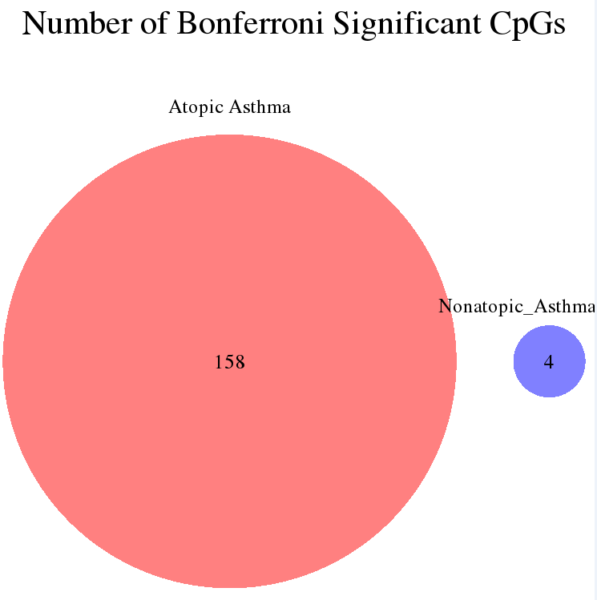
46/342 – FDR significant CpGs from NA model are Bonferroni significant in AA model

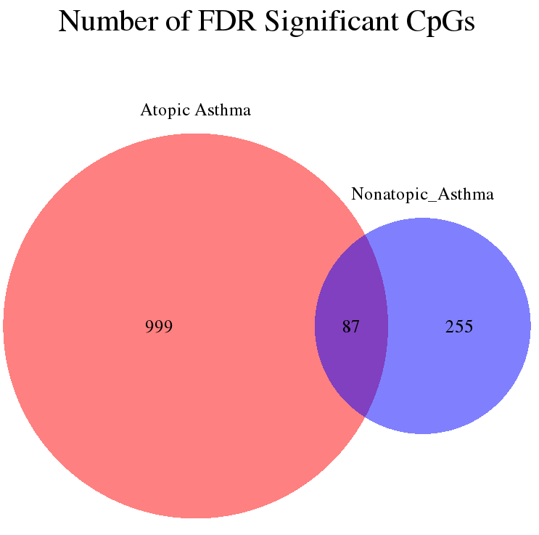

Summary of Beta Coefficients from 1,341 CpGs that were at least FDR significant after adjusting for season and state
 | Beta Coefficients
 | Atopy = No  Asthma = Yes | Atopy = Yes  Asthma = Yes
Min | -132.1 | -206.9
1st Qu | -11.5 | -23.96
Median | -7.09 | -14.82
Mean | -8.82 | -17.34
3rd Qu | -4.28 | -8.48
Max | 32.6 | 68.66

Mi Kyeong suggested I look at season dichotomized. Since differences across the 4 season is driven by fall, it made sense to dichotomized season to fall or not fall.

 |  | All – adj season |  |  | All – adj fall |  |  | Restrict to Priority #1 – adj fall |  |  |  | All -adj fall, atopy cutoff 0.35
 | N | # Bonf Sig CpGs | FDR Sig | Lambda | # Bonf Sig CpGs | FDR Sig | Lambda | N | # Bonf Sig CpGs | FDR Sig | Lambda | N | # Bonf Sig CpGs | FDR Sig | Lambda
Nonatopic/  Nonasthmatic | 1157 | Ref | Ref | Ref | Ref | Ref | Ref | 1157 | Ref | Ref | Ref | 814 | Ref | Ref | Ref
Atopic/  Nonasthmatic | 185 | 0 | 0 | 0.99 | 0 | 0 | 0.97 | -- | -- | -- | -- | 528 | 0 | 0 | 0.91
Nonatopic/  Asthmatic | 673 | 4 | 342 | 1.14 | 5 | 524 | 1.14 | 451 | 1 | 3 | 1.17 | 483 | 0 | 9 | 1.15
Atopic/  Asthmatic | 271 | 158 | 1086 | 0.98 | 160 | 1086 | 0.98 | 214 | 90 | 909 | 1.09 | 461 | 109 | 847 | 1.07

All models adjusted for gender, smoking, bmi, packyears, age, state, season, and 4 cell types

1 of the 1,506 FDR significant CpGs were part of the 977 CpG sites that Illumina had excluded due to changes in manufacturing processes. cg15284593 was FDR significant among AA

Reran analyses for the 1,506 Bonferroni or FDR significant CpGs to test for interaction between CpG x gender
 | Nonatopic, No Asthma |  | Nonatopic Asthma |  | Atopic Asthma
N Male | 625 |  | 300 |  | 138
N Female | 532 |  | 373 |  | 133
 | Bonferroni | FDR | Bonferroni | FDR | Bonferroni | FDR
# sig CpG | ref | ref | 5 | 524 | 160 | 1,086
# P interaction < Bonf¹ | ref | ref | 0 | 0 | 0 | 0
# P interaction < FDR² | ref | ref | 0 | 0 | 0 | 0
# P interaction < 0.05 | ref | ref | 0 | 0 | 0 | 0
¹Based on the number of significant CpGs
² FDR p < 0.05

Used McCartney et al. 2016. Genomics Data. (n=42,558) to check if any FDR significant CpG probes are potentially cross-reactive probes or polymorphic.

29 (1.9%) CpGs are cross-reactive

581 (38.6%) CpGs are potentially polymorphic (distribution below)
# of SNPs the CpG probe is polymorphic with | Count
1 | 485
2 | 95
3 | 1

Of the 29 cross-reactive CpGs and 581 polymorphic CpGs, 13 CpGs are both cross-reactive and potentially polymorphic (distribution below)
# of SNPs the CpG probe is polymorphic with | Count
1 | 10
2 | 3

No atopy, Asthma
242/529 (45.7%) FDR significant CpGs are polymorphic

Atopy, Asthma
492/1,246 (39.5%) FDR significant CpGs are polymorphic

 | McCartney – 2016 | Pidsley – 2016 | Zhou - 2017
PMID | 27330998 | 27717381 | 27924034
Method | Based on Chen 2014  (23314698) | Based on Chen 2014 (23314698) | BISCUIT aligner
# Cross Reactive Probes | 42,558 | 43,254 | 63,483
# Cross Reactive Probes, restricted to “cg” | 42,558 | 42,917 | 63,098
# FDR sig CpG on list | 29 (1.9%) | 29 (1.9%) | 57 (3.8%)
Table of potentially cross-reactive probes on the EPIC array by paper

Checked density plot of 1,056 CpGs visually – all unimodal

Create boxplots to compare the distribution of the methylation values by case/noncase status

FDR NA – potentially problematic:

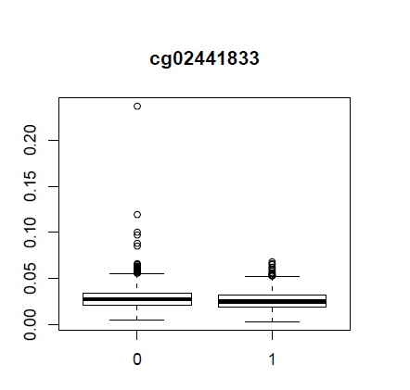
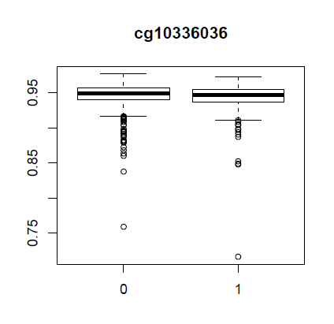

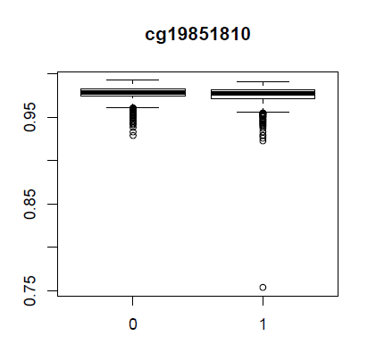

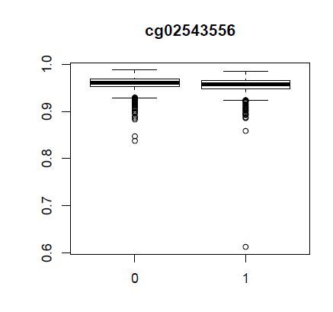
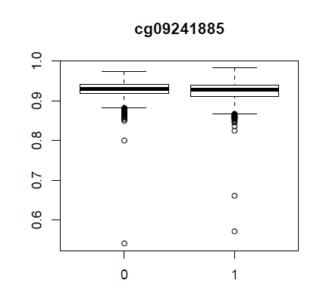

FDR Atopic Asthma
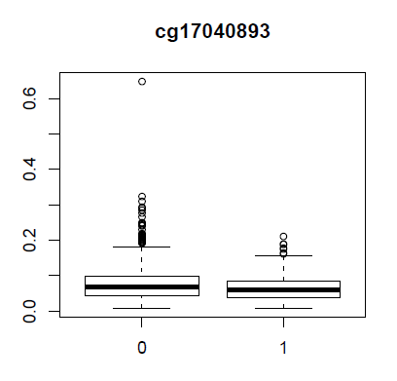
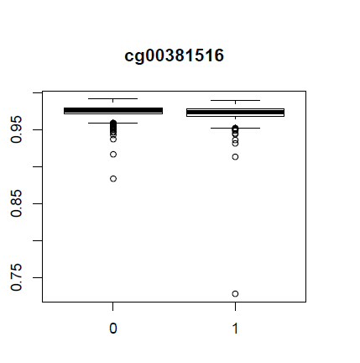

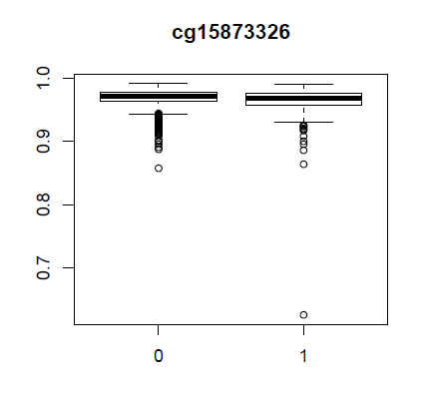

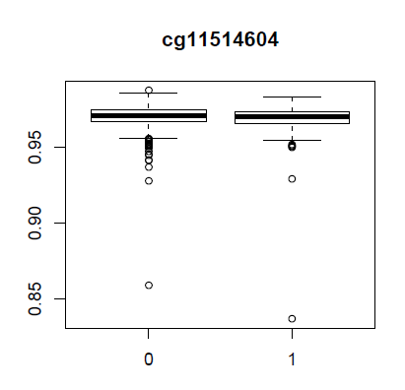
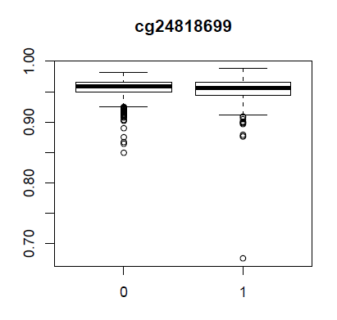
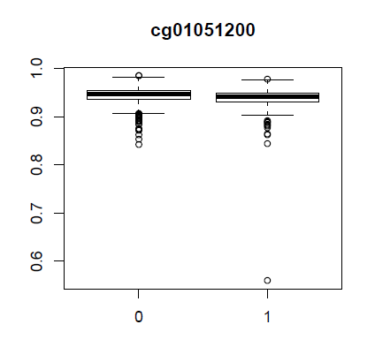

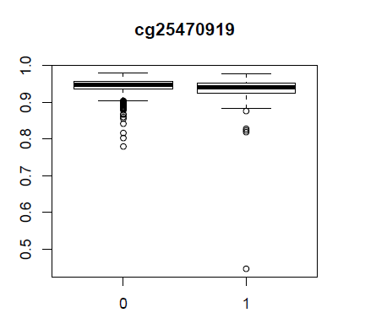
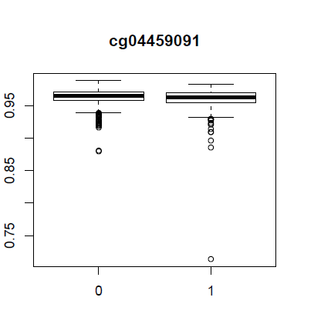
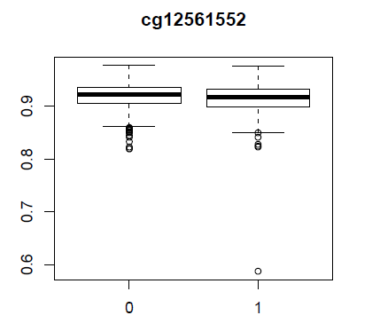

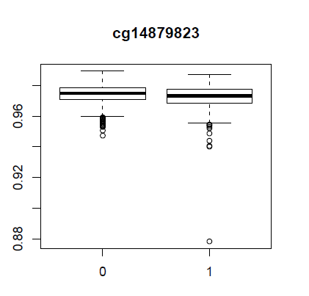

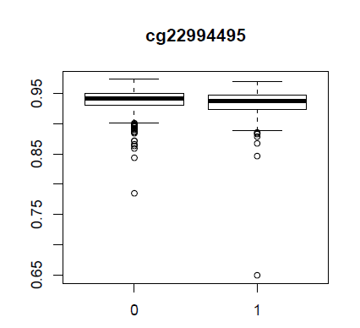

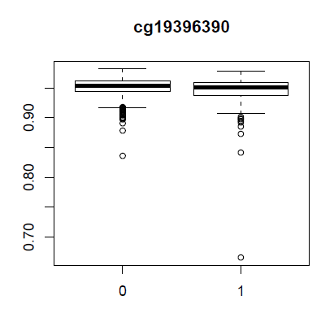
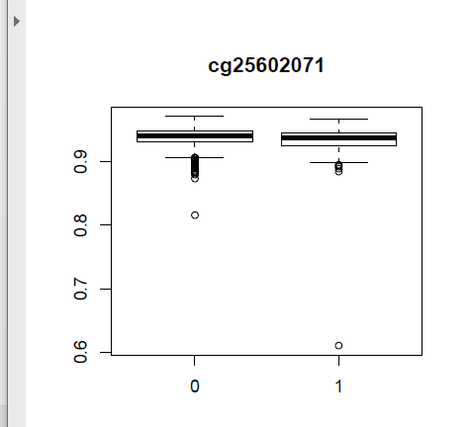
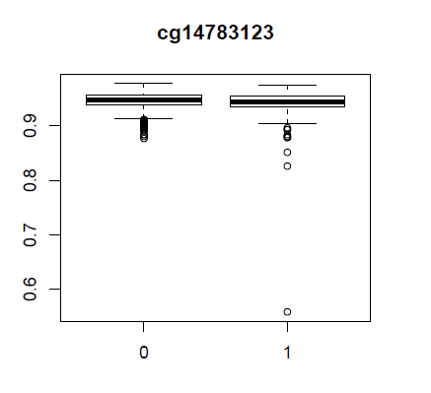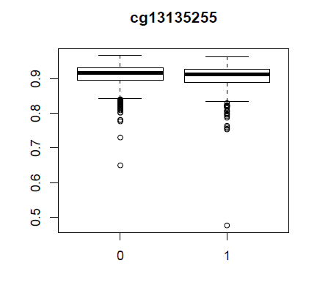

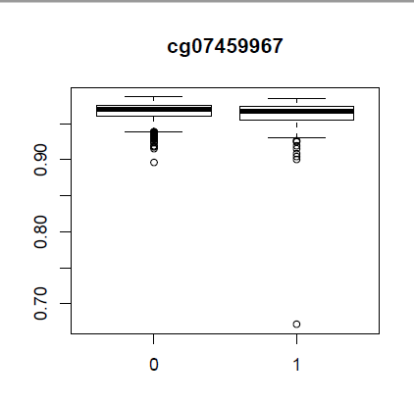
I removed all the potential outliers and re-ran logistic regression for the 22 CpGs from above. The results after removing the potential outliers were very similar to the results including the potential outliers. Thus, no potential outliers were removed.

Sarah’s paper:
Table E5 – 102 CpGs identified in both PACE and ALHS
27 CpGs – Bonferroni significant in atopic asthma
1 CpG – Bonferroni significant in nonatopic asthma

Sarah identified 196 genes from the literature that are associated with asthma. The FDR significant CpGs were annotated to genes. 13 CpGs were annotated to 7 genes that were previously identified in the literature.

UCSC Annotation
Gene | Annotation | Frequency | Comments
CUX1 | UCSC | 1
IKZF4 | UCSC & Homer | 1
IL1RL1 | UCSC & Homer | 1
IL4 | UCSC & Homer | 2 | 1 BonferroniSig_AA
PDE4D | UCSC & Homer | 1
ZFPM1 | UCSC | 3 | 2 BonferroniSig_AA
AHR | Homer | 1
LIF | Homer | 2 | 1 BonferroniSig_AA

Look up Xu’s 14 CpGs in ALHS:
CpGs from Xu et al. | Sig in NA | Sig in AA | FDR sig in PACE
cg01445399 | Not Sig | Not Sig
cg01770400 | Not Sig | Not Sig
cg16592897 | Not Sig | Not Sig
cg19764973 | Not Sig | Not Sig
cg11456013 | Not analyzed in ALHS | Not analyzed in ALHS
cg08085199 | Not Sig | Bonferroni Sig
cg01901579 | Not Sig | Bonferroni Sig | FDR Sig
cg06483820 | Not Sig | Bonferroni Sig
cg15344640 | Not Sig | FDR Sig
cg13628444 | Not Sig | FDR Sig | FDR Sig
cg10142874 | Not Sig | FDR Sig | FDR Sig
cg14011077 | Not Sig | FDR Sig | FDR Sig
cg13835688 | Not Sig | FDR Sig | FDR Sig
cg03131767 | Not Sig | FDR Sig | FDR Sig
6 FDR significant in AA but not FDR significant in NA
3 Bonf sig in AA, not significant in NA
4 not FDR significant in NA or AA
1 not analyzed in our study

None of the 14 CpGs are annotated to any of the 7 previously reported asthma genes

Compare Asthma/Atopy Results by Different Atopy Cutoffs (0.70, 0.35)

 |  | All – adj fall, atopy cutoff = 0.70 |  |  | All -adj fall, atopy cutoff = 0.35
 | N | # Bonf Sig CpGs | FDR Sig | Lambda | N | # Bonf Sig CpGs | FDR Sig | Lambda
Nonatopic/  Nonasthmatic | 1157 | Ref | Ref | Ref | 814 | Ref | Ref | Ref
Atopic/  Nonasthmatic | 185 | 0 | 0 | 0.97 | 528 | 0 | 0 | 0.91
Nonatopic/  Asthmatic | 673 | 5 | 524 | 1.14 | 483 | 0 | 9 | 1.15
Atopic/  Asthmatic | 271 | 160 | 1086 | 0.98 | 461 | 109 | 847 | 1.07
All models adjusted for gender, smoking, bmi, packyears, age, state, fall (yes/no), and 4 cell types

Non-atopic Asthma (Restricted to CpGs that are FDR significant at either atopy cutoff)

Atopic Asthma (Restricted to CpGs that are FDR significant at either atopy cutoff)

Functional enrichment (based on Illumina’s manifest) for FDR significant CpGs identified among asthmatics without atopy and asthmatics with atopy. This includes the cross-reactive probes in the background (# CpGs=817,235).

Functional enrichment (based on Illumina’s manifest) for FDR significant CpGs identified among asthmatics without atopy and asthmatics with atopy. This excludes the cross-reactive probes in the background (# CpGs=776,588). NA and AA results similar to above. Results available in “NA_AA_Enrichment_Results_Combined.xlsx”.

December 18, 2018
Thanh discovered that Mi Kyeong used Rv3.4.0 for the quality control of DNA methylation. Thanh had been using Rv3.3.2 for the analyses. Thanh reran the analyses using Rv3.4.0. The results were the same (the output using Rv3.3.2 provides more decimal places than the results from Rv3.4.0).

Enrichment/Depletion Analyses – remove cross reactive probes from background
Details in “Summary_Enrichment_Analyses.xlsx”
See “Potential functional enrichment analyses based on Zhou et al.docx” for information about Zhou’s annotations.

January 30, 2019 – GRS, calculated from beta coefficients (n=2,886 – excludes 2 without smoking info)
Risk Score Model | Asthma (yes/no) |  | Asthma without atopy |  | Asthma with atopy
 | OR (95% CI) | P | OR (95% CI) | P | OR (95% CI) | P
R² = 0.5, P=5x10⁻⁸ | 1.1245  (1.0631, 1.1898) | 4.41 x 10⁻⁵ | 1.0932  (1.0253, 1.1660) | 0.00658 | 1.2978  (1.1838, 1.4250) | 3.51 x 10⁻⁸

Distribution of genetic risk score by asthma status
 | Min | 1st Qu | Median | Mean | 3rd Qu | Max
No Asthma  (n=1,342) | 3.230 | 7.905 | 8.975 | 8.943 | 9.963 | 13.508
Asthma  (n=944) | 4.168 | 8.190 | 9.171 | 9.203 | 10.293 | 14.437

EWAS with genetic risk score (not controlling for other covariates, univariate) (544 bonferroni significant CpGs, 4,653 FDR significant)

Distribution of SNPs in Risk Score and Bonferroni significant CpGs by chromosome
Chr | # SNPs in Risk Score (n=98) | # Bonferroni Sig CpGs (n=544)
1 | 0 | 1
2 | 8 | 6 (1.1%)
3 | 0 | 2
4 | 0 | 3
5 | 17 (17.3%) | 1
6 | 35 (35.7%) | 466 (85.7%)
7 | 0 | 1
8 | 1 | 1
9 | 8 | 1
10 | 2 | 1
11 | 1 | 1
12 | 2 | 5 (1.0%)
13 | 0 | 0
14 | 0 | 3
15 | 3 | 2
16 | 2 | 0
17 | 19 (19.4%) | 47 (8.6%)
18 | 0 | 1
19 | 0 | 2
20 | 0 | 0
21 | 0 | 1
22 | 0 | 0

EWAS of GRS, adjusting for 4 cell types age, gender, packyears, smoking, BMI, fall, and state (looks similar to EWAS of GRS without adjustments)

EWAS with different GRS models
 | # Bonf Sig CpGs | # FDR Sig CpGs | Lambda
GRS | 544 | 4,653 | 1.68
GRS, adj 4 cell types, age, gender | 562 | 3,130 | 1.34
GRS, adj 4 cell types, age, gender, packyears, smoking, bmi, fall, state | 566 | 3,055 | 1.39
N=2,286

Compare Asthma/Atopy EWAS Results with and without adjustment for GRS
 | Did not adj for GRS |  |  |  | Adj for GRS
 | N | # Bonf Sig CpGs | FDR Sig | Lambda | N | # Bonf Sig CpGs | FDR Sig | Lambda
Nonatopic/  Nonasthmatic | 1157 | Ref | Ref | Ref | 1157 | Ref | Ref | Ref
Atopic/  Nonasthmatic | 185 | 0 | 0 | 0.97 | 185 | 0 | 0 | 0.99
Nonatopic/  Asthmatic | 673 | 5 | 524 | 1.14 | 673 | 3 | 66 | 1.14
Atopic/  Asthmatic | 271 | 160 | 1086 | 0.98 | 271 | 132 | 954 | 0.96
All models adjusted for gender, smoking, bmi, packyears, age, state, fall (yes/no), and 4 cell types

Atopy, no Asthma
Asthma without Atopy
Asthma with Atopy

***below image: FDR Significant, not Bonferroni***

Non-atopic asthma: 458 CpGs that were FDR significant in the model without the asthma GRS became non-significant after adjusting for asthma GRS

Distribution of the CpGs by chromosome
Chromosome | # CpGs FDR without GRS adj (n=524) | # CpGs not FDR significant after adj GRS (%) (n=458) | # FDR sig CpGs after adj GRS (n=66)
1 | 61 (11.6) | 53 (11.6) | 8 (12.1)
2 | 40 (7.6) | 35 (7.6) | 5 (7.6)
3 | 34 (6.5) | 28 (6.1) | 6 (9.1)
4 | 12 (2.3) | 9 (2.0) | 3 (4.5)
5 | 17 (3.2) | 15 (3.3) | 2 (3.0)
6 | 31 (5.9) | 28 (6.1) | 3 (4.5)
7 | 25 (4.8) | 21 (4.6) | 4 (6.1)
8 | 7 (1.3) | 6 (1.3) | 1 (1.5)
9 | 14 (2.7) | 13 (2.8) | 1 (1.5)
10 | 22 (1.9) | 19 (4.1) | 3 (4.5)
11 | 39 (7.4) | 36 (7.9) | 3 (4.5)
12 | 36 (6.9) | 34 (7.4) | 2 (3.0)
13 | 13 (2.5) | 9 (2.0) | 4 (6.1)
14 | 17 (3.2) | 14 (3.1) | 3 (4.5)
15 | 19 (3.6) | 13 (2.8) | 6 (9.1)
16 | 36 (6.9) | 32 (7.0) | 4 (6.1)
17 | 42 (8.0) | 37 (8.1) | 5 (7.6)
18 | 10 (1.9) | 9 (2.0) | 1 (1.5)
19 | 15 (2.9) | 14 (3.1) | 1 (1.5)
20 | 18 (3.4) | 18 (3.9) | 0 (0.0)
21 | 6 (1.1) | 5 (1.1) | 1 (1.5)
22 | 10 (1.9) | 10 (2.2) | 0 (0.0)
Red means the frequency difference is at least 3%

Compare the overlap of FDR significant CpGs in univariate GRS EWAS and asthma EWAS (with and without GRS)
Non-atopic Asthma
Did not adjust for GRS

Adjusted for GRS

Atopic Asthma
Did not adjust for GRS

Adjusted for GRS
The 17 CpGs that overlap are all part of the 32 that overlap in the previous venn diagram

Compare the overlap of FDR significant CpGs in GRS EWAS (6 & 12 covariates) and asthma EWAS (with and without GRS) – these include potentially cross-reactive probes
Non-atopic Asthma
Atopic Asthma
Only ~2% of FDR significant CpGs from asthma EWAS overlap with GRS EWAS in both atopic and non-atopic models
<1% of FDR significant CpGs from GRS EWAS overlap with asthma EWAS

Re-run EWAS, using Houseman estimated cell types instead of 4 measured + estimated cell types

 | Original model (Atopy ≥0.70)¹ |  |  |  |  | Adj using 7 est cell types²
 | N | # Bonf Sig CpGs | # FDR Sig CpGs | Lambda |  | N | # Bonf Sig CpGs | # FDR Sig CpGs | Lambda
Non-atopic & Non-asthmatic | 1157 | Ref | Ref | Ref |  | 1157 | Ref | Ref | Ref
Atopic & Non-asthmatic | 185 | 0 | 0 | 0.97 |  | 185 | 0 | 0 | 1.12
Non-atopic & Asthmatic | 673 | 5 | 524 | 1.14 |  | 673 | 379 | 2243 | 1.66
Atopic & Asthmatic | 271 | 160 | 1,086 | 1.07 |  | 271 | 105 | 2947 | 1.21
¹Adjusted for gender, smoking, BMI, packyears, age, state, fall, and 4 cell types
²Adjusted for gender, smoking, BMI, packyears, age, state, fall, and 7 estimated cell types

Overall, more significant CpG sites observed using the Houseman cell types than measured cell types.

Non-atopic asthma

Beta coefficients from logistic regressions are similar across the 2 different models (4 meas+est cell types vs 7 est cell types) across all CpG sites (R²=0.86-0.97) and when restricted to FDR significant CpG sites based on both models (R²=0.91-0.97).

Log p-value are moderately similar across the 2 different models (4 meas+est cell types vs 7 est cell types) across all CpG sites (R²=0.59-0.69) and poorly correlated when restricted to FDR significant CpG sites based on both models (R²=0.19-0.29).

All CpG sites
3,110 FDR significant CpG sites across both models

Atopic asthma

Beta coefficients from logistic regressions are similar across the 2 different models (4 meas+est cell types vs 7 est cell types) across all CpG sites (R²=0.92-0.97) and when restricted to FDR significant CpG sites based on both models (R²=0.97-0.99).

Log p-value are similar across the 2 different models (4 meas+est cell types vs 7 est cell types) across all CpG sites (R²=0.79-0.89) and when restricted to FDR significant CpG sites based on both models (R²=0.78-0.87).

All CpG sites

2,253 FDR significant CpG sites across both models

 | Original model (Atopy ≥0.70)¹ |  |  |  |  | Restricting to 621956 CpGs²
 | N | # Bonf Sig CpGs | # FDR Sig CpGs | Lambda |  | N | # Bonf Sig CpGs | # FDR Sig CpGs | Lambda
Non-atopic & Non-asthmatic | 1157 | Ref | Ref | Ref |  | 1157 | Ref | Ref | Ref
Atopic & Non-asthmatic | 185 | 0 | 0 | 0.97 |  | 185 | 0 | 0 | 0.97
Non-atopic & Asthmatic | 673 | 5 | 524 | 1.14 |  | 673 | 6 | 1,068 | 1.16
Atopic & Asthmatic | 271 | 160 | 1,086 | 1.07 |  | 271 | 166 | 1,200 | 0.97
¹Adjusted for gender, smoking, BMI, packyears, age, state, fall, and 4 cell types
²Removed CpG sites where the difference between the 5th and 95th percentile is <0.02.

June 13, 2019
Mi Kyeong informed Thanh about the new PCs. Thanh checked the 10 PCs with state, gender, and asthma. State was significantly (p<0.05) associated with 9/10 PCs. Gender was associated with 1 PC. Asthma was not associated with any PCs. Thanh reran EWAS, replacing the 10 PCs for state and 10 PCs + state.

Thanh reran EWAS for the following models:
- Adjust for BMI, packyears, age, fall, 4 cell types, and 10 PCs (did not adjust for gender or state)
- Adjust for gender, BMI, packyears, age, fall, 4 cell types, and 10 PCs (did not adjust for state)
- Adjust for gender, BMI, packyears, age, state, fall, 4 cell types, and 10 PCs (original model + 10 PCs)

Comparing the FDR significant CpGs identified from the original model and model #2 (10 PCs and no state), below are venn diagrams showing the overlap for non-atopic and atopic asthma.

Because the PCs were not associated with asthma, I decided not to include the PCs and keep the original model.

REPLICATION LOOK-UP

Run EWAS for the following models in case studies cannot stratify by atopy status:
- Adult Asthma, adjusting for atopy
- Adult Atopy (0.70 cutoff), adjusting for asthma (yes/no)

Adult atopy - 0 CpGs were FDR significant
Adult asthma - 1,223 CpGs were FDR significant

Thus, only the Asthma, NA, and AA models were compared

There was a total of 2,013 unique FDR significant CpGs across the 3 models.
Distribution based on nominal p-value of these 2,013 CpGs
 | Nominal P < 0.05 | Nominal P > 0.05
Asthma | 1,976 (98.2%) | 37 (1.8%)
AA | 1,683 (83.6%) | 330 (16.4%)
NA | 1,846 (92.7%) | 167 (8.3%)

5 CpGs had different direction of association across the 3 models. The breakdown of the 5 CpGs are:
- 4 CpGs
  - AA: p-value > 0.05 and beta coefficients were in positive direction
    - P-value range: 0.64-0.99
  - Asthma and NA: p-value <0.001 and beta coefficients were in the inverse direction
- 1 CpG
  - AA: p-value <0.0001 and had inverse beta coefficients
  - Asthma: p-value = 0.87 and inverse beta coefficient
  - NA: p-value = 0.56 and positive beta coefficient

2,008 CpGs had the same direction of association for all 3 models. Restricting to the CpGs that were not nominally significant in a model, the distribution of the p-value in the other 2 models are provided:
 | Nominal P > 0.05 | Asthma | AA | NA
Asthma | 36  [IQR: 0.06 – 0.13] | --- | 36 p-values <0.05  [range: 5.72E-5 to 5.96E-07] | 36 p-values > 0.05  [range: 0.082 to 0.952]
AA | 326  [IQR: 0.08 – 0.22] | 326 p-values <0.05  [range: 0.007 to 8.33E-7] | --- | 326 p-values <0.05 [range: 0.001 to 3.73E-8]
NA | 166  [IQR: 0.07 – 0.27] | 130 p-values <0.05  [range: 0.048 to 6.8E-4]  36 p-values > 0.05  [range: 0.0501 to 0.60] | 166 p-values < 0.05  [range: 6.5E-5 to 1.47E-9] | ---

- Asthma model: 36 CpGs had nominal p-value > 0.05
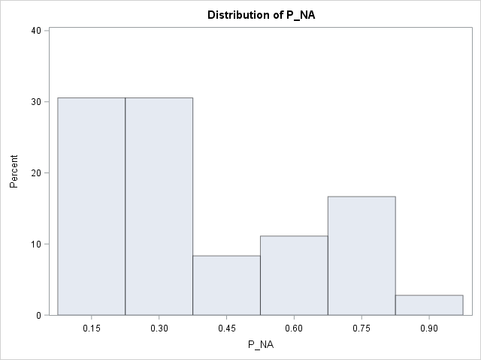
  - NA: 36 CpGs p-value > 0.05 in NA [range: 0.082 to 0.952]

  - AA: 36 CpGs <0.05 [range: 5.72E-5 to 5.96E-07]
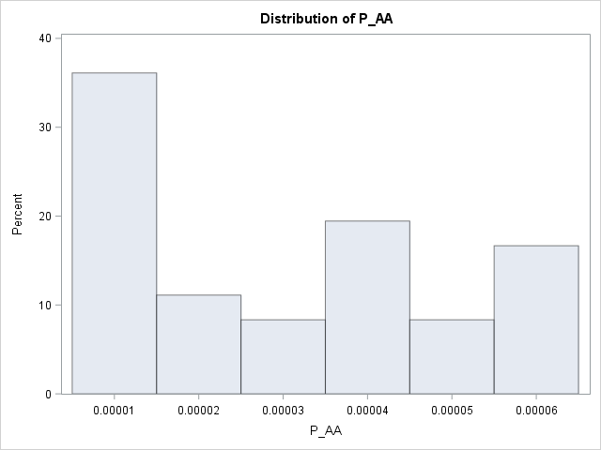

- AA model: 326 CpGs nominal p-value >0.05
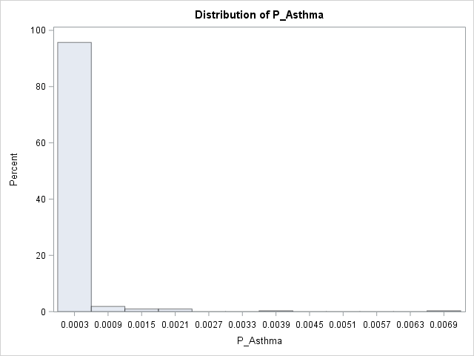
  - Asthma: 326 CpGs p-value <0.05 [range: 0.007 to 8.33E-7]

  - NA: 326 CpGs p-value <0.05 [range: 0.001 to 3.73E-8]

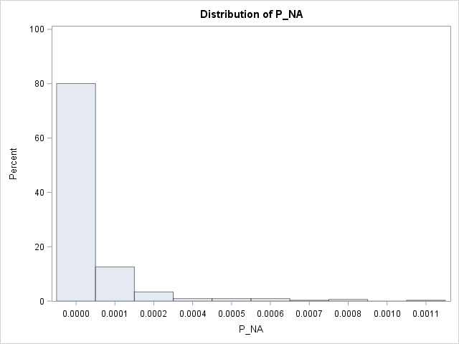
- NA model: 166 CpGs nominal p-value > 0.05
  - Asthma
    - 130 CpGs nominal p-value <0.05 [ range: 0.048 to 6.8E-4]
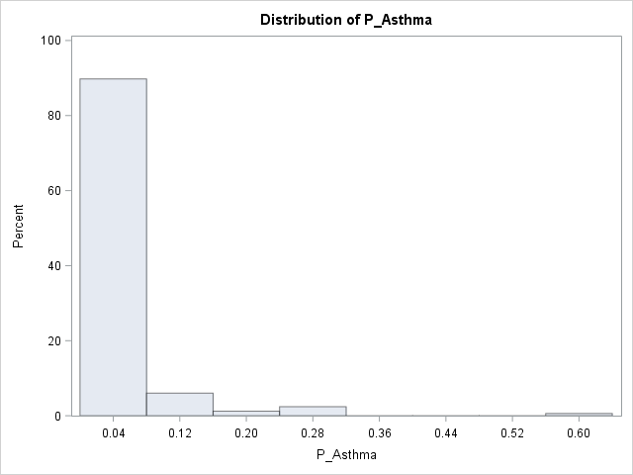
    - 36 CpGs nominal p-value > 0.05 [ range: 0.0501 to 0.60]

  - AA: 166 CpGs p-value < 0.05 [range: 6.5E-5 to 1.47E-9]

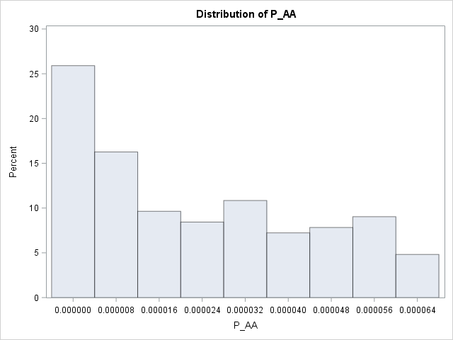

Of the FDR significant CpGs in the ALHS Asthma EWAS (includes cross-reactive probes), Jianping pulled Sarah’s results from older kids. Of the 1,506 CpGs, only 486 CpGs were available in Sarah’s paper.
Compare to Sarah’s results | FDR_NA<0.05  (524 CpGs) | FDR_AA<0.05  (1,086 CpGs) | FDR_Asthma<0.05  (1,223 CpGs)
Number of CpGs <0.05 in ALHS EWAS that  were identified in Sarah’s paper | 174 | 357
Same Direction | 148 (85.1%) | 352 (98.6%)
Opposite Direction | 26 (14.9%) | 5 (1.4%)
FDR significant in older kids | 21 (12.1%) | 102 (28.6%)
Nominal p (p<0.05) in older kids | 69 (39.7%) | 297 (83.2%)
Same Direction | 69 (100%) | 296 (99.7%)
Opposite Direction | 0 (0%) | 1 (0.3%)

Number of FDR significant CpGs by including or excluding cross-reactive probes and type of array
 | Cross-reactive probes included |  | Cross-reactive probes excluded
 | EPIC | 450K | EPIC | 450K
NA | 524 | 175 | 509 | 169
AA | 1,086 | 359 | 1,070 | 349
Unique¹ | 1,506 | 489 | 1,477 | 474
Asthma | 1,223 | 378 | 1,196 | 368
Unique² | 2,013 | 637 | 1,970 | 618
¹CpG is significant in either NA or AA model (removes overlap from summing NA and AA rows)
²CpG is significant in either NA, AA, or Asthma model (removes overlap from summing NA, AA, and Asthma rows)

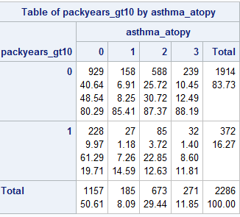

Peng et al. 2019 [PMID: 30876376] identified 705 CpG sites (FDR p < 0.05) associated with atopic sensitization in mid-childhood. 653/705 CpG sites overlapped in the ALHS analyses. We pulled the results from the ALHS atopy vs no atopy and no asthma analysis. 85/653 CpG sites had a nominal p-value < 0.05. 78/85 CpGs had a negative beta coefficient in both Peng et al. and ALHS. 0/85 CpGs were in the positive direction in both Peng et al. and ALHS.

Based on the 653 overlapping CpG sites in Peng et al. and ALHS
 | # CpG sites
Negative beta coefficient in both Peng and ALHS | 437
Positive beta coefficient in both Peng and ALHS | 57
Negative beta coefficient in Peng and positive beta coefficient in ALHS | 69
Positive beta coefficient in Peng and negative beta coefficient in ALHS | 90

Distribution of inhaled steroid use by asthma/atopy status:
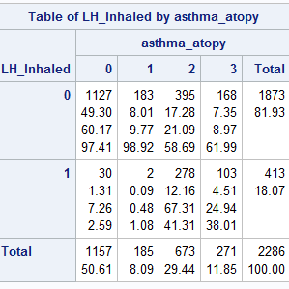
Difference in inhaled steroid use is not different among non-atopic asthmatics and atopic asthmatics (chi-sq p=0.35)

Distribution of last used medication for asthma by asthma/atopy status:
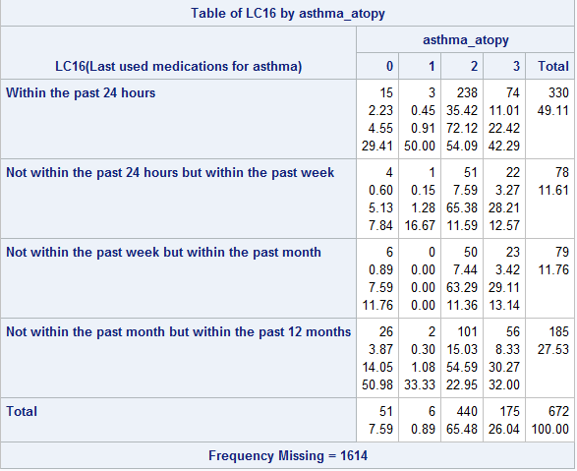
More non-atopic cases used medication for asthma in the last 24 hours than atopic cases. This trend did not differ when stratified by gender or season.

Pathway analysis:
For the 1477 CpG sites, the distribution of the distance to the nearest TSS is:

summary(results$Distance_to_TSS)
Min. 1st Qu. Median Mean 3rd Qu. Max. NA's
-473049 -4800 2926 9533 23339 649168 1

October 22, 2019
Compare LH_CURRENT_FARM_v3 to LH_FARMWORK_curr
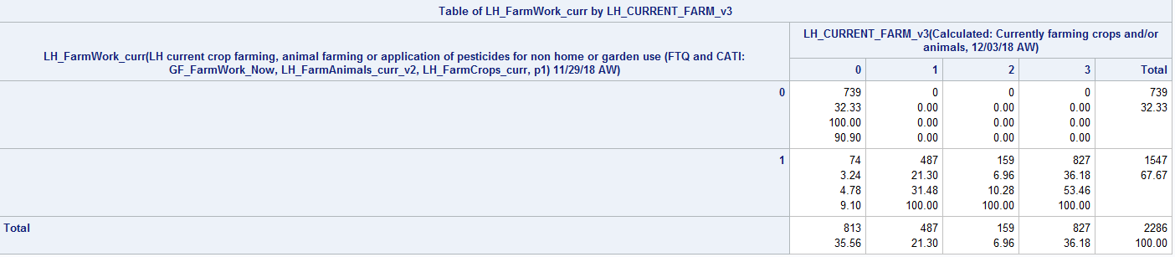

LH_CURRENT_FARM_v3 does not take into account pesticide use. If reported using pesticide, then considered as currently doing farm (LH_FARMWORK_curr).

I examined the distribution of LH_CURRENT_FARM_v3 and LH_FARMWORK_curr by atopy (≥0.70) and the combined asthma/atopy variable. Distribution was similar across atopy status and the 4-level asthma/atopy variable for both farm work variables (chi-square p-value > 0.05). Stratifying by gender, distribution also did not differ.

I decided to use the LH_FARMWORK_curr variable to include those who used pesticide.

Distribution of current farming exposure by combined asthma/atopy variable
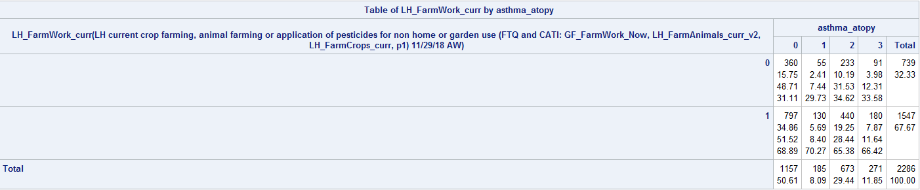

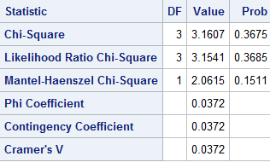

Males
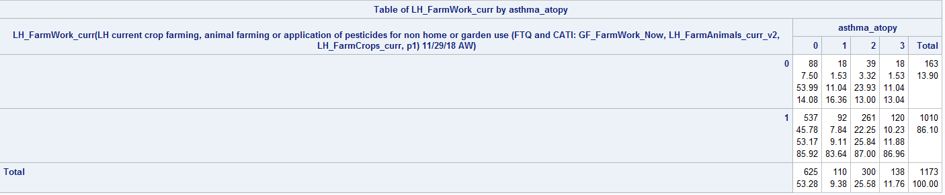

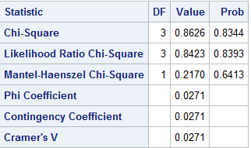

Females

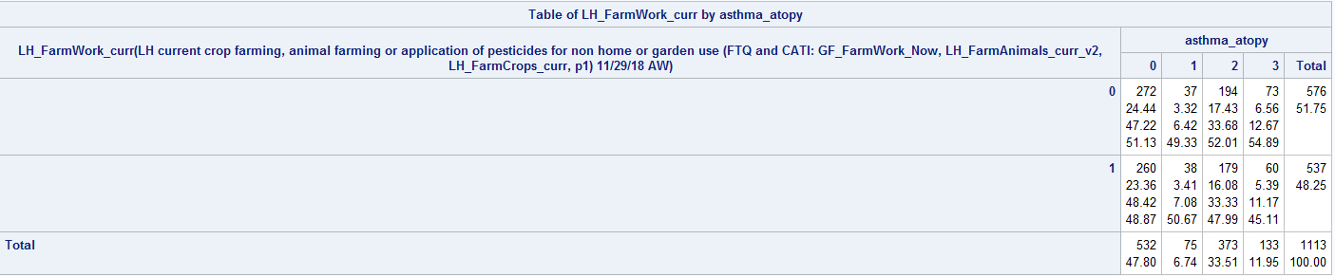

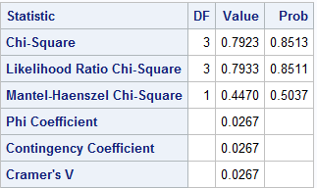

Re-run EWAS adjusting for current farming exposures (LH_FarmWork_curr)
Results were similar.

Non-atopic asthma
Venn Diagram comparing the overlapping FDR significant CpGs

Scatterplot of -log10p of FDR significant CpGs identified in either non-atopic asthma models (# of Bonferroni significant listed, Rp = pearson correlation, Pp = pearson p-value, Rs = spearman correlation, Ps = spearman p-value, red line is the Bonferroni threshold (6.11E-08))

Scatterplot of beta coefficients of FDR significant CpGs from either non-atopic asthma model

Atopic asthma

Scatterplot of -log10p of FDR significant CpGs from either atopic asthma model
Scatterplot of beta coefficients of FDR significant CpGs from either atopic asthma model

