Cataloging gene-environment interaction candidate SNPs for over 3,000 UK Biobank disease phenotypes through variance loci analysis
Xiaoran Tong, <authors>, Alison Motsinger-Reif

Abstract
Detecting gene-by-environment interactions (GxEs) is statistically and computationally challenging due to the high dimensionality of the combined genome and exposome. Variance quantitative trait loci (vQTL), which capture non-uniformity in the residual variance of a quantitative trait caused by unaccounted-for GxEs, can suggest candidate single nucleotide polymorphisms (SNPs) without the need for exposome profiling.
We propose variance loci analysis (VLA), which improves vQTL by adding a positive gradient test and maintains power to detect GxE candidates with weak direct environmental effects. More importantly, VLA overcomes the inability of vQTL to analyze case-control phenotypes.
Using VLA, we ranked the potential of each SNP in GxEs for 3,273 phenotypes from the UK Biobank and created the VLA Catalog, which is hosted as an open resource (genelist.niehs.nih.gov). Combining the rich exposome data from the Personalized Environment and Genes Study and high-ranking SNPs determined from VLA, we detected significant GxEs for type 2 diabetes, including an interaction between the ABCB7 gene and exposure to inkjet printing inks and toner.

Introduction [No heading or subheadings]

Background and motivation
A portion of the “missing” heritability in genome-wide association studies (GWAS) is due to unaccounted-for gene-by-environment (GxE) interactions (Eichler et al. 2010; Van Ijzendoorn et al. 2011). Despite findings that genetic effects are context-dependent (9-13), the difficulty of measuring exposures and insufficient sample sizes make it challenging to identify GxE effects (9–11). Further, the number of main effects and interactions in a genome-exposome-wide association study (GxE-WAS) presents both computational and multiple testing burdens. These challenges are commonly addressed by choosing candidate genomic variants via a priori biological knowledge or selecting significant genomic variants from GWAS. However, the first approach hinders discovery, and the latter tends to produce false positives due to the ostensible assumption that strong genetic marginal effects exist in all GxE interaction models.

Variance quantitative trait loci (vQTL) analysis
Variance quantitative trait loci (vQTL) analysis is an alternative approach to identifying GxE candidates that relies on the heterogenous variation of quantitative traits among individuals of different allele carriage in the presence of strong GxEs (Cao et al. 2014; Deng, Asma, and Paré 2014; Struchalin et al. 2012; Yang et al. 2012). The most intuitive vQTL test is the double linear model (DLM), which essentially considers the squared residuals of a GWAS as new phenotypes, which are then used to perform a second GWAS (Struchalin et al. 2012). However, DLM assumes homogeneous variation among individuals of the same genotype and thus phenotypes must be nearly Gaussian, which precludes many outcomes of interest related to human health. More robust vQTL tests have shown varying success for quantitative non-Gaussian phenotypes, such as the deviation regression model (DRM), which replaces squared residuals with distance to the group median (Marderstein et al. 2021), Levene’s robust test of heterogeneous variance (LVT), which captures non-parametric vQTLs (Paré et al. 2010), and double generalized linear modeling (DGLM) (Smyth 1989; Lee and Nelder 2006), which models phenotypic variance in log scale. However, for binary phenotypes, these vQTL tests produce substantial false positives because of the close link between mean $μ$ and variance $v$ ($v=2μ(1-μ))$ (Paré et al. 2010; Marderstein et al. 2021; H. Wang et al. 2019). Further, additive vQTL tests such as DLM and DRM have diminished power to detect pure GxE candidates when there is a weak direct environmental effect on the phenotypic mean, even for Gaussian phenotypes.

Variance loci analysis (VLA)
Motivated by the issues with existing vQTL tests, we developed variance loci analysis (VLA) to detect GxE candidate variants. VLA works similarly to DLM, but rather than fitting a slope through the squared residuals (i.e., in a second GWAS), VLA instead fits a curve and tests its positive gradient. Compared to existing methods, VLA provides superior control of type 1 errors for binary (i.e., case-control) phenotypes while maintaining power for Gaussian phenotypes with weak environmental main effects.
In VLA, the phenotype is first smoothed by carefully chosen covariates. The best covariates are non-confounding yet predictive. For example, age and age² are excellent covariates because they are neither heritable nor determined by the exposome (and are thus non-confounding) but are strong determinants of diseases (i.e., predictive). The residual of these covariates is a quantitative representation of the underlying risk contributed by the genome, exposome, and the interaction of the two. By replacing a binary phenotype with smoothed residual risk, the positive gradient test can detect candidate GxE variance loci.
In subsequent sections, we illustrate the rationale for using variance loci to identify GxE candidates and the ability of the proposed VLA method to address the shortcomings of existing methods. We then describe simulation studies based on 1000 Genomes Project data and discuss the true positive (i.e., power) and net positive rates for VLA and existing variance loci tests. Subsequently, we use data on BMI and T2D in UK Biobank (UKBB) and Personalized Environment and Genes Study (PEGS) data to benchmark the performance of VLA, mean-based GWAS, and other variance-based tests for selecting candidate GxE variants. We next describe the application of VLA to PEGS data to identify GxEs for type 2 diabetes (T2D), importantly, between X chromosome gene ABCB7 and printer inks, dyes, and toner. We also discuss the database of candidate variant loci for 3,273 phenotypes, of which 1,693 are binary disease status derived from PHECODE mapping (Wei et al. 2017; Wu et al. 2019), that we created and host (https://genelist.niehs.nih.gov/vla).

Results

Illustration
To conceptually demonstrate the approach, we applied VLA to generated data points with and without environmental exposures (Figure 1, magenta and orange dots), with no GxE effects, some GxE effects, and pure GxE effects.
The results illustrate that variance loci are induced by GxE effects unaccounted for in a GWAS linear model, resulting in the uneven distribution of a phenotype across genotypes (Figure 1c, left) (Paré et al. 2010). Variance loci are detected by testing the non-zero slope of a line fit through the amount of phenotypic variation (Figure 1c, right, green), as with DLM. With VLA, variance loci are detected by testing the positive gradient of a curve fit through the variation (Figure 1c, right, red). In the absence of a GxE, SNPs are not identified as variance loci because the phenotype is uniformly distributed across genotypes (Figure 1a, left). With this distribution, DLM and VLA correctly retain the null because both the line (DLM) and curve (VLA) fit through the phenotypic variation are flat (Figure 1a, right).
For binary, case-control data, when an SNP itself affects a phenotype (Figure 1b, left), the slope-based DLM test causes false positives because the line fit through the phenotypic variation always has a positive slope, even in the absence of a GxE (Figure 1b, right, green). In this case, however, VLA, which tests the positive gradient, correctly retains the null because the fitted curve has a negative gradient (Figure 1b, right, red).
When a pure GxE affects a phenotype without a direct environmental effect (Figure 1e and 1f, left), the slope-based DLM test lacks statistical power because the line fit through phenotypic variation is flat (Figure 1e and 1f right, green). Despite the presence of a strong GxE, the positive gradient of VLA can detect variance loci since the fitted curve has a positive gradient (Figures 1e and 1f, red).

Variance loci analysis
VLA (Figure 10, bottom) modifies DLM in two important ways. Given a quantitative trait, an SNP, and covariates, DLM fits a GWAS linear model, adjusting for covariates, and treats the squared residual as a “new” phenotype, which is subsequently used to fit another GWAS linear model with the same SNP and covariates (Figure 10, top). If the SNP coefficient of the second linear model is significant, the SNP is a vQTL, that is, a GxE candidate for the particular quantitative phenotype. Intuitively, the second linear model fits the squared distance from the fitted values of the first linear model (i.e., conditional mean given the SNP and covariates). Because the mean of squared distance from the mean is variance, in essence, this models the phenotypic variance.
With VLA, for the second linear model, 1) the squared SNP is used and 2) a one-sided t-test is performed, assuming a non-negative coefficient. For a binary trait, the rare event (i.e., disease) is coded as 1 and the covariates are chosen from non-heritable predictors. There is no need to replace the first linear model with generalized linear modeling (GLM) (i.e., logistic regression). The supplement provides theoretical justification for these important improvements.

Simulation
We evaluated and compared the performance of VLA to that of DLM, LVT, DRM, and GWAS with simulation experiments. We ran 20,000 repeats for each of two scenarios: 1) a pure GxE effect and 2) a GxE effect co-occurring with an environmental main effect. For each simulation repeat, we generated vectors of the environment and covariates with a normal distribution and selected a genotype from an SNP randomly picked from Phase 3 of the 1000 Genomes Project (Consortium 2012; Consortium and others 2015) with an MAF≥0.01 and a sample size varying from 2⁴ to 2¹⁶.
We generated phenotypes as the sum of a strong covariate effect, weak genotype main effect, possible environmental main effect, and possible GxE effect. We fixed the alpha to 0.05, rejecting the null for p-values <0.05.
Both scenarios detected additive variance loci. For each scenario, we also simulated a corresponding null scenario by zeroing out the GxE effect. Rejecting the null in these scenarios added to a method’s false positive rate, or type 1 error. We considered a test superior if it had a high true positive rate (indicating power) while controlling the false positive rate (type 1 error). Accordingly, we used the net positive rate (i.e., the true positive rate minus the false positive rate) as an overall measure of performance.
For balanced binary phenotypes (i.e., a 50% case rate), the variance loci and genetic main effects became less distinguishable as the sample size increased, which increased the false positive rate (Figure 4b, panels 1 and 3) at the cost of the net positive rate (Figure 4b, panels 2 and 4). Among the tests, only VLA controlled the false positive rate. VLA also had the best performance in detecting true candidate SNPs for pure GxE effects (Figure 4b, panel 2, solid red line).
For imbalanced binary phenotypes (7.6% case rate), for which it is difficult to distinguish an SNP main effect on the phenotypic mean from the effect on phenotypic variance, resulting in overall inflation of the false positive rate, VLA had the best performance in detecting true GxE candidates (Figure 2c).
Overall, the simulation results indicate VLA has better performance for detecting additive variance loci induced by pure GxE effects and is more robust in the presence of false positives caused by imbalanced, non-Gaussian phenotypes. As expected, VLA underperformed with multiplicative variance loci because a negative allele effect on logged variance corresponds with an improper, non-real-valued additive GxE effect.
The supplement details the simulation and provides the full results, including true positive rates and values for multiplicative variance loci.

UKBB genome-wide variance loci analysis
We applied DLM, VLA, LVT, and DRM (excluding DGLM due to its low speed and instability) in BMI and T2D data from the UKBB to examine each test’s selection of variance loci. We also performed GWAS with linear and logistic regression for BMI and T2D, respectively, and recorded five test statistics for each SNP. We assembled two populations: 1) 353,605 unrelated British Whites and 2) 379,561 unrelated individuals, including all individuals in the first selection population in addition to Irish and other individuals with any European ancestry. The two populations included 9.2 million SNPs on chromosomes 1-22 and X with MAF >0.01. The covariates were age, sex, age², age×sex, age²×sex, the first 20 genetic principal components, and the genotyping array for a total of 26 covariates, including the intercept. Figure 3 shows Manhattan plots and QQ plots in both original [0, 1] and -log10(p) scale with a genomic inflation factor (λ_{GC}), based on the second, larger population. Table S2 lists the most significant SNPs for each test.
LVT and DRM were abnormally positive on the X chromosome (Figure 3, orange circles) because the lower frequency of the heterozygous genotype in men causes these tests to erroneously attribute changes of phenotypic variance due to sex as due to genotype.
For BMI (Figure 3a, Table s2a), GWAS returned more significant SNPs with over-confidence (λ_{GC}=1.998). The variance loci tests distinguished genetic effects on the phenotypic mean and variance with relative ease. For T2D, except for the X chromosome, all five tests largely agreed on the most significant loci, reflecting the interchangeability of genetic effects on the phenotypic mean and variance for binary outcomes. However, VLA showed the least genomic inflation (λ_{GC}=1.02). Of note, rs6712203 (2:164700808 C/T), rs860262 (7:28194397 C/A), and rs76895963 (12:4384844 T/G) (GRCh37) were not selected by VLA but were identified by the other tests (Figure 3b, red circles).

GxE enrichment analysis
We conducted GxE enrichment analysis to gauge how well the top-ranked SNPs from a variance loci test in one population enrich the detection of significant GxE interactions in a discovery population. In one population, we ranked SNPs by 1–p-value for each test’s primary statistics. In the discovery population, we scored SNPs by the number of two-way GxE p-values below a series of cut-offs and the overall sum of negative p-values. By regressing the scores on the ranks, the coefficient acted as a measure of GxE enrichment. We performed an internal GxE enrichment assessment among sub-populations in the UKBB and an external assessment in the PEGS cohort.

Internal GxE enrichment
In UKBB data, we ranked SNPs using test statistics (i.e., DLM, LVT, DRM, VLA, and GWAS) based on 353,605 British Whites and scored SNPs using two-way GxE statistics based on 25,481 non-British Whites. For BMI, VLA was the most efficient for SNP selection overall (Figure 4a, red) and exhibited pronounced advantages compared to the other tests (Figure 4b, red). VLA was also more efficient for GxE SNPs with p-values <5e-7. The supplement provides the score-rank GxE enrichment regression coefficients (Table?) and a flowchart of the analysis (Figure?).
For T2D, DLM has similar performance as GWAS (Figure 4b, gray and green). At stricter GxE p-value thresholds, LVT and DRM also had similar performance. There were redundancies due to the high correlation between SNP ranks (i.e., 1–p-value) from GWAS and non-GWAS tests, namely DLM (0.985), LVT (0.613), DRM (0.8871), and VLA (0.004). In contrast, for BMI, which is a quantitative phenotype (Figure 4a), the four variance loci tests exhibited selection patterns distinct from those of GWAS, with the following correlations: DLM (0.053), LVT (0.032), DRM, (0.012), and VLA (0.007).

External GxE enrichment
We performed two-way GxE-WAS in PEGS data for 4,603 individuals with age, sex, income level, the first 10 principal components, and ethnicity coded as a categorical variable (European American, African American, Asian, and other) as covariates. For the T2D analyses, we also included BMI as a covariate. We scored SNPs by the number of two-way GxE p-values below a series of cut-offs and the overall sum of negative p-values. In UKBB data, we used the five tests (i.e., DLM, LVT, DRM, VLA, and GWAS) to rank SNPs based on the population of 379,561 European Whites. The PEGS and UKBB cohorts shared 8,331,313 SNPs with MAF >0.01 in the UKBB. The supplement provides the score-rank GxE enrichment regression coefficients (Table?) and a flowchart of the analysis (Figure?).
In BMI data from PEGS, SNPs ranked by VLA had the best chance of detecting highly significant GxEs (p-value < 5e-7, …, 5e-9) and the second-best chance of detecting overall GxEs (3.82, se=0.34) (Figures 4c and 4d). Interestingly, while DRM produced by far the most conservative statistics for BMI (see Figure 3a), it resulted in the best overall enrichment (4.64, se=0.35) in the discovery cohort. For T2D, only VLA enriched the detection of medium to highly significant GxEs with p-values <5e-6, …, 5e-9 and overall GxEs (0.89, se=0.34) in the discovery cohort, while other tests showed negative coefficients (i.e., depletion) without exception. Again, the coefficients from DLM were highly similar to those from GWAS and, to a lesser degree, DRM, reflecting the redundancy of the slope-based variance loci test for binary phenotypes.

Functional enrichment analysis
We also examined enrichment from a functional perspective to examine which classes of SNPs were over-represented among the significant loci identified by each test. For example, loci identified by GWAS were more frequent among SNPs in or near genes than between genes. We labeled each SNP as an intergenic, upstream, intronic, exonic, or downstream variant using ANNOVAR (K. Wang, Li, and Hakonarson 2010) and calculated the combined annotation dependent depletion (CADD) score (Kircher et al. 2014; Rentzsch et al. 2019) as a continuous measure of pathogenic tendency. We treated the functional labels as binary variables and CADD scores as a continuous response variable and regressed them on the SNP rankings given by each test. A positive significant coefficient indicated variance loci were over-represented among certain types of SNPs or those with higher CADD scores. The supplement provides functional enrichment regression coefficients (Table?) and a flowchart of the analysis (Figure?).
For both BMI and T2D, all tests except VLA significantly underrepresented intergenic SNPs outside of genes, and none prioritized exonic SNPs. For BMI, VLA evenly selected all classes of SNPs (Figure 4e, red). DRM under-selected downstream SNPs (Figure 4e, orange), and GWAS, DLM, and LVT prioritized intronic SNPs and those with high CADD scores. For T2D, VLA prioritized intergenic SNPs (Figure 4f, red) but not intronic SNPs or those with high CADD scores. The other four tests produced largely similar results, which is unsurprising given their redundancy with binary phenotypes.

PEGS GxE adjusted by UKBB variance loci
We performed an exhaustive two-way GxE-WAS for T2D in the PEGS cohort that resulted in 10.8 trillion GxE test statistics (i.e., genome variants × exposome items). We retained 36.7 billion (0.40%) GxE that were 1) of or beyond moderate significance (P < 5e-4) and 2) matched by coordinates and alleles with variance loci from the previous analysis of UKBB White Europeans. After binning the GxE and matched variance loci into genome segments, we selected the most significant GxE and variance loci per bin, further narrowing the number to 1,608,961 representative GxE (0.015%) and nearby variance loci. We applied Bonferroni correction, considering 0.47 billion selectable GxE tests, and then adjusted the corrected p-values, considering the most significant variance loci in the neighborhood.

ABCB7 × print material on T2D
For each exposure in PEGS, we used VLA to detect GxEs with an adjusted p-value <0.05. The findings revealed significant GxEs for 13 protein-coding genes (CTNND2, TMEM132D, DMD, ABCB7, NXF3, PTPRK, ZNF157, CYCS, C7orf31, CNBD2, RAPGEF5, TRNT1, IL5RA) and exposure to dyes, inks, and toner (PEGS ID: A_B194i). The top hit in the GxE-WAS was X chromosome gene ABCB7 (ATP binding cassette subfamily B member 7, X:75,051,048 - 75,156,732, ENSG00000131269) and its immediate downstream variant UPRT (uracil phosphoribosyl transferase homolog, X:75,156,388 - 75,304,885, ENSG00000094841). The two genes are enclosed by q13.3 and were suggested by nearby SNP rs4409555 with raw GxE p-values of 9.25e-12 and 4.39e-2 after Bonferroni correction and 6.45E-05 after adjustment by VLA. It should be noted that LVT and DRM were not utilized because the methods are invalid for chromosome X.
We downloaded and analyzed gene-expression data to corroborate the significant GxE between SNPs around ABCB7-UPRT and exposure to dyes, inks, and toner. The differential expression of ABCB7 among workers occupationally exposed to inkjet printers, archived as GEO dataset GSE142351 (Guo et al. 2020), substantiates the finding. ABCB7 is involved in metabolism and multi-drug resistance and is related to transport pathways of glucose and other sugars, bile salts, organic acids, metal ions, and amine compounds. Notably, the gene encodes a half-transporter involved in the transport of heme from the mitochondria to the cytosol. ABCB7 is also an ATP-dependent mitochondrial transporter implicated in Fe–S cluster assembly, and the absence of ABCB7 impairs the maturation of cytosolic iron-sulfur proteins and induces iron accumulation in mitochondria. Inherited mutations in the gene have been linked to inherited and acquired sideroblastic anemia with cerebellar ataxia (Pain and Dancis 2016; Allikmets et al. 1999).
Further, the knockdown of ABCB7 in HEK293T cells causes mitochondrial iron accumulation and the activation of SOD enzymes while iron and iron-regulatory proteins and cadmium alter ABCB7 expression. This is notable because some pigments in printer ink dyes, such as potash blue or soda blue, contain iron based on ferrous and ferric cyanides, and printer inks may also contain cadmium (Podhajny 2001). Also of interest is the association of ABCB7 with fatty liver disease, which is notable because T2D is a significant risk factor for fatty liver disease and could share common pathways (SILAGHI et al. 2016; Lonardo et al. 2019). In summary, prior work shows that the region around ABCB7, statistically prioritized by VLA, biologically interacts with exposure to print materials, affecting the risk of developing T2D.

UKBB variance loci catalog
Inspired by the Pan-UK Biobank GWAS catalog at pan.ukbb.broadinstitute.org, we created a catalog of variance loci statistics for UKBB phenotypes and variants that is hosted on the NIEHS website (genelist.niehs.nih.gov). The catalog is a public resource that can be queried by phenotype, enabling researchers to prioritize candidate variants most likely to invoke significant GxEs. Figure 8 illustrates the workflow of creating the catalog and the query process.
Briefly, we summarized 1,580 health-relevant phenotypes chosen from UKBB data fields accessible to NIEHS plus an additional 1,693 diseases derived from hospital records using PHECODE, a codebook for extrapolating diseases using ICD9/10 records (www.phewascatalog.org) (39, 40) for a phenome comprising 3,273 items. We distinguished the selected UKBB phenotypes into binomial, multinomial, ordinal, and continuous variables and subsequently recoded and normalized them. For the genome, we limited the variants to those with an overall minor allele frequency of at least 0.005, for a final 11,841,785 variants after quality control. The supplement provides details of this process.
For each of the four main racial/ethnic groups in the UKBB (British Whites, Irish, Blacks, and Asian), we performed VLA for the whole phenome and genome to archive variant statistics. We used the plinkFile and vla R packages to traverse the genome by window while scanning variance loci for thousands of phenotypes and variants. We divided the genome into approximately 1,200 groups of 10,000 variants each and summarized the VLA statistics for British Whites, which is the largest group in the UKBB with a working sample size of 384,000, in 12 hours using the NIH HPC Biowulf cluster (hpc.nih.gov).

Methods

Variance loci tests to identify GxE candidate SNPs
VLA modifies DLM in several important ways. (Figure 10, bottom) First, the second linear model for VLA uses the squared SNP. Second, a one-sided t-test is used with the assumption of a non-negative coefficient. Third, VLA fits a curve and tests its positive gradient instead of fitting a slope through the squared residuals as in DLM. The covariates for VLA must be non-confounding yet predictive as their residual is a quantitative representation of the underlying risk contributed by the genome, exposome, and their interaction. Replacing a binary phenotype with a smoothed residual enables the detection of candidate GxE variance loci from a positive gradient.

We created R-language wrapper functions for DRM and LVT from the car R package (citation) and for DGLM from the dglmR package (citation). Because DGLM is unstable with small sample sizes and requires substantial computational time for large sample sizes, we used this method only as a benchmark for the simulation studies.
We also considered traditional GWAS as a reference for GxE candidate selection. Using PLINK2’s “--glm” routine, we fit a GWAS linear model for BMI and logistic regression for T2D. We included GWAS for GxE enrichment and functional enrichment analysis only.
tThe supplement provides details of the statistical tests.

Two-way GxE-WAS
In a discovery cohort with normalized environment $u$ and standardized SNP $g$, GxE interaction effects are typically captured by adding a two-way product term $ug$ to a GWAS linear model,
$y=m_{0}+ag+bug+cu+dx+e$,
where $e$ is a vector of Gaussian noise and $x$ is the covariate. Rejecting $h_{0}:b=0$ at a given p-value threshold suggests the presence of a GxE interaction between SNP $g$ and environment $u$. This process is repeated for all two-way combinations of SNPs and environmental exposures. For PEGS, this is a total of 14,874,008 x 765 models, and for White non-British in the UKBB, this is 9,298,089 x 16 models. While we exhaustively analyzed all two-way combinations for the purpose of demonstration, in an actual application, the VLA Catalog should be queried and GxE-WAS should be limited to the top-ranked SNPs or/and those below a p-value threshold for shorter running time and mitigation of the burden of multiple testing.

UK Biobank (UKBB) data
To evaluate the performance of VLA in selecting GxE candidates, we used data from the UKBB, a large-scale resource consisting of genetic and health information for over half a million participants (Application ID: 57849, version 2) collected via questionnaires, electronic health records, biological samples, oral interviews, imaging, and genotype data. Using the imputed genotype, we created a comprehensive catalog of the whole genome. After quality control and filtering, we divided the remaining 375,992individuals into five major ancestry groups—African (afr), non-Chinese Asian (asi), White British (bri), Irish (iri), and White but non-British (wnb)—that are the basis of the NIEHS VLA Catalog. The bri and wnb groups serve as training and testing datasets, respectively. The supplement provides details. We also manually compiled UKBB phenotype data (Table 2) for T2D, CAD, BMI, and fasting glucose level and used UKBB data on 16 environmental variables (Table 3). Additionally, we derived phecodes using phenotypes and disease diagnoses from electronic health record data for UKBB participants recorded as International Classification of Diseases (ICD) codes (40) (41) (40, 42). The supplement provides details on how we compiled the phenotypes, including criteria for each phetype, the UKBB data fields used, and details of our phecode mapping.

PEGS data
For the external GxE enrichment analysis, we used data from PEGS, a North Carolina-based cohort of 19,672 participants of varying age, race, socioeconomic status, and education level. Whole-genome sequencing data is available for 4,610 participants. We used questionnaire-based exposome data in its original form for binary and integer-based items. We derived T2D and BMI phenotype data from the survey data. The supplement provides information on case-control definitions and quality control measures.

Discussion
VLA is a powerful new method that addresses the constraints of existing vQTL analysis approaches.
For binary traits, when screening GxE candidate SNPs, vQTL tests (i.e., DLM, DRM, DGLM, and LVT) produce false positive rates as high as that of GWAS. Essentially, the close tie between the mean and variance grossly violates the assumption of homogeneous variation among individuals of identical allele carriage, causing these tests to falsely identify any GWAS-significant SNP as a GxE candidate regardless of the presence of a GxE. However, VLA resists spurious GxE candidates of binary traits and, with carefully chosen covariates that reconstruct the underlying risk of a binary trait, is more efficient in selecting true GxE candidates. For quantitative traits, VLA can detect pure GxE candidates with weak direct environmental effects.
GxE enrichment analyses in both the internal discovery population of UKBB non-British Whites and the external discovery population of PEGS participants demonstrated the reliability of VLA for prioritizing GxE candidates for both quantitative and binary phenotypes such as BMI and T2D.

The ability of VLA to identify GxE candidates for binary phenotypes enabled us to analyze a large number of case-control outcomes. The simplicity of the method enabled the rapid ranking of variants for multiple phenotypes, facilitating the creation of the VLA Catalog. The searchable/downloadable catalog comprises a rich phenome of 3,237 phenotypes, of which 1,693 are binary, and a whole genome of 11.8 million SNPs from the UKBB and is hosted on the NIEHS website (https://genelist.niehs.nih.gov/vla). The VLA Catalog is stratified for gender and multiple ancestries and is a resource for research on GxEs, as well as alternative variant effect sizes for summary statistics-based analysis (i.e., polygenic risk scores).
To demonstrate how the VLA Catalog can be used in research, we tested candidate SNPs from the UKBB in the PEGS cohort, for which both genetic and environmental exposure data are available, and found that the SNPs were involved in many significant GxEs.
Using 11.8 million whole-genome VLA test statistics for UKBB European Whites as a reference, we readjusted the Bonferroni corrected p-values of 10.8 trillion (~14 million SNPs × ~700 exposures) two-way GxE-WAS for PEGS participants. This made it practical to manually track down the most promising GxEs involving a handful of coding genes and exposure to paints and pesticides. We followed up the top finding from our analyses, a GxE for ABCB7 and printer ink and toner exposure, in gene-expression data. We found that ABCB7 is differentially expressed among workers who operate inkjet printers, suggesting environmental targets of intervention for individuals occupationally exposed to inks, dyes, and toner.

There are several caveats regarding the use of VLA. First, VLA is appropriate for detecting additive GxEs. Since VLA is an additive variance loci method, it prioritizes SNPs involved in additive GxEs in model $y=m_{0}+ag+bug+cu+dx+e$ where $h_{0}:b≠0$. For SNPs involved in multiplicative GxE where $h_{0}:\left|\frac{b}{a}\right|≠1$, multiplicative variance loci methods such as DGLM and LVT should be employed. VLA covariates recover the quantitative risk underlying a binary phenotype and must simultaneously be weak confounders and strong predictors. Suggested covariates for VLA are age, age², sex, age/sex interaction, and genetic principal components.
Second, because VLA de facto tests $h_{0}:b^{2}>0$, the assumption is that $g=\{0,1,2\}$ counts the allele that increases phenotypic variance, so $b^{2}$ is guaranteed to be non-negative. In real-world applications, however, the allelic effect on phenotypic variance is not necessarily incremental, either because $g$ is not truly involved in GxE or because $g$ counts the wrong allele. In these applications, VLA’s power is not hindered because neighboring variants will count the correct allele if the neighborhood harbors a GxE hot spot.
Third, because VLA regresses on a squared variant g2, researchers interested in summarizing a VLA-based polygenic risk score are encouraged to use g2 from the new genotype instead of g. The summaries downloaded from the VLA Catalog can be used to aid in GxE-WAS by either 1) limiting the GxE-WAS to variants near the top VLA loci and applying less stringent p-value correction or 2) conducting an exhaustive GxE-WAS, correcting the p-values, and adjusting the p-values according to the significance of nearby variance loci.g2g2g

While VLA has numerous advantages over existing methods, limitations/issues do exist. First, the simulation results indicate that VLA better controls the false positive rate than existing vQTL tests but cannot fully control it when either an SNP is a significant GWAS locus or the binary phenotype is imbalanced. However, because VLA was the only method capable of positive GxE enrichment for T2D, false positives may be mitigated by the fact that the vast majority of variants have a negligible effect on T2D. Second,
it has been suggested that using logistic regression to fit a stage 1 model for binary traits would reduce false positives, but the poor performance of DGLM (Figure 2) indicates otherwise. In terms of power, a linear model is indistinguishable from a logistic model since logit $f\left(x\right)={\left[exp\left(1+x\right)\right]}^{-1}$ is monotonic and closely approximated by identity $f\left(x\right)=x$ near $x=0$. Therefore, the VLA package uses plain linear models only.
In future work, we plan to XXX.

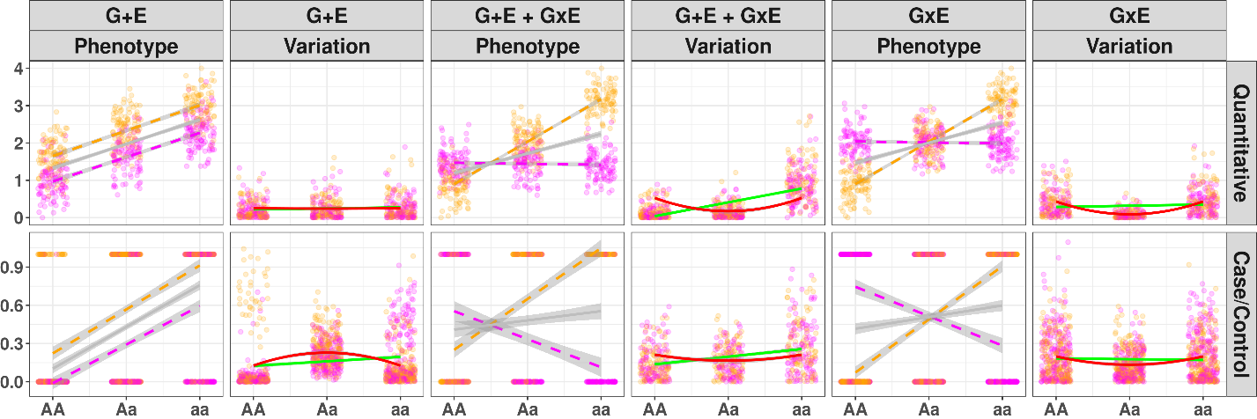
Figure 1: Illustration of variance loci analysis for suggesting GxE candidate SNPs
Gray line: regression lines fitted by GWAS that do not account for environmental exposures; green line: regression lines fitted by a double linear model (DLM) with a non-zero slope test; solid red line: curves fitted by variance loci analysis (VLA) with a positive gradient test; magenta/orange: environment-specific observations; x-axis: SNP genotypes (allele counts); y-axis: phenotype value or variation. Columns 1 and 2 (a, b) show the presence of an SNP effect and direct environmental effect (G+E) but no GxE; columns 3 and 4 (c, d) show the presence of an SNP effect, direct environmental effect, and GxE (G+E + GxE); and columns 5 and 6 (e, f) show the presence of an SNP effect and pure GxE effect (G + GxE) without a direct environment effect.
Row 1 (a, c, e) shows quantitative phenotypes. (a) In the absence of a GxE (G+E), the phenotype spreads uniformly across genotypes, and a flat line fits the variation. Therefore, DLM and VLA indicate that A/a is not a variance loci while GWAS significance erroneously suggests A/a as a GxE candidate. (c) In the presence of a GxE (G+E + GxE), the phenotype spreads unevenly across genotypes, and a line with non-zero slope (solid green) and a curve with positive gradient (solid red) fit the variation. Therefore, DLM and VLA detect A/a as a variance loci and GxE candidate. (e) In the presence of a pure GxE, a flat line fits the variation (solid green line) so DLM does not recognize the variance loci. However, a curve with a positive gradient (solid red) fits, allowing VLA to detect the variance loci.
Row 2 (b, d, f) shows case-control phenotypes. (b) Even in the absence of a GxE, a non-zero slope fits the variation (solid green) and thus DLM wrongfully classifies A/a as a GxE candidate, inflating type 1 errors. However, VLA’s positive gradient test does not inflate type 1 errors because the curve that fits the variation has a negative gradient (solid red). (d) In the presence of a GxE, VLA’s positive gradient test can detect A/a as a GxE candidate (solid red line).; (f) VLA’s positive gradient test also detects pure GxE candidates (solid red) in cases where DLM’s non-zero slope test fails (solid green).

(a)
(c)

(b)
(e)

(d)

(f)

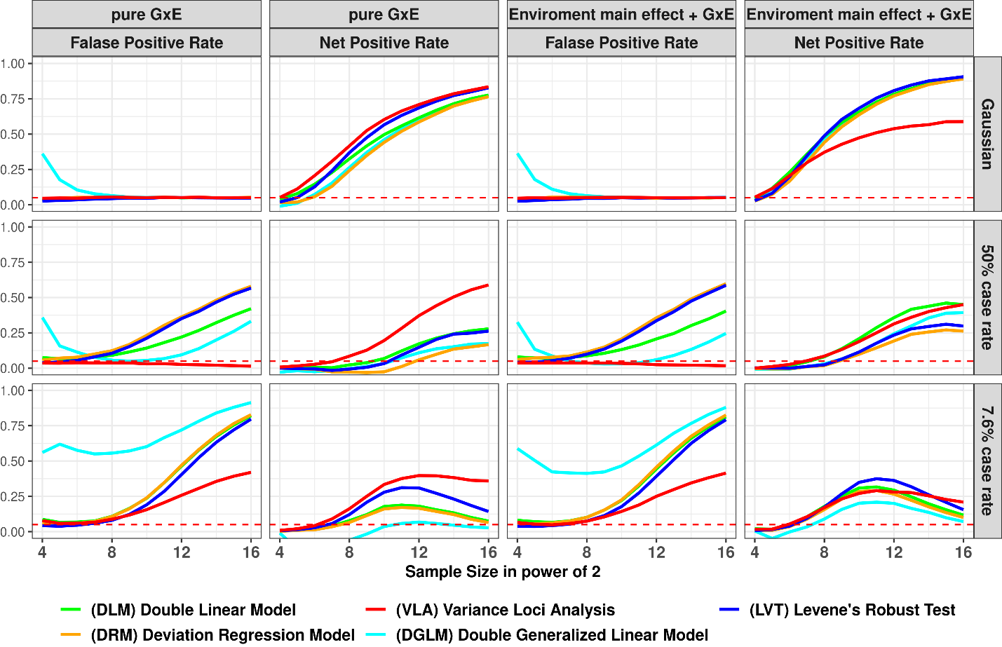
Figure 2: False positive and net positive rates of simulation studies
Columns 1 and 3: GxE is null, and the y-axis is the false positive rate (FPR). An FPR of 0.05 (denoted by red dashes) is used as the threshold, with a higher FPR suggesting over-confidence and a lower FPR suggesting over-conservativeness. Column 2 and 4: Additive variance loci induced by a pure GxE or a GxE co-occurring with a standalone environmental main effect. The y-axis shows the net positive rate (NPR), with a higher NPR indicating better performance, and the x-axis shows sample sizes in powers of two.
(a)
(b)
(c)

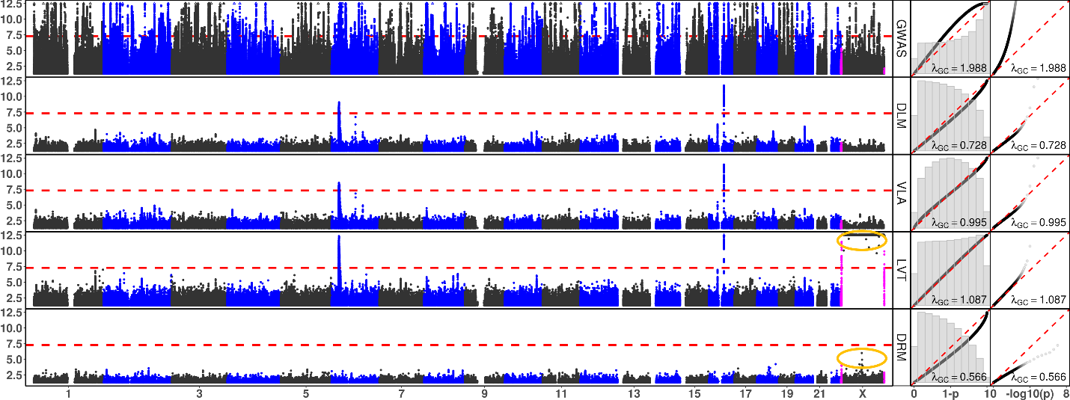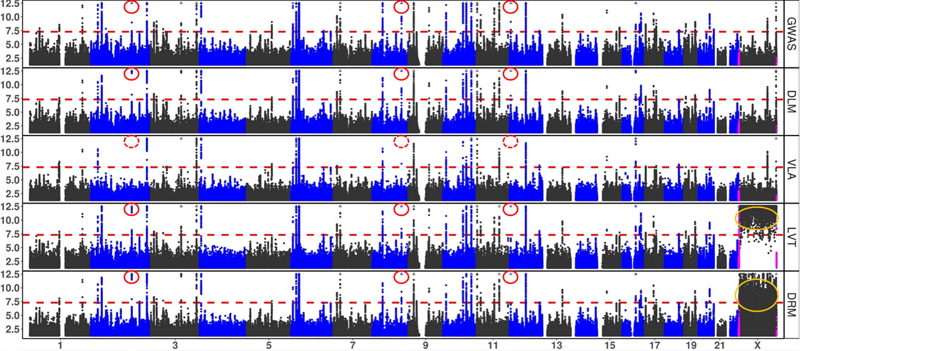
Figure 3: Manhattan and QQ Plots, with λ_{GC}
a) BMI and b) type 2 diabetes. The x-axis represents chromosomes (Manhattan plot). Theoretically, 1–p (QQ plot 1) or -log₁₀(p) (QQ plot 2). The y-axis represents -log₁₀(p) (Manhattan and QQ plot 2), or 1–p (QQ plot 1). Red dashed lines represent the significance threshold of -log₁₀(5e-8) (Manhattan plot). Each point represents 269,534 binned base pairs. Magenta points represent pseudo-autosome regions (PAR) in X. Orange circles represent abnormal p-values excluded from QQ plots and λ_{GC.} Rows represent statistical tests.
GWAS: genome wide association study, DLM: double linear model, VLA: variance loci analysis (upwardness test), LVT: Levene’s robust test, DRM: deviation regression model; red circles: rs860262 (Chr7) and rs76895963 (Chr12), which were not identified by VLA but were selected by the other tests.

(a) Body Mass Index

(b) Type 2 Diabetes

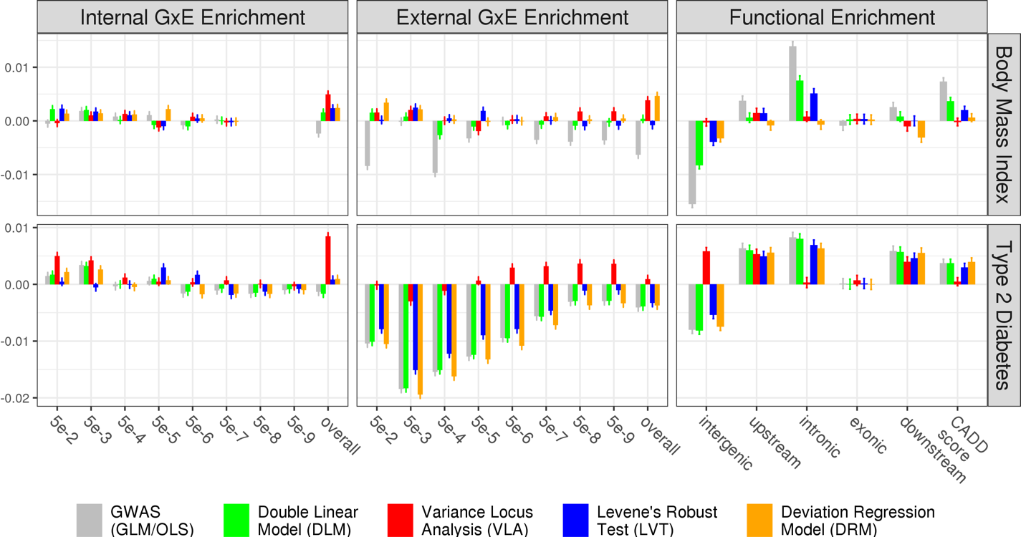

(a)
(c)
(d)
(b)

(f)
(e)
Figure 4: Empirical GxE and Functional Enrichment Analysis
a, c, e) Results for BMI. b, d, f): Results for type 2 diabetes. a, b, c, d): GxE enrichment analysis. The x-axis denotes the level of GxE significance by p-value, which is used to score the GxE activeness of an SNP. “overall” means scoring an SNP by the sum of negative log p-values of GxE across all exposome items. The y-axis represents GxE enrichment coefficients, where higher values indicate better performance of a statistical test. e, f): Functional enrichment analysis. The x-axis enumerate SNP labels. The combined annotation dependent depletion (CADD) score. Lower or higher enrichment is merely descriptive and does not indicate the performance of a statistical test. The missing bars in a indicate that no GxEs for BMI reached a significance level of p<5e-8.

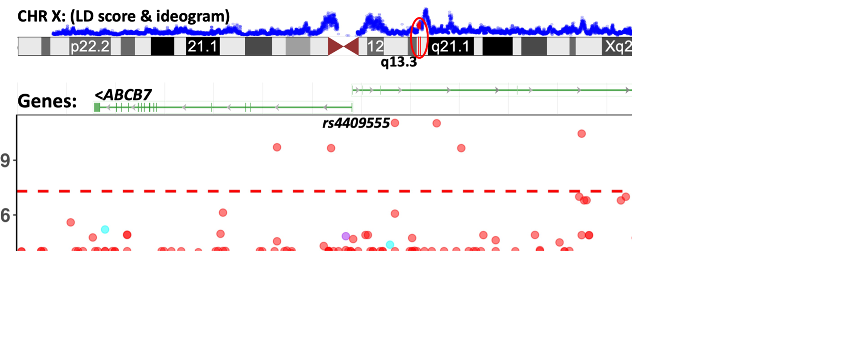
Figure 5: GxE between SNPs in ABCB7-UPRT and print materials associated with T2D in PEGS
a) Ideogram showing chromosome X (rendered by the UCSC genome browser), the enclosing region q13.3 (red), and linkage disequilibrium scores (blue) based on 3104 genotyped females (68.4%) in PEGS. The GxE between SNPs in ABCB7-UPRT and toner (red points) reached beyond conventional genome-wide significance (-log₁₀(5e-8), red horizontal dash). b) Manhattan plot showing unadjusted -log₁₀(P) (y-axis) for GxEs with SNPs between X: 75,020,000–75,360,000 (x-axis) and exposure to printing materials (colored points). The gene bars show ABCB7 and UPRT (rendered by the NCBI genome viewer). Although the smallest p-value (rs4409555, 9.25e-12) did not guarantee significance after Bonferroni correction over 4.74 billion selectable GxE tests, the region was prioritized by significant variance loci found by VLA in the UK Biobank.

(Xiaoran: Reworking this figure)
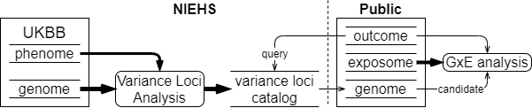
Figure 9: UKBB variance loci catalog workflow

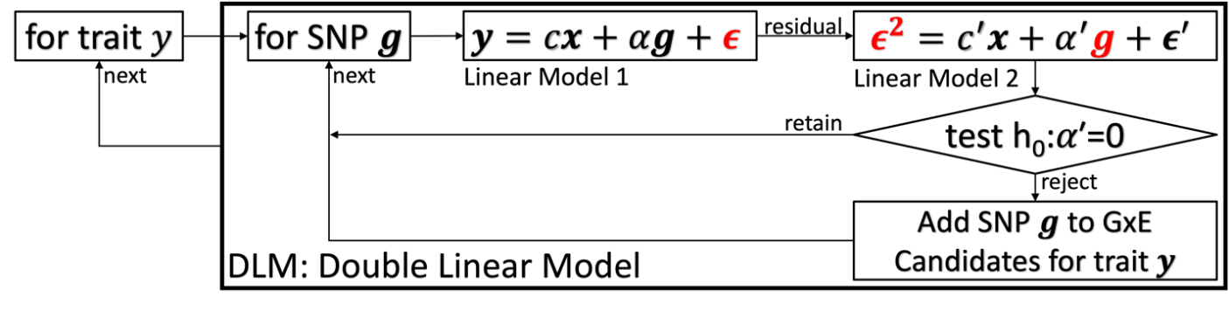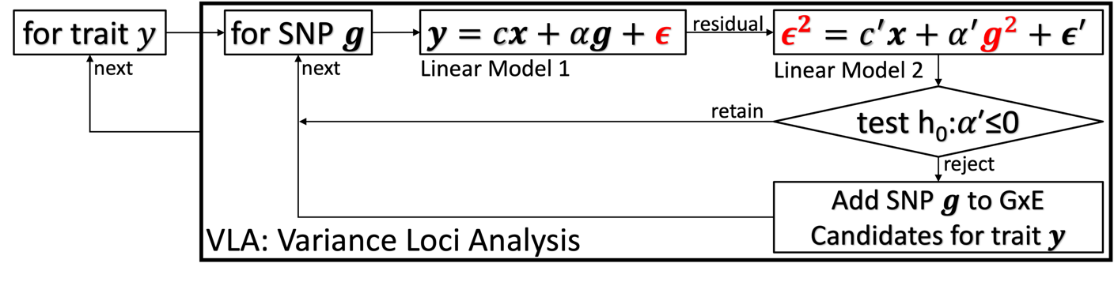
Figure 10: diagram of double linear model (DLM) and variance loci analysis (VLA)

 | Description | N | Min | Median | Mean | Max | Histogram
BMI | Body mass index | 489955 | 18.0 | 26.7 | 27.4 | 48.0 | 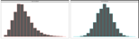
T2D | Type 2 diabetes | 493619 | 0.0 | 0.0 | 0.1 | 1.0 | 
Table 2. UK Biobank phenotypes used
The histograms show distributions before and after normalization. Normalized distributions were used in genome-wide variance loci tests and two-way GxE-WAS.

 | Description | N | Min | Med | Mean | Max | 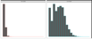  Histogram
ALC | Weekly alcohol intake | 427697 | 0.0 | 8.0 | 11.9 | 603.0
DGP | Domestic garden percentage | 440874 | 0.1 | 24.3 | 24.3 | 66.1 | 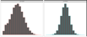  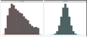
GSP | Green space percentage | 440874 | 4.4 | 41.5 | 45.0 | 99.2
MET | Metabolic equivalent minutes | 498628 | 0.0 | 1386.0 | 2553.7 | 125118.0 | 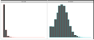
NEP | Nature environment percentage | 497542 | 0.0 | 36.6 | 40.5 | 100.0 | 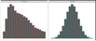
NO1 | Nitrogen oxide | 495124 | 19.7 | 42.4 | 44.1 | 265.9 | 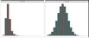  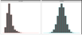
NO2 | Nitrogen dioxide | 495124 | 5.1 | 21.3 | 22.4 | 98.6 | 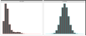
NOI | Noise | 495124 | 46.7 | 50.1 | 51.2 | 88.5
PM1 | Air pollution, PM10 | 495113 | 5.9 | 19.0 | 18.6 | 30.5 | 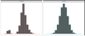
PM2 | Air pollution, PM2.5 | 461201 | 8.2 | 9.9 | 10.0 | 21.3 | 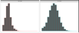
SDN | Sedentary behavior | 500967 | 0.0 | 4.0 | 4.5 | 48.0 | 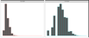
SEA | Distance to coast | 497542 | 0.0 | 44.0 | 41.6 | 108.0 | 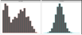  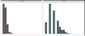
SIB | Number of siblings | 493402 | 0.0 | 2.0 | 2.2 | 44.0 | 
SMK | Ever smoke | 499620 | 0.0 | 1.0 | 0.6 | 1.0
TRF | Traffic intensity | 495124 | 0.8 | 78.2 | 172.6 | 100810.0 | 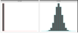  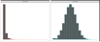
WTP | Water percentage | 440874 | 0.0 | 0.5 | 1.3 | 59.4
Table 3. UK Biobank exposome
The histograms show distributions before and after normalization. Normalized distributions were used in two-way GxE-WAS.

References
Allikmets, Rando, Wendy H. Raskind, Amy Hutchinson, Nichole D. Schueck, Michael Dean, and David M. Koeller. 1999. “Mutation of a Putative Mitochondrial Iron Transporter Gene (ABC7) in X-Linked Sideroblastic Anemia and Ataxia (XLSA/A).” Human Molecular Genetics 8 (5): 743–49. https://doi.org/10.1093/hmg/8.5.743.
Cao, Ying, Peng Wei, Matthew Bailey, John SK Kauwe, Taylor J. Maxwell, and Alzheimer’s Disease Neuroimaging Initiative. 2014. “A Versatile Omnibus Test for Detecting Mean and Variance Heterogeneity.” Genetic Epidemiology 38 (1): 51–59.
Deng, Wei Q., Senay Asma, and Guillaume Paré. 2014. “Meta-Analysis of SNPs Involved in Variance Heterogeneity Using Levene’s Test for Equal Variances.” European Journal of Human Genetics 22 (3): 427–30.
Eichler, Evan E., Jonathan Flint, Greg Gibson, Augustine Kong, Suzanne M. Leal, Jason H. Moore, and Joseph H. Nadeau. 2010. “Missing Heritability and Strategies for Finding the Underlying Causes of Complex Disease.” Nature Reviews Genetics 11 (6): 446–50.
Guo, Nancy Lan, Dhimiter Bello, Qing Ye, Rebecca Tagett, Lucia Chanetsa, Dilpreet Singh, Tuang Yeow Poh, et al. 2020. “Pilot Deep RNA Sequencing of Worker Blood Samples from Singapore Printing Industry for Occupational Risk Assessment.” NanoImpact 19 (July): 100248. https://doi.org/10.1016/j.impact.2020.100248.
Kircher, Martin, Daniela M Witten, Preti Jain, Brian J O’roak, Gregory M Cooper, and Jay Shendure. 2014. “A General Framework for Estimating the Relative Pathogenicity of Human Genetic Variants.” Nature Genetics 46 (3): 310–15.
Lee, Youngjo, and John A Nelder. 2006. “Double Hierarchical Generalized Linear Models (with Discussion).” Journal of the Royal Statistical Society: Series C (Applied Statistics) 55 (2): 139–85.
Lonardo, Amedeo, Simonetta Lugari, Stefano Ballestri, Fabio Nascimbeni, Enrica Baldelli, and Mauro Maurantonio. 2019. “A Round Trip from Nonalcoholic Fatty Liver Disease to Diabetes: Molecular Targets to the Rescue?” Acta Diabetologica 56 (4): 385–96. https://doi.org/10.1007/s00592-018-1266-0.
Marderstein, Andrew R., Emily R. Davenport, Scott Kulm, Cristopher V. Van Hout, Olivier Elemento, and Andrew G. Clark. 2021. “Leveraging Phenotypic Variability to Identify Genetic Interactions in Human Phenotypes.” The American Journal of Human Genetics 108 (1): 49–67.
Pain, Debkumar, and Andrew Dancis. 2016. “Roles of Fe–S Proteins: From Cofactor Synthesis to Iron Homeostasis to Protein Synthesis.” Current Opinion in Genetics & Development, Molecular and genetic bases of disease, 38 (June): 45–51. https://doi.org/10.1016/j.gde.2016.03.006.
Paré, Guillaume, Nancy R. Cook, Paul M. Ridker, and Daniel I. Chasman. 2010. “On the Use of Variance per Genotype as a Tool to Identify Quantitative Trait Interaction Effects: A Report from the Women’s Genome Health Study.” PLoS Genetics 6 (6): e1000981.
Podhajny, Richard M. 2001. “A Brief Chemistry Lesson on Printing Ink Pigments.” Paper, Film and Foil Converter 75 (11): 20.
Rentzsch, Philipp, Daniela Witten, Gregory M. Cooper, Jay Shendure, and Martin Kircher. 2019. “CADD: Predicting the Deleteriousness of Variants throughout the Human Genome.” Nucleic Acids Research 47 (D1): D886–94.
SILAGHI, CRISTINA ALINA, HORATIU SILAGHI, HORATIU ALEXANDRU COLOSI, ANCA ELENA CRACIUN, ANCA FARCAS, DANIEL TUDOR COSMA, NICOLAE HANCU, RALUCA PAIS, and CARMEN EMANUELA GEORGESCU. 2016. “Prevalence and Predictors of Non-Alcoholic Fatty Liver Disease as Defined by the Fatty Liver Index in a Type 2 Diabetes Population.” Clujul Medical 89 (1): 82–88. https://doi.org/10.15386/cjmed-544.
Smyth, Gordon K. 1989. “Generalized Linear Models with Varying Dispersion.” Journal of the Royal Statistical Society: Series B (Methodological) 51 (1): 47–60.
Struchalin, Maksim V., Najaf Amin, Paul HC Eilers, Cornelia M. van Duijn, and Yurii S. Aulchenko. 2012. “An R Package" VariABEL" for Genome-Wide Searching of Potentially Interacting Loci by Testing Genotypic Variance Heterogeneity.” BMC Genetics 13 (1): 1–7.
Van Ijzendoorn, Marinus H, Marian J Bakermans-Kranenburg, Jay Belsky, Steven Beach, Gene Brody, Kenneth A Dodge, Mark Greenberg, Michael Posner, and Stephen Scott. 2011. “Gene-by-Environment Experiments: A New Approach to Finding the Missing Heritability.” Nature Reviews Genetics 12 (12): 881–881.
Wang, Huanwei, Futao Zhang, Jian Zeng, Yang Wu, Kathryn E Kemper, Angli Xue, Min Zhang, et al. 2019. “Genotype-by-Environment Interactions Inferred from Genetic Effects on Phenotypic Variability in the UK Biobank.” Science Advances 5 (8): eaaw3538.
Wang, Kai, Mingyao Li, and Hakon Hakonarson. 2010. “ANNOVAR: Functional Annotation of Genetic Variants from High-Throughput Sequencing Data.” Nucleic Acids Research 38 (16): e164–e164.
Wei, Wei-Qi, Lisa A. Bastarache, Robert J. Carroll, Joy E. Marlo, Travis J. Osterman, Eric R. Gamazon, Nancy J. Cox, Dan M. Roden, and Joshua C. Denny. 2017. “Evaluating Phecodes, Clinical Classification Software, and ICD-9-CM Codes for Phenome-Wide Association Studies in the Electronic Health Record.” PloS One 12 (7): e0175508.
Wu, Patrick, Aliya Gifford, Xiangrui Meng, Xue Li, Harry Campbell, Tim Varley, Juan Zhao, Robert Carroll, Lisa Bastarache, and Joshua C. Denny. 2019. “Mapping ICD-10 and ICD-10-CM Codes to Phecodes: Workflow Development and Initial Evaluation.” JMIR Medical Informatics 7 (4): e14325.
Yang, Jian, Ruth JF Loos, Joseph E. Powell, Sarah E. Medland, Elizabeth K. Speliotes, Daniel I. Chasman, Lynda M. Rose, Gudmar Thorleifsson, Valgerdur Steinthorsdottir, and Reedik Mägi. 2012. “FTO Genotype Is Associated with Phenotypic Variability of Body Mass Index.” Nature 490 (7419): 267–72.

References
1. Eichler EE, Flint J, Gibson G, Kong A, Leal SM, Moore JH, et al. Missing heritability and strategies for finding the underlying causes of complex disease. Nat Rev Genet. 2010;11(6):446-50.
2. van Ijzendoorn MH, Bakermans-Kranenburg MJ, Belsky J, Beach S, Brody G, Dodge KA, et al. Gene-by-environment experiments: a new approach to finding the missing heritability. Nat Rev Genet. 2011;12(12):881; author reply
3. Cao Y, Wei P, Bailey M, Kauwe JSK, Maxwell TJ. A versatile omnibus test for detecting mean and variance heterogeneity. Genet Epidemiol. 2014;38(1):51-9.
4. Deng WQ, Asma S, Paré G. Meta-analysis of SNPs involved in variance heterogeneity using Levene's test for equal variances. Eur J Hum Genet. 2014;22(3):427-30.
5. Struchalin MV, Amin N, Eilers PH, van Duijn CM, Aulchenko YS. An R package "VariABEL" for genome-wide searching of potentially interacting loci by testing genotypic variance heterogeneity. BMC Genet. 2012;13:4.
6. Yang J, Loos RJ, Powell JE, Medland SE, Speliotes EK, Chasman DI, et al. FTO genotype is associated with phenotypic variability of body mass index. Nature. 2012;490(7419):267-72.
7. Paré G, Cook NR, Ridker PM, Chasman DI. On the use of variance per genotype as a tool to identify quantitative trait interaction effects: a report from the Women's Genome Health Study. PLoS Genet. 2010;6(6):e1000981.
8. Smyth GK. Generalized linear models with varying dispersion. Journal of the Royal Statistical Society: Series B (Methodological). 1989;51(1):47-60.
9. Lee Y, Nelder JA. Double hierarchical generalized linear models (with discussion). Journal of the Royal Statistical Society: Series C (Applied Statistics). 2006;55(2):139-85.
10. Rönnegård L, Felleki M, Fikse F, Mulder HA, Strandberg E. Genetic heterogeneity of residual variance - estimation of variance components using double hierarchical generalized linear models. Genet Sel Evol. 2010;42(1):8.
11. Rönnegård L, Valdar W. Detecting major genetic loci controlling phenotypic variability in experimental crosses. Genetics. 2011;188(2):435-47.
12. Marderstein AR, Davenport ER, Kulm S, Van Hout CV, Elemento O, Clark AG. Leveraging phenotypic variability to identify genetic interactions in human phenotypes. Am J Hum Genet. 2021;108(1):49-67.
13. Wang H, Zhang F, Zeng J, Wu Y, Kemper KE, Xue A, et al. Genotype-by-environment interactions inferred from genetic effects on phenotypic variability in the UK Biobank. Sci Adv. 2019;5(8):eaaw3538.
14. Brown MB, Forsythe AB. Robust tests for the equality of variances. Journal of the American Statistical Association. 1974;69(346):364-7.
15. Levene H. Robust tests for equality of variances. Contributions to probability and statistics Essays in honor of Harold Hotelling. 1961:279-92.
16. Bycroft C, Freeman C, Petkova D, Band G, Elliott LT, Sharp K, et al. The UK Biobank resource with deep phenotyping and genomic data. Nature. 2018;562(7726):203-9.
17. Sudlow C, Gallacher J, Allen N, Beral V, Burton P, Danesh J, et al. UK biobank: an open access resource for identifying the causes of a wide range of complex diseases of middle and old age. PLoS Med. 2015;12(3):e1001779.
18. Pain D, Dancis A. Roles of Fe-S proteins: from cofactor synthesis to iron homeostasis to protein synthesis. Curr Opin Genet Dev. 2016;38:45-51.
19. Allikmets R, Raskind WH, Hutchinson A, Schueck ND, Dean M, Koeller DM. Mutation of a putative mitochondrial iron transporter gene (ABC7) in X-linked sideroblastic anemia and ataxia (XLSA/A). Hum Mol Genet. 1999;8(5):743-9.
20. Podhajny RM. A Brief Chemistry Lesson On Printing Ink Pigments. Paper, Film & Foil Converter Magazine [Internet]. 2001. Available from: https://www.pffc-online.com/magazine/782-paper-brief-chemistry-lesson.
21. Silaghi CA, Silaghi H, Colosi HA, Craciun AE, Farcas A, Cosma DT, et al. Prevalence and predictors of non-alcoholic fatty liver disease as defined by the fatty liver index in a type 2 diabetes population. Clujul Med. 2016;89(1):82-8.
22. Lonardo A, Lugari S, Ballestri S, Nascimbeni F, Baldelli E, Maurantonio M. A round trip from nonalcoholic fatty liver disease to diabetes: molecular targets to the rescue? Acta Diabetol. 2019;56(4):385-96.
23. Xiao L, Shi XY, Li ZL, Li M, Zhang MM, Yan SJ, et al. Downregulation of LINC01508 contributes to cisplatin resistance in ovarian cancer via the regulation of the Hippo-YAP pathway. J Gynecol Oncol. 2021;32(5):e77.
24. Gui W, Zhu WF, Zhu Y, Tang S, Zheng F, Yin X, et al. LncRNAH19 improves insulin resistance in skeletal muscle by regulating heterogeneous nuclear ribonucleoprotein A1. Cell Commun Signal. 2020;18(1):173.
25. Wang J, Yang W, Chen Z, Chen J, Meng Y, Feng B, et al. Long Noncoding RNA lncSHGL Recruits hnRNPA1 to Suppress Hepatic Gluconeogenesis and Lipogenesis. Diabetes. 2018;67(4):581-93.
26. Liu D, Liu F, Li Z, Pan S, Xie J, Zhao Z, et al. HNRNPA1-mediated exosomal sorting of miR-483-5p out of renal tubular epithelial cells promotes the progression of diabetic nephropathy-induced renal interstitial fibrosis. Cell Death Dis. 2021;12(3):255.
27. Zhao M, Shen L, Ouyang Z, Li M, Deng G, Yang C, et al. Loss of hnRNP A1 in murine skeletal muscle exacerbates high-fat diet-induced onset of insulin resistance and hepatic steatosis. J Mol Cell Biol. 2020;12(4):277-90.
28. Wei WQ, Bastarache LA, Carroll RJ, Marlo JE, Osterman TJ, Gamazon ER, et al. Evaluating phecodes, clinical classification software, and ICD-9-CM codes for phenome-wide association studies in the electronic health record. PLoS One. 2017;12(7):e0175508.
29. Wu P, Gifford A, Meng X, Li X, Campbell H, Varley T, et al. Mapping ICD-10 and ICD-10-CM Codes to Phecodes: Workflow Development and Initial Evaluation. JMIR Med Inform. 2019;7(4):e14325.
30. Chang CC, Chow CC, Tellier LC, Vattikuti S, Purcell SM, Lee JJ. Second-generation PLINK: rising to the challenge of larger and richer datasets. Gigascience. 2015;4(1):s13742-015-0047-8.
31. Purcell S, Neale B, Todd-Brown K, Thomas L, Ferreira MA, Bender D, et al. PLINK: a tool set for whole-genome association and population-based linkage analyses. Am J Hum Genet. 2007;81(3):559-75.
32. Chang CC. Plink binary biallelic genotype table 2021 [Available from: https://www.cog-genomics.org/plink/1.9/formats#bed.
33. Abecasis GR, Auton A, Brooks LD, DePristo MA, Durbin RM, Handsaker RE, et al. An integrated map of genetic variation from 1,092 human genomes. Nature. 2012;491(7422):56-65.
34. Auton A, Brooks LD, Durbin RM, Garrison EP, Kang HM, Korbel JO, et al. A global reference for human genetic variation. Nature. 2015;526(7571):68-74.
35. National Institute of Environmental Health Sciences. Personalized Environment and Genes Study Data Freeze 1.1. 2021.
36. Wang K, Li M, Hakonarson H. ANNOVAR: functional annotation of genetic variants from high-throughput sequencing data. Nucleic Acids Res. 2010;38(16):e164.
37. Kircher M, Witten DM, Jain P, O'Roak BJ, Cooper GM, Shendure J. A general framework for estimating the relative pathogenicity of human genetic variants. Nat Genet. 2014;46(3):310-5.
38. Rentzsch P, Witten D, Cooper GM, Shendure J, Kircher M. CADD: predicting the deleteriousness of variants throughout the human genome. Nucleic Acids Res. 2019;47(D1):D886-d94.
39. Wei W-Q, Bastarache LA, Carroll RJ, Marlo JE, Osterman TJ, Gamazon ER, et al. Evaluating phecodes, clinical classification software, and ICD-9-CM codes for phenome-wide association studies in the electronic health record. PLOS ONE. 2017;12(7):e0175508.
40. Wu P, Gifford A, Meng X, Li X, Campbell H, Varley T, et al. Developing and Evaluating Mappings of ICD-10 and ICD-10-CM codes to Phecodes. BioRxiv. 2019;
:462077.
41. World Health Organization. International Statistical Classification of Diseases and Related Health Problems (ICD) 2021 [Available from: https://www.who.int/standards/classifications/classification-of-diseases.
42. Bastarache L. Using Phecodes for Research with the Electronic Health Record: From PheWAS to PheRS. Annual Review of Biomedical Data Science. 2021;4(1):1-19.

