Cataloging gene-environment interaction candidate SNPs for over 3,000 UK Biobank disease phenotypes through variance loci analysis
Xiaoran Tong, John House, Alison Motsinger-Reif

Abstract
The combined dimension of genome and exposome is statistically and computationally challenging for the detection of gene by environment interactions (GxEs). Variance quantitative trait loci (vQTL) can suggest candidate single nucleotide polymorphisms (SNPs) without exposome profiling, by capturing non-uniformity in residual variance of a quantitative trait caused by unaccounted for GxEs.
We propose variance loci analysis (VLA) to improve vQTL with positive gradient test, which maintains power to detect GxE candidates with weak direct environmental effects, and more importantly, over-come the inability of vQTL to analyze case/control phenotypes.
We ranked the potential of each SNP in GxEs for 3,273 phenotypes from the UK Biobank and hosted the VLA Catalog (genelist.niehs.nih.gov) as an open resource. Combining the rich exposome from the Personalized Environmental Genetic Study (PEGS) and high-ranking SNPs from VLA, we detected significant GxE between gene ABCB7 and inkjet toners on type 2 diabetes.

Introduction
A portion of the “missing” heritability from genome-wide association studies (GWAS) is due to unaccounted for gene by environment (GxE) interactions (Eichler et al. 2010; Van Ijzendoorn et al. 2011). Despite findings that genetic effects are context-dependent (9-13), difficulty in exposure measurement and insufficient sample sizes make identification of GxE effects challenging (9–11). Further, the number of main effects and interactions in a genome-exposome-wide association study (GxE-WAS) presents both computational and multiple testing burdens. Two oft-used approaches are to select candidate genomic variants via a priori biological knowledge or to select significant genomic variants from GWAS. The first approach hinders discovery, and the latter tends to produce false positives due to the ostensible assumption that strong marginal genetic effect suggests strong GxE interaction.
A better approach to identify GxE candidates is variance quantitative trait loci (vQTL) analysis, since the presence of strong GxEs causes heterogenous variation of a quantitative trait among individuals of different allele carriage (Cao et al. 2014; Deng, Asma, and Paré 2014; Struchalin et al. 2012; Yang et al. 2012), illustrated in Figure 1c. The most intuitive vQTL analysis is double linear model (DLM) that treats the squared residuals of a GWAS fit, that is, the variation around fitted mean, as a new “phenotype” to fit a second “GWAS” (Struchalin et al. 2012), essentially testing the allele additive effect on phenotypic variance, or additive vQTL. More robust vQTL tests have shown varying success. The deviation regression model (DRM) replaces squared residuals with distance to group median and is more robust than DLM for heavy tailed phenotypes (Marderstein et al. 2021); Levene’s robust test (LVT) (Paré et al. 2010) detects non-additive allele effect on phenotypic variance which occurs when direct environmental effect is weak (i.e., pure GxE); the double generalized linear modeling (DGLM) tests additive allele effect on phenotypic variance in log scale (Smyth 1989; Lee and Nelder 2006), or multiplicative vQTL.
However, vQTLs tests assumes independence between phenotypic mean and variance, otherwise, a variant affecting the mean, that is, a GWAS hit, is automatically a vQTL even if the variant is factually not involved in GxE. Therefore, phenotypes are preferably bell-shaped and nearly Gaussian, which precludes many health outcomes in the form of binary case/control since the strong tie between the mean and variance frequently induces false positive vQTLs (Paré et al. 2010; Marderstein et al. 2021; H. Wang et al. 2019). We also show herein that additive vQTL tests such as DLM and DRM have diminished power to detect pure GxE candidates with a weak direct environmental effect on the phenotypic mean, even if the phenotype is Gaussian.
To efficiently select of GxE candidate variants for binary phenotypes, we modified the DLM and developed variance loci analysis (VLA). Unlike DLM that fits a straight line through the squared residuals of a GWAS then tests its slope, VLA fits a second order curve then test its positive gradient. The positive gradient test is protected against mean-variance induced false GxE candidate, and by adjusting the binary phenotype with well-chosen covariates, the test is able to detect true GxE candidates, including pure GxE candidates that eludes a DLM. The residual of such covariates is a quantitative representation of the underlying risk contributed by the genome, exposome, and their interaction. By replacing a binary phenotype with smoothed residual risk, the positive gradient test can detect candidate GxE variance loci. The best covariates are non-confounding yet predictive. For example, age and age^2, as they are neither heritable nor determined by the exposome (i.e., non-confounding), but strong determinants of diseases (i.e., predictive).
In the subsequent sections, we first illustrate the rationale of variance loci and the proposed VLA addressing shortcomings in existing methods; second, with simulation studies based on 1000 genome data, we present the true positive (i.e., power) and net positive rate of VLA and competing variance loci tests; we then use exemplars of BMI and T2D in the UK Biobank and PEGS cohort to empirically benchmark the efficiency of finding candidate GxE variants with proposed VLA, the mean based GWAS, and other variance-based test; we then applied VLA to PEGS to identify the interaction between X chromosome gene ABCB7 and printer inks/dyes/toners. Lastly, we describe a database of GxE candidates created with VLA (https://genelist.niehs.nih.gov/vla) for 3,273 phenotypes, of which 1,693 are dichotomous disease status derived from the latest PHECODE (Wei et al. 2017; Wu et al. 2019).

Results

Illustration of Rationale
We generated 200 data points experiencing two environments (Figure 1, magenta and orange dots), with null GxE (column 1), some GxE (column 2), or pure GxE (column 3) effect on Gaussian (row 1) and binary (row 2) outcomes.
We first illustrated that a variance locus is induced by a GxE effect unaccounted for by a GWAS linear model fit (figure 1c left, gray), resulting in uneven variation of outcome across allele dosages (0=AA, 1=Aa, and 2=aa). The variance locus is detectable by testing the non-zero slop of a line through the amount of variation (figure 1c right, green), adopted by the DLM; it is also detectable by testing the positive gradient of a second order curve through the amount of variation (figure 1c right, red), as the proposed VLA does. The curve was fit by regressing the amount of variation on squared allele counts (0=AA, 1=Aa, 4=aa), and the test of positive gradient is equivalent to right-side t-test of the regression coefficient.
Conversely, in the absence of GxE, the variant is not a variance locus because the variation of phenotype is uniform across genotypes (Figure 1a left), DLM and VLA correctly retain the null, since the line and curve through the variation are both flat (Figure 1a right).
However, when the outcome is binary and the variant affects the phenotypic mean (Figure 1b left), the slop based DLM test declares false positive because the line fit through the amount of variation is slopped even in the absence of GxE (Figure 1b right, green). In this case, the positive gradient test of VLA still correctly retained the null, because the fitted curve has negative gradient (Figure 1b right, red).
When a pure GxE affects a phenotype without direct environment effect (Figure 1e/1f left), the slop based DLM became statistically powerless because the line fit through phenotypic variation is flat (Figure 1e/1f right, green) despite the unevenness across genotypes, yet the positive gradient test of VLA is able to detect the variance loci since the fitted curve has a positive gradient (Figure 1e/1f, red).

Simulation Studies
We compared the performance of VLA against existing variance loci tests (DLM, LVT, DRM, and DGLM) under simulated scenarios of Gaussian and non-Gaussian distributions, with sample sizes varying from 2⁴ to 2¹⁶ and 20,000 repeats each. In a repeat, we generated vectors of the environment and covariates with a normal distribution and sample the vector of genotype from an SNP randomly picked from Phase 3 of the 1000 Genomes Project (Consortium 2012; Consortium and others 2015) with an MAF≥0.01. In all scenarios, we rejected the null if the p-value of a test was less than 0.05.
We treated phenotypes as the sum of a strong covariate effect, weak genotype main effect, possible environmental main effect, and possible GxE effect. We simulated two scenarios that gave rise to additive variance loci, 1) a pure GxE effect, and 2) a GxE effect in addition to environmental main effect, where rejecting the null added to a test’s true positive rate, or power. We also simulated two corresponding null scenarios by zeroing out the GxE effects, rejecting the null in these latter scenarios added to a test’s false positive rate, or type 1 error. We considered a test superior if it had a high true positive rate (power) while controlling the false positive rate (type 1 error). Accordingly, we used the net positive rate (i.e., the true positive rate minus the false positive rate) as an overall measure of performance.
For balanced binary phenotypes (i.e., a 50% case rate), except VLA (Figure 2b, solid red line), the false positive rates increased (Figure 2b, column 1 and 3) with sample sizes at the cost of the net positive rates (Figure 2b, column 2 and 4), leaving VLA the best performed test. For imbalanced binary phenotypes (7.6% case rate), the inflation of the false positive rate was even more severe, but VLA still gave the best performance in detecting true GxE candidates (Figure 2c). Overall, the simulations showed that the VLA was more sensitive to variance loci induced by pure GxE (Figure 2a, column 2), and more robust in the presence of false positives caused by imbalanced, non-Gaussian phenotypes. As expected, VLA underperformed with multiplicative variance loci because a negative allele effect on logged variance corresponds with an improper, non-real-valued additive GxE effect.
The supplement details the simulation and provides the full results, including false positive rates, scenarios involving multiplicative variance loci, and Poison phenotype.

Genome Wide Analysis
To characterize the GxE candidate selection by different methods, we applied 4 variance-based tests (VLA, DLM, LVT and DRM) and the mean-based GWAS to BMI and T2D data from UKBB. As a result, we computed five test statistics for 11.4 million SNPs on autosomes and chromosome X with MAF > 0.01 using 379K unrelated Whites in the UKBB. The covariates included age, sex, age², age×sex, age²×sex, the first 20 genetic principal components, and the genotyping array (a total of 26, including the intercept). Figure 3 shows Manhattan plots, QQ plots in both original [0, 1] and -log10(p) scale with a genomic inflation factor (λ_{GC}), based on the 379K Whites. The supplement Table s2 lists the most significant variants of each test.
LVT and DRM tests were abnormally positive on the X chromosome (Figure 3, orange circles) because of the low frequency of heterozygous genotype (i.e., Aa) in men causing the two erroneously attribute changes of phenotypic variance due to sex, as due to allele.
For BMI (Supplement Figure 3a, Table 2a), GWAS returned more significant variants with over-confidence (λ_{GC}=1.998). The four variance-based tests could separate genetic effects on the phenotypic mean and variance with relative ease. For T2D (Supplement Figure 3b, Table 2b), except for the X chromosome, all five tests largely agreed on the most significant loci, however, VLA showed the least genomic inflation (λ_{GC}=1.02). We pick the region surrounding rs6712203 (2:164700808 C/T, Hg19/GRCh38) for display in Figure 3, where only VLA focus on a different loci while the other 4 tests highlighted the same loci.

GxE Enrichment Analysis
To empirically compare the efficiency of the 4 variance-based tests and GWAS, we divided the unrelated Whites into 354K British and 25K non-British. For BMI and T2D, we applied the 5 tests statistics for the 11.4M variants using the British and treated one minus the p-values of a test as the putative GxE ranking given that test. We then exhaustively tested the GxE between the same 11.4M variants and 16 exposures using the non-British and calculated the empirical GxE scores for each variant by the number of p-values (up to 16) below a series of cut-offs, or by the sum of negative log p-values across 16 exposures (overall score). By regressing a vector of GxE scores on a vector of putative GxE ranks, a more positive regression coefficient means the test that produced the ranks is better at selecting GxE variants. We present the coefficients in Figure 4a/b and supplement table 1a/b, also see flowchart X1 for more details.
For BMI, VLA was the most efficient GxE candidate test overall (Figure 4a, right most bar). For T2D, VLA was also the most efficient overall (Figure 4b, right most bar), and the other 4 tests tend to negatively select GxE variants of high significance (Figure 4b, 5e-7 to 5e-9).
We expanded the comparison from within UKBB to between the UKBB and PEGS, basing the 5 putative GxE ranking on the genome wide statistics of 379K unrelated Whites from the previous section, and basing the empirical GxE scores on 4.6k PEGS participants with 15M variants and 768 exposures. We then regressed each empirical GxE score vector on each putative GxE ranking vector, of variants matched between the two cohorts, and presented the regression coefficient in Figure 4c and 4d, and supplement table XZ. See flowchart X2 for more details.
Next, we expanded the comparison from within UKBB to between the UKBB and PEGS, basing the 5 putative GxE ranking on the genome wide statistics of 379K unrelated Whites from the previous section, and basing the empirical GxE scores on 4.6k PEGS participants with 15M variants and 768 exposures. We then regressed each empirical GxE score vector on each putative GxE ranking vector, with 8.3m variants matched between the two cohorts (Flowchart X2). We presented the regression coefficient in Figure 4c and 4d, and supplement table XZ.
For BMI, DRM test is the most efficient GxE variants selection test overall; VLA positively selected GxE variants of high significance and the second most efficient overall (Figure 4c). For T2D, only VLA positively selected GxE variants while the other 3 variance-based tests (DLM, LVT, DRM) exerting patterns of negative selection (Figure 4d) similar to the mean-based GWAS, due to the mean-variance non-dependence of a binary phenotype.

VLA emphasize variants outside of genes
We are also interested in the type of variants prioritized by different GxE selection tests. For each of the 11.4m variants in UKBB, we labeled it as intergenic, upstream (of a gene), intronic, exonic, or downstream (of a gene) using ANNOVAR (K. Wang, Li, and Hakonarson 2010), also calculated its combined annotation dependent depletion (CADD) score (Kircher et al. 2014; Rentzsch et al. 2019) which measures pathogenic tendency. We regressed each vector of labels or CADD scores on each vector of putative GxE rankings based on 379k Whites (Flowchart X3). Therefore, a positive significant regression coefficient means a type of variants (i.e., intergenic, upstream, intronic, exonic, downstream, and of high CADD) are emphasized by a GxE selection test. We report the regression coefficients in Figure 4e and 4f, and supplement Table XZ.
Overall, VLA tend to select all types of variants more evenly (Figure 4e, red), be more emphasized on the outside of genes (i.e., intergenic, Figure 4f, red), and not sensitive to variants of high pathogenic tendency (i.e., CADD). The other 4 tests tend to prioritize variants around genes and those of high pathogenic tendency, and again, exerting similar pattern for a binary phenotype (i.e., T2D).
--- xiaoran’s edit stops here ---
The following has to be re-worked, since we are going to restrict the GxE test statistics among variants and exposures of adequate working quality after removal of missing data.

PEGS GxE weighted by UKBB Variance Loci
Using the PEGS data, we conducted an exhaustive two-way GxE-WAS, adjusting age, sex, race and 10 principal components. From 10.8 billion GxE test statistics (i.e., 15m variants × 768 exposures), we retained 6.42 billion (59.3%) involving 8.8 million variants matched with the variance loci of UKBB Whites; we further limited GxE test statistics to those above moderate significance (P < 5e-4), bringing the number down to 36.7 million (0.34%). We then divided the genome into bins, and in each bin retained the most significant variance loci, and for each environment we retain the most significant GxE per bin. The final results are 1,608,961 top GxE (0.015%) and nearby variance loci. We applied Bonferroni correction considering 6.42 billion selectable GxE tests, then adjusted the corrected p-values considering the most significant variance loci in the neighborhood.
For each exposure in PEGS, we checked the GxE with VLA weighted P < 0.05 for T2D, which revealed significant GxEs between 13 protein coding genes (CTNND2, TMEM132D, DMD, ABCB7, NXF3, PTPRK, ZNF157, CYCS, C7orf31, CNBD2, RAPGEF5, TRNT1, IL5RA) and exposures to dyes, inks, and toners (PEGS ID: A_B194i). Of interest is X-chromosome gene ABCB7 (ATP binding cassette subfamily B member 7, X:75,051,048 - 75,156,732, ENSG00000131269) and its immediate down-stream UPRT (uracil phosphoribosyl transferase homolog, X:75,156,388 - 75,304,885, ENSG00000094841). The two genes were enclosed by q13.3 and were suggested by nearby SNP rs4409555 with a raw GxE p-value 9.25e-12 and 4.39e-2 after Bonferroni correction, and 6.45E-05 after adjustment by VLA. As a reminder, LVT and DRM statistics were absent because the two are invalid on chromosome X.
The significant GxE between SNPs around ABCB7-UPRT and toners corroborated with the differential expression of ABCB7 among workers occupationally exposed to inkjet printers, archived as GEO dataset GSE142351 (Guo et al. 2020). ABCB7 is involved in metabolism and multi-drug resistance and is related to transport pathways of glucose and other sugars, bile salts, organic acids, metal ions, and amine compounds. Notably, the gene encodes a half-transporter involved in the transport of heme from the mitochondria to the cytosol. ABCB7 is also an ATP-dependent mitochondrial transporter implicated in Fe–S cluster assembly. Inherited mutations in ABCB7 have been linked to inherited and acquired sideroblastic anemia with cerebellar ataxia (Pain and Dancis 2016; Allikmets et al. 1999). The absence of ABCB7 impairs the maturation of cytosolic iron-sulfur proteins and induces iron accumulation in mitochondria.
Further, the knockdown of ABCB7 in HEK293T cells causes mitochondrial iron accumulation and the activation of SOD enzymes, while iron and iron-regulatory proteins and cadmium alter ABCB7 expression. Some pigments in printer ink dyes, such as potash blue or soda blue, contain iron based on ferrous and ferric cyanides, and printer inks may also contain cadmium (Podhajny 2001). Also of interest is the association of ABCB7 with fatty liver disease, which is notable because T2D is a significant risk factor for fatty liver disease and could share common pathways (SILAGHI et al. 2016; Lonardo et al. 2019)..
The above suggests that the region around ABCB7, statistically prioritized by VLA, is biologically interacting with exposure to print materials to affect the risk of developing type 2 diabetes.

UKBB variance loci catalog
Inspired by the Pan-UK Biobank GWAS catalog at pan.ukbb.broadinstitute.org, we created and host a catalog of variance loci statistics for UKBB phenotypes and variants on NIEHS (genelist.niehs.nih.gov). The catalog is a public resource that allows researchers to prioritize candidate variants most likely to invoke significant GxEs.
For nearly all 502K samples, we compiled a phenome of 3,273 items, 1,580 directly from health-relevant UKBB baseline survey fields, and 1,693 diseases derived from hospital records using PHECODE - a codebook for extrapolating diseases using ICD9/10 (www.phewascatalog.org). As for the genome, 11,414,373 variants and 405,418 unrelated individuals passed quality control.
For each of the three groups by ancestry (Whites, Blacks, and Asians) and the three groups by sex (male, female, and both), we performed VLA for the whole phenome and genome to archive variant statistics. We used the plinkFile and vla R packages to traverse the genome and compute variance loci statistics for 3,273 of phenotypes simultaneously while adjusting 26 covariates. We divided the genome into approximately 1,200 batches of 10,000 variants each and finished the VLA for 379,548 unrelated Whites in 12 hours using the NIH HPC Biowulf cluster (hpc.nih.gov).
Figure?d illustrates the creation and use of VLA-catalog. The “material and method” section in supplements details the quality control and analytical pipeline.

Methods

Putative GxE tests to identify candidate variants
Given a quantitative trait, a variant, and covariates, DLM fits a GWAS linear model, adjusting the covariates, and treats the squared residual as a “new phenotype”, subsequently fitting another GWAS linear model with the same SNP and covariates (Figure 10 top). If the SNP coefficient of linear model 2 is significant, we say the SNP is a vQTL, that is, a GxE candidate for that particular quantitative phenotype. Intuitively, the linear model 2 fits the squared distance from fitted mean of linear model 1 given the SNP and covariates, which amounts to modeling the phenotypic variance, since the mean of squared distance from the mean, is variance. VLA (variance loci analysis) slightly modifies DLM: (1) the second linear model uses squared allele dosage and (2) perform a one-sided t-test assuming non-negative coefficient. For a binary trait, the rare event (i.e., disease) is coded as 1 and the covariates should choose from non-heritable predictors; there is no need to replace linear model 1 with GLM (i.e., logistic regression).
In addition, we created R-language wrapper functions for deviation regression model (DRM), Levene’s Robust Test (LVT) from R-package “car” (citation), and double generalized linear model (DGLM) from R-package “dglm” (citation). Because DGLM is unstable with small samples and slow to compute for large ones, we used DGLM as a benchmark in simulation studies only.
Lastly, we considered the traditional GWAS as a reference GxE candidate selector. We use PLINK2’s “--glm” routine to fit GWAS linear model for body mass index (BMI), and logistic regression for type 2 diabetes (T2D). We only included GWAS for GxE enrichment and functional enrichment analysis.
More detailed description of the statistical tests is in supplement S2.

Empirical Two-way GxE-WAS
In a cohort with environment $u$ and standardized SNP $g$, GxE interaction effects are typically captured by adding a two-way product term $ug$ to a GWAS linear model,
$y=m_{0}+ag+bug+cu+dx+e$,
where $e$ is a vector of Gaussian noise and $x$ is the covariate; rejecting $h_{0}:b=0$ at a given p-value threshold suggest the GxE interaction between SNP $g$ and environment $u$. The above is repeated for all 2-way combinations of SNPs and environmental exposures, which, for PEGS, means a total of 14,874,008 x 765 models; for non-British Whites in the UKBB, the number is 9,298,089 x 16. We exhaustively analyzed all the two-way combination for demonstrative purpose, in an actual study, one could query the VLA-catalog and limit the GxE-WAS among top ranking SNPs to shorten the running time and mitigate multiple testing.

UK Biobank (UKBB)
The UKBB is a large-scale resource consisting of genetic and health information for over half a million participants (Application ID: 57849, version 2) collected via questionnaires, electronic health records, biological samples, oral interviews, imaging, and genotype data. Imputed genotype data is available for 499K individuals. Using the imputed genotype, we created a comprehensive catalog of the whole genome. After quality control, we divided the remaining individuals into five major ancestry groups—African (afr), non-Chinese Asian (asi), White British (bri), Irish (iri), and White but non-British (wnb)— leaving 375,992 individuals. These ancestry groups are the basis of the NIEHS VLA Catalog, and the bri and wnb groups serve as training and testing datasets, respectively. Details can be found in the supplement. For phenotype data, we manually compiled UKBB phenotype data, which is summarized in Table 2, for T2D, CAD, BMI, and fasting glucose level. For environmental data, we used data on 16 environmental variables in UKBB, which are outlined in Table 3. We also derived phecodes using phenotypes and disease diagnoses from electronic health record (EHR) data for UKBB participants recorded as International Classification of Diseases (ICD) codes (40) (41) (40, 42). The supplement provides details of how we compiled the phenotypes, including criteria and the UKBB data fields used as well as details of our phecode mapping.

Personalized Gene and Environment Study (PEGS)
PEGS is a North Carolina-based cohort varying age, race, socioeconomic status, and education level. Health and Exposome survey is available for 9,765 participants, and whole-genome sequencing data is available for 4,610 participants. We used questionnaire-based survey data in its original form as binary and integer-based exposome items. We also derived T2D and BMI phenotype data from the survey. The Supplement provides information on case/control definitions and quality control.

Discussion
VLA is a powerful new method that addresses the constraints of existing vQTL analysis approaches. To demonstrate how the VLA Catalog can be used in research, we tested candidate SNPs from UKBB in the PEGS cohort, which has both genetic and environmental exposure data, and found that the SNPs were involved in many significant GXEs.
For binary traits, the false positive of vQTL tests (DLM, DRM, DGLM, and LVT) in screening GxE candidate SNPs is as high as GWAS. Essentially, the close tie between the mean and variance grossly violates the assumption of homogeneous variation among individuals of identical allele carriage, causing those tests to falsely identify any GWAS-significant SNP as a GxE candidate regardless of the presence of GxEs. The VLA test resist spurious GxE candidates of binary traits, with covariates carefully chosen to reconstruct the underlying risk of a binary trait, VLA is more efficient in selecting true GxE candidates. For quantitative traits, VLA is sensitive to pure GxE candidates when direct environmental effect is weak.
The GxE enrichment analysis in both the internal discovery population of UKBB non-British Whites and the external discovery population of PEGS participants demonstrate the reliability of VLA to prioritize GxE candidates for quantitative and binary phenotypes alike, such as BMI and T2D.
We followed up the top finding from our analyses (ABCB7 and printer ink/toner) in gene-expression data. Subsequently, using 11.8 million whole genome VLA test statistics on the UKBB European Whites as a reference, we re-adjusted the Bonferroni corrected p-values of 10.8 trillion (~14 million SNPs × ~700 exposures) 2-way GxE-WAS tested on the PEGS participants, which made practical to manually track down the most promising GxEs involving a handful of coding genes and exposure to paints and pesticides. The gene ABCB7 as an example, associated with fatty liver disease, is differentially expressed among workers operating inkjet printers, suggesting environmental targets of intervention for individuals occupationally exposed to inks, dyes, and toners.
Our results provide an unprecedented number of VLA across traits as a searchable/downloadable catalog. The ability of VLA to identify GxE candidates for binary phenotypes enables analysis of a large number of case/control outcomes. The simplicity of VLA allows rapid ranking of variants for multiple phenotypes in parallel, facilitating the creation of the VLA Catalog for a rich phenome of 3,237 phenotypes, of which 1,693 are binary, and a whole genome of 11.8 million SNPs, collected by the UKBB. The VLA Catalog for multiple ancestral and gender strata is hosted by NIEHS (https://genelist.niehs.nih.gov/vla), serving as a reference for research on GxEs, as well as alternative variant effect sizes for summary statistics-based analysis (i.e., polygenic risk scores).
How and when to use VLA? (Additive versus multiplicative) Since VLA is an additive variance loci method, it prioritizes SNPs involved in significant additive GxE in model $y=m_{0}+ag+bug+cu+dx+e$ detected via $h_{0}:b≠0$. For those interested SNPs involved in multiplicative GxE detected via $h_{0}:\left|\frac{b}{a}\right|≠1$, they should resort to multiplicative variance loci methods accordingly, such as DGLM and VLT. VLA requires covariates to recovery quantitative risk underlying a binary phenotype, and good covariates must be weak confounders and strong predictors at the same time. We suggest age, age², sex, age / sex interaction, and genetic principal components.
(How to use the catalog) To use the summaries downloaded from the VLA-catalog to aid GxE-WAS, one could either 1) limit the GxE-WAS to variants near a few top VLA loci and apply less stringent p-values correction; 2) conduct an exhaustive GxE-WAS, correct the p-values, and adjust the p-values according to the significance of nearby variance loci. (How to construct PRS) Because VLA regresses on squared variant $g^{2}$, researchers interested in summarizing a VLA based polygenic risk score are encouraged to use $g^{2}$ instead of $g$ from the new genotype.
Issue of SNP coding. Because VLA is de facto testing $h_{0}:b^{2}>0$, it assumes $g=\{0,1,2\}$ counts the allele that increases phenotypic variance so $b^{2}$ is guaranteed to be non-negative. In reality, the allele effect on phenotypic variance is not necessarily incremental, either because $g$ truly is not involved in GxE, or because $g$ counts the wrong allele. In reality, VLA’s power is not hindered because neighboring variants are bound to count the right allele if that neighborhood indeed harbors a GxE hot spot.
(Limitations and issues) Simulation showed that VLA better controls the false positive rate than existing vQTL tests, but not in full control when 1) the SNP a significant GWAS loci, and 2) the binary phenotype is imbalanced. However, VLA was the only statistics capable of positive GxE enrichment for T2D, the false positives may be mitigated by the fact that the vast majority of variants have negligible effect on T2D.
It was suggested that using logistic regression to fit the stage 1 model for binary traits should reduce false positives, but the poor performance of DGLM (Figure 2) proved otherwise. In terms of power, a linear model is indistinguishable from a logistic model since logit $f\left(x\right)={\left[exp\left(1+x\right)\right]}^{-1}$ is monotonic and closely approximated by identity $f\left(x\right)=x$ near $x=0$. Therefore, the VLA package use plain linear models only, a simplicity that allowed rapid analysis of 3,237 phenotypes to create the VLA-catalog.
(Future work).

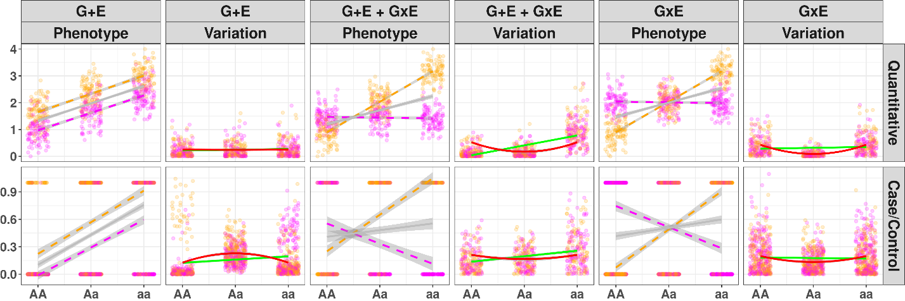
Figure 1: Illustration of Variance Loci suggesting GxE candidate SNP
Gray line: regression lines fitted by GWAS not accounting environment exposure; green line: regression lines fitted by double linear model (DLM) for non-zero slop test; solid red line: curves fitted by variance loci analysis (VLA) for positive gradient test; magenta/orange: environment-specific observations; x-axis: SNP genotypes (allele counts); y-axis: phenotype value or among of variation. column 1 and 2 (a, b): presence of SNP effect and environment direct effect (G+E), but no GxE interaction; column 3 and 4 (c, d): SNP effect, environment direct effect, and GxE interaction (G+E + GxE); column 5 and 6 (e, f): SNP effect and pure GxE effect (G + GxE) without environment direct effect.
Row 1 (a, c, e): quantitative phenotypes. (a) In the absence of a GxE (G+E), the phenotype spreads uniformly across genotypes and a flat line fits through the variation, therefore DLM and VLA maintain that A/a is not a variance loci, but GWAS significance erroneously suggests A/a as a GxE candidate; (c) In the presence of a GxE (G+E + GxE), the phenotype spreads unevenly across genotypes, a line with non-zero slop (solid green) and a curve with positive gradient (solid red) fit through the variation, therefore, DLM and VLA recognize A/a as a variance loci and GxE candidate; (e) In the presence of a pure GxE, a flat line fit through the variation (solid green line) so DLM could not recognize the variance loci, but a curve with positive gradient (solid red) still fits through, allowing VLA to detect the variance loci.
Row 2 (b, d, f): case/control phenotype. (b) Even in the absence of a GxE, a non-zero slope still fits through the variation (solid green). Therefore, DLM wrongfully classifies A/a as a GxE candidate, inflating type 1 error, but VLA’s positive gradient test does not because the curve fit through the variation had negative gradient (solid red); (d) in the presence of GxE, VLA’s positive gradient test can detect A/a as a GxE candidate (solid red line); (f) VLA positive gradient test also detects pure GxE candidate (solid red) where DLM non-zero slop test fails (solid green).

(a)
(c)

(b)
(e)

(d)

(f)
Xiaoran: Figure 1’s drawing and description have been reworked.
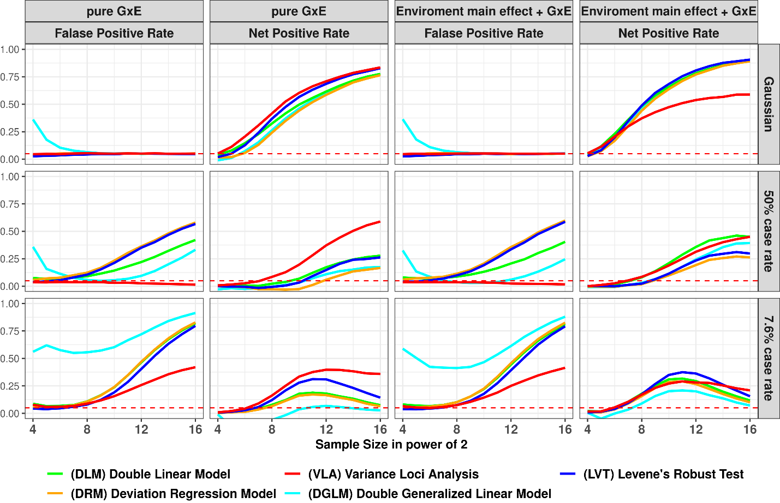
Figure 2: False Positive and Net Positive rates of Simulation Studies
Column 1 and 3: GxE is null, the y-axis is false positive rates (FPR), an FPR of 0.05 (denoted by red dashes) is proper, higher FPR suggest over confidence, lower means overly conservative; Column 2 and 4: additive variance loci induced by pure GxE, or GxE coexisting with standalone environmental main effect, in these cases the y-axis are net positive rates (NPR), higher means better; x-axis: sample sizes in powers of 2; colors: statistical tests.
(a)
(b)
(c)

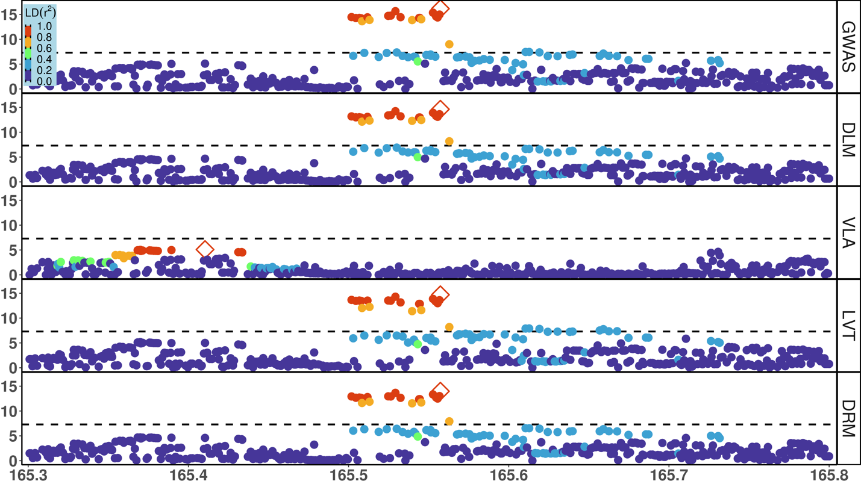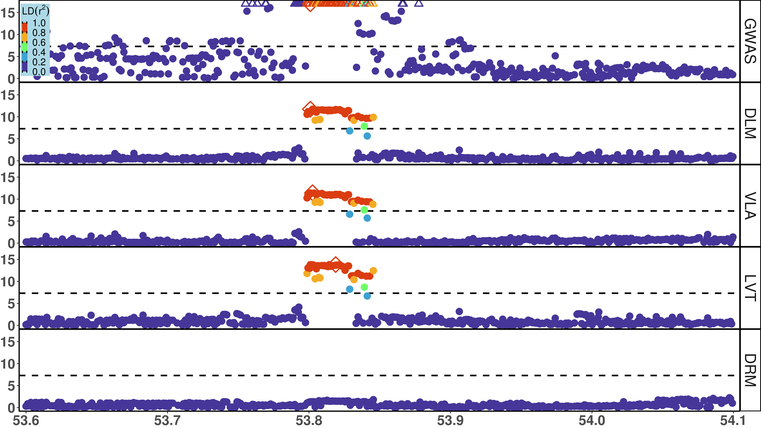
Figure 3: Local Manhattan Plot for BMI and T2D
x-axis: Mb on chromosome 16 (BMI) or chromosome 2 (T2D); y-axis: -log10(p); dash: significance threshold -log10(5e-8); each dot stands for a few dozen variants in a bin, represented by the most significant one.
Rows: 5 putative GxE test, GWAS = genome wide association study, DLM = double linear model, VLA = variance loci analysis (order-2 polynomial positive gradient test), LVT = Levene’s robust test, DRM = Deviation Regression Model; Color: denote LD between the top hit (diamond) and rest of the variants; red means high LD, blue means low LD.
Body Mass Index (BMI), Chromosome 16
Type 2 Diabetes (T2D), Chromosome 2

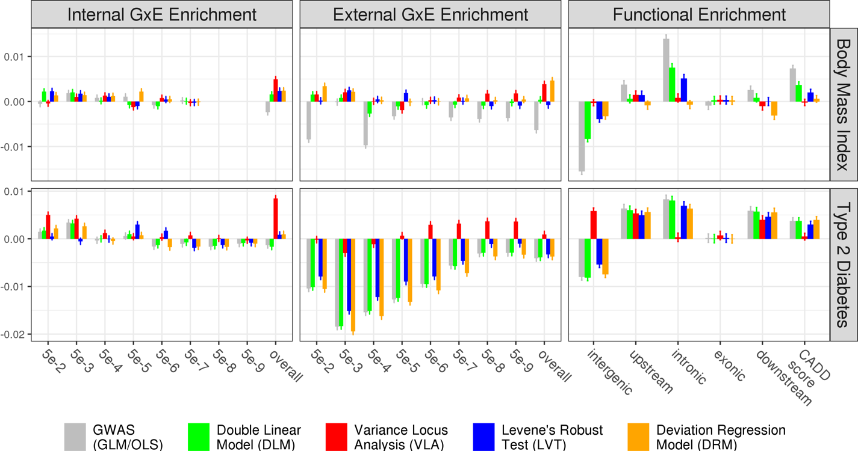

(a)
(c)
(d)
(b)

(f)
(e)
Figure 4: Empirical GxE and Functional Enrichment Analysis
top: results for body mass index (BMI); bottom: results for type 2 diabetes (T2D); (a)(b)(c)(d): GxE enrichment analysis, x-axis denotes the level of GxE significance by p-value used to score a SNP’s GxE activeness, “overall” means scoring a SNP by the sum of negative log p-values of GxE across all exposome items; the y-axis are GxE enrichment coefficient, higher means better statistical test; (e)(f): functional enrichment analysis, x-axis enumerate SNP labels, CADD score stands for “combined annotation dependent depletion” score, in this case, lower or higher enrichment is merely descriptive that does not suggest good or bad statistical test; the missing bars in (a) was due to the absence of significant GxE p-value for BMI reaching for 5e-8 and lower.

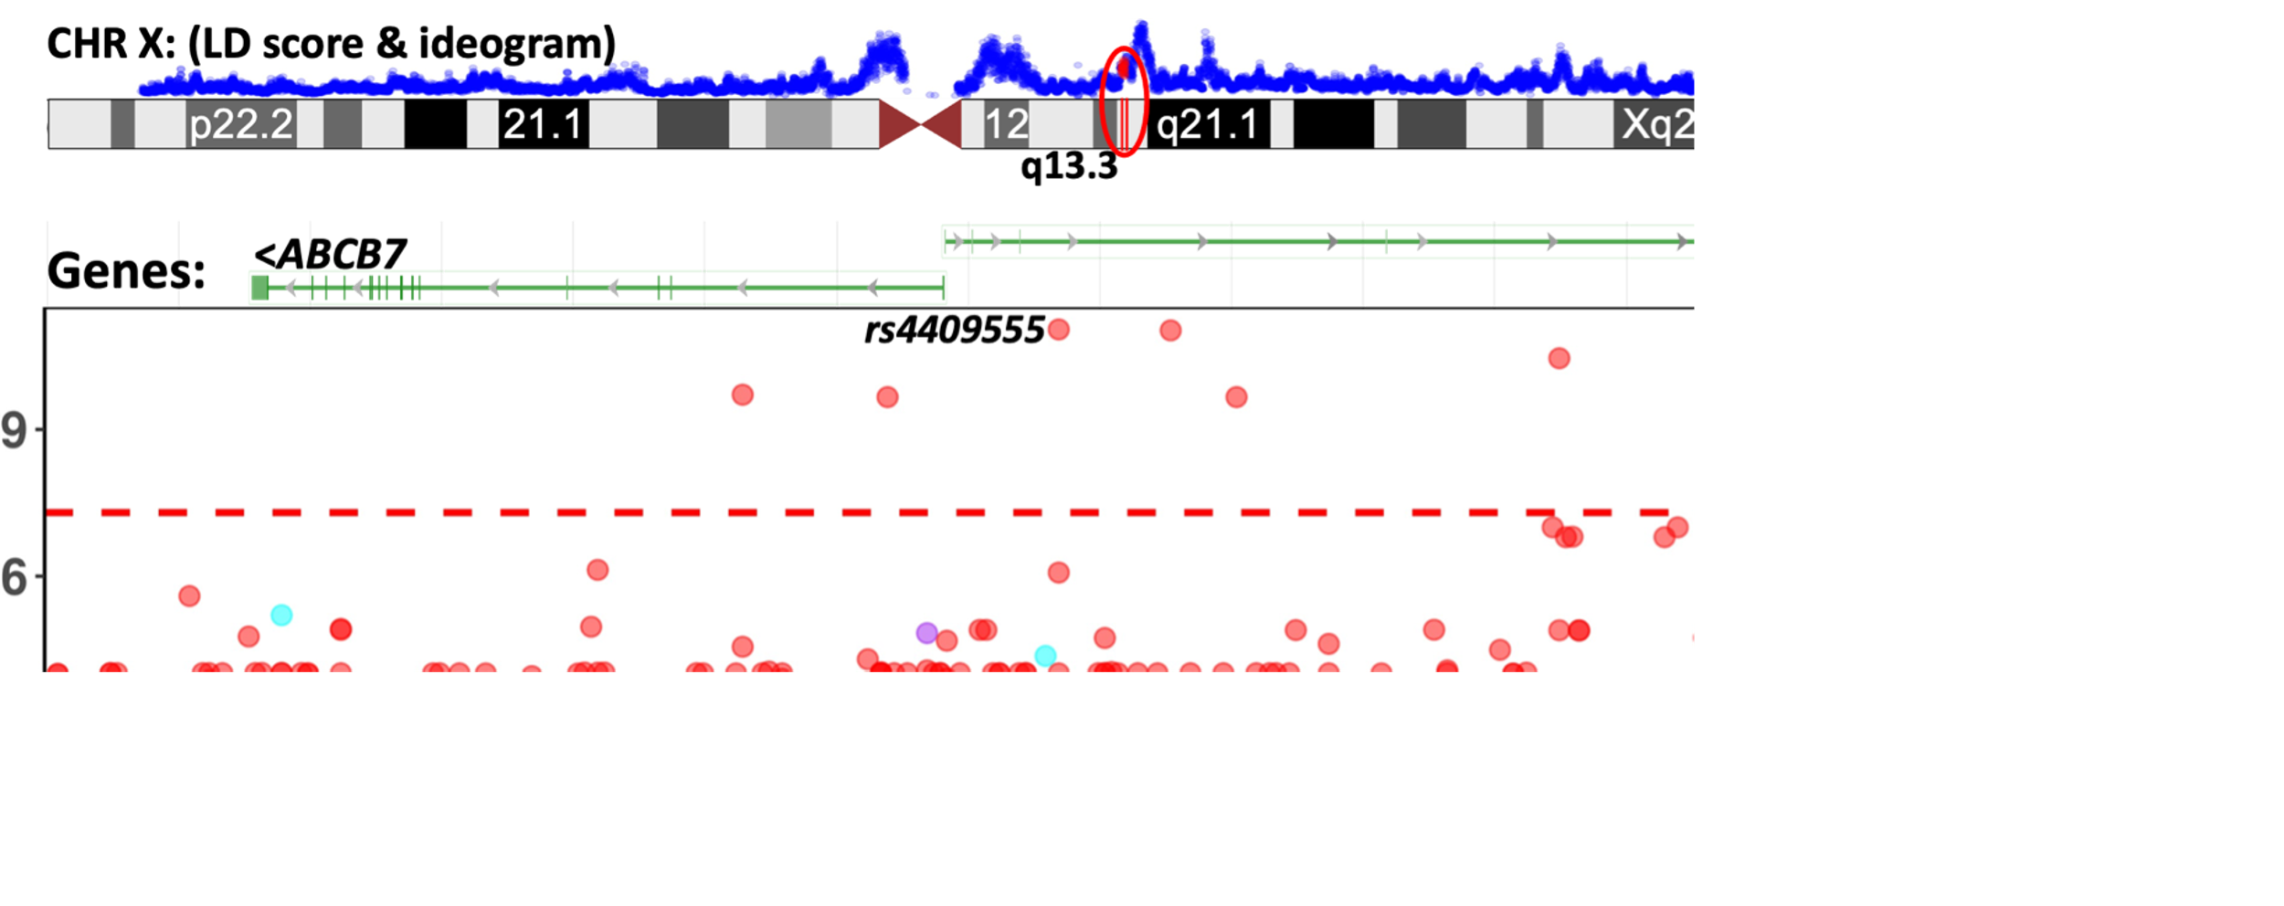
Figure 5: GxE interaction between SNPs in ABCB7-UPRT and print materials associated with T2D in PEGS
The Manhattan plot shows unadjusted -log₁₀(P) (y-axis) for GxE due to SNPs between X: 75,020,000 - 75,360,000 (x-axis) and exposures to print materials (colored points); The gene bars shows ABCB7 and UPRT (rendered by NCBI genome viewer); the ideogram on top shows chromosome X (rendered by UCSC genome browser), the enclosing region q13.3 (red), and LD scores (blue) based on 3104 genotyped females (68.4%) in PEGS; the GxE between SNPs in ABCB7-UPRT and toner (red points) reached beyond conventional genome wide significance (-log₁₀(5e-8), red horizontal dash). Although the smallest p-value (rs4409555, 9.25e-12) did not guarantee significance after Bonferroni correction over 4.74 billion selectable GxE tests, the region was prioritized by significant variance loci found by VLA in the UK Biobank.
The histograms show distributions before and after normalization, the latter were used in 2-way GxE-WAS.
PHE | description | N | min | median | mean | max | histogram
bmi | Body Mass Index | 489955 | 18.0 | 26.7 | 27.4 | 48.0 | 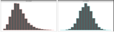
t2d | Type 2 Diabetes | 493619 | 0.0 | 0.0 | 0.1 | 1.0 | 
EPR | description | N | min | med | mean | max | histogram
alc | Weekly alcohol intake | 427697 | 0.0 | 8.0 | 11.9 | 603.0
dgp | Domestic Garden percent | 440874 | 0.1 | 24.3 | 24.3 | 66.1
gsp | Green Space percentage | 440874 | 4.4 | 41.5 | 45.0 | 99.2
met | Metabolic Equivalents Minute | 498628 | 0.0 | 1386.0 | 2553.7 | 125118.0
nep | Nature Environment percent | 497542 | 0.0 | 36.6 | 40.5 | 100.0
no1 | Nitrogen Oxides | 495124 | 19.7 | 42.4 | 44.1 | 265.9
no2 | Nitrogen Dioxide | 495124 | 5.1 | 21.3 | 22.4 | 98.6
noi | Noise | 495124 | 46.7 | 50.1 | 51.2 | 88.5
pm1 | Air pollution, PM10 | 495113 | 5.9 | 19.0 | 18.6 | 30.5
pm2 | Air pollution, PM2.5 | 461201 | 8.2 | 9.9 | 10.0 | 21.3
sdn | Sedentary behaviors | 500967 | 0.0 | 4.0 | 4.5 | 48.0
sea | Closeness to sea | 497542 | 0.0 | 44.0 | 41.6 | 108.0
sib | Number of siblings | 493402 | 0.0 | 2.0 | 2.2 | 44.0
smk | Ever smoke | 499620 | 0.0 | 1.0 | 0.6 | 1.0 | 
trf | Traffic intensity | 495124 | 0.8 | 78.2 | 172.6 | 100810.0
wtp | Water percentage | 440874 | 0.0 | 0.5 | 1.3 | 59.4
CVR | description | N | min | median | mean | max | histogram
sex
age

References
Allikmets, Rando, Wendy H. Raskind, Amy Hutchinson, Nichole D. Schueck, Michael Dean, and David M. Koeller. 1999. “Mutation of a Putative Mitochondrial Iron Transporter Gene (ABC7) in X-Linked Sideroblastic Anemia and Ataxia (XLSA/A).” Human Molecular Genetics 8 (5): 743–49. https://doi.org/10.1093/hmg/8.5.743.
Cao, Ying, Peng Wei, Matthew Bailey, John SK Kauwe, Taylor J. Maxwell, and Alzheimer’s Disease Neuroimaging Initiative. 2014. “A Versatile Omnibus Test for Detecting Mean and Variance Heterogeneity.” Genetic Epidemiology 38 (1): 51–59.
Deng, Wei Q., Senay Asma, and Guillaume Paré. 2014. “Meta-Analysis of SNPs Involved in Variance Heterogeneity Using Levene’s Test for Equal Variances.” European Journal of Human Genetics 22 (3): 427–30.
Eichler, Evan E., Jonathan Flint, Greg Gibson, Augustine Kong, Suzanne M. Leal, Jason H. Moore, and Joseph H. Nadeau. 2010. “Missing Heritability and Strategies for Finding the Underlying Causes of Complex Disease.” Nature Reviews Genetics 11 (6): 446–50.
Guo, Nancy Lan, Dhimiter Bello, Qing Ye, Rebecca Tagett, Lucia Chanetsa, Dilpreet Singh, Tuang Yeow Poh, et al. 2020. “Pilot Deep RNA Sequencing of Worker Blood Samples from Singapore Printing Industry for Occupational Risk Assessment.” NanoImpact 19 (July): 100248. https://doi.org/10.1016/j.impact.2020.100248.
Kircher, Martin, Daniela M Witten, Preti Jain, Brian J O’roak, Gregory M Cooper, and Jay Shendure. 2014. “A General Framework for Estimating the Relative Pathogenicity of Human Genetic Variants.” Nature Genetics 46 (3): 310–15.
Lee, Youngjo, and John A Nelder. 2006. “Double Hierarchical Generalized Linear Models (with Discussion).” Journal of the Royal Statistical Society: Series C (Applied Statistics) 55 (2): 139–85.
Lonardo, Amedeo, Simonetta Lugari, Stefano Ballestri, Fabio Nascimbeni, Enrica Baldelli, and Mauro Maurantonio. 2019. “A Round Trip from Nonalcoholic Fatty Liver Disease to Diabetes: Molecular Targets to the Rescue?” Acta Diabetologica 56 (4): 385–96. https://doi.org/10.1007/s00592-018-1266-0.
Marderstein, Andrew R., Emily R. Davenport, Scott Kulm, Cristopher V. Van Hout, Olivier Elemento, and Andrew G. Clark. 2021. “Leveraging Phenotypic Variability to Identify Genetic Interactions in Human Phenotypes.” The American Journal of Human Genetics 108 (1): 49–67.
Pain, Debkumar, and Andrew Dancis. 2016. “Roles of Fe–S Proteins: From Cofactor Synthesis to Iron Homeostasis to Protein Synthesis.” Current Opinion in Genetics & Development, Molecular and genetic bases of disease, 38 (June): 45–51. https://doi.org/10.1016/j.gde.2016.03.006.
Paré, Guillaume, Nancy R. Cook, Paul M. Ridker, and Daniel I. Chasman. 2010. “On the Use of Variance per Genotype as a Tool to Identify Quantitative Trait Interaction Effects: A Report from the Women’s Genome Health Study.” PLoS Genetics 6 (6): e1000981.
Podhajny, Richard M. 2001. “A Brief Chemistry Lesson on Printing Ink Pigments.” Paper, Film and Foil Converter 75 (11): 20.
Rentzsch, Philipp, Daniela Witten, Gregory M. Cooper, Jay Shendure, and Martin Kircher. 2019. “CADD: Predicting the Deleteriousness of Variants throughout the Human Genome.” Nucleic Acids Research 47 (D1): D886–94.
SILAGHI, CRISTINA ALINA, HORATIU SILAGHI, HORATIU ALEXANDRU COLOSI, ANCA ELENA CRACIUN, ANCA FARCAS, DANIEL TUDOR COSMA, NICOLAE HANCU, RALUCA PAIS, and CARMEN EMANUELA GEORGESCU. 2016. “Prevalence and Predictors of Non-Alcoholic Fatty Liver Disease as Defined by the Fatty Liver Index in a Type 2 Diabetes Population.” Clujul Medical 89 (1): 82–88. https://doi.org/10.15386/cjmed-544.
Smyth, Gordon K. 1989. “Generalized Linear Models with Varying Dispersion.” Journal of the Royal Statistical Society: Series B (Methodological) 51 (1): 47–60.
Struchalin, Maksim V., Najaf Amin, Paul HC Eilers, Cornelia M. van Duijn, and Yurii S. Aulchenko. 2012. “An R Package" VariABEL" for Genome-Wide Searching of Potentially Interacting Loci by Testing Genotypic Variance Heterogeneity.” BMC Genetics 13 (1): 1–7.
Van Ijzendoorn, Marinus H, Marian J Bakermans-Kranenburg, Jay Belsky, Steven Beach, Gene Brody, Kenneth A Dodge, Mark Greenberg, Michael Posner, and Stephen Scott. 2011. “Gene-by-Environment Experiments: A New Approach to Finding the Missing Heritability.” Nature Reviews Genetics 12 (12): 881–881.
Wang, Huanwei, Futao Zhang, Jian Zeng, Yang Wu, Kathryn E Kemper, Angli Xue, Min Zhang, et al. 2019. “Genotype-by-Environment Interactions Inferred from Genetic Effects on Phenotypic Variability in the UK Biobank.” Science Advances 5 (8): eaaw3538.
Wang, Kai, Mingyao Li, and Hakon Hakonarson. 2010. “ANNOVAR: Functional Annotation of Genetic Variants from High-Throughput Sequencing Data.” Nucleic Acids Research 38 (16): e164–e164.
Wei, Wei-Qi, Lisa A. Bastarache, Robert J. Carroll, Joy E. Marlo, Travis J. Osterman, Eric R. Gamazon, Nancy J. Cox, Dan M. Roden, and Joshua C. Denny. 2017. “Evaluating Phecodes, Clinical Classification Software, and ICD-9-CM Codes for Phenome-Wide Association Studies in the Electronic Health Record.” PloS One 12 (7): e0175508.
Wu, Patrick, Aliya Gifford, Xiangrui Meng, Xue Li, Harry Campbell, Tim Varley, Juan Zhao, Robert Carroll, Lisa Bastarache, and Joshua C. Denny. 2019. “Mapping ICD-10 and ICD-10-CM Codes to Phecodes: Workflow Development and Initial Evaluation.” JMIR Medical Informatics 7 (4): e14325.
Yang, Jian, Ruth JF Loos, Joseph E. Powell, Sarah E. Medland, Elizabeth K. Speliotes, Daniel I. Chasman, Lynda M. Rose, Gudmar Thorleifsson, Valgerdur Steinthorsdottir, and Reedik Mägi. 2012. “FTO Genotype Is Associated with Phenotypic Variability of Body Mass Index.” Nature 490 (7419): 267–72.

