Supplemental Materials

Simulation
This section details the generation of phenotypes of various distribution with or without variance loci. We began with a minimum sample size of N=16 (i.e., 2⁴), doubling it until N=65,536 (i.e., 2¹⁶). Each scenario and each N repeats 20,000 times.

Acquire components
Each repeat of the simulation required the following components.

Vector of genotype, $g$
In each repeat, we randomly acquire a single variant from genome region 17q3 (chromosome 17, between base-pair 10,700,001 to 16,000,000) of the 1000 Genomes Project, with an MAF no less than 0.01 and 1,807 unrelated samples (of a total 2,502 provided by Phase 3).
From the 1,807 bi-allelic genotype values (i.e., AA, Aa, and aa), we sample with replacement until the desired sample size N (i.e., 2⁴, 2⁵ … 2¹⁶) and save the values as the vector of genotype g. We coded the genotype values as allele dosages: AA=0, Aa=1, and aa=2.
We used R-package (located on GitHub repository https://github.com/xiaoran831213/simgen) to sample genotype vector g.

Vector of environment, $u$
In each repeat, we draw a vector of environmental exposures from a normal distribution until the desired N and save the values as the vector of environment u:
$$u_{i}\overset{\text{i.i.d}}{\sim }N\left(0,1\right), i=(1…N)$$

Vector of covariate, $x$
In each repeat, we draw a vector of covariate from a normal distribution until the desired N and save the values as the vector of covariate x:
$$x_{i}\overset{\text{i.i.d}}{\sim }N\left(0,1\right), i=(1…N)$$

Vector of GxE interaction, $ug$
In each repeat, after acquiring the vector of genotype g and environment u with sample size N, we acquire the element-wise product, ug, as the vector of gene-by-environment interaction:
$${(ug)}_{i}=u_{i}g_{i}, i=(1…N)$$

Scenarios with Gaussian phenotype
In each repeat, given the vector of allele dosage genotype g, the vector of environment u, the vector of covariate x, and the vector of GxE interaction ug, we generate a Gaussian phenotype either additively or multiplicatively to introduce either additive or multiplicative variance loci, respectively.

Additive Gaussian Phenotype
For each N, we generate a Gaussian phenotype with the additive GxE model in equation (1)
$$y_{i}=m_{0}+ag_{i}+b{\left(ug\right)}_{i}+cu_{i}+dx_{i}+ e_{i}, e_{i}\overset{\text{i.i.d}}{\sim }N\left(0,v_{e}\right), i=1…N \\ a\sim N\left(0,v_{a}\right), b\sim N\left(0,v_{b}\right), c\sim N\left(0,v_{c}\right), d\sim N\left(0,v_{d}\right)$$
where the phenotype of the $i$ th individual is the sum of the grand mean $m_{0}$, the genotype main effect of $g_{i}$ with effect size $a$, the GxE interaction effect of ${\left(ug\right)}_{i}$ with effect size $b$, the environmental main effect $u_{i}$ with effect size $c$, the covariate effect of $x_{i}$ with effect size $d$, and random Gaussian white noise $e_{i}$.
The effect sizes $\{a,b,c,d\}$ from normal distributions of mean zero at the beginning of each repeat and used to generate all N samples (i=1 … N) for that particular repeat; the grand mean $m_{0}$, the variance of the aforementioned unit effect sizes $\{v_{a},v_{b},v_{c},v_{d}\}$, and the variance of white noise $v_{e}$ are pre-determined by the scenario to be simulated and are fixed throughout all 20,000 repeats.
Two scenarios involve additively generated Gaussian phenotype–one with coexisting environmental main effect and GxE effect, one with pure GxE effect. The following parameters:
- $m_{0}=0:$ grand mean
- $v_{a}=0.5$: variance of genotype main effect $a$
- $v_{b}=1.0$: variance of GxE interaction effect $b$ (when not null)
- $v_{c}$: variance of environmental main effect $c$
  - $v_{c}=0.5$: coexisting environmental main effect and GxE effect
  - $v_{c}=0.0$: pure GxE effect
- $v_{d}=1:$ variance of covariate effect d
- $v_{e}=1:$ variance of white noise
When additively generated phenotype $y$, along with genotype $g$ and covariate $x$ were presented as if environment $u$ was unobserved, $g$ is an additive variance locus when $v_{b}≠0$. We also generate two corresponding scenario of null variance loci by setting $v_{b}=0$.

Multiplicative Gaussian Phenotype
For each N, we also generate the phenotype according to the Gaussian multiplicative model in equation (5)
$y_{i}\sim N\left(m_{0}+ag_{i}+dx_{i},e^{μ+αg_{i}+βg_{i}^{2}}\right), i=1…N$
In this case, the grand mean $m_{0}$ and genotype main effect $a$ act in the same way as the additive scenarios, but the vector of environment $u$. $μ$ is the size of non-genetically determined phenotypic variance in log scale, including environmental and white noise; $α$ and $β$ determine the link between genotype and phenotypic variance in log scale. When either $α$ or $β$ is non-zero, genotype $g$ becomes a multiplicative variance locus by definition. For simplicity, we fixed $β$ to 0. To choose $μ$ and $α$, we used $l_{0}=\log\left(v_{e}+v_{c}\right)$, that is, the variance of the additively generated phenotype in log scale without GxE interaction; we also used $l_{1}=\log\left(v_{e}+v_{c}+v_{b}v_{g}\right)$, the variance of additively generated phenotype in log scale with GxE effect, where $v_{g}$ is the genotype variance, or $4×MAF×(1-2×MAF)$. Next, we let the following had an equal chance to happen
$$μ=l_{0}, α=\frac{1}{2}\left|l_{1}-l_{0}\right| or μ=l_{1}, α=-\frac{1}{2}\left|l_{1}-l_{0}\right|$$The latter, where phenotypic variance shrinks with each additional allele, corresponds to a latent additive GxE model with squared GxE effect ${\tilde{b}}^{2}<0$. As stated in the methods, VLA is powerless when GxE effect $b$ is not real, so we expect VLA to underperform in detecting variance loci for multiplicatively generated phenotypes.
The above steps ensure the multiplicatively generated phenotype share similar numerical scale with the additively generated phenotype and has a null multiplicative variance locus when the additively generated phenotype within the same simulation repeat has null GxE effect (i.e., $v_{b}=0$) since $l_{0}=l_{0}=\log\left(v_{e}+v_{c}\right)$ and $α=0$. We used the following parameters to multiplicatively generate a Gaussian phenotype:
- $m_{0}=0$: grand mean.
- $v_{a}=0.5$: variance of genotype main effect $a$.
- $v_{d}=1$: variance of covariate effect $d$.
- $μ:$ phenotypic variance not determined by genotype, in log scale
  - $μ=0.405$ when $α≥0$ or $0.733$ when $α<0$, corresponds to $v_{c}=0.5$ and $v_{e}=1.0$ in an additive scenario
- $α$: effect of genotype on phenotypic variance, in log scale
  - $α=+0.164$, multiplicative variance locus exists, numerically corresponds to $v_{b}=+1.0$, which is proper for an additive scenario
  - $α=-0.164$, multiplicative variance locus exists, numerically corresponds to $v_{b}=-1.0$, which is improper for an additive scenario
  - $α=0.0$, null multiplicative variance locus, corresponding to $v_{b}=0$.
- $β=0$: change of squared phenotypic variance per allele, in log scale
With the parameters, we drew phenotype $y$ from the normal distribution and present it along with genotype $g$ and covariate $x$.
We simulated 6 scenarios for the Gaussian phenotype, with parameters in Table 1a.

Scenarios involving binary phenotype
To simulate a vector of binary phenotype $y$, we first generate a vector of Gaussian signal $η$ either additively or multiplicatively as the previous section, then convert $η$ to probabilities of disease onset with logistic function. Finally, we randomly drew 1 = case and 0 = control as phenotype from one-trail binomial distribution (i.e., Bernoulli trial) with the said probabilities of disease onset, that is,
$$y_{i}\sim binomial\left(n=1, p=π_{i}\right), π_{i}={\left(1+e^{-η_{i}}\right)}^{-1}, i=1…N$$
We manipulated the grand mean $m_{0}$ of the Gaussian signal $η$ to engineer rarity of the resulting binary phenotype, such that $m_{0}=0$ gives balance case/control ratio and $m_{0}=-2.5$ gives a prevalence of 7.6% which is close to the rate of type 2 diabetes in the UK Biobank. We enlarged the variance of GxE and environmental main effect to $v_{b}=2.0$ and $v_{c}=1.0$ and shrunk the variance of noise to $v_{e}=0.1$ so the genetic and environmental effect are more pronounced; we also enlarged the variance of covariate effect to $v_{d}=4$ since covariate adjustment is crucial in recovering the quantitative risk underlying a binary phenotype; lastly, we maintain the variance of genotype main effect to $v_{a}=0.1$ so all methods are challenged to distinguish the genetic effect on phenotypic mean from variance.
A total of 12 scenarios, which is two times of the Gaussian phenotypes because we varied the ground mean $m_{0}$ in $\left\{0, -2.5\right\}$ to create imbalanced case/control ratio. The simulation parameters for binary phenotypes are shown in Table 1b.

Scenarios involving Poisson phenotypes
In a similar fashion, we simulated Poisson phenotype $y$ by passing the Gaussian signal $η$ into exponent function for a rate value, then drew counts from Poisson distribution of the said rate.
$$y_{i}\sim Poisson\left(λ_{i}\right), λ_{i}=e^{η_{i}}, i=1…N$$
In this case, the grand mean $m_{0}$ of the Gaussian signal $η$ determines the proportion of zeros in the converted counts, where $m_{0}=0$ gives in 37% zeros and $m_{0}=-2.5$ gives 92%.
We kept the simulation parameters mostly the same with Gaussian case but reduced the variance of genotype main effect and noise to 0.1. The simulation parameters are shown in Table 1c.

Execution and summary of simulations
Once a scenario is decided, the parameters and phenotype converters were given, in each of the 20,000 repeats.
- Data generation
  - Acquire vector of genotype $g$, environment $u$, and covariate $x$.
  - Draw effect sizes $\{a, b,c,d\}$ from normal of mean 0 and variances $\{v_{a}, v_{b},v_{c},v_{d}\}$.
  - Draw vector of noise $e$ from normal of mean 0 and variance $v_{e}$.
  - Generate vector of phenotype $y$
    - either additively, as $y_{i}=m_{0}+ag_{i}+b{\left(ug\right)}_{i}+cu_{i}+dx_{i}+ e_{i}$
    - or multiplicatively, as yi~Nm0+agi+dxi,eμ+αgi+βgi2
    - or nullify genotype effect on variance (a=0 for additive, α=0 for multiplicative).
- Present data $\{y,x,g\}$ to various statistical tests:
  - DLM: double linear model
  - VLA: variance locus analysis, the proposed method
  - LVT: Levene’s robust test of heterogeneous variance
  - DRM: deviation regression model
  - DGLM: double generalized linear model
- Collect the p-values of the primary test statistics from the above methods.
In all scenarios, we fixed the size of statistical test at 0.05, rejecting the null hypothesis $h_{0}$: the genotype $g$ is not a variance locus of phenotype $y$ when the p-value for a method is below 0.05.
When a scenario allows variance loci, the proportion of times $h_{0}$ is rejected among 20,000 repeats shows a method’s power, or true positive rate. Conversely, when a scenario has null variance loci, the number of times $h_{0}$ is rejected in 20,000 repeats shows a method’s type 1 error, or false positive rate. We also calculate the net positive rate as the true positive rate of each non-null scenario minus the false positive rate of the corresponding null scenario.
The 6 scenarios for Gaussian phenotype are shown in Figure 1a. The 12 scenarios involving binary phenotypes are shown in 2 figures, 1b and 1c,m0 one for balanced case rate (50%, mu=0.0), another for imbalanced case rate (7.8%, mu=-2.5), each present 6 scenarios. For Poisson phenotypes, the results are shown in Figure 1d and 1f, with layout similar to binomial phenotypes.

Parameters for each scenario
Gaussian phenotype | Variance locus? | Additive | Multiplicative
Coexisting environmental main effect and GxE | Yes | $$m_{0}=0, v_{a}=0.5, v_{b}=1.0,$$  $$v_{c}=0.5,v_{d}=1.0,v_{e}=1.0$$ | $$m_{0}=0, v_{a}=0.5,v_{d}=1.0,$$  $β=0, μ=0.405, α=0.164$,  or $μ=0.733, α=-0.164$
Coexisting environmental main effect and GxE | Null | $$m_{0}=0, v_{a}=0.5, v_{b}=0.0,$$  $$v_{c}=0.5,v_{d}=1.0,v_{e}=1.0$$ | $$m_{0}=0, v_{a}=0.5,v_{d}=1.0,$$  $$β=0,μ=0.405, α=0.0$$
Pure GxE | Yes | $$m_{0}=0, v_{a}=0.5, v_{b}=1.0, \\ v_{c}=0.0,v_{d}=1.0,v_{e}=1.0$$ | (Not simulated)
Pure GxE | Null | $$m_{0}=0, v_{a}=0.5, v_{b}=0.0, \\ v_{c}=0.0,v_{d}=1.0,v_{e}=1.0$$ | (Not simulated)
Table 1a: Simulation scenarios for Gaussian phenotypes
Binary phenotype | Variance locus? | Additive | Multiplicative
Coexisting environmental main effect and GxE | Yes | $m_{0}=\left\{0, -2.5\right\}$,$$v_{a}=0.1, v_{b}=4.0, v_{c}=2.0,$$  $$v_{d}=4.0,v_{e}=0.1$$ | $m_{0}=\left\{0, -2.5\right\}$,  $$v_{a}=0.1,v_{d}=4.0,β=0$$  $μ=0.710, α=0.100$,  or $μ=0.911, α=-0.100$
Coexisting environmental main effect and GxE | Null | $m_{0}=\left\{0, -2.5\right\}$,  $$v_{a}=0.1, v_{b}=0.0,v_{c}=0.5,$$  $$v_{d}=4.0,v_{e}=0.1$$ | $m_{0}=\left\{0, -2.5\right\}$,  $$v_{a}=0.1,v_{d}=4.0,β=0$$  $$μ=0.710, α=0.0$$
Pure GxE | Yes | $m_{0}=\left\{0, -2.5\right\}$,  $$v_{a}=0.1, v_{b}=4.0,v_{c}=0.0,$$  $$v_{d}=4.0,v_{e}=1.0$$ | (Not simulated)
Pure GxE | Null | $m_{0}=\left\{0, -2.5\right\}$,  $$v_{a}=0.1, v_{b}=0.0,v_{c}=0.0,$$  $$v_{d}=4.0,v_{e}=1.0$$ | (Not simulated)
Table 1b: Simulation scenarios for binary phenotypes
Poisson phenotype | Variance locus? | Additive | Multiplicative
Coexisting environmental main effect and GxE | Yes | $m_{0}=\left\{0, -2.5\right\}$,$$v_{a}=0.1, v_{b}=1.0,v_{c}=0.5,$$  $$v_{d}=1.0,v_{e}=0.1$$ | $$m_{0}=\left\{0, -2.5\right\},$$  $$v_{a}=0.5,v_{d}=1.0,β=0,$$  $μ=-0.440, α=0.288$,  or $μ=0.135, α=-0.288,$
Coexisting environmental main effect and GxE | Null | $m_{0}=\left\{0, -2.5\right\}$,  $$v_{a}=0.1, v_{b}=0.0,v_{c}=0.5,$$  $$v_{d}=1.0,v_{e}=0.1$$ | $m_{0}=\left\{0, -2.5\right\}$,  $$v_{a}=0.5,v_{d}=1.0,β=0$$  $$μ=-0.440, α=0.0$$
Pure GxE | Yes | $m_{0}=\left\{0, -2.5\right\}$,$$v_{a}=0.1, v_{b}=1.0,v_{c}=0.0,$$  $$v_{d}=1.0,v_{e}=0.1$$ | (Not simulated)
Pure GxE | Null | $m_{0}=\left\{0, -2.5\right\}$,  $$v_{a}=0.1, v_{b}=0.0,v_{c}=0.0,$$  $$v_{d}=1.0,v_{e}=0.1$$ | (Not simulated)
Table 1c: Simulation scenarios for binary phenotypes

Results
This section we present performance of various variance loci tests by the distribution of phenotypes. We used R scripts to generate phenotype, execute and summarize the simulation in figures. The GitHub link to the corresponding script is under each figure.

Gaussian phenotype
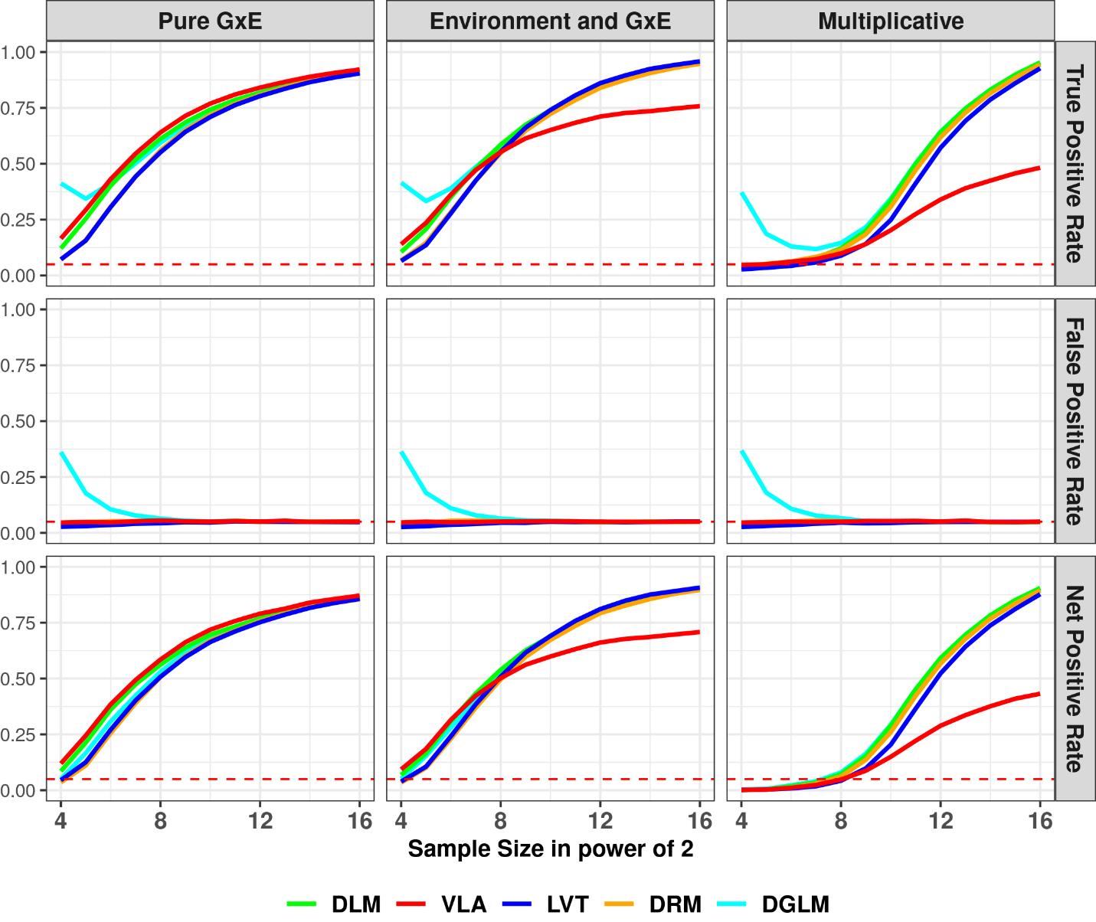Figure 1a: performance on simulated Gaussian phenotype
top row: y-axis is true positive rate (a.k.a., power); middle row: y-axis is false positive rate (a.k.a., type 1 error); bottom row: y-axis is net positive rate (true positive – false positive); left columns (pure GxE): variance loci were additively induced by GxE, without environmental main effect; middle column (environmental main effect and GxE): variance loci were additively induced by GxE locus, with coexisting environmental main effect; right column (multiplicative): variance loci were multiplicative; colored solid lines: variance loci tests; red dashed line: expected false positive rate at the size of hypothesis testing (0.05).
<place holder: links to the R-script>

Binary phenotype, 50% cases
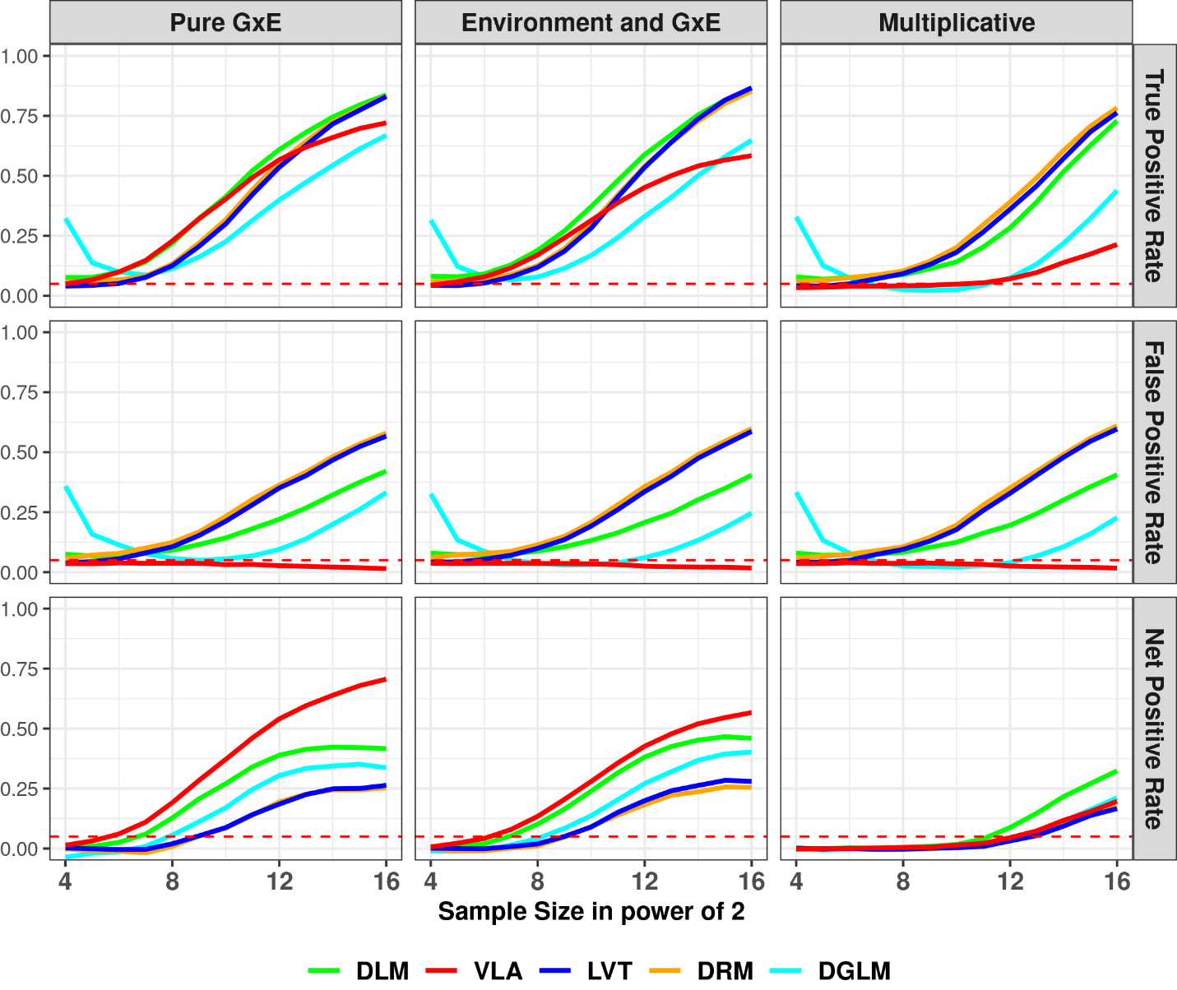
Figure 1b: Performance on simulated binary phenotype with balanced case rate (50%)
top row: y-axis is true positive rate (a.k.a., power); middle row: y-axis is false positive rate (a.k.a., type 1 error); bottom row: y-axis is net positive rate (true positive – false positive); left columns (pure GxE): variance loci were additively induced by GxE, without environmental main effect; middle column (environmental main effect and GxE): variance loci were additively induced by GxE locus, with coexisting environmental main effect; right column (multiplicative): variance loci were multiplicative; colored solid lines: variance loci tests; red dashed line: expected false positive rate at the size of hypothesis testing (0.05).
<place holder: links to the R-script>

Binary phenotype, 7.8% cases
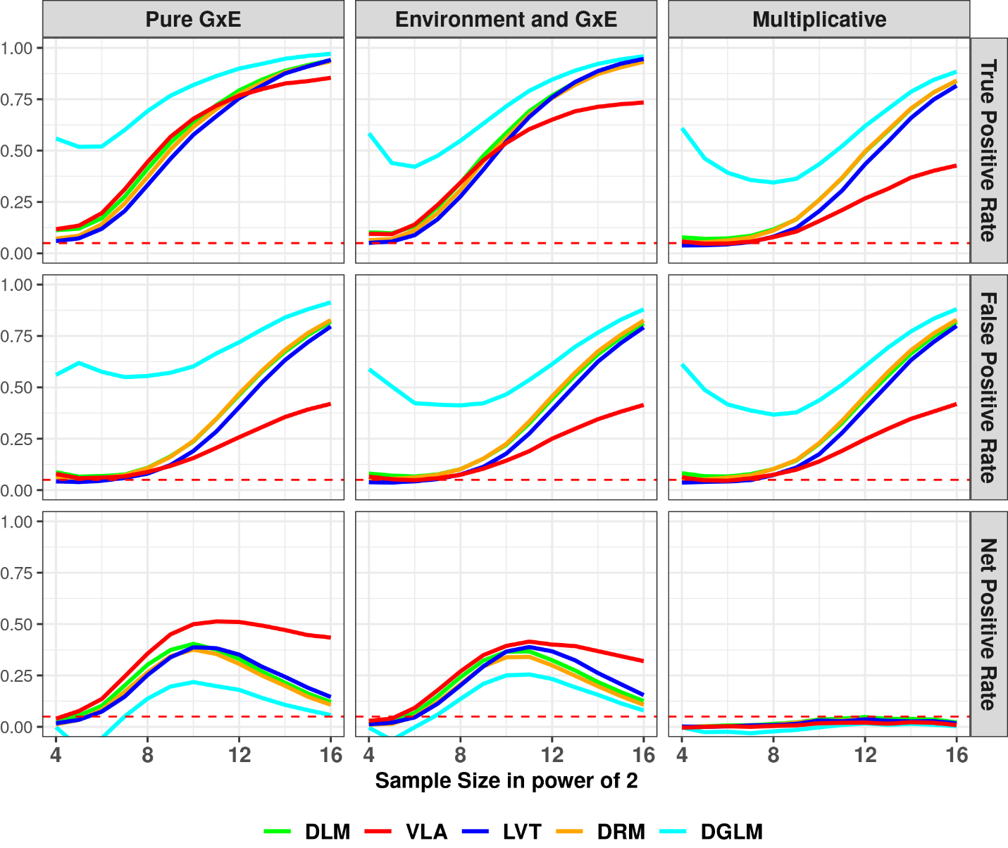
Figure 1c: Performance on simulated binary phenotype with imbalanced case rate (7.8%)
top row: y-axis is true positive rate (a.k.a., power); middle row: y-axis is false positive rate (a.k.a., type 1 error); bottom row: y-axis is net positive rate (true positive – false positive); left columns (pure GxE): variance loci were additively induced by GxE, without environmental main effect; middle column (environmental main effect and GxE): variance loci were additively induced by GxE locus, with coexisting environmental main effect; right column (multiplicative): variance loci were multiplicative; colored solid lines: variance loci tests; red dashed line: expected false positive rate at the size of hypothesis testing (0.05).
<place holder: links to the R-script>

Poisson phenotype, 37% zeros
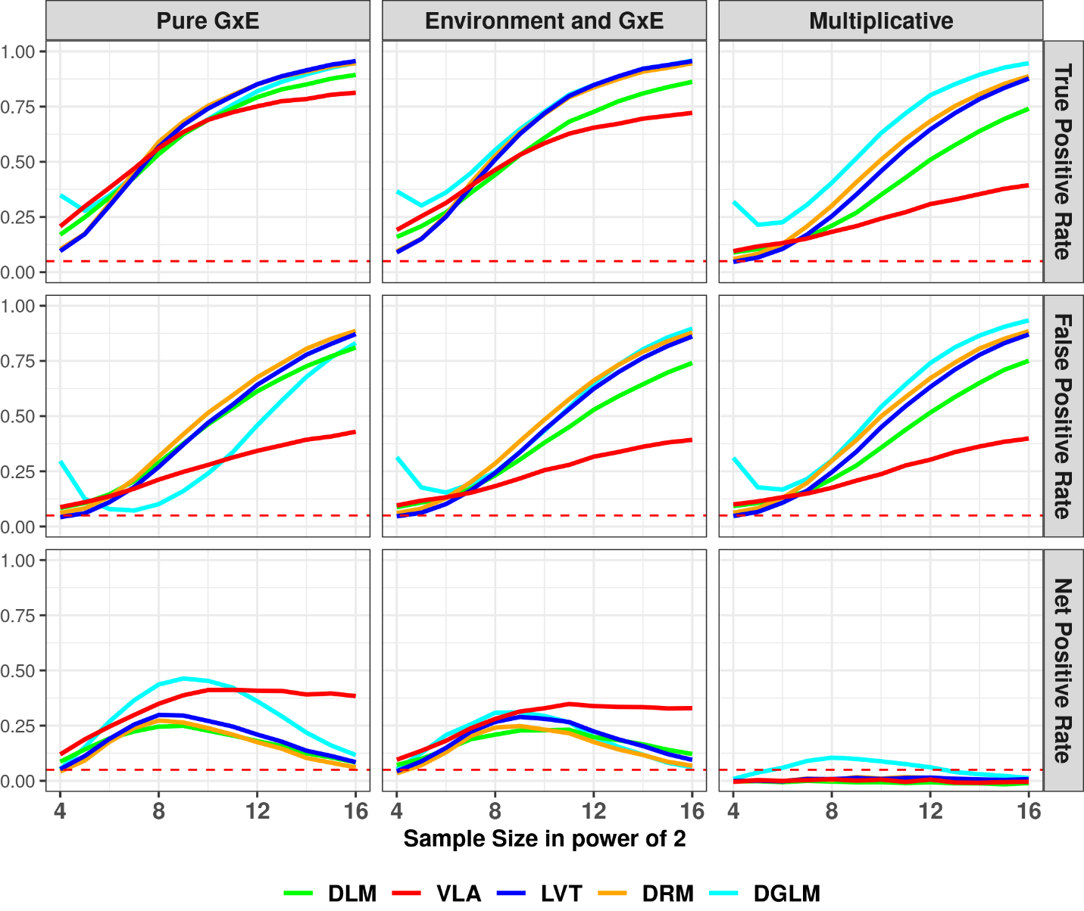 Figure 1d: Performance on simulated Poisson phenotype with moderate number of zeros (37%)
top row: y-axis is true positive rate (a.k.a., power); middle row: y-axis is false positive rate (a.k.a., type 1 error); bottom row: y-axis is net positive rate (true positive – false positive); left columns (pure GxE): variance loci were additively induced by GxE, without environmental main effect; middle column (environmental main effect and GxE): variance loci were additively induced by GxE locus, with coexisting environmental main effect; right column (multiplicative): variance loci were multiplicative; colored solid lines: variance loci tests; red dashed line: expected false positive rate at the size of hypothesis testing (0.05).

Poisson phenotype, 92% zeros
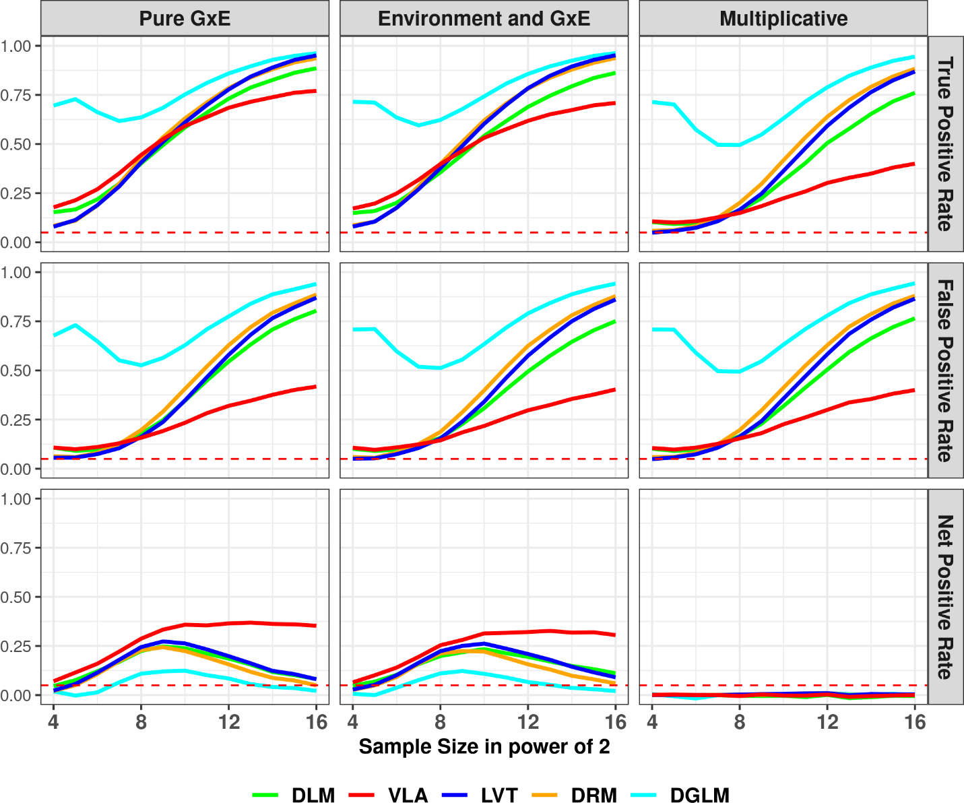 Figure 1e: Performance on simulated Poisson phenotype with high number of zeros (92%)
top row: y-axis is true positive rate (a.k.a., power); middle row: y-axis is false positive rate (a.k.a., type 1 error); bottom row: y-axis is net positive rate (true positive – false positive); left columns (pure GxE): variance loci were additively induced by GxE, without environmental main effect; middle column (environmental main effect and GxE): variance loci were additively induced by GxE locus, with coexisting environmental main effect; right column (multiplicative): variance loci were multiplicative; colored solid lines: variance loci tests; red dashed line: expected false positive rate at the size of hypothesis testing (0.05).

Scripts
We drew SNP dosage values from a small part of the 1000 genome project data and used R-language to implement the 5 variance loci test perform the simulation study, which is available in GitHub repository https://github.com/xiaoran831213/vla_sim.

Genome Wide Putative GxE Variant Tests
In this section we provide results 5 putative GxE tests on distant white participants in the UK Biobank on an imputed genome-wide scale for a representative quantitative phenotype—body mass index (BMI) —and a representative binary (case/control) phenotype—type 2 diabetes (T2D).

Manhattan Plot
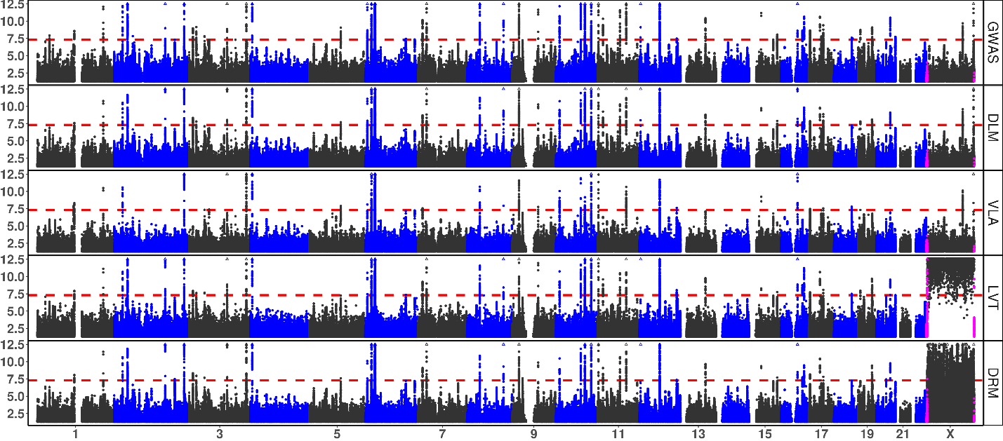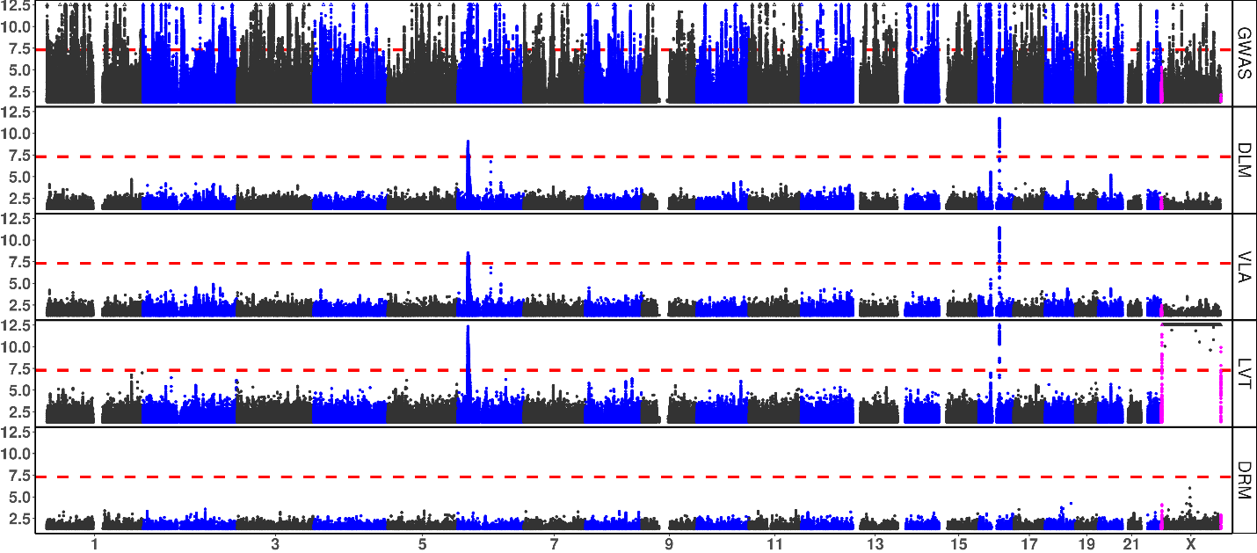
Supplement Figure 3b: Manhattan and QQ Plots, with λ_{GC}
x-axis: chromosome position; y-axis: –log₁₀P; red dash: significance threshold –log₁₀(5e-8); each dot bins 269,534 basepairs; magenta dots denote pseudo-autosome regions (PAR) on X; hollow triangle dots denote significant variant capped at a maximum displayable –log₁₀P of 12; orange circle: abnormal p-values (excluded from λ_{GC}); rows: statistical tests, GWAS = genome wide association study; DLM = double linear model, VLA = variance loci analysis (order-2 polynomial positive gradient test), LVT = Levene’s robust test, DRM = Deviation Regression Model; red region (T2D only) surrounding rs6712203 on chromosome 2 corresponds to the local Manhattan plots in in main text Figure 3.
(a) Body Mass Index

(b) Type 2 Diabetes

Top hits for Body Mass Index
SNP | chromosome  (Hg19/  GRCh37) | basepair  (Hg19/  GRCh37) | MAF | Statistical Test P-value
 |  |  |  | GWAS  (GLM/OLS) | Double  Linear Model  (DLM) | Variance  Loci Analysis  (VLA) | Levene's  Robust Test  (LVT) | Deviation  Reg. Model  (DRM)
rs539515 | 1 | 177889025 | 0.2049 | 1.07E-66 | 2.04E-03 | 3.98E-04 | 1.37E-02 | 9.77E-01
rs6689335 | 1 | 219628682 | 0.4189 | 2.99E-06 | 2.86E-05 | 1.00E+00 | 1.73E-07 | 8.12E-01
rs11578107 | 1 | 247193435 | 0.0284 | 1.16E-02 | 4.88E-01 | 4.02E-01 | 1.02E-07 | 1.00E+00
rs6744646 | 2 | 628504 | 0.1717 | 5.44E-72 | 1.35E-02 | 5.31E-03 | 3.67E-03 | 1.10E-01
rs10182181 | 2 | 25150296 | 0.4858 | 3.25E-57 | 1.98E-01 | 5.39E-02 | 1.08E-01 | 5.26E-01
rs115063350 | 2 | 160999596 | 0.0793 | 4.43E-01 | 2.03E-01 | 8.94E-01 | 3.68E-01 | 2.59E-04
rs183280845 | 6 | 26921528 | 0.1097 | 2.88E-07 | 8.74E-10 | 2.98E-09 | 4.48E-13 | 5.69E-01
rs561277 | 6 | 86014152 | 0.4435 | 8.30E-02 | 1.94E-07 | 1.53E-07 | 2.68E-01 | 9.44E-01
rs552749467 | 6 | 112272977 | 0.0160 | 5.93E-02 | 5.53E-05 | 1.20E-05 | 8.31E-05 | 3.23E-01
rs34845977 | 16 | 31027833 | 0.3653 | 8.84E-29 | 2.90E-06 | 3.40E-06 | 1.06E-07 | 2.19E-01
rs1421085 | 16 | 53800954 | 0.4035 | 1.98E-213 | 1.86E-12 | 3.57E-12 | 1.52E-14 | 3.37E-02
rs8064540 | 17 | 13742387 | 0.2206 | 1.70E-01 | 4.18E-01 | 2.07E-01 | 6.12E-01 | 2.84E-04
rs269989 | 18 | 42787046 | 0.3324 | 6.87E-01 | 1.25E-01 | 2.41E-02 | 3.95E-03 | 1.68E-04
noR02BE30 | 18 | 46967624 | 0.0549 | 9.96E-02 | 5.53E-01 | 1.95E-01 | 1.26E-01 | 2.31E-04
rs58084604 | 18 | 57849429 | 0.2328 | 2.79E-85 | 2.05E-04 | 2.07E-04 | 6.06E-04 | 9.55E-01
rs62095352 | 18 | 67241731 | 0.0744 | 4.81E-01 | 2.61E-01 | 8.81E-02 | 4.29E-01 | 5.70E-05
Table s2a: Top 5 SNPs for body mass index (BMI)
The 5 most significant SNP by any of the 5 tests, the total is less than 25 because some SNPs were detected by more than one tests; each SNP represents nearby others in 336,918 basepairs; the redness denote significance; for X chromosome the p-value for LVT and DRM are left blank.

Top hits for Type 2 Diabetes
SNP | chromosome  (Hg19/  GRCh37) | Basepair  (Hg19/  GRCh37) | MAF | Statistical Test P-value
 |  |  |  | GWAS  (GLM/OLS) | Double  Linear Model  (DLM) | Variance  Loci Analysis  (VLA) | Levene's  Robust Test  (LVT) | Deviation  Reg. Model  (DRM)
rs2943635 | 2 | 227077377 | 0.3190 | 6.75E-15 | 9.72E-14 | 2.17E-13 | 4.70E-14 | 4.05E-13
rs35841686 | 3 | 123087916 | 0.2660 | 3.61E-18 | 1.65E-16 | 3.88E-17 | 2.40E-18 | 2.01E-16
noC0B7185 | 3 | 185511745 | 0.3120 | 1.35E-25 | 2.81E-22 | 2.43E-20 | 8.66E-24 | 6.09E-23
rs4689398 | 4 | 6302199 | 0.4103 | 3.87E-18 | 3.81E-16 | 8.55E-18 | 5.44E-18 | 9.52E-17
rs67131976 | 6 | 20686878 | 0.1735 | 4.71E-30 | 2.30E-26 | 1.12E-27 | 2.71E-30 | 1.07E-27
rs9273363 | 6 | 32626272 | 0.2999 | 5.37E-22 | 1.13E-19 | 9.72E-25 | 1.51E-26 | 6.57E-21
rs860262 | 7 | 28194397 | 0.4979 | 1.80E-19 | 1.68E-17 | 1.00E+00 | 2.81E-18 | 7.51E-17
rs13266634 | 8 | 118184783 | 0.3099 | 5.89E-25 | 1.04E-22 | 1.00E+00 | 8.10E-22 | 1.39E-22
rs10965248 | 9 | 22132878 | 0.1767 | 1.78E-24 | 3.30E-21 | 1.00E+00 | 2.43E-20 | 6.46E-21
rs5015480 | 10 | 94465559 | 0.4090 | 3.01E-20 | 6.53E-18 | 1.00E+00 | 1.63E-16 | 2.46E-16
rs7903146 | 10 | 114758349 | 0.2897 | 7.71E-166 | 3.70E-143 | 1.42E-127 | 1.96E-156 | 1.76E-148
rs2237895 | 11 | 2857194 | 0.4150 | 8.00E-17 | 8.04E-15 | 3.69E-13 | 2.98E-16 | 2.19E-16
rs76895963 | 12 | 4384844 | 0.0142 | 6.30E-25 | 1.72E-23 | 1.00E+00 | 1.25E-23 | 6.71E-23
rs1421085 | 16 | 53800954 | 0.4033 | 6.39E-26 | 9.75E-24 | 9.77E-22 | 7.80E-26 | 2.16E-24
rs3020789 | X | 152892987 | 0.2184 | 4.34E-20 | 7.64E-19 | 4.07E-18
Table s2b: Top 10 SNP for type 2 diabetes (T2D)
The 10 most significant SNP by any of the 5 tests, the total is less than 50 because some SNPs were detected by more than one tests; each SNP represents nearby others in 336,918 basepairs; the redness denote significance; for X chromosome the p-value for LVT and DRM are left blank.

GxE and Functional Enrichment Analysis
This section provides tabulated reports of GxE and functional enrichment analysis corresponding to bar-charts in the main text

UKBB Internal GxE enrichment analysis
The following summarize internal GxE enrichment coefficients based on divided populations within UKBB.
 | Statistical Test | Estimated GXE enrichment coefficient (Standard Error) in 1e-3s
 | Statistical Test | Significant GXE by p-value cut-off |  |  |  |  |  |  |  | overall
 | Statistical Test | 5.00E-02 | 5.00E-03 | 5.00E-04 | 5.00E-05 | 5.00E-06 | 5.00E-07 | 5.00E-08 | 5.00E-09 | overall
BMI | GWAS (GLM/OLS) | -0.49 | 1.83 | 0.79 | 1.05 | -0.8 | 0.23 |  |  | -2.33
BMI | Double Linear Model (DLM) | 2.18 | 2.01 | 0.15 | -0.76 | -1 | 0.06 |  |  | 1.55
BMI | Variance Loci Analysis (VLA) | -0.41 | 1 | 1.28 | -1.21 | 0.76 | -0.27 |  |  | 4.91
BMI | Levene's Robust Test (LVT) | 2.27 | 1.72 | 1.03 | -0.97 | 0.43 | -0.23 |  |  | 2.34
BMI | Deviation Reg. Model (DRM) | 1.34 | 1.39 | 1.18 | 2.18 | 0.46 | -0.14 |  |  | 2.39
T2D | GWAS (GLM/OLS) | 1.43 | 3.38 | -0.32 | 0.58 | -1.59 | -1.06 | -1.64 | -1 | -1.3
T2D | Double Linear Model (DLM) | 1.68 | 3.21 | -0.02 | 0.96 | -1.28 | -0.74 | -1.46 | -0.85 | -1.64
T2D | Variance Loci Analysis (VLA) | 4.97 | 4.2 | 1.17 | 0.45 | 0.34 | 0.69 | 0.07 | -0.32 | 8.44
T2D | Levene's Robust Test (LVT) | 0.44 | -0.52 | -0.06 | 2.96 | 1.66 | -1.85 | -1.27 | -0.81 | 0.81
T2D | Deviation Reg. Model (DRM) | 2.15 | 2.6 | -0.45 | 0.7 | -1.73 | -1.6 | -1.67 | -0.99 | 0.92
Standard error in 1e-3s |  | 0.33 | 0.34 | 0.34 | 0.34 | 0.34 | 0.34 | 0.32 | 0.34 | 0.33
Table s3a: Internal GxE enrichment analysis (UKBB White British to White non-British)
The enrichment coefficient for GxE and SE at several p-value thresholds and overall -- more positive at more stringent threshold means better; Red: best performing statistical test; BMI: body mass index; T2D: type 2 diabetes; Blank: absence of significant GxE at a threshold; only one SE are shown per threshold because they are nearly identical for all tests and phenotypes.

PEGS External GxE enrichment analysis
The following summarize external GxE enrichment coefficients based on UKBB and PEGS.
PHE | Test | Estimated GXE enrichment coefficient (Standard Error) in 1e-3
PHE | Test | GXE significance by p-value cut-offs |  |  |  |  |  |  |  | overall
PHE | Test | 5.00E-02 | 5.00E-03 | 5.00E-04 | 5.00E-05 | 5.00E-06 | 5.00E-07 | 5.00E-08 | 5.00E-09 | overall
BMI | GWAS (GLM/OLS) | -8.38 | -0.13 | -9.68 | -3.24 | -0.04 | -3.51 | -3.86 | -3.62 | -6.29
BMI | Double Linear Model (DLM) | 1.51 | 0.78 | -2.64 | -1.04 | -0.78 | -0.68 | -0.88 | -0.28 | 0.38
BMI | Variance Loci Analysis (VLA) | 1.54 | 2.02 | 0.03 | -1.88 | 0.27 | 0.84 | 1.74 | 1.77 | 3.82
BMI | Levene's Robust Test (LVT) | 0.17 | 2.45 | 0.45 | 1.85 | 0.3 | 0.1 | -0.98 | -0.87 | -0.78
BMI | Deviation REG Model DRM) | 3.38 | 2.13 | 0.26 | -0.17 | -0.05 | 0.69 | 0.26 | 0.42 | 4.63
T2D | GWAS (GLM/OLS) | -10.4 | -18.4 | -15.4 | -12.7 | -9.42 | -5.59 | -3.06 | -2.94 | -4.05
T2D | Double Linear Model (DLM) | -10.1 | -18.3 | -15.1 | -12.4 | -9.48 | -5.69 | -2.92 | -2.88 | -3.87
T2D | Variance Loci Analysis (VLA) | -0.17 | -2.98 | -1.12 | 0.64 | 2.92 | 3.17 | 3.63 | 3.6 | 0.89
T2D | Levene's Robust Test (LVT) | -7.88 | -15.1 | -12.2 | -8.95 | -7.87 | -4.62 | -1.09 | -1.01 | -3.26
T2D | Deviation REG Model DRM) | -10.5 | -19.4 | -16.2 | -13.2 | -10.8 | -7.17 | -3.68 | -3.32 | -3.7
Standard error in 1e-3s |  | 0.35 | 0.35 | 0.35 | 0.35 | 0.35 | 0.35 | 0.35 | 0.35 | 0.35
Table s3b: External GxE enrichment coefficients (UKBB White European to PEGS)
The enrichment coefficient for GxE and SE at several p-value thresholds and overall -- more positive at more stringent threshold means better; red/blue: best/second best performance; BMI: body mass index; T2D: type 2 diabetes; only one SE are shown per threshold because they are nearly identical for all tests and phenotypes.

Functional Enrichment Analysis
phenotype | statistical test | estimated functional enrichment coefficient (standard error) in 1e-3
phenotype | statistical test | intergenic | In or near genes |  |  |  | CADD score
phenotype | statistical test | intergenic | upstream | intronic | exonic | downstream | CADD score
Body  Mass  Index  (BMI) | GWAS (GLM/OLS) | -15.50 (0.34) | 3.74 (0.44) | 13.90 (0.44) | -0.88 (0.44) | 2.54 (0.44) | 7.32 (0.35)
Body  Mass  Index  (BMI) | Double Linear Model (DLM) | -8.27 (0.34) | 0.59 (0.44) | 7.50 (0.44) | 0.26 (0.44) | 0.80 (0.44) | 3.66 (0.35)
Body  Mass  Index  (BMI) | Variance Loci Analysis (VLA) | -0.28 (0.34) | 1.45 (0.44) | 0.79 (0.44) | 0.36 (0.44) | -1.00 (0.44) | -0.20 (0.35)
Body  Mass  Index  (BMI) | Levene's Robust Test (LVT) | -3.89 (0.34) | 1.41 (0.45) | 5.10 (0.45) | 0.33 (0.44) | 0.00 (0.45) | 1.99 (0.36)
Body  Mass  Index  (BMI) | Deviation Reg. Model (DRM) | -3.24 (0.34) | -0.83 (0.45) | -0.68 (0.45) | 0.23 (0.44) | -3.09 (0.45) | 0.60 (0.36)
Type 2  Diabetes  (T2D) | GWAS (GLM/OLS) | -7.99 (0.34) | 6.34 (0.44) | 8.27 (0.44) | 0.14 (0.44) | 5.86 (0.44) | 3.72 (0.35)
Type 2  Diabetes  (T2D) | Double Linear Model (DLM) | -8.13 (0.34) | 6.00 (0.44) | 8.01 (0.44) | 0.03 (0.44) | 5.69 (0.44) | 3.72 (0.35)
Type 2  Diabetes  (T2D) | Variance Loci Analysis (VLA) | 5.81 (0.34) | 5.30 (0.44) | 0.30 (0.44) | 0.68 (0.44) | 3.96 (0.44) | 0.46 (0.35)
Type 2  Diabetes  (T2D) | Levene's Robust Test (LVT) | -5.37 (0.34) | 4.91 (0.45) | 6.91 (0.45) | 0.14 (0.44) | 4.60 (0.45) | 2.97 (0.36)
Type 2  Diabetes  (T2D) | Deviation Reg. Model (DRM) | -7.45 (0.34) | 5.57 (0.45) | 6.32 (0.45) | -0.02 (0.44) | 5.52 (0.45) | 3.94 (0.36)
Table s3c: Functional enrichment coefficients (UKBB White European)
This table shows the enrichment coefficient (and standard error) for SNPs function labels and CADD score; positive significant (red) mean SNPs of a certain label or high CPDD are overrepresented among significant loci of a test (GWAS, DLM, VLA, LVT, or DRM), negative significant (green) means opposite.

ABCB7 and Printing Ink Exposure
From the 14,874,008 x 765 2-way GxE-WAS test statistics based on PEGS, we first extract those with p-values less than 5e-4 (num), than joined the results with summaries from variance loci test statistics (i.e., DLM, VLA, LVT, DRM, and GWAS).
To test whether the expression in these top genes was modified by this exposure (GEO number GSE142351), we used gene expression data from a study that examined changes in gene expression with occupational printer exposure. In this study, blood was collected from female office workers in three groups: a control group (n=2), those exposed to inkjet printers (n=2), and those exposed to laser printers (n=7) at four time points, on each Monday and Friday of two subsequent weeks, and sequenced to determine mRNA expression. Samples from Mondays and sample from Fridays were each grouped together, with the assumptions that all participants worked a typical Monday-Friday workweek and that the same effects would be observable for any genes with expression changes on all Mondays or all Fridays.
Building on QC completed in Tuxedo, we removed gene IDs with less than two counts in five or more of the 33 samples (from nine participants at four time points) and used DESeq2 to obtain normalized gene counts, treating repeated measures for each subject as replicates. We performed filtering based on the gene list and conducted repeated measures linear regression for the 10 genes of interest. ABCB7 was the only gene expressed in this dataset, which is expected given that the others are pseudogenes or non-coding regions. Because there were no male controls, we used data only on females. Details of the QC and analysis are included in the Supplement. MAKE A STATEMENT OF SIGNIFICANCE BETWEEN EXPOSED AND UNEXPOSESD
We manually checked genome features on or near significant GxE post-adjustment and found significant two-way GxE-WAS results (p-value < 5e-8) for T2D involving the top 10,000 VLA-selected SNPs, 10 genes on or near these SNPs were found, namely LINC02552, LINC02812, SLC25A3P1, LINC02812, SLC25A3P1, RNU6-61P, HNRNPA1P31, LINC01508, ABCB7, and BUD31P2 (TODO: tabulate these genes and the nearest top GxE). Of interest is the significant interaction between T2D and X-chromosome gene ABCB7 (ATP binding cassette subfamily B member 7, X:75,051,048 - 75,156,732, ENSG00000131269), its immediate downstream UPRT (uracil phosphoribosyl transferase homolog, X:75,156,388 - 75,304,885, ENSG00000094841), and exposure to dyes and inks (PEGS ID: A_B194*). The two genes, enclosed by q13.3, were suggested by nearby SNP rs4409555 (X:75173801 C/G) with the smallest raw GxE p-values of 9.25e-12 and 4.39e-2 after Bonferroni correction. Nearby significant variance loci were found in UK Biobank data by GWAS (p-value = 1.24e-3, CDF = 7.52e-3), DLM (p-value = 1.94e-3, CDF = 7.18e-3), and VLA (p-value = 7.74e-5, CDF=1.47e-3), with adjusted GxE p-values of 3.30e-4 (GWAS), 3.15e-4 (DLM), and 6.45e-5 (VLA), respectively. The p-values and cumulative distribution function of variance loci indicate VLA had better performance for identifying GxE near ABCB7-UPRT than GWAS and DLM. Values for LVT and DRM are not included because the two tests are invalid on chromosome X.
Figure 5 is a localized Manhattan plot near ABCB7 and UPRT. The region displayed came close to the highest peak in LD (linkage disequilibrium) on chromosome X (Figure 5 top) based on 3,104 genotyped females (68.4%) in PEGS, with a median LD score of 422.29, which was above the overall median of 110.1815 for the entire chromosome X.

6. Processing UK Biobank data
UK Biobank (UKBB) data
The UKBB data to evaluate the performance of VLA and the other considered methods in selecting GxE candidates was collected via questionnaires, electronic health records, biological samples, oral interviews, imaging, and genotype data.
Genotype data
To create a comprehensive catalog of the whole genome, we began with 97,059,328 imputed variants from 487,411 individuals. After a series of quality control measures, 405,432 individuals with high-quality micro-array genotyping remained. We divided these samples into five major ancestry groups—African (afr), non-Chinese Asian (asi), White British (bri), Irish (iri), and White but non-British (wnb)—and subsequently removed 29,440 individuals belonging to ethnic groups with a small sample size (e.g., Chinese with a sample size of 1574) or unclear ancestry, leaving 375,992 individuals from the original total (77.1% of 487,411 with imputed genotypes and 74.8% of the total 502,505). The afr, asi, bri, and iri groups form the basis of the NIEHS VLA Catalog. We used the bri and wnb groups as training and testing datasets, respectively, to compare performance of the methods.
Phenotype data
To compile phenotypes for type 2 diabetes, coronary artery disease, body mass index, and fasting glucose level, we used baseline data collected at UKBB participants’ first visit. For the phenotypes, we used the following UKBB data fields and took the following steps XXX.
Environmental data
We used data on 16 environmental variables in UKBB, including number of siblings (SIB), physical activity in metabolic equivalent minutes (MET), ever smoking (SMK), weekly alcohol intake (ALC), neighborhood traffic (TRF), nitrogen oxide (NO1), nitrogen dioxide (NO2), particulate matter air pollution, 10m (P10), particulate matter air pollution, 2.5m (P25), and noise (NOI). We also included several neighborhood exposures in a 1000-m buffer around an individual’s home address, namely green space percentage (GSP), domestic garden percentage (DGP), water percentage (WTP), natural environment percentage (NEP) and distance to the coast (SEA). We used the following UKBB fields to calculate the variables XXX.
Phecodes
To derive phecodes, we used phenotypes and disease diagnoses from electronic health record (EHR) data for UKBB participants recorded as International Classification of Diseases (ICD) codes. ICD codes are used to record medical diagnoses, signs and symptoms, abnormal findings, and injuries. Although more than 100 countries use ICD codes to track morbidity and mortality (41), they do not provide an appropriate level of granularity for phenotypes relevant for genetic association studies. Phecodes are manually curated groups of ICD codes aggregated into a distinct medical concept, disease, or phenotype intended to capture clinically meaningful concepts for research (40). Phecodes provide embedded case-control definitions based on exclusion criteria for controls, enabling the rapid characterization of large numbers of phenotypes. They are widely used for phenotyping participants with EHR data, especially for genetic association studies (40, 42). The use of phecodes in such studies produces superior results compared to ICD and Clinical Classification Software (CCS) codes.
7. PEGS
PEGS administered comprehensive surveys on 756 exposome items for 9,765 participants, divided into three parts. The Health and Exposure survey (part C) collects information on general health and lifestyle, and occupational exposures as well as individual and family medical histories (n=9,414); the External Exposure survey (part A) collects information on exogenous exposures throughout life, including but not limited to chemical and environmental exposures at home and work (n=3,519); the Internal Exposure survey (Part B) collects information on endogenous exposures such as medication as well as lifestyle factors, including sleep patterns, stress, physical activity, and diet (n=2,962). The Supplement provides information on how the surveys were formulated.

Whole-genome sequencing
The Broad Institute performed genotype sequencing for 4,610 PEGS participants and conducted quality control. It also compared the number of variants identified for each PEGS participant to the number determined in a parallel analysis of the same data based on the hg19 genome assembly. The Supplement provides further details on all the sequencing and filtering steps.
We derived T2D and BMI phenotype data from Health and Exposure survey data.
PEGS participants complete extensive questionnaires measuring a rich exposome of 728 items organized into 416 parent questions on daily life, home environment, and workplace hazards. Overall, 505 of the exposome items are binary, and 223 are positive integers less than 8, so we retained the items in their original form when developing GxE terms with centered SNP dosage.

Principal components analysis
The UKBB performed principal components analysis for all genotyped individuals. Data field 22009 provides the first 40 principal components. For PEGS, we performed PCA using the pca command in PLINK2. Before removing any variants or samples as part of QC, we performed PCA with the original whole genome sequencing (WGS) data for 40,123,943 variants (38,528,374 in the autosomes) in 4,610 individuals.

Gene-Environment Interaction Analysis
For each environment e, genome variant g, outcome y, and some covariates X, we fitted model y = g + e + ge + X. We tested the significance of the coefficient on ge and kept the p-value. The term ge is the product of g and e. For the UKBB, g is one of the imputed variants, and e is one of the 16 environment exposures described in the Materials section. The covariates X are age, sex, the top 40 PCs, and the genotyping array used (i.e., BiLEVE or Axiom). Because the GxE analysis was conducted for non-British whites only, ethnicity is not included among the covariates. For PEGS, g is one of the WGS variants after quality control, e is one the 766 available environment exposures, and the covariates X are age, sex, self-identified ethnicity, and the top 20 PCs. The proportion of each self-identified ethnicity is: 2.19% Asian, 27.46% Black, 62.34 White, and 2.21% other, coded as 3 dummy variables in X.

