Cataloging gene-environment interaction candidate SNPs for over 3,000 UK Biobank disease phenotypes through variance loci analysis
Xiaoran Tong, <authors>, Alison Motsinger-Reif

Abstract
Detecting gene by environment interactions (GxEs) for diseases enriches the ontology of genetic effects and helps identify environmental targets for interventions with the goal of improving health outcomes. However, combining the dimensions of the genome and exposome poses challenges in terms of both computational and statistical power. Both additive and multiplicative genome-wide variance quantitative trait loci (vQTL) analysis methods have recently received attention for their ability to find candidate single nucleotide polymorphisms (SNPs) for GxEs without actual environmental exposome profiling. The rationale is that unaccounted GxEs cause the residual variance of a quantitative trait to change across allele dosages—a non-uniformity that, when captured, suggests GxEs.
Based on the simplest additive vQTL approach, the double linear model (DLM), we propose variance loci analysis (VLA) by augmenting the DLM with squared allele dosage. We show that VLA maintains superior power to detect GxE candidates with weak direct environmental effects on the phenotype. We also demonstrate that multiplicative vQTL methods—the double generalized linear model (DGLM) and Levene’s test (LVT)—are overly generic with squared dosage or overly restrictive without squared dosage. More importantly, we demonstrate that by appropriately adjusting covariates, VLA can overcome the inability of DLM/DGLM/LVT to analyze thousands of non-quantitative phenotypes.
We performed VLA for 3,273 health- and disease-related phenotypes derived from the UK Biobank and ranked the potential involvement of each SNP in GxEs. We created and hosted the VLA Catalog (genelist.niehs.nih.gov) as an open resource of GWAS, vQTL, and VLA mapping for these traits, along with the metadata required for reproducibility and independent applications. Using environmental exposome data collected in the Personalized Environmental Genetic Study (PEGS), we found that high-ranking genome variants selected by VLA enriched the detection of genome-exposome-wide significant GxE SNPs for cardiovascular disease, type 2 diabetes, and body mass index.

Introduction

Background and motivation
Most human traits have a complex etiology and are affected by both genetic and environmental factors and their interactions. Because environmental exposures can regulate the biological processes underlying a phenotype , unaccounted-for gene by environment (GxE) effects are recognized as part of the heritability “missed” by variants selected by genome-wide association studies (GWAS)(Eichler et al. 2010; Van Ijzendoorn et al. 2011). While research in agricultural genetics, model organisms, and cell culture has consistently found that genetic effects are context-dependent (9-13), there has been limited success in identifying GxEs in humans. Among the reasons for this are the difficulty of measuring many environmental exposures and insufficient sample sizes (9–11).
In large cohorts with comprehensive exposome and genome data, a genome-exposome wide association study (GxE-WAS) can test for interactions between genome variants (i.e., SNPs) and environmental exposures. However, due to the overwhelming number of combinations between exposures and genome variants, the burden of multiple testing and computation time are severe challenges. More practically, candidate SNPs in or near genome features likely to affect the phenotype according to a priori biological knowledge, or variants reaching a certain significance level in GWAS, can be prioritized for interaction testing. These approaches, however, either hinder hypothesis generation due to the reliance on prior knowledge or are prone to false positives due to the assumption that all GXE interaction models involve strong genetic marginal effects, which is not necessarily true.
These issues have motivated the development of alternative approaches. A promising strategy is to perform a genome-wide search for variance quantitative trait loci (vQTL) in a selection cohort rich in genome data and then use the vQTLs as candidates for GxE studies in a discovery cohort rich in exposome data. The selection cohort must collect phenotypes close to that of interest in the discovery cohort, but no exposome data is required in the former. Analogous to classic QTLs from a GWAS that tests the allelic effect on the phenotypic mean, vQTLs test the allelic effect on phenotypic variance. However, vQTLs are superior candidates than GWAS QTL, because the presence of strong GxEs causes heterogenous variation of a quantitative trait among individuals of different allele carriage (3-6).

Variance quantitative trait loci (vQTL) analysis
A vQTL can be induced by a GxE effect unaccounted for in a GWAS linear model, resulting in uneven variation around the mean regression line across genotypes (7). Such vQTLs can be detected by fitting the variation with the same genotype via a second linear model. Recent high-profile work proposes a vQTL test that is a double linear model (DLM), where the first stage is a de facto GWAS, and the second stage treats the squared residual as a new phenotype. When a variant is not involved in a GxE (Figure 1a), the phenotypic variation, now measured by squared residuals, is nearly uniform across dosage, resulting in a flat regression line in stage 2. Conversely, when the variant is involved in a GxE (Figure 1b), the phenotypic variation changes with allele dosage, resulting in a non-zero slope in stage 2. Because DLM assumes each allele adds a certain quantity to the phenotypic variance, we intuitively call it an additive vQTL model.
More traditionally, modeling the mean and variance of a quantitative phenotype with shared genotype predictors (i.e., SNPs) is done by double generalized linear modeling (DGLM)(8) and double hierarchical generalized linear model (DHGLM)(9). Although the original intent of these approaches was to exclude vQTLs and prioritize variants resistant to environmental changes (10, 11), DGLM/DHGLM is a common benchmark for comparing power to identify GxE candidates (12, 13). DGLM also involves two-stage modeling but allows link functions to accommodate non-normal outcomes and assumes that the squared residual deviance of a stage-1 model follows not a Gaussian but a Gamma distribution. Because DGLM uses log-linked Gamma regression in stage 2, it essentially models the phenotypic variance in log scale with allele dosage, thus capturing multiplicative vQTLs. A multiplicative vQTL test assumes each allele multiplies the phenotypic variance by a factor.

Issues with vQTL analysis
Under the null of no GxE, vQTL tests assume homogeneous variation among individuals of the same genotype, therefore, they require the phenotypes to be nearly Gaussian. Otherwise, the link between mean and variance of a non-Gaussian random variable makes a locus affecting the phenotypic mean automatically a locus affecting the phenotypic variance, wrongfully capturable by DLM and DGLM. More robust methods have shown varying success in balancing the statistical power and control of false positives. The deviation regression model (DRM), as a modified DLM that replaces squared distance from the phenotype to genotype group mean (i.e., the squared residuals of the stage-1 linear model) with the distance to the group median, is recommended for capturing additive vQTL (Marderstein et al. 2021). The Levene’s robust test of heterogeneous variance (LVT) is recommended for capturing non-parametric vQTL. In simulations where the phenotypic mean were the sum of covariate, genotype effects, environmental effects, and GxE effects (i.e., inducing additive vQTL), DRM outperformed DGLM and LVT (Marderstein et al. 2021). In another situation where Gaussian phenotypes were simulated with the variance being the exponent of allele dosage (i.e., multiplicative vQTL by definition), LVT performed optimally when the phenotype was further distorted into non-Gaussian quantities (H. Wang et al. 2019).
Still, vQTL tests are not meant for binary case/control outcomes(Paré et al. 2010; Marderstein et al. 2021; H. Wang et al. 2019). When the phenotype is binary, the mean $μ$ and variance $v$ are tightly related by $v=μ(1-μ)$, grossly violating the homogeneous variation assumption under the null. In this case, DLM (Figure 1c) sees a GWAS significant SNP as a GxE candidate, regardless of the presence GxE. DRM, LVT and DGLM also showed run away type 1 errors despite the first two being robust with quantitative non-Gaussian phenotypes (see “simulation” under “result”). In addition, additive vQTL tests like DLM and DRM diminishes the power to detect strong but pure GxE candidates where direct environmental effect on the phenotypic mean is weak, even if the phenotype is Gaussian (Figure 1d).
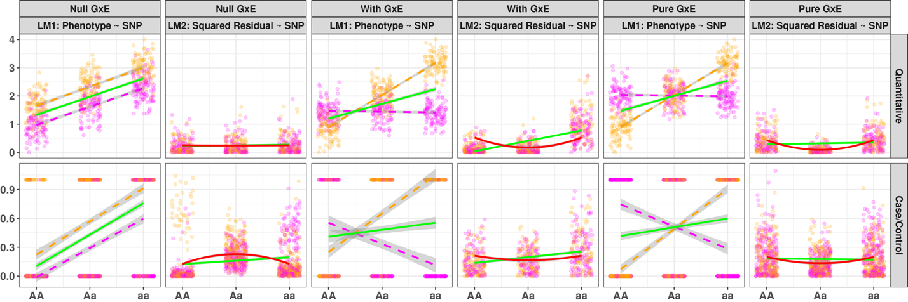
Figure 1: Rationale of Variance Loci suggesting GxE candidate SNP
Green solid lines: marginal linear regression lines; red solid lines: curves fitted by variance loci analysis (VLA) for upwardness test; Magenta /orange points and dashed lines: environment specific observations and regression lines.
(a) In the absence of GxE, the spread of GWAS residuals (LM1) are uniform across genotypes, a flat line can fit through squared residuals (LM2, solid line) so variant A/a is not a vQTL, only GWAS will erroneously identify A/a as a GxE candidate. (b) In the presence of GxE, the spread of GWAS residuals (LM1) are uneven, a non-zero slope fits through the squared residuals (LM2), and variant A/a is a vQTL, therefore a double linear model (DLM) can recognize A/a as a true GxE candidate; (c) for a case/control phenotype, even in the absence of GxE (LM1, parallel dashes in orange and magenta), a non-zero slope still fits through squared residuals (LM2, green solid line), therefore, DLM wrongfully classify A/a as a GxE candidate, but VLA’s upwardness test will not (LM2, red solid line). (d) despite the present of a pure GxE, a double linear model could not identify A/a as a vQTL, but the VLA’s upwardness test can.

(a)
(b)

(c)
(d)

(e)

Variance loci analysis (VLA)
To address the issues with vQTL analysis, we propose variance locus analysis (VLA) to select GxE candidates for both Gaussian and binary phenotypes. VLA takes an additive perspective, but instead of testing the non-zero slope of the stage-2 regression line like DLM, VLA fits a curve and tests its upwardness (Figure 1b, red solid line). For binary phenotypes, VLA better controls the type 1 errors because when the alleles have no GxE effects on the phenotype, the fitted curve in the second stage tend to be flat or bending downwards (Figure 1c, solid red line). For Gaussian phenotypes, VLA’s upwardness test retains the power under weak environmental main effect and is able to detect pure GxE candidate (Figure 1d, solid red line).
However, the upwardness test alone lacks power for detecting true candidate SNP for binary traits when GxE does exists (see the solid green line in Figure 3a), because the dichotomized phenotype glosses over the underlying quantitative risk leading up to the binary event. The gradient of underlying risk can be reconstructed to some extent as residuals by regressing the binary phenotype on a covariate such as age. The residual is a quantitative representation of the underlying risk contributed by the genome, exposome, and GxEs.
With well-chosen covariates, the residuals can be nearly Gaussian. By replacing a binary phenotype with its residualized risk, the upwardness test can detect variance loci involved in GxEs (see Figure 3b). Good covariate should be non-confounding yet predictive, for example, as age and sex, which are neither heritable (not considering Y-chromosome) nor determined by the exposome (i.e., non-confounding), but are strong determinants of diseases (i.e., predictive). A confounding covariate in the model could be useful but may bias the VLA results towards null as a mediator, or create spurious genome and exposome effects as a collider (Aschard et al. 2015); a non-predictive covariate, though not affecting type 1 error, it does not help to reveal the fine gradient of underlying risk required to recover the power to detect variance loci.

Application of VLA
To empirically assess the ability of VLA to prioritize SNPs involved in GXE affecting quantitative and binary phenotypes, and to compare with established variance loci tests (i.e., DLM, LVT, DRM, and even GWAS), we applied genome-wide all 5 methods for type 2 diabetes (T2D) (16, 17) and body mass index (BMI) on a selection population, followed by a two-way genome x exposome wide association study (GxE-WAS) in an independent discovery population.
In the selection population, we ranked each SNP by 1 minus the p-value of VLA and others’ primary statistics; in the discovery population, we scored each SNP by the number of statistically significant GxE effect it incurred at a given p-value cut-off, or by the sum of negative log p-value of all tests of GxE effect it involved. We regress the scores on the ranks so the estimated coefficient act as a measure of GxE enrichment, such that a positive significant enrichment coefficient suggests a method can aid GxE detection by forwarding the right candidate SNP.
Within the UKBB, we took 353,605 unrelated white British descent as a selection population and 25,481 white non-British descent as a discovery population with an exposome of 16 items to perform an internal enrichment analysis. We summarize the top significant hits of all 5 variance loci tests and the corresponding enrichment coefficient in table X and Figure 6 under “Result”
We expand the selection population to 379,561 unrelated individuals of any European descent in the UKBB and replace the discovery population with 4,610 individuals of various ancestries participated the North Carolina based Carolina-based Personalized Gene and Environment Study (PEGS) cohort with whole genome sequencing and an extensive exposome of 765 survey items, to perform an external GxE enrichment analysis. (765 is from freeze 2, grouped into 416 parent items). We report the top significant candidate SNP selected by 5 variance loci tests and the corresponding significant 2-way GxE-WAS in table XX, and the GxE enrichment coefficients in Figure 7 under “Result”.
The description of populations, GxE candidate selection, and 2-way GxE-WAS discovery can be found in “Material” and “Method”. More details, links to scripts, and links to Excel sheets of top significant per-SNP x per-Exposure results can be found in Supplement 2.
ALSO NEED TO DO SOME SORT OF MORE TRADITIONAL OVER REPRESENTATION APPROACH. NEED A SUNSET PLOT FOR T2D IN UKBB. ALSO, HOW MANY WERE SIGNIFICANT AT GWAS CUTOFF.
We also investigated the functional enrichment by regressing the functional class of the SNPs (i.e., intergenic, exonic, intronic, etc.) on the aforementioned ranks based on 1 – values of a variance loci test statistics. We expect the 5 different tests prioritize different classes of SNPs. We summarize the finding in Figure 8 under “Result”.
Referring to significant 2-way GxE-WAS (p-value < 5e-8) for type 2 diabetes involving VLA selected SNPs, some genes stood out. In particular, the 2-way interactions between SNPs in/near ABCB7, a gene involved in glucose transportation pathway, and the PEGS exposome item “dyes, inks and tonners”, led us to corroborative evidence of ABCB7’s differential expression among workers with occupational exposure to Inkjet printers, archived as GEO number GSE142351. We describe the selection of candidate genes and differential expression studies in “Results” and “Methods”.
We implemented VLA as a self-contained R-package “vla”(Tong 2022b) that simultaneously analyzes thousands of phenotypes and thousands of SNPs with optimized matrix algebra, similar to the group optimization trick adopted by PLINK2’s association analysis (Chang 2022); we created another R-package “plinkFile”(Tong 2022a) to help traverse massive genotype in binary biallelic format (Chang 2021) too big to fit into machine memory.
With the tools and the same selection population of 379,561 unrelated individual of European descent, we expanded the genome wide VLA of 11 million variants beyond T2D and BMI, to a comprehensive phenome of 3,273 health related traits in the UKBB, among which 1,693 are simi-automatically derived disease case/control status based on the most recent PHECODE mapping table (Wei et al. 2017; Wu et al. 2019). We hosted the catalog of whole genome VLA statistics on the NIEHS website (https://genelist.niehs.nih.gov/vla) similar to the Pan-UK Biobank GWAS catalog (https://www.pan.ukbb.broadinstitute.org) and the EBI GWAS catalog (https://www.ebi.ac.uk/gwas). The NIEHS VLA-Catalog summarizes the interaction potential for each variant given phenotypes of interest and can be used to prioritize GxE candidates in future research. PREVIOUS WORK ONLY 13ish TRAITS.

Results
Here we present the results of simulation studies comparing the statistical power of variance loci analysis, and contemporary methods in terms of selecting the correct GxE candidate SNP, followed by the results of GxE enrichment analysis on empirical data of UKBB and PEGS, the findings of functional enrichment analysis, and the GxE interaction between type 2 diabetes gene ABCB7 and exposure to inks and tonners.

Simulation
In each simulation repeat we generated vectors of environment and covariate from normal, and drew genotype form an actual SNP randomly picked from the 1000 Genomes Project Phase 3 (Consortium 2012; Consortium and others 2015) with an MAF≥0.01 and a varying sample size between from 2⁴ and 2¹⁶.
We treat the phenotype additively, as the sum of strong covariate effect, weak genotype main effect, possible environmental main effect, and possible GxE effect. We consider scenarios of (1) pure GxE effect or (2) coexisting environmental and GxE effect, both give rise to additive variance loci. For comparison, we also let (3) the genotype directly affect the phenotypic variance in log scale, giving rise to multiplicative variance loci. Rejecting the null (i.e., declaring a SNP a GxE candidate) in all three scenarios contribute to a method’s true positive rates, or power. Next, for each of the scenarios, we simulate a corresponding null scenario by zeroing out the GxE effect (additive variance loci in (1) and (2)) or the genetic effect on logged phenotypic variance (multiplicative variance loci in (2)), rejecting the null in these latter scenarios add to a method’s false positive rate, or type 1 error.
We compared five statistical tests, namely, the simplest double linear model (DLM), the proposed variance locus analysis / curve upwardness test (VLA), deviation regression model (DRM), Levene’s robust test (LVT), and double generalized linear model (DGLM). We ran 20,000 repeats for each scenario. In all scenarios, we fixed the size of test to 0.05, that is, rejecting the null if the p-value is less than 0.05. A test is superior if it exerts higher true positive rate (power) while controlling the false positive rate (type 1 error), therefore, we treat net positive rate, that is, true positive minus false positive rate, as an overall measure of performance.
In this section, we report the false positive and net positive rate regarding additive variance loci (scenario (1) and (2) and null) that motivated VLA’s upwardness test. The full reports with false positive rate and multiplicative variance loci (scenarios (3)) are available in supplement 1.
Figure 2a shows the performance for Gaussian phenotypes, where all tests controlled the false positive rates except DGLM with same samples (panel 1 and 3). When variance loci were induced by pure GxE, VLA gave the highest performance in detecting candidate SNPs (red solid line in column 2). With coexisting environmental main effect, VLA is less sensitive (panel 4).
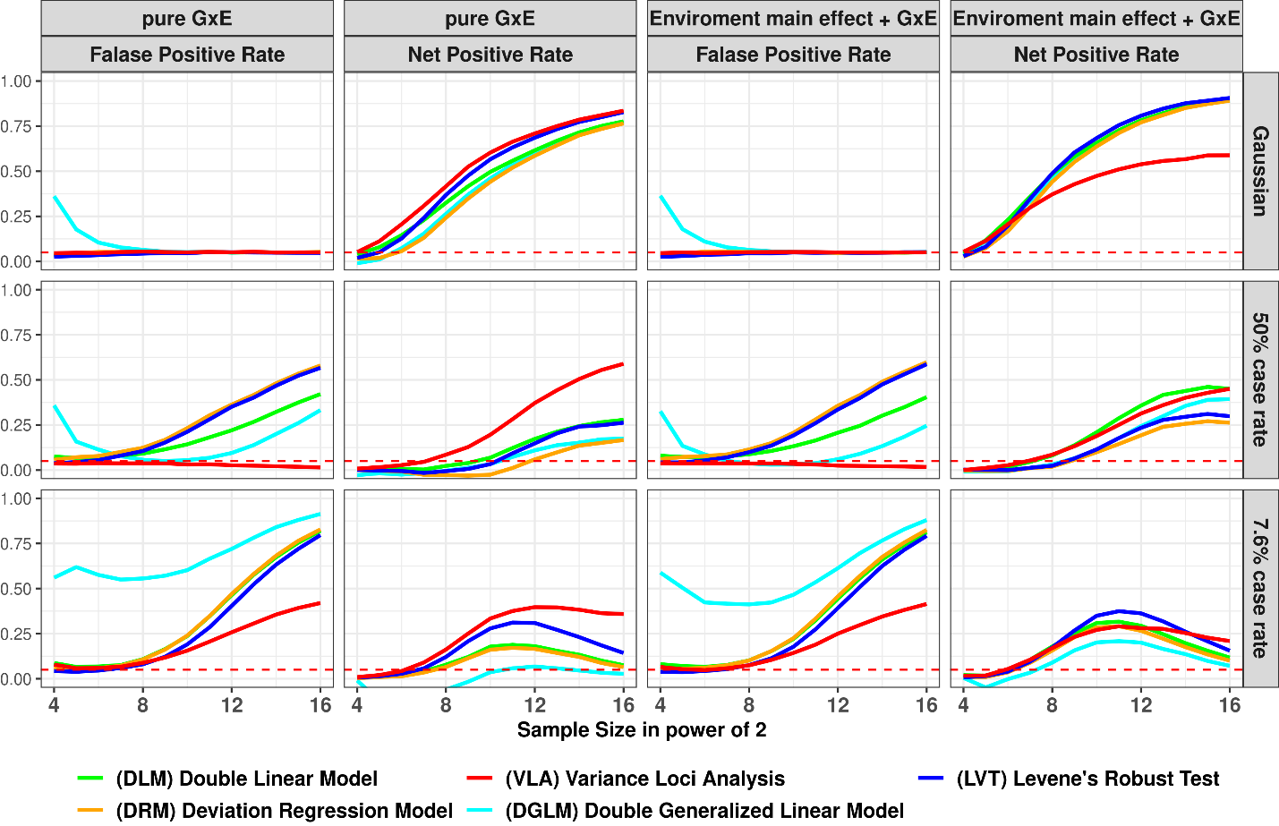
Figure 2: False Positive and Net Positive rates of Simulation Studies
column 1 & 3: GxE is null, the y-axis are false positive rates (FPR), an FPR of 0.05 (denoted by red dashes) is proper, higher FPR suggest over confidence, lower means overly conservative; column 2 & 4: additive variance loci induced by pure GxE, or GxE coexisting with standalone environmental main effect, in these cases the y-axis are net positive rates (NPR), higher means better; x-axis: sample sizes in powers of 2; colors: statistical tests.
(a)
(b)
(c)
Figure 2b shows the performance for balanced binary phenotypes (50% case rate). With growing sample sizes, the variance loci and genetic main effect become less distinguishable, which elevated false positive rate (column 1 and 3) at the cost of net positive rate (column 2 and 4). As a result, all tests except VLA lost control of false positive rate. VLA again was the best detector of true candidate SNPs with pure GxE effect (red solid line in panel 2).
Figure 2c shows the performance for imbalanced binary phenotypes (7.6% case rate), under which it is even more difficult to distinguish SNP main effect on the phenotypic mean from effect on the phenotypical variance, causing an overall inflation of false positives. Still, VLA maintained the best ability to detect true GxE candidates.
The simulation of binary phenotype is detailed in supplement S1, along with the full display of true positive rate and scenarios involving multiplicative variance loci.
We also simulated Poisson phenotypes. Like the binaries, the mean and variance loci of a Poisson phenotype are intertwined, and all tests came under the pressure of inflated false positive rate. The VLA again better maintained the ability to detect true GxE candidate.
Overall, the simulations showed that the VLA was more specialized in detecting additive variance loci induced by pure GxE effect and was overall more robust under the pressure of false positives caused by imbalanced, non-Gaussian phenotype. As expected, VLA underperformed when the variance loci were generated multiplicatively, because when the allele effect on logged variance is negative, it corresponds to an improper, unreal valued additive GxE effect (see “methods”). To re-create our results, see “supplement S1” for simulation materials, parameters, and R-scripts.

UKBB Genome Wide Variance Loci Analysis
We are interested in how each test selects variance loci. We choose body mass index (BMI) and type 2 diabetes (T2D) in the UK Biobank and applied variance loci analysis (VLA) and other tests, except DGLM (low speed and instability). In addition, we performed GWAS with linear and logistic regression for BMI and T2D, respectively. In total, we calculated 5 test statistics for each SNP.
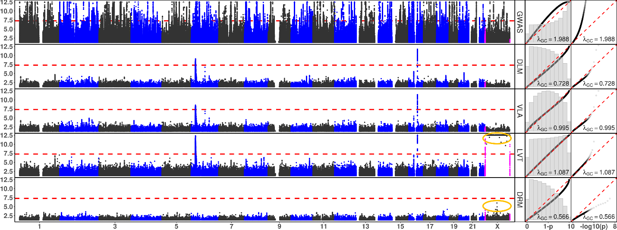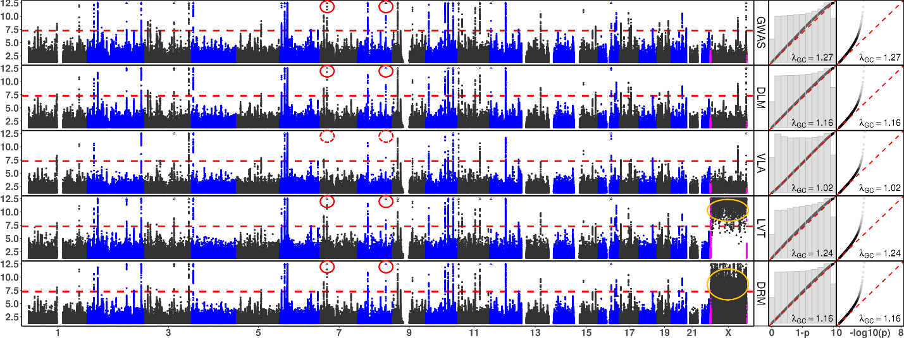
Figure 3: Manhattan and QQ Plots, with λ_{GC}
x-axis: chromosomes (Manhattan plot), theoretical 1 - p (QQ plot 1), or theoretical -log₁₀(p) (QQ plot 2); y-axis: -log₁₀(p) (Manhattan and QQ plot 2), or 1 - p (QQ plot 1); red dash: significance threshold -log₁₀(5e-8) (Manhattan plot); each point bins 269,534 basepairs; magenta points pseudo-autosome regions (PAR) in X; orange circle: abnormal p-values excluded from QQ plots and λ_{GC}; rows: statistical tests, GWAS = genome wide association study; DLM = double linear model, VLA = variance loci analysis (upwardness test), LVT = Levene’s robust test, DRM = Deviation Regression Model; red circle: rs860262 (Chr7) and rs76895963 (Chr12) avoided by VLA but picked up by other tests.

(a) Body Mass Index

(b) Type 2 Diabetes

We assembled two selection populations: (1) 353,605 unrelated British Whites, or (2) 379,561 unrelated individuals of European ancestry, where the later encompassed the former, the Irish, and individuals of any white background. We gathered SNPs on chromosome 1-22 and X with working MAF > 0.1, as a result, a total of 9,298,089 and 9,298,331 were allowed by the two selection populations, respectively. The covariates included age, sex, age², age×sex, age²×sex, the first 20 genetic principal components, and the genotyping array (26 in total, intercept included). Figure 3 shows Manhattan plots, QQ plots in both original [0, 1] and -log10(p) scale with genomic inflation factor (λ_{GC}), based on 379,561 unrelated White Europeans with 9,298,331 SNPs (the larger of two selection populations). The most significant SNPs by any of the 5 tests are listed in supplementary material Table s2a and s2b.
Levene’s robust test (LVT) and Deviation Regression Model (DRM) were abnormally positive on X chromone (Figure 3, orange circles), because the much lower frequencies of heterozygous genotype in men than in women causes LVT and DRM erroneously attribute phenotypic variance due to sex to the SNPs. For this reason, we omitted the X-chromosome for LVT and DRM from the QQ plots, the genomic inflation factor (λ_{GC}), the top significant variants (supplement table s2), and subsequent analysis.
For body mass index (BMI) (Figure 3a, Table s2a), GWAS clearly turned up more significant SNPs with over-confidence (λ_{GC}=1.998). The 4 variance loci tests distinguished themselves from GWAS and separated genetic effect on the phenotypic mean and variance with relative ease. Except the X chromosome, DLM, VLA, and LVT agreed on the most significant variance loci. Between DLM and VLA, despite the similarity in Manhattan and log scaled QQ plots, VLA’s performance was balanced (λ_{GC}=0.995) compared to the conservativeness of DLM (λ_{GC}=0.728), this was due to the ranking of a massive number of less and non-significant SNPs obscured in the lower portion of Manhattan and log scaled QQ plots, but evident in [0, 1] scaled QQ plot. DRM were overly conservative (λ_{GC}=0.566) presented a unique perspective on variance loci (table s2a, column 9).
For type 2 diabetes (T2D), except the X chromosome, all 5 tests largely agreed on the most significant loci, reflecting the fact that the genetic effect on phenotypic mean and variance are interchangeable for a binary outcome. However, (1) VLA showed the least genomic inflation (λ_{GC}=1.02), in fact, SNP rs860262 on chromosome 7 basepair 28,194,397 and rs76895963 on chromosome 12 basepair 4,384,844 (GRCh37) were not selected by VLA but other tests (Figure 3b, red circles in or table s1b, row 7 and 13). This may prove VLA to be more prudent when rs860262 and rs76895963 turned out to be inactive in GxE.
We detail the treatment of UKBB and PEGS phenotypes, genotypes, covariate and environmental exposures in “Material”. The GWAS were performed using PLINK2. The links to R-script performing VLA, DLM, LVT and DRM are provided in supplement S1 (the same with simulation).

GxE Enrichment Analysis
To empirically gauge how well the SNPs ranked ahead by a variance loci test in a selection population can truly enrich the detection of significant GxE interactions in a discovery population. We performed an internal GxE enrichment assessment among sub-populations within the UKBB, and an external assessment involving the NC based PEGS cohort.

Internal GxE enrichment
Inside UKBB, we took the p-values of VLA, DLM, LVT, DRM, and GWAS based on 353,605 unrelated British Whites (i.e., smaller of the two-selection population) with 9,298,089 SNP and 26 covariates, then treated 1 – p-value as the rank of significance according to any of the 5 test statistics.
The discovery population consists of 25,481 unrelated non-British Whites with the same SNPs and covariates. We performed a two-way GxE-WAS with a 16-item exposome covering lifestyle (i.e., drinking and smoking), neighborhood (i.e., water, noise, air, etc.), and family structure (i.e., siblings). As a result, the two-way GxE-WAS assigned each SNP 16 p-values corresponding to product terms between centered SNP dosage and normalized exposure values. We scored each SNP by the number of GxE p-values went below a threshold from 10⁻² to 10⁻⁹. Therefore, a higher score (up to 16) at a threshold means the SNP was more involved in GxEs as significant as the threshold; we also summed up all 16 negative log p-values as an overall GxE activation score for each SNP.
Next, we regressed each GxE score on the significance ranking (i.e., 1 – p-values) based on VLA, DLM, LVT, DRM, and GWAS where the SNPs were weighted by their imputation information. As a result, the regression coefficient became a measure of the GxE enrichment, such that a positive significant coefficient means a method (i.e., VLA) enriches GxE detection by assigning higher ranks to SNPs more involved in GxE, and a negative coefficient means the method deplete GxE detection.
Figure 4a and 4b shows the internal GxE enrichment coefficients (with standard errors) for SNPs passing several GxE p-value thresholds and overall, given rankings backed by GWAS, DLM, VLA, LVT, and DRM. A higher coefficient means a test can better select GxE candidates. For BMI (Figure 4a), VLA was the most efficient selector overall (Figure 4a, red); DLM, LVT, and DRM showed better performance for less and moderately significant GxE but fell behind overall; GWAS produced the worst SNP rankings which depleted GxE detection instead. For T2D (Figure 4b), the advantage of VLA over others are far more pronounced (Figure 4b, red), it was also more efficient for GxE SNPs with p-values < 5e-7; LVT and DRM barely enriched the detection of GxE overall and depleted the highly significant ones (Figure 4b, blue and orange); GWAS and DLM both depleted the detection of GxE overall (Figure 4b, gray and green). We provide exact values of the GxE internal enrichment coefficients and standard error in supplement table s3a.
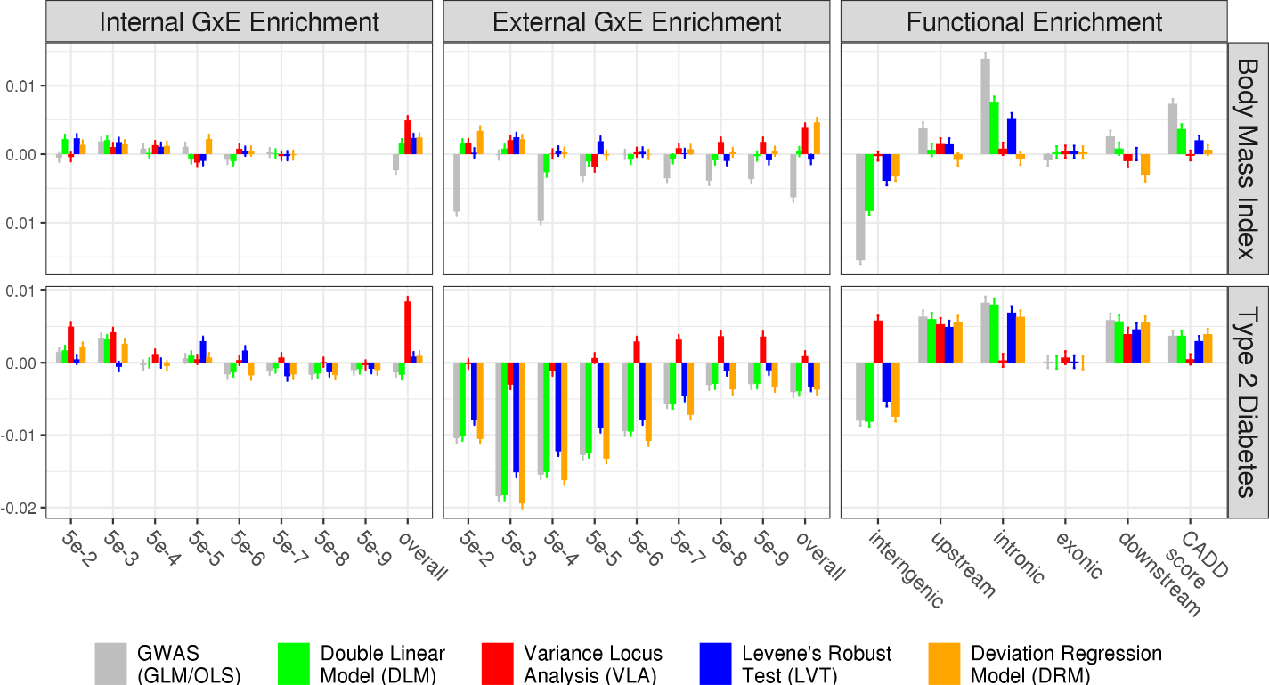

(a)
(c)
(d)
(b)

(f)
(e)
Figure 4: Empirical GxE and Functional Enrichment Analysis
top: results for body mass index (BMI); bottom: results for type 2 diabetes (T2D); (a)(b)(c)(d): GxE enrichment analysis, x-axis denotes the level of GxE significance by p-value used to score a SNP’s GxE activeness, “overall” means scoring a SNP by the sum of negative log p-values of GxE across all exposome items; the y-axis are GxE enrichment coefficient, higher means better statistical test; (e)(f): functional enrichment analysis, x-axis enumerate SNP labels, CADD score stands for “combined annotation dependent depletion” score, in this case, lower or higher enrichment is merely descriptive that does not suggest good or bad statistical test; the missing bars in (a) was due to the absence of significant GxE p-value for BMI reaching for 5e-8 and lower.

Notice for binary phenotype T2D, the GxE enrichment via DLM closely resemble GWAS (Figure 4b, gray and green), showing the fact that phenotypic mean loci are also variance loci for non-Gaussian phenotypes. As a result, the variance loci-based test statistic is nearly colinear with GWAS and redundant; to a lesser degree, such redundancies were also apparent for LVT and DRM at stricter GxE p-value thresholds. Taking the correlation between SNP rankings (i.e., 1 – p value) form GWAS and other tests as a measurement of redundancy, they were 0.985 for DLM, 0.613 for LVT, 0.8871 for DRM, and only 0.004 for VLA. In contrast, for quantitative phenotype BMI (Figure 4a), the 4 variance loci tests exert selection patterns distinct from GWAS. In this case, the correlation between the GWAS based ranking and the rest were 0.053 (DLM), 0.032 (LVT), 0.012 (DRM), and 0.007 (VLA).

External GxE Enrichment
We performed the same two-way GxE-WAS for T2D and BMI on an external discovery population of 4,603 unrelated individuals in PEGS with whole-genome sequencing data and diverse ancestry background (“PEGS: Personalized Environment and Genes Study” n.d.). Participants in PEGS underwent extensive questionnaires measuring a rich exposome of 728 items organized in 416 parent questions regarding daily life, home environment, and workplace hazards. Because the numerical scale of the exposome items is stable, of which 505 are binary, and 223 are positive integers less than 8, we retain the items in their original form when forming GxE terms with centered SNP dosage. The covariates for GxE-WAS included age, sex, income level, the first 10 principal components, and nominal variable coded ethnicity (European American, African American, Asian, and others). BMI also joined the covariates when T2D was analyzed. To rank the SNPs, we used GWAS, DLM, VLA, LVT and DRM test statistics based on 379,561 unrelated White Europeans in the UKBB (i.e., the larger of two selection populations).
After quality control, the White Europeans in UKBB and participants in PEGS shared a total of 8,331,313 SNPs with working MAF > 0.1 in the former (we did not enforce MAF threshold in PEGS). Again, we scored each SNP by the number of 2-way GxE p-values went below a series of p-value cut-offs (i.e., up to 728) and the overall sum of negative p-values, then regressed the scores on the rankings according to GWAS, DLM, VLA, LVT and DRM. We also provide exact values of the GxE external enrichment coefficients and standard error in supplement table s3b.
Figure 4c and 4d shows the external GxE enrichment coefficients (with standard errors). For BMI, SNPs ranked by VLA had the best chance of detecting highly significant GxE (p-value < 5e-7, …, 5e-9), and the second-best chance of detecting overall GXE (3.82, se=0.34) in PEGS. Interestingly, DRM, being by far the most conservative statistics for BMI (see the Manhattan plot in Figure 3a), gave the best overall enrichment (4.64, se=0.35) in PEGS. For T2D, only VLA enriched the detection of medium-to-highly significant GxE with p-values < 5e-6, …, 5e-9, and the overall GxE (0.89, se=0.34) in PEGS, while other tests showed negative coefficients (i.e., depletion) without exception. We notice, again, the coefficients of DLM closely follows the GWAS, and to a lesser degree, DRM as well, reflecting the fact that slope-based variance loci test tends to be redundant for binary phenotypes.
Comparing the GxE enrichment (Figure 4 a-d, Table s3a, s3bb) with the variance loci test statistics (Figure 3, Table s3), DRM and VLA did not produce as much significant loci as others yet gave the highest boost to GxE detection for BMI and T2D, respectively. It seems, while a Manhattan plot (Figure 3) highlighting the strongest signals, it does not reveal how different statistics ranked the bulk of loci differently. It seems two strategies should be considered when picking candidate SNPs, by a pre-defined p-value (or false discovery rate, FDR) cut-off, and SNPs ranked forward even if they did not necessarily pass the said threshold.

Functional enrichment Analysis
We are also interested in the enrichment from a functional perspective, that is, what kind of SNPs (i.e., exonic, intronic, intergenic, etc.) were overrepresented among the significant loci of a statistical test.
If SNPs prioritized by one of the tests are prone to have certain genomic function, the significant loci of that test should represent different types of SNPs unevenly. For example, GWAS loci are more frequent among SNPs in or near genes than between genes. We used ANNOVAR (K. Wang, Li, and Hakonarson 2010) to label each SNP as intergenic, upstream, intronic, exonic, or downstream variant. We also calculated the combined annotation dependent depletion (CADD) score (Kircher et al. 2014; Rentzsch et al. 2019) as a continuous measure of pathogenic tendency. We treated the functional labels as binary and CADD score as continues response variables, to regress on SNP rankings given by VLA, DLM, LVT, DRM, and GWAS. A positive significant coefficient means the variance loci are over-represented among SNPs of certain types or of higher CADD. We summarize the exact functional enrichment coefficients for BMI and T2D in supplement Table s3c and Figure 4e and 4f.
For both phenotypes, the most obvious is that all tests but VLA significantly underrepresented intergenic SNPs, while inside or near genes, none of the tests prioritize exonic SNPs.
For BMI, VLA tends to pick all types of SNPs evenly (Figure 4e, red); DRM is the only test under-selected downstream SNPs (i.e., near the end of a gene) (Figure 4e, orange); the other 3 tests prioritized intronic SNPs, and those with high CADD scores.
For T2D, only VLA distinguished itself by prioritizing intergenic SNPs (Figure 4f, red), while not prioritizing intronic SNPs or those with high CADD scores. Other 4 tests largely agreed with each other, which is no surprise given their redundancy regarding a binary phenotype.
Taking genome wide variance loci analysis (Figure 3, Table s2) and GxE enrichment analysis together (Figure 4e-f, Table s3c), it seems an effective variance loci test should attend SNPs not directly contributing to protein function. Also recall that VLA and DRM gave the best GxE enrichment for BMI (Figure 4a, c), and both showed no preference for high CADD scores here; VLA was the only test enriched GxE detection for T2D (Figure 4b, e), it is also the only one not prioritizing CADD and emphasizing SNPs outside of genes.

ABCB7
Among significant 2-way GxE-WAS results (p-value < 5e-8) for type 2 diabetes involving the top 10K VLA selected SNPs, 10 genes on or near these SNPs were found, which were: LINC02552, LINC02812, SLC25A3P1, LINC02812, SLC25A3P1, RNU6-61P, HNRNPA1P31, LINC01508, ABCB7, and BUD31P2 (TODO: tabulate these genes and the nearest top GxE).
In particular, the interaction involving SNPs in/near ABCB7 in Chromosome X, and PEGS items regarding “dyes inks and tonners” stands out. We show the localized Manhattan plot of ABCB7 in figure {?}.
led us to corroborative evidence of ABCB7’s differential expression among workers with occupational exposure to Inkjet printers, archived as GEO number GSE142351. We describe the selection of candidate genes and differential expression studies in “Results” and “Methods”.

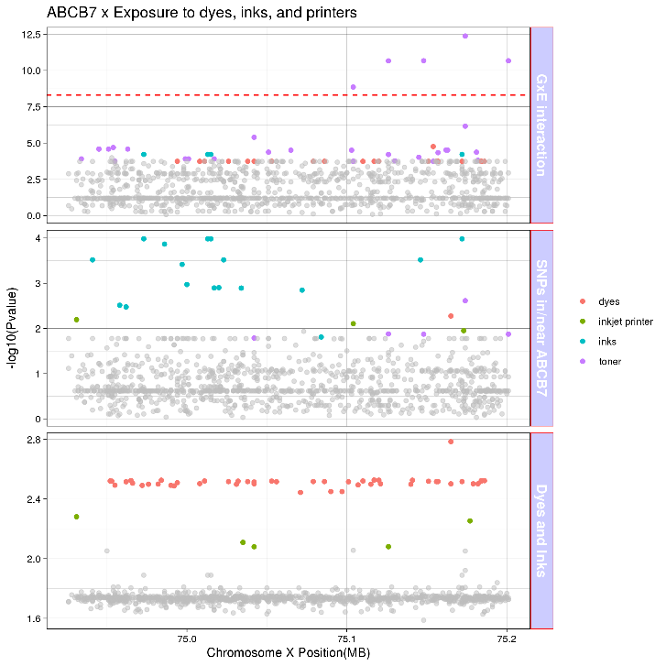
(re-design this plot)

UKBB variance loci catalog
Inspired by the Pan-UK Biobank GWAS catalog at pan.ukbb.broadinstitute.org, we created and host a catalog of variance loci statistics for UKBB phenotypes and variants on the NIEHS website (genelist.niehs.nih.gov). The catalog is a public resource that can be queried by phenotype, enabling researchers to prioritize candidate variants most likely to invoke significant GxEs. Figure 8 illustrates the workflow of creating the catalog and the query process.
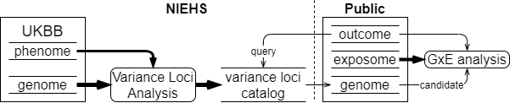We summarized 1,580 health-relevant phenotypes chosen from UKBB data fields accessible to NIEHS plus an additional 1,693 diseases derived from hospital records using PHECODE, a codebook for extrapolating diseases using ICD9/10 records (www.phewascatalog.org) (39, 40) for a phenome comprising 3,273 items. We distinguished the selected UKBB phenotypes into binomial, multinomial, ordinal, and continuous variables and subsequently recoded and normalized them. For the genome, we limited the variants to those with an overall minor allele frequency of at least 0.005, for a final number of 11,841,785 variants after quality control measures. The materials section provides details of these processes.
Figure 9: UKBB variance loci catalog workflow
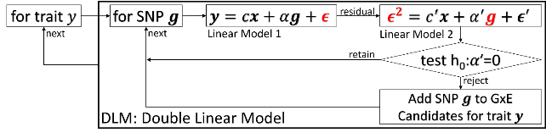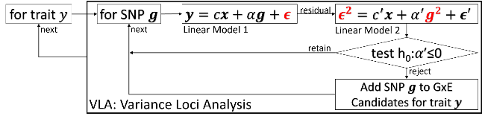
Figure 10: diagram of double linear model (DLM, left) and variance loci analysis (VLA, right)
For each of the four main racial/ethnic groups in the UKBB (British Whites, Irish, Blacks, and Asian), we performed VLA for the whole phenome and genome to archive variant statistics. We used the plinkFile and vla R packages to traverse the genome by window while scanning variance loci for thousands of phenotypes and variants. We divided the genome into approximately 1,200 groups of 10,000 variants each and summarized the VLA statistics for British Whites, which is the largest group in the UKBB, with a working sample size of 384,000 in 12 hours, using the NIH HPC Biowulf cluster (hpc.nih.gov).

Methods

Variance loci tests to Find GxE candidate SNPs
We started with DLM (double linear model, Figure 10 left), the most intuitive vQTL test. Given a quantitative treat, a SNP, and some covariates, DLM fits a GWAS linear model adjusting the covariates, treats the squared residual as a “new phenotype” and fits another GWAS linear model with the same SNP and covariates. If the SNP coefficient of linear model 2 is significant, we say the SNP is a vQTL, that is, a GxE candidate for that particular quantitative phenotype. Intuitively, the linear model 2 fits the squared distance from the fitted values of linear model 1 (i.e., conditional mean given the SNP and covariates), which amounts to modeling the phenotypic variance, since the mean of squared distance from the mean, is variance. The VLA (variance loci analysis, Figure 10 right) slightly modifies DLM: (1) the second linear model uses squared SNP and (2) perform a one-sided t-test assuming non-negative coefficient. For a binary trait, the rare event (i.e., disease) is coded as 1 and the covariates should choose from non-heritable predictors; there is no need to replace linear model 1 with GLM (i.e., logistic regression).
In addition, we created R-language wrapper functions for deviation regression model (DRM), Levene’s Robust Test (LVT) from R-package “car” (citation), and double generalized linear model (DGLM) from R-package “dglm” (citation). Because DGLM is unstable with small samples and slow to compute for large ones, we used DGLM as a benchmark in simulation studies only.
Lastly, we considered the traditional GWAS as a reference GxE candidate selector. We use PLINK2’s “--glm” routine to fit GWAS linear model for body mass index (BMI), and logistic regression for type 2 diabetes (T2D). We only included GWAS for GxE enrichment and functional enrichment analysis.
More detailed description of the statistical tests is in supplement S2.

2-way GxE-WAS
In a discovery cohort with normalized environment $u$ and standardized SNP $g$, GxE interaction effects are typically captured by adding a two-way product term $ug$ to a GWAS linear model,
$y=m_{0}+ag+bug+cu+dx+e$,
where $e$ is a vector of Gaussian noise and $x$ is the covariate; rejecting $h_{0}:b=0$ at a given p-value threshold suggest the GxE interaction between SNP $g$ and environment $u$. The above is repeated for all 2-way combinations of SNPs and environmental exposures, which, for PEGS, means a total of 14,874,008 x 765 models; for white non-British in the UKBB, the combination is 9,298,089 x 16. We exhaustively analyzed all the 2-way combination for demonstrative purpose, in an actual application, one should query the VLA-catalog and limit the GxE-WAS among top ranking SNPs or/and those blow a p-value threshold for shorter running time and mitigated multiple testing.

Find ABCB7
From the 14,874,008 x 765 2-way GxE-WAS test statistics based on PEGS, we first extract those with p-values less than 5e-4 (num), than joined the results with summaries from variance loci test statistics (i.e., DLM, VLA, LVT, DRM, and GWAS).
To test whether the expression in these top genes was modified by this exposure (GEO number GSE142351), we used gene expression data from a study that examined changes in gene expression with occupational printer exposure. In this study, blood was collected from female office workers in three groups: a control group (n=2), those exposed to inkjet printers (n=2), and those exposed to laser printers (n=7) at four time points, on each Monday and Friday of two subsequent weeks, and sequenced to determine mRNA expression. Samples from Mondays and sample from Fridays were each grouped together, with the assumptions that all participants worked a typical Monday-Friday workweek and that the same effects would be observable for any genes with expression changes on all Mondays or all Fridays.
Building on QC completed in Tuxedo, we removed gene IDs with less than two counts in five or more of the 33 samples (from nine participants at four time points) and used DESeq2 to obtain normalized gene counts, treating repeated measures for each subject as replicates. We performed filtering based on the gene list and conducted repeated measures linear regression for the 10 genes of interest. ABCB7 was the only gene expressed in this dataset, which is expected given that the others are pseudogenes or non-coding regions. Because there were no male controls, we used data only on females. Details of the QC and analysis are included in the Supplement. MAKE A STATEMENT OF SIGNIFICANCE BETWEEN EXPOSED AND UNEXPOSESD
The expression of ABCB7 is an interesting key finding.. ABCB7 is involved in metabolism and multi-drug resistance and is related to transport pathways of glucose and other sugars, bile salts and organic acids, metal ions, and amine compounds. Notably, the gene encodes a half-transporter involved in the transport of heme from the mitochondria to the cytosol. ABCB7 is also an ATP-dependent mitochondrial transporter implicated in Fe–S cluster assembly. Inherited mutations in ABCB7 have been linked to inherited and acquired sideroblastic anemia with cerebellar ataxia (18, 19), and the absence of ABCB7 impairs the maturation of cytosolic iron–sulfur proteins and induces iron accumulation in mitochondria. Further, knockdown of ABCB7 in HEK293T cells causes mitochondrial iron accumulation and the activation of SOD enzymes. This is important because iron and iron-regulatory proteins and cadmium alter ABCB7 expression, and some pigments in printer ink dyes, such as potash blue or soda blue pigments, contain iron based on ferro and ferric cyanides. Printer inks may also contain cadmium (20). Also of interest is the association of ABCB7 with fatty liver disease. This is notable because T2D is a major risk factor for fatty liver disease and could have common pathways (21, 22).

Materials

UK Biobank (UKBB) data
We used UKBB data to evaluate the performance of VLA is selecting GxE candidates and compare it with other methods. The UK Biobank is a large-scale resource consisting of genetic and health information for over half a million participants (Application ID: 57849, version 2) collected via questionnaires, electronic health records, biological samples, oral interviews, imaging, and genotype data. Details of this resource are included in the Supplement.

Genotype data
Using the imputed genotype, we created a comprehensive catalog of the whole genome. Beginning with 97,059,328 imputed variants from 487,411 individuals, we performed a series of quality control measures, after which 405,432 individuals with high-quality micro-array genotyping remained. We divided the remaining samples into five major ancestry groups—African (afr), non-Chinese Asian (asi), White British (bri), Irish (iri), and White but non-British (wnb)—and subsequently removed 29,440 individuals belonging to ethnic groups with a small sample size (e.g., Chinese with a sample size of 1574) or unclear ancestry, leaving 375,992 individuals from the original total (77.1% of 487,411 with imputed genotypes and 74.8% of the total 502,505). The afr, asi, bri, and iri groups serve as the basis of the NIEHS VLA Catalog, and the bri and wnb groups serve as training and testing datasets, respectively, for comparison of the performance of methods. Details of the quality control steps are provided in the Supplement.

Phenotype data
We manually compiled several phenotypes from baseline data collected at UKBB participants’ first visit, as summarized in Table 2. These phenotypes are type 2 diabetes, coronary artery disease, body mass index, and fasting glucose level. Details of how we compiled these phenotypes, including criteria and the UKBB data fields used, are included in the Supplement.

Environmental data
We collected 16 environmental variables in UKBB, which include the number of siblings (SIB), physical activity in metabolic equivalent minutes (MET), ever smoking (SMK), alcohol intake (ALC), neighborhood traffic (TRF), nitrogen oxide (NO1), nitrogen dioxide (NO2), particulate matter air pollution, 10μm (P10), particulate matter air pollution, 2.5μm (P25), and noise (NOI). We also included several neighborhood exposures in a 1000-m buffer around an individual’s home address, namely green space percentage (GSP), domestic garden percentage (DGP), water percentage (WTP), and natural environment percentage (NEP) and distance to the coast (SEA). Table 3 outlines the environmental variables, and the Supplement provides details on the methods and fields used to calculate the variables.

Phecodes
We derived phecodes for our analysis using phenotypes and disease diagnoses from electronic health record (EHR) data for UKBB participants recorded as International Classification of Diseases (ICD) codes. ICD codes are used to record medical diagnoses, signs and symptoms, abnormal findings, and injuries. Although more than 100 countries use ICD codes to track morbidity and mortality (41), they do not provide an appropriate level of granularity for phenotypes relevant for genetic association studies. Phecodes are manually curated groups of ICD codes aggregated into a distinct medical concept, disease, or phenotype intended to capture clinically meaningful concepts for research (40). Phecodes provide embedded case-control definitions based on exclusion criteria for controls, enabling the rapid characterization of large numbers of phenotypes. They are widely used for phenotyping participants with EHR data, especially for genetic association studies (40, 42). The use of phecodes in such studies produces superior results compared to ICD and Clinical Classification Software (CCS) codes. The Supplement provides details of our phecode mapping.
 | Description | N | Min | Median | Mean | Max | Histogram
BMI | Body mass index | 489955 | 18.0 | 26.7 | 27.4 | 48.0 | 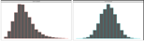
T2D | Type 2 diabetes | 493619 | 0.0 | 0.0 | 0.1 | 1.0 | 
Table 2. UK Biobank Phenotypes Used
The histogram shows distributions before and after normalization, the latter entered analysis.

 | Description | N | Min | Med | Mean | Max | 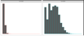  Histogram
ALC | Weekly alcohol intake | 427697 | 0.0 | 8.0 | 11.9 | 603.0
DGP | Domestic garden percentage | 440874 | 0.1 | 24.3 | 24.3 | 66.1 | 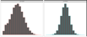  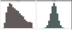
GSP | Green space percentage | 440874 | 4.4 | 41.5 | 45.0 | 99.2
MET | Metabolic equivalent minutes | 498628 | 0.0 | 1386.0 | 2553.7 | 125118.0 | 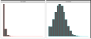
NEP | Nature environment percentage | 497542 | 0.0 | 36.6 | 40.5 | 100.0 | 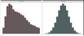
NO1 | Nitrogen oxide | 495124 | 19.7 | 42.4 | 44.1 | 265.9 | 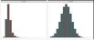  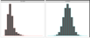
NO2 | Nitrogen dioxide | 495124 | 5.1 | 21.3 | 22.4 | 98.6 | 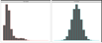
NOI | Noise | 495124 | 46.7 | 50.1 | 51.2 | 88.5
PM1 | Air pollution, PM10 | 495113 | 5.9 | 19.0 | 18.6 | 30.5 | 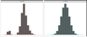
PM2 | Air pollution, PM2.5 | 461201 | 8.2 | 9.9 | 10.0 | 21.3 | 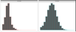
SDN | Sedentary behavior | 500967 | 0.0 | 4.0 | 4.5 | 48.0 | 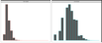
SEA | Distance to coast | 497542 | 0.0 | 44.0 | 41.6 | 108.0 | 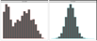  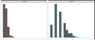
SIB | Number of siblings | 493402 | 0.0 | 2.0 | 2.2 | 44.0 | 
SMK | Ever smoke | 499620 | 0.0 | 1.0 | 0.6 | 1.0
TRF | Traffic intensity | 495124 | 0.8 | 78.2 | 172.6 | 100810.0 | 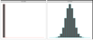  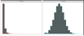
WTP | Water percentage | 440874 | 0.0 | 0.5 | 1.3 | 59.4
Table 3. UK Biobank Exposome (16 items)
The histograms show distributions before and after normalization, the latter entered analysis.

PEGS
The North Carolina-based Personalized Gene and Environment Study (PEGS) is a cohort of 19,672 participants of varying age, race, socioeconomic status, and education level. and whole-genome sequencing data for 4,610 individuals. Details of the cohort and genotyping are found in the supplement.

Exposome data
PEGS conducted extensive survey on 756 exposome items for 9,765 participants, divided into three parts. The General Health & Exposure survey (part C) collected information on general health, lifestyle, and occupational exposure information as well as individual and family medical histories (n=9,414); the extended external exposure survey (part A) requests information on exogenous exposures throughout life, including but not limited to chemical and environmental exposures at home and work (n=3,519); the extended internal exposure survey (Part B) requests information on endogenous exposures such as medication as well as lifestyle factors, including sleep patterns, stress, physical activity, and diet (n=2,962). The Supplement provides information on how the surveys were formulated.

Phenotype data
We derived T2D and BMI phenotype data from the General Health & Exposure survey. The Supplement provides information on cases / controls definitions and quality control.

Whole-genome sequencing
The PEGS provide Broad Institute sequenced genotype for 4,610 participants and conducted quality control, it also compared the number of variants identified for each PEGS participant to the number determined in a parallel analysis of the same data based on the hg19 genome assembly. The Supplement provides further details on all the sequencing and filtering steps.

Principal Components Analysis
The UKBB performed the principal components analysis for all genotyped individuals. Data field 22009 provides the first 40 principal components. For PEGS, we performed PCA using the pca command in PLINK2. Before removing any variants or samples as part of QC, we performed PCA with the original whole genome sequencing (WGS) data for 40,123,943 variants (38,528,374 in the autosomes) in 4,610 individuals.

Gene-Environment Interaction Analysis
For each environment e, genome variant g, outcome y, and some covariates X, we fitted model y = g + e + ge + X. We tested the significance of the coefficient on ge and kept the p-value. The term ge is the product of g and e. For the UKBB, g is one of the imputed variants, and e is one of the 16 environment exposures described in the Materials section. The covariates X are age, sex, the top 40 PCs, and the genotyping array used (i.e., BiLEVE or Axiom). Because the GxE analysis was conducted for non-British whites only, ethnicity is not included among the covariates. For PEGS, g is one of the WGS variants after quality control, e is one the 766 available environment exposures, and the covariates X are age, sex, self-identified ethnicity, and the top 20 PCs. The proportion of each self-identified ethnicity is: 2.19% Asian, 27.46% Black, 62.34 White, and 2.21% other, coded as 3 dummy variables in X.

Discussion
Using VLA, we scanned more than 11 million SNPs in the UKBB White British population and selected the top 1% most significantly associated with the variance of T2D status as candidates for GxEs. By querying the VLA catalog for T2D status in the UKBB Irish population, we narrowed down the candidates to fewer than 10,000 variants. Due to the compactness of candidate variants, it was statistically practical to search for significant GxEs for T2D among the more than 700 environmental exposures for which PEGS collected information. The significant GxEs pointed to genes associated with fatty liver disease and differentially expressed among individuals with ink, paint, and pesticide exposures, suggesting targets for intervention in the identified genes and in workplaces containing these materials. Considering ABCB7 as an exemplar gene, we validated our GxE analysis in the PEGS cohort.
GxE enrichment analysis results in both the internal discovery population of UKBB non-British Whites (Figure 6) and the external discovery population of PEGS participants (Figure 7) demonstrate the advantages of VLA in prioritizing GxE candidates for binary phenotypes such as T2D and CAD. The advantage is more pronounced for PEGS, as it contains a much wider range of involved environmental exposures (728 vs. 16 in the UKBB). The link between the phenotypic mean and variance of binary phenotypes renders the vQTL statistics obtained from DLM redundant to the QTL statistics obtained from GWAS, as demonstrated by the nearly overlapping enrichment curves of GWAS and vQTL for binary phenotypes (Figures 6 and 7, T2D and CAD, red and blue). For quantitative phenotypes, vQTL statistics indicate the method has greater power than GWAS to select GxE candidates, as demonstrated by varying enrichment curves for vQTL and GWAS (Figures 6 and 7, BMI and GLU, red and blue). vQTL is ideal for phenotypes that are nearly perfectly Gaussian, such as GLU. In this scenario, GWAS lacks power to select GxE candidates, as demonstrated by separation of the phenotypic mean and variance. For quantitative phenotypes that are not fully Gaussian, such as BMI, GWAS has some demonstrated ability to select GxE candidates because vQTL and QTL are somewhat related.
When treating GLU as a quantitative surrogate of T2D, the GWAS provided the best overall GxE candidate ranking based on statistics (Figure 7, panel 3, GLU/T2D). For T2D without a surrogate, GWAS provided better enrichment coefficients (e.g., 0.0125 at 10⁻²) than VLA (e.g., 0.0025 at 10⁻², Figure 7, panel 1, T2D). However, the choice of GLU as a surrogate for T2D depends on prior knowledge and subjective judgement (e.g., BMI is also a potential surrogate of T2D) and thus such a technique is unsuitable for automated GxE hypothesis exploration before weighting and choosing surrogates, which is also an automated process. Despite these limitations, we provide the GWAS p-values in addition to VLA p-values for each phenotype in the VLA catalog to allow surrogate GxE candidate rankings based on subjective knowledge of disease etiology.
VLA was initially proposed as an additive vQTL scanner that prioritizes pure GxE effects and improves on existing two-stage methods such as DLM, DRM and LVT concerning the quality of GxE candidates selected for quantitative traits. However, after transforming simulated Gaussian phenotypes to case/control status via a logistic function and Bernoulli sampling, VLA was consistently conservative while DLM, DRM, and LVT resulted in uncontrolled type 1 errors with non-zero genetic effects on the original Gaussian phenotypic mean. To address this, we scanned variance loci for binary phenotypes using VLA in conjunction with covariates. This approach is based on the concept that the adjusted binary phenotypes of covariates can be treated as new phenotypes that more clearly represent combined genotype and environment effects. vQTL scanners can be used with high-quality, quantitative covariates. To ensure control of type 1 errors with lower-quality covariates, we used the curve upwardness test for VLA. A combined DLM and VLA test for statistical power to detect variance loci was unable to control type 1 errors unless the covariates were perfect.
The best covariates are non-confounding predictors, which, in essence, are variables unaffected by the genotype or environment yet associated with the outcome. Such covariates have been shown to improve statistical power in GWAS and epidemiology studies (Aschard et al. 2015). If covariates are non-confounding, adjusting them neither removes the genetic or environmental effect on the phenotype nor creates spurious associations between the genotype/environment and the phenotype. For a covariate to be predictive, after removing the effect of the covariate, the adjusted phenotype becomes closer to the combined genotype/environment effect than the original phenotype. Recommend covariates are age and age², or more than three age bins (e.g., <20, 20-40, 40-60, >60 years), because age is unaffected by the genotype or environment but predictive of most diseases. Sex, age × sex, and age² × sex can also be used if a disease affects both sexes and the analysis is limited to autosomes.
If the genotype and the environment (e.g., pollution and climate) are considered precursors of all phenotypes, confounding predictors are either mediators or colliders linking the precursors and the outcomes. Adjusting either attenuates (for mediators) or inflates (for colliders) the genetic and environmental effects (Hernán et al. 2002). However, some confounding predictors are useful, including genetic principal components. Although the components are the weighted sum of common genome variants, the association between a component and a single variant is typically insignificant. A contrasting example is the use of BMI and socioeconomic status (SES) variables (e.g., income and education) as adjusted covariates in T2D studies. BMI can be both a mediator and a collider because it is both heritable and an indicator of T2D risk, and T2D onset can reversely affect BMI through changes in lifestyle. Accordingly, we did not include BMI and SES in the VLA scan in the UKBB White British population.
Using VLA as a GxE candidate scanner for binary phenotypes enables analysis of a large number of case/control outcomes collected in a sizable cohort such as the UKBB. Archive VLA statistics as a reference for research on the environmental genetic effects on health motivated creation of the NIEHS-hosted VLA Catalog. For binary phenotypes, a logit linked, iteratively optimized binomial linear model is typically chosen for association analysis due to its befitting interpretation of the odds ratio per additional allele and predicted probability, which never exceeds the range of the phenotype (i.e., 0=control, 1=case). In contrast, plain linear models optimizable in close form are adopted for two-stage VLA (i.e., ordinary least squares) because the priority is not interpretating odds ratios and predicting binomial probability but quickly ranking variants’ potential to invoke GxE effects for a phenotype. Additionally, the logit link function $f\left(x\right)={\left[exp\left(1+x\right)\right]}^{-1}$ is monotonic and closely approximated by the trivial identity link function $f\left(x\right)=x$ near $x=0$. Therefore, the significance and direction of a variant effect identified by a logit linked binomial linear model can also be recognized by a plain linear model. The simplicity of VLA allows the rapid ranking of variants for multiple phenotypes en masse, facilitating creation of the VLA Catalog based on rich phenome (3,237 phenotypes, of which 1,693 are binary) and genome data from the UKBB.
Despite the use of VLA to select candidate variants for GxEs, type 1 errors are still inflated in simulations with highly imbalanced case/control ratios and large allele effects on the phenotypic mean. In this scenario, VLA performs similar to GWAS based on statistics. Specifically, effects on the phenotypic mean become indistinguishable from effects on phenotypic variance, causing VLA to identify variants not involved in a GxE as variance loci. In practice, however, this issue is mitigated by the fact that for complex diseases like T2D and CAD, few if any variants exert clinically noticeable marginal effects, but tens of thousands of variants exert clinically weak but statistically significant effects. To demonstrate this phenomenon, we used GWAS to select the top 1% most significant autosome variants (p <0.01) and inspected the correlations between the p-values given by GWAS, VLA, and additive vQTL analysis (although vQTL is intended for quantitative phenotypes only). For T2D in the UKBB White British population, the correlation between GWAS and VLA was nearly 0 but 0.79 between GWA and vQTL analysis. For CAD, the correlation between GWAS and VLA was again nearly 0 but 0.85 between GWAS and vQTL analysis. The unrelatedness between GWAS and VLA statistics means the latter ranks variants differently from the former and thus offers a unique perspective in selecting GxE candidates. Conversely, the high correlation between GWAS and vQTL statistics means the latter is redundant concerning binary phenotypes. For quantitative phenotypes such as BMI, the correlation between GWAS and VLA is 0, and the correlation between GWAS and vQTL analysis is as low as 0.04, reflecting the fact that vQTL analysis is appropriate for quantitative traits only. Because the p-values for additive vQTL are close to p-values for GWAS, we set the latter to NaN for all 1,698 binary phenotypes in the VLA Catalog.
Besides serving as a reference database for gene-by-environment analysis, the VLA Catalog can also aid summary statistics-based analysis. In polygenic risk score (PRS)-based prediction, PRS is the sum of allele dosage in a discovery cohort weighted by GWAS statistics from a training cohort. Because VLA statistics are sufficiently distinct from GWAS statistics yet relevant to the phenotype of interest, they can be considered an alternative weight vector for calculating PRS. A discovery model can improve overall fit and subsequent prediction by using two PRS vectors based on GWAS and VLA, respectively, or better, by including additional vector products between VLA-based PRS and environments of interest. Since VLA-significant variants are more evenly distributed in the entire genome compared to GWAS-significant variants, using VLA for variant weights can enable pathway analysis to identify alternative sets of regions affecting a disease phenotype.
A next step is better countering type 1 errors caused by imbalanced outcomes (e.g., case/control outcomes) in a prospective cohort and Poisson-distributed phenotypes, where it is difficult to separate the allele effect on the mean and variance. In a simulation study, we dropped the intercept term in stage-1 VLA model, forcing it to recognize 0.5 as the mean of an imbalanced binary phenotype (i.e., 0=control, 1=case). Type 1 errors were controlled when the simulated GxE effect was null, but statistical power substantially decreased when the GxE effect was non-null. Another approach is including additional non-confounding predictive covariates to break up the underlying risk of a discrete trait into a finer gradient closely resembling a Gaussian variable. However, besides age and sex, there are few covariates universally collected by cohort studies guaranteed to be free of genetic and environment effects yet predictive of outcomes. In the future, however, we anticipate that GWAS, vQTL (for quantitative phenotypes), and VLA statistics will be included for genotyped cohorts as a common practice to facilitate science on genetic and environmental effects on health.
Aschard, Hugues, Bjarni J. Vilhjálmsson, Amit D. Joshi, Alkes L. Price, and Peter Kraft. 2015. “Adjusting for Heritable Covariates Can Bias Effect Estimates in Genome-Wide Association Studies.” The American Journal of Human Genetics 96 (2): 329–39.
Chang, Christopher. 2021. “PLINK Binary Biallelic Genotype Table.” June 2021. https://www.cog-genomics.org/plink/1.9/formats#bed.
———. 2022. “PLINK 2.0 Association Analysis: Option --Glm.” March 31, 2022. https://www.cog-genomics.org/plink/2.0/assoc#glm.
Consortium, 1000 Genomes Project. 2012. “An Integrated Map of Genetic Variation from 1,092 Human Genomes.” Nature 491 (7422): 56–65.
Consortium, 1000 Genomes Project and others. 2015. “A Global Reference for Human Genetic Variation.” Nature 526 (7571): 68.
Eichler, Evan E., Jonathan Flint, Greg Gibson, Augustine Kong, Suzanne M. Leal, Jason H. Moore, and Joseph H. Nadeau. 2010. “Missing Heritability and Strategies for Finding the Underlying Causes of Complex Disease.” Nature Reviews Genetics 11 (6): 446–50.
Hernán, Miguel A., Sonia Hernández-Díaz, Martha M. Werler, and Allen A. Mitchell. 2002. “Causal Knowledge as a Prerequisite for Confounding Evaluation: An Application to Birth Defects Epidemiology.” American Journal of Epidemiology 155 (2): 176–84. https://doi.org/10.1093/aje/155.2.176.
Kircher, Martin, Daniela M Witten, Preti Jain, Brian J O’roak, Gregory M Cooper, and Jay Shendure. 2014. “A General Framework for Estimating the Relative Pathogenicity of Human Genetic Variants.” Nature Genetics 46 (3): 310–15.
Marderstein, Andrew R., Emily R. Davenport, Scott Kulm, Cristopher V. Van Hout, Olivier Elemento, and Andrew G. Clark. 2021. “Leveraging Phenotypic Variability to Identify Genetic Interactions in Human Phenotypes.” The American Journal of Human Genetics 108 (1): 49–67.
Paré, Guillaume, Nancy R. Cook, Paul M. Ridker, and Daniel I. Chasman. 2010. “On the Use of Variance per Genotype as a Tool to Identify Quantitative Trait Interaction Effects: A Report from the Women’s Genome Health Study.” PLoS Genetics 6 (6): e1000981.
“PEGS: Personalized Environment and Genes Study.” n.d. National Institute of Environmental Health Sciences. Accessed November 14, 2021. https://www.niehs.nih.gov/research/clinical/studies/pegs/index.cfm.
Rentzsch, Philipp, Daniela Witten, Gregory M. Cooper, Jay Shendure, and Martin Kircher. 2019. “CADD: Predicting the Deleteriousness of Variants throughout the Human Genome.” Nucleic Acids Research 47 (D1): D886–94.
Tong, Xiaoran. 2022a. R-Package: (Github) PlinkFile (version 0.2.1). R. https://github.com/xiaoran831213/plinkFile.
———. 2022b. R-Package: Vla (Github) (version 0.1.0). R. https://github.com/xiaoran831213/vla.
Van Ijzendoorn, Marinus H, Marian J Bakermans-Kranenburg, Jay Belsky, Steven Beach, Gene Brody, Kenneth A Dodge, Mark Greenberg, Michael Posner, and Stephen Scott. 2011. “Gene-by-Environment Experiments: A New Approach to Finding the Missing Heritability.” Nature Reviews Genetics 12 (12): 881–881.
Wang, Huanwei, Futao Zhang, Jian Zeng, Yang Wu, Kathryn E Kemper, Angli Xue, Min Zhang, et al. 2019. “Genotype-by-Environment Interactions Inferred from Genetic Effects on Phenotypic Variability in the UK Biobank.” Science Advances 5 (8): eaaw3538.
Wang, Kai, Mingyao Li, and Hakon Hakonarson. 2010. “ANNOVAR: Functional Annotation of Genetic Variants from High-Throughput Sequencing Data.” Nucleic Acids Research 38 (16): e164–e164.
Wei, Wei-Qi, Lisa A. Bastarache, Robert J. Carroll, Joy E. Marlo, Travis J. Osterman, Eric R. Gamazon, Nancy J. Cox, Dan M. Roden, and Joshua C. Denny. 2017. “Evaluating Phecodes, Clinical Classification Software, and ICD-9-CM Codes for Phenome-Wide Association Studies in the Electronic Health Record.” PloS One 12 (7): e0175508.
Wu, Patrick, Aliya Gifford, Xiangrui Meng, Xue Li, Harry Campbell, Tim Varley, Juan Zhao, Robert Carroll, Lisa Bastarache, and Joshua C. Denny. 2019. “Mapping ICD-10 and ICD-10-CM Codes to Phecodes: Workflow Development and Initial Evaluation.” JMIR Medical Informatics 7 (4): e14325.

References
1. Eichler EE, Flint J, Gibson G, Kong A, Leal SM, Moore JH, et al. Missing heritability and strategies for finding the underlying causes of complex disease. Nat Rev Genet. 2010;11(6):446-50.
2. van Ijzendoorn MH, Bakermans-Kranenburg MJ, Belsky J, Beach S, Brody G, Dodge KA, et al. Gene-by-environment experiments: a new approach to finding the missing heritability. Nat Rev Genet. 2011;12(12):881; author reply
3. Cao Y, Wei P, Bailey M, Kauwe JSK, Maxwell TJ. A versatile omnibus test for detecting mean and variance heterogeneity. Genet Epidemiol. 2014;38(1):51-9.
4. Deng WQ, Asma S, Paré G. Meta-analysis of SNPs involved in variance heterogeneity using Levene's test for equal variances. Eur J Hum Genet. 2014;22(3):427-30.
5. Struchalin MV, Amin N, Eilers PH, van Duijn CM, Aulchenko YS. An R package "VariABEL" for genome-wide searching of potentially interacting loci by testing genotypic variance heterogeneity. BMC Genet. 2012;13:4.
6. Yang J, Loos RJ, Powell JE, Medland SE, Speliotes EK, Chasman DI, et al. FTO genotype is associated with phenotypic variability of body mass index. Nature. 2012;490(7419):267-72.
7. Paré G, Cook NR, Ridker PM, Chasman DI. On the use of variance per genotype as a tool to identify quantitative trait interaction effects: a report from the Women's Genome Health Study. PLoS Genet. 2010;6(6):e1000981.
8. Smyth GK. Generalized linear models with varying dispersion. Journal of the Royal Statistical Society: Series B (Methodological). 1989;51(1):47-60.
9. Lee Y, Nelder JA. Double hierarchical generalized linear models (with discussion). Journal of the Royal Statistical Society: Series C (Applied Statistics). 2006;55(2):139-85.
10. Rönnegård L, Felleki M, Fikse F, Mulder HA, Strandberg E. Genetic heterogeneity of residual variance - estimation of variance components using double hierarchical generalized linear models. Genet Sel Evol. 2010;42(1):8.
11. Rönnegård L, Valdar W. Detecting major genetic loci controlling phenotypic variability in experimental crosses. Genetics. 2011;188(2):435-47.
12. Marderstein AR, Davenport ER, Kulm S, Van Hout CV, Elemento O, Clark AG. Leveraging phenotypic variability to identify genetic interactions in human phenotypes. Am J Hum Genet. 2021;108(1):49-67.
13. Wang H, Zhang F, Zeng J, Wu Y, Kemper KE, Xue A, et al. Genotype-by-environment interactions inferred from genetic effects on phenotypic variability in the UK Biobank. Sci Adv. 2019;5(8):eaaw3538.
14. Brown MB, Forsythe AB. Robust tests for the equality of variances. Journal of the American Statistical Association. 1974;69(346):364-7.
15. Levene H. Robust tests for equality of variances. Contributions to probability and statistics Essays in honor of Harold Hotelling. 1961:279-92.
16. Bycroft C, Freeman C, Petkova D, Band G, Elliott LT, Sharp K, et al. The UK Biobank resource with deep phenotyping and genomic data. Nature. 2018;562(7726):203-9.
17. Sudlow C, Gallacher J, Allen N, Beral V, Burton P, Danesh J, et al. UK biobank: an open access resource for identifying the causes of a wide range of complex diseases of middle and old age. PLoS Med. 2015;12(3):e1001779.
18. Pain D, Dancis A. Roles of Fe-S proteins: from cofactor synthesis to iron homeostasis to protein synthesis. Curr Opin Genet Dev. 2016;38:45-51.
19. Allikmets R, Raskind WH, Hutchinson A, Schueck ND, Dean M, Koeller DM. Mutation of a putative mitochondrial iron transporter gene (ABC7) in X-linked sideroblastic anemia and ataxia (XLSA/A). Hum Mol Genet. 1999;8(5):743-9.
20. Podhajny RM. A Brief Chemistry Lesson On Printing Ink Pigments. Paper, Film & Foil Converter Magazine [Internet]. 2001. Available from: https://www.pffc-online.com/magazine/782-paper-brief-chemistry-lesson.
21. Silaghi CA, Silaghi H, Colosi HA, Craciun AE, Farcas A, Cosma DT, et al. Prevalence and predictors of non-alcoholic fatty liver disease as defined by the fatty liver index in a type 2 diabetes population. Clujul Med. 2016;89(1):82-8.
22. Lonardo A, Lugari S, Ballestri S, Nascimbeni F, Baldelli E, Maurantonio M. A round trip from nonalcoholic fatty liver disease to diabetes: molecular targets to the rescue? Acta Diabetol. 2019;56(4):385-96.
23. Xiao L, Shi XY, Li ZL, Li M, Zhang MM, Yan SJ, et al. Downregulation of LINC01508 contributes to cisplatin resistance in ovarian cancer via the regulation of the Hippo-YAP pathway. J Gynecol Oncol. 2021;32(5):e77.
24. Gui W, Zhu WF, Zhu Y, Tang S, Zheng F, Yin X, et al. LncRNAH19 improves insulin resistance in skeletal muscle by regulating heterogeneous nuclear ribonucleoprotein A1. Cell Commun Signal. 2020;18(1):173.
25. Wang J, Yang W, Chen Z, Chen J, Meng Y, Feng B, et al. Long Noncoding RNA lncSHGL Recruits hnRNPA1 to Suppress Hepatic Gluconeogenesis and Lipogenesis. Diabetes. 2018;67(4):581-93.
26. Liu D, Liu F, Li Z, Pan S, Xie J, Zhao Z, et al. HNRNPA1-mediated exosomal sorting of miR-483-5p out of renal tubular epithelial cells promotes the progression of diabetic nephropathy-induced renal interstitial fibrosis. Cell Death Dis. 2021;12(3):255.
27. Zhao M, Shen L, Ouyang Z, Li M, Deng G, Yang C, et al. Loss of hnRNP A1 in murine skeletal muscle exacerbates high-fat diet-induced onset of insulin resistance and hepatic steatosis. J Mol Cell Biol. 2020;12(4):277-90.
28. Wei WQ, Bastarache LA, Carroll RJ, Marlo JE, Osterman TJ, Gamazon ER, et al. Evaluating phecodes, clinical classification software, and ICD-9-CM codes for phenome-wide association studies in the electronic health record. PLoS One. 2017;12(7):e0175508.
29. Wu P, Gifford A, Meng X, Li X, Campbell H, Varley T, et al. Mapping ICD-10 and ICD-10-CM Codes to Phecodes: Workflow Development and Initial Evaluation. JMIR Med Inform. 2019;7(4):e14325.
30. Chang CC, Chow CC, Tellier LC, Vattikuti S, Purcell SM, Lee JJ. Second-generation PLINK: rising to the challenge of larger and richer datasets. Gigascience. 2015;4(1):s13742-015-0047-8.
31. Purcell S, Neale B, Todd-Brown K, Thomas L, Ferreira MA, Bender D, et al. PLINK: a tool set for whole-genome association and population-based linkage analyses. Am J Hum Genet. 2007;81(3):559-75.
32. Chang CC. Plink binary biallelic genotype table 2021 [Available from: https://www.cog-genomics.org/plink/1.9/formats#bed.
33. Abecasis GR, Auton A, Brooks LD, DePristo MA, Durbin RM, Handsaker RE, et al. An integrated map of genetic variation from 1,092 human genomes. Nature. 2012;491(7422):56-65.
34. Auton A, Brooks LD, Durbin RM, Garrison EP, Kang HM, Korbel JO, et al. A global reference for human genetic variation. Nature. 2015;526(7571):68-74.
35. National Institute of Environmental Health Sciences. Personalized Environment and Genes Study Data Freeze 1.1. 2021.
36. Wang K, Li M, Hakonarson H. ANNOVAR: functional annotation of genetic variants from high-throughput sequencing data. Nucleic Acids Res. 2010;38(16):e164.
37. Kircher M, Witten DM, Jain P, O'Roak BJ, Cooper GM, Shendure J. A general framework for estimating the relative pathogenicity of human genetic variants. Nat Genet. 2014;46(3):310-5.
38. Rentzsch P, Witten D, Cooper GM, Shendure J, Kircher M. CADD: predicting the deleteriousness of variants throughout the human genome. Nucleic Acids Res. 2019;47(D1):D886-d94.
39. Wei W-Q, Bastarache LA, Carroll RJ, Marlo JE, Osterman TJ, Gamazon ER, et al. Evaluating phecodes, clinical classification software, and ICD-9-CM codes for phenome-wide association studies in the electronic health record. PLOS ONE. 2017;12(7):e0175508.
40. Wu P, Gifford A, Meng X, Li X, Campbell H, Varley T, et al. Developing and Evaluating Mappings of ICD-10 and ICD-10-CM codes to Phecodes. BioRxiv. 2019;
:462077.
41. World Health Organization. International Statistical Classification of Diseases and Related Health Problems (ICD) 2021 [Available from: https://www.who.int/standards/classifications/classification-of-diseases.
42. Bastarache L. Using Phecodes for Research with the Electronic Health Record: From PheWAS to PheRS. Annual Review of Biomedical Data Science. 2021;4(1):1-19.

