Supplemental Materials

1. Simulation
This section details the generation of phenotypes of various distribution with or without variance loci. For each scenario, we start with a minimum sample size of N=16 (i.e., 2⁴), doubling it until N=65,536 (i.e., 2¹⁶), for each scenario and each sample size 20,000 times.

Acquire components
Each repeat of the simulation required the following components.

Vector of genotype, $g$
In each repeat, we randomly acquire a single variant from genome region 17q3 (chromosome 17, between base-pair 10,700,001 to 16,000,000) of the 1000 Genomes Project, with an MAF no less than 0.01 and 1,807 unrelated samples (of a total 2,502 provided by Phase 3).
From the 1,807 bi-allelic genotype values (i.e., AA, Aa, and aa), we sample with replacement until the desired sample size N (i.e., 2⁴, 2⁵ … 2¹⁶) is reached and save the values as the vector of genotype g. We coded the genotype values as alternative allele dosages: AA=0, Aa=1, and aa=2.
We used R-package simgen (located on GitHub repository https://github.com/xiaoran831213/simgen) to determine genotype vector g.

Vector of environment, $u$
In each repeat, we draw a vector of environmental exposures from a normal distribution until the desired N is reached and save the values as the vector of environment u:
$$u_{i}\overset{\text{i.i.d}}{\sim }N\left(0,1\right), i=(1…N)$$

Vector of covariate, $x$
In each repeat, we draw a vector of covariate from a normal distribution until the desired N is reached and save the values as the vector of covariate x:
$$x_{i}\overset{\text{i.i.d}}{\sim }N\left(0,1\right), i=(1…N)$$

Vector of GxE interaction, $ug$
In each repeat, after acquiring the vector of genotype g and environment u with sample size N, we acquire the element-wise product, ug, as the vector of gene-by-environment interaction:
$${(ug)}_{i}=u_{i}g_{i}, i=(1…N)$$

Scenarios with Gaussian phenotype
In each repeat, given the vector of allele dosage genotype g, the vector of environment u, the vector of covariate x, and the vector of GxE interaction ug, we generate a Gaussian phenotype either additively or multiplicatively which give rise to either additive or multiplicative variance loci.

Additive Gaussian Phenotype
For each sample size N, we generate a Gaussian phenotype with the additive GxE model in equation (1)
$$y_{i}=m_{0}+ag_{i}+b{\left(ug\right)}_{i}+cu_{i}+dx_{i}+ e_{i}, e_{i}\overset{\text{i.i.d}}{\sim }N\left(0,v_{e}\right), i=1…N \\ a\sim N\left(0,v_{a}\right), b\sim N\left(0,v_{b}\right), c\sim N\left(0,v_{c}\right), d\sim N\left(0,v_{d}\right)$$
where the phenotype of the $i$ th individual is the sum of the grand mean $m_{0}$, the genotype main effect of $g_{i}$ with effect size $a$, the GxE interaction effect of ${\left(ug\right)}_{i}$ with effect size $b$, the environmental main effect $u_{i}$ with effect size $c$, the covariate effect of $x_{i}$ with effect size $d$, and random Gaussian white noise $e_{i}$.
The effect sizes $\{a,b,c,d\}$ are drawn from normal distributions of mean zero at the beginning of each repeat and used to generate all N samples (i=1 … N) for that particular repeat; the grand mean $m_{0}$, the variance of the aforementioned unit effect sizes $\{v_{a},v_{b},v_{c},v_{d}\}$, and the variance of white noise $v_{e}$ are pre-determined by the scenario to be simulated and are fixed throughout all 20,000 repeats.
Two scenarios involve additively generated Gaussian phenotype, one with coexisting environmental main effect and GxE effect, one with pure GxE effect. The two scenarios used the following parameters:
- $m_{0}=0:$ grand mean
- $v_{a}=0.5$: variance of genotype main effect $a$
- $v_{b}=1.0$: variance of GxE interaction effect $b$ (when not null)
- $v_{c}$: variance of environmental main effect $c$
  - $v_{c}=0.5$: coexisting environmental main effect and GxE effect
  - $v_{c}=0.0$: pure GxE effect
- $v_{d}=1:$ variance of covariate effect d
- $v_{e}=1:$ variance of white noise
When additively generated phenotype $y$, along with genotype $g$ and covariate $x$ were presented as if environment $u$ was unobserved, $g$ is an additive variance locus when $v_{b}≠0$. We also generate two corresponding scenario of null variance loci by setting $v_{b}=0$.

Multiplicative Gaussian Phenotype
For each sample size N, we also generate the phenotype according to the Gaussian multiplicative model in equation (5)
$y_{i}\sim N\left(m_{0}+ag_{i}+dx_{i},e^{μ+αg_{i}+βg_{i}^{2}}\right), i=1…N$
In this case, the grand mean $m_{0}$ and genotype main effect $a$ act in the same way as the additive scenarios but the vector of environment $u$ is unused. The parameter $μ$ is the size of non-genetically determined phenotypic variance in log scale, including environmental and white noise; the parameter $α$ and $β$ determine the link between genotype and phenotypic variance in log scale. When either $α$ or $β$ is non-zero, genotype $g$ becomes a multiplicative variance locus by definition. For simplicity, we fixed $β$ to 0. To choose $μ$ and $α$, we saved $l_{0}=\log\left(v_{e}+v_{c}\right)$, the variance of the additively generated phenotype in log scale without GxE interaction; we also saved $l_{1}=\log\left(v_{e}+v_{c}+v_{b}v_{g}\right)$, the variance of additively generated phenotype in log scale with GxE effect, where $v_{g}$ is the genotype variance, or $4×MAF×(1-2×MAF)$. Next, we let the following had an equal chance to happen
$$μ=l_{0}, α=\frac{1}{2}\left|l_{1}-l_{0}\right| or μ=l_{1}, α=-\frac{1}{2}\left|l_{1}-l_{0}\right|$$where the latter, phenotypic variance shrinks with each additional allele, corresponding to a latent additive GxE model with squared GxE effect ${\hat{b}}^{2}<0$. As stated in the methods, VLA is powerless when GxE effect $b$ is not real, so we expect VLA to underperform in detecting variance loci for multiplicatively generated phenotypes.
The above steps ensure the multiplicatively generated phenotype share similar numerical scale with the additively generated phenotype and has a null multiplicative variance locus when the additively generated phenotype has null GxE effect (i.e., $v_{b}=0$) since in the latter case $l_{0}=l_{0}=\log\left(v_{e}+v_{c}\right)$ and $α=0$. We used the following parameters to multiplicatively generate a Gaussian phenotype:
- $m_{0}=0$: grand mean.
- $v_{a}=0.5$: variance of genotype main effect $a$.
- $v_{d}=1$: variance of covariate effect $d$.
- $μ:$ phenotypic variance not determined by genotype, in log scale
  - $μ=0.405$ when $α≥0$ and $0.733$ when $α<0$,
  - numerically corresponds to $v_{c}=0.5$ and $v_{e}=1.0$ in an additive scenario
- $α$: effect of genotype on phenotypic variance, in log scale
  - $α=+0.164$, multiplicative variance locus exists, numerically corresponds to $v_{b}=+1.0$, which is proper for an additive scenario
  - $α=-0.164$, multiplicative variance locus exists, numerically corresponds to $v_{b}=-1.0$, which is improper for an additive scenario
  - $α=0.0$, null multiplicative variance locus, corresponding to $v_{b}=0$.
- $β=0$: change of squared phenotypic variance per allele, in log scale
With the parameters, we drew phenotype $y$ from the normal distribution and present it along with genotype $g$ and covariate $x$.
We simulated 6 scenarios for the Gaussian phenotype, listed below with parameters.
Gaussian phenotype | Variance locus? | Additive | Multiplicative
Coexisting environmental main effect and GxE | Yes | $$m_{0}=0, v_{a}=0.5, v_{b}=1.0,$$  $$v_{c}=0.5,v_{d}=1.0,v_{e}=1.0$$ | $$m_{0}=0, v_{a}=0.5,v_{d}=1.0,$$  $β=0, μ=0.405, α=0.164$,  or $μ=0.733, α=-0.164$
Coexisting environmental main effect and GxE | Null | $$m_{0}=0, v_{a}=0.5, v_{b}=0.0,$$  $$v_{c}=0.5,v_{d}=1.0,v_{e}=1.0$$ | $$m_{0}=0, v_{a}=0.5,v_{d}=1.0,$$  $$β=0,μ=0.405, α=0.0$$
Pure GxE | Yes | $$m_{0}=0, v_{a}=0.5, v_{b}=1.0, \\ v_{c}=0.0,v_{d}=1.0,v_{e}=1.0$$ | (Not simulated)
Pure GxE | Null | $$m_{0}=0, v_{a}=0.5, v_{b}=0.0, \\ v_{c}=0.0,v_{d}=1.0,v_{e}=1.0$$ | (Not simulated)

Scenarios involving Binary phenotype
To simulate a vector of binary phenotype $y$, we first generate a vector of Gaussian signal $η$ either additively or multiplicatively as the previous section, then convert $η$ to probabilities of disease onset with logistic function, and finally, we randomly drew 1 = case and 0 = control as phenotype from one-trail binomial distribution (i.e., Bernoulli trial) with the said probabilities of disease onset, that is,
$$y_{i}\sim binomial\left(n=1, p=π_{i}\right), π_{i}={\left(1+e^{-η_{i}}\right)}^{-1}, i=1…N$$
We manipulated the grand mean $m_{0}$ of the Gaussian signal $η$ to engineer rarity of the resulting binary phenotype, such that $m_{0}=0$ gives balance case/control ratio and $m_{0}=-2.5$ gives a prevalence of 7.6% which is close to the rate of type 2 diabetes in the UK Biobank. We enlarged the variance of GxE and environmental main effect to $v_{b}=2.0$ and $v_{c}=1.0$, and shrunk the variance of noise to $v_{e}=0.1$ so the genetic and environmental effect are more pronounced; we also enlarged the variance of covariate effect to $v_{d}=4$ since covariate adjustment is crucial in restoring statistical power for binary phenotypes; lastly, we reduce the variance of genotype main effect to $v_{a}=0.1$ so all methods are still challenged to distinguish the genetic effect on phenotypic mean from variance, but not diminishing their difference in performance. The simulation parameters for binary phenotypes are shown below,
Binary phenotype | Variance locus? | Additive | Multiplicative
Coexisting environmental main effect and GxE | Yes | $m_{0}=\left\{0, -2.5\right\}$,$$v_{a}=0.1, v_{b}=4.0, v_{c}=2.0,$$  $$v_{d}=4.0,v_{e}=0.1$$ | $m_{0}=\left\{0, -2.5\right\}$,  $$v_{a}=0.1,v_{d}=4.0,β=0$$  $μ=0.710, α=0.100$,  or $μ=0.911, α=-0.100$
Coexisting environmental main effect and GxE | Null | $m_{0}=\left\{0, -2.5\right\}$,  $$v_{a}=0.1, v_{b}=0.0,v_{c}=0.5,$$  $$v_{d}=4.0,v_{e}=0.1$$ | $m_{0}=\left\{0, -2.5\right\}$,  $$v_{a}=0.1,v_{d}=4.0,β=0$$  $$μ=0.710, α=0.0$$
Pure GxE | Yes | $m_{0}=\left\{0, -2.5\right\}$,  $$v_{a}=0.1, v_{b}=4.0,v_{c}=0.0,$$  $$v_{d}=4.0,v_{e}=1.0$$ | (Not simulated)
Pure GxE | Null | $m_{0}=\left\{0, -2.5\right\}$,  $$v_{a}=0.1, v_{b}=0.0,v_{c}=0.0,$$  $$v_{d}=4.0,v_{e}=1.0$$ | (Not simulated)
A total of 12 scenarios were simulated, which is two times of the Gaussian phenotypes because we varied the ground mean $m_{0}$ in $\left\{0, -2.5\right\}$ to create imbalanced case / control ratio. In addition, we simulated another set of 12 scenarios for binary phenotype where the GxE effect were nullified.

Scenarios involving Poisson phenotypes
In a similar fashion, we simulated Poisson phenotype $y$ by passing the Gaussian signal $η$ into exponent function for a rate value, then drew counts from Poisson distribution of the said rate.
$$y_{i}\sim Poisson\left(λ_{i}\right), λ_{i}=e^{η_{i}}, i=1…N$$
In this case, the grand mean $m_{0}$ of the Gaussian signal $η$ determines the proportion of zeros in the converted counts, where $m_{0}=0$ gives in 37% zeros and $m_{0}=-2.5$ gives 92%.
We kept the simulation parameters mostly the same with Gaussian case but reduced the variance of genotype main effect and noise to 0.1. The simulation parameters are shown below
Poisson phenotype | Variance locus? | Additive | Multiplicative
Coexisting environmental main effect and GxE | Yes | $m_{0}=\left\{0, -2.5\right\}$,$$v_{a}=0.1, v_{b}=1.0,v_{c}=0.5,$$  $$v_{d}=1.0,v_{e}=0.1$$ | $$m_{0}=\left\{0, -2.5\right\},$$  $$v_{a}=0.5,v_{d}=1.0,β=0,$$  $μ=-0.440, α=0.288$,  or $μ=0.135, α=-0.288,$
Coexisting environmental main effect and GxE | Null | $m_{0}=\left\{0, -2.5\right\}$,  $$v_{a}=0.1, v_{b}=0.0,v_{c}=0.5,$$  $$v_{d}=1.0,v_{e}=0.1$$ | $m_{0}=\left\{0, -2.5\right\}$,  $$v_{a}=0.5,v_{d}=1.0,β=0$$  $$μ=-0.440, α=0.0$$
Pure GxE | Yes | $m_{0}=\left\{0, -2.5\right\}$,$$v_{a}=0.1, v_{b}=1.0,v_{c}=0.0,$$  $$v_{d}=1.0,v_{e}=0.1$$ | (Not simulated)
Pure GxE | Null | $m_{0}=\left\{0, -2.5\right\}$,  $$v_{a}=0.1, v_{b}=0.0,v_{c}=0.0,$$  $$v_{d}=1.0,v_{e}=0.1$$ | (Not simulated)

Execution and summary of simulations
Once a scenario is decided, the parameters, and phenotype converters were given, in each of the 20,000 repeats we do the following
- Data generation
  - Acquire vector of genotype $g$, environment $u$, and covariate $x$.
  - Draw effect sizes $\{a, b,c,d\}$ from normal distribution of mean 0 and variances $\{v_{a}, v_{b},v_{c},v_{d}\}$.
  - Draw vector of noise $e$ from normal of mean 0 and variance $v_{e}$.
  - Generate vector of phenotype $y$
    - either additively, as $y_{i}=m_{0}+ag_{i}+b{\left(ug\right)}_{i}+cu_{i}+dx_{i}+ e_{i}$
    - or multiplicatively, as $y_{i}\sim N\left(m_{0}+ag_{i}+dx_{i},e^{μ+αg_{i}+βg_{i}^{2}}\right)$
- Present data $\{y,x,g\}$ to various statistical tests:
  - DLM: double linear model
  - VLA: variance locus analysis, the proposed method
  - LVT: Levene’s robust test of heterogeneous variance
  - DRM: deviation regression model
  - DGLM: double generalized linear model
- Collect the p-values of the primary test statistics from the above methods.
In all scenarios, we fixed the size of statistical test at 0.05, that is, rejecting the null hypothesis $h_{0}$: the genotype $g$ is not a variance locus of phenotype $y$, when the p-value for a method is below 0.05.
When a scenario allows variance loci, the proportion of times rejecting $h_{0}$ among 20,000 repeats shows a method’s power, or true positive rate. Conversely, when a scenario has null variance loci, the number of times rejecting $h_{0}$ in 20,000 repeats shows a method’s type 1 error, or false positive rate. We also calculate the net positive rates as the true positive rate of each non-null scenario minus the false positive rate of the corresponding null scenario. Figures s1-s3 present the results across the sample sizes for each scenario.
For binomial phenotypes, the presentation is divided into 2 groups corresponding to the grand mean $m_{0}$. The first group shows the results of balanced case rate (50%), followed by results of imbalanced case rate (7.8%). Each group present 6 scenarios similar to the Gaussian scenarios. For Poisson phenotypes, the layout is the same as binomial phenotypes.

Results and scripts
In this section we present performance of various variance loci tests by the distribution of phenotypes. We used R scripts to generate phenotype, execute and summarize the simulation in figures. The GitHub link to the corresponding script is under each figure.

Gaussian phenotype
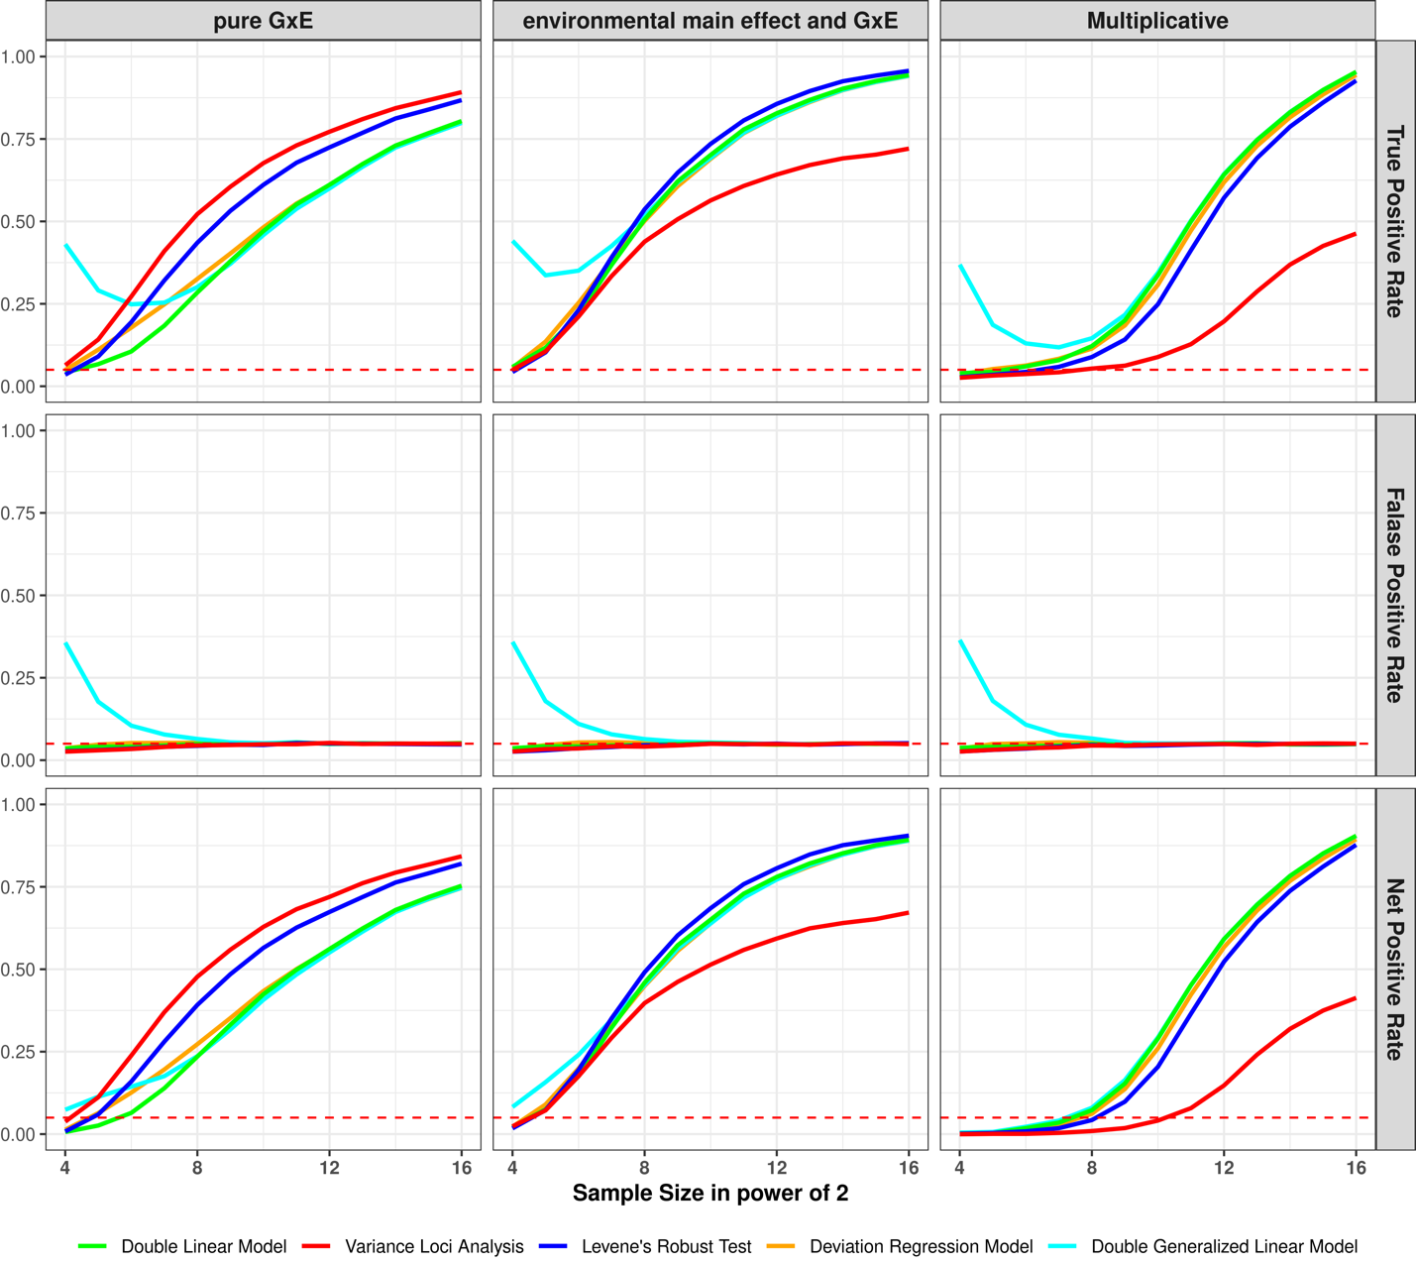Figure s1a: performance on simulated Gaussian phenotype
top row: y-axis is true positive rate (a.k.a., power); middle row: y-axis is false positive rate (a.k.a., type 1 error); bottom row: y-axis is net positive rate (true positive – false positive); left columns (pure GxE): variance loci were additively induced by GxE, without environmental main effect; middle column (environmental main effect and GxE): variance loci were additively induced by GxE locus, with coexisting environmental main effect; right column (multiplicative): variance loci were multiplicative; colored solid lines: variance loci tests; red dashed line: expected false positive rate at the size of hypothesis testing (0.05).
<place holder: links to the R-script>

Binary phenotype, 50% cases
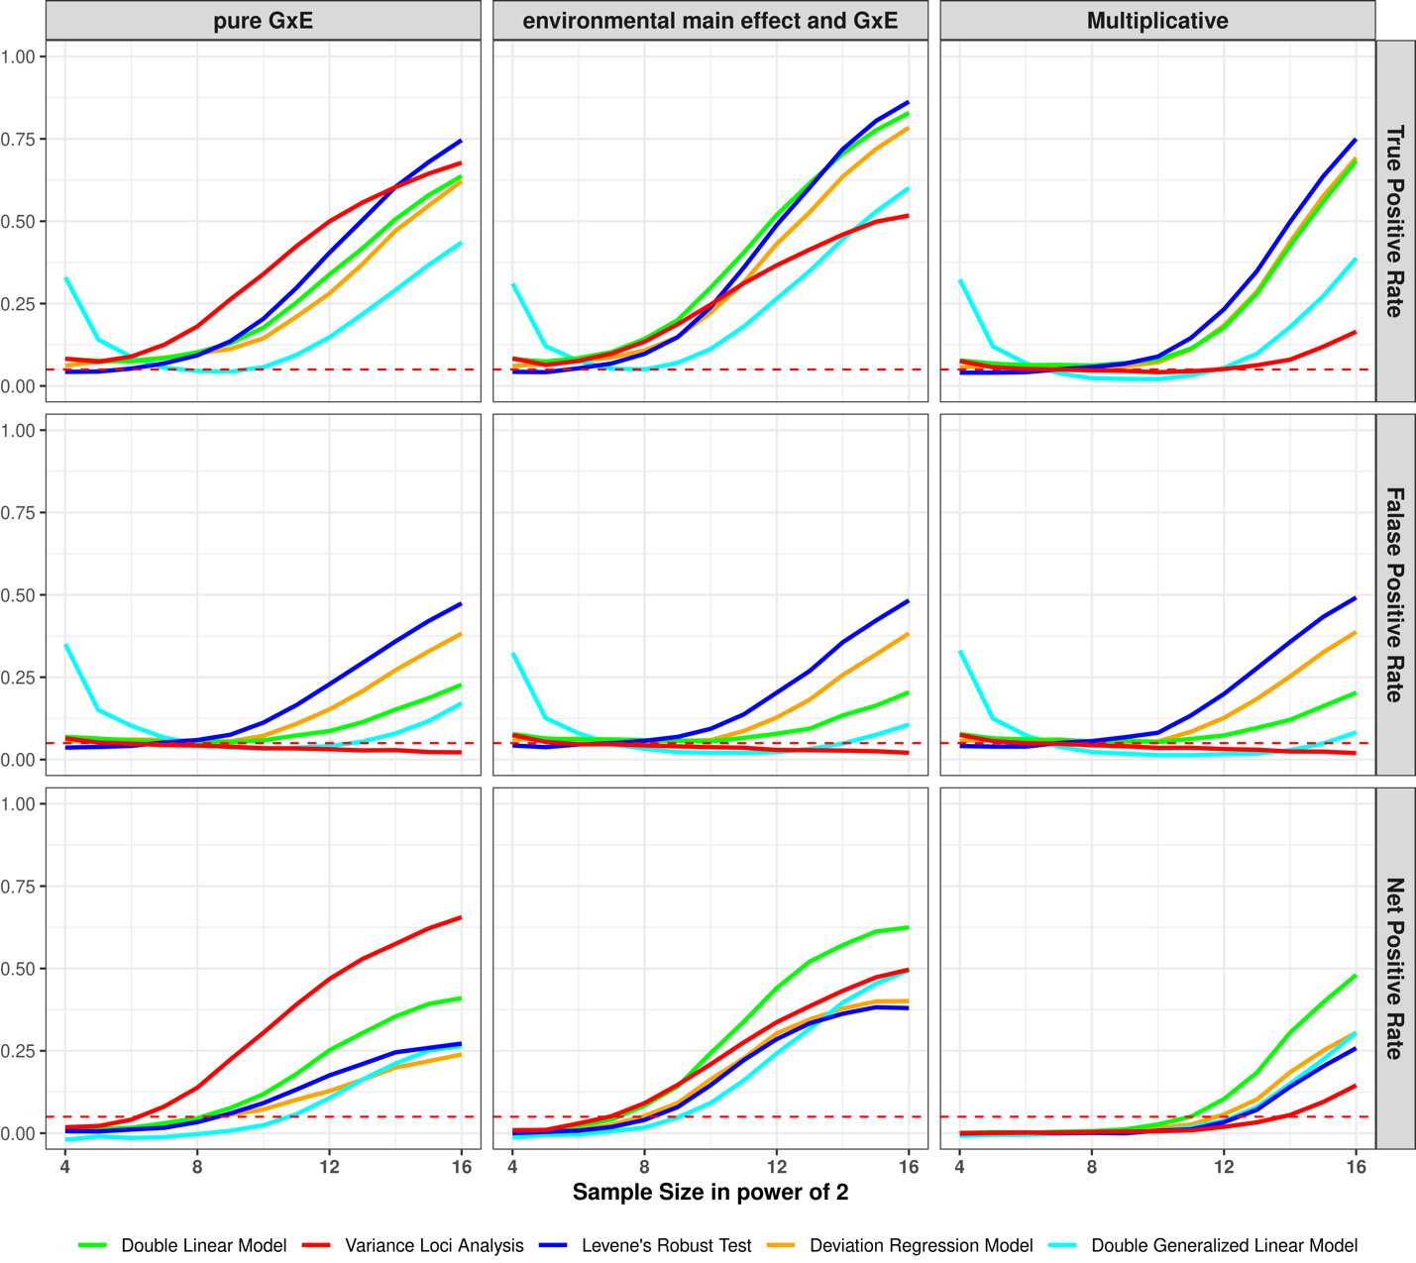
Figure s1b: Performance on simulated binary phenotype with balanced case rate (50%)
top row: y-axis is true positive rate (a.k.a., power); middle row: y-axis is false positive rate (a.k.a., type 1 error); bottom row: y-axis is net positive rate (true positive – false positive); left columns (pure GxE): variance loci were additively induced by GxE, without environmental main effect; middle column (environmental main effect and GxE): variance loci were additively induced by GxE locus, with coexisting environmental main effect; right column (multiplicative): variance loci were multiplicative; colored solid lines: variance loci tests; red dashed line: expected false positive rate at the size of hypothesis testing (0.05).
<place holder: links to the R-script>

Binary phenotype, 12% cases
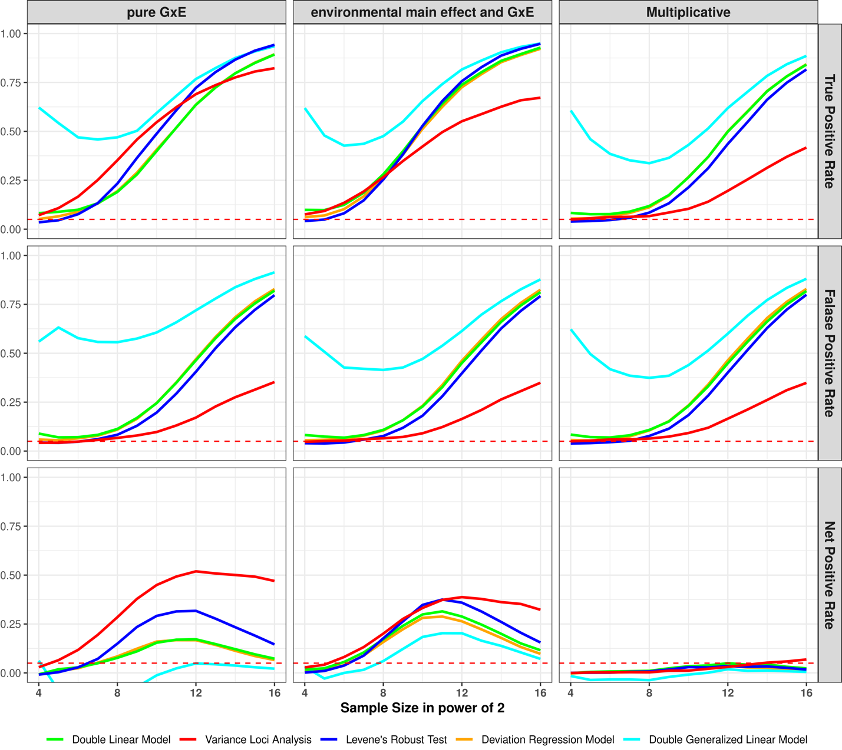
Figure s1c: Performance on simulated binary phenotype with imbalanced case rate (7.8%)
top row: y-axis is true positive rate (a.k.a., power); middle row: y-axis is false positive rate (a.k.a., type 1 error); bottom row: y-axis is net positive rate (true positive – false positive); left columns (pure GxE): variance loci were additively induced by GxE, without environmental main effect; middle column (environmental main effect and GxE): variance loci were additively induced by GxE locus, with coexisting environmental main effect; right column (multiplicative): variance loci were multiplicative; colored solid lines: variance loci tests; red dashed line: expected false positive rate at the size of hypothesis testing (0.05).
<place holder: links to the R-script>

Poisson phenotype, 37% zeros
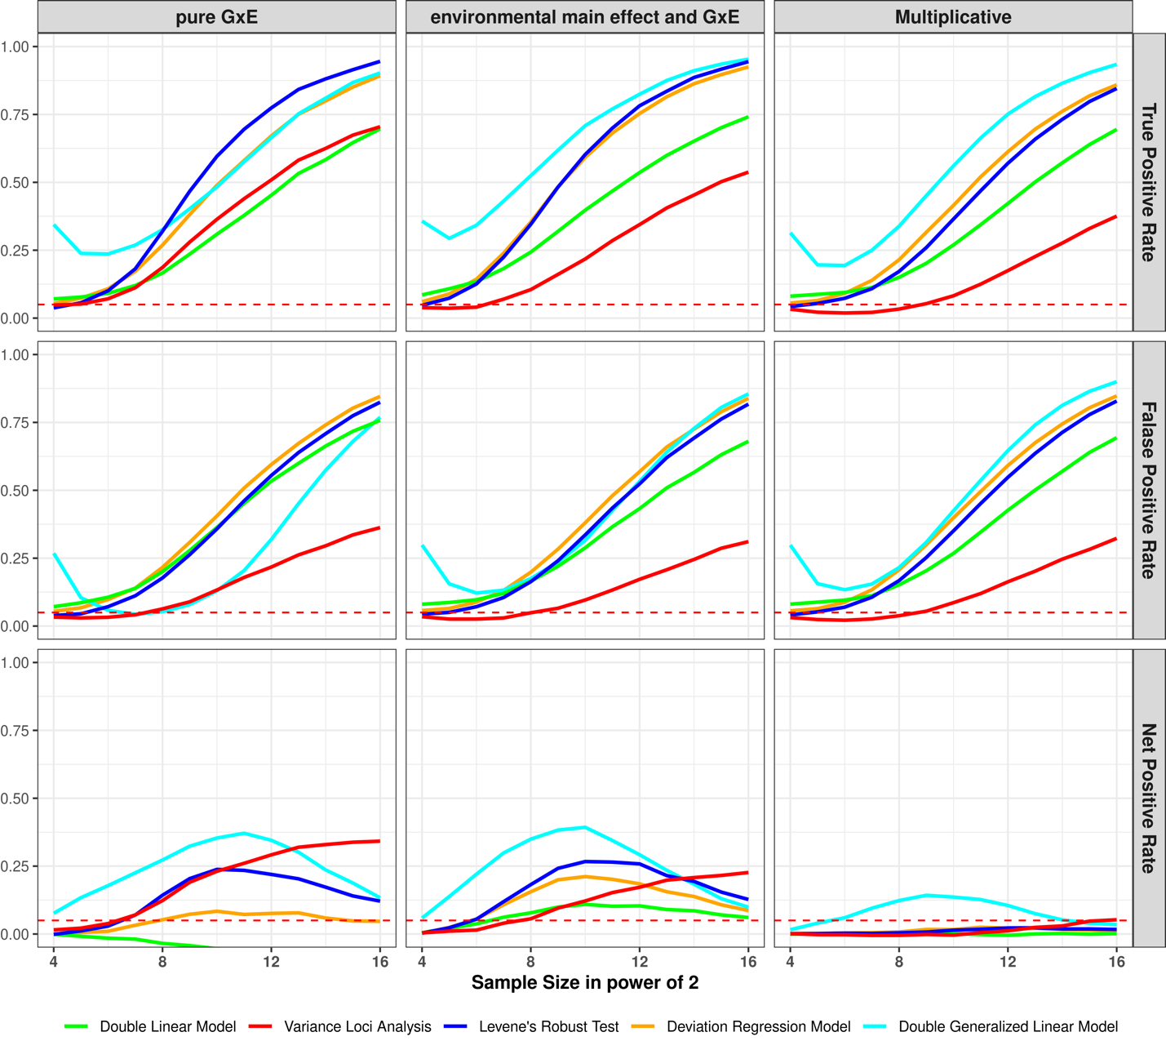 Figure s1d: Performance on simulated Poisson phenotype with moderate number of zeros (37%)
top row: y-axis is true positive rate (a.k.a., power); middle row: y-axis is false positive rate (a.k.a., type 1 error); bottom row: y-axis is net positive rate (true positive – false positive); left columns (pure GxE): variance loci were additively induced by GxE, without environmental main effect; middle column (environmental main effect and GxE): variance loci were additively induced by GxE locus, with coexisting environmental main effect; right column (multiplicative): variance loci were multiplicative; colored solid lines: variance loci tests; red dashed line: expected false positive rate at the size of hypothesis testing (0.05).

Poisson phenotype, 92% zeros
Figure s1d: Performance on simulated Poisson phenotype with high number of zeros (92%)
top row: y-axis is true positive rate (a.k.a., power); middle row: y-axis is false positive rate (a.k.a., type 1 error); bottom row: y-axis is net positive rate (true positive – false positive); left columns (pure GxE): variance loci were additively induced by GxE, without environmental main effect; middle column (environmental main effect and GxE): variance loci were additively induced by GxE locus, with coexisting environmental main effect; right column (multiplicative): variance loci were multiplicative; colored solid lines: variance loci tests; red dashed line: expected false positive rate at the size of hypothesis testing (0.05).

2. Genome Wide Variance Loci Tests
This section details the software implementation of variance loci statistical tests, and the result of genome wide analysis in the UK Biobank, using the imputed genotypes, a representative quantitative phenotype -- body mass index, and a representative binary (case/control) phenotype -- type 2 diabetes.

Implementation of statistical tests

GWAS (GLM/OLS):
The usual genome wide association study is implemented by PLINK2’s “--glm” option. The software automatically applies ordinary least square (OLS, linear regression) for quantitative phenotypes (i.e., body mass index), and generalized linear model (GLM, logistic regression) for case/control phenotypes (i.e., type 2 diabetes). Although GWAS is not a variance loci test, it is included as a traditional GxE candidate SNP selection criteria, assuming that SNPs actively involved in strong GxE should exert strong marginal effect as well. For numerical stability, PLINK2 requires the user to standardize covariates to z-scores.

Double Linear Model (DLM):
The double linear model is the most intuitive variance loci test, where the first stage is identical to a GWAS OLS even for case/control phenotypes, and the second stage treat the squared residual of first stage, that is, the squared Euclidian distance between the original phenotype and fitted values, as a “new phenotype”, and perform another OLS with the same set of covariates and SNP. The DLM is a cheap byproduct when performing variance loci analysis (VLA). For binary phenotypes, the DLM statistics closely mirrors the GWAS, changing the first stage to logistic regression will not change such phenomenon.

Variance Loci Analysis (VLA):
The proposed variance loci analysis is a modified DLM, which replaces the SNP in the second stage OLS with squared SNP, and the 2-sided t-test to one-sided positive t-test. VLA is implemented by R-package vla (https://github.com/xiaoran831213/vla) which also performs DLM as a cheap by-product.

Levene’s Robust Test (LVT):
Levene’s Regular Test and Levene’s Robust Test (LVT) are implemented in R package car, which group the samples by allele carriage and test the different in variance across groups. The Robust test change the group center form mean to medium. Because LVT does not support covariate adjustment, the user must regress the phenotype on the covariates first and took out residual as the actual input. The residual works fine when covariates are not associated with SNPs, which is not true for SNPs on X chromosome. Because men have significantly fewer heterozygous genotypes (i.e., Aa) than women in X chromosome, LVT will mistakenly capture the fluctuation of variances due to sex groups as fluctuation due to genotype groups. To overcome such an issue, one has to separately analyze men and women, and only suggest SNPs that are similarly significant in both tests. We scripted a convenient R wrapper function of LVT <github> and used it for both simulation and genome wide analysis.

Deviation Regression Model (DRM):
The deviation regression model can be seen as a merge between DLM and LVT, where the squared residual of DLM’s first stage is replaced by the absolute difference between the original phenotype and the median of fitted values, grouped by genotypes, and act as the “phenotype” of second stage OLS. Although the second stage also adjusts covariates, grouping by genotypes still introduces spurious variance loci when SNPs are associated with some covariates. Therefore, like LVT, DRM is abnormally positive for SNPs in the X chromosome. We implemented DRM in R-language and used it for both simulation studies and genome wide tests <github>..

Results
Here presents the top hits by the 5 statistical tests on body mass index (BMI) and type 2 diabetes (T2D).

Body Mass Index
SNP | chromosome  (Hg19/  GRCh37) | basepair  (Hg19/  GRCh37) | MAF | Statistical Test P-value
 |  |  |  | GWAS  (GLM/OLS) | Double  Linear Model  (DLM) | Variance  Loci Analysis  (VLA) | Levene's  Robust Test  (LVT) | Deviation  Reg. Model  (DRM)
rs539515 | 1 | 177889025 | 0.2049 | 1.07E-66 | 2.04E-03 | 3.98E-04 | 1.37E-02 | 9.77E-01
rs6689335 | 1 | 219628682 | 0.4189 | 2.99E-06 | 2.86E-05 | 1.00E+00 | 1.73E-07 | 8.12E-01
rs11578107 | 1 | 247193435 | 0.0284 | 1.16E-02 | 4.88E-01 | 4.02E-01 | 1.02E-07 | 1.00E+00
rs6744646 | 2 | 628504 | 0.1717 | 5.44E-72 | 1.35E-02 | 5.31E-03 | 3.67E-03 | 1.10E-01
rs10182181 | 2 | 25150296 | 0.4858 | 3.25E-57 | 1.98E-01 | 5.39E-02 | 1.08E-01 | 5.26E-01
rs115063350 | 2 | 160999596 | 0.0793 | 4.43E-01 | 2.03E-01 | 8.94E-01 | 3.68E-01 | 2.59E-04
rs183280845 | 6 | 26921528 | 0.1097 | 2.88E-07 | 8.74E-10 | 2.98E-09 | 4.48E-13 | 5.69E-01
rs561277 | 6 | 86014152 | 0.4435 | 8.30E-02 | 1.94E-07 | 1.53E-07 | 2.68E-01 | 9.44E-01
rs552749467 | 6 | 112272977 | 0.0160 | 5.93E-02 | 5.53E-05 | 1.20E-05 | 8.31E-05 | 3.23E-01
rs34845977 | 16 | 31027833 | 0.3653 | 8.84E-29 | 2.90E-06 | 3.40E-06 | 1.06E-07 | 2.19E-01
rs1421085 | 16 | 53800954 | 0.4035 | 1.98E-213 | 1.86E-12 | 3.57E-12 | 1.52E-14 | 3.37E-02
rs8064540 | 17 | 13742387 | 0.2206 | 1.70E-01 | 4.18E-01 | 2.07E-01 | 6.12E-01 | 2.84E-04
rs269989 | 18 | 42787046 | 0.3324 | 6.87E-01 | 1.25E-01 | 2.41E-02 | 3.95E-03 | 1.68E-04
noR02BE30 | 18 | 46967624 | 0.0549 | 9.96E-02 | 5.53E-01 | 1.95E-01 | 1.26E-01 | 2.31E-04
rs58084604 | 18 | 57849429 | 0.2328 | 2.79E-85 | 2.05E-04 | 2.07E-04 | 6.06E-04 | 9.55E-01
rs62095352 | 18 | 67241731 | 0.0744 | 4.81E-01 | 2.61E-01 | 8.81E-02 | 4.29E-01 | 5.70E-05
Table s2a: Top 5 SNP for body mass index (BMI)
The 5 most significant SNP by any of the 5 tests, the total is less than 25 because some SNPs were detected by more than one tests; each SNP represents nearby others in 336,918 basepairs; the redness denote significance; for X chromosome the p-value for LVT and DRM are left blank.

Type 2 Diabetes
SNP | chromosome  (Hg19/  GRCh37) | Basepair  (Hg19/  GRCh37) | MAF | Statistical Test P-value
 |  |  |  | GWAS  (GLM/OLS) | Double  Linear Model  (DLM) | Variance  Loci Analysis  (VLA) | Levene's  Robust Test  (LVT) | Deviation  Reg. Model  (DRM)
rs2943635 | 2 | 227077377 | 0.3190 | 6.75E-15 | 9.72E-14 | 2.17E-13 | 4.70E-14 | 4.05E-13
rs35841686 | 3 | 123087916 | 0.2660 | 3.61E-18 | 1.65E-16 | 3.88E-17 | 2.40E-18 | 2.01E-16
noC0B7185 | 3 | 185511745 | 0.3120 | 1.35E-25 | 2.81E-22 | 2.43E-20 | 8.66E-24 | 6.09E-23
rs4689398 | 4 | 6302199 | 0.4103 | 3.87E-18 | 3.81E-16 | 8.55E-18 | 5.44E-18 | 9.52E-17
rs67131976 | 6 | 20686878 | 0.1735 | 4.71E-30 | 2.30E-26 | 1.12E-27 | 2.71E-30 | 1.07E-27
rs9273363 | 6 | 32626272 | 0.2999 | 5.37E-22 | 1.13E-19 | 9.72E-25 | 1.51E-26 | 6.57E-21
rs860262 | 7 | 28194397 | 0.4979 | 1.80E-19 | 1.68E-17 | 1.00E+00 | 2.81E-18 | 7.51E-17
rs13266634 | 8 | 118184783 | 0.3099 | 5.89E-25 | 1.04E-22 | 1.00E+00 | 8.10E-22 | 1.39E-22
rs10965248 | 9 | 22132878 | 0.1767 | 1.78E-24 | 3.30E-21 | 1.00E+00 | 2.43E-20 | 6.46E-21
rs5015480 | 10 | 94465559 | 0.4090 | 3.01E-20 | 6.53E-18 | 1.00E+00 | 1.63E-16 | 2.46E-16
rs7903146 | 10 | 114758349 | 0.2897 | 7.71E-166 | 3.70E-143 | 1.42E-127 | 1.96E-156 | 1.76E-148
rs2237895 | 11 | 2857194 | 0.4150 | 8.00E-17 | 8.04E-15 | 3.69E-13 | 2.98E-16 | 2.19E-16
rs76895963 | 12 | 4384844 | 0.0142 | 6.30E-25 | 1.72E-23 | 1.00E+00 | 1.25E-23 | 6.71E-23
rs1421085 | 16 | 53800954 | 0.4033 | 6.39E-26 | 9.75E-24 | 9.77E-22 | 7.80E-26 | 2.16E-24
rs3020789 | X | 152892987 | 0.2184 | 4.34E-20 | 7.64E-19 | 4.07E-18
Table s2b: Top 10 SNP for type 2 diabetes (T2D)
The 10 most significant SNP by any of the 5 tests, the total is less than 50 because some SNPs were detected by more than one tests; each SNP represents nearby others in 336,918 basepairs; the redness denote significance; for X chromosome the p-value for LVT and DRM are left blank.

3. GxE and Functional Enrichment Analysis
This section reports the results of GxE and functional enrichment analysis in tables.

UKBB Internal GxE enrichment analysis
The following summarize internal GxE enrichment coefficients based on sub-populations within UKBB.
 | Statistical Test | Estimated GXE enrichment coefficient (Standard Error) in 1e-3s
 | Statistical Test | Significant GXE by p-value cut-off |  |  |  |  |  |  |  | overall
 | Statistical Test | 5.00E-02 | 5.00E-03 | 5.00E-04 | 5.00E-05 | 5.00E-06 | 5.00E-07 | 5.00E-08 | 5.00E-09 | overall
BMI | GWAS (GLM/OLS) | -0.49 | 1.83 | 0.79 | 1.05 | -0.8 | 0.23 |  |  | -2.33
BMI | Double Linear Model (DLM) | 2.18 | 2.01 | 0.15 | -0.76 | -1 | 0.06 |  |  | 1.55
BMI | Variance Loci Analysis (VLA) | -0.41 | 1 | 1.28 | -1.21 | 0.76 | -0.27 |  |  | 4.91
BMI | Levene's Robust Test (LVT) | 2.27 | 1.72 | 1.03 | -0.97 | 0.43 | -0.23 |  |  | 2.34
BMI | Deviation Reg. Model (DRM) | 1.34 | 1.39 | 1.18 | 2.18 | 0.46 | -0.14 |  |  | 2.39
T2D | GWAS (GLM/OLS) | 1.43 | 3.38 | -0.32 | 0.58 | -1.59 | -1.06 | -1.64 | -1 | -1.3
T2D | Double Linear Model (DLM) | 1.68 | 3.21 | -0.02 | 0.96 | -1.28 | -0.74 | -1.46 | -0.85 | -1.64
T2D | Variance Loci Analysis (VLA) | 4.97 | 4.2 | 1.17 | 0.45 | 0.34 | 0.69 | 0.07 | -0.32 | 8.44
T2D | Levene's Robust Test (LVT) | 0.44 | -0.52 | -0.06 | 2.96 | 1.66 | -1.85 | -1.27 | -0.81 | 0.81
T2D | Deviation Reg. Model (DRM) | 2.15 | 2.6 | -0.45 | 0.7 | -1.73 | -1.6 | -1.67 | -0.99 | 0.92
Standard error in 1e-3s |  | 0.33 | 0.34 | 0.34 | 0.34 | 0.34 | 0.34 | 0.32 | 0.34 | 0.33
Table s3a: Internal GxE enrichment analysis (UKBB White British to White non-British)
The enrichment coefficient for GxE and SE at several p-value thresholds and overall -- more positive at more stringent threshold means better; Red: best performing statistical test; BMI: body mass index; T2D: type 2 diabetes; Blank: absence of significant GxE at a threshold; only one SE are shown per threshold because they are nearly identical for all tests and phenotypes.

PEGS External GxE enrichment analysis
The following summarize external GxE enrichment coefficients based on the White Europeans in UKBB and PEGS.
PHE | Test | Estimated GXE enrichment coefficient (Standard Error) in 1e-3
PHE | Test | GXE significance by p-value cut-offs |  |  |  |  |  |  |  | overall
PHE | Test | 5.00E-02 | 5.00E-03 | 5.00E-04 | 5.00E-05 | 5.00E-06 | 5.00E-07 | 5.00E-08 | 5.00E-09 | overall
BMI | GWAS (GLM/OLS) | -8.38 | -0.13 | -9.68 | -3.24 | -0.04 | -3.51 | -3.86 | -3.62 | -6.29
BMI | Double Linear Model (DLM) | 1.51 | 0.78 | -2.64 | -1.04 | -0.78 | -0.68 | -0.88 | -0.28 | 0.38
BMI | Variance Loci Analysis (VLA) | 1.54 | 2.02 | 0.03 | -1.88 | 0.27 | 0.84 | 1.74 | 1.77 | 3.82
BMI | Levene's Robust Test (LVT) | 0.17 | 2.45 | 0.45 | 1.85 | 0.3 | 0.1 | -0.98 | -0.87 | -0.78
BMI | Deviation REG Model DRM) | 3.38 | 2.13 | 0.26 | -0.17 | -0.05 | 0.69 | 0.26 | 0.42 | 4.63
T2D | GWAS (GLM/OLS) | -10.4 | -18.4 | -15.4 | -12.7 | -9.42 | -5.59 | -3.06 | -2.94 | -4.05
T2D | Double Linear Model (DLM) | -10.1 | -18.3 | -15.1 | -12.4 | -9.48 | -5.69 | -2.92 | -2.88 | -3.87
T2D | Variance Loci Analysis (VLA) | -0.17 | -2.98 | -1.12 | 0.64 | 2.92 | 3.17 | 3.63 | 3.6 | 0.89
T2D | Levene's Robust Test (LVT) | -7.88 | -15.1 | -12.2 | -8.95 | -7.87 | -4.62 | -1.09 | -1.01 | -3.26
T2D | Deviation REG Model DRM) | -10.5 | -19.4 | -16.2 | -13.2 | -10.8 | -7.17 | -3.68 | -3.32 | -3.7
Standard error in 1e-3s |  | 0.35 | 0.35 | 0.35 | 0.35 | 0.35 | 0.35 | 0.35 | 0.35 | 0.35
Table s3b: External GxE enrichment coefficients (UKBB White European to PEGS)
The enrichment coefficient for GxE and SE at several p-value thresholds and overall -- more positive at more stringent threshold means better; red/blue: best/second best performance; BMI: body mass index; T2D: type 2 diabetes; only one SE are shown per threshold because they are nearly identical for all tests and phenotypes.

Functional Enrichment Analysis
phenotype | statistical test | estimated functional enrichment coefficient (standard error) in 1e-3
phenotype | statistical test | intergenic | In or near genes |  |  |  | CADD score
phenotype | statistical test | intergenic | upstream | intronic | exonic | downstream | CADD score
Body  Mass  Index  (BMI) | GWAS (GLM/OLS) | -15.50 (0.34) | 3.74 (0.44) | 13.90 (0.44) | -0.88 (0.44) | 2.54 (0.44) | 7.32 (0.35)
Body  Mass  Index  (BMI) | Double Linear Model (DLM) | -8.27 (0.34) | 0.59 (0.44) | 7.50 (0.44) | 0.26 (0.44) | 0.80 (0.44) | 3.66 (0.35)
Body  Mass  Index  (BMI) | Variance Loci Analysis (VLA) | -0.28 (0.34) | 1.45 (0.44) | 0.79 (0.44) | 0.36 (0.44) | -1.00 (0.44) | -0.20 (0.35)
Body  Mass  Index  (BMI) | Levene's Robust Test (LVT) | -3.89 (0.34) | 1.41 (0.45) | 5.10 (0.45) | 0.33 (0.44) | 0.00 (0.45) | 1.99 (0.36)
Body  Mass  Index  (BMI) | Deviation Reg. Model (DRM) | -3.24 (0.34) | -0.83 (0.45) | -0.68 (0.45) | 0.23 (0.44) | -3.09 (0.45) | 0.60 (0.36)
Type 2  Diabetes  (T2D) | GWAS (GLM/OLS) | -7.99 (0.34) | 6.34 (0.44) | 8.27 (0.44) | 0.14 (0.44) | 5.86 (0.44) | 3.72 (0.35)
Type 2  Diabetes  (T2D) | Double Linear Model (DLM) | -8.13 (0.34) | 6.00 (0.44) | 8.01 (0.44) | 0.03 (0.44) | 5.69 (0.44) | 3.72 (0.35)
Type 2  Diabetes  (T2D) | Variance Loci Analysis (VLA) | 5.81 (0.34) | 5.30 (0.44) | 0.30 (0.44) | 0.68 (0.44) | 3.96 (0.44) | 0.46 (0.35)
Type 2  Diabetes  (T2D) | Levene's Robust Test (LVT) | -5.37 (0.34) | 4.91 (0.45) | 6.91 (0.45) | 0.14 (0.44) | 4.60 (0.45) | 2.97 (0.36)
Type 2  Diabetes  (T2D) | Deviation Reg. Model (DRM) | -7.45 (0.34) | 5.57 (0.45) | 6.32 (0.45) | -0.02 (0.44) | 5.52 (0.45) | 3.94 (0.36)
Table s3c: Functional enrichment coefficients (UKBB White European)
This table shows the enrichment coefficient (and standard error) for SNPs function labels and CADD score; positive significant (red) mean SNPs of a certain label or high CPDD are overrepresented among significant loci of a test (GWAS, DLM, VLA, LVT, or DRM), negative significant (green) means opposite.

4. Processing UK Biobank

