Cataloging gene-environment interaction candidate SNPs for over 3,000 UK Biobank disease phenotypes through variance loci analysis
Xiaoran Tong, <authors>, Alison Motsinger-Reif

Abstract
Detecting gene by environment interactions (GxEs) for diseases enriches the ontology of genetic effects and helps identify environmental targets for interventions with the goal of improving health outcomes. However, combining the dimensions of the genome and exposome poses challenges in terms of both computational and statistical power. Both additive and multiplicative genome-wide variance quantitative trait loci (vQTL) analysis methods have recently received attention for their ability to find candidate single nucleotide polymorphisms (SNPs) for GxEs without actual environmental exposome profiling. The rationale is that unaccounted GxEs cause the residual variance of a quantitative trait to change across allele dosages—a non-uniformity that, when captured, suggests GxEs.
Based on the simplest additive vQTL approach, the double linear model (DLM), we propose variance loci analysis (VLA) by augmenting the DLM with squared allele dosage. We show that VLA maintains superior power to detect GxE candidates with weak direct environmental effects on the phenotype. We also demonstrate that multiplicative vQTL methods—the double generalized linear model (DGLM) and Levene’s test (LVT)—are overly generic with squared dosage or overly restrictive without squared dosage. More importantly, we demonstrate that by appropriately adjusting covariates, VLA can overcome the inability of DLM/DGLM/LVT to analyze thousands of non-quantitative phenotypes.
We performed VLA for 3,273 health- and disease-related phenotypes derived from the UK Biobank and ranked the potential involvement of each SNP in GxEs. We created and hosted the VLA Catalog (genelist.niehs.nih.gov) as an open resource of GWAS, vQTL, and VLA mapping for these traits, along with the metadata required for reproducibility and independent applications. Using environmental exposome data collected in the Personalized Environmental Genetic Study (PEGS), we found that high-ranking genome variants selected by VLA enriched the detection of genome-exposome-wide significant GxE SNPs for cardiovascular disease, type 2 diabetes, and body mass index.

Introduction

Background and motivation
Most human traits have a complex etiology and are affected by genetic and environmental factors and their interactions. Because environmental exposures can regulate the biological processes underlying a phenotype, unaccounted gene by environment (GxE) effects are recognized as part of the heritability “missed” by variants selected by genome-wide association studies (GWAS) (Eichler et al. 2010; Van Ijzendoorn et al. 2011). While research in agricultural genetics, model organisms, and cell culture has consistently found that genetic effects are context-dependent (9-13), there has been limited success in identifying GxE in humans. Among the reasons for this are the difficulty of measuring many environmental exposures and insufficient sample sizes (9–11).
A 2-way genome-exposome-wide association study (GxE-WAS) can test for interactions between genome variants (i.e., SNPs) and environmental exposures in large cohorts with comprehensive exposome and genome data. However, due to the overwhelming number of combinations between the two, multiple testing and computation burden is a severe challenge. More practically, one could prioritize candidate SNPs in or near genome features likely to affect the phenotype according to a priori biological knowledge or those reaching a certain level of significance in GWAS for interaction testing. However, these approaches either hinder hypothesis generation due to reliance on prior knowledge or are prone to false positives due to the assumption that GxE interaction should invoke strong genetic marginal effects, which is not necessarily true.
These issues have motivated the development of alternative approaches. A promising strategy is to perform a genome-wide search for variance quantitative trait loci (vQTL) in a selection cohort rich in genome data and then use the vQTLs as candidates for GxE studies in a discovery cohort rich in exposome data. The selection cohort must collect phenotypes close to those in the discovery cohort, but no exposome data is required in the former. Analogous to classic QTLs from a GWAS that tests the allelic effect on the phenotypic mean, vQTLs test the allelic effect on phenotypic variance. However, vQTLs are superior candidates to GWAS QTL because the presence of GxE causes heterogeneous variation of a quantitative trait among individuals of different allele carriage (3-6).

Variance quantitative trait loci (vQTL) analysis
A vQTL can be induced by a GxE effect unaccounted for in a GWAS linear model, resulting in uneven variation around the mean regression line across genotypes (7). Such vQTLs can be detected by fitting the variation with the same genotype via a second linear model. Recent high-profile work proposes a vQTL test that is a double linear model (DLM), where the first stage is a de facto GWAS, and the second stage treats the squared residual as a new phenotype. When a variant is not involved in a GxE (Figure 1a), the phenotypic variation, now measured by squared residuals, is nearly uniform across dosage, resulting in a flat regression line in stage 2. Conversely, when the variant is involved in a GxE (Figure 1b), the phenotypic variation changes with allele dosage, resulting in a non-zero slope in stage 2. Because DLM assumes each allele adds a certain quantity to the phenotypic variance, we intuitively call it an additive vQTL model.
More traditionally, modeling the mean and variance of a quantitative phenotype with shared genotype predictors (i.e., SNPs) is done by double generalized linear modeling (DGLM)(8) and double hierarchical generalized linear model (DHGLM)(9). Although the original intent of these approaches was to exclude vQTLs and prioritize variants resistant to environmental changes (10, 11), DGLM/DHGLM is a common benchmark for comparing power to identify GxE candidates (12, 13). DGLM also involves two-stage modeling but allows link functions to accommodate non-normal outcomes and assumes that the squared residual deviance of a stage-1 model follows not a Gaussian but a Gamma distribution. Because DGLM uses log-linked Gamma regression in stage 2, it essentially models the phenotypic variance in log scale with allele dosage, thus capturing multiplicative vQTLs. A multiplicative vQTL test assumes each allele multiplies the phenotypic variance by a factor.

Issues with vQTL analysis
Under the null of no GxE, vQTL tests assume homogeneous variation among individuals of the same genotype. Therefore, they require the phenotypes to be nearly Gaussian. Otherwise, the link between mean and variance of a non-Gaussian makes a locus affecting the phenotypic mean automatically a locus affecting the phenotypic variance, wrongfully capturable by DLM and DGLM. More robust methods have shown success in balancing the statistical power and control of false positives. The deviation regression model (DRM) as a modified DLM that replaces squared Euclidian distance from the phenotype to genotype group means (i.e., squared residuals of the stage-1 linear model) with distance to the group medians, is recommended for capturing additive vQTL (Marderstein et al. 2021). Levene’s robust test of heterogeneous variance (LVT) is recommended for capturing non-parametric vQTL. In simulations where the phenotypic mean was the sum of the covariate, genotype, environment, and GxE effects (i.e., inducing additive vQTL), DRM outperformed DGLM and LVT(Marderstein et al. 2021). In another situation where the alleles directly affect variance in log scale (i.e., multiplicative vQTL), LVT performed optimally when the phenotype was distorted into non-Gaussian (H. Wang et al. 2019).
Still, vQTL tests are not meant for binary case/control outcomes (Paré et al. 2010; Marderstein et al. 2021; H. Wang et al. 2019). When the phenotype is binary, the mean $μ$ and variance $v$ are tightly related by $v=μ(1-μ)$, grossly violating the homogeneous variation assumption under the null. In this case, DLM (Figure 1b) sees a SNP affecting the mean as a GxE candidate, regardless of the presence of GxE. DRM, LVT, and DGLM also showed run-away type 1 errors despite the first two being robust with quantitative non-Gaussian phenotypes (see “simulation” under “result”). In addition, additive vQTL tests like DLM and DRM diminish the power to detect strong but pure GxE candidates where the direct environmental effect on the phenotypic mean is weak even if the phenotype is Gaussian (Figure 1e).
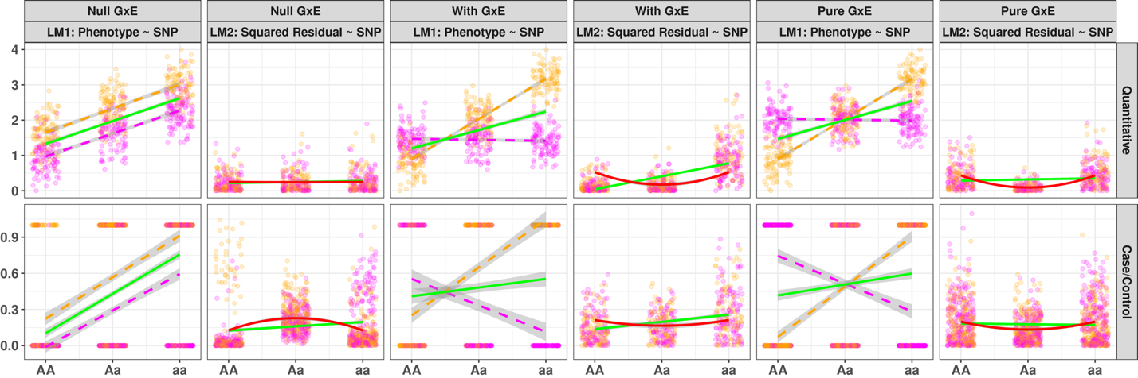
Figure 1: Rationale of Variance Loci suggesting GxE candidate SNP
solid green line: marginal linear regression lines fitted by GWAS for double linear model (DLM); solid red line: curves fitted by variance loci analysis (VLA) for upwardness test; magenta/orange points and dashed lines: environment specific observations and regression lines; x-axis: genotype as allele counts; y-axis: phenotype value or squared residuals.
row 1 (a, c, e): quantitative phenotype. (a) In the absence of GxE, the spread of residuals are uniform (LM1), so a flat line fits through squared residuals and A/a is not a vQTL (LM2); (c) In the presence of GxE, the spread of residuals are uneven (LM1), a non-zero slope (solid green line) or an upward curve (solid red line) fits through the squared residuals (LM2), therefore, both DLM and VLA recognize A/a as a true GxE candidate; (e) in the present of pure GxE (LM1), a flat line through squared residuals (solid green line) so DLM could not identify the vQTL, but a upward bending curve (solid red) still fit through, so VLA can detect the vQTL.
row 2 (b, d, f): case/control phenotype. (b) despite the absence of GxE (LM1), a non-zero slope still fits through squared residuals (LM2, solid green line), therefore, DLM wrongfully classify A/a as a GxE candidate, but VLA’s upwardness test does not because the curve bends downwards (LM2, solid red line); (d) in the presence of GxE, VLA’s upwardness test can detect A/a as a GxE candidate (LM2, solid red line); (f) VLA’s upwardness test also detects candidate due to pure GxE (LM2, solid red line) where DLM fails.

(a)
(c)

(b)
(e)

(d)

(f)

Variance loci analysis (VLA)
To address the issues with vQTL analysis, we propose variance locus analysis (VLA) to select GxE candidates for Gaussian and binary phenotypes. VLA takes an additive perspective, but instead of testing the non-zero slope of the stage-2 regression line like DLM, VLA fits a curve and tests its upwardness (Figure 1c, solid red line). VLA better controls the type 1 errors for binary phenotypes because when the allele has no GxE effect on the phenotype, the fitted curve tends to be flat or bend downwards (Figure 1b, solid red line). For phenotypes involving pure GxE, VLA’s upwardness test retains the power to detect the GxE candidates (Figure 1e and 1f, solid red lines).
However, the upwardness test alone lacks power for detecting candidate SNP for binary traits when GxE exists because the dichotomized phenotype glosses over the underlying quantitative risk leading up to the binary event. The gradient of underlying risk can be reconstructed to some extent as residuals by regressing the binary phenotype on a covariate such as age. The residual is a quantitative representation of the underlying risk possibly contributed by the genome, exposome, and GxE.
With well-chosen covariates, the residuals for a binary phenotype can be nearly Gaussian. Notice in Figure 1b, 1d, and 1f, despite the phenotype only took values from 0 or 1 (left panel, LM1), the squared residuals are well spread between 0 and 1 (right panel LM2). By replacing a binary phenotype with its residual risk, the upwardness test can detect variance loci involved in GxE (Figure 1e and 1f). The best covariates are non-confounding yet predictive. For example, age and age2 are neither heritable nor determined by the exposome (i.e., non-confounding) but are strong determinants of most diseases (i.e., predictive). A confounding covariate could still be helpful but may bias the VLA test either towards null as mediators such as sex and X-chromosome or create spurious genetic, environmental, and GxE effects as a collider (Aschard et al. 2015). A non-predictive covariate does not cause false positives, but neither help to reveal the fine gradient of underlying risk that empowers the variance loci test.

Application of VLA
We want to empirically assess the ability of VLA to prioritize SNPs involved in GXE affecting quantitative and binary phenotypes in comparison to established variance loci tests (i.e., DLM, LVT, DRM, and even GWAS). To do so, we applied all five variance loci tests genome-wide for type 2 diabetes (T2D) (16, 17) and body mass index (BMI) on a selection population, followed by a two-way genome x exposome-wide association study (GxE-WAS) in an independent discovery population.
We ranked each SNP by one minus the p-value of VLA and other test statistics in the selection population. In the discovery population, we scored each SNP by the number of significant GxE incurred at a given p-value cut-off or by the sum of the negative log p-value of all GxE tests involved. We regress the scores on the ranks, so the estimated coefficient acts as a measure of GxE enrichment. A positive significant enrichment coefficient suggests a method can aid GxE detection by putting the right candidate SNP forward.
Inside the UKBB, we took 353,605 unrelated white British as selection the population and 25,481 white non-British as the discovery population with a 16-item exposome to perform the internal enrichment analysis. We summarize the top significant hits of all five variance loci tests and the corresponding enrichment coefficient in Figure 4a-b under “Result” and Table s3a in Supplement 1.
To perform external GxE enrichment analysis, we expand the selection population to 379,561 unrelated White European descent in the UKBB and replace the discovery population with individuals of various ancestries who participated in the Personalized Gene and Environment Study (PEGS). The PEGS cohort came with 4,610 whole-genome sequencing samples and an extensive exposome of 765 survey items. We report the GxE enrichment coefficients in Figure 4c-d under the “Result” section and Table s3b in supplement 1. In addition, we list the most significant 2-way GxE-WAS (SNP × exposome item) with nearby candidate SNP selected by five variance loci tests in file pgs.xlsx.
The description of populations, GxE candidate selection, and 2-way GxE-WAS discovery can be found in “Material” and “Method”. More details, links to scripts, and links to Excel sheets of top significant per-SNP x per-Exposure results can be found in Supplement 2.
We also investigated the functional enrichment by regressing the label of the SNPs (i.e., intergenic, exonic, intronic, etc.) on the ranks as mentioned earlier based on 1 – values of a variance loci test statistics. We expect the five different tests to prioritize distinct classes of SNPs. We summarize the finding in Figure 8 in “Result.”
In the PEGS cohort, some genes stood out when referring to significant 2-way GxE-WAS (p-value < 5e-8) for type 2 diabetes involving VLA-selected SNPs. In particular, the 2-way interactions between SNPs in or near ABCB7 and exposome item “dyes, inks and tonners”. On the one hand, the ABCB7 gene involves in the glucose transportation pathway associated with type 2 diabetes. On the other hand, the exposome item “dyes, inks and tonners” corroborates the study of ABCB7’s differential expression among workers with occupational exposure to inkjet printers, archived as GEO accession number GSE142351. We describe the selection of candidate genes and differential expression studies in “Results” and “Methods.”
We implemented VLA as a self-contained R-package “vla”(Tong 2022b) that simultaneously analyzes thousands of phenotypes and thousands of SNPs with optimized matrix algebra similar to the group optimization trick adopted by PLINK2’s association analysis (Chang 2022); we created another R-package “plinkFile”(Tong 2022a) to help traverse massive genotype in binary biallelic format (Chang 2021) too big to fit into machine memory.
With the software tools and the selection population of 379,561 unrelated European Whites, we expanded the genome-wide VLA of 11 million variants from T2D and BMI to a comprehensive phenome of 3,273 health-related traits in the UKBB. Among the 3,273 traits, 1,693 are semi-automatically derived disease case/control status based on the most recent PHECODE mapping table (Wei et al. 2017; Wu et al. 2019). We hosted the catalog of whole-genome VLA statistics on the NIEHS website (https://genelist.niehs.nih.gov/vla), similar to the Pan-UK Biobank GWAS catalog (https://www.pan.ukbb.broadinstitute.org) and the EBI GWAS catalog (https://www.ebi.ac.uk/gwas). The NIEHS VLA-Catalog summarizes the interaction potential for each variant given phenotypes of interest and can be used to prioritize GxE candidates in future research.
PREVIOUS WORK ONLY 13ish TRAITS.

Results
We first present the results of simulation studies comparing the statistical power of the proposed variance loci analysis (VLA) and contemporary variance loci tests to select the correct GxE candidate SNP. We then report the results of the empirical GxE enrichment analysis the functional enrichment analysis based on data of UKBB and PEGS and. Lastly, we validate the GxE interaction found in PEGS between gene ABCB7 and exposure to print materials affecting type 2 diabetes, prioritized by SNP found by VLA in UKBB.

Simulation
In each simulation repeat, we generated vectors of environment and covariate from the normal distribution and drew genotype from an actual SNP randomly picked from the 1000 Genomes Project Phase 3 (Consortium 2012; Consortium and others 2015) with a MAF≥0.01 and varying sample size between 2⁴ and 2¹⁶.
We treat the phenotype additively as the sum of a strong covariate effect, a weak genotype main effect, a possible environmental main effect, and a possible GxE effect. We consider scenarios of (1) pure GxE effect or (2) coexisting environmental and GxE effect; both give rise to additive variance loci. We also let the (3) genotype directly affect the phenotypic variance in the log scale, giving rise to multiplicative variance loci. Rejecting the null (i.e., declaring an SNP a GxE candidate) in all three scenarios contribute to a method’s true-positive rates or power.
We simulate a corresponding null for each scenario by zeroing out either the GxE effect (scenarios 1 and 2, additive variance loci) or the allele effect on logged phenotypic variance (scenario 3, multiplicative variance loci). Rejecting the null in these later cases adds to a method’s false-positive rate or type 1 error.
We compared five statistical tests, namely, the simplest double linear model (DLM), the proposed variance locus analysis/curve upwardness test (VLA), deviation regression model (DRM), Levene’s robust test (LVT), and double generalized linear model (DGLM).
We ran 20,000 repeats for each scenario. We fixed the size of the tests to 0.05, that is, rejecting the null if the p-value is less than 0.05. A test statistic is superior if it exerts a higher true-positive rate (power) while controlling the false-positive rate (type 1 error). Therefore, we derived the net-positive rate, as true-positive minus false positive rate, as an overall performance measure.
This section reports the false-positive and net-positive rates regarding additive variance loci (scenario (1), (2), and null) that motivated VLA’s upwardness test. The complete reports with false-positive rates and multiplicative variance loci (scenarios (3)) are available in supplement 1.
Figure 2a shows the performance for Gaussian phenotypes, where all tests controlled the false-positive rates except DGLM (panels 1 and 3). When pure GxE induced variance loci, VLA scored the highest in detecting candidate SNPs (solid red line in column 2). When stand alone environmental main effect coexists with GxE effect, VLA is less sensitive (panel 4).
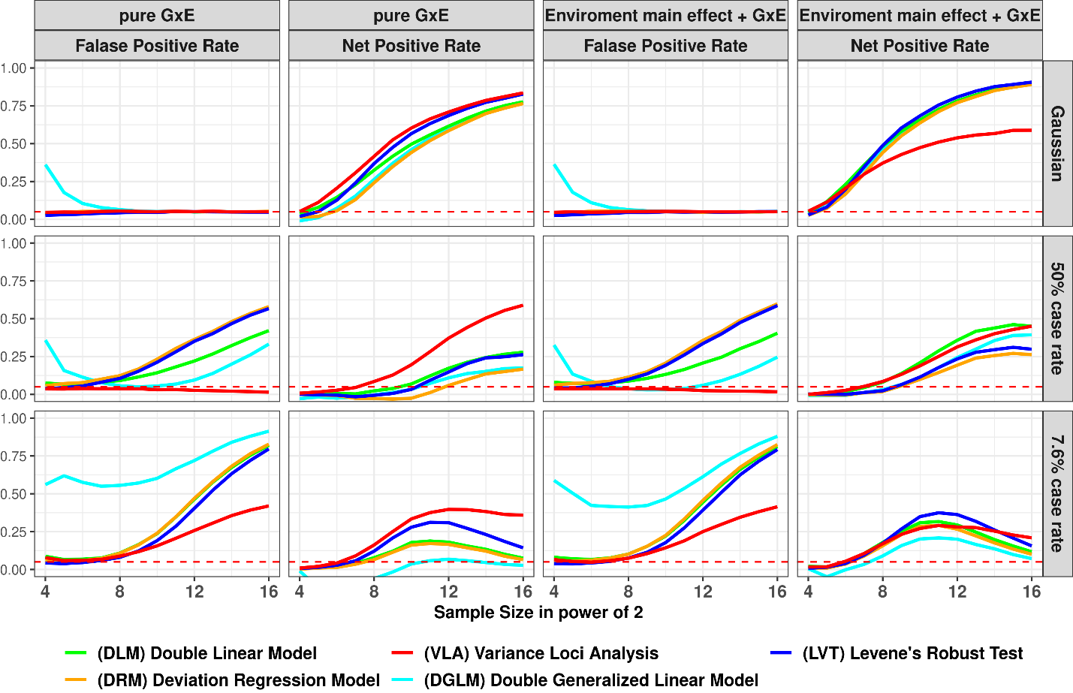
Figure 2: False Positive and Net Positive rates of Simulation Studies
column 1 & 3: GxE is null, the y-axis shows false positive rates (FPR), an FPR of 0.05 (denoted by red dashes) is proper, higher FPR suggest over confidence, lower means overconservative; column 2 & 4: additive variance loci induced by pure GxE, or GxE coexisting with standalone environmental main effect, in these cases the y-axis are net positive rates (NPR), higher means better; x-axis: sample sizes in powers of 2; colors: statistical tests.
(a)
(b)
(c)
Figure 2b (row 2) shows the performance for balanced binary phenotypes (50% case rate). With growing sample sizes, the variance loci and main genetic effect become less distinguishable, elevating the false positive rate (columns 1 and 3) at the cost of the net positive rate (columns 2 and 4). As a result, all tests except VLA lost control of the false-positive rate. VLA again was the best detector of true candidate SNPs with pure GxE effect (solid red line in panel 2).
Figure 2c shows the performance for imbalanced binary phenotypes (7.6% case rate). It is even more challenging to distinguish SNP's effect on the phenotypic mean from that of the phenotypical variance, causing overall inflation of false positives. Still, VLA maintained the best ability to detect genuine GxE candidates.
The simulation of binary phenotype is detailed in supplement S1, along with the full display of separated true-positive and false-positive rates and scenarios involving multiplicative variance loci. We also simulated Poisson phenotypes. Like the binaries, the mean and variance loci of a Poisson phenotype are intertwined, and all variance loci tests came under the pressure of an inflated false-positive rate. The VLA again better maintained the ability to detect actual GxE candidates.
Overall, the simulations showed that the VLA specialized in detecting additive variance loci induced by the pure GxE effect and was more robust under the pressure of false positives caused by imbalanced non-Gaussian phenotype. As expected, VLA underperformed when the simulation generated the variance loci multiplicatively. Because when the allele effect on logged variance is negative, it corresponds to an improper latent GxE with a negative square effect, that is, a non-real valued effect, violating the assumption of "more allele, more variance" (see "methods"). To re-create the simulation results, see the acquisition of SNPs genotype, effect sizes, and the generation of phenotypes of various distributions in "Simulation" in "supplement S1", with links to the R-scripts.

UKBB Genome Wide Variance Loci Analysis
We are interested in how each test selects variance loci. We chose body mass index (BMI) and Type-2 Diabetes (T2D) in the UK Biobank and applied variance loci analysis (VLA) and other tests, except DGLM (low speed and instability). In addition, we performed GWAS with linear and logistic regression for BMI and T2D, respectively. In total, we calculated five test statistics for each SNP.
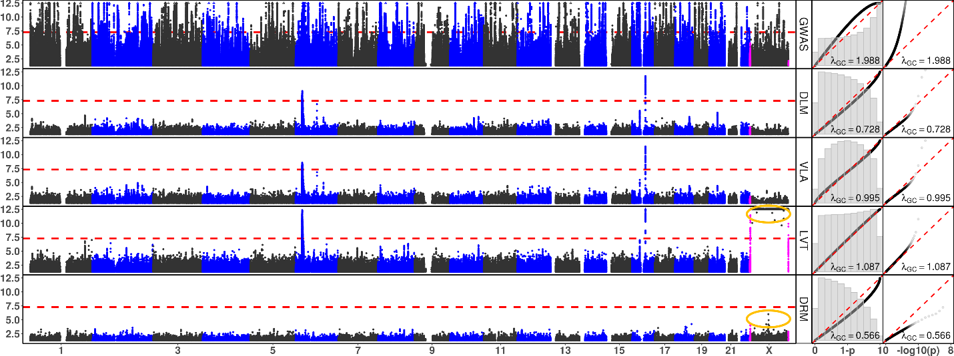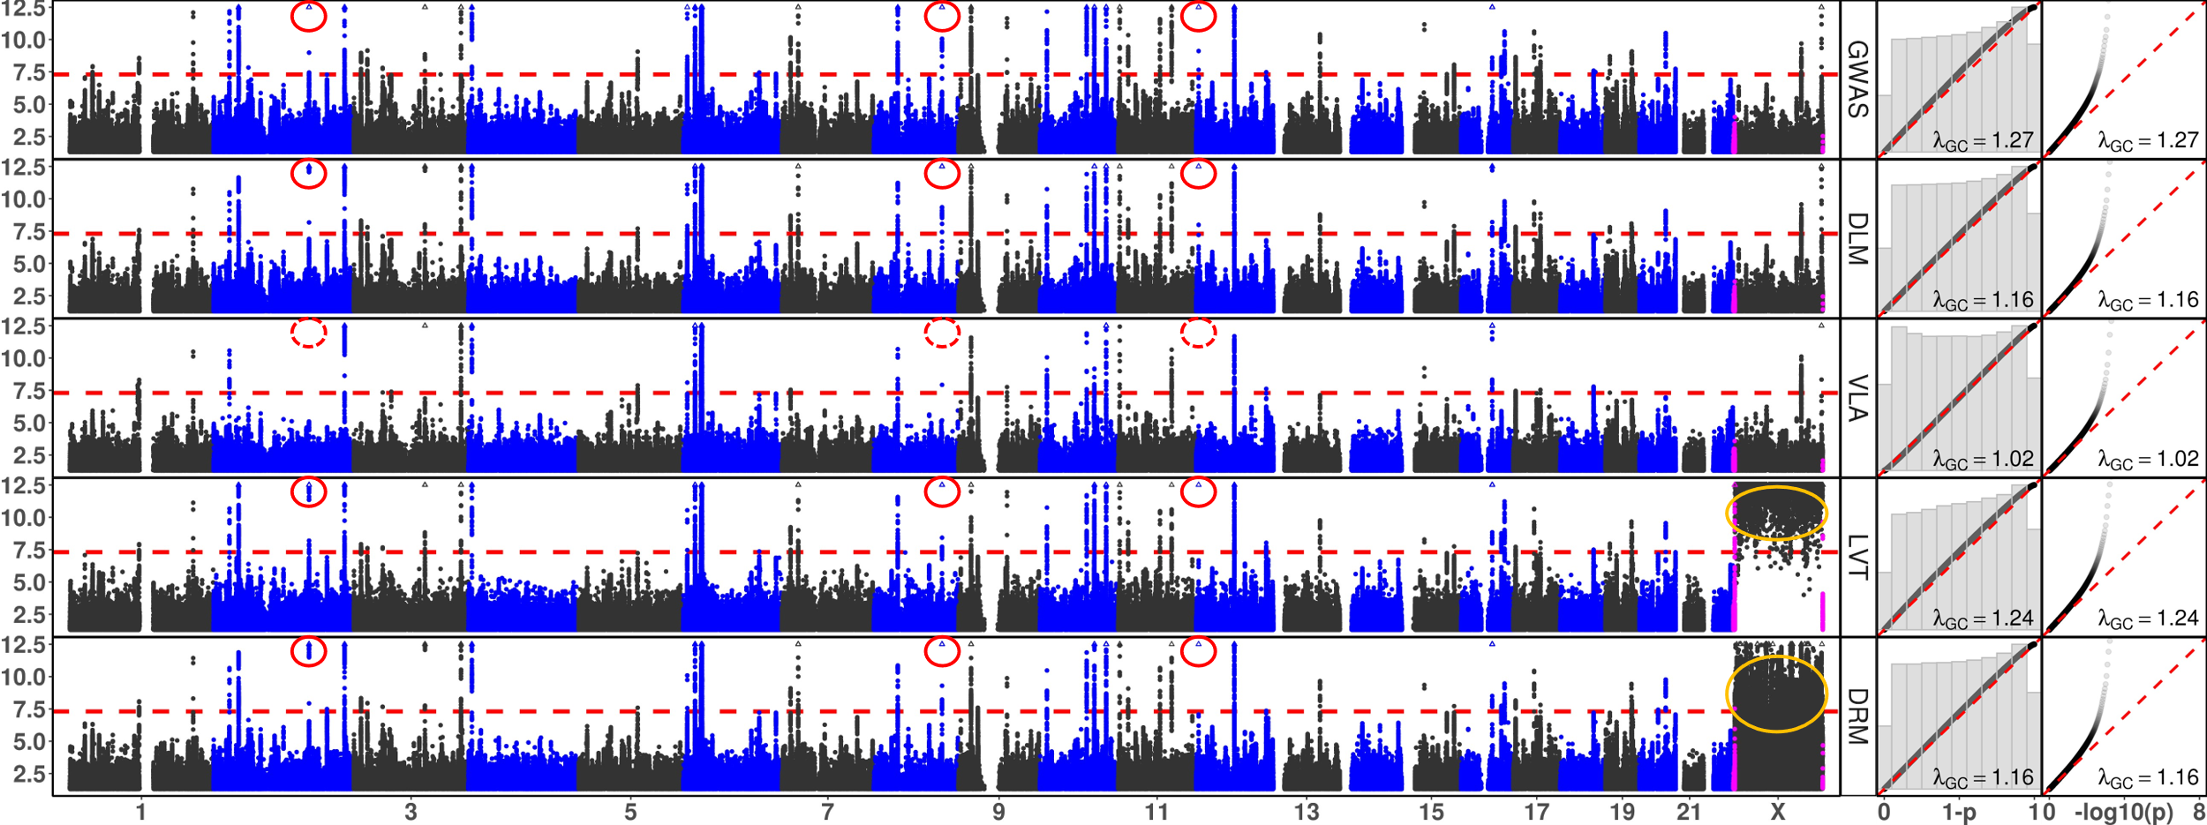
Figure 3: Manhattan and QQ Plots, with λ_{GC}
x-axis: chromosomes (Manhattan plot), theoretical 1 - p (QQ plot 1), or theoretical -log₁₀(p) (QQ plot 2); y-axis: -log₁₀(p) (Manhattan and QQ plot 2), or 1 - p (QQ plot 1); red dash: significance threshold -log₁₀(5e-8) (Manhattan plot); each point bins 269,534 basepairs; magenta points pseudo-autosome regions (PAR) in X; orange circle: abnormal p-values excluded from QQ plots and λ_{GC}; rows: statistical tests, GWAS = genome wide association study; DLM = double linear model, VLA = variance loci analysis (upwardness test), LVT = Levene’s robust test, DRM = Deviation Regression Model; red circle: rs860262 (Chr7) and rs76895963 (Chr12) avoided by VLA but picked up by other tests.

(a) Body Mass Index

(b) Type 2 Diabetes

We assembled two selection populations, (1) 353,605 unrelated British Whites and (2) 379,561 unrelated European Whites, where the latter fully encompassed the former, the Irish, and individuals of any white background. We gathered SNPs on chromosomes 1-22 and X with working MAF > 0.1; as a result, a total of 9,298,089 and 9,298,331 were allowed by the two selection populations, respectively. The covariates included age, sex, age2, age×sex, age²×sex, the first 20 genetic principal components, and the genotyping array (26 in total, intercept included). Figure 3 shows Manhattan plots and QQ plots in both the original [0, 1] scale overlayed with histograms and -log10(p) scale with genomic inflation factor (λ_{GC}), based on the White Europeans (i.e., larger of two selection populations). The five tests' most significant SNPs are listed in supplementary material in Tables s2a and s2b.
Levene’s robust test (LVT) and Deviation Regression Model (DRM) were abnormally positive on X chromone (Figure 3, orange circles). Because the frequencies of heterozygous genotype in men were much lower than in women, which caused LVT and DRM erroneously attribute phenotypic variance due to sex to the SNPs. For this reason, we omitted the X-chromosome for LVT and DRM from the QQ plots, the genomic inflation factor (λ_{GC}), the top significant variants (supplement table s2), and subsequent analysis.
For body mass index (BMI) (Figure 3a, Table s2a), GWAS turned up more significant SNPs with over-confidence (λ_{GC}=1.998). The four variance loci tests distinguished themselves from GWAS and were able to separate the genetic effect on the phenotypic mean and phenotypic variance. Except for the X chromosome, DLM, VLA, and LVT agreed on the most significant variance loci. Between DLM and VLA, despite the striking similarity of the two Manhattan plots and log scaled QQ plots, the latter was balanced (λ_{GC}=0.995) compared to the conservativeness of the former (λ_{GC}=0.728) -- because the rankings of the massive number of lesser and non-significant SNPs are visually obscured in the bottom of Manhattan plots and log-scaled QQ plots but evident in original-scaled QQ plots in (and histograms). DRM was overly conservative (λ_{GC}=0.566) yet presented a unique perspective on variance loci (table s2a, column 9).
For type 2 diabetes (T2D), except for the X chromosome, all five tests largely agreed on the most significant loci, reflecting that the genetic effect on phenotypic mean and variance are interchangeable for a binary outcome. However, VLA showed the most negligible genomic inflation (λGC=1.02), in particular, rs6712203 (2:164700808C/T), rs860262 (7:28194397 C/A), and rs76895963 (12: 4384844T/G) in GRCh37/Hg19 coordinate were avoided by VLA but not by other tests (Figure 3b red circles). Avoiding significant variance loci that were likely artifacts due to GWAS significance of a binary phenotype may allow VLA to prioritize genuine GxE candidates under the pressure of inflated type 1 error.
We detail the treatment of UKBB and PEGS phenotypes, genotypes, covariates, and environmental exposures in “Material.” The GWAS was performed using PLINK2. The links to R-script performing VLA, DLM, LVT, and DRM are provided in supplement S1 (the same with simulation).

GxE Enrichment Analysis
To empirically gauge how well the SNPs ranked ahead by a variance loci test in a selection population can truly enrich the detection of significant GxE interactions in a discovery population. We performed an internal GxE enrichment assessment among sub-populations within the UKBB, and an external assessment involving the NC based PEGS cohort.

Internal GxE enrichment
Inside UKBB, we took the p-values of VLA, DLM, LVT, DRM, and GWAS based on 353,605 unrelated British Whites (i.e., smaller of the two-selection population) with 9,298,089 SNP and 26 covariates, then treated 1 – p-value as the rank of significance according to any of the 5 test statistics.
The discovery population consists of 25,481 unrelated non-British Whites with the same SNPs and covariates. We performed a two-way GxE-WAS with a 16-item exposome covering lifestyle (i.e., drinking and smoking), neighborhood (i.e., water, noise, air, etc.), and family structure (i.e., siblings). As a result, the two-way GxE-WAS assigned each SNP 16 p-values corresponding to product terms between centered SNP dosage and normalized exposure values. We scored each SNP by the number of GxE p-values went below a threshold from 10⁻² to 10⁻⁹. Therefore, a higher score (up to 16) at a threshold means the SNP was more involved in GxEs as significant as the threshold; we also summed up all 16 negative log p-values as an overall GxE activation score for each SNP.
Next, we regressed each GxE score on the significance ranking (i.e., 1 – p-values) based on VLA, DLM, LVT, DRM, and GWAS where the SNPs were weighted by their imputation information. As a result, the regression coefficient became a measure of the GxE enrichment, such that a positive significant coefficient means a method (i.e., VLA) enriches GxE detection by assigning higher ranks to SNPs more involved in GxE, and a negative coefficient means the method deplete GxE detection.
Figure 4a and 4b shows the internal GxE enrichment coefficients (with standard errors) for SNPs passing several GxE p-value thresholds and overall, given rankings backed by GWAS, DLM, VLA, LVT, and DRM. A higher coefficient means a test can better select GxE candidates. For BMI (Figure 4a), VLA was the most efficient selector overall (Figure 4a, red); DLM, LVT, and DRM showed better performance for less and moderately significant GxE but fell behind overall; GWAS produced the worst SNP rankings which depleted GxE detection instead. For T2D (Figure 4b), the advantage of VLA over others are far more pronounced (Figure 4b, red), it was also more efficient for GxE SNPs with p-values < 5e-7; LVT and DRM barely enriched the detection of GxE overall and depleted the highly significant ones (Figure 4b, blue and orange); GWAS and DLM both depleted the detection of GxE overall (Figure 4b, gray and green). We provide exact values of the GxE internal enrichment coefficients and standard error in supplement table s3a.
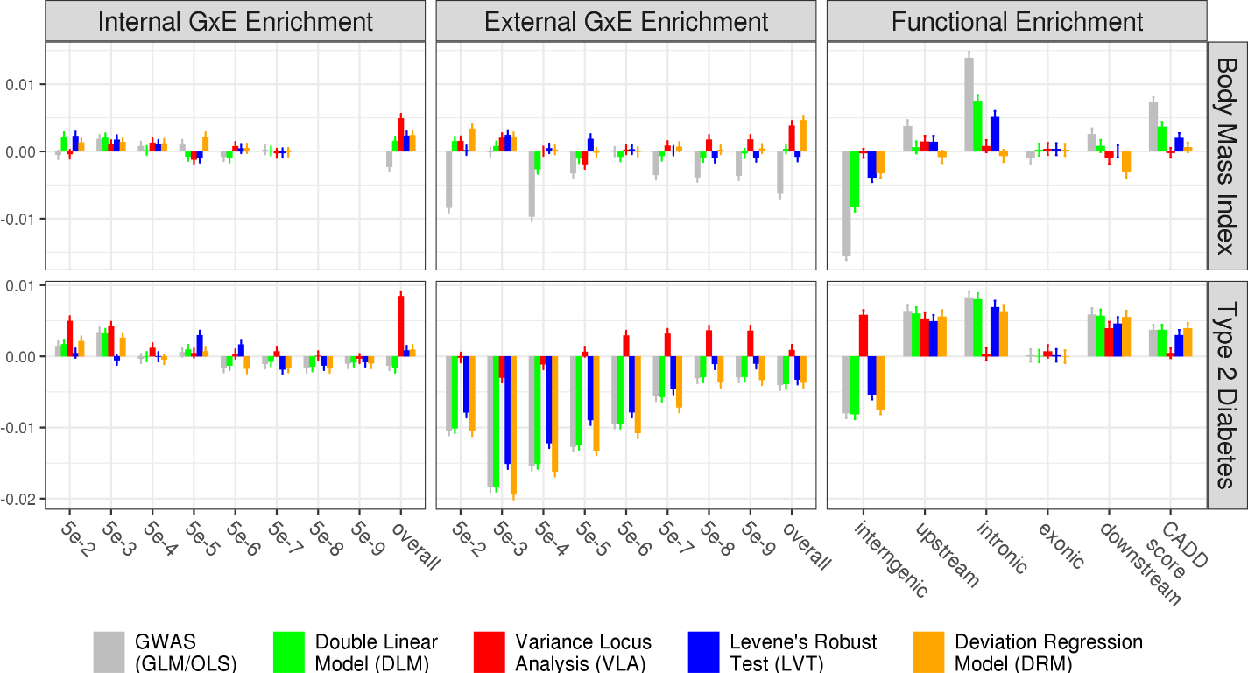

(a)
(c)
(d)
(b)

(f)
(e)
Figure 4: Empirical GxE and Functional Enrichment Analysis
top: results for body mass index (BMI); bottom: results for type 2 diabetes (T2D); (a)(b)(c)(d): GxE enrichment analysis, x-axis denotes the level of GxE significance by p-value used to score a SNP’s GxE activeness, “overall” means scoring a SNP by the sum of negative log p-values of GxE across all exposome items; the y-axis are GxE enrichment coefficient, higher means better statistical test; (e)(f): functional enrichment analysis, x-axis enumerate SNP labels, CADD score stands for “combined annotation dependent depletion” score, in this case, lower or higher enrichment is merely descriptive that does not suggest good or bad statistical test; the missing bars in (a) was due to the absence of significant GxE p-value for BMI reaching for 5e-8 and lower.

Notice for binary phenotype T2D, the GxE enrichment via DLM closely resemble GWAS (Figure 4b, gray and green), showing the fact that phenotypic mean loci are also variance loci for non-Gaussian phenotypes. As a result, the variance loci-based test statistic is nearly colinear with GWAS and redundant; to a lesser degree, such redundancies were also apparent for LVT and DRM at stricter GxE p-value thresholds. Taking the correlation between SNP rankings (i.e., 1 – p value) form GWAS and other tests as a measurement of redundancy, they were 0.985 for DLM, 0.613 for LVT, 0.8871 for DRM, and only 0.004 for VLA. In contrast, for quantitative phenotype BMI (Figure 4a), the 4 variance loci tests exert selection patterns distinct from GWAS. In this case, the correlation between the GWAS based ranking and the rest were 0.053 (DLM), 0.032 (LVT), 0.012 (DRM), and 0.007 (VLA). We also checked the top SNPs rs6712203, rs860262 and rs76895963 visible in the Manhattan of all tests but avoided by VLA, their GxE enrichment is shown below

External GxE Enrichment
We performed the same two-way GxE-WAS for T2D and BMI on an external discovery population of 4,603 unrelated individuals in PEGS with whole-genome sequencing data and diverse ancestry background (“PEGS: Personalized Environment and Genes Study” n.d.). Participants in PEGS underwent extensive questionnaires measuring a rich exposome of 728 items organized in 416 parent questions regarding daily life, home environment, and workplace hazards. Because the numerical scale of the exposome items is stable, of which 505 are binary, and 223 are positive integers less than 8, we retain the items in their original form when forming GxE terms with centered SNP dosage. The covariates for GxE-WAS included age, sex, income level, the first 10 principal components, and nominal variable coded ethnicity (European American, African American, Asian, and others). BMI also joined the covariates when T2D was analyzed. To rank the SNPs, we used GWAS, DLM, VLA, LVT and DRM test statistics based on 379,561 unrelated White Europeans in the UKBB (i.e., the larger of two selection populations).
After quality control, the White Europeans in UKBB and participants in PEGS shared a total of 8,331,313 SNPs with working MAF > 0.01 in the former and MAF > 0.005 in the latter. Again, we scored each SNP by the number of 2-way GxE p-values went below a series of p-value cut-offs (i.e., up to 728) and the overall sum of negative p-values, then regressed the scores on the rankings according to GWAS, DLM, VLA, LVT and DRM. We also provide exact values of the GxE external enrichment coefficients and standard error in supplement table s3b.
Figure 4c and 4d shows the external GxE enrichment coefficients (with standard errors). For BMI, SNPs ranked by VLA had the best chance of detecting highly significant GxE (p-value < 5e-7, …, 5e-9), and the second-best chance of detecting overall GXE (3.82, se=0.34) in PEGS. Interestingly, DRM, being by far the most conservative statistics for BMI (see the Manhattan plot in Figure 3a), gave the best overall enrichment (4.64, se=0.35) in PEGS. For T2D, only VLA enriched the detection of medium-to-highly significant GxE with p-values < 5e-6, …, 5e-9, and the overall GxE (0.89, se=0.34) in PEGS, while other tests showed negative coefficients (i.e., depletion) without exception. We notice, again, the coefficients of DLM closely follows the GWAS, and to a lesser degree, DRM as well, reflecting the fact that slope-based variance loci test tends to be redundant for binary phenotypes.
Comparing the GxE enrichment (Figure 4 a-d, Table s3a, s3bb) with the variance loci test statistics (Figure 3, Table s3), DRM and VLA did not produce as much significant loci as others yet gave the highest boost to GxE detection for BMI and T2D, respectively. It seems, while a Manhattan plot (Figure 3) highlighting the strongest signals, it does not reveal how different statistics ranked the bulk of loci differently. It seems two strategies should be considered when picking candidate SNPs, by a pre-defined p-value (or false discovery rate, FDR) cut-off, and SNPs ranked forward even if they did not necessarily pass the said threshold.

Functional enrichment Analysis
We are also interested in the enrichment from a functional perspective, that is, what kind of SNPs (i.e., exonic, intronic, intergenic, etc.) were overrepresented among the significant loci of a statistical test.
If SNPs prioritized by one of the tests are prone to have a particular genomic function, the significant loci of that test should represent different types of SNPs unevenly. For example, GWAS loci are more frequent among SNPs in or near genes than between genes. We used ANNOVAR (K. Wang, Li, and Hakonarson 2010) to label each SNP as an intergenic, upstream, intronic, exonic, or downstream variant. We also calculated the combined annotation-dependent depletion (CADD) score (Kircher et al. 2014; Rentzsch et al. 2019) as a continuous measure of pathogenic tendency. We treated the functional labels as binary and CADD scores as continuous response variables to regress on SNP rankings given by VLA, DLM, LVT, DRM, and GWAS. A positive significant coefficient means the variance loci are over-represented among SNPs of certain types or higher CADD. We summarize the exact functional enrichment coefficients for BMI and T2D in supplement Table s3c and Figures 4e and 4f.
For both phenotypes, all tests except VLA underrepresented intergenic SNPs; while inside or near genes, none of the tests prioritize exonic SNPs.
For BMI, VLA tends to pick all types of SNPs evenly (Figure 4e, red); DRM is the only test under-selected downstream SNPs (i.e., near the end of a gene) (Figure 4e, orange); the other three tests prioritized intronic SNPs and those with high CADD scores.
For T2D, only VLA distinguished itself by prioritizing intergenic SNPs (Figure 4f, red) while not prioritizing intronic SNPs or those with high CADD scores. The other four tests largely agreed, which is no surprise given their redundancy regarding a binary phenotype.
Taking genome-wide variance loci analysis (Figure 3, Table s2) and GxE enrichment analysis together (Figure 4e-f, Table s3c), it seems a practical variance loci test should attend SNPs not directly contributing to protein function. Because VLA and DRM gave the best GxE enrichment for BMI (Figure 4a, c), both showed no preference for SNPs of high CADD scores. Also, VLA was the only test enriched GxE detection for T2D (Figure 4b, e), which was also the only test not prioritizing high CADD while emphasizing SNPs between genes.

PEGS GxE adjusted by UKBB Variance Loci
We conducted an exhaustive 2-way GxE-WAS in PEGS for type 2 diabetes, resulting in 10.8 trillion GxE test statistics (i.e., genome variants × exposome items). We retained 36.7 billion (0.40%) GxE of or beyond moderate significance (P < 5e-4) and matched by coordinate and alleles with variance loci from previous analysis of unrelated White Europeans in the UKBB. The GxE and matched variance loci were binned into segments in the genome and have the most significant GxE and variance loci elected per bin, which further thinned the number to 1,608,961 representative GxE (0.015%) and nearby variance loci. We applied Bonferroni multiple testing corrections to the p-values per bin, then re-adjusted the p-value by the significance of nearby variance loci; this allowed more GxE to enter the subsequent database search than relying on the Bonferroni corrected p-values alone.
The 2-way GxE-WAS analysis in PEGS, summary, p-value correction, and re-adjustment by variance loci are detailed in "Method"; the preparation of PEGS data is described "Material".

ABCB7 × Print Material on T2D
By manually checking genome features on or near significant GxE post-adjustment, a particular interaction affecting T2D stood out between the X chromosome gene ABCB7 (ATP binding cassette subfamily B member 7, X:75,051,048 - 75,156,732, ENSG00000131269), its immediate downstream UPRT (uracil phosphoribosyl transferase homolog, X:75,156,388 - 75,304,885, ENSG00000094841), and exposure to print material (PEGS ID: A_B194*, dyes and inks). The two genes were enclosed by q13.3 and were suggested by nearby SNP rs4409555 with the smallest raw GxE p-value 9.25e-12 and 4.39e-2 after Bonferroni correction. Given the nearby significant variance loci found in UK Biobank by GWAS (P = 1.24e-3, CDF = 7.52e-3), DLM (P = 1.94e-3, CDF = 7.18e-3), and VLA (P = 7.74e-5, CDF=1.47e-3), the adjusted GxE p-values were 3.30e-4 (GWAS), 3.15e-4 (DLM) and 6.45e-5 (VLA), respectively. By looking at the p-values and CDF of variance loci, VLA anticipated GxE near ABCB7-UPRT more than GWAS and DLM did. As a reminder, LVT and DRM were absent because the two tests are invalid on chromosome X.
Figure 5 presents a localized Manhattan plot near ABCB7 and UPRT. The region in display came close to the highest peak in LD (linkage disequilibrium) in chromosome X (Figure 5 top) based on 3104 genotyped females (68.4%) in PEGS, with a median LD score of 422.29, which was above the overall median of 110.1815 for the entire chromosome X. The significant GxE interaction between SNPs around ABCB7-UPRT and printer toners points to evidence of differential expression of ABCB7 among workers occupationally exposed to inkjet printers, archived as GEO dataset GSE142351 (Guo et al. 2020). We offer more detail on the differential expression studies in “Methods.”
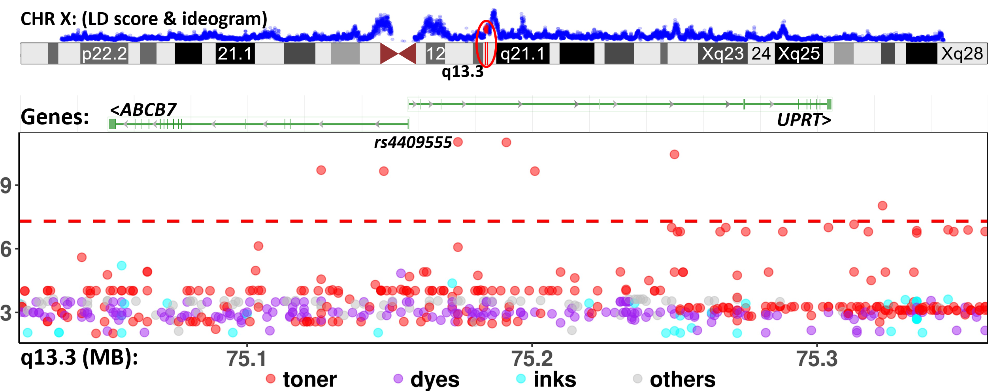
Figure 5: GxE interaction between SNPs in ABCB7-UPRT and print materials associated with T2D in PEGS
The Manhattan plot shows unadjusted -log₁₀(P) (y-axis) for GxE due to SNPs between X: 75,020,000 - 75,360,000 (x-axis) and exposures to print materials (colored points); The gene bars shows ABCB7 and UPRT (rendered by NCBI genome viewer); the ideogram on top shows chromosome X (rendered by UCSC genome browser), the enclosing region q13.3 (red), and LD scores (blue) based on 3104 genotyped females (68.4%) in PEGS; the GxE between SNPs in ABCB7-UPRT and toner (red points) reached beyond conventional genome wide significance (-log₁₀(5e-8), red horizontal dash). Although the smallest p-value (rs4409555, 9.25e-12) did not guarantee significance after Bonferroni correction over 4.74 billion selectable GxE tests, the region was prioritized by significant variance loci found by VLA in the UK Biobank.

ABCB7 is involved in metabolism and multi-drug resistance and is related to transport pathways of glucose and other sugars, bile salts, organic acids, metal ions, and amine compounds. Notably, the gene encodes a half-transporter involved in the transport of heme from the mitochondria to the cytosol. ABCB7 is also an ATP-dependent mitochondrial transporter implicated in Fe–S cluster assembly. Inherited mutations in ABCB7 have been linked to inherited and acquired sideroblastic anemia with cerebellar ataxia (Pain and Dancis 2016; Allikmets et al. 1999). The absence of ABCB7 impairs the maturation of cytosolic iron-sulfur proteins and induces iron accumulation in mitochondria.
Further, the knockdown of ABCB7 in HEK293T cells causes mitochondrial iron accumulation and the activation of SOD enzymes, while iron and iron-regulatory proteins and cadmium alter ABCB7 expression. Some pigments in printer ink dyes, such as potash blue or soda blue, contain iron based on ferrous and ferric cyanides, and printer inks may also contain cadmium (Podhajny 2001). Also of interest is the association of ABCB7 with fatty liver disease, which is notable because T2D is a significant risk factor for fatty liver disease and could share common pathways (SILAGHI et al. 2016; Lonardo et al. 2019)..
The above suggests that the region around ABCB7, statistically prioritized by VLA, is biologically interacting with exposure to print materials to affect the risk of developing type 2 diabetes.

UKBB variance loci catalog
Based on the results for T2D, it is natural to expand the application of variance loci analysis (VLA) from a few phenotypes to a large number. Inspired by the Pan-UK Biobank GWAS catalog at pan.ukbb.broadinstitute.org, we created and hosted the variance loci analysis catalog for UKBB phenotypes and variants on the NIEHS website (http://genelist.niehs.nih.gov). The VLA-catalog is a public resource queried by phenotype, enabling researchers to prioritize candidate variants most likely to invoke significant GxE interaction. Figure 8 illustrates the workflow of creating the catalog and the public query.
We handpicked 1,580 health-relevant phenotypes from UKBB data fields accessible by NIEHS, plus an additional 1,693 diseases derived from hospital records using PHECODE -- a codebook for extrapolating diseases using records in ICD9/10 (www.phewascatalog.org) (Wei et al. 2017; Wu et al. 2019). In total, we compiled a phenome comprising 3,273 items. We distinguished the phenotypes into binomial, multinomial, ordinal, and continuous variables subjected to recoding and normalization. To prepare the genome, we limited the variants to those with an overall minor allele frequency of no less than 0.005, yielding 11,841,785 variants after quality control. The “material” provides more details.
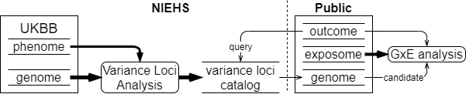
Figure 9: UKBB variance loci catalog workflow
We performed VLA for the whole phenome and genome to archive variant statistics for each of the three main racial/ethnic groups (European Whites, Blacks, and Asian) and male/female separately in the UKBB. We used R-package plinkFile to traverse the genome by a reading window while detecting variance loci for thousands of phenotypes and variants using R-package vla. By dividing the UKBB genome into approximately 1,200 groups of 10,000 variants each, we summarized the VLA statistics for 384,000 European Whites in 12 hours using the NIH HPC Biowulf cluster (hpc.nih.gov).

Methods

Variance loci tests to Find GxE candidate SNPs
We started with DLM (double linear model, Figure 10 left), the most intuitive vQTL test. Given a quantitative treat, a SNP, and some covariates, DLM fits a GWAS linear model adjusting the covariates, treats the squared residual as a “new phenotype” and fits another GWAS linear model with the same SNP and covariates. If the SNP coefficient of linear model 2 is significant, we say the SNP is a vQTL, that is, a GxE candidate for that particular quantitative phenotype. Intuitively, the linear model 2 fits the squared distance from the fitted values of linear model 1 (i.e., conditional mean given the SNP and covariates), which amounts to modeling the phenotypic variance, since the mean of squared distance from the mean, is variance. The VLA (variance loci analysis, Figure 10 right) slightly modifies DLM: (1) the second linear model uses squared SNP and (2) perform a one-sided t-test assuming non-negative coefficient. For a binary trait, the rare event (i.e., disease) is coded as 1 and the covariates should choose from non-heritable predictors; there is no need to replace linear model 1 with GLM (i.e., logistic regression).
In addition, we used R to implement deviation regression model (DRM), and wrapper functions for Levene’s Robust Test (LVT) available in R-package “car”, and double generalized linear model (DGLM) in “dglm”. Because DGLM is unstable with small samples and slow to compute for large ones, it was used as a benchmark in simulation studies only.
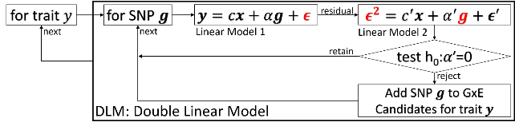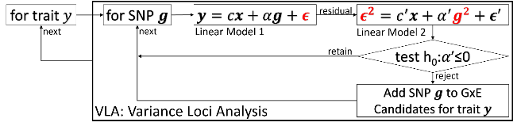Lastly, we considered the traditional GWAS as a reference GxE candidate selector. We use PLINK2’s “--glm” routine to fit GWAS linear model for body mass index (BMI), and logistic regression for type 2 diabetes (T2D). We excluded GWAS from simulation studies since it is easy to arbitrary inflate the false positive rate by allowing non-zero SNP effect on phenotypes. Details of variance loci statistical tests are described in supplement S2.
Figure 10: diagram of double linear model (DLM, left) and variance loci analysis (VLA, right)

2-way GxE-WAS
In a discovery cohort with environment $u$ and standardized SNP $g$, GxE interaction effects are typically captured by adding a two-way product term $ug$ to a GWAS linear model,
$y=m_{0}+ag+bug+cu+dx+e$,
where $e$ is a vector of Gaussian noise and $x$ is the covariate; rejecting $h_{0}:b=0$ at a given p-value threshold suggest the GxE interaction between SNP $g$ and environment $u$. The above is repeated for all 2-way combinations of SNPs and environmental exposures, which, for PEGS, means a total of 14,874,008 × 728 = 10,828,277,824 models (i.e., genome variants × exposome items); for White non-British in the UKBB, the number was 9,298,089 × 16 = 148,769,424.
For our current study interested in few phenotypes (i.e., T2D and BMI), it is affordable to exhaustively analyze all 2-way combination between PEGS genome and exposome with computational resources of the NIH HPC Biowulf cluster (http://hpc.nih.gov), and to latter adjust the GxE p-values with the empirical CDF of variance loci’s p-values. To exhaustively study many outcomes however (i.e., 3-way combination of phenome, genome, and exposome), it is more practical to follow the workflow in Figure 9, to first query the VLA-catalog first and find out variance loci of suggestive genome-wide significance (i.e., P < 5e-6) by each phenotype, then limit the 2-way GxE-WAS among candidate SNPs inside the LD blocks surrounding the variance loci, reducing computation while enabling targeted GxE testing.

Summarize GxE-WAS for T2D
For T2D, the initial 10.8 trillion 2-way GxE-WAS test statistics were first trimmed down to 89,103,943 (0.82%) with P < 5e-4, and further down to 36,721,414 (0.40%) matchable by coordinate with variance loci statistics produced by GWAS, DLM, VLA, LVT and DRM based on unrelated White Europeans in the UKBB. The coordinates of the variance loci were converted from UKBB’s original GRCh37/Hg19 to PEGS’ GRCh38/Hg38 using UCSC’s lift-over tools.
The remaining GxE and matched variance loci were binned into genome segments at least 249.2 kilobase apart (one thousandth of chromosome 1), resulting in varying number of bins per exposome item (min=1, median=2460, mean=2238, max=3854). Retaining the most significant GxE and variance loci in each bin as representatives further reduced the number of reported GxE statistics to 1,608,961 (0.015%). To correct for multiple testing, we consider the maximum number of unrelated GxE tests selectable by variance loci, which was 474,4197,536 = 11,404,321 × 416, that is, the number of variance loci in UKBB’s genotype data times the number of parent questions in PEGS’ exposome survey, therefore, the Bonferroni correction would enlarge the GxE p-value by 0.47 billion folds. Taking the representative (i.e., most significant) variance locus in a bin into account however, an adjusted GxE p-value is re-calculated as (Bonferroni correction) x (empirical CDF of the variance locus’ p-value). Using CDF ensures that variants put forward by a variance loci test statistics are prioritized regardless of the magnitude of p-values, as we have seen the relatively conservative statistics (e.g., VLA and DRM) better enriched the detection of GxE overall (Figure 4 a-d). The CDF also give a sense of what Bonferroni corrected p-value would be as if the 2-way GxE-WAS were restricted among certain percentage of most significant variance loci. The representative GxE in each bin for each exposome item were reported in supplement “pgs.xlsx”, along with adjusted p-values according to the empirical CDF of 5 variance loci tests based on UKBB’s unrelated white Europeans.
To test whether the expression in these top genes was modified by this exposure (GEO number GSE142351), we used gene expression data from a study that examined changes in gene expression with occupational printer exposure. In this study, blood was collected from female office workers in three groups: a control group (n=2), those exposed to inkjet printers (n=2), and those exposed to laser printers (n=7) at four time points, on each Monday and Friday of two subsequent weeks, and sequenced to determine mRNA expression. Samples from Mondays and sample from Fridays were each grouped together, with the assumptions that all participants worked a typical Monday-Friday workweek and that the same effects would be observable for any genes with expression changes on all Mondays or all Fridays.
Building on QC completed in Tuxedo, we removed gene IDs with less than two counts in five or more of the 33 samples (from nine participants at four time points) and used DESeq2 to obtain normalized gene counts, treating repeated measures for each subject as replicates. We performed filtering based on the gene list and conducted repeated measures linear regression for the 10 genes of interest. ABCB7 was the only gene expressed in this dataset, which is expected given that the others are pseudogenes or non-coding regions. Because there were no male controls, we used data only on females. Details of the QC and analysis are included in the Supplement. MAKE A STATEMENT OF SIGNIFICANCE BETWEEN EXPOSED AND UNEXPOSESD
The expression of ABCB7 is an interesting key finding..

Materials

UK Biobank (UKBB) data
Our study relied on UKBB to evaluate the performance of variance loci test statistics, and to build the whole genome VLA catalog of GxE candidate. The UK Biobank is a large-scale resource consisting of genetic and health information for over half a million participants (Application ID: 57849, version 2) collected via questionnaires, electronic health records, biological samples, oral interviews, imaging, and genotype data.

Genotype data
Among the initial 502,505 individuals, 487,411 has imputed allele dosage genotype with 97,059,328 variants, the quality control retained 405,432 unrelated individuals with high-quality genotype. The remaining samples were categorized into five ancestries—African (afr), non-Chinese Asian (asi), White Europeans (eur), White British (bri), and White non-British (wnb) while 29,440 individuals with too small group sizes (e.g., 1574 Chinese) or unclear ancestry were removed, which retained 375,992 individuals (74.8%). Among the ancestry groups, afr, asi, and eur, groups were the backbone of the VLA Catalog hosted in NIEHS; the bri and wnb population were used for UKBB internal GxE enrichment analysis, the eur population were used for genomic functional enrichment analysis, and together with the PEGS, were used for external GxE enrichment analysis. The workflow of the quality control is provided in the Supplement.

Phenotype data
We manually compiled several phenotypes from baseline data collected at UKBB participants’ first visit, as summarized in Table 2. These phenotypes are type 2 diabetes, coronary artery disease, body mass index, and fasting glucose level. Details of how we compiled these phenotypes, including criteria and the UKBB data fields used, are included in the Supplement.

Environmental data
We collected 16 environmental variables in UKBB, which include the number of siblings (SIB), physical activity in metabolic equivalent minutes (MET), ever smoking (SMK), alcohol intake (ALC), neighborhood traffic (TRF), nitrogen oxide (NO1), nitrogen dioxide (NO2), particulate matter air pollution, 10μm (P10), particulate matter air pollution, 2.5μm (P25), and noise (NOI). We also included several neighborhood exposures in a 1000-m buffer around an individual’s home address, namely green space percentage (GSP), domestic garden percentage (DGP), water percentage (WTP), and natural environment percentage (NEP) and distance to the coast (SEA). Table 3 outlines the environmental variables, and the Supplement provides details on the methods and fields used to calculate the variables.

PHECODEs
We derived PHECODEs for our analysis using phenotypes and disease diagnoses from electronic health record (EHR) data for UKBB participants recorded as International Classification of Diseases (ICD) codes. ICD codes are used to record medical diagnoses, signs and symptoms, abnormal findings, and injuries. Although more than 100 countries use ICD codes to track morbidity and mortality (41), they do not provide an appropriate level of granularity for phenotypes relevant for genetic association studies. PHECODEs are manually curated groups of ICD codes aggregated into a distinct medical concept, disease, or phenotype intended to capture clinically meaningful concepts for research (40). PHECODEs provide embedded case-control definitions based on exclusion criteria for controls, enabling the rapid characterization of large numbers of phenotypes. They are widely used for phenotyping participants with EHR data, especially for genetic association studies (40, 42). The use of PHECODEs in such studies produces superior results compared to ICD and Clinical Classification Software (CCS) codes. The Supplement provides details of our PHECODEs mapping.
 | Description | N | Min | Median | Mean | Max | Histogram
BMI | Body mass index | 489955 | 18.0 | 26.7 | 27.4 | 48.0 | 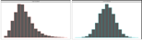
T2D | Type 2 diabetes | 493619 | 0.0 | 0.0 | 0.1 | 1.0 | 
Table 2. UK Biobank Phenotypes Used
The histogram shows distributions before and after normalization, the latter entered analysis.

 | Description | N | Min | Med | Mean | Max | 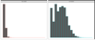  Histogram
ALC | Weekly alcohol intake | 427697 | 0.0 | 8.0 | 11.9 | 603.0
DGP | Domestic garden percentage | 440874 | 0.1 | 24.3 | 24.3 | 66.1 | 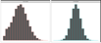  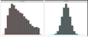
GSP | Green space percentage | 440874 | 4.4 | 41.5 | 45.0 | 99.2
MET | Metabolic equivalent minutes | 498628 | 0.0 | 1386.0 | 2553.7 | 125118.0 | 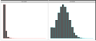
NEP | Nature environment percentage | 497542 | 0.0 | 36.6 | 40.5 | 100.0 | 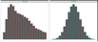
NO1 | Nitrogen oxide | 495124 | 19.7 | 42.4 | 44.1 | 265.9 | 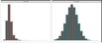  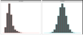
NO2 | Nitrogen dioxide | 495124 | 5.1 | 21.3 | 22.4 | 98.6 | 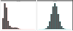
NOI | Noise | 495124 | 46.7 | 50.1 | 51.2 | 88.5
PM1 | Air pollution, PM10 | 495113 | 5.9 | 19.0 | 18.6 | 30.5 | 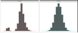
PM2 | Air pollution, PM2.5 | 461201 | 8.2 | 9.9 | 10.0 | 21.3 | 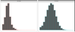
SDN | Sedentary behavior | 500967 | 0.0 | 4.0 | 4.5 | 48.0 | 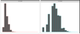
SEA | Distance to coast | 497542 | 0.0 | 44.0 | 41.6 | 108.0 | 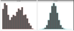  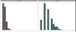
SIB | Number of siblings | 493402 | 0.0 | 2.0 | 2.2 | 44.0
SMK | Ever smoke | 499620 | 0.0 | 1.0 | 0.6 | 1.0 | 
TRF | Traffic intensity | 495124 | 0.8 | 78.2 | 172.6 | 100810.0 | 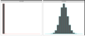  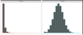
WTP | Water percentage | 440874 | 0.0 | 0.5 | 1.3 | 59.4
Table 3. UK Biobank Exposome (16 items)
The histograms show distributions before and after normalization, the latter entered analysis.

PEGS
The North Carolina-based Personalized Gene and Environment Study (PEGS) is a cohort of 19,672 participants of varying age, race, socioeconomic status, and education level. and whole-genome sequencing data for 4,610 individuals. Details of the cohort and genotyping are found in the supplement.

Exposome data
PEGS conducted extensive survey on 756 exposome items for 9,765 participants, divided into three parts. The General Health & Exposure survey (part C) collected information on general health, lifestyle, and occupational exposure information as well as individual and family medical histories (n=9,414); the extended external exposure survey (part A) requests information on exogenous exposures throughout life, including but not limited to chemical and environmental exposures at home and work (n=3,519); the extended internal exposure survey (Part B) requests information on endogenous exposures such as medication as well as lifestyle factors, including sleep patterns, stress, physical activity, and diet (n=2,962). The Supplement provides information on how the surveys were formulated.

Phenotype data
We derived T2D and BMI phenotype data from the General Health & Exposure survey. The Supplement provides information on cases / controls definitions and quality control.

Whole-genome sequencing
The PEGS provide Broad Institute sequenced genotype for 4,610 participants and conducted quality control, it also compared the number of variants identified for each PEGS participant to the number determined in a parallel analysis of the same data based on the hg19 genome assembly. The Supplement provides further details on all the sequencing and filtering steps.

Principal Components Analysis
The UKBB performed the principal components analysis for all genotyped individuals. Data field 22009 provides the first 40 principal components. For PEGS, we performed PCA using the pca command in PLINK2. Before removing any variants or samples as part of QC, we performed PCA with the original whole genome sequencing (WGS) data for 40,123,943 variants (38,528,374 in the autosomes) in 4,610 individuals.

Gene-Environment Interaction Analysis
For each environment e, genome variant g, outcome y, and some covariates X, we fitted model y = g + e + ge + X. We tested the significance of the coefficient on ge and kept the p-value. The term ge is the product of g and e. For the UKBB, g is one of the imputed variants, and e is one of the 16 environment exposures described in the Materials section. The covariates X are age, sex, the top 40 PCs, and the genotyping array used (i.e., BiLEVE or Axiom). Because the GxE analysis was conducted for non-British whites only, ethnicity is not included among the covariates. For PEGS, g is one of the WGS variants after quality control, e is one the 766 available environment exposures, and the covariates X are age, sex, self-identified ethnicity, and the top 20 PCs. The proportion of each self-identified ethnicity is: 2.19% Asian, 27.46% Black, 62.34 White, and 2.21% other, coded as 3 dummy variables in X.

Discussion
Using VLA, we scanned more than 11 million SNPs in the UKBB White British population and selected the top 1% most significantly associated with the variance of T2D status as candidates for GxEs. By querying the VLA catalog for T2D status in the UKBB Irish population, we narrowed down the candidates to fewer than 10,000 variants. Due to the compactness of candidate variants, it was statistically practical to search for significant GxEs for T2D among the more than 700 environmental exposures for which PEGS collected information. The significant GxEs pointed to genes associated with fatty liver disease and differentially expressed among individuals with ink, paint, and pesticide exposures, suggesting targets for intervention in the identified genes and in workplaces containing these materials. Considering ABCB7 as an exemplar gene, we validated our GxE analysis in the PEGS cohort.
GxE enrichment analysis results in both the internal discovery population of UKBB non-British Whites (Figure 6) and the external discovery population of PEGS participants (Figure 7) demonstrate the advantages of VLA in prioritizing GxE candidates for binary phenotypes such as T2D and CAD. The advantage is more pronounced for PEGS, as it contains a much wider range of involved environmental exposures (728 vs. 16 in the UKBB). The link between the phenotypic mean and variance of binary phenotypes renders the vQTL statistics obtained from DLM redundant to the QTL statistics obtained from GWAS, as demonstrated by the nearly overlapping enrichment curves of GWAS and vQTL for binary phenotypes (Figures 6 and 7, T2D and CAD, red and blue). For quantitative phenotypes, vQTL statistics indicate the method has greater power than GWAS to select GxE candidates, as demonstrated by varying enrichment curves for vQTL and GWAS (Figures 6 and 7, BMI and GLU, red and blue). vQTL is ideal for phenotypes that are nearly perfectly Gaussian, such as GLU. In this scenario, GWAS lacks power to select GxE candidates, as demonstrated by separation of the phenotypic mean and variance. For quantitative phenotypes that are not fully Gaussian, such as BMI, GWAS has some demonstrated ability to select GxE candidates because vQTL and QTL are somewhat related.
When treating GLU as a quantitative surrogate of T2D, the GWAS provided the best overall GxE candidate ranking based on statistics (Figure 7, panel 3, GLU/T2D). For T2D without a surrogate, GWAS provided better enrichment coefficients (e.g., 0.0125 at 10⁻²) than VLA (e.g., 0.0025 at 10⁻², Figure 7, panel 1, T2D). However, the choice of GLU as a surrogate for T2D depends on prior knowledge and subjective judgement (e.g., BMI is also a potential surrogate of T2D) and thus such a technique is unsuitable for automated GxE hypothesis exploration before weighting and choosing surrogates, which is also an automated process. Despite these limitations, we provide the GWAS p-values in addition to VLA p-values for each phenotype in the VLA catalog to allow surrogate GxE candidate rankings based on subjective knowledge of disease etiology.
VLA was initially proposed as an additive vQTL scanner that prioritizes pure GxE effects and improves on existing two-stage methods such as DLM, DRM and LVT concerning the quality of GxE candidates selected for quantitative traits. However, after transforming simulated Gaussian phenotypes to case/control status via a logistic function and Bernoulli sampling, VLA was consistently conservative while DLM, DRM, and LVT resulted in uncontrolled type 1 errors with non-zero genetic effects on the original Gaussian phenotypic mean. To address this, we scanned variance loci for binary phenotypes using VLA in conjunction with covariates. This approach is based on the concept that the adjusted binary phenotypes of covariates can be treated as new phenotypes that more clearly represent combined genotype and environment effects. vQTL scanners can be used with high-quality, quantitative covariates. To ensure control of type 1 errors with lower-quality covariates, we used the curve upwardness test for VLA. A combined DLM and VLA test for statistical power to detect variance loci was unable to control type 1 errors unless the covariates were perfect.
The best covariates are non-confounding predictors, which, in essence, are variables unaffected by the genotype or environment yet associated with the outcome. Such covariates have been shown to improve statistical power in GWAS and epidemiology studies (Aschard et al. 2015). If covariates are non-confounding, adjusting them neither removes the genetic or environmental effect on the phenotype nor creates spurious associations between the genotype/environment and the phenotype. For a covariate to be predictive, after removing the effect of the covariate, the adjusted phenotype becomes closer to the combined genotype/environment effect than the original phenotype. Recommend covariates are age and age², or more than three age bins (e.g., <20, 20-40, 40-60, >60 years), because age is unaffected by the genotype or environment but predictive of most diseases. Sex, age × sex, and age² × sex can also be used if a disease affects both sexes and the analysis is limited to autosomes.
If the genotype and the environment (e.g., pollution and climate) are considered precursors of all phenotypes, confounding predictors are either mediators or colliders linking the precursors and the outcomes. Adjusting either attenuates (for mediators) or inflates (for colliders) the genetic and environmental effects (Hernán et al. 2002). However, some confounding predictors are useful, including genetic principal components. Although the components are the weighted sum of common genome variants, the association between a component and a single variant is typically insignificant. A contrasting example is the use of BMI and socioeconomic status (SES) variables (e.g., income and education) as adjusted covariates in T2D studies. BMI can be both a mediator and a collider because it is both heritable and an indicator of T2D risk, and T2D onset can reversely affect BMI through changes in lifestyle. Accordingly, we did not include BMI and SES in the VLA scan in the UKBB White British population.
Using VLA as a GxE candidate scanner for binary phenotypes enables analysis of a large number of case/control outcomes collected in a sizable cohort such as the UKBB. Archive VLA statistics as a reference for research on the environmental genetic effects on health motivated creation of the NIEHS-hosted VLA Catalog. For binary phenotypes, a logit linked, iteratively optimized binomial linear model is typically chosen for association analysis due to its befitting interpretation of the odds ratio per additional allele and predicted probability, which never exceeds the range of the phenotype (i.e., 0=control, 1=case). In contrast, plain linear models optimizable in close form are adopted for two-stage VLA (i.e., ordinary least squares) because the priority is not interpretating odds ratios and predicting binomial probability but quickly ranking variants’ potential to invoke GxE effects for a phenotype. Additionally, the logit link function $f\left(x\right)={\left[exp\left(1+x\right)\right]}^{-1}$ is monotonic and closely approximated by the trivial identity link function $f\left(x\right)=x$ near $x=0$. Therefore, the significance and direction of a variant effect identified by a logit linked binomial linear model can also be recognized by a plain linear model. The simplicity of VLA allows the rapid ranking of variants for multiple phenotypes en masse, facilitating creation of the VLA Catalog based on rich phenome (3,237 phenotypes, of which 1,693 are binary) and genome data from the UKBB.
Despite the use of VLA to select candidate variants for GxEs, type 1 errors are still inflated in simulations with highly imbalanced case/control ratios and large allele effects on the phenotypic mean. In this scenario, VLA performs similar to GWAS based on statistics. Specifically, effects on the phenotypic mean become indistinguishable from effects on phenotypic variance, causing VLA to identify variants not involved in a GxE as variance loci. In practice, however, this issue is mitigated by the fact that for complex diseases like T2D and CAD, few if any variants exert clinically noticeable marginal effects, but tens of thousands of variants exert clinically weak but statistically significant effects. To demonstrate this phenomenon, we used GWAS to select the top 1% most significant autosome variants (p <0.01) and inspected the correlations between the p-values given by GWAS, VLA, and additive vQTL analysis (although vQTL is intended for quantitative phenotypes only). For T2D in the UKBB White British population, the correlation between GWAS and VLA was nearly 0 but 0.79 between GWA and vQTL analysis. For CAD, the correlation between GWAS and VLA was again nearly 0 but 0.85 between GWAS and vQTL analysis. The unrelatedness between GWAS and VLA statistics means the latter ranks variants differently from the former and thus offers a unique perspective in selecting GxE candidates. Conversely, the high correlation between GWAS and vQTL statistics means the latter is redundant concerning binary phenotypes. For quantitative phenotypes such as BMI, the correlation between GWAS and VLA is 0, and the correlation between GWAS and vQTL analysis is as low as 0.04, reflecting the fact that vQTL analysis is appropriate for quantitative traits only. Because the p-values for additive vQTL are close to p-values for GWAS, we set the latter to NaN for all 1,698 binary phenotypes in the VLA Catalog.
Besides serving as a reference database for gene-by-environment analysis, the VLA Catalog can also aid summary statistics-based analysis. In polygenic risk score (PRS)-based prediction, PRS is the sum of allele dosage in a discovery cohort weighted by GWAS statistics from a training cohort. Because VLA statistics are sufficiently distinct from GWAS statistics yet relevant to the phenotype of interest, they can be considered an alternative weight vector for calculating PRS. A discovery model can improve overall fit and subsequent prediction by using two PRS vectors based on GWAS and VLA, respectively, or better, by including additional vector products between VLA-based PRS and environments of interest. Since VLA-significant variants are more evenly distributed in the entire genome compared to GWAS-significant variants, using VLA for variant weights can enable pathway analysis to identify alternative sets of regions affecting a disease phenotype.
A next step is better countering type 1 errors caused by imbalanced outcomes (e.g., case/control outcomes) in a prospective cohort and Poisson-distributed phenotypes, where it is difficult to separate the allele effect on the mean and variance. In a simulation study, we dropped the intercept term in stage-1 VLA model, forcing it to recognize 0.5 as the mean of an imbalanced binary phenotype (i.e., 0=control, 1=case). Type 1 errors were controlled when the simulated GxE effect was null, but statistical power substantially decreased when the GxE effect was non-null. Another approach is including additional non-confounding predictive covariates to break up the underlying risk of a discrete trait into a finer gradient closely resembling a Gaussian variable. However, besides age and sex, there are few covariates universally collected by cohort studies guaranteed to be free of genetic and environment effects yet predictive of outcomes. In the future, however, we anticipate that GWAS, vQTL (for quantitative phenotypes), and VLA statistics will be included for genotyped cohorts as a common practice to facilitate science on genetic and environmental effects on health.
Allikmets, Rando, Wendy H. Raskind, Amy Hutchinson, Nichole D. Schueck, Michael Dean, and David M. Koeller. 1999. “Mutation of a Putative Mitochondrial Iron Transporter Gene (ABC7) in X-Linked Sideroblastic Anemia and Ataxia (XLSA/A).” Human Molecular Genetics 8 (5): 743–49. https://doi.org/10.1093/hmg/8.5.743.
Aschard, Hugues, Bjarni J. Vilhjálmsson, Amit D. Joshi, Alkes L. Price, and Peter Kraft. 2015. “Adjusting for Heritable Covariates Can Bias Effect Estimates in Genome-Wide Association Studies.” The American Journal of Human Genetics 96 (2): 329–39.
Chang, Christopher. 2021. “PLINK Binary Biallelic Genotype Table.” June 2021. https://www.cog-genomics.org/plink/1.9/formats#bed.
———. 2022. “PLINK 2.0 Association Analysis: Option --Glm.” March 31, 2022. https://www.cog-genomics.org/plink/2.0/assoc#glm.
Consortium, 1000 Genomes Project. 2012. “An Integrated Map of Genetic Variation from 1,092 Human Genomes.” Nature 491 (7422): 56–65.
Consortium, 1000 Genomes Project and others. 2015. “A Global Reference for Human Genetic Variation.” Nature 526 (7571): 68.
Eichler, Evan E., Jonathan Flint, Greg Gibson, Augustine Kong, Suzanne M. Leal, Jason H. Moore, and Joseph H. Nadeau. 2010. “Missing Heritability and Strategies for Finding the Underlying Causes of Complex Disease.” Nature Reviews Genetics 11 (6): 446–50.
Guo, Nancy Lan, Dhimiter Bello, Qing Ye, Rebecca Tagett, Lucia Chanetsa, Dilpreet Singh, Tuang Yeow Poh, et al. 2020. “Pilot Deep RNA Sequencing of Worker Blood Samples from Singapore Printing Industry for Occupational Risk Assessment.” NanoImpact 19 (July): 100248. https://doi.org/10.1016/j.impact.2020.100248.
Hernán, Miguel A., Sonia Hernández-Díaz, Martha M. Werler, and Allen A. Mitchell. 2002. “Causal Knowledge as a Prerequisite for Confounding Evaluation: An Application to Birth Defects Epidemiology.” American Journal of Epidemiology 155 (2): 176–84. https://doi.org/10.1093/aje/155.2.176.
Kircher, Martin, Daniela M Witten, Preti Jain, Brian J O’roak, Gregory M Cooper, and Jay Shendure. 2014. “A General Framework for Estimating the Relative Pathogenicity of Human Genetic Variants.” Nature Genetics 46 (3): 310–15.
Lonardo, Amedeo, Simonetta Lugari, Stefano Ballestri, Fabio Nascimbeni, Enrica Baldelli, and Mauro Maurantonio. 2019. “A Round Trip from Nonalcoholic Fatty Liver Disease to Diabetes: Molecular Targets to the Rescue?” Acta Diabetologica 56 (4): 385–96. https://doi.org/10.1007/s00592-018-1266-0.
Marderstein, Andrew R., Emily R. Davenport, Scott Kulm, Cristopher V. Van Hout, Olivier Elemento, and Andrew G. Clark. 2021. “Leveraging Phenotypic Variability to Identify Genetic Interactions in Human Phenotypes.” The American Journal of Human Genetics 108 (1): 49–67.
Pain, Debkumar, and Andrew Dancis. 2016. “Roles of Fe–S Proteins: From Cofactor Synthesis to Iron Homeostasis to Protein Synthesis.” Current Opinion in Genetics & Development, Molecular and genetic bases of disease, 38 (June): 45–51. https://doi.org/10.1016/j.gde.2016.03.006.
Paré, Guillaume, Nancy R. Cook, Paul M. Ridker, and Daniel I. Chasman. 2010. “On the Use of Variance per Genotype as a Tool to Identify Quantitative Trait Interaction Effects: A Report from the Women’s Genome Health Study.” PLoS Genetics 6 (6): e1000981.
“PEGS: Personalized Environment and Genes Study.” n.d. National Institute of Environmental Health Sciences. Accessed November 14, 2021. https://www.niehs.nih.gov/research/clinical/studies/pegs/index.cfm.
Podhajny, Richard M. 2001. “A Brief Chemistry Lesson on Printing Ink Pigments.” Paper, Film and Foil Converter 75 (11): 20.
Rentzsch, Philipp, Daniela Witten, Gregory M. Cooper, Jay Shendure, and Martin Kircher. 2019. “CADD: Predicting the Deleteriousness of Variants throughout the Human Genome.” Nucleic Acids Research 47 (D1): D886–94.
SILAGHI, CRISTINA ALINA, HORATIU SILAGHI, HORATIU ALEXANDRU COLOSI, ANCA ELENA CRACIUN, ANCA FARCAS, DANIEL TUDOR COSMA, NICOLAE HANCU, RALUCA PAIS, and CARMEN EMANUELA GEORGESCU. 2016. “Prevalence and Predictors of Non-Alcoholic Fatty Liver Disease as Defined by the Fatty Liver Index in a Type 2 Diabetes Population.” Clujul Medical 89 (1): 82–88. https://doi.org/10.15386/cjmed-544.
Tong, Xiaoran. 2022a. R-Package: (Github) PlinkFile (version 0.2.1). R. https://github.com/xiaoran831213/plinkFile.
———. 2022b. R-Package: Vla (Github) (version 0.1.0). R. https://github.com/xiaoran831213/vla.
Van Ijzendoorn, Marinus H, Marian J Bakermans-Kranenburg, Jay Belsky, Steven Beach, Gene Brody, Kenneth A Dodge, Mark Greenberg, Michael Posner, and Stephen Scott. 2011. “Gene-by-Environment Experiments: A New Approach to Finding the Missing Heritability.” Nature Reviews Genetics 12 (12): 881–881.
Wang, Huanwei, Futao Zhang, Jian Zeng, Yang Wu, Kathryn E Kemper, Angli Xue, Min Zhang, et al. 2019. “Genotype-by-Environment Interactions Inferred from Genetic Effects on Phenotypic Variability in the UK Biobank.” Science Advances 5 (8): eaaw3538.
Wang, Kai, Mingyao Li, and Hakon Hakonarson. 2010. “ANNOVAR: Functional Annotation of Genetic Variants from High-Throughput Sequencing Data.” Nucleic Acids Research 38 (16): e164–e164.
Wei, Wei-Qi, Lisa A. Bastarache, Robert J. Carroll, Joy E. Marlo, Travis J. Osterman, Eric R. Gamazon, Nancy J. Cox, Dan M. Roden, and Joshua C. Denny. 2017. “Evaluating Phecodes, Clinical Classification Software, and ICD-9-CM Codes for Phenome-Wide Association Studies in the Electronic Health Record.” PloS One 12 (7): e0175508.
Wu, Patrick, Aliya Gifford, Xiangrui Meng, Xue Li, Harry Campbell, Tim Varley, Juan Zhao, Robert Carroll, Lisa Bastarache, and Joshua C. Denny. 2019. “Mapping ICD-10 and ICD-10-CM Codes to Phecodes: Workflow Development and Initial Evaluation.” JMIR Medical Informatics 7 (4): e14325.

References
1. Eichler EE, Flint J, Gibson G, Kong A, Leal SM, Moore JH, et al. Missing heritability and strategies for finding the underlying causes of complex disease. Nat Rev Genet. 2010;11(6):446-50.
2. van Ijzendoorn MH, Bakermans-Kranenburg MJ, Belsky J, Beach S, Brody G, Dodge KA, et al. Gene-by-environment experiments: a new approach to finding the missing heritability. Nat Rev Genet. 2011;12(12):881; author reply
3. Cao Y, Wei P, Bailey M, Kauwe JSK, Maxwell TJ. A versatile omnibus test for detecting mean and variance heterogeneity. Genet Epidemiol. 2014;38(1):51-9.
4. Deng WQ, Asma S, Paré G. Meta-analysis of SNPs involved in variance heterogeneity using Levene's test for equal variances. Eur J Hum Genet. 2014;22(3):427-30.
5. Struchalin MV, Amin N, Eilers PH, van Duijn CM, Aulchenko YS. An R package "VariABEL" for genome-wide searching of potentially interacting loci by testing genotypic variance heterogeneity. BMC Genet. 2012;13:4.
6. Yang J, Loos RJ, Powell JE, Medland SE, Speliotes EK, Chasman DI, et al. FTO genotype is associated with phenotypic variability of body mass index. Nature. 2012;490(7419):267-72.
7. Paré G, Cook NR, Ridker PM, Chasman DI. On the use of variance per genotype as a tool to identify quantitative trait interaction effects: a report from the Women's Genome Health Study. PLoS Genet. 2010;6(6):e1000981.
8. Smyth GK. Generalized linear models with varying dispersion. Journal of the Royal Statistical Society: Series B (Methodological). 1989;51(1):47-60.
9. Lee Y, Nelder JA. Double hierarchical generalized linear models (with discussion). Journal of the Royal Statistical Society: Series C (Applied Statistics). 2006;55(2):139-85.
10. Rönnegård L, Felleki M, Fikse F, Mulder HA, Strandberg E. Genetic heterogeneity of residual variance - estimation of variance components using double hierarchical generalized linear models. Genet Sel Evol. 2010;42(1):8.
11. Rönnegård L, Valdar W. Detecting major genetic loci controlling phenotypic variability in experimental crosses. Genetics. 2011;188(2):435-47.
12. Marderstein AR, Davenport ER, Kulm S, Van Hout CV, Elemento O, Clark AG. Leveraging phenotypic variability to identify genetic interactions in human phenotypes. Am J Hum Genet. 2021;108(1):49-67.
13. Wang H, Zhang F, Zeng J, Wu Y, Kemper KE, Xue A, et al. Genotype-by-environment interactions inferred from genetic effects on phenotypic variability in the UK Biobank. Sci Adv. 2019;5(8):eaaw3538.
14. Brown MB, Forsythe AB. Robust tests for the equality of variances. Journal of the American Statistical Association. 1974;69(346):364-7.
15. Levene H. Robust tests for equality of variances. Contributions to probability and statistics Essays in honor of Harold Hotelling. 1961:279-92.
16. Bycroft C, Freeman C, Petkova D, Band G, Elliott LT, Sharp K, et al. The UK Biobank resource with deep phenotyping and genomic data. Nature. 2018;562(7726):203-9.
17. Sudlow C, Gallacher J, Allen N, Beral V, Burton P, Danesh J, et al. UK biobank: an open access resource for identifying the causes of a wide range of complex diseases of middle and old age. PLoS Med. 2015;12(3):e1001779.
18. Pain D, Dancis A. Roles of Fe-S proteins: from cofactor synthesis to iron homeostasis to protein synthesis. Curr Opin Genet Dev. 2016;38:45-51.
19. Allikmets R, Raskind WH, Hutchinson A, Schueck ND, Dean M, Koeller DM. Mutation of a putative mitochondrial iron transporter gene (ABC7) in X-linked sideroblastic anemia and ataxia (XLSA/A). Hum Mol Genet. 1999;8(5):743-9.
20. Podhajny RM. A Brief Chemistry Lesson On Printing Ink Pigments. Paper, Film & Foil Converter Magazine [Internet]. 2001. Available from: https://www.pffc-online.com/magazine/782-paper-brief-chemistry-lesson.
21. Silaghi CA, Silaghi H, Colosi HA, Craciun AE, Farcas A, Cosma DT, et al. Prevalence and predictors of non-alcoholic fatty liver disease as defined by the fatty liver index in a type 2 diabetes population. Clujul Med. 2016;89(1):82-8.
22. Lonardo A, Lugari S, Ballestri S, Nascimbeni F, Baldelli E, Maurantonio M. A round trip from nonalcoholic fatty liver disease to diabetes: molecular targets to the rescue? Acta Diabetol. 2019;56(4):385-96.
23. Xiao L, Shi XY, Li ZL, Li M, Zhang MM, Yan SJ, et al. Downregulation of LINC01508 contributes to cisplatin resistance in ovarian cancer via the regulation of the Hippo-YAP pathway. J Gynecol Oncol. 2021;32(5):e77.
24. Gui W, Zhu WF, Zhu Y, Tang S, Zheng F, Yin X, et al. LncRNAH19 improves insulin resistance in skeletal muscle by regulating heterogeneous nuclear ribonucleoprotein A1. Cell Commun Signal. 2020;18(1):173.
25. Wang J, Yang W, Chen Z, Chen J, Meng Y, Feng B, et al. Long Noncoding RNA lncSHGL Recruits hnRNPA1 to Suppress Hepatic Gluconeogenesis and Lipogenesis. Diabetes. 2018;67(4):581-93.
26. Liu D, Liu F, Li Z, Pan S, Xie J, Zhao Z, et al. HNRNPA1-mediated exosomal sorting of miR-483-5p out of renal tubular epithelial cells promotes the progression of diabetic nephropathy-induced renal interstitial fibrosis. Cell Death Dis. 2021;12(3):255.
27. Zhao M, Shen L, Ouyang Z, Li M, Deng G, Yang C, et al. Loss of hnRNP A1 in murine skeletal muscle exacerbates high-fat diet-induced onset of insulin resistance and hepatic steatosis. J Mol Cell Biol. 2020;12(4):277-90.
28. Wei WQ, Bastarache LA, Carroll RJ, Marlo JE, Osterman TJ, Gamazon ER, et al. Evaluating PHECODEs, clinical classification software, and ICD-9-CM codes for phenome-wide association studies in the electronic health record. PLoS One. 2017;12(7):e0175508.
29. Wu P, Gifford A, Meng X, Li X, Campbell H, Varley T, et al. Mapping ICD-10 and ICD-10-CM Codes to PHECODEs: Workflow Development and Initial Evaluation. JMIR Med Inform. 2019;7(4):e14325.
30. Chang CC, Chow CC, Tellier LC, Vattikuti S, Purcell SM, Lee JJ. Second-generation PLINK: rising to the challenge of larger and richer datasets. Gigascience. 2015;4(1):s13742-015-0047-8.
31. Purcell S, Neale B, Todd-Brown K, Thomas L, Ferreira MA, Bender D, et al. PLINK: a tool set for whole-genome association and population-based linkage analyses. Am J Hum Genet. 2007;81(3):559-75.
32. Chang CC. Plink binary biallelic genotype table 2021 [Available from: https://www.cog-genomics.org/plink/1.9/formats#bed.
33. Abecasis GR, Auton A, Brooks LD, DePristo MA, Durbin RM, Handsaker RE, et al. An integrated map of genetic variation from 1,092 human genomes. Nature. 2012;491(7422):56-65.
34. Auton A, Brooks LD, Durbin RM, Garrison EP, Kang HM, Korbel JO, et al. A global reference for human genetic variation. Nature. 2015;526(7571):68-74.
35. National Institute of Environmental Health Sciences. Personalized Environment and Genes Study Data Freeze 1.1. 2021.
36. Wang K, Li M, Hakonarson H. ANNOVAR: functional annotation of genetic variants from high-throughput sequencing data. Nucleic Acids Res. 2010;38(16):e164.
37. Kircher M, Witten DM, Jain P, O'Roak BJ, Cooper GM, Shendure J. A general framework for estimating the relative pathogenicity of human genetic variants. Nat Genet. 2014;46(3):310-5.
38. Rentzsch P, Witten D, Cooper GM, Shendure J, Kircher M. CADD: predicting the deleteriousness of variants throughout the human genome. Nucleic Acids Res. 2019;47(D1):D886-d94.
39. Wei W-Q, Bastarache LA, Carroll RJ, Marlo JE, Osterman TJ, Gamazon ER, et al. Evaluating PHECODEs, clinical classification software, and ICD-9-CM codes for phenome-wide association studies in the electronic health record. PLOS ONE. 2017;12(7):e0175508.
40. Wu P, Gifford A, Meng X, Li X, Campbell H, Varley T, et al. Developing and Evaluating Mappings of ICD-10 and ICD-10-CM codes to PHECODEs. BioRxiv. 2019;
:462077.
41. World Health Organization. International Statistical Classification of Diseases and Related Health Problems (ICD) 2021 [Available from: https://www.who.int/standards/classifications/classification-of-diseases.
42. Bastarache L. Using PHECODEs for Research with the Electronic Health Record: From PheWAS to PheRS. Annual Review of Biomedical Data Science. 2021;4(1):1-19.

