Cataloging gene-environment interaction candidate SNPs for over 3,000 UK Biobank disease phenotypes through variance loci analysis
Xiaoran Tong, <authors>, Alison Motsinger-Reif

Abstract [150 words for Nature Genetics]
Detecting gene by environment interactions (GxEs) for diseases enriches the ontology of genetic effects and helps identify environmental targets for interventions with the goal of improving health outcomes. However, combining the dimensions of the genome and exposome poses challenges in terms of both computational and statistical power. Both additive and multiplicative genome-wide variance quantitative trait loci (vQTL) analysis methods have recently received attention for their ability to find candidate single nucleotide polymorphisms (SNPs) for GxEs without actual environmental exposome profiling. The rationale is that unaccounted for GxEs cause the residual variance of a quantitative trait to change across allele dosages—a non-uniformity that, when captured, suggests GxEs.
Based on the simplest additive vQTL approach, the double linear model (DLM), we propose variance loci analysis (VLA) by augmenting the DLM with squared allele dosage. We show that VLA maintains superior power to detect GxE candidates with weak direct environmental effects on the phenotype. We also demonstrate that multiplicative vQTL methods—the double generalized linear model (DGLM) and Levene’s test (LVT)—are overly generic with squared dosage and overly restrictive without squared dosage. More importantly, we show that by appropriately adjusting covariates, VLA can overcome the inability of DLM/DGLM/LVT to analyze thousands of non-quantitative phenotypes.
We performed VLA for 3,273 health- and disease-related phenotypes derived from the UK Biobank and ranked the potential involvement of each SNP in GxEs. We created and hosted the VLA Catalog (genelist.niehs.nih.gov) as an open resource of GWAS, vQTL, and VLA mapping for these traits, along with the metadata required for reproducibility and independent applications. Using environmental exposome data collected in the Personalized Environmental Genetic Study (PEGS), we found that high-ranking genome variants selected by VLA enriched the detection of genome-exposome-wide significant GxE SNPs for cardiovascular disease, type 2 diabetes, and body mass index.

Introduction [No heading or subheadings]

Background and motivation
A portion of the “missing” heritability from genome-wide association studies (GWAS) is due to unaccounted for gene by environment (GxE) interactions (Eichler et al. 2010; Van Ijzendoorn et al. 2011). Despite findings that genetic effects are context-dependent (9-13), difficulty in exposure measurement and insufficient sample sizes make identification of GxE effects challenging (9–11). Further, the number of main effects and interactions in a genome-exposome-wide association study (GxE-WAS) presents both computational and multiple testing burdens. Two oft-used approaches to these problems are to select candidate genomic variants via a priori biological knowledge or to select significant genomic variants from GWAS. The first approach hinders discovery, and the latter tends to produce false positives due to the ostensible assumption that strong genetic marginal effects exist in all GxE interaction models.
Another approach to identify candidate variants for GxE is to use variance quantitative trait loci (vQTL) analysis. Genomic variants that exhibit substantial differences in variance across genotype are considered superior GxE candidates because the presence of strong GxEs causes heterogenous variation of a quantitative trait among individuals of different allele carriage (3-6).

Issues with vQTL analysis
Under the null of no GxE effect, existing vQTL tests assume homogeneous variation among individuals of the same genotype and, therefore, phenotypes must be nearly Gaussian. This precludes many human health outcomes of interest. More robust vQTL methods have shown varying success in balancing the statistical power and control of false positives. These include the deviation regression model (DRM), a modified double linear model (DLM) that replaces squared distance from the phenotype to genotype group mean (i.e., the squared residuals of the stage-1 linear model) with distance to the group median to capture additive vQTL (Marderstein et al. 2021). Levene’s robust test of heterogeneous variance (LVT) can capture non-parametric vQTL. However, for binary phenotypes, due to the tight relationship between mean μ and variance v (v=μ(1-μ))), these different vQTL tests are ineffective (Paré et al. 2010; Marderstein et al. 2021; H. Wang et al. 2019) and produce either substantial false positives (DLM) or false negatives (DGLM), despite their robustness with quantitative non-Gaussian phenotypes (DRM, LVT). We also show herein that additive vQTL tests such as DLM and DRM have diminished power to detect strong but pure GxE candidates with a weak direct environmental effect on the phenotypic mean, even if the phenotype is Gaussian.

Variance loci analysis (VLA)

Motivated by these issues, we developed variance loci analysis (VLA) that performs well with binary human health-related outcomes.

μvv=μ(1-μ)μvv=μ(1-μ)

Our (VLA) approach addresses previously mentioned issues with existing methods, and exhibits superior performance for binary traits while also performing well for quantitative or Gaussian phenotypes. VLA takes an additive perspective but rather than testing the non-zero slope of the stage-2 regression line as with DLM, VLA fits a one-sided curve and tests for upward inflection. Compared to other variance methods, VLA provides superior control of type 1 errors in binary phenotypes while maintaining power in Gaussian distributed phenotypes with weak environmental main effects to detect pure GxE candidates.
This is accomplished by the initial fitting of covariates with the locus of interest and using the squared residuals as the outcome in a secondary fit. The residual thereby becomes a quantitative representation of the underlying risk contributed by the genome, exposome, and their interaction. With well-chosen covariates, the residuals can be nearly Gaussian. By replacing a binary phenotype with its residualized risk, and testing for upward inflection, we can detect candidate GxE variance loci in binary traits.

Good covariates should be non-confounding yet predictive. For example, age and sex are good covariates, as they are neither heritable (Y-chromosome excluded), nor determined by the exposome (i.e., non-confounding), but are strong determinants of diseases (i.e., predictive).
To empirically assess and compare VLA’s ability to identify candidate genomic variants for GxE compared with established variance loci tests (as well GWAS) in both quantitative and binary phenotypes, we used body mass index (BMI) and type 2 diabetes (T2D) as exemplars. These methods were first applied in a selection population, followed by a two-way genome by exposome wide association study (GxE-WAS) in an independent discovery population.
JSH -As noted in the comment, I think the content below here prior to results should be weaved into “rational” sentences for each section of the results or into methods. You might consider here in the intro closing paragraph a few sentences to “walk” the reader through the manuscript. My previous paragraph to this colored not here, could be part of that “walkthrough”
i.e. First we illustrate the our proposed method graphically and demonstrate how it addresses shortcomings in existing methods of variance-loci identification. Second, we present simulation studies using…..(see supplemental methods for complete details) to characterize Type I and Type II errors across variance. We then compare our VLA method for identifying candidate GxE loci with a means-based approach to finding candidate genes (GWAS) and with existing variance-based methods using exemplars of BMI and T2D in UKbioBank data. We show proof of principle by using our methods in the PEGS cohort (reference Eunice’s paper) to find and validate GxE loci. Lastly, we provide an exhaustive user-flexible database to download candidate variant loci for each of xxx/yyy continuous/dichotomous phenotypes.

Application of VLA

We also conducted internal enrichment analysis in populations from the UK Biobank and followed up the results with an external enrichment analysis in a population from the North Carolina-based Personalized Gene and Environment Study (PEGS), which has whole genome sequencing and extensive exposome data. In the GxE-WAS, numerous significant (p-value < 5e-8) GxEs for type 2 diabetes were found in PEGS involving VLA-selected SNPs. We followed up the top signal for ABCB7, a gene involved in the glucose transportation pathway, and the PEGS exposome item “dyes, inks and tonners” to validate our findings and found corroborative evidence of ABCB7’s differential expression among workers with occupational exposure to inkjet printers, archived as GEO number GSE142351. As an additional step, we created a catalog of all 3,273 phenotypes, among which 1,693 are semi-automatically derived case/control disease status based on the most recent PHECODE mapping table (Wei et al. 2017; Wu et al. 2019), in the UKBB tested with VLA that is available as a community resource hosted on the NIEHS website (https://genelist.niehs.nih.gov/vla). This represents a significant expansion as the largest number of phenotypes previously analyzed using available vQTL tests is 18. The NIEHS VLA-Catalog summarizes the interaction potential for each variant given phenotypes of interest and can be used to prioritize GxE candidates in future research.
In the selection population, we ranked each SNP by 1 minus the p-value of VLA and the other tests’ primary statistics; in the discovery population, we scored each SNP by the number of statistically significant GxE effects identified at a given p-value cut-off, or by the sum of the negative log p-value of all tests for the GxE effect it involved. We regressed the scores on the ranks so the estimated coefficient acted as a measure of GxE enrichment, such that a positive significant enrichment coefficient suggests that the particular method can aid GxE detection by prioritizing the right candidate SNP.

We investigated functional enrichment by regressing the functional class of SNPs (i.e., intergenic, upstream, intronic, exonic, downstream) on the aforementioned ranks based on 1 – value of variance loci test statistics. As expected, each test prioritized different classes of SNPs. Figure 8 summarizes the findings.

Results
We illustrate the differences between the recently developed double linear model (DLM) used in vQTL and VLA in Figure 1. Under the null of no GxE for a given variant, even when mean differences exist across allele dosage, the phenotypic variation as measured by squared residuals from the initial fit (outcome ~ covariates + genotype) is nearly uniform across allele dosage, resulting in a flat regression line in stage 2 (Figure 1a). Conversely, when the variant is involved in a GxE, the phenotypic variation changes with allele dosage, resulting in a non-zero slope in stage 2.
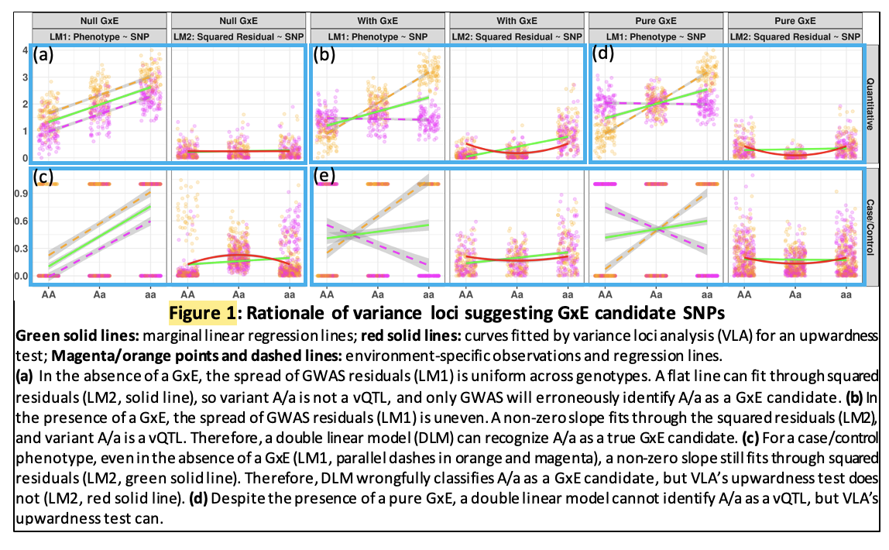

Simulation
We ran 20,000 repeats for each of three scenarios. For each simulation repeat, we generated vectors of the environment and covariates with a normal distribution and selected a genotype from an SNP randomly picked from Phase 3 of the 1000 Genomes Project (Consortium 2012; Consortium and others 2015) with an MAF≥0.01 and a sample size varying from 2⁴ to 2¹⁶. In all scenarios, we fixed the alpha to 0.05, where the null was rejected if the p-value was less than 0.05.
We treated phenotypes additively, as the sum of a strong covariate effect, weak genotype main effect, possible environmental main effect, and possible GxE effect. Both a pure GxE effect (scenario 1) and a GxE effect co-occurring with an environmental main effect (scenario 3) gave rise to additive variance loci. For comparison, we let the genotype directly affect the phenotypic variance in log scale (scenario 2), which gave rise to multiplicative variance loci. For each scenario, we also simulated a corresponding null scenario by zeroing out the GxE effect (the additive variance loci in scenarios 1 and 2) or the genetic effect on the logged phenotypic variance (the multiplicative variance loci in scenario 3). Next, for each scenario, we simulated a corresponding null scenario by zeroing out the GxE effect (additive variance loci in scenarios 1 and 3) or the genetic effect on logged phenotypic variance (multiplicative variance loci in scenario 2), rejecting the null in these latter scenarios added to a method’s false positive rate, or type 1 error. We considered a

test superior if it had a high true positive rate (power) while controlling the false positive rate (type 1 error). Accordingly, we used the net positive rate (i.e., the true positive rate minus the false positive rate) as an overall measure of performance.
For balanced binary phenotypes (i.e., a 50% case rate), the variance loci and genetic main effects became less distinguishable as the sample size increased, which increased the false positive rate (panels 1 and 3 of Figure 4b) at the cost of the net positive rate (panels 2 and 4 of Figure 4b). As a result, with the exception of VLA, none of the tests were able to control the false positive rate. VLA again had the best performance in detecting true candidate SNPs for pure GxE effects (solid red line in panel 2 of Figure 4b).

For imbalanced binary phenotypes (7.6% case rate), for which it is difficult to distinguish an SNP main effect on the phenotypic mean from the effect on the phenotypic variance, causing overall inflation of the false positive rate, VLA had the best performance in detecting true GxE candidates (Figure 2c).

Overall, the simulations showed that the VLA was better at detecting additive variance loci induced by pure GxE effects and more robust in the presence of false positives caused by imbalanced, non-Gaussian phenotypes. As expected, VLA underperformed with multiplicative variance loci because a negative allele effect on logged variance corresponds with an improper, non-real-valued additive GxE effect.
The supplement details the simulation and provides the full results, including true positive rates and values for multiplicative variance loci.

UKBB Genome Wide Variance Loci Analysis
To examine how each test selects variance loci, we applied all the tests (except DGLM due to low speed and instability) in BMI and T2D data from UKBB. We also performed GWAS with linear and logistic regression for BMI and T2D, respectively, and calculated five test statistics for each SNP.
We assembled two selection populations: 1) 353,605 unrelated British Whites and 2) 379,561 unrelated individuals of European ancestry, including all individuals in the first selection population in addition to Irish, and individuals with any European ancestry. The two selection populations included 9,298,089 and 9,298,331 SNPs, respectively, on chromosomes 1-22 and X with a working MAF > 0.1. The covariateswere age, sex, age², age×sex, age²×sex, the first 20 genetic principal components, and the genotyping array (a total of 26, including the intercept). Figure 3 shows Manhattan plots, QQ plots in both original [0, 1] and -log10(p) scale with a genomic inflation factor (λ_{GC}), based on second selection population. The supplements lists the most significant SNPs for each test.
LVT and DRM were abnormally positive on the X chromosome (Figure 3, orange circles) because the much lower frequency of the heterozygous genotype in men causes LVT and DRM to erroneously attribute phenotypic variance. Accordingly, we omitted the X-chromosome for LVT and DRM from subsequent analyses.
For BMI (Figure 3a, Table s2a), GWAS returned more significant SNPs with over-confidence (λ_{GC}=1.998). The four variance loci tests were distinguished from GWAS and separated the genetic effect on the phenotypic mean and variance with relative ease.
For T2D, except for the X chromosome, all five tests largely agreed on the most significant loci, reflecting the interchangeability of the genetic effect on phenotypic mean and variance for binary outcomes. However, VLA showed the least genomic inflation (λ_{GC}=1.02). Of note, SNP rs860262 on chromosome 7 basepair 28,194,397 and rs76895963 on chromosome 12 basepair 4,384,844 (GRCh37) were not selected by VLA but were by the other tests (Figure 3b, red circles in or table s1b, row 7 and 13). This may prove VLA to be more prudent when rs860262 and rs76895963 turned out to be inactive in GxE.

GxE Enrichment Analysis
To empirically gauge how well the top-ranked SNPs from a variance loci test in a selection population enrich the detection of significant GxE interactions in a discovery population, we performed an internal GxE enrichment assessment in sub-populations in the UKBB and an external assessment in the NC-based PEGS cohort.

Internal GxE enrichment

For BMI (Figure 4a), VLA was the most efficient SNP selector overall (Figure 4a, red) and has pronounced advantages over the other tests (Figure 4b, red). VLA was also more efficient for GxE SNPs with p-values < 5e-7. The supplement provides coefficient values and standard errors.
For T2D , DLM performed similarly as GWAS (Figure 4b, gray and green), indicating that phenotypic mean loci are also variance loci for non-Gaussian phenotypes. Accordingly, VLA is nearly colinear with GWAS and thus redundant; to a lesser degree, there was also redundancy for LVT and DRM at stricter GxE p-value thresholds. Correlation between SNP rankings (i.e., 1 – p value) measured redundancy from GWAS and other tests (DLM, 0.985; LVT, 0.613; DRM, 0.8871; VLA, 0.004). In contrast, for the quantitative BMI phenotype (Figure 4a), the four variance loci tests had distinct selection patterns from GWAS. The correlation between the GWAS-based ranking and tests was DLM (0.053), LVT (0.032), DRM, (0.012), and VLA (0.007).

External GxE Enrichment
We performed additional two-way GxE-WAS in an external discovery population with age, sex, income level, the first 10 principal components, and nominal variable coded ethnicity (European American, African American, Asian, and others) as covariates. BMI was also a covariate for the T2D analyses. We ranked SNPs using tests statistics for all tests based on the larger selection population.
After quality control, the selection and discovery populations shared 8,331,313 SNPs with a working MAF > 0.1 in the UKBB selection population (we did not enforce an MAF threshold in PEGS). We scored SNPs by the number of two-way GxE p-values below a series of p-value cut-offs (i.e., up to 728) and the overall sum of negative p-values and then regressed the scores on the rankings according to each test. The supplement provides coefficient and standard errors.
For BMI, SNPs ranked by VLA had the best chance of detecting highly significant GxE (p-value < 5e-7, …, 5e-9), and the second-best chance of detecting overall GXEs (3.82, se=0.34) in PEGS (Figures 4c and 4d). Interestingly, while DRM had by far the most conservative statistics for BMI (see Figure 3a), it resulted in the best overall enrichment (4.64, se=0.35) in the discovery cohort. For T2D, only VLA enriched the detection of medium-to-highly significant GxE with p-values < 5e-6, …, 5e-9 and overall GxEs (0.89, se=0.34) in the discovery cohort, while other tests showed negative coefficients (i.e., depletion) without exception. Again, the coefficients of DLM closely followed those GWAS and, to a lesser degree, DRM, reflecting the redundancy of the slope-based variance loci test for binary phenotypes.

Functional enrichment analysis
We also examined enrichment from a functional perspective, that is, which classes of SNPs were overrepresented among the significant loci identified by each test.
If the SNPs prioritized by a test are prone to a certain genomic function, the significant loci identified by that test should unevenly represent different types of SNPs. For example, GWAS loci are more frequent among SNPs in or near genes than between genes. We labeled each SNP as an intergenic, upstream, intronic, exonic, or downstream variant using ANNOVAR (K. Wang, Li, and Hakonarson 2010) and calculated the combined annotation dependent depletion (CADD) score (Kircher et al. 2014; Rentzsch et al. 2019) as a continuous measure of pathogenic tendency. We treated the functional labels as binary variables and CADD scores as continuous response variables and regressed them on the SNP rankings given by each test. A positive significant coefficient means the variance loci are over-represented among SNPs of certain types or with higher CADD scores. The supplement provides the functional enrichment coefficients for BMI and T2D.
For both phenotypes, all tests but VLA significantly underrepresented intergenic SNPs inside or near genes, and none prioritized exonic SNPs.
For BMI, VLA evenly selected all classes of SNPs (Figure 4e, red). DRM under-selected downstream SNPs (Figure 4e, orange), and the other three tests prioritized intronic SNPs and those with high CADD scores.
For T2D, VLA prioritized intergenic SNPs (Figure 4f, red) but not intronic SNPs or those with high CADD scores. The other four tests largely produced similar results, which is unsurprising given their redundancy regarding a binary phenotype.

PEGS GxE adjusted by UKBB Variance Loci
An exhaustive two-way GxE-WAS for T2D in the discovery cohort resulted in 10.8 trillion GxE test statistics (i.e., genome variants × exposome items). We retained 36.7 billion (0.40%) GxE that were 1) of or beyond moderate significance (P < 5e-4) and 2) matched by coordinates and alleles with variance loci from the previous analysis in the selection cohort. After binning the GxE and matched variance loci into genome segments, we selected the most significant GxE and variance loci per bin, further narrowing the number to 1,608,961 representative GxE (0.015%) and nearby variance loci. After multiple testing correction, further adjusting by the significance of variance loci allowed more SNPs and exposures to enter latter stage of database search than looking at the corrected p-values alone.

ABCB7 × Print Material on T2D

We found 10 genes, namely LINC02552, LINC02812, SLC25A3P1, LINC02812, SLC25A3P1, RNU6-61P, HNRNPA1P31, LINC01508, ABCB7, and BUD31P2, on or near the top 10,000 VLA-selected SNPs in the significant two-way GxE-WAS results (p-value < 5e-8) for T2D. Of interest is the significant interaction between T2D and X-chromosome gene ABCB7 (ATP binding cassette subfamily B member 7, X:75,051,048 - 75,156,732, ENSG00000131269), its immediate down-stream UPRT (uracil phosphoribosyl transferase homolog, X:75,156,388 - 75,304,885, ENSG00000094841), and exposure to dyes and inks (PEGS ID: A_B194*). The p-values and cumulative distribution function of variance loci of nearby significant variance loci found in the UK Biobank by GWAS (p-value = 1.24e-3, CDF = 7.52e-3), DLM (p-value = 1.94e-3, CDF = 7.18e-3), and VLA (p-value = 7.74e-5, CDF=1.47e-3) indicate VLA had better performance for identifying GxE near ABCB7-UPRT than GWAS and DLM.

The significant interaction between SNPs with printer toners provides corroborative evidence of the differential expression of ABCB7 among workers occupationally exposed to inkjet printers, archived as GEO dataset GSE142351 (Guo et al. 2020).

The expression of ABCB7 is an interesting finding because the gene is involved in metabolism and multi-drug resistance and is related to transport pathways of glucose and other sugars, bile salts and organic acids, metal ions, and amine compounds. Notably, the gene encodes a half-transporter involved in the transport of heme from the mitochondria to the cytosol. ABCB7 is also an ATP-dependent mitochondrial transporter implicated in Fe–S cluster assembly. Inherited mutations in ABCB7 have been linked to inherited and acquired sideroblastic anemia with cerebellar ataxia (18, 19), and the absence of ABCB7 impairs the maturation of cytosolic iron–sulfur proteins and induces iron accumulation in mitochondria. Further, knockdown of ABCB7 in HEK293T cells causes mitochondrial iron accumulation and the activation of SOD enzymes. This is important because iron and iron-regulatory proteins and cadmium alter ABCB7 expression, and some pigments in printer ink dyes, such as potash blue or soda blue pigments, contain iron based on ferro and ferric cyanides. Printer inks may also contain cadmium (20). Also of interest is the association of ABCB7 with fatty liver disease. This is notable because T2D is a major risk factor for fatty liver disease and could have common pathways (21, 22).

UKBB variance loci catalog
Inspired by the Pan-UK Biobank GWAS catalog at pan.ukbb.broadinstitute.org, we created and host a catalog of variance loci statistics for UKBB phenotypes and variants on the NIEHS website (genelist.niehs.nih.gov). The catalog is a public resource that can be queried by phenotype, enabling researchers to prioritize candidate variants most likely to invoke significant GxEs. Figure 8 illustrates the workflow of creating the catalog and the query process.
We summarized 1,580 health-relevant phenotypes chosen from UKBB data fields accessible to NIEHS plus an additional 1,693 diseases derived from hospital records using PHECODE, a codebook for extrapolating diseases using ICD9/10 records (www.phewascatalog.org) (39, 40) for a phenome comprising 3,273 items. We distinguished the selected UKBB phenotypes into binomial, multinomial, ordinal, and continuous variables and subsequently recoded and normalized them. For the genome, we limited the variants to those with an overall minor allele frequency of at least 0.005, for a final number of 11,841,785 variants after quality control measures. The materials section provides details of these processes.
For each of the four main racial/ethnic groups in the UKBB (British Whites, Irish, Blacks, and Asian), we performed VLA for the whole phenome and genome to archive variant statistics. We used the plinkFile and vla R packages to traverse the genome by window while scanning variance loci for thousands of phenotypes and variants. We divided the genome into approximately 1,200 groups of 10,000 variants each and summarized the VLA statistics for British Whites, which is the largest group in the UKBB, with a working sample size of 384,000 in 12 hours, using the NIH HPC Biowulf cluster (hpc.nih.gov).

Methods

Variance loci tests to identify GxE candidate SNPs
Given a quantitative trait, an SNP, and covariates, DLM fits a GWAS linear model, adjusting the covariates, and treats the squared residual as a “new phenotype”, subsequently fitting another GWAS linear model with the same SNP and covariates (Figure 10 left). If the SNP coefficient of linear model 2 is significant, we say the SNP is a vQTL, that is, a GxE candidate for that particular quantitative phenotype. Intuitively, the linear model 2 fits the squared distance from the fitted values of linear model 1 (i.e., conditional mean given the SNP and covariates), which amounts to modeling the phenotypic variance, since the mean of squared distance from the mean, is variance. VLA (variance loci analysis, Figure 10 right) slightly modifies DLM: (1) the second linear model uses squared SNP and (2) perform a one-sided t-test assuming non-negative coefficient. For a binary trait, the rare event (i.e., disease) is coded as 1 and the covariates should choose from non-heritable predictors; there is no need to replace linear model 1 with GLM (i.e., logistic regression).
In addition, we created R-language wrapper functions for deviation regression model (DRM), Levene’s Robust Test (LVT) from R-package “car” (citation), and double generalized linear model (DGLM) from R-package “dglm” (citation). Because DGLM is unstable with small samples and slow to compute for large ones, we used DGLM as a benchmark in simulation studies only.
Lastly, we considered the traditional GWAS as a reference GxE candidate selector. We use PLINK2’s “--glm” routine to fit GWAS linear model for body mass index (BMI), and logistic regression for type 2 diabetes (T2D). We only included GWAS for GxE enrichment and functional enrichment analysis.
More detailed description of the statistical tests is in supplement S2.

Two-way GxE-WAS
In a discovery cohort with normalized environment $u$ and standardized SNP $g$, GxE interaction effects are typically captured by adding a two-way product term $ug$ to a GWAS linear model,
$y=m_{0}+ag+bug+cu+dx+e$,
where $e$ is a vector of Gaussian noise and $x$ is the covariate; rejecting $h_{0}:b=0$ at a given p-value threshold suggest the GxE interaction between SNP $g$ and environment $u$. The above is repeated for all 2-way combinations of SNPs and environmental exposures, which, for PEGS, means a total of 14,874,008 x 765 models; for white non-British in the UKBB, the combination is 9,298,089 x 16. We exhaustively analyzed all the two-way combination for demonstrative purpose, in an actual application, one should query the VLA-catalog and limit the GxE-WAS among top ranking SNPs or/and those below a p-value threshold for shorter running time and mitigated multiple testing.

UK Biobank (UKBB) data
To evaluate the performance of VLA in selecting GxE candidates, we used data from the UKBB, a large-scale resource consisting of genetic and health information for over half a million participants (Application ID: 57849, version 2) collected via questionnaires, electronic health records, biological samples, oral interviews, imaging, and genotype data. For genotype data,

using the imputed genotype, we created a comprehensive catalog of the whole genome. After quality control, we divided the remaining individuals into five major ancestry groups—African (afr), non-Chinese Asian (asi), White British (bri), Irish (iri), and White but non-British (wnb)— leaving 375,992 individuals. These ancestry groups are the basis of the NIEHS VLA Catalog, and the bri and wnb groups serve as training and testing datasets, respectively. Details can be found in the supplement. For phenotype data,

we manually compiled UKBB phenotype data, which is summarized in Table 2, for T2D, CAD, BMI, and fasting glucose level. For environmental data, we used

data on 16 environmental variables in UKBB, which are outlined in Table 3.

We also derived phecodes using phenotypes and disease diagnoses from electronic health record (EHR) data for UKBB participants recorded as International Classification of Diseases (ICD) codes (40) (41) (40, 42). The supplement provides details of how we compiled the phenotypes, including criteria and the UKBB data fields used as well as details of our phecode mapping.

PEGS data
For the external GxE enrichment analysis, we used data from the Personalized Gene and Environment Study (PEGS), a North Carolina-based cohort of 19,672 participants of varying age, race, socioeconomic status, and education level. Whole-genome sequencing data is available for 4,610 participants. We used questionnaire-based exposome data in its original form for binary and integer-based items.

We derived T2D and BMI phenotype data from the survey data. The Supplement provides information on case/control definitions and quality control.

Discussion
Using VLA, we scanned more than 11 million SNPs in the UKBB White British population and selected the top 1% most significantly associated with the variance of T2D status as candidates for GxEs. By querying the VLA catalog for T2D status in the UKBB Irish population, we narrowed down the candidates to fewer than 10,000 variants. Due to the compactness of candidate variants, it was statistically practical to search for significant GxEs for T2D among the more than 700 environmental exposures for which PEGS collected information. The significant GxEs pointed to genes associated with fatty liver disease and differentially expressed among individuals with ink, paint, and pesticide exposures, suggesting targets for intervention in the identified genes and in workplaces containing these materials. Considering ABCB7 as an exemplar gene, we validated our GxE analysis in the PEGS cohort.
GxE enrichment analysis results in both the internal discovery population of UKBB non-British Whites (Figure 6) and the external discovery population of PEGS participants (Figure 7) demonstrate the advantages of VLA in prioritizing GxE candidates for binary phenotypes such as T2D and CAD. The advantage is more pronounced for PEGS, as it contains a much wider range of involved environmental exposures (728 vs. 16 in the UKBB). The link between the phenotypic mean and variance of binary phenotypes renders the vQTL statistics obtained from DLM redundant to the QTL statistics obtained from GWAS, as demonstrated by the nearly overlapping enrichment curves of GWAS and vQTL for binary phenotypes (Figures 6 and 7, T2D and CAD, red and blue). For quantitative phenotypes, vQTL statistics indicate the method has greater power than GWAS to select GxE candidates, as demonstrated by varying enrichment curves for vQTL and GWAS (Figures 6 and 7, BMI and GLU, red and blue). vQTL is ideal for phenotypes that are nearly perfectly Gaussian, such as GLU. In this scenario, GWAS lacks power to select GxE candidates, as demonstrated by separation of the phenotypic mean and variance. For quantitative phenotypes that are not fully Gaussian, such as BMI, GWAS has some demonstrated ability to select GxE candidates because vQTL and QTL are somewhat related.
When treating GLU as a quantitative surrogate of T2D, the GWAS provided the best overall GxE candidate ranking based on statistics (Figure 7, panel 3, GLU/T2D). For T2D without a surrogate, GWAS provided better enrichment coefficients (e.g., 0.0125 at 10⁻²) than VLA (e.g., 0.0025 at 10⁻², Figure 7, panel 1, T2D). However, the choice of GLU as a surrogate for T2D depends on prior knowledge and subjective judgement (e.g., BMI is also a potential surrogate of T2D) and thus such a technique is unsuitable for automated GxE hypothesis exploration before weighting and choosing surrogates, which is also an automated process. Despite these limitations, we provide the GWAS p-values in addition to VLA p-values for each phenotype in the VLA catalog to allow surrogate GxE candidate rankings based on subjective knowledge of disease etiology.
VLA was initially proposed as an additive vQTL scanner that prioritizes pure GxE effects and improves on existing two-stage methods such as DLM, DRM and LVT concerning the quality of GxE candidates selected for quantitative traits. However, after transforming simulated Gaussian phenotypes to case/control status via a logistic function and Bernoulli sampling, VLA was consistently conservative while DLM, DRM, and LVT resulted in uncontrolled type 1 errors with non-zero genetic effects on the original Gaussian phenotypic mean. To address this, we scanned variance loci for binary phenotypes using VLA in conjunction with covariates. This approach is based on the concept that the adjusted binary phenotypes of covariates can be treated as new phenotypes that more clearly represent combined genotype and environment effects. vQTL scanners can be used with high-quality, quantitative covariates. To ensure control of type 1 errors with lower-quality covariates, we used the curve upwardness test for VLA. A combined DLM and VLA test for statistical power to detect variance loci was unable to control type 1 errors unless the covariates were perfect.
The best covariates are non-confounding predictors, which, in essence, are variables unaffected by the genotype or environment yet associated with the outcome. Such covariates have been shown to improve statistical power in GWAS and epidemiology studies (Aschard et al. 2015). If covariates are non-confounding, adjusting them neither removes the genetic or environmental effect on the phenotype nor creates spurious associations between the genotype/environment and the phenotype. For a covariate to be predictive, after removing the effect of the covariate, the adjusted phenotype becomes closer to the combined genotype/environment effect than the original phenotype. Recommend covariates are age and age², or more than three age bins (e.g., <20, 20-40, 40-60, >60 years), because age is unaffected by the genotype or environment but predictive of most diseases. Sex, age × sex, and age² × sex can also be used if a disease affects both sexes and the analysis is limited to autosomes.
If the genotype and the environment (e.g., pollution and climate) are considered precursors of all phenotypes, confounding predictors are either mediators or colliders linking the precursors and the outcomes. Adjusting either attenuates (for mediators) or inflates (for colliders) the genetic and environmental effects (Hernán et al. 2002). However, some confounding predictors are useful, including genetic principal components. Although the components are the weighted sum of common genome variants, the association between a component and a single variant is typically insignificant. A contrasting example is the use of BMI and socioeconomic status (SES) variables (e.g., income and education) as adjusted covariates in T2D studies. BMI can be both a mediator and a collider because it is both heritable and an indicator of T2D risk, and T2D onset can reversely affect BMI through changes in lifestyle. Accordingly, we did not include BMI and SES in the VLA scan in the UKBB White British population.
Using VLA to identify GxE candidates for binary phenotypes enables analysis of a large number of case/control outcomes collected in a sizable cohort such as the UKBB. Archive VLA statistics as a reference for research on the environmental genetic effects on health motivated creation of the NIEHS-hosted VLA Catalog. For binary phenotypes, a logit linked, iteratively optimized binomial linear model is typically chosen for association analysis due to its befitting interpretation of the odds ratio per additional allele and predicted probability, which never exceeds the range of the phenotype (i.e., 0=control, 1=case). In contrast, plain linear models optimizable in close form are adopted for two-stage VLA (i.e., ordinary least squares) because the priority is not interpretating odds ratios and predicting binomial probability but quickly ranking variants’ potential to invoke GxE effects for a phenotype. Additionally, the logit link function $f\left(x\right)={\left[exp\left(1+x\right)\right]}^{-1}$ is monotonic and closely approximated by the trivial identity link function $f\left(x\right)=x$ near $x=0$. Therefore, the significance and direction of a variant effect identified by a logit linked binomial linear model can also be recognized by a plain linear model. The simplicity of VLA allows the rapid ranking of variants for multiple phenotypes en masse, facilitating creation of the VLA Catalog based on rich phenome (3,237 phenotypes, of which 1,693 are binary) and genome data from the UKBB.
Despite the use of VLA to select candidate variants for GxEs, type 1 errors are still inflated in simulations with highly imbalanced case/control ratios and large allele effects on the phenotypic mean. In this scenario, VLA performs similar to GWAS based on statistics. Specifically, effects on the phenotypic mean become indistinguishable from effects on phenotypic variance, causing VLA to identify variants not involved in a GxE as variance loci. In practice, however, this issue is mitigated by the fact that for complex diseases like T2D and CAD, few if any variants exert clinically noticeable marginal effects, but tens of thousands of variants exert clinically weak but statistically significant effects. To demonstrate this phenomenon, we used GWAS to select the top 1% most significant autosome variants (p <0.01) and inspected the correlations between the p-values given by GWAS, VLA, and additive vQTL analysis (although vQTL is intended for quantitative phenotypes only). For T2D in the UKBB White British population, the correlation between GWAS and VLA was nearly 0 but 0.79 between GWA and vQTL analysis. For CAD, the correlation between GWAS and VLA was again nearly 0 but 0.85 between GWAS and vQTL analysis. The unrelatedness between GWAS and VLA statistics means the latter ranks variants differently from the former and thus offers a unique perspective in selecting GxE candidates. Conversely, the high correlation between GWAS and vQTL statistics means the latter is redundant concerning binary phenotypes. For quantitative phenotypes such as BMI, the correlation between GWAS and VLA is 0, and the correlation between GWAS and vQTL analysis is as low as 0.04, reflecting the fact that vQTL analysis is appropriate for quantitative traits only. Because the p-values for additive vQTL are close to p-values for GWAS, we set the latter to NaN for all 1,698 binary phenotypes in the VLA Catalog.
Besides serving as a reference database for gene-by-environment analysis, the VLA Catalog can also aid summary statistics-based analysis. In polygenic risk score (PRS)-based prediction, PRS is the sum of allele dosage in a discovery cohort weighted by GWAS statistics from a training cohort. Because VLA statistics are sufficiently distinct from GWAS statistics yet relevant to the phenotype of interest, they can be considered an alternative weight vector for calculating PRS. A discovery model can improve overall fit and subsequent prediction by using two PRS vectors based on GWAS and VLA, respectively, or better, by including additional vector products between VLA-based PRS and environments of interest. Since VLA-significant variants are more evenly distributed in the entire genome compared to GWAS-significant variants, using VLA for variant weights can enable pathway analysis to identify alternative sets of regions affecting a disease phenotype.
A next step is better countering type 1 errors caused by imbalanced outcomes (e.g., case/control outcomes) in a prospective cohort and Poisson-distributed phenotypes, where it is difficult to separate the allele effect on the mean and variance. In a simulation study, we dropped the intercept term in stage-1 VLA model, forcing it to recognize 0.5 as the mean of an imbalanced binary phenotype (i.e., 0=control, 1=case). Type 1 errors were controlled when the simulated GxE effect was null, but statistical power substantially decreased when the GxE effect was non-null. Another approach is including additional non-confounding predictive covariates to break up the underlying risk of a discrete trait into a finer gradient closely resembling a Gaussian variable. However, besides age and sex, there are few covariates universally collected by cohort studies guaranteed to be free of genetic and environment effects yet predictive of outcomes. In the future, however, we anticipate that GWAS, vQTL (for quantitative phenotypes), and VLA statistics will be included for genotyped cohorts as a common practice to facilitate science on genetic and environmental effects on health.

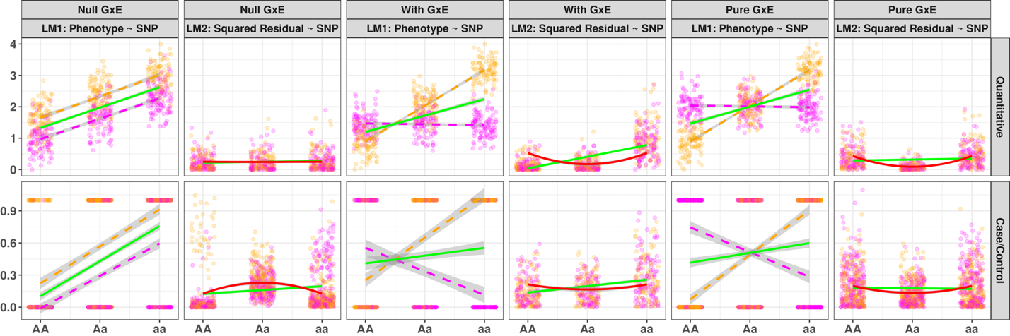
Figure 1: Rationale of variance loci suggesting GxE candidate SNPs
Green solid lines: marginal linear regression lines; red solid lines: curves fitted by variance loci analysis (VLA) for an upwardness test; Magenta/orange points and dashed lines: environment-specific observations and regression lines.
(a) In the absence of a GxE, the spread of GWAS residuals (LM1) is uniform across genotypes. A flat line can fit through squared residuals (LM2, solid line), so variant A/a is not a vQTL, and only GWAS will erroneously identify A/a as a GxE candidate. (b) In the presence of a GxE, the spread of GWAS residuals (LM1) is uneven. A non-zero slope fits through the squared residuals (LM2), and variant A/a is a vQTL. Therefore, a double linear model (DLM) can recognize A/a as a true GxE candidate. (c) For a case/control phenotype, even in the absence of a GxE (LM1, parallel dashes in orange and magenta), a non-zero slope still fits through squared residuals (LM2, green solid line). Therefore, DLM wrongfully classifies A/a as a GxE candidate, but VLA’s upwardness test does not (LM2, red solid line). (d) Despite the presence of a pure GxE, a double linear model cannot identify A/a as a vQTL, but VLA’s upwardness test can.

(a)
(b)

(c)
(d)

(e)

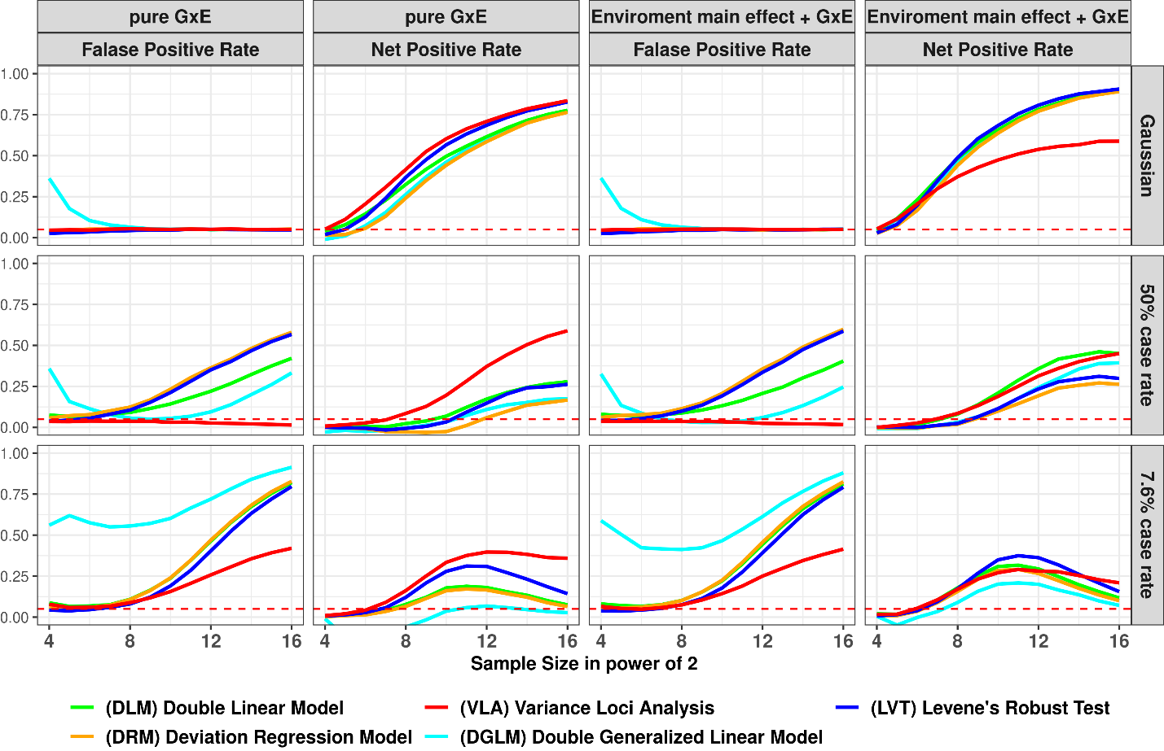
Figure 2: False Positive and Net Positive rates of Simulation Studies
Column 1 and 3: GxE is null, the y-axis is false positive rates (FPR), an FPR of 0.05 (denoted by red dashes) is proper, higher FPR suggest over confidence, lower means overly conservative; Column 2 and 4: additive variance loci induced by pure GxE, or GxE coexisting with standalone environmental main effect, in these cases the y-axis are net positive rates (NPR), higher means better; x-axis: sample sizes in powers of 2; colors: statistical tests.
(a)
(b)
(c)

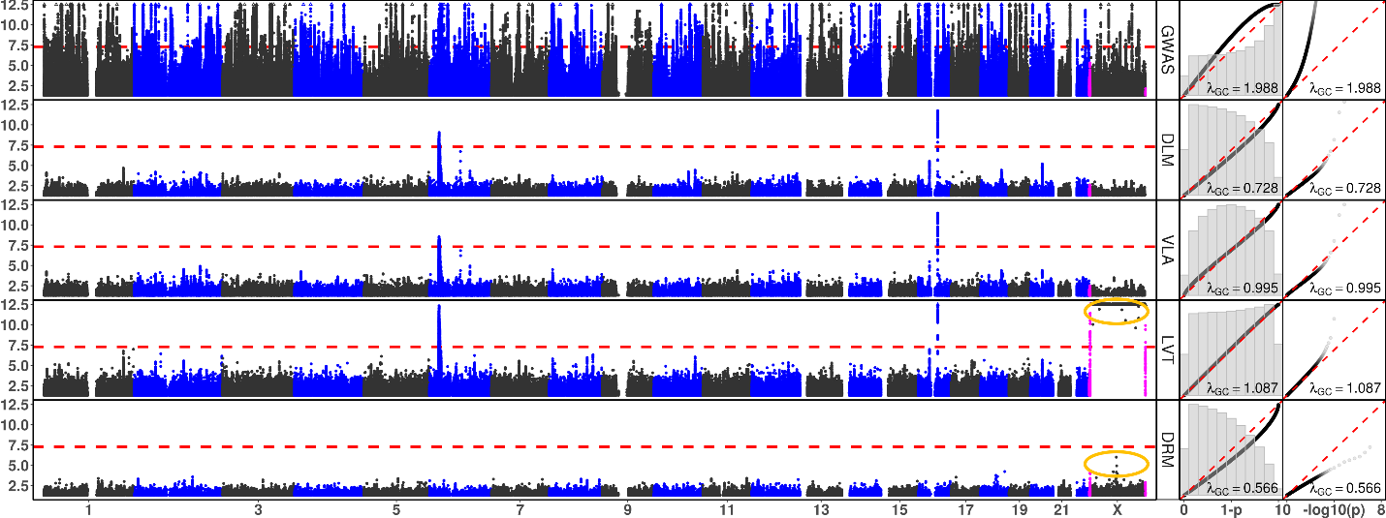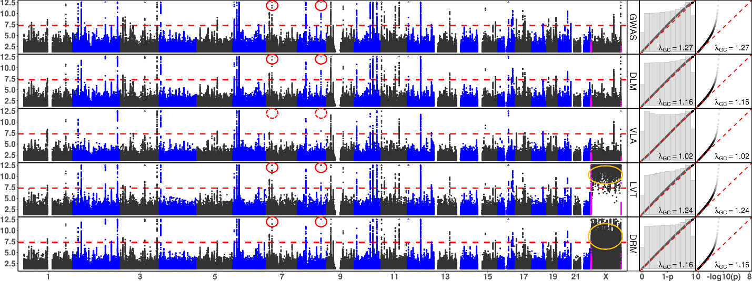
Figure 3: Manhattan and QQ Plots, with λ_{GC}
x-axis: chromosomes (Manhattan plot), theoretical 1 - p (QQ plot 1), or theoretical -log₁₀(p) (QQ plot 2); y-axis: -log₁₀(p) (Manhattan and QQ plot 2), or 1 - p (QQ plot 1); red dash: significance threshold -log₁₀(5e-8) (Manhattan plot); each point bins 269,534 basepairs; magenta points pseudo-autosome regions (PAR) in X; orange circle: abnormal p-values excluded from QQ plots and λ_{GC}; rows: statistical tests, GWAS = genome wide association study; DLM = double linear model, VLA = variance loci analysis (upwardness test), LVT = Levene’s robust test, DRM = Deviation Regression Model; red circle: rs860262 (Chr7) and rs76895963 (Chr12) avoided by VLA but picked up by other tests.

(a) Body Mass Index

(b) Type 2 Diabetes

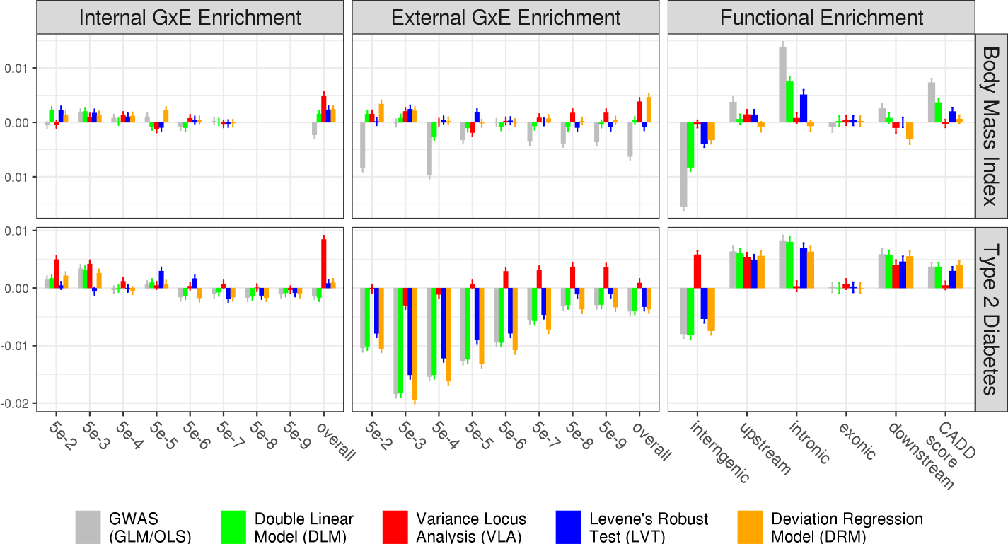

(a)
(c)
(d)
(b)

(f)
(e)
Figure 4: Empirical GxE and Functional Enrichment Analysis
top: results for body mass index (BMI); bottom: results for type 2 diabetes (T2D); (a)(b)(c)(d): GxE enrichment analysis, x-axis denotes the level of GxE significance by p-value used to score a SNP’s GxE activeness, “overall” means scoring a SNP by the sum of negative log p-values of GxE across all exposome items; the y-axis are GxE enrichment coefficient, higher means better statistical test; (e)(f): functional enrichment analysis, x-axis enumerate SNP labels, CADD score stands for “combined annotation dependent depletion” score, in this case, lower or higher enrichment is merely descriptive that does not suggest good or bad statistical test; the missing bars in (a) was due to the absence of significant GxE p-value for BMI reaching for 5e-8 and lower.

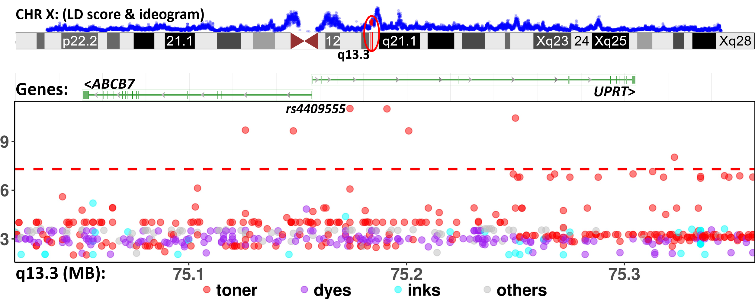

Figure 5: GxE interaction between SNPs in ABCB7-UPRT and print materials associated with T2D in PEGS
The Manhattan plot shows unadjusted -log₁₀(P) (y-axis) for GxE due to SNPs between X: 75,020,000 - 75,360,000 (x-axis) and exposures to print materials (colored points); The gene bars shows ABCB7 and UPRT (rendered by NCBI genome viewer); the ideogram on top shows chromosome X (rendered by UCSC genome browser), the enclosing region q13.3 (red), and LD scores (blue) based on 3104 genotyped females (68.4%) in PEGS; the GxE between SNPs in ABCB7-UPRT and toner (red points) reached beyond conventional genome wide significance (-log₁₀(5e-8), red horizontal dash). Although the smallest p-value (rs4409555, 9.25e-12) did not guarantee significance after Bonferroni correction over 4.74 billion selectable GxE tests, the region was prioritized by significant variance loci found by VLA in the UK Biobank.

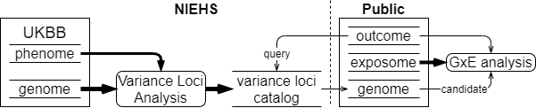
Figure 9: UKBB variance loci catalog workflow

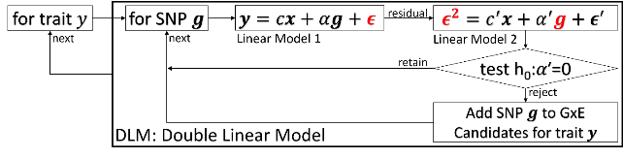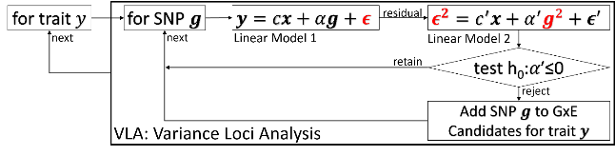
Figure 10: diagram of double linear model (DLM, left) and variance loci analysis (VLA, right)
 | Description | N | Min | Median | Mean | Max | Histogram
BMI | Body mass index | 489955 | 18.0 | 26.7 | 27.4 | 48.0 | 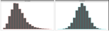
T2D | Type 2 diabetes | 493619 | 0.0 | 0.0 | 0.1 | 1.0 | 
Table 2. UK Biobank Phenotypes Used
The histogram shows distributions before and after normalization. Distributions after normalization were included in the analysis.

 | Description | N | Min | Med | Mean | Max | 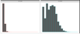  Histogram
ALC | Weekly alcohol intake | 427697 | 0.0 | 8.0 | 11.9 | 603.0
DGP | Domestic garden percentage | 440874 | 0.1 | 24.3 | 24.3 | 66.1 | 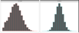  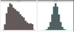
GSP | Green space percentage | 440874 | 4.4 | 41.5 | 45.0 | 99.2
MET | Metabolic equivalent minutes | 498628 | 0.0 | 1386.0 | 2553.7 | 125118.0 | 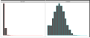
NEP | Nature environment percentage | 497542 | 0.0 | 36.6 | 40.5 | 100.0 | 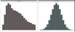
NO1 | Nitrogen oxide | 495124 | 19.7 | 42.4 | 44.1 | 265.9 | 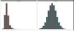  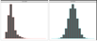
NO2 | Nitrogen dioxide | 495124 | 5.1 | 21.3 | 22.4 | 98.6 | 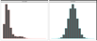
NOI | Noise | 495124 | 46.7 | 50.1 | 51.2 | 88.5
PM1 | Air pollution, PM10 | 495113 | 5.9 | 19.0 | 18.6 | 30.5 | 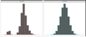
PM2 | Air pollution, PM2.5 | 461201 | 8.2 | 9.9 | 10.0 | 21.3 | 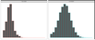
SDN | Sedentary behavior | 500967 | 0.0 | 4.0 | 4.5 | 48.0 | 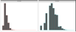
SEA | Distance to coast | 497542 | 0.0 | 44.0 | 41.6 | 108.0 | 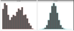  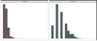
SIB | Number of siblings | 493402 | 0.0 | 2.0 | 2.2 | 44.0 | 
SMK | Ever smoke | 499620 | 0.0 | 1.0 | 0.6 | 1.0
TRF | Traffic intensity | 495124 | 0.8 | 78.2 | 172.6 | 100810.0 | 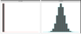  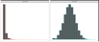
WTP | Water percentage | 440874 | 0.0 | 0.5 | 1.3 | 59.4
Table 3. UK Biobank Exposome (16 items)
The histograms show distributions before and after normalization. Distributions after normalization were included in the analysis.

References
Aschard, Hugues, Bjarni J. Vilhjálmsson, Amit D. Joshi, Alkes L. Price, and Peter Kraft. 2015. “Adjusting for Heritable Covariates Can Bias Effect Estimates in Genome-Wide Association Studies.” The American Journal of Human Genetics 96 (2): 329–39.
Chang, Christopher. 2021. “PLINK Binary Biallelic Genotype Table.” June 2021. https://www.cog-genomics.org/plink/1.9/formats#bed.
———. 2022. “PLINK 2.0 Association Analysis: Option --Glm.” March 31, 2022. https://www.cog-genomics.org/plink/2.0/assoc#glm.
Consortium, 1000 Genomes Project. 2012. “An Integrated Map of Genetic Variation from 1,092 Human Genomes.” Nature 491 (7422): 56–65.
Consortium, 1000 Genomes Project and others. 2015. “A Global Reference for Human Genetic Variation.” Nature 526 (7571): 68.
Eichler, Evan E., Jonathan Flint, Greg Gibson, Augustine Kong, Suzanne M. Leal, Jason H. Moore, and Joseph H. Nadeau. 2010. “Missing Heritability and Strategies for Finding the Underlying Causes of Complex Disease.” Nature Reviews Genetics 11 (6): 446–50.
Hernán, Miguel A., Sonia Hernández-Díaz, Martha M. Werler, and Allen A. Mitchell. 2002. “Causal Knowledge as a Prerequisite for Confounding Evaluation: An Application to Birth Defects Epidemiology.” American Journal of Epidemiology 155 (2): 176–84. https://doi.org/10.1093/aje/155.2.176.
Kircher, Martin, Daniela M Witten, Preti Jain, Brian J O’roak, Gregory M Cooper, and Jay Shendure. 2014. “A General Framework for Estimating the Relative Pathogenicity of Human Genetic Variants.” Nature Genetics 46 (3): 310–15.
Marderstein, Andrew R., Emily R. Davenport, Scott Kulm, Cristopher V. Van Hout, Olivier Elemento, and Andrew G. Clark. 2021. “Leveraging Phenotypic Variability to Identify Genetic Interactions in Human Phenotypes.” The American Journal of Human Genetics 108 (1): 49–67.
Paré, Guillaume, Nancy R. Cook, Paul M. Ridker, and Daniel I. Chasman. 2010. “On the Use of Variance per Genotype as a Tool to Identify Quantitative Trait Interaction Effects: A Report from the Women’s Genome Health Study.” PLoS Genetics 6 (6): e1000981.
“PEGS: Personalized Environment and Genes Study.” n.d. National Institute of Environmental Health Sciences. Accessed November 14, 2021. https://www.niehs.nih.gov/research/clinical/studies/pegs/index.cfm.
Rentzsch, Philipp, Daniela Witten, Gregory M. Cooper, Jay Shendure, and Martin Kircher. 2019. “CADD: Predicting the Deleteriousness of Variants throughout the Human Genome.” Nucleic Acids Research 47 (D1): D886–94.
Tong, Xiaoran. 2022a. R-Package: (Github) PlinkFile (version 0.2.1). R. https://github.com/xiaoran831213/plinkFile.
———. 2022b. R-Package: Vla (Github) (version 0.1.0). R. https://github.com/xiaoran831213/vla.
Van Ijzendoorn, Marinus H, Marian J Bakermans-Kranenburg, Jay Belsky, Steven Beach, Gene Brody, Kenneth A Dodge, Mark Greenberg, Michael Posner, and Stephen Scott. 2011. “Gene-by-Environment Experiments: A New Approach to Finding the Missing Heritability.” Nature Reviews Genetics 12 (12): 881–881.
Wang, Huanwei, Futao Zhang, Jian Zeng, Yang Wu, Kathryn E Kemper, Angli Xue, Min Zhang, et al. 2019. “Genotype-by-Environment Interactions Inferred from Genetic Effects on Phenotypic Variability in the UK Biobank.” Science Advances 5 (8): eaaw3538.
Wang, Kai, Mingyao Li, and Hakon Hakonarson. 2010. “ANNOVAR: Functional Annotation of Genetic Variants from High-Throughput Sequencing Data.” Nucleic Acids Research 38 (16): e164–e164.
Wei, Wei-Qi, Lisa A. Bastarache, Robert J. Carroll, Joy E. Marlo, Travis J. Osterman, Eric R. Gamazon, Nancy J. Cox, Dan M. Roden, and Joshua C. Denny. 2017. “Evaluating Phecodes, Clinical Classification Software, and ICD-9-CM Codes for Phenome-Wide Association Studies in the Electronic Health Record.” PloS One 12 (7): e0175508.
Wu, Patrick, Aliya Gifford, Xiangrui Meng, Xue Li, Harry Campbell, Tim Varley, Juan Zhao, Robert Carroll, Lisa Bastarache, and Joshua C. Denny. 2019. “Mapping ICD-10 and ICD-10-CM Codes to Phecodes: Workflow Development and Initial Evaluation.” JMIR Medical Informatics 7 (4): e14325.

References
1. Eichler EE, Flint J, Gibson G, Kong A, Leal SM, Moore JH, et al. Missing heritability and strategies for finding the underlying causes of complex disease. Nat Rev Genet. 2010;11(6):446-50.
2. van Ijzendoorn MH, Bakermans-Kranenburg MJ, Belsky J, Beach S, Brody G, Dodge KA, et al. Gene-by-environment experiments: a new approach to finding the missing heritability. Nat Rev Genet. 2011;12(12):881; author reply
3. Cao Y, Wei P, Bailey M, Kauwe JSK, Maxwell TJ. A versatile omnibus test for detecting mean and variance heterogeneity. Genet Epidemiol. 2014;38(1):51-9.
4. Deng WQ, Asma S, Paré G. Meta-analysis of SNPs involved in variance heterogeneity using Levene's test for equal variances. Eur J Hum Genet. 2014;22(3):427-30.
5. Struchalin MV, Amin N, Eilers PH, van Duijn CM, Aulchenko YS. An R package "VariABEL" for genome-wide searching of potentially interacting loci by testing genotypic variance heterogeneity. BMC Genet. 2012;13:4.
6. Yang J, Loos RJ, Powell JE, Medland SE, Speliotes EK, Chasman DI, et al. FTO genotype is associated with phenotypic variability of body mass index. Nature. 2012;490(7419):267-72.
7. Paré G, Cook NR, Ridker PM, Chasman DI. On the use of variance per genotype as a tool to identify quantitative trait interaction effects: a report from the Women's Genome Health Study. PLoS Genet. 2010;6(6):e1000981.
8. Smyth GK. Generalized linear models with varying dispersion. Journal of the Royal Statistical Society: Series B (Methodological). 1989;51(1):47-60.
9. Lee Y, Nelder JA. Double hierarchical generalized linear models (with discussion). Journal of the Royal Statistical Society: Series C (Applied Statistics). 2006;55(2):139-85.
10. Rönnegård L, Felleki M, Fikse F, Mulder HA, Strandberg E. Genetic heterogeneity of residual variance - estimation of variance components using double hierarchical generalized linear models. Genet Sel Evol. 2010;42(1):8.
11. Rönnegård L, Valdar W. Detecting major genetic loci controlling phenotypic variability in experimental crosses. Genetics. 2011;188(2):435-47.
12. Marderstein AR, Davenport ER, Kulm S, Van Hout CV, Elemento O, Clark AG. Leveraging phenotypic variability to identify genetic interactions in human phenotypes. Am J Hum Genet. 2021;108(1):49-67.
13. Wang H, Zhang F, Zeng J, Wu Y, Kemper KE, Xue A, et al. Genotype-by-environment interactions inferred from genetic effects on phenotypic variability in the UK Biobank. Sci Adv. 2019;5(8):eaaw3538.
14. Brown MB, Forsythe AB. Robust tests for the equality of variances. Journal of the American Statistical Association. 1974;69(346):364-7.
15. Levene H. Robust tests for equality of variances. Contributions to probability and statistics Essays in honor of Harold Hotelling. 1961:279-92.
16. Bycroft C, Freeman C, Petkova D, Band G, Elliott LT, Sharp K, et al. The UK Biobank resource with deep phenotyping and genomic data. Nature. 2018;562(7726):203-9.
17. Sudlow C, Gallacher J, Allen N, Beral V, Burton P, Danesh J, et al. UK biobank: an open access resource for identifying the causes of a wide range of complex diseases of middle and old age. PLoS Med. 2015;12(3):e1001779.
18. Pain D, Dancis A. Roles of Fe-S proteins: from cofactor synthesis to iron homeostasis to protein synthesis. Curr Opin Genet Dev. 2016;38:45-51.
19. Allikmets R, Raskind WH, Hutchinson A, Schueck ND, Dean M, Koeller DM. Mutation of a putative mitochondrial iron transporter gene (ABC7) in X-linked sideroblastic anemia and ataxia (XLSA/A). Hum Mol Genet. 1999;8(5):743-9.
20. Podhajny RM. A Brief Chemistry Lesson On Printing Ink Pigments. Paper, Film & Foil Converter Magazine [Internet]. 2001. Available from: https://www.pffc-online.com/magazine/782-paper-brief-chemistry-lesson.
21. Silaghi CA, Silaghi H, Colosi HA, Craciun AE, Farcas A, Cosma DT, et al. Prevalence and predictors of non-alcoholic fatty liver disease as defined by the fatty liver index in a type 2 diabetes population. Clujul Med. 2016;89(1):82-8.
22. Lonardo A, Lugari S, Ballestri S, Nascimbeni F, Baldelli E, Maurantonio M. A round trip from nonalcoholic fatty liver disease to diabetes: molecular targets to the rescue? Acta Diabetol. 2019;56(4):385-96.
23. Xiao L, Shi XY, Li ZL, Li M, Zhang MM, Yan SJ, et al. Downregulation of LINC01508 contributes to cisplatin resistance in ovarian cancer via the regulation of the Hippo-YAP pathway. J Gynecol Oncol. 2021;32(5):e77.
24. Gui W, Zhu WF, Zhu Y, Tang S, Zheng F, Yin X, et al. LncRNAH19 improves insulin resistance in skeletal muscle by regulating heterogeneous nuclear ribonucleoprotein A1. Cell Commun Signal. 2020;18(1):173.
25. Wang J, Yang W, Chen Z, Chen J, Meng Y, Feng B, et al. Long Noncoding RNA lncSHGL Recruits hnRNPA1 to Suppress Hepatic Gluconeogenesis and Lipogenesis. Diabetes. 2018;67(4):581-93.
26. Liu D, Liu F, Li Z, Pan S, Xie J, Zhao Z, et al. HNRNPA1-mediated exosomal sorting of miR-483-5p out of renal tubular epithelial cells promotes the progression of diabetic nephropathy-induced renal interstitial fibrosis. Cell Death Dis. 2021;12(3):255.
27. Zhao M, Shen L, Ouyang Z, Li M, Deng G, Yang C, et al. Loss of hnRNP A1 in murine skeletal muscle exacerbates high-fat diet-induced onset of insulin resistance and hepatic steatosis. J Mol Cell Biol. 2020;12(4):277-90.
28. Wei WQ, Bastarache LA, Carroll RJ, Marlo JE, Osterman TJ, Gamazon ER, et al. Evaluating phecodes, clinical classification software, and ICD-9-CM codes for phenome-wide association studies in the electronic health record. PLoS One. 2017;12(7):e0175508.
29. Wu P, Gifford A, Meng X, Li X, Campbell H, Varley T, et al. Mapping ICD-10 and ICD-10-CM Codes to Phecodes: Workflow Development and Initial Evaluation. JMIR Med Inform. 2019;7(4):e14325.
30. Chang CC, Chow CC, Tellier LC, Vattikuti S, Purcell SM, Lee JJ. Second-generation PLINK: rising to the challenge of larger and richer datasets. Gigascience. 2015;4(1):s13742-015-0047-8.
31. Purcell S, Neale B, Todd-Brown K, Thomas L, Ferreira MA, Bender D, et al. PLINK: a tool set for whole-genome association and population-based linkage analyses. Am J Hum Genet. 2007;81(3):559-75.
32. Chang CC. Plink binary biallelic genotype table 2021 [Available from: https://www.cog-genomics.org/plink/1.9/formats#bed.
33. Abecasis GR, Auton A, Brooks LD, DePristo MA, Durbin RM, Handsaker RE, et al. An integrated map of genetic variation from 1,092 human genomes. Nature. 2012;491(7422):56-65.
34. Auton A, Brooks LD, Durbin RM, Garrison EP, Kang HM, Korbel JO, et al. A global reference for human genetic variation. Nature. 2015;526(7571):68-74.
35. National Institute of Environmental Health Sciences. Personalized Environment and Genes Study Data Freeze 1.1. 2021.
36. Wang K, Li M, Hakonarson H. ANNOVAR: functional annotation of genetic variants from high-throughput sequencing data. Nucleic Acids Res. 2010;38(16):e164.
37. Kircher M, Witten DM, Jain P, O'Roak BJ, Cooper GM, Shendure J. A general framework for estimating the relative pathogenicity of human genetic variants. Nat Genet. 2014;46(3):310-5.
38. Rentzsch P, Witten D, Cooper GM, Shendure J, Kircher M. CADD: predicting the deleteriousness of variants throughout the human genome. Nucleic Acids Res. 2019;47(D1):D886-d94.
39. Wei W-Q, Bastarache LA, Carroll RJ, Marlo JE, Osterman TJ, Gamazon ER, et al. Evaluating phecodes, clinical classification software, and ICD-9-CM codes for phenome-wide association studies in the electronic health record. PLOS ONE. 2017;12(7):e0175508.
40. Wu P, Gifford A, Meng X, Li X, Campbell H, Varley T, et al. Developing and Evaluating Mappings of ICD-10 and ICD-10-CM codes to Phecodes. BioRxiv. 2019;
:462077.
41. World Health Organization. International Statistical Classification of Diseases and Related Health Problems (ICD) 2021 [Available from: https://www.who.int/standards/classifications/classification-of-diseases.
42. Bastarache L. Using Phecodes for Research with the Electronic Health Record: From PheWAS to PheRS. Annual Review of Biomedical Data Science. 2021;4(1):1-19.

