Results
We performed a series of simulations to compare the statistical power of variance loci analysis/curve upwardness test (VLA) and other widely used methods for selecting candidate SNPs for GxE interactions, namely, the double linear model (DLM), deviation regression model (DRM), Levene’s robust test (LVT), and double generalized linear model (DGLM). We performed GxE enrichment analysis using empirical data from UKBB and PEGS and functional enrichment analysis. This section outlines the results of these analyses and discusses GxE interactions between ABCB7, which is linked with type 2 diabetes, and exposure to printing inks and toner.

Simulation

We ran 20,000 repeats for each of three scenarios. For each simulation repeat, we generated vectors of the environment and covariates with a normal distribution and selected a genotype from an actual SNP randomly picked from Phase 3 of the 1000 Genomes Project (Consortium 2012; Consortium and others 2015) with an MAF≥0.01 and a sample size varying from 2⁴ to 2¹⁶. In all scenarios, we fixed the alpha to 0.05, where the null was rejected if the p-value was less than 0.05.

We treated phenotypes additively, as the sum of a strong covariate effect, weak genotype main effect, possible environmental main effect, and possible GxE effect. Both a pure GxE effect (scenario 1) and a GxE effect co-occurring with an environmental main effect (scenario 3) gave rise to additive variance loci. For comparison, we let the genotype directly affect the phenotypic variance in log scale (scenario 3), which gave rise to multiplicative variance loci. For each scenario, we also simulated a corresponding null scenario by zeroing out the GxE effect (the additive variance loci in scenarios 1 and 2) or the genetic effect on the logged phenotypic variance (the multiplicative variance loci in scenario 3). Next, for each of the scenarios, we simulate a corresponding null scenario by zeroing out the GxE effect (additive variance loci in (1) and (2)) or the genetic effect on logged phenotypic variance (multiplicative variance loci in (2)), rejecting the null in these latter scenarios add to a method’s false positive rate, or type 1 error.

For all three original scenarios, rejecting the null (i.e., declaring an SNP a GxE candidate) increased a method’s true positive rate, or power.
For the corresponding null scenarios, rejecting the null increased a method’s false positive rate, or type 1 error. A test was considered superior if it exerted a high true positive rate (power) while controlling the false positive rate (type 1 error). Accordingly, we used the net positive rate (i.e., the true positive rate minus the false positive rate) as an overall measure of performance.

Results
In this section, we report the false positive and net positive rates for additive variance loci (scenarios 1 and 2 and all three null scenarios) that motivated the VLA upwardness test. The full results, including false positive rates and values for multiplicative variance loci (scenario 3) are available in the supplement.

For Gaussian phenotypes, all the methods except DGLM controlled the false positive rate with the same samples (panels 1 and 3 of Figure 4a). When variance loci were induced by pure GxE effects, VLA had the best performance in detecting candidate SNPs (solid red line in panel 2 of Figure 4a). However, with a co-occurring environmental main effect, VLA had poorer performance than the other methods (panel 4 of Figure 4a).
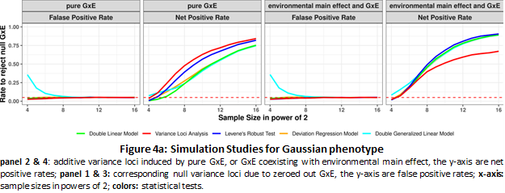
Figure 4a: Simulation studies for Gaussian phenotypes. Panels 2 and 4: Additive variance loci induced by a pure GxE effect or a GxE effect co-occurring with an environmental main effect. The y-axis is the net positive rate. Panels 1 and 3: Corresponding null variance loci zeroed out by GxE effects. The y-axis is the false positive rate, and the x-axis is the sample size by powers of 2 (i.e., 2² to 2¹⁶).

For balanced binary phenotypes (i.e., a 50% case rate), the variance loci and genetic main effects became less distinguishable as the sample size increased, which increased the false positive rate (panels 1 and 3 of Figure 4b) at the cost of the net positive rate (panels 2 and 4 of Figure 4b). As a result, with the exception of VLA, none of the tests were able to control the false positive rate. VLA again had the best performance in detecting true candidate SNPs for pure GxE effects (solid red line in panel 2 of Figure 4b).
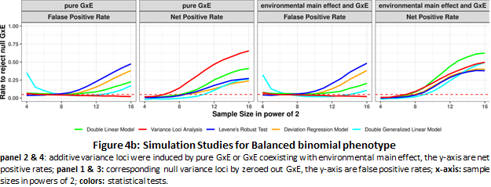
Figure 4b: Simulation studies for balanced binomial phenotypes. Panels 2 and 4: Additive variance loci induced by a pure GxE effect or a GxE effect co-occurring with an environmental main effect. The y-axis is the net positive rate. Panels 1 and 3: Corresponding null variance loci zeroed out by GxE effects. The y-axis is the false positive rate, and the x-axis is the sample size by powers of 2 (i.e., 2² to 2¹⁶).

For imbalanced binary phenotypes (i.e., a 7.6% case rate), it is difficult to distinguish an SNP main effect on the phenotypic mean from an effect on the phenotypic variance, causing overall inflation of the false positive rate. In this situation, VLA had the best performance in detecting true GxE candidates (Figure 4c).
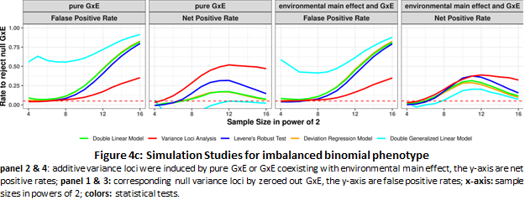
Figure 4c: Simulation studies for imbalanced binomial phenotypes. Panels 2 and 4: Additive variance loci induced by a pure GxE effect or a GxE effect co-occurring with an environmental main effect. The y-axis is the net positive rate. Panels 1 and 3: Corresponding null variance loci zeroed out by GxE effects. The y-axis is the false positive rate, and the x-axis is the sample size by powers of 2 (i.e., 22 to 216).

Supplement S1 details the simulation and provides the full results, including true positive rates and values for multiplicative variance loci.

Overall, the simulation results indicate that the VLA has the best performance in detecting additive variance loci induced by pure GxE effects and, overall, was more robust in the presence of false positives caused by imbalanced, non-Gaussian phenotypes. As expected, VLA underperformed with multiplicative variance loci because a negative allele effect on logged variance corresponds with an improper, non-real-valued additive GxE effect (see the Methods section). To recreate our results, see Supplement S1 for simulation materials, parameters, and R-scripts.

Analysis of body mass index and type 2 diabetes
To compare the performance of the methods in selecting variance loci in real-world data, we performed GxE enrichment analysis in data for body mass index (BMI) and type 2 diabetes (T2D) from the UK Biobank and PEGS. We applied VLA, DLM, DRM, and LVT but excluded DGLM due to its low speed and instability. We also performed GWAS with linear and logistic regression for BMI and T2D, respectively. For each SNP, we calculated p-values for each of the five tests.
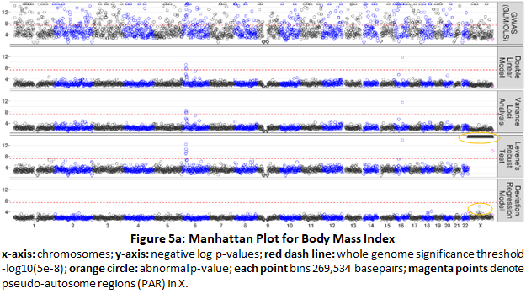

Figure 5a: Manhattan plot for body mass index. X-axis: chromosomes; y-axis: negative log p-values; red dashed lines: whole genome significance threshold of -log10(5e-8); orange circles: abnormal p-values. Each point bins 269,534 base pairs. The magenta points denote pseudo-autosome regions in X.

SNP | Chromosome  (Hg19/  GRCh37) | Base pair  (Hg19/  GRCh37) | MAF | Statistical test p-value
 |  |  |  | GWAS  (GLM/OLS) | Double  linear model  (DLM) | Variance  loci analysis  (VLA) | Levene's  robust test  (LVT) | Deviation  reg. model  (DRM)
rs539515 | 1 | 177889025 | 0.2049 | 1.07E-66 | 2.04E-03 | 3.98E-04 | 1.37E-02 | 9.77E-01
rs6689335 | 1 | 219628682 | 0.4189 | 2.99E-06 | 2.86E-05 | 1.00E+00 | 1.73E-07 | 8.12E-01
rs11578107 | 1 | 247193435 | 0.0284 | 1.16E-02 | 4.88E-01 | 4.02E-01 | 1.02E-07 | 1.00E+00
rs6744646 | 2 | 628504 | 0.1717 | 5.44E-72 | 1.35E-02 | 5.31E-03 | 3.67E-03 | 1.10E-01
rs10182181 | 2 | 25150296 | 0.4858 | 3.25E-57 | 1.98E-01 | 5.39E-02 | 1.08E-01 | 5.26E-01
rs115063350 | 2 | 160999596 | 0.0793 | 4.43E-01 | 2.03E-01 | 8.94E-01 | 3.68E-01 | 2.59E-04
rs183280845 | 6 | 26921528 | 0.1097 | 2.88E-07 | 8.74E-10 | 2.98E-09 | 4.48E-13 | 5.69E-01
rs561277 | 6 | 86014152 | 0.4435 | 8.30E-02 | 1.94E-07 | 1.53E-07 | 2.68E-01 | 9.44E-01
rs552749467 | 6 | 112272977 | 0.0160 | 5.93E-02 | 5.53E-05 | 1.20E-05 | 8.31E-05 | 3.23E-01
rs34845977 | 16 | 31027833 | 0.3653 | 8.84E-29 | 2.90E-06 | 3.40E-06 | 1.06E-07 | 2.19E-01
rs1421085 | 16 | 53800954 | 0.4035 | 1.98E-213 | 1.86E-12 | 3.57E-12 | 1.52E-14 | 3.37E-02
rs8064540 | 17 | 13742387 | 0.2206 | 1.70E-01 | 4.18E-01 | 2.07E-01 | 6.12E-01 | 2.84E-04
rs269989 | 18 | 42787046 | 0.3324 | 6.87E-01 | 1.25E-01 | 2.41E-02 | 3.95E-03 | 1.68E-04
noR02BE30 | 18 | 46967624 | 0.0549 | 9.96E-02 | 5.53E-01 | 1.95E-01 | 1.26E-01 | 2.31E-04
rs58084604 | 18 | 57849429 | 0.2328 | 2.79E-85 | 2.05E-04 | 2.07E-04 | 6.06E-04 | 9.55E-01
rs62095352 | 18 | 67241731 | 0.0744 | 4.81E-01 | 2.61E-01 | 8.81E-02 | 4.29E-01 | 5.70E-05
Table 1a: Top five SNPs for body mass index
The five most significant SNPs detected by each test. Fewer than 25 are listed because some SNPs were detected by more than one test. Each SNP represents others nearby in 336,918 base pairs. The highlighted cells denote significance. For the X chromosome, the p-values for LVT and DRM are blank.
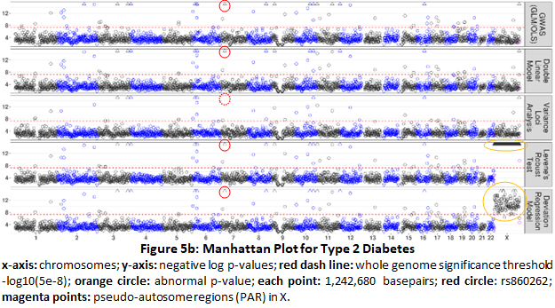
Figure 5b: Manhattan plot for type 2 diabetes. X-axis: chromosomes; y-axis: negative log p-values; red dashed lines: whole genome significance threshold of -log10(5e-8); orange circles: abnormal p-values; red circle: rs860262. Each point bins 269,534 base pairs. The magenta points denote pseudo-autosome regions in X.

SNP | chromosome  (Hg19/  GRCh37) | Base pair  (Hg19/  GRCh37) | MAF | Statistical test p-value
 |  |  |  | GWAS  (GLM/OLS) | Double  linear model  (DLM) | Variance  loci analysis  (VLA) | Levene's  robust test  (LVT) | Deviation  reg. model  (DRM)
rs2943635 | 2 | 227077377 | 0.3190 | 6.75E-15 | 9.72E-14 | 2.17E-13 | 4.70E-14 | 4.05E-13
rs35841686 | 3 | 123087916 | 0.2660 | 3.61E-18 | 1.65E-16 | 3.88E-17 | 2.40E-18 | 2.01E-16
noC0B7185 | 3 | 185511745 | 0.3120 | 1.35E-25 | 2.81E-22 | 2.43E-20 | 8.66E-24 | 6.09E-23
rs4689398 | 4 | 6302199 | 0.4103 | 3.87E-18 | 3.81E-16 | 8.55E-18 | 5.44E-18 | 9.52E-17
rs67131976 | 6 | 20686878 | 0.1735 | 4.71E-30 | 2.30E-26 | 1.12E-27 | 2.71E-30 | 1.07E-27
rs9273363 | 6 | 32626272 | 0.2999 | 5.37E-22 | 1.13E-19 | 9.72E-25 | 1.51E-26 | 6.57E-21
rs860262 | 7 | 28194397 | 0.4979 | 1.80E-19 | 1.68E-17 | 1.00E+00 | 2.81E-18 | 7.51E-17
rs13266634 | 8 | 118184783 | 0.3099 | 5.89E-25 | 1.04E-22 | 1.00E+00 | 8.10E-22 | 1.39E-22
rs10965248 | 9 | 22132878 | 0.1767 | 1.78E-24 | 3.30E-21 | 1.00E+00 | 2.43E-20 | 6.46E-21
rs5015480 | 10 | 94465559 | 0.4090 | 3.01E-20 | 6.53E-18 | 1.00E+00 | 1.63E-16 | 2.46E-16
rs7903146 | 10 | 114758349 | 0.2897 | 7.71E-166 | 3.70E-143 | 1.42E-127 | 1.96E-156 | 1.76E-148
rs2237895 | 11 | 2857194 | 0.4150 | 8.00E-17 | 8.04E-15 | 3.69E-13 | 2.98E-16 | 2.19E-16
rs76895963 | 12 | 4384844 | 0.0142 | 6.30E-25 | 1.72E-23 | 1.00E+00 | 1.25E-23 | 6.71E-23
rs1421085 | 16 | 53800954 | 0.4033 | 6.39E-26 | 9.75E-24 | 9.77E-22 | 7.80E-26 | 2.16E-24
rs3020789 | X | 152892987 | 0.2184 | 4.34E-20 | 7.64E-19 | 4.07E-18
Table 1b: Top 10 SNP for type 2 diabetes
The 10 most significant SNP detected by each test. Fewer than 50 are listed because some SNPs were detected by more than one test. Each SNP represents others nearby in 336,918 base pairs. The highlighted cells denote significance. For the X chromosome, the p-values for LVT and DRM are blank.

We assembled two selection populations: (1) 353,605 unrelated British Whites and (2) 379,561 unrelated individuals of European ancestry, including all of the first selection population and additional individuals. The selection populations contained 9,298,089 and 9,298,331 SNPs, respectively, on chromosomes 1-22 and X with an MAF >0.1. The covariates were age, sex, age², age×sex, age²×sex, the first 20 genetic principal components, and the genotyping array (26, including the intercept). Figure 5 is Manhattan plots for the larger of the two selection populations (379,561 individuals and 9,298,331 SNPs), and Tables 1a and 1b list the most significant SNPs detected by each test.

The p-values for LVT and DRM were abnormally positive for the X chromosome (Figure 5, orange circles) for several reasons. First, the frequencies of the heterozygous genotype are much lower in men than in women (and parts of pseudo-autosome regions). Second, when LVT and DRM grouped the samples by genotype {AA, Aa, aa}, the genotype was not adjusted by sex (in addition to other covariates) and thus the differences in phenotypic variance due to sex were erroneously attributed to the SNP. Third, methods that do not rely on genotype grouping adjusted the SNP by covariates (including sex) and were thus robust. Accordingly, we excluded the p-values for LVT and DRM in Table 1 and subsequent analyses.

For BMI, GWAS detected a higher number of significant SNPs, meaning that the four variance loci tests were able to distinguish genetic effects on the phenotypic mean from phenotypic variance. Except for the X chromosome, DLM, VLA, and LVT selected the same variance loci as the most significant. DRM was conservative overall but presented a relatively unique set of variance loci (Table 1a, last column).

For T2D, except for the X chromosome, all five tests largely selected the same significant loci, reflecting the fact that the genetic effect on phenotypic mean and variance are interchangeable for a binary outcome. However, SNP rs860262 (Figure 5b, red circles, and Table 1b, row 7) on chromosome 7 base pair 28,194,397 (GRCh37) was selected by all the texts except VLA. This may indicate that VLA is more prudent as rs860262 was inactive in GxE interactions.

The Materials section details the treatment of data from the UKBB and PEGS on phenotypes, genotypes, covariates, and environmental exposures. We performed the GWAS using PLINK2. Supplement S1 provides the R-scripts used for VLA, DLM, LVT, and DRM.

