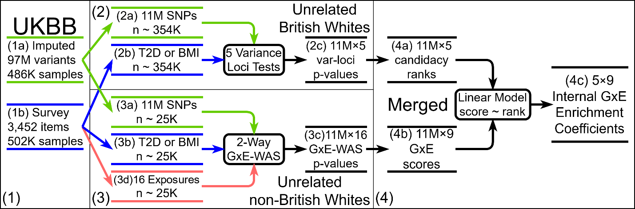
Figure a: Flowchart of UK-Biobank Internal GxE enrichment analysis.
Overview: The internal GxE enrichment analysis relies on UK-Biobank (box 1), it starts with variance loci tests on the British whites (box 2) that summarizes per-SNP candidacy rank, followed by 2-way GxE-WAS on non-British white (box 3) that summarizes per-SNP GxE score, and finishes by reporting the regression coefficient of GxE scores on candidacy ranks (box 4).
Box 1: the UKBB provided imputed genotype of 97 million variants for 499K individuals (1a), and a survey data of 3.4K items for 502K individuals (1b).
Box 2: from imputed genotypes, 11.4 million SNPs and 354K unrelated British whites passed the quality control (2a); from the survey, two phenotypes, T2D and BMI, were extracted for the same 373K unrelated British whites (2b) ^{[note 1]}; for each phenotype, the 5 competing variance loci tests, namely, GWAS ^{[note 2]}, DLM, VLA, VLT, and DRM, were applied genome wide, producing 11.4 million × 5 variance loci test p-values (2c).
Box 3: the same 11.4 million SNPs (3a) and two phenotypes (3b) were available for 25.4K unrelated non-British whites; in addition, 16 exposure items were summarized from the survey for the same unrelated non-British whites (3d); for each phenotype, an exhaustive 2-way GxE-WAS was conducted, producing 11.4 million × 16 GxE test p-values (3c).
Box 4: the 11.4 million p-values from each of the 5 variance loci tests (2c) were converted into SNP candidacy ranks (4a); the 16 GxE test p-values for each SNP (3c) was summarized into 9 GxE scores by counting the number of p-values below 8 thresholds (5e-2, …, 5e-9) and by adding up 16 negative log p-values (4b); by regressing each one of the 9 GxE scores (of 11.4 million SNPs) on each one of the 5 candidacy ranks (of the same 11.4 million SNPs), the regression coefficient measures the enrichment of GxE detection among significant variance loci (4c).
Note 1: for simplicity, the covariates extracted from UKBB are not presented.
Note 2: although GWAS is not a variance-loci test, it was kept as a reference.
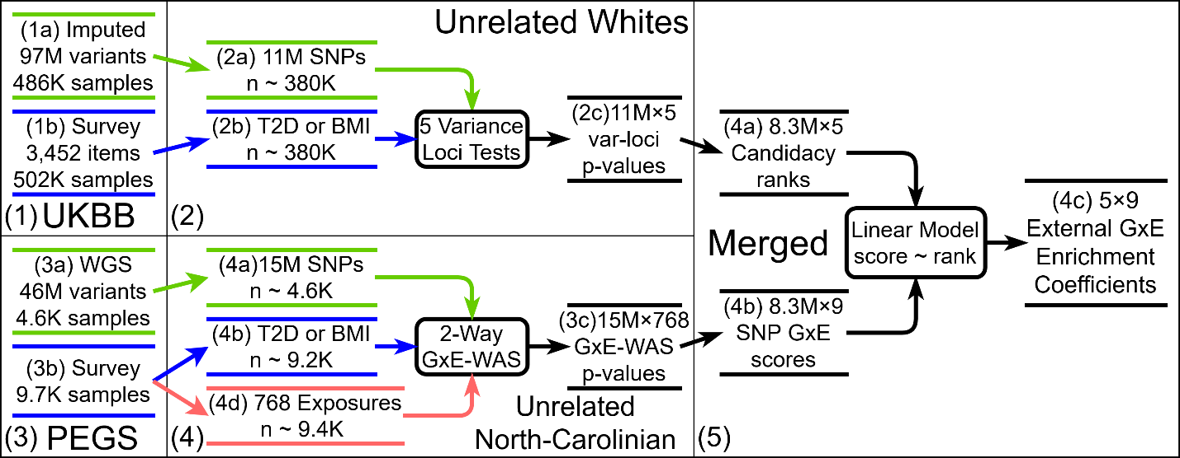
Figure b: Flowchart of UK-Biobank / PEGS Internal GxE enrichment analysis.
Overview: The extern GxE enrichment analysis use UK-Biobank (box 1) and PEGS (box 3), it starts with variance loci tests on the UKBB European whites (box 2) that summarizes per-SNP candidacy rank, followed by 2-way GxE-WAS on PEGS participants (box 4) that summarizes per-SNP GxE score, and finishes by reporting the regression coefficient of GxE scores on candidacy ranks, which measures the enrichment of GxE detection (box 5).
Box 1: the UKBB provided imputed genotype of 97 million variants for 499K individuals (1a), and a survey data of 3.4K items for 502K individuals (1b). Box 2: among imputed genotypes, 11.4 million SNPs and 380K unrelated white European passed quality control (2a); from the survey, two phenotypes, T2D and BMI, were extracted for the same 380K unrelated white European (2b)^{[note 1]}; for each phenotype, the 5 competing variance loci tests, namely, GWAS ^{[note 2]}, DLM, VLA, VLT, and DRM, were applied genome wide, producing 11.4 million × 5 variance loci test p-values (2c).
Box 3: PEGS conducted whole genome sequencing (WGS) of 46 million variants for 4.6K of its participants (3a), and a survey of environmental exposures 9.7K participants. Box 4: from PEGS whole genome sequencing data, 15 million SNPs and nearly all genotyped individuals passed quality control (4a); from the survey, the two phenotypes, T2D and BMI, were available for 9.2K individuals (4b) ^{[note 3]}; 768 exposures items were also available for a maximum of 9.4K individuals (4d). For each phenotype, an exhaustive 2-way GxE-WAS was conducted, producing 15 million × 768 GxE test p-values (4c).
Box 5: between the 11 million SNPs from UKBB and 15 million SNPs from PEGS, 8.3M were matched by chromosome position and alleles. The p-values from each of the 5 variance loci tests (2c) were converted into SNP candidacy ranks (4a); the 768 GxE test p-values for each SNP (3c) was summarized into 9 GxE scores by counting the number of p-values went below 8 thresholds (5e-2, …, 5e-9) and by adding up 768 negative log p-values (4b); by regressing each one of the 9 GxE scores (of 8.3 million matched SNPs) on each one of the 5 candidacy ranks (of the same 8.3 million SNPs), the regression coefficient measures the enrichment of GxE detection among significant variance loci (4c).
Note 1: for simplicity, the covariates extracted from UKBB are not presented.
Note 2: although GWAS is not a variance-loci test, it was kept as a reference.
Note 3: for simplicity, the covariates extracted from PEGS are not presented.

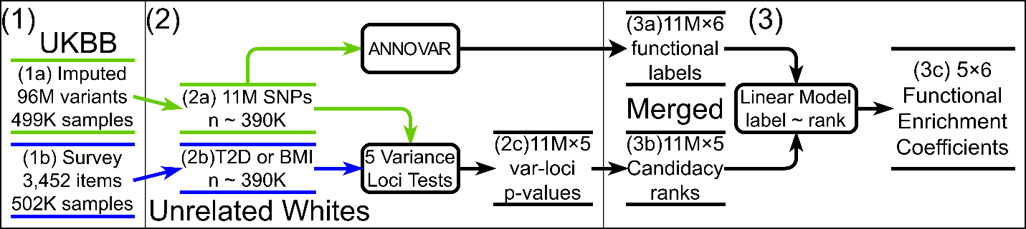
Figure c: Flowchart of functional enrichment analysis.
Overview: The functional enrichment analysis relies on UK-Biobank (box 1); it starts by assigning each SNP 6 functional labels (intronic, exonic, upstream, downstream, intergenic, and CPDD score) using ANNOVAR, followed by 5 genome-wide variance loci tests on the British whites (box 2) that summarizes the SNPs’ GxE candidacy ranks, and finishes by reporting the regression coefficients of functional labels on candidacy ranks, as a measure of functional enrichment (box 3).
Box 1: the UKBB provided imputed genotype of 97 million variants for 499K individuals (1a), and a survey data of 3.4K items for 502K individuals (1b).
Box 2: from imputed genotypes, 11.4 million SNPs and 390K unrelated European whites passed the quality control (2a); the SNPs were passed to ANNOVAR, producing in 11.4 million × 6 functional labels (3a); from the survey, two phenotypes, T2D and BMI, were extracted for the same 390K unrelated European whites (2b) ^{[note 1]}; for each phenotype, the 5 competing variance loci tests, namely, GWAS^{[note 2]}, DLM, VLA, VLT, and DRM, were applied genome wide, producing 11.4 million × 5 p-values (2c).
Box 3: 11.4 million p-values resulted from each of the 5 variance loci tests (2c) were converted to SNP candidacy ranks (4a); by regressing one of the 6 function labels (of 11.4 million SNPs) on one of the 5 candidacy ranks (of the same 11.4 million SNPs), the regression coefficient measures the enrichment of GxE detection due to the corresponding variance loci test (4c).
Note 1: for simplicity, the covariates extracted from UKBB survey are not presented.
Note 2: although GWAS is not a variance-loci test, it was kept as a reference.

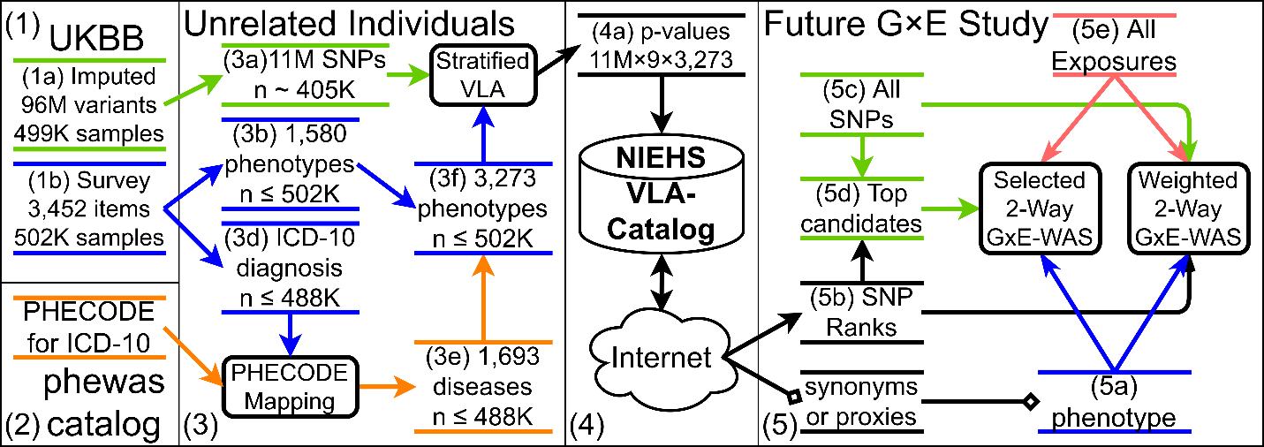
Figure d: Flowchart of the creation and use of VLA-Catalog.
Overview: The VLA-catalog relies on UK-Biobank (box 1) and PHECODE ICD-10 mapping (box 2); to create the catalog, a phenome of 3.2K items was compiled, followed by a genome-wide VLA performed per items and per strata (box 3); the results constituted the VLA-catalog hosted by NIEHS (box 4); a future GxE study fetches the VLA summary statistics for its own phenotype, then conduct 2-way GxE-WAS for either 1) top SNPs selected by VLA, or 2) all SNPs weighted by VLA statistics.
Box 1: the UKBB provided imputed genotype of 97 million variants for 499K individuals (1a), and a survey data of 3.4K items for 502K individuals (1b). Box 2: the PHECODE is the mapping from ICD-10 diagnosis records to disease case/control status, provided by phewascalalog.org.
box 3: from imputed genotypes, 11.4 million SNPs and 405K unrelated individuals passed the quality control; a phenome of 3,273 items was compiled (3f), with 1,580 directly from UKBB’s baseline survey item (3b), and 1,693 diseases derived from hospital diagnosis in ICD-10 according to the PHECODE (3e); a genome-wide VLA is performed per phenotype, per stratum^{[note 1]}.
box 4: the resulting summary statistics for 11.4 million SNPs, 9 strata ({male, female, both sex} x {Asian, African, European}) and 3,273 phenotypes (4a), were re-structured into the VLA-catalog hosted by NIESH and accessible via internet.
box 5: a future study interested in 2-way GxE-WAS^{[note 1]} can first search by the names, synonyms, or proxies of its phenotypes (5a) in the VLA-catalog, to retrieve genome-wide VLA statistics (5b); given a rich exposome (5e) it could either perform a selected GxE-WAS among top GxE candidate SNPs (5d) according to the VLA statistics, or an exhaustive GxE-WAS with all SNPs (5c) weighted by VLA statistics.
Note 1: for simplicity, the covariates extracted from UKBB survey, and the future study are not presented.

