Cataloging gene-environment interaction candidate SNPs for over 3,000 UK Biobank disease phenotypes through variance loci analysis
Xiaoran Tong, <authors>, Alison Motsinger-Reif

Abstract
The combined dimension of genome and exposome is statistically and computationally challenging for the detection of gene by environment interactions (GxEs). Variance quantitative trait loci (vQTL) can suggest candidate single nucleotide polymorphisms (SNPs) without exposome profiling, by capturing non-uniformity in residual variance of a quantitative trait caused by unaccounted for GxEs.
We propose variance loci analysis (VLA) to improve vQTL with positive gradient test, which maintains power to detect GxE candidates with weak direct environmental effects, and more importantly, over-come the inability of vQTL to analyze case/control phenotypes.
We ranked the potential of each SNP in GxEs for 3,273 phenotypes from the UK Biobank and hosted the VLA Catalog (genelist.niehs.nih.gov) as an open resource. Combining the rich exposome from the Personalized Environmental Genetic Study (PEGS) and high-ranking SNPs from VLA, we detected significant GxE between gene ABCB7 and inkjet toners on type 2 diabetes.

Introduction [No heading or subheadings]

Background and motivation
A portion of the “missing” heritability from genome-wide association studies (GWAS) is due to unaccounted for gene by environment (GxE) interactions (Eichler et al. 2010; Van Ijzendoorn et al. 2011). Despite findings that genetic effects are context-dependent (9-13), difficulty in exposure measurement and insufficient sample sizes make identification of GxE effects challenging (9–11). Further, the number of main effects and interactions in a genome-exposome-wide association study (GxE-WAS) presents both computational and multiple testing burdens. Two oft-used approaches to these problems are to select candidate genomic variants via a priori biological knowledge or to select significant genomic variants from GWAS. The first approach hinders discovery, and the latter tends to produce false positives due to the ostensible assumption that strong genetic marginal effects exist in all GxE interaction models.
A better approach to identify candidates for GxE is variance quantitative trait loci (vQTL) analysis, since the presence of strong GxEs causes heterogenous variation of a quantitative trait among individuals of different allele carriage (Cao et al. 2014; Deng, Asma, and Paré 2014; Struchalin et al. 2012; Yang et al. 2012).

Variance quantitative trait loci (vQTL) analysis
The most intuitive vQTL test is double linear model (DLM), which essentially sees the squared residuals of a GWAS as a new phenotype to performs a second GWAS (Struchalin et al. 2012). However, DLM assumes homogeneous variation among individuals of the same genotype and, therefore, phenotypes must be nearly Gaussian, which precludes many human health outcomes of interest. More robust vQTL tests have shown varying success in quantitative non-Gaussian phenotypes, such as deviation regression model (DRM) that replaces squared residuals with distance to group median (Marderstein et al. 2021), Levene’s robust test of heterogeneous variance (LVT) which captures non-parametric vQTL (Paré et al. 2010), and double generalized linear modeling (DGLM) (Smyth 1989; Lee and Nelder 2006) which models phenotypic variance in log scale. However, for binary phenotypes, the link between mean $μ$ and variance $v$ is so tight ($v=2μ(1-μ))$, these different vQTL tests produce substantial false positives (Paré et al. 2010; Marderstein et al. 2021; H. Wang et al. 2019). We also show herein that additive vQTL tests such as DLM and DRM have diminished power to detect pure GxE candidates with a weak direct environmental effect on the phenotypic mean, even if the phenotype is Gaussian.

Variance loci analysis (VLA)
Motivated by these issues, we developed variance loci analysis (VLA) to detect GxE candidate variants. VLA works like DLM, but rather than a slope fit through the squared residuals (i.e., the second GWAS), VLA fits a curve and tests its positive gradient instead. Compared to existing methods, VLA provides superior control of type 1 errors for binary phenotypes (i.e., case/control) while maintaining power for Gaussian phenotypes with weak environmental main effects.
VLA requires the phenotype to be smoothed first by well-chosen covariates. The residual of such covariates is a quantitative representation of the underlying risk contributed by the genome, exposome, and their interaction. By replacing a binary phenotype with smoothed residual risk, the positive gradient test can detect candidate GxE variance loci. The best covariates are non-confounding yet predictive. For example, age and age^2, as they are neither heritable nor determined by the exposome (i.e., non-confounding), but strong determinants of diseases (i.e., predictive).
In the subsequent sections, we first illustrate the rationale of variance loci and the proposed VLA addressing shortcomings in existing methods; second, with simulation studies based on 1000 genome data, we present the true positive (i.e., power) and net positive rate of VLA and competing variance loci tests; we then use exemplars of BMI and T2D in the UK Biobank and PEGS cohort to benchmark the efficiency of finding candidate GxE variants with proposed VLA, the mean based GWAS, and other variance-based test; we then applied VLA to PEGS to identify the interaction between X chromosome gene ABCB7 and printer inks/dyes/toners. Lastly, we host a database of candidate variant loci (https://genelist.niehs.nih.gov/vla) for 3,273 phenotypes, of which 1,693 are dichotomous disease status derived from the latest PHECODE (Wei et al. 2017; Wu et al. 2019).

Results

Illustration
We generated 200 data point with and without environment exposure (Figure 1, magenta and orange dots) under no GxE effect (G+E only), some GxE (G+E + GxE), and purely GxE (GxE only).
We illustrated that a variance loci is induced by a GxE effect unaccounted for in a GWAS linear model, resulting in uneven phenotype spread across genotypes (figure 1c left) (Paré et al. 2010). A variance locus is detected by testing the non-zero slop of a line through the amount of variation (figure 1c right, green), as the double linear model (DLM) does; it is also detectable by testing the positive gradient of a curve through the variation (figure 1c right, red), as the proposed variance loci analysis (VLA) does. Conversely, in the absence of GxE, the SNP is not a variance locus because the spread of phenotype is uniform across genotypes (Figure 1a left), allowing DLM and VLA correctly retain the null, since the line and curve fit through the variation are both flat (Figure 1a right).
When the data points are binary case/control and the SNP itself affects the phenotype (Figure 1b left), the slop based DLM test causes false positive because the line fit through the variation is always slopped even in the absence of GxE (Figure 1b right, green), but the positive gradient based VLA test correctly retained the null in this case, because the fitted curve has negative gradient (Figure 1b right, red).
When a pure GxE affects a phenotype without direct environment effect (Figure 1e/1f left), the slop based DLM became statistically powerless because the line fit through phenotypic variation is flat (Figure 1e/1f right, green) despite the presence of a strong GxE, yet the positive gradient of VLA is able to since the fitted curve has a positive gradient (Figure 1e/1f, red).

Simulation
We ran 20,000 repeats for each of three scenarios. For each simulation repeat, we generated vectors of the environment and covariates with a normal distribution and selected a genotype from an SNP randomly picked from Phase 3 of the 1000 Genomes Project (Consortium 2012; Consortium and others 2015) with an MAF≥0.01 and a sample size varying from 2⁴ to 2¹⁶. In all scenarios, we fixed the alpha to 0.05, where the null was rejected if the p-value was less than 0.05.
We treated phenotypes as the sum of a strong covariate effect, weak genotype main effect, possible environmental main effect, and possible GxE effect. Both a pure GxE effect (scenario 1) and a GxE effect co-occurring with an environmental main effect (scenario 2) gave rise to additive variance loci. For each scenario, we also simulated a corresponding null scenario by zeroing out the GxE effect, rejecting the null in these latter scenarios added to a method’s false positive rate, or type 1 error. We considered a test superior if it had a high true positive rate (power) while controlling the false positive rate (type 1 error). Accordingly, we used the net positive rate (i.e., the true positive rate minus the false positive rate) as an overall measure of performance.
For balanced binary phenotypes (i.e., a 50% case rate), the variance loci and genetic main effects became less distinguishable as the sample size increased, which increased the false positive rate (panels 1 and 3 of Figure 4b) at the cost of the net positive rate (panels 2 and 4 of Figure 4b). Except VLA, none of the tests were able to control false positive rate. VLA again had the best performance in detecting true candidate SNPs for pure GxE effects (solid red line in panel 2 of Figure 4b). For imbalanced binary phenotypes (7.6% case rate), for which it is difficult to distinguish an SNP main effect on the phenotypic mean from the effect on the phenotypic variance, causing overall inflation of the false positive rate, VLA had the best performance in detecting true GxE candidates (Figure 2c). Overall, the simulations showed that the VLA was better at detecting additive variance loci induced by pure GxE effects and more robust in the presence of false positives caused by imbalanced, non-Gaussian phenotypes. As expected, VLA underperformed with multiplicative variance loci because a negative allele effect on logged variance corresponds with an improper, non-real-valued additive GxE effect.
The supplement details the simulation and provides the full results, including true positive rates and values for multiplicative variance loci.

UKBB Genome Wide Variance Loci Analysis
To examine how each test selects variance loci, we applied all the tests except DGLM due to low speed and instability in BMI and T2D data from UKBB. We also performed GWAS with linear and logistic regression for BMI and T2D, respectively. In total, we recorded five test statistics for each SNP. We assembled two populations: 1) 353,605 unrelated British Whites and 2) 379,561 unrelated individuals including the British, the Irish, and those with any European ancestry. The two populations included 9.2 million SNPs on chromosomes 1-22 and X with MAF > 0.01. The covariates were age, sex, age², age×sex, age²×sex, the first 20 genetic principal components, and the genotyping array (a total of 26, including the intercept). Figure 3 shows Manhattan plots, QQ plots in both original [0, 1] and -log10(p) scale with a genomic inflation factor (λ_{GC}), based on the larger population. The supplement Table s2 lists the most significant SNPs for each test.
LVT and DRM were abnormally positive on the X chromosome (Figure 3, orange circles) because the lower frequency of the heterozygous genotype in men causes the two tests to erroneously attribute changes of phenotypic variance due to sex as due to genotype.
For BMI (Figure 3a, Table s2a), GWAS returned more significant SNPs with over-confidence (λ_{GC}=1.998). The four variance loci tests could tell apart genetic effects on the phenotypic mean and variance with relative ease. For T2D, except for the X chromosome, all five tests largely agreed on the most significant loci, reflecting the interchangeability of genetic effect on the phenotypic mean and variance for binary outcomes. However, VLA showed the least genomic inflation (λ_{GC}=1.02). Of note, rs6712203 (2:164700808 C/T), rs860262 (7:28194397 C/A), and rs76895963 (12:4384844 T/G) (GRCh37) were not selected by VLA but were by the other tests (Figure 3b, red circles).

GxE Enrichment Analysis
The aim is to gauge how well the top-ranked SNPs from a variance loci test in one population enrich the detection of significant GxE interactions in a discovery population. In the former, we ranked SNPs by one minus the p-value of each test’s primary statistics. In the latter, we scored SNPs by the number of two-way GxE p-values below a series of cut-offs and the overall sum of negative p-values. By regressing the scores on the ranks, the coefficient acted as a measure of GxE enrichment. We performed an internal GxE enrichment assessment among sub-populations in the UKBB and an external assessment involving the NC-based PEGS cohort.

Internal GxE enrichment
Within the UK Biobank, we ranked SNPs using test statistics (i.e., DLM, LVT, DRM, VLA, and GWAS) based on 353,605 British Whites and scored SNPs using 2-way GxE statistics based on 25,481 non-British Whites. For BMI, VLA was the most efficient SNP selector overall (Figure 4a, red) and has pronounced advantages over the other tests (Figure 4b, red). VLA was also more efficient for GxE SNPs with p-values < 5e-7. The supplement provides the score-rank GxE enrichment regression coefficients (Table?) and flowchart of the analysis (Figure?).
For T2D, DLM performed similarly as GWAS (Figure 4b, gray and green), so were LVT and DRM at stricter GxE p-value thresholds. The redundancies are reflected by high correlation between SNP ranks (i.e., 1 – p value) from GWAS and non-GWAS tests, which were DLM (0.985), LVT (0.613), DRM (0.8871), and VLA (0.004). In contrast, BMI as a quantitative phenotype (Figure 4a) allowed the four variance loci tests distinct selection patterns from GWAS, and the correlations were DLM (0.053), LVT (0.032), DRM, (0.012), and VLA (0.007).

External GxE Enrichment
In PEGS, we performed two-way GxE-WAS in for 4,603 individuals with age, sex, income level, the first 10 principal components, and nominal variable coded ethnicity (European American, African American, Asian, and others) as covariates. BMI was also a covariate for the T2D analyses. We scored SNPs by the number of two-way GxE p-values (i.e., up to 728) below a series of cut-offs and the overall sum of negative p-values. In the UKBB, we ranked SNPs by the five tests based on the 379,561 European Whites. The two cohorts shared 8,331,313 SNPs with MAF > 0.01 in the UKBB. The supplement provides the score-rank GxE enrichment regression coefficients (Table?) and flowchart of the analysis (Figure?).
For BMI, SNPs ranked by VLA had the best chance of detecting highly significant GxE (p-value < 5e-7, …, 5e-9), and the second-best chance of detecting overall GXEs (3.82, se=0.34) in PEGS (Figures 4c and 4d). Interestingly, while DRM had by far the most conservative statistics for BMI (see Figure 3a), it resulted in the best overall enrichment (4.64, se=0.35) in the discovery cohort. For T2D, only VLA enriched the detection of medium-to-highly significant GxE with p-values < 5e-6, …, 5e-9 and overall GxEs (0.89, se=0.34) in the discovery cohort, while other tests showed negative coefficients (i.e., depletion) without exception. Again, the coefficients of DLM closely followed those GWAS and, to a lesser degree, DRM, reflecting the redundancy of the slope-based variance loci test for binary phenotypes.

Functional enrichment analysis
We also examined enrichment from a functional perspective, that is, which classes of SNPs were overrepresented among the significant loci identified by each test. For example, GWAS loci are more frequent among SNPs in or near genes than between genes. We labeled each SNP as an intergenic, upstream, intronic, exonic, or downstream variant using ANNOVAR (K. Wang, Li, and Hakonarson 2010) and calculated the combined annotation dependent depletion (CADD) score (Kircher et al. 2014; Rentzsch et al. 2019) as a continuous measure of pathogenic tendency. We treated the functional labels as binary variables and CADD scores as a continuous response variable and regressed them on the SNP rankings given by each test. A positive significant coefficient means the variance loci are over-represented among SNPs of certain types or with higher CADD scores. The supplement provides functional enrichment regression coefficients (Table?) and flowchart of the analysis (Figure?).
For both phenotypes, all tests except VLA significantly underrepresented intergenic SNPs outside of genes, and none prioritized exonic SNPs. For BMI, VLA evenly selected all classes of SNPs (Figure 4e, red). DRM under-selected downstream SNPs (Figure 4e, orange), and the other three tests prioritized intronic SNPs and those with high CADD scores. For T2D, VLA prioritized intergenic SNPs (Figure 4f, red) but not intronic SNPs or those with high CADD scores. The other four tests largely produced similar results, which is unsurprising given their redundancy regarding a binary phenotype.

PEGS GxE adjusted by UKBB Variance Loci
An exhaustive two-way GxE-WAS for T2D in the PEGS cohort resulted in 10.8 trillion GxE test statistics (i.e., genome variants × exposome items). We retained 36.7 billion (0.40%) GxE that were 1) of or beyond moderate significance (P < 5e-4) and 2) matched by coordinates and alleles with variance loci from the previous analysis of UKBB White Europeans. After binning the GxE and matched variance loci into genome segments, we selected the most significant GxE and variance loci per bin, further narrowing the number to 1,608,961 representative GxE (0.015%) and nearby variance loci. We applied Bonferroni correction considering 0.47 billion selectable GxE tests, we then adjusted the corrected p-values considering the most significant variance loci in the neighborhood.

ABCB7 × Print Material on T2D
For each exposure in PEGS, we checked the GxE with VLA adjusted P < 0.05 for T2D, which revealed significant GxEs between 13 protein coding genes (CTNND2, TMEM132D, DMD, ABCB7, NXF3, PTPRK, ZNF157, CYCS, C7orf31, CNBD2, RAPGEF5, TRNT1, IL5RA) and exposures to dyes, inks, and toners (PEGS ID: A_B194i). Of interest is X-chromosome gene ABCB7 (ATP binding cassette subfamily B member 7, X:75,051,048 - 75,156,732, ENSG00000131269) and its immediate down-stream UPRT (uracil phosphoribosyl transferase homolog, X:75,156,388 - 75,304,885, ENSG00000094841). The two genes were enclosed by q13.3 and were suggested by nearby SNP rs4409555 with a raw GxE p-value 9.25e-12 and 4.39e-2 after Bonferroni correction, and 6.45E-05 after adjustment by VLA. As a reminder, LVT and DRM were absent because the two are invalid on chromosome X.
The significant GxE between SNPs around ABCB7-UPRT and toners corroborated with the differential expression of ABCB7 among workers occupationally exposed to inkjet printers, archived as GEO dataset GSE142351 (Guo et al. 2020). ABCB7 is involved in metabolism and multi-drug resistance and is related to transport pathways of glucose and other sugars, bile salts, organic acids, metal ions, and amine compounds. Notably, the gene encodes a half-transporter involved in the transport of heme from the mitochondria to the cytosol. ABCB7 is also an ATP-dependent mitochondrial transporter implicated in Fe–S cluster assembly. Inherited mutations in ABCB7 have been linked to inherited and acquired sideroblastic anemia with cerebellar ataxia (Pain and Dancis 2016; Allikmets et al. 1999). The absence of ABCB7 impairs the maturation of cytosolic iron-sulfur proteins and induces iron accumulation in mitochondria.
Further, the knockdown of ABCB7 in HEK293T cells causes mitochondrial iron accumulation and the activation of SOD enzymes, while iron and iron-regulatory proteins and cadmium alter ABCB7 expression. Some pigments in printer ink dyes, such as potash blue or soda blue, contain iron based on ferrous and ferric cyanides, and printer inks may also contain cadmium (Podhajny 2001). Also of interest is the association of ABCB7 with fatty liver disease, which is notable because T2D is a significant risk factor for fatty liver disease and could share common pathways (SILAGHI et al. 2016; Lonardo et al. 2019)..
The above suggests that the region around ABCB7, statistically prioritized by VLA, is biologically interacting with exposure to print materials to affect the risk of developing type 2 diabetes.

UKBB variance loci catalog
Inspired by the Pan-UK Biobank GWAS catalog at pan.ukbb.broadinstitute.org, we created and host a catalog of variance loci statistics for UKBB phenotypes and variants on the NIEHS website (genelist.niehs.nih.gov). The catalog is a public resource that can be queried by phenotype, enabling researchers to prioritize candidate variants most likely to invoke significant GxEs. Figure 8 illustrates the workflow of creating the catalog and the query process.
We summarized 1,580 health-relevant phenotypes chosen from UKBB data fields accessible to NIEHS plus an additional 1,693 diseases derived from hospital records using PHECODE, a codebook for extrapolating diseases using ICD9/10 records (www.phewascatalog.org) (39, 40) for a phenome comprising 3,273 items. We distinguished the selected UKBB phenotypes into binomial, multinomial, ordinal, and continuous variables and subsequently recoded and normalized them. For the genome, we limited the variants to those with an overall minor allele frequency of at least 0.005, for a final number of 11,841,785 variants after quality control measures. The materials section provides details of these processes.
For each of the four main racial/ethnic groups in the UKBB (British Whites, Irish, Blacks, and Asian), we performed VLA for the whole phenome and genome to archive variant statistics. We used the plinkFile and vla R packages to traverse the genome by window while scanning variance loci for thousands of phenotypes and variants. We divided the genome into approximately 1,200 groups of 10,000 variants each and summarized the VLA statistics for British Whites, which is the largest group in the UKBB, with a working sample size of 384,000 in 12 hours, using the NIH HPC Biowulf cluster (hpc.nih.gov).

Methods

Variance loci tests to identify GxE candidate SNPs
Given a quantitative trait, a SNP, and covariates, DLM fits a GWAS linear model, adjusting the covariates, and treats the squared residual as a “new phenotype”, subsequently fitting another GWAS linear model with the same SNP and covariates (Figure 10 top). If the SNP coefficient of linear model 2 is significant, we say the SNP is a vQTL, that is, a GxE candidate for that particular quantitative phenotype. Intuitively, the linear model 2 fits the squared distance from the fitted values of linear model 1 (i.e., conditional mean given the SNP and covariates), which amounts to modeling the phenotypic variance, since the mean of squared distance from the mean, is variance. VLA (variance loci analysis, Figure 10 bottom) slightly modifies DLM: (1) the second linear model uses squared SNP and (2) perform a one-sided t-test assuming non-negative coefficient. For a binary trait, the rare event (i.e., disease) is coded as 1 and the covariates should choose from non-heritable predictors; there is no need to replace linear model 1 with GLM (i.e., logistic regression).
In addition, we created R-language wrapper functions for deviation regression model (DRM), Levene’s Robust Test (LVT) from R-package “car” (citation), and double generalized linear model (DGLM) from R-package “dglm” (citation). Because DGLM is unstable with small samples and slow to compute for large ones, we used DGLM as a benchmark in simulation studies only.
Lastly, we considered the traditional GWAS as a reference GxE candidate selector. We use PLINK2’s “--glm” routine to fit GWAS linear model for body mass index (BMI), and logistic regression for type 2 diabetes (T2D). We only included GWAS for GxE enrichment and functional enrichment analysis.
More detailed description of the statistical tests is in supplement S2.

Two-way GxE-WAS
In a discovery cohort with normalized environment $u$ and standardized SNP $g$, GxE interaction effects are typically captured by adding a two-way product term $ug$ to a GWAS linear model,
$y=m_{0}+ag+bug+cu+dx+e$,
where $e$ is a vector of Gaussian noise and $x$ is the covariate; rejecting $h_{0}:b=0$ at a given p-value threshold suggest the GxE interaction between SNP $g$ and environment $u$. The above is repeated for all 2-way combinations of SNPs and environmental exposures, which, for PEGS, means a total of 14,874,008 x 765 models; for white non-British in the UKBB, the combination is 9,298,089 x 16. We exhaustively analyzed all the two-way combination for demonstrative purpose, in an actual application, one should query the VLA-catalog and limit the GxE-WAS among top ranking SNPs or/and those below a p-value threshold for shorter running time and mitigated multiple testing.

UK Biobank (UKBB) data
To evaluate the performance of VLA in selecting GxE candidates, we used data from the UKBB, a large-scale resource consisting of genetic and health information for over half a million participants (Application ID: 57849, version 2) collected via questionnaires, electronic health records, biological samples, oral interviews, imaging, and genotype data. For genotype data, using the imputed genotype, we created a comprehensive catalog of the whole genome. After quality control, we divided the remaining individuals into five major ancestry groups—African (afr), non-Chinese Asian (asi), White British (bri), Irish (iri), and White but non-British (wnb)— leaving 375,992 individuals. These ancestry groups are the basis of the NIEHS VLA Catalog, and the bri and wnb groups serve as training and testing datasets, respectively. Details can be found in the supplement. For phenotype data, we manually compiled UKBB phenotype data, which is summarized in Table 2, for T2D, CAD, BMI, and fasting glucose level. For environmental data, we used data on 16 environmental variables in UKBB, which are outlined in Table 3. We also derived phecodes using phenotypes and disease diagnoses from electronic health record (EHR) data for UKBB participants recorded as International Classification of Diseases (ICD) codes (40) (41) (40, 42). The supplement provides details of how we compiled the phenotypes, including criteria and the UKBB data fields used as well as details of our phecode mapping.

PEGS data
For the external GxE enrichment analysis, we used data from the Personalized Gene and Environment Study (PEGS), a North Carolina-based cohort of 19,672 participants of varying age, race, socioeconomic status, and education level. Whole-genome sequencing data is available for 4,610 participants. We used questionnaire-based exposome data in its original form for binary and integer-based items. We derived T2D and BMI phenotype data from the survey data. The Supplement provides information on case/control definitions and quality control.

Discussion
VLA is a powerful new method that addresses the constraints of existing vQTL analysis approaches. To demonstrate how the VLA Catalog can be used in research, we tested candidate SNPs from UKBB in the PEGS cohort, which has both genetic and environmental exposure data, and found that the SNPs were involved in many significant GXEs.
For binary traits, the false positive of vQTL tests (DLM, DRM, DGLM, and LVT) in screening GxE candidate SNPs is as high as GWAS. Essentially, the close tie between the mean and variance grossly violates the assumption of homogeneous variation among individuals of identical allele carriage, causing those tests to falsely identify any GWAS-significant SNP as a GxE candidate regardless of the presence of GxEs. The VLA test resist spurious GxE candidates of binary traits, with covariates carefully chosen to reconstruct the underlying risk of a binary trait, VLA is more efficient in selecting true GxE candidates. For quantitative traits, VLA is sensitive to pure GxE candidates when direct environmental effect is weak.
The GxE enrichment analysis in both the internal discovery population of UKBB non-British Whites and the external discovery population of PEGS participants demonstrate the reliability of VLA to prioritize GxE candidates for quantitative and binary phenotypes alike, such as BMI and T2D.
We followed up the top finding from our analyses (ABCB7 and printer ink/toner) in gene-expression data. Subsequently, using 11.8 million whole genome VLA test statistics on the UKBB European Whites as a reference, we re-adjusted the Bonferroni corrected p-values of 10.8 trillion (~14 million SNPs × ~700 exposures) 2-way GxE-WAS tested on the PEGS participants, which made practical to manually track down the most promising GxEs involving a handful of coding genes and exposure to paints and pesticides. The gene ABCB7 as an example, associated with fatty liver disease, is differentially expressed among workers operating inkjet printers, suggesting environmental targets of intervention for individuals occupationally exposed to inks, dyes, and toners.
Our results provide an unprecedented number of VLA across traits as a searchable/downloadable catalog. The ability of VLA to identify GxE candidates for binary phenotypes enables analysis of a large number of case/control outcomes. The simplicity of VLA allows rapid ranking of variants for multiple phenotypes in parallel, facilitating the creation of the VLA Catalog for a rich phenome of 3,237 phenotypes, of which 1,693 are binary, and a whole genome of 11.8 million SNPs, collected by the UKBB. The VLA Catalog for multiple ancestral and gender strata is hosted by NIEHS (https://genelist.niehs.nih.gov/vla), serving as a reference for research on GxEs, as well as alternative variant effect sizes for summary statistics-based analysis (i.e., polygenic risk scores).
How and when to use VLA? (Additive versus multiplicative) Since VLA is an additive variance loci method, it prioritizes SNPs involved in significant additive GxE in model $y=m_{0}+ag+bug+cu+dx+e$ detected via $h_{0}:b≠0$. For those interested SNPs involved in multiplicative GxE detected via $h_{0}:\left|\frac{b}{a}\right|≠1$, they should resort to multiplicative variance loci methods accordingly, such as DGLM and VLT. VLA requires covariates to recovery quantitative risk underlying a binary phenotype, and good covariates must be weak confounders and strong predictors at the same time. We suggest age, age², sex, age / sex interaction, and genetic principal components.
(How to use the catalog) To use the summaries downloaded from the VLA-catalog to aid GxE-WAS, one could either 1) limit the GxE-WAS to variants near a few top VLA loci and apply less stringent p-values correction; 2) conduct an exhaustive GxE-WAS, correct the p-values, and adjust the p-values according to the significance of nearby variance loci. (How to construct PRS) Because VLA regresses on squared variant $g^{2}$, researchers interested in summarizing a VLA based polygenic risk score are encouraged to use $g^{2}$ instead of $g$ from the new genotype.
Issue of SNP coding. Because VLA is de facto testing $h_{0}:b^{2}>0$, it assumes $g=\{0,1,2\}$ counts the allele that increases phenotypic variance so $b^{2}$ is guaranteed to be non-negative. In reality, the allele effect on phenotypic variance is not necessarily incremental, either because $g$ truly is not involved in GxE, or because $g$ counts the wrong allele. In reality, VLA’s power is not hindered because neighboring variants are bound to count the right allele if that neighborhood indeed harbors a GxE hot spot.
(Limitations and issues) Simulation showed that VLA better controls the false positive rate than existing vQTL tests, but not in full control when 1) the SNP a significant GWAS loci, and 2) the binary phenotype is imbalanced. However, VLA was the only statistics capable of positive GxE enrichment for T2D, the false positives may be mitigated by the fact that the vast majority of variants have negligible effect on T2D.
It was suggested that using logistic regression to fit the stage 1 model for binary traits should reduce false positives, but the poor performance of DGLM (Figure 2) proved otherwise. In terms of power, a linear model is indistinguishable from a logistic model since logit $f\left(x\right)={\left[exp\left(1+x\right)\right]}^{-1}$ is monotonic and closely approximated by identity $f\left(x\right)=x$ near $x=0$. Therefore, the VLA package use plain linear models only, a simplicity that allowed rapid analysis of 3,237 phenotypes to create the VLA-catalog.
(Future work).

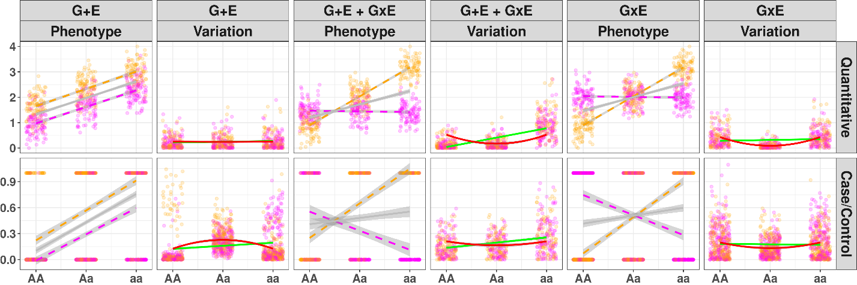
Figure 1: Illustration of Variance Loci suggesting GxE candidate SNP
Gray line: regression lines fitted by GWAS not accounting environment exposure; green line: regression lines fitted by double linear model (DLM) for non-zero slop test; solid red line: curves fitted by variance loci analysis (VLA) for positive gradient test; magenta/orange: environment-specific observations; x-axis: SNP genotypes (allele counts); y-axis: phenotype value or among of variation. column 1 and 2 (a, b): presence of SNP effect and environment direct effect (G+E), but no GxE interaction; column 3 and 4 (c, d): SNP effect, environment direct effect, and GxE interaction (G+E + GxE); column 5 and 6 (e, f): SNP effect and pure GxE effect (G + GxE) without environment direct effect.
Row 1 (a, c, e): quantitative phenotypes. (a) In the absence of a GxE (G+E), the phenotype spreads uniformly across genotypes and a flat line fits through the variation, therefore DLM and VLA maintain that A/a is not a variance loci, but GWAS significance erroneously suggests A/a as a GxE candidate; (c) In the presence of a GxE (G+E + GxE), the phenotype spreads unevenly across genotypes, a line with non-zero slop (solid green) and a curve with positive gradient (solid red) fit through the variation, therefore, DLM and VLA recognize A/a as a variance loci and GxE candidate; (e) In the presence of a pure GxE, a flat line fit through the variation (solid green line) so DLM could not recognize the variance loci, but a curve with positive gradient (solid red) still fits through, allowing VLA to detect the variance loci.
Row 2 (b, d, f): case/control phenotype. (b) Even in the absence of a GxE, a non-zero slope still fits through the variation (solid green). Therefore, DLM wrongfully classifies A/a as a GxE candidate, inflating type 1 error, but VLA’s positive gradient test does not because the curve fit through the variation had negative gradient (solid red); (d) in the presence of GxE, VLA’s positive gradient test can detect A/a as a GxE candidate (solid red line); (f) VLA positive gradient test also detects pure GxE candidate (solid red) where DLM non-zero slop test fails (solid green).

(a)
(c)

(b)
(e)

(d)

(f)
Xiaoran: Figure 1’s drawing and description have been reworked.
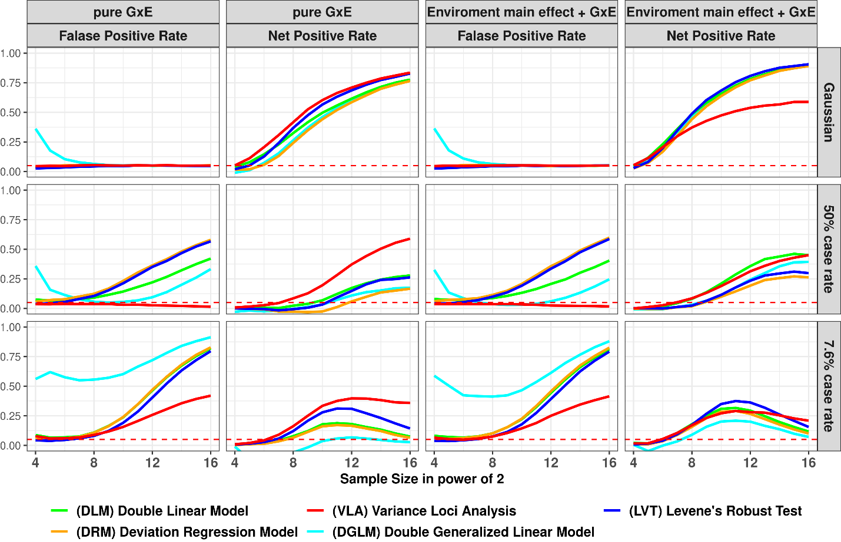
Figure 2: False Positive and Net Positive rates of Simulation Studies
Column 1 and 3: GxE is null, the y-axis is false positive rates (FPR), an FPR of 0.05 (denoted by red dashes) is proper, higher FPR suggest over confidence, lower means overly conservative; Column 2 and 4: additive variance loci induced by pure GxE, or GxE coexisting with standalone environmental main effect, in these cases the y-axis are net positive rates (NPR), higher means better; x-axis: sample sizes in powers of 2; colors: statistical tests.
(a)
(b)
(c)

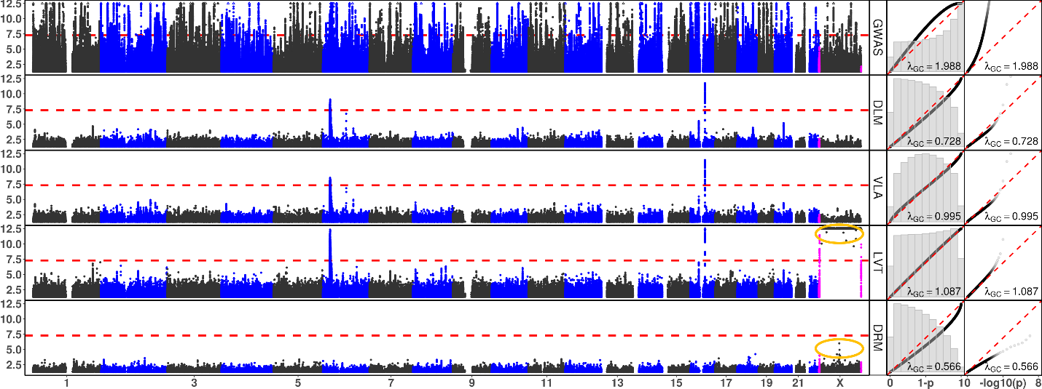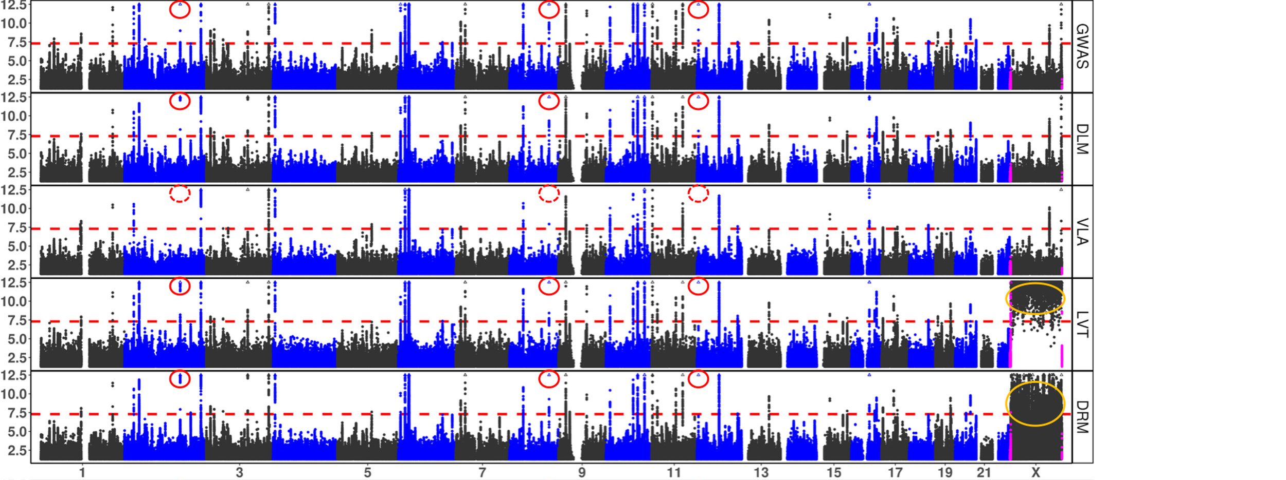
Figure 3: Manhattan and QQ Plots, with λ_{GC}
x-axis: chromosomes (Manhattan plot), theoretical 1 - p (QQ plot 1), or theoretical -log₁₀(p) (QQ plot 2); y-axis: -log₁₀(p) (Manhattan and QQ plot 2), or 1 - p (QQ plot 1); red dash: significance threshold -log₁₀(5e-8) (Manhattan plot); each point bins 269,534 basepairs; magenta points pseudo-autosome regions (PAR) in X; orange circle: abnormal p-values excluded from QQ plots and λ_{GC}; rows: statistical tests, GWAS = genome wide association study; DLM = double linear model, VLA = variance loci analysis (upwardness test), LVT = Levene’s robust test, DRM = Deviation Regression Model; red circle: rs6712203 (Chr2), rs860262 (Chr7) and rs76895963 (Chr12) avoided by VLA but picked up by other tests.

(a) Body Mass Index

(b) Type 2 Diabetes

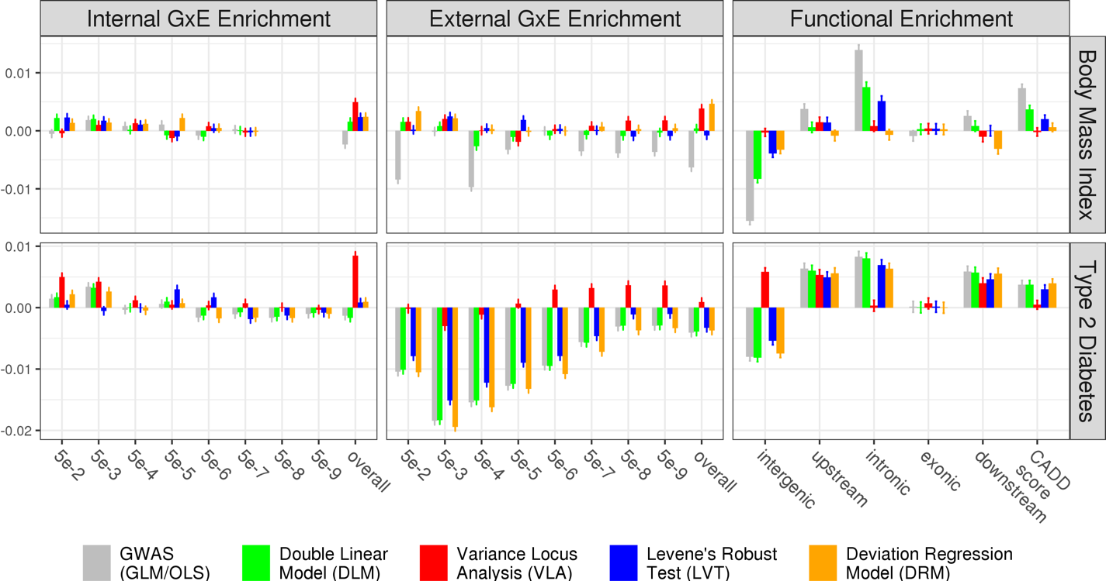

(a)
(c)
(d)
(b)

(f)
(e)
Figure 4: Empirical GxE and Functional Enrichment Analysis
top: results for body mass index (BMI); bottom: results for type 2 diabetes (T2D); (a)(b)(c)(d): GxE enrichment analysis, x-axis denotes the level of GxE significance by p-value used to score a SNP’s GxE activeness, “overall” means scoring a SNP by the sum of negative log p-values of GxE across all exposome items; the y-axis are GxE enrichment coefficient, higher means better statistical test; (e)(f): functional enrichment analysis, x-axis enumerate SNP labels, CADD score stands for “combined annotation dependent depletion” score, in this case, lower or higher enrichment is merely descriptive that does not suggest good or bad statistical test; the missing bars in (a) was due to the absence of significant GxE p-value for BMI reaching for 5e-8 and lower.

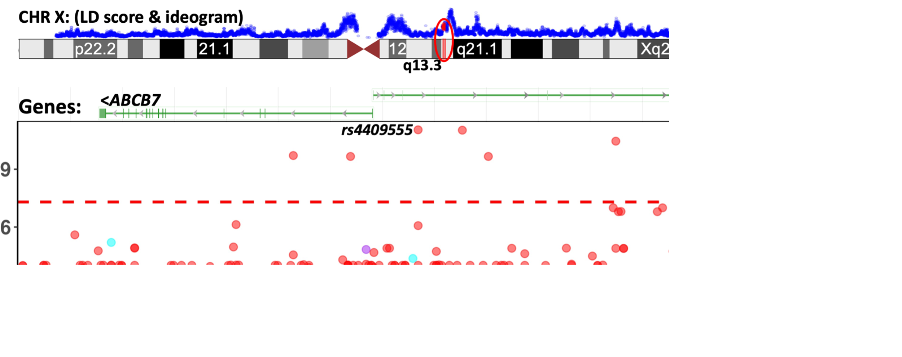
Figure 5: GxE interaction between SNPs in ABCB7-UPRT and print materials associated with T2D in PEGS
The Manhattan plot shows unadjusted -log₁₀(P) (y-axis) for GxE due to SNPs between X: 75,020,000 - 75,360,000 (x-axis) and exposures to print materials (colored points); The gene bars shows ABCB7 and UPRT (rendered by NCBI genome viewer); the ideogram on top shows chromosome X (rendered by UCSC genome browser), the enclosing region q13.3 (red), and LD scores (blue) based on 3104 genotyped females (68.4%) in PEGS; the GxE between SNPs in ABCB7-UPRT and toner (red points) reached beyond conventional genome wide significance (-log₁₀(5e-8), red horizontal dash). Although the smallest p-value (rs4409555, 9.25e-12) did not guarantee significance after Bonferroni correction over 4.74 billion selectable GxE tests, the region was prioritized by significant variance loci found by VLA in the UK Biobank.

(Xiaoran: Reworking this figure)
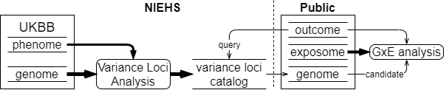
Figure 9: UKBB variance loci catalog workflow

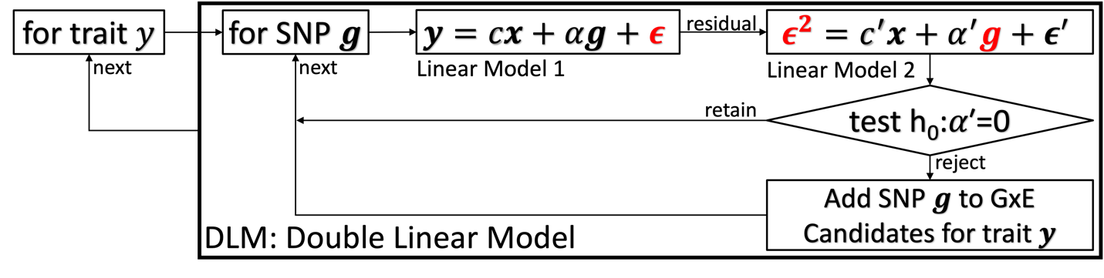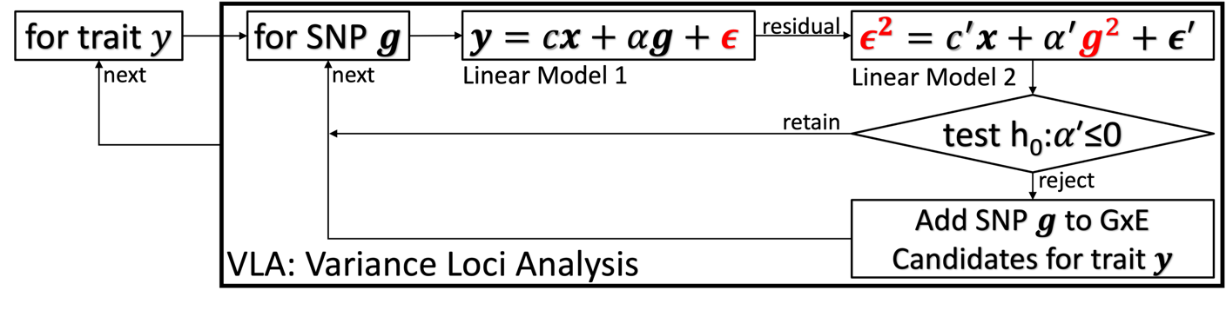
Figure 10: diagram of double linear model (DLM) and variance loci analysis (VLA)

 | Description | N | Min | Median | Mean | Max | Histogram
BMI | Body mass index | 489955 | 18.0 | 26.7 | 27.4 | 48.0 | 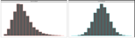
T2D | Type 2 diabetes | 493619 | 0.0 | 0.0 | 0.1 | 1.0 | 
Table 2. UK Biobank Phenotypes
The histograms show distributions before and after normalization, the latter were used in genome wide variance loci tests and 2-way GxE-WAS.

 | Description | N | Min | Med | Mean | Max | 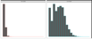  Histogram
ALC | Weekly alcohol intake | 427697 | 0.0 | 8.0 | 11.9 | 603.0
DGP | Domestic garden percentage | 440874 | 0.1 | 24.3 | 24.3 | 66.1 | 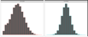  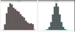
GSP | Green space percentage | 440874 | 4.4 | 41.5 | 45.0 | 99.2
MET | Metabolic equivalent minutes | 498628 | 0.0 | 1386.0 | 2553.7 | 125118.0 | 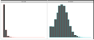
NEP | Nature environment percentage | 497542 | 0.0 | 36.6 | 40.5 | 100.0 | 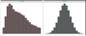
NO1 | Nitrogen oxide | 495124 | 19.7 | 42.4 | 44.1 | 265.9 | 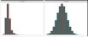  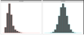
NO2 | Nitrogen dioxide | 495124 | 5.1 | 21.3 | 22.4 | 98.6 | 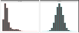
NOI | Noise | 495124 | 46.7 | 50.1 | 51.2 | 88.5
PM1 | Air pollution, PM10 | 495113 | 5.9 | 19.0 | 18.6 | 30.5 | 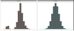
PM2 | Air pollution, PM2.5 | 461201 | 8.2 | 9.9 | 10.0 | 21.3 | 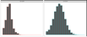
SDN | Sedentary behavior | 500967 | 0.0 | 4.0 | 4.5 | 48.0 | 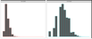
SEA | Distance to coast | 497542 | 0.0 | 44.0 | 41.6 | 108.0 | 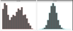  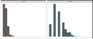
SIB | Number of siblings | 493402 | 0.0 | 2.0 | 2.2 | 44.0 | 
SMK | Ever smoke | 499620 | 0.0 | 1.0 | 0.6 | 1.0
TRF | Traffic intensity | 495124 | 0.8 | 78.2 | 172.6 | 100810.0 | 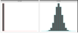  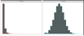
WTP | Water percentage | 440874 | 0.0 | 0.5 | 1.3 | 59.4
Table 3. UK Biobank Exposome (16 items)
The histograms show distributions before and after normalization, the latter were used in 2-way GxE-WAS.

References
Allikmets, Rando, Wendy H. Raskind, Amy Hutchinson, Nichole D. Schueck, Michael Dean, and David M. Koeller. 1999. “Mutation of a Putative Mitochondrial Iron Transporter Gene (ABC7) in X-Linked Sideroblastic Anemia and Ataxia (XLSA/A).” Human Molecular Genetics 8 (5): 743–49. https://doi.org/10.1093/hmg/8.5.743.
Cao, Ying, Peng Wei, Matthew Bailey, John SK Kauwe, Taylor J. Maxwell, and Alzheimer’s Disease Neuroimaging Initiative. 2014. “A Versatile Omnibus Test for Detecting Mean and Variance Heterogeneity.” Genetic Epidemiology 38 (1): 51–59.
Deng, Wei Q., Senay Asma, and Guillaume Paré. 2014. “Meta-Analysis of SNPs Involved in Variance Heterogeneity Using Levene’s Test for Equal Variances.” European Journal of Human Genetics 22 (3): 427–30.
Eichler, Evan E., Jonathan Flint, Greg Gibson, Augustine Kong, Suzanne M. Leal, Jason H. Moore, and Joseph H. Nadeau. 2010. “Missing Heritability and Strategies for Finding the Underlying Causes of Complex Disease.” Nature Reviews Genetics 11 (6): 446–50.
Guo, Nancy Lan, Dhimiter Bello, Qing Ye, Rebecca Tagett, Lucia Chanetsa, Dilpreet Singh, Tuang Yeow Poh, et al. 2020. “Pilot Deep RNA Sequencing of Worker Blood Samples from Singapore Printing Industry for Occupational Risk Assessment.” NanoImpact 19 (July): 100248. https://doi.org/10.1016/j.impact.2020.100248.
Kircher, Martin, Daniela M Witten, Preti Jain, Brian J O’roak, Gregory M Cooper, and Jay Shendure. 2014. “A General Framework for Estimating the Relative Pathogenicity of Human Genetic Variants.” Nature Genetics 46 (3): 310–15.
Lee, Youngjo, and John A Nelder. 2006. “Double Hierarchical Generalized Linear Models (with Discussion).” Journal of the Royal Statistical Society: Series C (Applied Statistics) 55 (2): 139–85.
Lonardo, Amedeo, Simonetta Lugari, Stefano Ballestri, Fabio Nascimbeni, Enrica Baldelli, and Mauro Maurantonio. 2019. “A Round Trip from Nonalcoholic Fatty Liver Disease to Diabetes: Molecular Targets to the Rescue?” Acta Diabetologica 56 (4): 385–96. https://doi.org/10.1007/s00592-018-1266-0.
Marderstein, Andrew R., Emily R. Davenport, Scott Kulm, Cristopher V. Van Hout, Olivier Elemento, and Andrew G. Clark. 2021. “Leveraging Phenotypic Variability to Identify Genetic Interactions in Human Phenotypes.” The American Journal of Human Genetics 108 (1): 49–67.
Pain, Debkumar, and Andrew Dancis. 2016. “Roles of Fe–S Proteins: From Cofactor Synthesis to Iron Homeostasis to Protein Synthesis.” Current Opinion in Genetics & Development, Molecular and genetic bases of disease, 38 (June): 45–51. https://doi.org/10.1016/j.gde.2016.03.006.
Paré, Guillaume, Nancy R. Cook, Paul M. Ridker, and Daniel I. Chasman. 2010. “On the Use of Variance per Genotype as a Tool to Identify Quantitative Trait Interaction Effects: A Report from the Women’s Genome Health Study.” PLoS Genetics 6 (6): e1000981.
Podhajny, Richard M. 2001. “A Brief Chemistry Lesson on Printing Ink Pigments.” Paper, Film and Foil Converter 75 (11): 20.
Rentzsch, Philipp, Daniela Witten, Gregory M. Cooper, Jay Shendure, and Martin Kircher. 2019. “CADD: Predicting the Deleteriousness of Variants throughout the Human Genome.” Nucleic Acids Research 47 (D1): D886–94.
SILAGHI, CRISTINA ALINA, HORATIU SILAGHI, HORATIU ALEXANDRU COLOSI, ANCA ELENA CRACIUN, ANCA FARCAS, DANIEL TUDOR COSMA, NICOLAE HANCU, RALUCA PAIS, and CARMEN EMANUELA GEORGESCU. 2016. “Prevalence and Predictors of Non-Alcoholic Fatty Liver Disease as Defined by the Fatty Liver Index in a Type 2 Diabetes Population.” Clujul Medical 89 (1): 82–88. https://doi.org/10.15386/cjmed-544.
Smyth, Gordon K. 1989. “Generalized Linear Models with Varying Dispersion.” Journal of the Royal Statistical Society: Series B (Methodological) 51 (1): 47–60.
Struchalin, Maksim V., Najaf Amin, Paul HC Eilers, Cornelia M. van Duijn, and Yurii S. Aulchenko. 2012. “An R Package" VariABEL" for Genome-Wide Searching of Potentially Interacting Loci by Testing Genotypic Variance Heterogeneity.” BMC Genetics 13 (1): 1–7.
Van Ijzendoorn, Marinus H, Marian J Bakermans-Kranenburg, Jay Belsky, Steven Beach, Gene Brody, Kenneth A Dodge, Mark Greenberg, Michael Posner, and Stephen Scott. 2011. “Gene-by-Environment Experiments: A New Approach to Finding the Missing Heritability.” Nature Reviews Genetics 12 (12): 881–881.
Wang, Huanwei, Futao Zhang, Jian Zeng, Yang Wu, Kathryn E Kemper, Angli Xue, Min Zhang, et al. 2019. “Genotype-by-Environment Interactions Inferred from Genetic Effects on Phenotypic Variability in the UK Biobank.” Science Advances 5 (8): eaaw3538.
Wang, Kai, Mingyao Li, and Hakon Hakonarson. 2010. “ANNOVAR: Functional Annotation of Genetic Variants from High-Throughput Sequencing Data.” Nucleic Acids Research 38 (16): e164–e164.
Wei, Wei-Qi, Lisa A. Bastarache, Robert J. Carroll, Joy E. Marlo, Travis J. Osterman, Eric R. Gamazon, Nancy J. Cox, Dan M. Roden, and Joshua C. Denny. 2017. “Evaluating Phecodes, Clinical Classification Software, and ICD-9-CM Codes for Phenome-Wide Association Studies in the Electronic Health Record.” PloS One 12 (7): e0175508.
Wu, Patrick, Aliya Gifford, Xiangrui Meng, Xue Li, Harry Campbell, Tim Varley, Juan Zhao, Robert Carroll, Lisa Bastarache, and Joshua C. Denny. 2019. “Mapping ICD-10 and ICD-10-CM Codes to Phecodes: Workflow Development and Initial Evaluation.” JMIR Medical Informatics 7 (4): e14325.
Yang, Jian, Ruth JF Loos, Joseph E. Powell, Sarah E. Medland, Elizabeth K. Speliotes, Daniel I. Chasman, Lynda M. Rose, Gudmar Thorleifsson, Valgerdur Steinthorsdottir, and Reedik Mägi. 2012. “FTO Genotype Is Associated with Phenotypic Variability of Body Mass Index.” Nature 490 (7419): 267–72.

References
1. Eichler EE, Flint J, Gibson G, Kong A, Leal SM, Moore JH, et al. Missing heritability and strategies for finding the underlying causes of complex disease. Nat Rev Genet. 2010;11(6):446-50.
2. van Ijzendoorn MH, Bakermans-Kranenburg MJ, Belsky J, Beach S, Brody G, Dodge KA, et al. Gene-by-environment experiments: a new approach to finding the missing heritability. Nat Rev Genet. 2011;12(12):881; author reply
3. Cao Y, Wei P, Bailey M, Kauwe JSK, Maxwell TJ. A versatile omnibus test for detecting mean and variance heterogeneity. Genet Epidemiol. 2014;38(1):51-9.
4. Deng WQ, Asma S, Paré G. Meta-analysis of SNPs involved in variance heterogeneity using Levene's test for equal variances. Eur J Hum Genet. 2014;22(3):427-30.
5. Struchalin MV, Amin N, Eilers PH, van Duijn CM, Aulchenko YS. An R package "VariABEL" for genome-wide searching of potentially interacting loci by testing genotypic variance heterogeneity. BMC Genet. 2012;13:4.
6. Yang J, Loos RJ, Powell JE, Medland SE, Speliotes EK, Chasman DI, et al. FTO genotype is associated with phenotypic variability of body mass index. Nature. 2012;490(7419):267-72.
7. Paré G, Cook NR, Ridker PM, Chasman DI. On the use of variance per genotype as a tool to identify quantitative trait interaction effects: a report from the Women's Genome Health Study. PLoS Genet. 2010;6(6):e1000981.
8. Smyth GK. Generalized linear models with varying dispersion. Journal of the Royal Statistical Society: Series B (Methodological). 1989;51(1):47-60.
9. Lee Y, Nelder JA. Double hierarchical generalized linear models (with discussion). Journal of the Royal Statistical Society: Series C (Applied Statistics). 2006;55(2):139-85.
10. Rönnegård L, Felleki M, Fikse F, Mulder HA, Strandberg E. Genetic heterogeneity of residual variance - estimation of variance components using double hierarchical generalized linear models. Genet Sel Evol. 2010;42(1):8.
11. Rönnegård L, Valdar W. Detecting major genetic loci controlling phenotypic variability in experimental crosses. Genetics. 2011;188(2):435-47.
12. Marderstein AR, Davenport ER, Kulm S, Van Hout CV, Elemento O, Clark AG. Leveraging phenotypic variability to identify genetic interactions in human phenotypes. Am J Hum Genet. 2021;108(1):49-67.
13. Wang H, Zhang F, Zeng J, Wu Y, Kemper KE, Xue A, et al. Genotype-by-environment interactions inferred from genetic effects on phenotypic variability in the UK Biobank. Sci Adv. 2019;5(8):eaaw3538.
14. Brown MB, Forsythe AB. Robust tests for the equality of variances. Journal of the American Statistical Association. 1974;69(346):364-7.
15. Levene H. Robust tests for equality of variances. Contributions to probability and statistics Essays in honor of Harold Hotelling. 1961:279-92.
16. Bycroft C, Freeman C, Petkova D, Band G, Elliott LT, Sharp K, et al. The UK Biobank resource with deep phenotyping and genomic data. Nature. 2018;562(7726):203-9.
17. Sudlow C, Gallacher J, Allen N, Beral V, Burton P, Danesh J, et al. UK biobank: an open access resource for identifying the causes of a wide range of complex diseases of middle and old age. PLoS Med. 2015;12(3):e1001779.
18. Pain D, Dancis A. Roles of Fe-S proteins: from cofactor synthesis to iron homeostasis to protein synthesis. Curr Opin Genet Dev. 2016;38:45-51.
19. Allikmets R, Raskind WH, Hutchinson A, Schueck ND, Dean M, Koeller DM. Mutation of a putative mitochondrial iron transporter gene (ABC7) in X-linked sideroblastic anemia and ataxia (XLSA/A). Hum Mol Genet. 1999;8(5):743-9.
20. Podhajny RM. A Brief Chemistry Lesson On Printing Ink Pigments. Paper, Film & Foil Converter Magazine [Internet]. 2001. Available from: https://www.pffc-online.com/magazine/782-paper-brief-chemistry-lesson.
21. Silaghi CA, Silaghi H, Colosi HA, Craciun AE, Farcas A, Cosma DT, et al. Prevalence and predictors of non-alcoholic fatty liver disease as defined by the fatty liver index in a type 2 diabetes population. Clujul Med. 2016;89(1):82-8.
22. Lonardo A, Lugari S, Ballestri S, Nascimbeni F, Baldelli E, Maurantonio M. A round trip from nonalcoholic fatty liver disease to diabetes: molecular targets to the rescue? Acta Diabetol. 2019;56(4):385-96.
23. Xiao L, Shi XY, Li ZL, Li M, Zhang MM, Yan SJ, et al. Downregulation of LINC01508 contributes to cisplatin resistance in ovarian cancer via the regulation of the Hippo-YAP pathway. J Gynecol Oncol. 2021;32(5):e77.
24. Gui W, Zhu WF, Zhu Y, Tang S, Zheng F, Yin X, et al. LncRNAH19 improves insulin resistance in skeletal muscle by regulating heterogeneous nuclear ribonucleoprotein A1. Cell Commun Signal. 2020;18(1):173.
25. Wang J, Yang W, Chen Z, Chen J, Meng Y, Feng B, et al. Long Noncoding RNA lncSHGL Recruits hnRNPA1 to Suppress Hepatic Gluconeogenesis and Lipogenesis. Diabetes. 2018;67(4):581-93.
26. Liu D, Liu F, Li Z, Pan S, Xie J, Zhao Z, et al. HNRNPA1-mediated exosomal sorting of miR-483-5p out of renal tubular epithelial cells promotes the progression of diabetic nephropathy-induced renal interstitial fibrosis. Cell Death Dis. 2021;12(3):255.
27. Zhao M, Shen L, Ouyang Z, Li M, Deng G, Yang C, et al. Loss of hnRNP A1 in murine skeletal muscle exacerbates high-fat diet-induced onset of insulin resistance and hepatic steatosis. J Mol Cell Biol. 2020;12(4):277-90.
28. Wei WQ, Bastarache LA, Carroll RJ, Marlo JE, Osterman TJ, Gamazon ER, et al. Evaluating phecodes, clinical classification software, and ICD-9-CM codes for phenome-wide association studies in the electronic health record. PLoS One. 2017;12(7):e0175508.
29. Wu P, Gifford A, Meng X, Li X, Campbell H, Varley T, et al. Mapping ICD-10 and ICD-10-CM Codes to Phecodes: Workflow Development and Initial Evaluation. JMIR Med Inform. 2019;7(4):e14325.
30. Chang CC, Chow CC, Tellier LC, Vattikuti S, Purcell SM, Lee JJ. Second-generation PLINK: rising to the challenge of larger and richer datasets. Gigascience. 2015;4(1):s13742-015-0047-8.
31. Purcell S, Neale B, Todd-Brown K, Thomas L, Ferreira MA, Bender D, et al. PLINK: a tool set for whole-genome association and population-based linkage analyses. Am J Hum Genet. 2007;81(3):559-75.
32. Chang CC. Plink binary biallelic genotype table 2021 [Available from: https://www.cog-genomics.org/plink/1.9/formats#bed.
33. Abecasis GR, Auton A, Brooks LD, DePristo MA, Durbin RM, Handsaker RE, et al. An integrated map of genetic variation from 1,092 human genomes. Nature. 2012;491(7422):56-65.
34. Auton A, Brooks LD, Durbin RM, Garrison EP, Kang HM, Korbel JO, et al. A global reference for human genetic variation. Nature. 2015;526(7571):68-74.
35. National Institute of Environmental Health Sciences. Personalized Environment and Genes Study Data Freeze 1.1. 2021.
36. Wang K, Li M, Hakonarson H. ANNOVAR: functional annotation of genetic variants from high-throughput sequencing data. Nucleic Acids Res. 2010;38(16):e164.
37. Kircher M, Witten DM, Jain P, O'Roak BJ, Cooper GM, Shendure J. A general framework for estimating the relative pathogenicity of human genetic variants. Nat Genet. 2014;46(3):310-5.
38. Rentzsch P, Witten D, Cooper GM, Shendure J, Kircher M. CADD: predicting the deleteriousness of variants throughout the human genome. Nucleic Acids Res. 2019;47(D1):D886-d94.
39. Wei W-Q, Bastarache LA, Carroll RJ, Marlo JE, Osterman TJ, Gamazon ER, et al. Evaluating phecodes, clinical classification software, and ICD-9-CM codes for phenome-wide association studies in the electronic health record. PLOS ONE. 2017;12(7):e0175508.
40. Wu P, Gifford A, Meng X, Li X, Campbell H, Varley T, et al. Developing and Evaluating Mappings of ICD-10 and ICD-10-CM codes to Phecodes. BioRxiv. 2019;
:462077.
41. World Health Organization. International Statistical Classification of Diseases and Related Health Problems (ICD) 2021 [Available from: https://www.who.int/standards/classifications/classification-of-diseases.
42. Bastarache L. Using Phecodes for Research with the Electronic Health Record: From PheWAS to PheRS. Annual Review of Biomedical Data Science. 2021;4(1):1-19.

