Cataloging gene-environment interaction candidate SNPs for over 3,000 UK Biobank disease phenotypes through variance loci analysis
Xiaoran Tong, <authors>, Alison Motsinger-Reif

Abstract [150 words for Nature Genetics]
Detecting gene by environment interactions (GxEs) for diseases enriches the ontology of genetic effects and helps identify environmental targets for interventions with the goal of improving health outcomes. However, combining the dimensions of the genome and exposome poses challenges in terms of both computational and statistical power. Both additive and multiplicative genome-wide variance quantitative trait loci (vQTL) analysis methods have recently received attention for their ability to find candidate single nucleotide polymorphisms (SNPs) for GxEs without actual environmental exposome profiling. The rationale is that unaccounted for GxEs cause the residual variance of a quantitative trait to change across allele dosages—a non-uniformity that, when captured, suggests GxEs.
Based on the simplest additive vQTL approach, the double linear model (DLM), we propose variance loci analysis (VLA) by augmenting the DLM with squared allele dosage. We show that VLA maintains superior power to detect GxE candidates with weak direct environmental effects on the phenotype. We also demonstrate that multiplicative vQTL methods—the double generalized linear model (DGLM) and Levene’s test (LVT)—are overly generic with squared dosage and overly restrictive without squared dosage. More importantly, we show that by appropriately adjusting covariates, VLA can overcome the inability of DLM/DGLM/LVT to analyze thousands of non-quantitative phenotypes.
We performed VLA for 3,273 health- and disease-related phenotypes derived from the UK Biobank and ranked the potential involvement of each SNP in GxEs. We created and hosted the VLA Catalog (genelist.niehs.nih.gov) as an open resource of GWAS, vQTL, and VLA mapping for these traits, along with the metadata required for reproducibility and independent applications. Using environmental exposome data collected in the Personalized Environmental Genetic Study (PEGS), we found that high-ranking genome variants selected by VLA enriched the detection of genome-exposome-wide significant GxE SNPs for cardiovascular disease, type 2 diabetes, and body mass index.

Introduction [No heading or subheadings – I left the subheadings for now to help with organization while we work.]

Background and motivation

Unaccounted-for gene by environment (GxE) effects are recognized as part of the heritability “missed” by variants selected by genome-wide association studies (GWAS)(Eichler et al. 2010; Van Ijzendoorn et al. 2011). Despite findings that genetic effects are context-dependent (9-13), there has been limited success identifying GxEs, in part due to the difficulty of measuring many environmental exposures and insufficient sample sizes (9–11). Genome-exposome wide association studies (GxE-WAS) can test for interactions between genome variants (i.e., SNPs) and environmental exposures in large cohorts with comprehensive exposome and genome data, but the burden of multiple testing and computation time present challenges, and the selection of candidate SNPs from a priori biological knowledge can hinder hypothesis generation. Further, selecting variants from those reaching significance in GWAS tends to produce false positives due to the ostensible assumption that all GXE interaction models involve strong genetic marginal effects.

Motivated by these issues, we developed variance loci analysis (VLA), an alternative approach that involves performing a genome-wide search for variance quantitative trait loci (vQTL) in a selection cohort rich in genome data and using these vQTLs as candidates for GxE studies in a discovery cohort rich in exposome data. The selection cohort must collect data on phenotypes similar to the phenotype of interest in the discovery cohort, but no exposome data is required in the discovery cohort. Analogous to classic QTLs from GWAS that test the allelic effect on the phenotypic mean, vQTLs test the allelic effect on phenotypic variance. However, vQTLs are superior candidates because the presence of strong GxEs causes heterogenous variation of a quantitative trait among individuals of different allele carriage (3-6).

Variance quantitative trait loci (vQTL) analysis
A vQTL can be induced by a GxE effect unaccounted for in a GWAS linear model, resulting in uneven variation around the mean regression line across genotypes (7). Such vQTLs can be detected by fitting the variation with the same genotype via a second linear model. In the recently developed double linear model (DLM) vQTL test, the first stage is a de facto GWAS, and the second stage treats the squared residual as a new phenotype. When a variant is not involved in a GxE (Figure 1a), the phenotypic variation, measured by squared residuals, is nearly uniform across dosage, resulting in a flat regression line in stage 2. Conversely, when the variant is involved in a GxE (Figure 1b), the phenotypic variation changes with allele dosage, resulting in a non-zero slope in stage 2. Because DLM assumes each allele adds a certain quantity to the phenotypic variance, this is called an additive vQTL model.
More traditionally, double generalized linear modeling (DGLM)(8) and double hierarchical generalized linear model (DHGLM)(9) are used for modeling the mean and variance of a quantitative phenotype with shared genotype predictors (i.e., SNPs). DGLM essentially models the phenotypic variance in log scale with allele dosage, thus capturing multiplicative vQTLs.

Issues with vQTL analysis
Under the null of no GxE, existing vQTL tests assume homogeneous variation among individuals of the same genotype and, therefore, phenotypes must be nearly Gaussian. Otherwise, the link between the mean and variance of a non-Gaussian random variable makes a locus affecting the phenotypic mean automatically a locus affecting the phenotypic variance, which can be wrongfully captured by a double linear model (DLM) and a double generalized linear model (DGLM). More robust methods have shown varying success in balancing the statistical power and control of false positives. The deviation regression model (DRM) is a modified DLM that replaces squared distance from the phenotype to genotype group mean (i.e., the squared residuals of the stage-1 linear model) with distance to the group median to capture additive vQTL (Marderstein et al. 2021). Levene’s robust test of heterogeneous variance (LVT) can capture non-parametric vQTL.
However, for binary phenotypes, because the mean μ and variance v are tightly related by v=μ(1-μ), these vQTL tests are ineffective (Paré et al. 2010; Marderstein et al. 2021; H. Wang et al. 2019) and can identify a GWAS-significant SNP as a GxE candidate regardless of the presence of a GxE (μvv=μ(1-μ)DLM, Figure 1c) or produce type 1 errors (DGLM), despite their robustness with quantitative non-Gaussian phenotypes (DRM, LVT). Additive vQTL tests such as DLM and DRM also have diminished power to detect strong but pure GxE candidates with weak direct environmental effect on the phenotypic mean, even if the phenotype is Gaussian (Figure 1d).

Variance loci analysis (VLA)
VLA addresses these issues and has superior performance for binary traits while also performing well for quantitative or Gaussian phenotypes. VLA takes an additive perspective but, instead of testing the non-zero slope of the stage-2 regression line as with DLM, fits a one-sided curve and tests its upwardness (Figure 1b, red solid line). For binary phenotypes, VLA provides better control of type 1 errors than other tests because, when alleles have no GxE effect on the phenotype, the fitted curve in the second stage tend to be flat or bend downward (Figure 1c, solid red line). For Gaussian phenotypes, VLA’s upwardness test retains power under a weak environmental main effect and can detect pure GxE candidates (Figure 1d, solid red line).
However, the upwardness test alone lacks power for detecting true candidate SNPs for binary traits when a GxE does exist (Figure 3a) because binary phenotypes gloss over the underlying quantitative risk leading up to the binary event. The gradient of underlying risk can be reconstructed to some extent as residuals by regressing the binary phenotype on a covariate such as age. The residual is a quantitative representation of the underlying risk contributed by the genome, exposome, and GxEs.
With well-chosen covariates, the residuals can be nearly Gaussian. By replacing a binary phenotype with its residualized risk, the upwardness test can detect variance loci involved in GxEs (see Figure 3b). Good covariates should be non-confounding yet predictive, for example, age and sex, which are neither heritable (not considering the Y-chromosome) nor determined by the exposome (i.e., non-confounding) but are strong determinants of diseases (i.e., predictive). A confounding covariate in a model could be useful but may bias the VLA results toward null as a mediator or create spurious genome and exposome effects as a collider (Aschard et al. 2015). A non-predictive covariate, while not affecting the type 1 error, does not help reveal the fine gradient of underlying risk required to recover the power to detect variance loci.

Application of VLA

To empirically assess the ability of VLA to prioritize SNPs involved in GXE affecting quantitative and binary phenotypes, and to compare the method with established variance loci tests (i.e., DLM, LVT, DRM, and even GWAS), we applied each method for a GWAS for type 2 diabetes (T2D) (16, 17) and body mass index (BMI) in a selection population, followed by a two-way genome by exposome wide association study (GxE-WAS) in an independent discovery population.
Enabled by the performance of VLA, we created a catalog of all 3,273 phenotypes in the UKBB, among which 1,693 are semi-automatically derived case/control disease status based on the most recent PHECODE mapping table (Wei et al. 2017; Wu et al. 2019), that is available as a community resource hosted on the NIEHS website (https://genelist.niehs.nih.gov/vla). This represents a significant expansion as previous analyses with existing vQTL tests included at most 18 phenotypes. The NIEHS VLA Catalog summarizes the interaction potential for each variant given phenotypes of interest and can be used to prioritize GxE candidates in future research.
To demonstrate the functionality of the VLA Catalog in empirical research, we conducted internal enrichment analysis in populations from the UK Biobank and followed up the results with an external enrichment analysis in the North Carolina-based Personalized Gene and Environment Study (PEGS), which has whole genome sequencing and extensive exposome data.
In the selection population, we ranked each SNP by 1 minus the p-value of VLA and the other tests’ primary statistics; in the discovery population, we scored each SNP by the number of statistically significant GxE effects identified at a given p-value cut-off, or by the sum of the negative log p-value of all tests for the GxE effect it involved. We regressed the scores on the ranks so the estimated coefficient acted as a measure of GxE enrichment, such that a positive significant enrichment coefficient suggests that the particular method can aid GxE detection by prioritizing the right candidate SNP.

We further investigated functional enrichment by regressing the functional class of SNPs (i.e., intergenic, upstream, intronic, exonic, downstream) on the aforementioned ranks based on 1 – value of variance loci test statistics. As expected, each test prioritized different classes of SNPs. Figure 8 summarizes the findings.
In the GxE-WAS, we found numerous significant (p-value < 5e-8) GxEs for type 2 diabetes involving VLA-selected SNPs in PEGS. We followed up the top signal for ABCB7, a gene involved in the glucose transportation pathway, and PEGS data on exposure to dyes, inks, and toners to validate our findings. We found corroborative evidence of ABCB7’s differential expression among workers with occupational exposure to inkjet printers, archived as GEO number GSE142351.

Results

Simulation
For simulation, we ran 20,000 repeats for each of three scenarios. For each repeat, we generated vectors of the environment and covariates with a normal distribution and a genotype from an SNP randomly picked from Phase 3 of the 1000 Genomes Project (Consortium 2012; Consortium and others 2015) with an MAF≥0.01 and a sample size varying from 2⁴ to 2¹⁶. In all scenarios, we fixed the alpha to 0.05, where the null was rejected if the p-value was less than 0.05.
We treated phenotypes additively, as the sum of a strong covariate effect, weak genotype main effect, possible environmental main effect, and possible GxE effect. Both a pure GxE effect (scenario 1) and a GxE effect co-occurring with an environmental main effect (scenario 3) gave rise to additive variance loci. For comparison, we let the genotype directly affect the phenotypic variance in log scale (scenario 2), which gave rise to multiplicative variance loci. For each scenario, we also simulated a corresponding null scenario by zeroing out the GxE effect (the additive variance loci in scenarios 1 and 2) or the genetic effect on the logged phenotypic variance (the multiplicative variance loci in scenario 3). Next, for each scenario, we simulated a corresponding null scenario by zeroing out the GxE effect (additive variance loci in scenarios 1 and 3) or the genetic effect on logged phenotypic variance (multiplicative variance loci in scenario 2), rejecting the null in these latter scenarios added to a method’s false positive rate, or type 1 error. We considered a

test superior if it had a high true positive rate (power) while controlling the false positive rate (type 1 error). Accordingly, we used the net positive rate (i.e., the true positive rate minus the false positive rate) as an overall measure of performance.
For balanced binary phenotypes (i.e., a 50% case rate), the variance loci and genetic main effects became less distinguishable as the sample size increased, which increased the false positive rate (panels 1 and 3 of Figure 4b) at the cost of the net positive rate (panels 2 and 4 of Figure 4b). As a result, with the exception of VLA, none of the tests were able to control the false positive rate. VLA again had the best performance in detecting true candidate SNPs for pure GxE effects (solid red line in panel 2 of Figure 4b).

For imbalanced binary phenotypes (7.6% case rate), for which it is difficult to distinguish an SNP main effect on the phenotypic mean from the effect on the phenotypic variance, causing overall inflation of the false positive rate, VLA had the best performance in detecting true GxE candidates (Figure 2c).

Overall, the simulations showed that the VLA was better at detecting additive variance loci induced by pure GxE effects and more robust in the presence of false positives caused by imbalanced, non-Gaussian phenotypes. As expected, VLA underperformed with multiplicative variance loci because a negative allele effect on logged variance corresponds with an improper, non-real-valued additive GxE effect.
The supplement details the simulation and provides the full results, including true positive rates and values for multiplicative variance loci.

UKBB Genome Wide Variance Loci Analysis
To examine how each test selects variance loci, we applied all the tests (except DGLM due to low speed and instability) in BMI and T2D data from UKBB. We also performed GWAS with linear and logistic regression for BMI and T2D, respectively, and calculated five test statistics for each SNP.
We assembled two selection populations: 1) 353,605 unrelated British Whites and 2) 379,561 unrelated individuals of European ancestry, including all individuals in the first selection population in addition to Irish, and individuals with any European ancestry. The two selection populations included 9,298,089 and 9,298,331 SNPs, respectively, on chromosomes 1-22 and X with a working MAF > 0.1. The covariateswere age, sex, age², age×sex, age²×sex, the first 20 genetic principal components, and the genotyping array (a total of 26, including the intercept). Figure 3 shows Manhattan plots, QQ plots in both original [0, 1] and -log10(p) scale with a genomic inflation factor (λ_{GC}), based on second selection population. The supplements lists the most significant SNPs for each test.
LVT and DRM were abnormally positive on the X chromosome (Figure 3, orange circles) because the much lower frequency of the heterozygous genotype in men causes LVT and DRM to erroneously attribute phenotypic variance. Accordingly, we omitted the X-chromosome for LVT and DRM from subsequent analyses.
For BMI (Figure 3a, Table s2a), GWAS returned more significant SNPs with over-confidence (λ_{GC}=1.998). The four variance loci tests were distinguished from GWAS and separated the genetic effect on the phenotypic mean and variance with relative ease.
For T2D, except for the X chromosome, all five tests largely agreed on the most significant loci, reflecting the interchangeability of the genetic effect on phenotypic mean and variance for binary outcomes. However, VLA showed the least genomic inflation (λ_{GC}=1.02). Of note, SNP rs860262 on chromosome 7 basepair 28,194,397 and rs76895963 on chromosome 12 basepair 4,384,844 (GRCh37) were not selected by VLA but were by the other tests (Figure 3b, red circles in or table s1b, row 7 and 13). This may prove VLA to be more prudent when rs860262 and rs76895963 turned out to be inactive in GxE.

GxE Enrichment Analysis
To empirically gauge how well the top-ranked SNPs from a variance loci test in a selection population enrich the detection of significant GxE interactions in a discovery population, we performed an internal GxE enrichment assessment in sub-populations in the UKBB and an external assessment in the NC-based PEGS cohort.

Internal GxE enrichment

For BMI (Figure 4a), VLA was the most efficient SNP selector overall (Figure 4a, red) and has pronounced advantages over the other tests (Figure 4b, red). VLA was also more efficient for GxE SNPs with p-values < 5e-7. The supplement provides coefficient values and standard errors.
For T2D , DLM performed similarly as GWAS (Figure 4b, gray and green), indicating that phenotypic mean loci are also variance loci for non-Gaussian phenotypes. Accordingly, VLA is nearly colinear with GWAS and thus redundant; to a lesser degree, there was also redundancy for LVT and DRM at stricter GxE p-value thresholds. Correlation between SNP rankings (i.e., 1 – p value) measured redundancy from GWAS and other tests (DLM, 0.985; LVT, 0.613; DRM, 0.8871; VLA, 0.004). In contrast, for the quantitative BMI phenotype (Figure 4a), the four variance loci tests had distinct selection patterns from GWAS. The correlation between the GWAS-based ranking and tests was DLM (0.053), LVT (0.032), DRM, (0.012), and VLA (0.007).

External GxE Enrichment
We performed additional two-way GxE-WAS in an external discovery population with age, sex, income level, the first 10 principal components, and nominal variable coded ethnicity (European American, African American, Asian, and others) as covariates. BMI was also a covariate for the T2D analyses. We ranked SNPs using test statistics for all tests based on the larger selection population.
After quality control, the selection and discovery populations shared 8,331,313 SNPs with a working MAF > 0.1 in the UKBB selection population (we did not enforce an MAF threshold in PEGS). We scored SNPs by the number of two-way GxE p-values below a series of p-value cut-offs (i.e., up to 728) and the overall sum of negative p-values and then regressed the scores on the rankings according to each test. The supplement provides coefficient and standard errors.
For BMI, SNPs ranked by VLA had the best chance of detecting highly significant GxEs (p-value < 5e-7, …, 5e-9), and the second-best chance of detecting overall GXEs (3.82, se=0.34) in PEGS (Figures 4c and 4d). Interestingly, while DRM had by far the most conservative statistics for BMI (see Figure 3a), it resulted in the best overall enrichment (4.64, se=0.35) in the discovery cohort. For T2D, only VLA enriched the detection of medium-to-highly significant GxEs with p-values < 5e-6, …, 5e-9 and overall GxEs (0.89, se=0.34) in the discovery cohort, while all other tests showed negative coefficients (i.e., depletion). Again, the coefficients of DLM closely followed those GWAS and, to a lesser degree, DRM, reflecting the redundancy of the slope-based variance loci test for binary phenotypes.

Functional enrichment analysis
We also examined enrichment from a functional perspective to examine which classes of SNPs were overrepresented among the significant loci identified by each test.
If the SNPs prioritized by a test are prone to a certain genomic function, the significant loci identified by that test should unevenly represent different types of SNPs. For example, GWAS loci are more frequent among SNPs in or near genes than between genes. We labeled each SNP as an intergenic, upstream, intronic, exonic, or downstream variant using ANNOVAR (K. Wang, Li, and Hakonarson 2010) and calculated the combined annotation dependent depletion (CADD) score (Kircher et al. 2014; Rentzsch et al. 2019) as a continuous measure of pathogenic tendency. We treated the functional labels as binary variables and CADD scores as continuous response variables and regressed them on the SNP rankings given by each test. A positive significant coefficient means the variance loci are over-represented among SNPs of certain types or with higher CADD scores. The supplement provides functional enrichment coefficients for BMI and T2D.
For both phenotypes, all tests but VLA significantly underrepresented intergenic SNPs inside or near genes, and none prioritized exonic SNPs.
For BMI, VLA evenly selected all classes of SNPs (Figure 4e, red). DRM under-selected downstream SNPs (Figure 4e, orange), and the other three tests prioritized intronic SNPs and those with high CADD scores.
For T2D, VLA prioritized intergenic SNPs (Figure 4f, red) but not intronic SNPs or those with high CADD scores. The other four tests largely produced similar results, which is unsurprising given their redundancy regarding a binary phenotype.

PEGS GxE adjusted by UKBB Variance Loci
An exhaustive two-way GxE-WAS for T2D in the discovery cohort resulted in 10.8 trillion GxE test statistics (i.e., genome variants × exposome items). We retained 36.7 billion (0.40%) GxE that were 1) of or beyond moderate significance (P < 5e-4) and 2) matched by coordinates and alleles with variance loci from the previous analysis in the selection cohort. After binning the GxE and matched variance loci into genome segments, we selected the most significant GxE and variance loci per bin, further narrowing the number to 1,608,961 representative GxE (0.015%) and nearby variance loci. After multiple testing correction, further adjusting by the significance of variance loci allowed more SNPs and exposures to enter latter stage of database search than looking at the corrected p-values alone.

ABCB7 × Print Material on T2D

We identified 10 genes, namely LINC02552, LINC02812, SLC25A3P1, LINC02812, SLC25A3P1, RNU6-61P, HNRNPA1P31, LINC01508, ABCB7, and BUD31P2, on or near the top 10,000 VLA-selected SNPs in the significant two-way GxE-WAS results (p-value < 5e-8) for T2D. Of interest is the significant interaction between T2D and X-chromosome gene ABCB7 (ATP binding cassette subfamily B member 7, X:75,051,048 - 75,156,732, ENSG00000131269), its immediate downstream SNP UPRT (uracil phosphoribosyl transferase homolog, X:75,156,388 - 75,304,885, ENSG00000094841), and exposure to dyes and inks (PEGS ID: A_B194*). The p-values and cumulative distribution function of variance loci of nearby significant variance loci found in the UK Biobank by GWAS (p-value = 1.24e-3, CDF = 7.52e-3), DLM (p-value = 1.94e-3, CDF = 7.18e-3), and VLA (p-value = 7.74e-5, CDF=1.47e-3) indicate VLA had better performance for identifying GxE near ABCB7-UPRT than GWAS and DLM.

The significant interaction between SNPs with printer ink and toner provides corroborative evidence of the differential expression of ABCB7 among workers occupationally exposed to inkjet printers, archived as GEO dataset GSE142351 (Guo et al. 2020).

The expression of ABCB7 is an interesting finding because the gene is involved in metabolism and multi-drug resistance and is related to transport pathways of glucose and other sugars, bile salts and organic acids, metal ions, and amine compounds. Notably, the gene encodes a half-transporter involved in the transport of heme from the mitochondria to the cytosol. ABCB7 is also an ATP-dependent mitochondrial transporter implicated in Fe–S cluster assembly. Inherited mutations in ABCB7 have been linked to inherited and acquired sideroblastic anemia with cerebellar ataxia (18, 19), and the absence of ABCB7 impairs the maturation of cytosolic iron–sulfur proteins and induces iron accumulation in mitochondria. Further, knockdown of ABCB7 in HEK293T cells causes mitochondrial iron accumulation and the activation of SOD enzymes. This is important because iron and iron-regulatory proteins and cadmium alter ABCB7 expression, and some pigments in printer ink dyes, such as potash blue or soda blue pigments, contain iron based on ferro and ferric cyanides. Printer inks may also contain cadmium (20). Also of interest is the association of ABCB7 with fatty liver disease. This is notable because T2D is a major risk factor for fatty liver disease and could have common pathways (21, 22).

UKBB variance loci catalog
Inspired by the Pan-UK Biobank GWAS catalog at pan.ukbb.broadinstitute.org, we created and host a catalog of variance loci statistics for UKBB phenotypes and variants on the NIEHS website (genelist.niehs.nih.gov). The catalog is a public resource that can be queried by phenotype, enabling researchers to prioritize candidate variants most likely to invoke significant GxEs. Figure 8 illustrates the workflow of creating the catalog and the query process.
We summarized 1,580 health-relevant phenotypes chosen from UKBB data fields accessible to NIEHS plus an additional 1,693 diseases derived from hospital records using PHECODE, a codebook for extrapolating diseases using ICD9/10 records (www.phewascatalog.org) (39, 40) for a phenome comprising 3,273 items. We distinguished the selected UKBB phenotypes into binomial, multinomial, ordinal, and continuous variables and subsequently recoded and normalized them. For the genome, we limited the variants to those with an overall minor allele frequency of at least 0.005, for a final number of 11,841,785 variants after quality control measures. The materials section provides details of these processes.
For each of the four main racial/ethnic groups in the UKBB (British Whites, Irish, Blacks, and Asian), we performed VLA for the whole phenome and genome to archive variant statistics. We used the plinkFile and vla R packages to traverse the genome by window while scanning variance loci for thousands of phenotypes and variants. We divided the genome into approximately 1,200 groups of 10,000 variants each and summarized the VLA statistics for British Whites, which is the largest group in the UKBB, with a working sample size of 384,000 in 12 hours, using the NIH HPC Biowulf cluster (hpc.nih.gov).

Discussion

VLA is a powerful new method that addresses the constraints of existing vQTL analysis approaches. DLM, DRM, DGLM, and LVT are overly generic with and overly restrictive without squared dosage, so VLA augments DLM with squared allele dosage. DLM and other existing vQTL tests assume homogeneous variation among individuals of the same genotype and thus phenotypes must be nearly Gaussian. DRM and LVT are ineffective for binary phenotypes, however, because of the close relationship between mean and variance, despite their robustness with quantitative non-Gaussian phenotypes (Paré et al. 2010; Marderstein et al. 2021; H. Wang et al. 2019). DLM can identify a GWAS-significant SNP as a GxE candidate regardless of the presence of a GxE, and DGLM produces type 1 errors. VLA has good performance for binary traits and can be used with covariates to reconstruct the underlying risk of a binary trait through residuals. Further, its performance for Gaussian traits is as good as or better than existing vQTL tests. The adjusted binary phenotypes of covariates can be treated as new phenotypes that more clearly represent combined genotype and environmental effects.

Our results provide an unprecedented number of VLA across traits as a searchable/downloadable catalog.
Using VLA to identify GxE candidates for binary phenotypes enables analysis of a large number of case/control outcomes collected in a sizable cohort such as the UKBB. The simplicity of VLA allows the rapid ranking of variants for multiple phenotypes, facilitating creation of the VLA Catalog based on rich phenome (3,237 phenotypes, of which 1,693 are binary) and genome data from the UKBB. We archived VLA statistics as a reference for research on GxEs in the NIEHS-hosted VLA Catalog. Besides serving as a reference database for gene-by-environment analysis, the VLA Catalog can also aid summary statistics-based analysis.

To demonstrate how the VLA Catalog can be used in research, we tested candidate SNPs from UKBB in the PEGS cohort, which has both genetic and environmental exposure data, and found that the SNPs were involved in many significant GXEs.

The GxE enrichment analysis results in both the internal discovery population of UKBB non-British Whites and the external discovery population of PEGS participants demonstrate the strong performance of VLA for prioritizing GxE candidates for binary phenotypes.

We followed up the top finding from our analyses (ABCB7 and printer ink/toner) in gene-expression data.

Using VLA, we scanned more than 11 million SNPs in the UKBB White British population and selected the top 1% most significantly associated with the variance of T2D status as candidates for GxEs. By querying the VLA catalog for T2D status in the UKBB Irish population, we narrowed down the candidates to fewer than 10,000 variants, making it statistically practical to search for significant GxEs for T2D among the more than 700 environmental exposures available for the PEGS cohort. The most significant GxEs pointed to genes associated with fatty liver disease and differentially expressed among individuals with ink, paint, and pesticide exposures, suggesting targets for intervention in the identified genes and in workplaces containing these materials. Considering ABCB7 as an exemplar gene, we validated our GxE analysis in the PEGS cohort. ABCB7’s differential expression among workers with occupational exposure to inkjet printing ink. The results support the potential of VLA to elucidate the mechanisms of disease risk due to gene-environment interactions.

fx=exp1+x-1fx=xx=0

Methods

Variance loci tests to identify GxE candidate SNPs
Given a quantitative trait, an SNP, and covariates, DLM fits a GWAS linear model, adjusting the covariates, and treats the squared residual as a “new phenotype”, subsequently fitting another GWAS linear model with the same SNP and covariates (Figure 10 left). If the SNP coefficient of the second linear model is significant, the SNP is a vQTL, that is, a GxE candidate for that particular quantitative phenotype. Intuitively, the second linear model fits the squared distance from the fitted values of the first linear model (i.e., conditional mean given the SNP and covariates), which amounts to modeling the phenotypic variance, since the mean of squared distance from the mean is variance. VLA (Figure 10, right) slightly modifies DLM. The second linear model uses the squared SNP and a one-sided t-test is performed, assuming a non-negative coefficient. For a binary trait, the rare event (i.e., disease) is coded as 1 and the covariates should be chosen from non-heritable predictors. There is no need to replace the first linear model with DGLM (i.e., logistic regression).
We created R-language wrapper functions for DRM, LVT from the car R package (citation), and DGLM from the dglm R package (citation). Because DGLM is unstable with small samples requires substantial computational time for large samples, we used it as a benchmark in only simulations.
Lastly, we considered the traditional GWAS as a reference GxE candidate selector. We use PLINK2’s “--glm” routine to fit GWAS linear models for BMI and logistic regression for T2D. We included GWAS only for GxE enrichment and functional enrichment analysis.

Two-way GxE-WAS
In a discovery cohort with normalized environment $u$ and standardized SNP $g$, GxE interaction effects are typically captured by adding a two-way product term $ug$ to a GWAS linear model,
$y=m_{0}+ag+bug+cu+dx+e$,
where $e$ is a vector of Gaussian noise and $x$ is the covariate; rejecting $h_{0}:b=0$ at a given p-value threshold suggest the GxE interaction between SNP $g$ and environment $u$. We repeated the above for all two-way combinations of SNPs and environmental exposures. For PEGS, this was 14,874,008 x 765 models, and, for white non-British in the UKBB, this was 9,298,089 x 16 models. While we analyzed all two-way combination for demonstrative purposes, in actual applications, the GxE-WAS should be limited to top-ranked SNPs by querying the VLA Catalog and those below a p-value threshold to minimize computational requirements and mitigate multiple testing.

UK Biobank (UKBB) data
To evaluate the performance of VLA in selecting GxE candidates, we used data from the UKBB, a large-scale resource consisting of genetic and health information for over half a million participants (Application ID: 57849, version 2) collected via questionnaires, electronic health records, biological samples, oral interviews, imaging, and genotype data.

We created a comprehensive catalog of the whole genome using the imputed genotype. After quality control, we divided the remaining individuals into five major ancestry groups—African (afr), non-Chinese Asian (asi), White British (bri), Irish (iri), and White but non-British (wnb)—with a total 375,992 individuals. These ancestry groups are the basis of the NIEHS VLA Catalog, and the bri and wnb groups serve as training and testing datasets, respectively.

We manually compiled UKBB phenotype data, which is summarized in Table 2, for T2D, CAD, BMI, and fasting glucose level. We used

data on 16 environmental variables in UKBB, which are outlined in Table 3.

We also derived phecodes using phenotypes and disease diagnoses from electronic health record (EHR) data for UKBB participants recorded as International Classification of Diseases (ICD) codes (40) (41) (40, 42). The supplement provides details of how we compiled the phenotypes, including criteria and the UKBB data fields used as well as details of our phecode mapping.

PEGS data
For the external GxE enrichment analysis, we used data from the Personalized Gene and Environment Study (PEGS), a North Carolina-based cohort of 19,672 participants of varying age, race, socioeconomic status, and education level. Whole-genome sequencing data is available for 4,610 participants. We used questionnaire-based exposome data in its original form for binary and integer-based items.

We derived T2D and BMI phenotype data from the survey data. The supplement provides information on case/control definitions and quality control.

Figures
Figure 1 – Can LM1 and LM2 be replaced. The acronym isn’t defined and using 1 and 2 would be sufficient.
Figure 2 – not referenced in text. Needs to be corrected – False is incorrectly spelled in the boxes across the top. Capitalization of heading in these boxes should be consistently changed to sentence case.
Figure 3 –
Figure 4 – Figure 4f needs to be corrected on the x axis – interngenic to intergenic.
Figure 5 – Needs to be labeled with a and b.

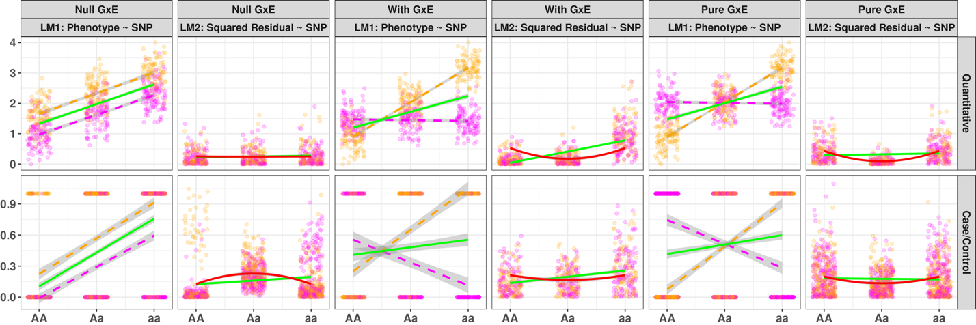
Figure 1: Rationale of variance loci suggesting GxE candidate SNPs
Green solid lines: marginal linear regression lines; red solid lines: curves fitted by variance loci analysis (VLA) for an upwardness test; magenta/orange points and dashed lines: environment-specific observations and regression lines.
(a) In the absence of a GxE, the spread of GWAS residuals (LM1) is uniform across genotypes. A flat line can be fit through squared residuals (LM2, solid line), so variant A/a is not a vQTL, and only GWAS will erroneously identify A/a as a GxE candidate. (b) In the presence of a GxE, the spread of GWAS residuals (LM1) is uneven. A non-zero slope fits through the squared residuals (LM2), and variant A/a is a vQTL. Therefore, a double linear model (DLM) can recognize A/a as a true GxE candidate. (c) For a case/control phenotype, even in the absence of a GxE (LM1, parallel dashes in orange and magenta), a non-zero slope can still be fit through squared residuals (LM2, green solid line). Therefore, DLM erroneously identifies A/a as a GxE candidate, but VLA’s upwardness test does not (LM2, red solid line). (d) Despite the presence of a pure GxE, DLM cannot identify A/a as a vQTL, but VLA’s upwardness test can.

(a)
(b)

(c)
(d)

(e)

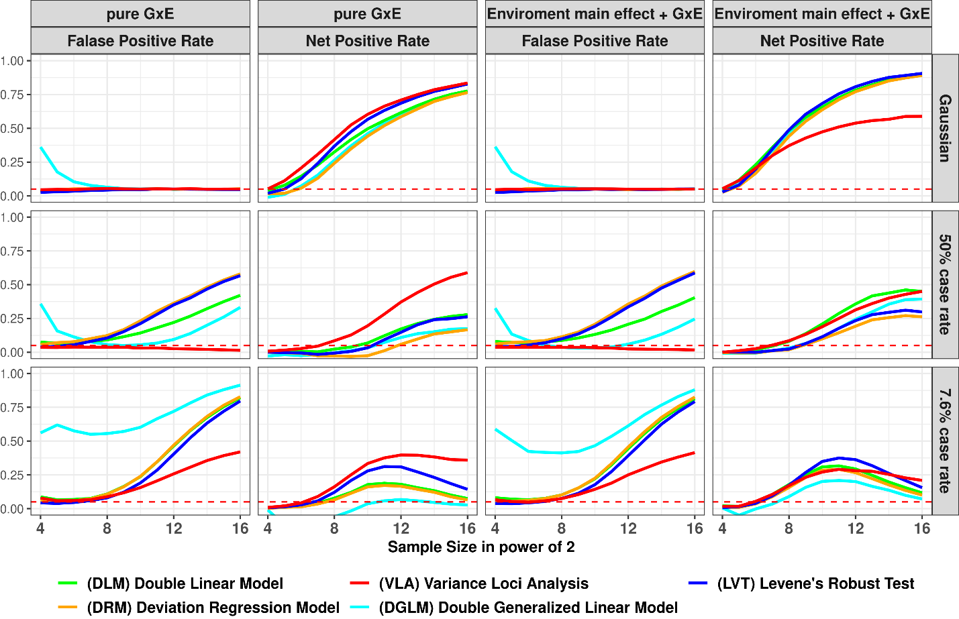
Figure 2: False Positive and Net Positive rates of Simulation Studies
Columns 1 and 3: Null GxE. The y-axis represents the false positive rate (FPR). An FPR of 0.05 (denoted by the red dashed lines) is appropriate. An FPR higher than this suggests overconfidence, and an FPR lower than this indicates overly conservative results. Columns 2 and 4: Additive variance loci induced by a pure GxE or a GxE co-occuring with a standalone environmental main effect. The y-axis represents the net positive rate (NPR). A higher NPR indicates better performance. The x-axis represents sample sizes in powers of two.
(a)
(b)
(c)

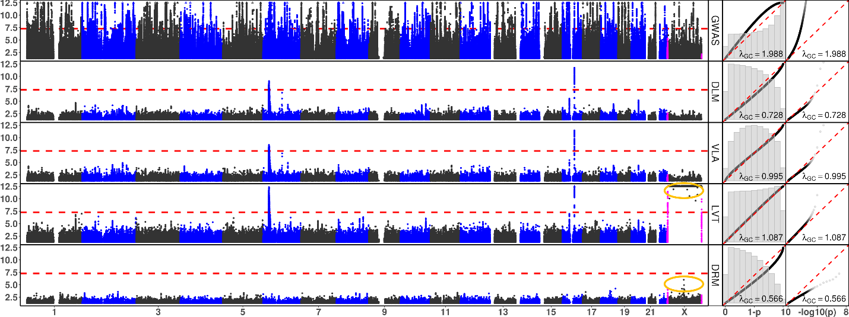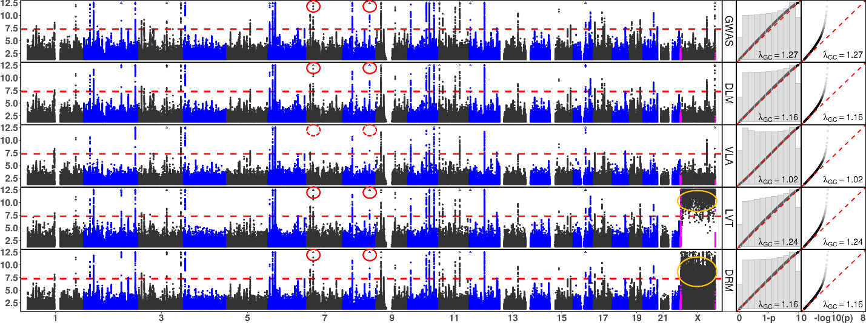
Figure 3: Manhattan and QQ Plots, with λ_{GC}
a) BMI and b) type 2 diabetes. The x-axis represents chromosomes (Manhattan plot). Theoretically, 1 - p (QQ plot 1) or -log₁₀(p) (QQ plot 2). The y-axis represents -log₁₀(p) (Manhattan and QQ plot 2), or 1 - p (QQ plot 1). Red dashed lines represent the significance threshold of -log₁₀(5e-8) (Manhattan plot). Each point represents 269,534 binned base pairs. Magenta points represent pseudo-autosome regions (PAR) in X. Orange circles represent abnormal p-values excluded from QQ plots and λ_{GC.} Rows represent statistical tests.
GWAS: genome wide association study, DLM: double linear model, VLA: variance loci analysis (upwardness test), LVT: Levene’s robust test, DRM: deviation regression model; red circles: rs860262 (Chr7) and rs76895963 (Chr12), which were not identified by VLA but were selected by the other tests.

(a) Body Mass Index

(b) Type 2 Diabetes

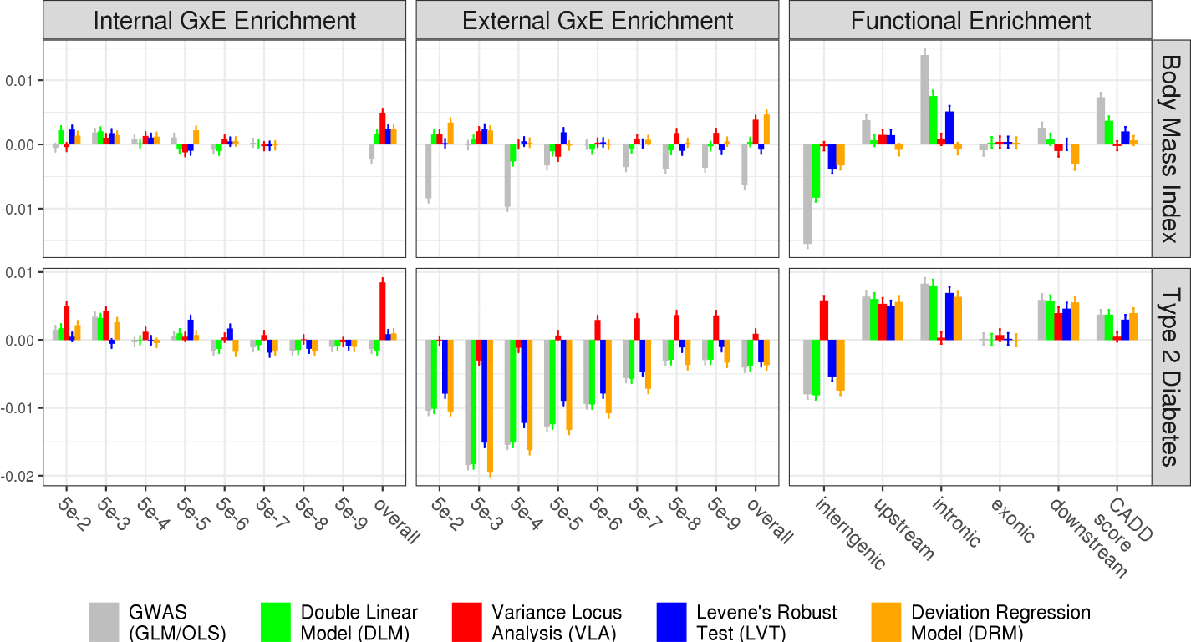

(a)
(c)
(d)
(b)

(f)
(e)
Figure 4: Empirical GxE and Functional Enrichment Analysis
a, c, e) Results for BMI. b, d, f): Results for type 2 diabetes. a, b, c, d): GxE enrichment analysis. The x-axis denotes the level of GxE significance by p-value, which is used to score the GxE activeness of an SNP. “overall” means scoring an SNP by the sum of negative log p-values of GxE across all exposome items. The y-axis represents GxE enrichment coefficients, where higher values indicate better performance of a statistical test. e, f): Functional enrichment analysis. The x-axis enumerate SNP labels. The combined annotation dependent depletion (CADD) score. Lower or higher enrichment is merely descriptive and does not indicate the performance of a statistical test. The missing bars in a indicate that no GxEs for BMI reached the significance level of p<5e-8.

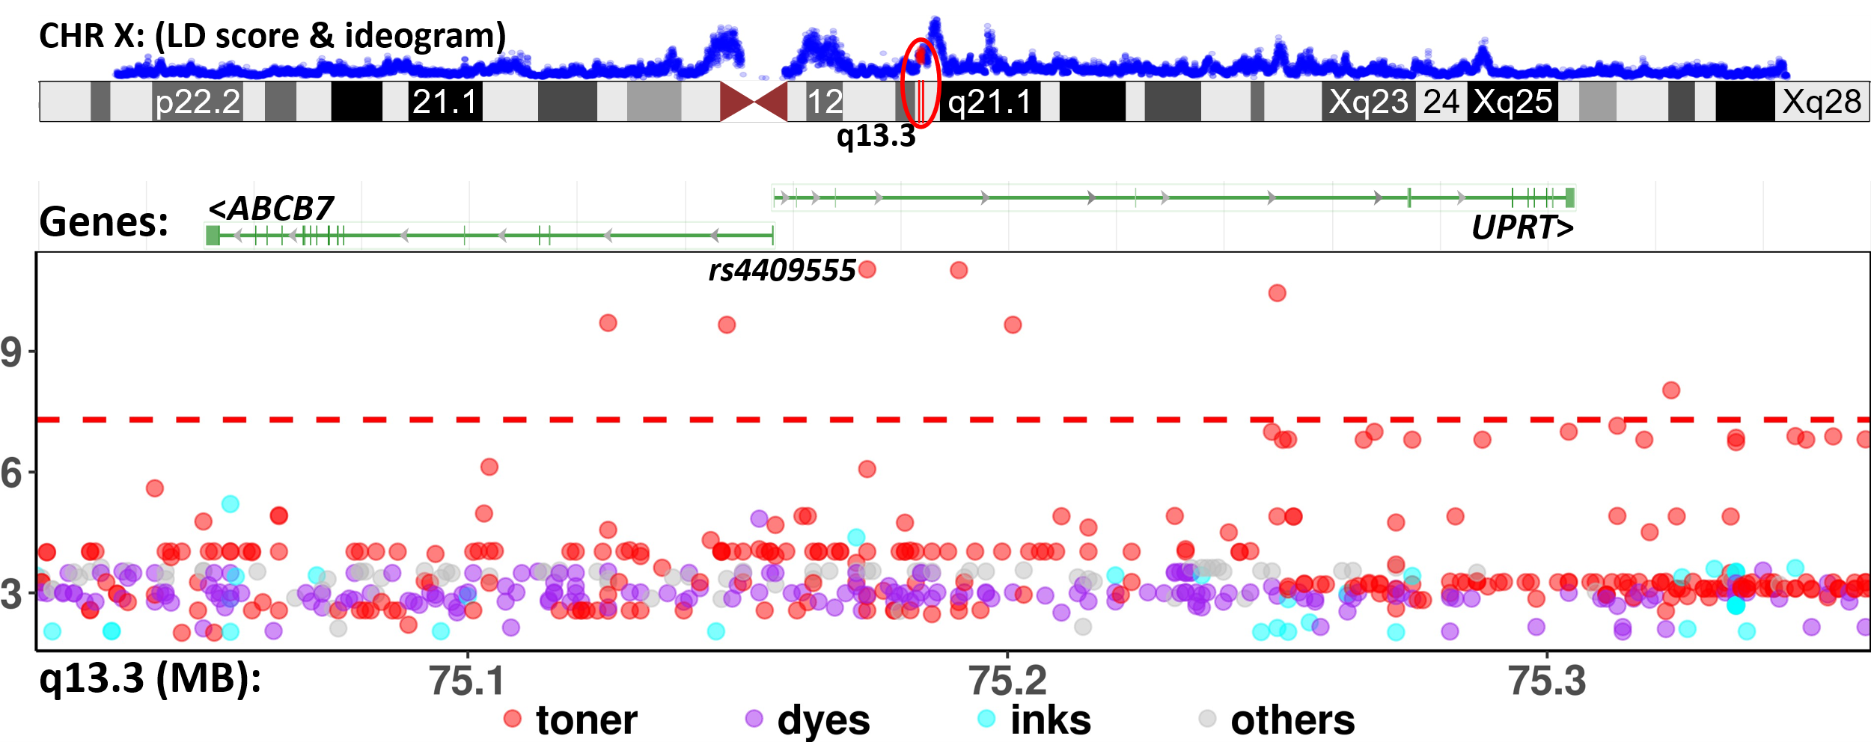

Figure 5: GxE for SNPs in ABCB7-UPRT and printer ink/toner exposure associated with T2D in PEGS
a) Ideogram of chromosome X (rendered by UCSC genome browser), the enclosing region q13.3 (red), and LD scores (blue) based on 3,104 genotyped females (68.4%) in PEGS. b) Manhattan plot of the unadjusted -log₁₀(P) (y-axis) for GxE due to SNPs between X: 75,020,000–75,360,000 (x-axis) and exposures to print materials (colored points). The gene bars shows ABCB7 and UPRT (rendered by NCBI genome viewer). The GxE between SNPs in ABCB7-UPRT and toner (red points) reached beyond conventional genome-wide significance (-log₁₀(5e-8) (red horizontal dashed line). Although the smallest p-value (rs4409555, 9.25e-12) did not guarantee significance after Bonferroni correction over 4.74 billion selectable GxE tests, the region was prioritized by significant UKBB variance loci identified by VLA.

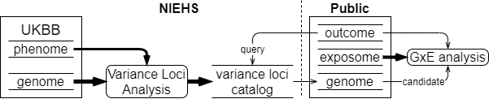
Figure 9: UKBB variance loci catalog workflow

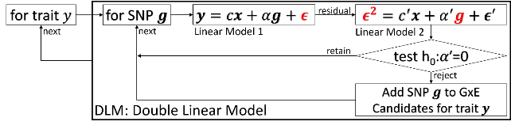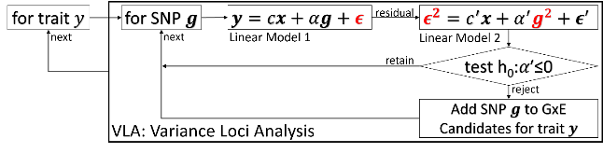
Figure 10: Diagram of double linear model (DLM, left) and variance loci analysis (VLA, right)

 | Description | N | Min | Median | Mean | Max | Histogram
BMI | Body mass index | 489955 | 18.0 | 26.7 | 27.4 | 48.0 | 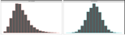
T2D | Type 2 diabetes | 493619 | 0.0 | 0.0 | 0.1 | 1.0 | 
Table 2. UK Biobank Phenotypes Used
Distributions before and after normalization. We used distributions after normalization for the analysis.

 | Description | N | Min | Med | Mean | Max | 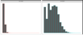  Histogram
ALC | Weekly alcohol intake | 427697 | 0.0 | 8.0 | 11.9 | 603.0
DGP | Domestic garden percentage | 440874 | 0.1 | 24.3 | 24.3 | 66.1 | 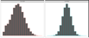  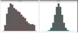
GSP | Green space percentage | 440874 | 4.4 | 41.5 | 45.0 | 99.2
MET | Metabolic equivalent minutes | 498628 | 0.0 | 1386.0 | 2553.7 | 125118.0 | 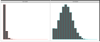
NEP | Nature environment percentage | 497542 | 0.0 | 36.6 | 40.5 | 100.0 | 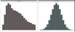
NO1 | Nitrogen oxide | 495124 | 19.7 | 42.4 | 44.1 | 265.9 | 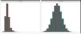  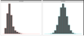
NO2 | Nitrogen dioxide | 495124 | 5.1 | 21.3 | 22.4 | 98.6 | 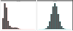
NOI | Noise | 495124 | 46.7 | 50.1 | 51.2 | 88.5
PM1 | Air pollution, PM10 | 495113 | 5.9 | 19.0 | 18.6 | 30.5 | 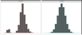
PM2 | Air pollution, PM2.5 | 461201 | 8.2 | 9.9 | 10.0 | 21.3 | 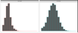
SDN | Sedentary behavior | 500967 | 0.0 | 4.0 | 4.5 | 48.0 | 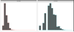
SEA | Distance to coast | 497542 | 0.0 | 44.0 | 41.6 | 108.0 | 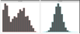  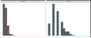
SIB | Number of siblings | 493402 | 0.0 | 2.0 | 2.2 | 44.0 | 
SMK | Ever smoke | 499620 | 0.0 | 1.0 | 0.6 | 1.0
TRF | Traffic intensity | 495124 | 0.8 | 78.2 | 172.6 | 100810.0 | 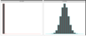  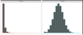
WTP | Water percentage | 440874 | 0.0 | 0.5 | 1.3 | 59.4
Table 3. UK Biobank Exposome
Distributions before and after normalization. We used distributions after normalization for the analysis.

References
Aschard, Hugues, Bjarni J. Vilhjálmsson, Amit D. Joshi, Alkes L. Price, and Peter Kraft. 2015. “Adjusting for Heritable Covariates Can Bias Effect Estimates in Genome-Wide Association Studies.” The American Journal of Human Genetics 96 (2): 329–39.
Chang, Christopher. 2021. “PLINK Binary Biallelic Genotype Table.” June 2021. https://www.cog-genomics.org/plink/1.9/formats#bed.
———. 2022. “PLINK 2.0 Association Analysis: Option --Glm.” March 31, 2022. https://www.cog-genomics.org/plink/2.0/assoc#glm.
Consortium, 1000 Genomes Project. 2012. “An Integrated Map of Genetic Variation from 1,092 Human Genomes.” Nature 491 (7422): 56–65.
Consortium, 1000 Genomes Project and others. 2015. “A Global Reference for Human Genetic Variation.” Nature 526 (7571): 68.
Eichler, Evan E., Jonathan Flint, Greg Gibson, Augustine Kong, Suzanne M. Leal, Jason H. Moore, and Joseph H. Nadeau. 2010. “Missing Heritability and Strategies for Finding the Underlying Causes of Complex Disease.” Nature Reviews Genetics 11 (6): 446–50.
Hernán, Miguel A., Sonia Hernández-Díaz, Martha M. Werler, and Allen A. Mitchell. 2002. “Causal Knowledge as a Prerequisite for Confounding Evaluation: An Application to Birth Defects Epidemiology.” American Journal of Epidemiology 155 (2): 176–84. https://doi.org/10.1093/aje/155.2.176.
Kircher, Martin, Daniela M Witten, Preti Jain, Brian J O’roak, Gregory M Cooper, and Jay Shendure. 2014. “A General Framework for Estimating the Relative Pathogenicity of Human Genetic Variants.” Nature Genetics 46 (3): 310–15.
Marderstein, Andrew R., Emily R. Davenport, Scott Kulm, Cristopher V. Van Hout, Olivier Elemento, and Andrew G. Clark. 2021. “Leveraging Phenotypic Variability to Identify Genetic Interactions in Human Phenotypes.” The American Journal of Human Genetics 108 (1): 49–67.
Paré, Guillaume, Nancy R. Cook, Paul M. Ridker, and Daniel I. Chasman. 2010. “On the Use of Variance per Genotype as a Tool to Identify Quantitative Trait Interaction Effects: A Report from the Women’s Genome Health Study.” PLoS Genetics 6 (6): e1000981.
“PEGS: Personalized Environment and Genes Study.” n.d. National Institute of Environmental Health Sciences. Accessed November 14, 2021. https://www.niehs.nih.gov/research/clinical/studies/pegs/index.cfm.
Rentzsch, Philipp, Daniela Witten, Gregory M. Cooper, Jay Shendure, and Martin Kircher. 2019. “CADD: Predicting the Deleteriousness of Variants throughout the Human Genome.” Nucleic Acids Research 47 (D1): D886–94.
Tong, Xiaoran. 2022a. R-Package: (Github) PlinkFile (version 0.2.1). R. https://github.com/xiaoran831213/plinkFile.
———. 2022b. R-Package: Vla (Github) (version 0.1.0). R. https://github.com/xiaoran831213/vla.
Van Ijzendoorn, Marinus H, Marian J Bakermans-Kranenburg, Jay Belsky, Steven Beach, Gene Brody, Kenneth A Dodge, Mark Greenberg, Michael Posner, and Stephen Scott. 2011. “Gene-by-Environment Experiments: A New Approach to Finding the Missing Heritability.” Nature Reviews Genetics 12 (12): 881–881.
Wang, Huanwei, Futao Zhang, Jian Zeng, Yang Wu, Kathryn E Kemper, Angli Xue, Min Zhang, et al. 2019. “Genotype-by-Environment Interactions Inferred from Genetic Effects on Phenotypic Variability in the UK Biobank.” Science Advances 5 (8): eaaw3538.
Wang, Kai, Mingyao Li, and Hakon Hakonarson. 2010. “ANNOVAR: Functional Annotation of Genetic Variants from High-Throughput Sequencing Data.” Nucleic Acids Research 38 (16): e164–e164.
Wei, Wei-Qi, Lisa A. Bastarache, Robert J. Carroll, Joy E. Marlo, Travis J. Osterman, Eric R. Gamazon, Nancy J. Cox, Dan M. Roden, and Joshua C. Denny. 2017. “Evaluating Phecodes, Clinical Classification Software, and ICD-9-CM Codes for Phenome-Wide Association Studies in the Electronic Health Record.” PloS One 12 (7): e0175508.
Wu, Patrick, Aliya Gifford, Xiangrui Meng, Xue Li, Harry Campbell, Tim Varley, Juan Zhao, Robert Carroll, Lisa Bastarache, and Joshua C. Denny. 2019. “Mapping ICD-10 and ICD-10-CM Codes to Phecodes: Workflow Development and Initial Evaluation.” JMIR Medical Informatics 7 (4): e14325.

References
1. Eichler EE, Flint J, Gibson G, Kong A, Leal SM, Moore JH, et al. Missing heritability and strategies for finding the underlying causes of complex disease. Nat Rev Genet. 2010;11(6):446-50.
2. van Ijzendoorn MH, Bakermans-Kranenburg MJ, Belsky J, Beach S, Brody G, Dodge KA, et al. Gene-by-environment experiments: a new approach to finding the missing heritability. Nat Rev Genet. 2011;12(12):881; author reply
3. Cao Y, Wei P, Bailey M, Kauwe JSK, Maxwell TJ. A versatile omnibus test for detecting mean and variance heterogeneity. Genet Epidemiol. 2014;38(1):51-9.
4. Deng WQ, Asma S, Paré G. Meta-analysis of SNPs involved in variance heterogeneity using Levene's test for equal variances. Eur J Hum Genet. 2014;22(3):427-30.
5. Struchalin MV, Amin N, Eilers PH, van Duijn CM, Aulchenko YS. An R package "VariABEL" for genome-wide searching of potentially interacting loci by testing genotypic variance heterogeneity. BMC Genet. 2012;13:4.
6. Yang J, Loos RJ, Powell JE, Medland SE, Speliotes EK, Chasman DI, et al. FTO genotype is associated with phenotypic variability of body mass index. Nature. 2012;490(7419):267-72.
7. Paré G, Cook NR, Ridker PM, Chasman DI. On the use of variance per genotype as a tool to identify quantitative trait interaction effects: a report from the Women's Genome Health Study. PLoS Genet. 2010;6(6):e1000981.
8. Smyth GK. Generalized linear models with varying dispersion. Journal of the Royal Statistical Society: Series B (Methodological). 1989;51(1):47-60.
9. Lee Y, Nelder JA. Double hierarchical generalized linear models (with discussion). Journal of the Royal Statistical Society: Series C (Applied Statistics). 2006;55(2):139-85.
10. Rönnegård L, Felleki M, Fikse F, Mulder HA, Strandberg E. Genetic heterogeneity of residual variance - estimation of variance components using double hierarchical generalized linear models. Genet Sel Evol. 2010;42(1):8.
11. Rönnegård L, Valdar W. Detecting major genetic loci controlling phenotypic variability in experimental crosses. Genetics. 2011;188(2):435-47.
12. Marderstein AR, Davenport ER, Kulm S, Van Hout CV, Elemento O, Clark AG. Leveraging phenotypic variability to identify genetic interactions in human phenotypes. Am J Hum Genet. 2021;108(1):49-67.
13. Wang H, Zhang F, Zeng J, Wu Y, Kemper KE, Xue A, et al. Genotype-by-environment interactions inferred from genetic effects on phenotypic variability in the UK Biobank. Sci Adv. 2019;5(8):eaaw3538.
14. Brown MB, Forsythe AB. Robust tests for the equality of variances. Journal of the American Statistical Association. 1974;69(346):364-7.
15. Levene H. Robust tests for equality of variances. Contributions to probability and statistics Essays in honor of Harold Hotelling. 1961:279-92.
16. Bycroft C, Freeman C, Petkova D, Band G, Elliott LT, Sharp K, et al. The UK Biobank resource with deep phenotyping and genomic data. Nature. 2018;562(7726):203-9.
17. Sudlow C, Gallacher J, Allen N, Beral V, Burton P, Danesh J, et al. UK biobank: an open access resource for identifying the causes of a wide range of complex diseases of middle and old age. PLoS Med. 2015;12(3):e1001779.
18. Pain D, Dancis A. Roles of Fe-S proteins: from cofactor synthesis to iron homeostasis to protein synthesis. Curr Opin Genet Dev. 2016;38:45-51.
19. Allikmets R, Raskind WH, Hutchinson A, Schueck ND, Dean M, Koeller DM. Mutation of a putative mitochondrial iron transporter gene (ABC7) in X-linked sideroblastic anemia and ataxia (XLSA/A). Hum Mol Genet. 1999;8(5):743-9.
20. Podhajny RM. A Brief Chemistry Lesson On Printing Ink Pigments. Paper, Film & Foil Converter Magazine [Internet]. 2001. Available from: https://www.pffc-online.com/magazine/782-paper-brief-chemistry-lesson.
21. Silaghi CA, Silaghi H, Colosi HA, Craciun AE, Farcas A, Cosma DT, et al. Prevalence and predictors of non-alcoholic fatty liver disease as defined by the fatty liver index in a type 2 diabetes population. Clujul Med. 2016;89(1):82-8.
22. Lonardo A, Lugari S, Ballestri S, Nascimbeni F, Baldelli E, Maurantonio M. A round trip from nonalcoholic fatty liver disease to diabetes: molecular targets to the rescue? Acta Diabetol. 2019;56(4):385-96.
23. Xiao L, Shi XY, Li ZL, Li M, Zhang MM, Yan SJ, et al. Downregulation of LINC01508 contributes to cisplatin resistance in ovarian cancer via the regulation of the Hippo-YAP pathway. J Gynecol Oncol. 2021;32(5):e77.
24. Gui W, Zhu WF, Zhu Y, Tang S, Zheng F, Yin X, et al. LncRNAH19 improves insulin resistance in skeletal muscle by regulating heterogeneous nuclear ribonucleoprotein A1. Cell Commun Signal. 2020;18(1):173.
25. Wang J, Yang W, Chen Z, Chen J, Meng Y, Feng B, et al. Long Noncoding RNA lncSHGL Recruits hnRNPA1 to Suppress Hepatic Gluconeogenesis and Lipogenesis. Diabetes. 2018;67(4):581-93.
26. Liu D, Liu F, Li Z, Pan S, Xie J, Zhao Z, et al. HNRNPA1-mediated exosomal sorting of miR-483-5p out of renal tubular epithelial cells promotes the progression of diabetic nephropathy-induced renal interstitial fibrosis. Cell Death Dis. 2021;12(3):255.
27. Zhao M, Shen L, Ouyang Z, Li M, Deng G, Yang C, et al. Loss of hnRNP A1 in murine skeletal muscle exacerbates high-fat diet-induced onset of insulin resistance and hepatic steatosis. J Mol Cell Biol. 2020;12(4):277-90.
28. Wei WQ, Bastarache LA, Carroll RJ, Marlo JE, Osterman TJ, Gamazon ER, et al. Evaluating phecodes, clinical classification software, and ICD-9-CM codes for phenome-wide association studies in the electronic health record. PLoS One. 2017;12(7):e0175508.
29. Wu P, Gifford A, Meng X, Li X, Campbell H, Varley T, et al. Mapping ICD-10 and ICD-10-CM Codes to Phecodes: Workflow Development and Initial Evaluation. JMIR Med Inform. 2019;7(4):e14325.
30. Chang CC, Chow CC, Tellier LC, Vattikuti S, Purcell SM, Lee JJ. Second-generation PLINK: rising to the challenge of larger and richer datasets. Gigascience. 2015;4(1):s13742-015-0047-8.
31. Purcell S, Neale B, Todd-Brown K, Thomas L, Ferreira MA, Bender D, et al. PLINK: a tool set for whole-genome association and population-based linkage analyses. Am J Hum Genet. 2007;81(3):559-75.
32. Chang CC. Plink binary biallelic genotype table 2021 [Available from: https://www.cog-genomics.org/plink/1.9/formats#bed.
33. Abecasis GR, Auton A, Brooks LD, DePristo MA, Durbin RM, Handsaker RE, et al. An integrated map of genetic variation from 1,092 human genomes. Nature. 2012;491(7422):56-65.
34. Auton A, Brooks LD, Durbin RM, Garrison EP, Kang HM, Korbel JO, et al. A global reference for human genetic variation. Nature. 2015;526(7571):68-74.
35. National Institute of Environmental Health Sciences. Personalized Environment and Genes Study Data Freeze 1.1. 2021.
36. Wang K, Li M, Hakonarson H. ANNOVAR: functional annotation of genetic variants from high-throughput sequencing data. Nucleic Acids Res. 2010;38(16):e164.
37. Kircher M, Witten DM, Jain P, O'Roak BJ, Cooper GM, Shendure J. A general framework for estimating the relative pathogenicity of human genetic variants. Nat Genet. 2014;46(3):310-5.
38. Rentzsch P, Witten D, Cooper GM, Shendure J, Kircher M. CADD: predicting the deleteriousness of variants throughout the human genome. Nucleic Acids Res. 2019;47(D1):D886-d94.
39. Wei W-Q, Bastarache LA, Carroll RJ, Marlo JE, Osterman TJ, Gamazon ER, et al. Evaluating phecodes, clinical classification software, and ICD-9-CM codes for phenome-wide association studies in the electronic health record. PLOS ONE. 2017;12(7):e0175508.
40. Wu P, Gifford A, Meng X, Li X, Campbell H, Varley T, et al. Developing and Evaluating Mappings of ICD-10 and ICD-10-CM codes to Phecodes. BioRxiv. 2019;
:462077.
41. World Health Organization. International Statistical Classification of Diseases and Related Health Problems (ICD) 2021 [Available from: https://www.who.int/standards/classifications/classification-of-diseases.
42. Bastarache L. Using Phecodes for Research with the Electronic Health Record: From PheWAS to PheRS. Annual Review of Biomedical Data Science. 2021;4(1):1-19.

