Supplemental Materials

1. Simulation
This section details the generation of phenotypes of various distributions with or without variance loci. We began with a minimum sample size of N=16 (i.e., 2⁴) and doubled it until N=65,536 (i.e., 2¹⁶). We repeated the simulation for each scenario and each sample size 20,000 times.

Acquire components
Each repeat of the simulation required the following components.

Vector of genotype, $g$
In each repeat, we randomly acquire a single variant from genome region 17q3 (chromosome 17, between base-pair 10,700,001 to 16,000,000) of the 1000 Genomes Project, with an MAF no less than 0.01 and 1,807 unrelated samples (of a total 2,502 provided by Phase 3).
From the 1,807 bi-allelic genotype values (i.e., AA, Aa, and aa), we sampled with replacement until reaching the desired sample size N (i.e., 2⁴, 2⁵ … 2¹⁶) and saved the values as the vector of genotype g. We coded the genotype values as allele dosages: AA=-1, Aa=0, and aa=1.
We used the simgen R-package (located on GitHub repository https://github.com/xiaoran831213/simgen) to determine genotype vector g.

Vector of environment, $u$
For each repeat, we drew a vector of environmental exposures from a normal distribution until reaching the desired N and saved the values as the vector of environment u:
$$u_{i}\overset{\text{i.i.d}}{\sim }N\left(0,1\right), i=(1…N)$$

Vector of covariate, $x$
For each repeat, we drew a vector of the covariate from a normal distribution until reaching the desired N and saved the values as the vector of covariate x:
$$x_{i}\overset{\text{i.i.d}}{\sim }N\left(0,1\right), i=(1…N)$$

Vector of GxE interaction, $ug$
For each repeat, after acquiring the vector of genotype g and environment u with sample size N, we acquired the element-wise product, ug, as the vector of gene-by-environment interaction:
$${(ug)}_{i}=u_{i}g_{i}, i=(1…N)$$

Scenarios with Gaussian phenotype
For each repeat, given the vector of allele dosage genotype g, the vector of environment u, the vector of covariate x, and the vector of GxE interaction ug, we generated a Gaussian phenotype either additively or multiplicatively which gave rise to either additive or multiplicative variance loci.

Additive Gaussian Phenotype
For each sample size N, we generated a Gaussian phenotype with the additive GxE model in equation (1)
$$y_{i}=m_{0}+ag_{i}+b{\left(ug\right)}_{i}+cu_{i}+dx_{i}+ e_{i}, e_{i}\overset{\text{i.i.d}}{\sim }N\left(0,v_{e}\right), i=1…N \\ a\sim N\left(0,v_{a}\right), b\sim N\left(0,v_{b}\right), c\sim N\left(0,v_{c}\right), d\sim N\left(0,v_{d}\right)$$
where the phenotype of the $i$ th individual is the sum of the grand mean $m_{0}$, the genotype main effect of $g_{i}$ with effect size $a$, the GxE interaction effect of ${\left(ug\right)}_{i}$ with effect size $b$, the environmental main effect $u_{i}$ with effect size $c$, the covariate effect of $x_{i}$ with effect size $d$, and random Gaussian white noise $e_{i}$.
We drew the effect sizes $\{a,b,c,d\}$ from normal distributions of mean zero at the beginning of each repeat and used them to generate all N samples (i=1 … N) for that particular repeat; the grand mean $m_{0}$, the variance of the aforementioned unit effect sizes $\{v_{a},v_{b},v_{c},v_{d}\}$, and the variance of white noise $v_{e}$ were pre-determined by the scenario being simulated and were fixed throughout all 20,000 repeats.
Two scenarios involved additively generated Gaussian phenotype–one with a coexisting environmental main effect and GxE effect and one with pure GxE effect. The following parameters were used for the two scenarios:
- $m_{0}=0:$ grand mean
- $v_{a}=0.5$: variance of genotype main effect $a$
- $v_{b}=1.0$: variance of GxE interaction effect $b$ (when not null)
- $v_{c}$: variance of environmental main effect $c$
  - $v_{c}=0.5$: coexisting environmental main effect and GxE effect
  - $v_{c}=0.0$: pure GxE effect
- $v_{d}=1:$ variance of covariate effect d
- $v_{e}=1:$ variance of white noise
When additively generated phenotype $y$, along with genotype $g$ and covariate $x$, was presented as if environment $u$ was unobserved, $g$ was an additive variance locus when $v_{b}≠0$. We also generated two corresponding scenarios of null variance loci by setting $v_{b}=0$.

Multiplicative Gaussian Phenotype
For each sample size N, we also generated the phenotype according to the Gaussian multiplicative model in equation (5)
$y_{i}\sim N\left(m_{0}+ag_{i}+dx_{i},e^{μ+αg_{i}+βg_{i}^{2}}\right), i=1…N$
In this case, the grand mean $m_{0}$ and genotype main effect $a$ acted in the same way as in the additive scenarios, but the vector of environment $u$ was not used. Parameter $μ$ is the size of non-genetically determined phenotypic variance in log scale, including environmental and white noise; parameters $α$ and $β$ determine the link between genotype and phenotypic variance in log scale. When either $α$ or $β$ is non-zero, genotype $g$ becomes a multiplicative variance locus by definition. For simplicity, we fixed $β$ to 0. To choose $μ$ and $α$, we saved $l_{0}=\log\left(v_{e}+v_{c}\right)$, which is the variance of the additively generated phenotype in log scale without GxE interaction; we also saved $l_{1}=\log\left(v_{e}+v_{c}+v_{b}v_{g}\right)$, which is the variance of the additively generated phenotype in log scale with a GxE effect, where $v_{g}$ is the genotype variance, or $4×MAF×(1-2×MAF)$. Next, we let the following have an equal chance of happening:
$$μ=l_{0}, α=\frac{1}{2}\left|l_{1}-l_{0}\right| or μ=l_{1}, α=-\frac{1}{2}\left|l_{1}-l_{0}\right|$$where the latter, phenotypic variance shrinks with each additional allele, corresponding to a latent additive GxE model with squared GxE effect ${\hat{b}}^{2}<0$. As stated in the methods section of the main paper, VLA is powerless when GxE effect $b$ is not real, so we expect VLA to underperform in detecting variance loci for multiplicatively generated phenotypes.
The above steps ensure the multiplicatively generated phenotype shares a similar numerical scale with the additively generated phenotype and has a null multiplicative variance locus when the additively generated phenotype has a null GxE effect (i.e., $v_{b}=0$) since in the latter case $l_{0}=l_{0}=\log\left(v_{e}+v_{c}\right)$ and $α=0$. We used the following parameters to multiplicatively generate a Gaussian phenotype:
- $m_{0}=0$: grand mean.
- $v_{a}=0.5$: variance of genotype main effect $a$.
- $v_{d}=1$: variance of covariate effect $d$.
- $μ:$ phenotypic variance not determined by the genotype, in log scale
  - $μ=0.405$ when $α≥0$ and $0.733$ when $α<0$ numericall corresponds to vc=0.5 and ve=1.0 in an additive scenario
vc=0.5ve=1.0
- $α$: effect of the genotype on phenotypic variance, in log scale
  - $α=+0.164$, multiplicative variance locus exists, numerically corresponding to $v_{b}=+1.0$, which is proper for an additive scenario
  - $α=-0.164$, multiplicative variance locus exists, numerically corresponding to $v_{b}=-1.0$, which is improper for an additive scenario
  - $α=0.0$, null multiplicative variance locus, corresponding to $v_{b}=0$.
- $β=0$: change of squared phenotypic variance per allele, in log scale
With these parameters, we drew phenotype $y$ from the normal distribution and presented it along with genotype $g$ and covariate $x$.
We simulated six scenarios for the Gaussian phenotype, which are listed below with parameters.
Gaussian phenotype | Variance locus? | Additive | Multiplicative
Coexisting environmental main effect and GxE | Yes | $$m_{0}=0, v_{a}=0.5, v_{b}=1.0,$$  $$v_{c}=0.5,v_{d}=1.0,v_{e}=1.0$$ | $$m_{0}=0, v_{a}=0.5,v_{d}=1.0,$$  $β=0, μ=0.405, α=0.164$,  or $μ=0.733, α=-0.164$
Coexisting environmental main effect and GxE | Null | $$m_{0}=0, v_{a}=0.5, v_{b}=0.0,$$  $$v_{c}=0.5,v_{d}=1.0,v_{e}=1.0$$ | $$m_{0}=0, v_{a}=0.5,v_{d}=1.0,$$  $$β=0,μ=0.405, α=0.0$$
Pure GxE | Yes | $$m_{0}=0, v_{a}=0.5, v_{b}=1.0, \\ v_{c}=0.0,v_{d}=1.0,v_{e}=1.0$$ | (Not simulated)
Pure GxE | Null | $$m_{0}=0, v_{a}=0.5, v_{b}=0.0, \\ v_{c}=0.0,v_{d}=1.0,v_{e}=1.0$$ | (Not simulated)

Scenarios involving a binary phenotype
To simulate a vector of binary phenotype $y$, we first generated a vector of Gaussian signal $η$ either additively or multiplicatively as described in the previous section and then converted $η$ to probabilities of disease onset with logistic function. Finally, we randomly drew 1 = case and 0 = control as thebphenotype from one-trail binomial distribution (i.e., Bernoulli trial) with the said probabilities of disease onset, that is,
$$y_{i}\sim binomial\left(n=1, p=π_{i}\right), π_{i}={\left(1+e^{-η_{i}}\right)}^{-1}, i=1…N$$
We manipulated the grand mean $m_{0}$ of the Gaussian signal $η$ to engineer rarity of the resulting binary phenotype, such that $m_{0}=0$ provides a balanced case/control ratio and $m_{0}=-2.5$ provides a prevalence of 7.6%, which is close to the rate of type 2 diabetes in the UK Biobank. We enlarged the variance of GxE and an environmental main effect to $v_{b}=2.0$ and $v_{c}=1.0$ and shrunk the variance of noise to $v_{e}=0.1$ so the genetic and environmental effect were more pronounced. We also enlarged the variance of the covariate effect to $v_{d}=4$ since covariate adjustment is crucial in restoring statistical power for binary phenotypes. Lastly, we reduced the variance of the genotype main effect to $v_{a}=0.1$ so all methods are still challenged to distinguish the genetic effect on phenotypic mean from variance, but their difference in performance was not diminished. The simulation parameters for binary phenotypes are shown below.
Binary phenotype | Variance locus? | Additive | Multiplicative
Coexisting environmental main effect and GxE | Yes | $m_{0}=\left\{0, -2.5\right\}$,$$v_{a}=0.1, v_{b}=4.0, v_{c}=2.0,$$  $$v_{d}=4.0,v_{e}=0.1$$ | $m_{0}=\left\{0, -2.5\right\}$,  $$v_{a}=0.1,v_{d}=4.0,β=0$$  $μ=0.710, α=0.100$,  or $μ=0.911, α=-0.100$
Coexisting environmental main effect and GxE | Null | $m_{0}=\left\{0, -2.5\right\}$,  $$v_{a}=0.1, v_{b}=0.0,v_{c}=0.5,$$  $$v_{d}=4.0,v_{e}=0.1$$ | $m_{0}=\left\{0, -2.5\right\}$,  $$v_{a}=0.1,v_{d}=4.0,β=0$$  $$μ=0.710, α=0.0$$
Pure GxE | Yes | $m_{0}=\left\{0, -2.5\right\}$,  $$v_{a}=0.1, v_{b}=4.0,v_{c}=0.0,$$  $$v_{d}=4.0,v_{e}=1.0$$ | (Not simulated)
Pure GxE | Null | $m_{0}=\left\{0, -2.5\right\}$,  $$v_{a}=0.1, v_{b}=0.0,v_{c}=0.0,$$  $$v_{d}=4.0,v_{e}=1.0$$ | (Not simulated)
We simulated 12 scenarios, which twicw the number of the Gaussian phenotypes because we varied the ground mean $m_{0}$ in $\left\{0, -2.5\right\}$ to create an imbalanced case/control ratio. In addition, we simulated another set of 12 scenarios for a binary phenotype where the GxE effect was nullified.

Scenarios involving Poisson phenotypes
In a similar fashion, we simulated Poisson phenotype $y$ by passing the Gaussian signal $η$ into the exponent function for a rate value and then drew counts from the Poisson distribution of the said rate.
$$y_{i}\sim Poisson\left(λ_{i}\right), λ_{i}=e^{η_{i}}, i=1…N$$
In this case, the grand mean $m_{0}$ of the Gaussian signal $η$ determines the proportion of zeros in the converted counts, where $m_{0}=0$ results in 37% zeros and $m_{0}=-2.5$ results in 92%.
We kept the simulation parameters mostly the same as with the Gaussian phenotypes but reduced the variance of the genotype main effect and noise to 0.1. The simulation parameters are shown below.
Poisson phenotype | Variance locus? | Additive | Multiplicative
Coexisting environmental main effect and GxE | Yes | $m_{0}=\left\{0, -2.5\right\}$,$$v_{a}=0.1, v_{b}=1.0,v_{c}=0.5,$$  $$v_{d}=1.0,v_{e}=0.1$$ | $$m_{0}=\left\{0, -2.5\right\},$$  $$v_{a}=0.5,v_{d}=1.0,β=0,$$  $μ=-0.440, α=0.288$,  or $μ=0.135, α=-0.288,$
Coexisting environmental main effect and GxE | Null | $m_{0}=\left\{0, -2.5\right\}$,  $$v_{a}=0.1, v_{b}=0.0,v_{c}=0.5,$$  $$v_{d}=1.0,v_{e}=0.1$$ | $m_{0}=\left\{0, -2.5\right\}$,  $$v_{a}=0.5,v_{d}=1.0,β=0$$  $$μ=-0.440, α=0.0$$
Pure GxE | Yes | $m_{0}=\left\{0, -2.5\right\}$,$$v_{a}=0.1, v_{b}=1.0,v_{c}=0.0,$$  $$v_{d}=1.0,v_{e}=0.1$$ | (Not simulated)
Pure GxE | Null | $m_{0}=\left\{0, -2.5\right\}$,  $$v_{a}=0.1, v_{b}=0.0,v_{c}=0.0,$$  $$v_{d}=1.0,v_{e}=0.1$$ | (Not simulated)

Execution and summary of simulations
For each scenario, after determining the parameters and phenotype converters, we performed the following steps for each of the 20,000 repeats.
- Data generation
  - Acquire vector of genotype $g$, environment $u$, and covariate $x$.
  - Draw the effect sizes $\{a, b,c,d\}$ from the normal of mean 0 and variances $\{v_{a}, v_{b},v_{c},v_{d}\}$.
  - Draw the vector of noise $e$ from the normal of mean 0 and variance $v_{e}$.
  - Generate the vector of phenotype $y$
      - Either additively, as $y_{i}=m_{0}+ag_{i}+b{\left(ug\right)}_{i}+cu_{i}+dx_{i}+ e_{i}$
      - Or multiplicatively, as $y_{i}\sim N\left(m_{0}+ag_{i}+dx_{i},e^{μ+αg_{i}+βg_{i}^{2}}\right)$
- Present data $\{y,x,g\}$ on various statistical tests:
  - DLM: double linear model
  - VLA: variance locus analysis, the proposed method
  - LVT: Levene’s robust test of heterogeneous variance
  - DRM: deviation regression model
  - DGLM: double generalized linear model
- Collect the p-values of the primary test statistics from the above methods.
For all scenarios, we fixed the size of the statistical test at 0.05, rejecting the null hypothesis $h_{0}$: the genotype $g$ is not a variance locus of phenotype $y$ when the p-value for a method is below 0.05.
When a scenario allows variance loci, the proportion of times $h_{0}$ is rejected among 20,000 repeats shows a method’s power, or true positive rate. Conversely, when a scenario has null variance loci, the number of times $h_{0}$ is rejected in 20,000 repeats shows a method’s type 1 error, or false positive rate. We also calculated the net positive rate as the true positive rate of each non-null scenario minus the false positive rate of the corresponding null scenario. Figures s1-s3 present the results across the sample sizes for each scenario.
We divided the results for binomial phenotype into two groups corresponding to the grand mean $m_{0}$. The first group shows the results for a balanced case rate (50%), and the second group shows the results for an imbalanced case rate (7.8%). For each group, there were six scenarios similar to the Gaussian scenarios. For Poisson phenotypes, the layout is the same as binomial phenotypes.

Results and scripts
This section outlines the performance of various variance loci tests by the distribution of phenotypes. We used R scripts to generate the phenotype, execute and summarize the simulation in figures. The GitHub link to the corresponding script is under each figure.

Gaussian phenotype
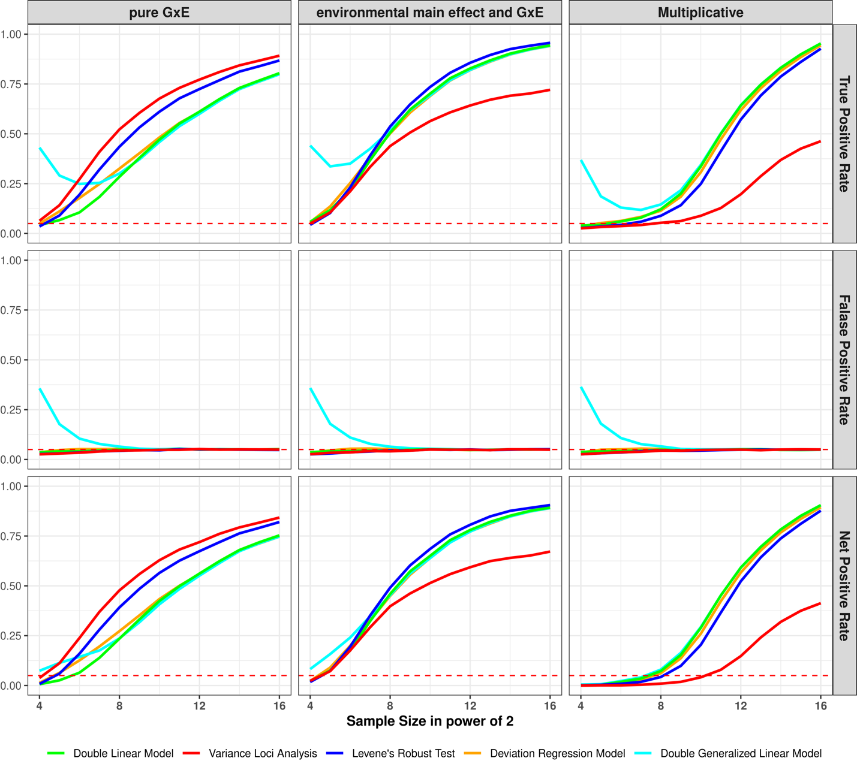Figure s1a: performance on simulated Gaussian phenotype
top row: y-axis is true positive rate (a.k.a., power); middle row: y-axis is false positive rate (a.k.a., type 1 error); bottom row: y-axis is net positive rate (true positive – false positive); left columns (pure GxE): variance loci were additively induced by GxE, without environmental main effect; middle column (environmental main effect and GxE): variance loci were additively induced by GxE locus, with coexisting environmental main effect; right column (multiplicative): variance loci were multiplicative; colored solid lines: variance loci tests; red dashed line: expected false positive rate at the size of hypothesis testing (0.05).
<place holder: links to the R-script>

Binary phenotype, 50% cases
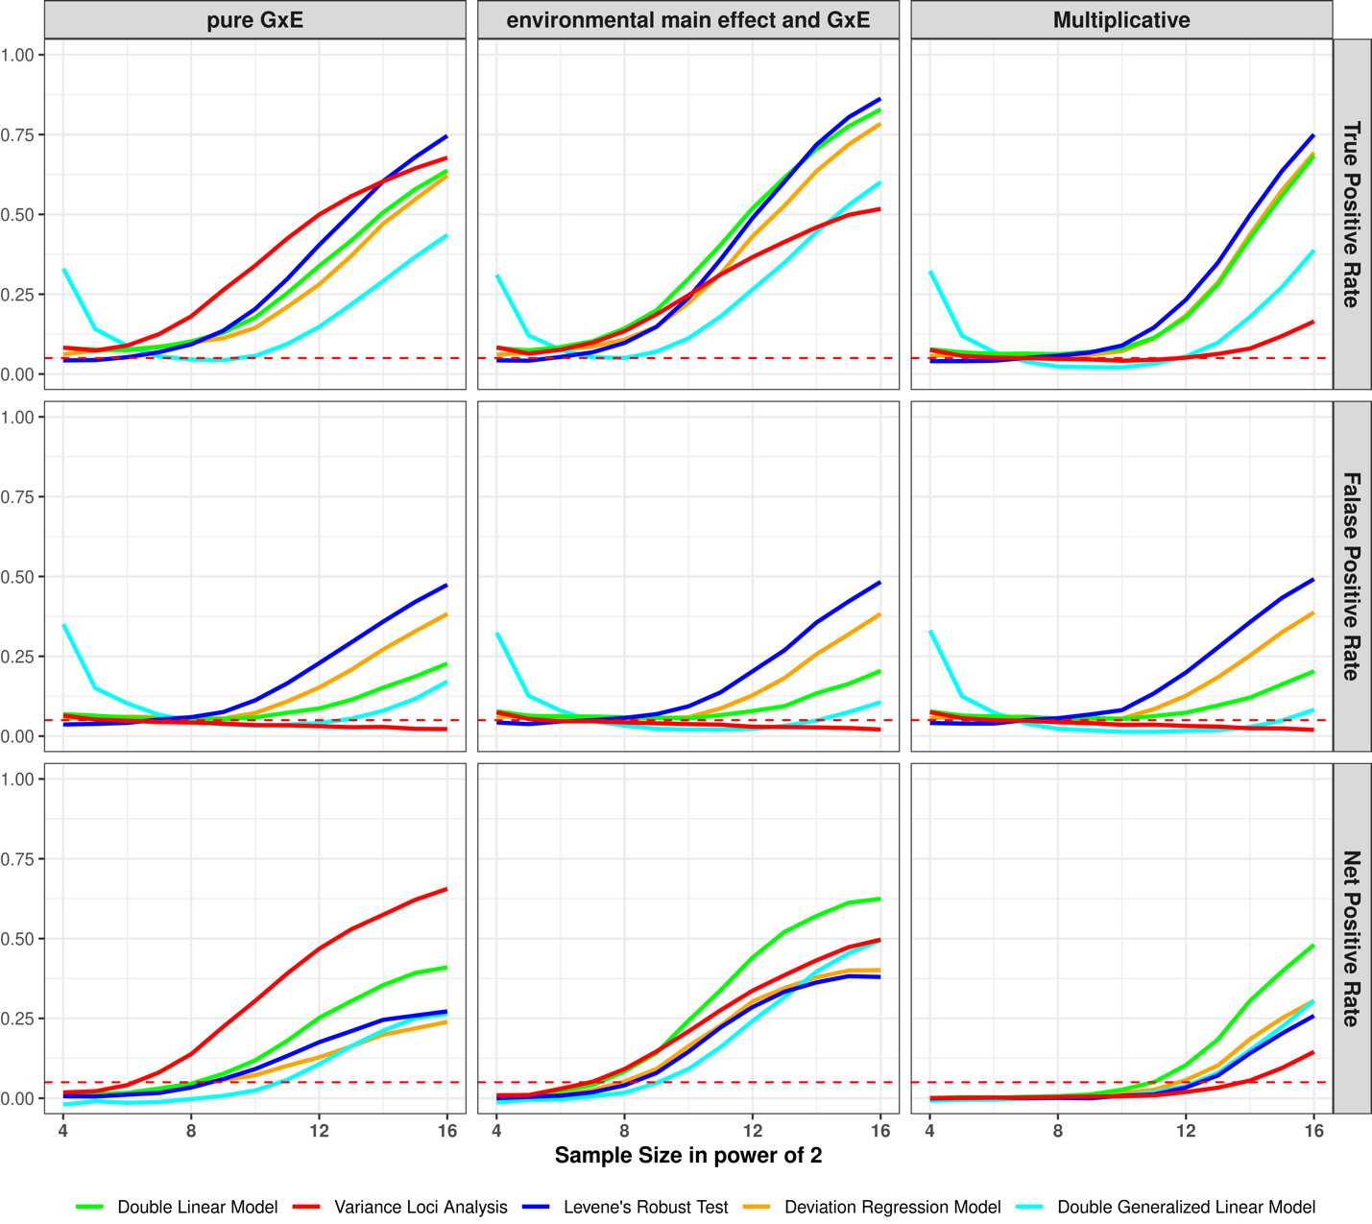
Figure s1b: Performance on simulated binary phenotype with balanced case rate (50%)
top row: y-axis is true positive rate (a.k.a., power); middle row: y-axis is false positive rate (a.k.a., type 1 error); bottom row: y-axis is net positive rate (true positive – false positive); left columns (pure GxE): variance loci were additively induced by GxE, without environmental main effect; middle column (environmental main effect and GxE): variance loci were additively induced by GxE locus, with coexisting environmental main effect; right column (multiplicative): variance loci were multiplicative; colored solid lines: variance loci tests; red dashed line: expected false positive rate at the size of hypothesis testing (0.05).
<place holder: links to the R-script>

Binary phenotype, 12% cases
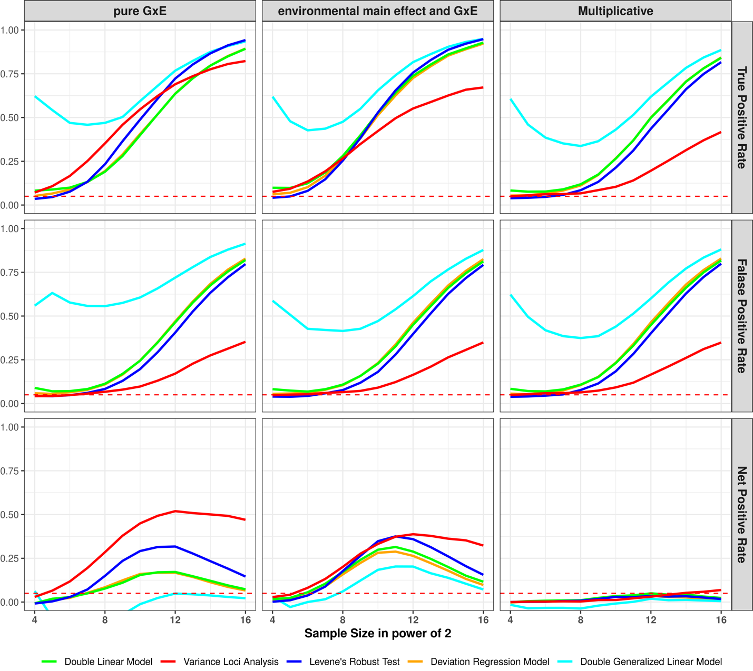
Figure s1c: Performance on simulated binary phenotype with imbalanced case rate (7.8%)
top row: y-axis is true positive rate (a.k.a., power); middle row: y-axis is false positive rate (a.k.a., type 1 error); bottom row: y-axis is net positive rate (true positive – false positive); left columns (pure GxE): variance loci were additively induced by GxE, without environmental main effect; middle column (environmental main effect and GxE): variance loci were additively induced by GxE locus, with coexisting environmental main effect; right column (multiplicative): variance loci were multiplicative; colored solid lines: variance loci tests; red dashed line: expected false positive rate at the size of hypothesis testing (0.05).
<place holder: links to the R-script>

Poisson phenotype, 37% zeros
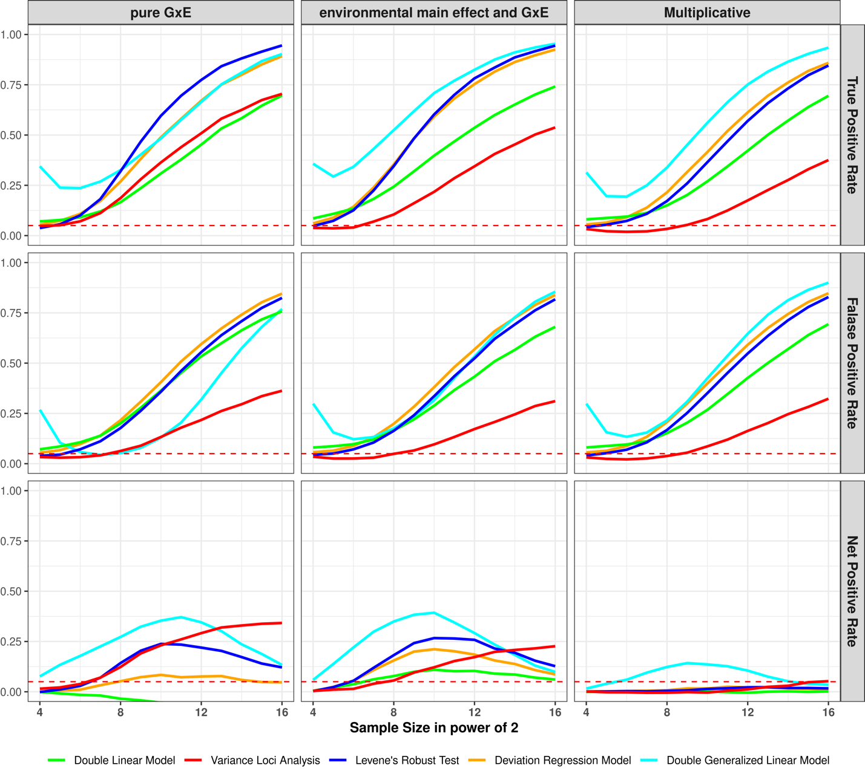 Figure s1d: Performance on simulated Poisson phenotype with moderate number of zeros (37%)
top row: y-axis is true positive rate (a.k.a., power); middle row: y-axis is false positive rate (a.k.a., type 1 error); bottom row: y-axis is net positive rate (true positive – false positive); left columns (pure GxE): variance loci were additively induced by GxE, without environmental main effect; middle column (environmental main effect and GxE): variance loci were additively induced by GxE locus, with coexisting environmental main effect; right column (multiplicative): variance loci were multiplicative; colored solid lines: variance loci tests; red dashed line: expected false positive rate at the size of hypothesis testing (0.05).

Poisson phenotype, 92% zeros
Figure s1d: Performance on simulated Poisson phenotype with high number of zeros (92%)
top row: y-axis is true positive rate (a.k.a., power); middle row: y-axis is false positive rate (a.k.a., type 1 error); bottom row: y-axis is net positive rate (true positive – false positive); left columns (pure GxE): variance loci were additively induced by GxE, without environmental main effect; middle column (environmental main effect and GxE): variance loci were additively induced by GxE locus, with coexisting environmental main effect; right column (multiplicative): variance loci were multiplicative; colored solid lines: variance loci tests; red dashed line: expected false positive rate at the size of hypothesis testing (0.05).

2. Genome Wide Variance Loci Tests
This section details the software implementation of variance loci statistical tests and presents the results of genome-wide analysis in the UK Biobank for imputed genotypes for a representative quantitative phenotype—body mass index—and a representative binary (case/control) phenotype—type 2 diabetes.

Implementation of statistical tests

GWAS (GLM/OLS):
We implemented a typical GWAS using PLINK2’s “--glm” option. The software automatically applies ordinary least squares (OLS) linear regression) for quantitative phenotypes (i.e., body mass index) and generalized linear model (GLM) logistic regression for case/control phenotypes (i.e., type 2 diabetes). Although GWAS is not a variance loci test, it is included as a traditional GxE candidate SNP selection criteria, assuming that SNPs actively involved in strong GxEs should also exert strong marginal effect. For numerical stability, PLINK2 requires the user to standardize covariates to z-scores.

Double Linear Model (DLM):
The double linear model is the most intuitive variance loci test, where the first stage is identical to a GWAS OLS even for case/control phenotypes, and the second stage treats the squared residual of first stage, that is, the squared Euclidian distance between the original phenotype and fitted values, as a “new phenotype” and performs another OLS with the same set of covariates and SNP. The DLM is a cheap byproduct when performing variance loci analysis (VLA). For binary phenotypes, DLM statistics closely mirror those of GWAS, so changing the first stage to logistic regression will not change such phenomenon.

Variance Loci Analysis (VLA):
The proposed variance loci analysis is a modified DLM, which replaces the SNP in the second-stage OLS with a squared SNP, and the two-sided t-test to a one-sided positive t-test. VLA is implemented using the vla R-package (https://github.com/xiaoran831213/vla), which also performs DLM as a cheap by-product.

Levene’s Robust Test (LVT):
Levene’s Regular Test and Levene’s Robust Test (LVT) are implemented using the car R package, which grouss samples by allele carriage and test the difference in variance across groups. LVT changes the group center from mean to medium. Because LVT does not support covariate adjustment, the user must first regress the phenotype on the covariates and take out the residual as the actual input. The residual works well when covariates are not associated with SNPs, which is not true for SNPs on the X chromosome. Because men have significantly fewer heterozygous genotypes (i.e., Aa) than women on the X chromosome, LVT mistakenly captures the fluctuation of variance due to sex as fluctuation due to genotype groups. To overcome this issue, separate analyses must ve performed for men and women, and the results only suggest SNPs that are similarly significant in both tests. We scripted a convenient R wrapper function of LVT <github> and used it for both simulation and genome-wide analysis.

Deviation Regression Model (DRM):
The deviation regression model can be considered as a merger of DLM and LVT, where the squared residual of DLM’s first stage is replaced by the absolute difference between the original phenotype and the median of fitted values, grouped by genotypes, and acts as the “phenotype” in second-stage OLS. Although covariates are adjusted in the second stage, grouping by genotypes still introduces spurious variance loci when SNPs are associated with some covariates. Therefore, like LVT, DRM is abnormally positive for SNPs on the X chromosome. We implemented DRM in R-language and used it for both simulation studies and genome-wide tests <github>..

Results
We performed all GWAS with PLINK2. The links to the R scripts used for VLA, DLM, LVT and DRM are provided in supplement S1 (the same with simulation).
For body mass index, except for the X chromosome, the most significant variance loci returned by DLM, VLA, and LVT were the same. Between DLM and VLA, despite the similarity in Manhattan and log scaled QQ plots, VLA had balanced performance (λGC=0.995) compared to the conservative performance of DLM (λGC=0.728). This was due to the ranking of a massive number of lower- and non-significant SNPs obscured in the lower portion of the Manhattan and log scaled QQ plots but evident in the [0, 1] scaled QQ plot. Although DRM was overly conservative (λGC=0.566), the results presented a unique perspective on variance loci (table s2a, column 9).

In this section, we report the false positive and net positive rate regarding additive variance loci (scenario (1) and (2) and null) that motivated VLA’s upwardness test. The full reports with false positive rate and multiplicative variance loci (scenarios (3)) are available in supplement 1.
Figure 2a shows the performance for Gaussian phenotypes, where all tests controlled the false positive rates except DGLM with same samples (panel 1 and 3). When variance loci were induced by pure GxE, VLA gave the highest performance in detecting candidate SNPs (red solid line in column 2). With coexisting environmental main effect, VLA is less sensitive (panel 4).

Figure 2b shows the performance for balanced binary phenotypes (50% case rate). With growing sample sizes, the variance loci and genetic main effect become less distinguishable, which elevated false positive rate (column 1 and 3) at the cost of net positive rate (column 2 and 4). As a result, all tests except VLA lost control of false positive rate. VLA again was the best detector of true candidate SNPs with pure GxE effect (red solid line in panel 2).

This section presents the top hits for the five statistical tests for body mass index (BMI) and type 2 diabetes (T2D).

Body Mass Index
SNP | chromosome  (Hg19/  GRCh37) | basepair  (Hg19/  GRCh37) | MAF | Statistical Test P-value
 |  |  |  | GWAS  (GLM/OLS) | Double  Linear Model  (DLM) | Variance  Loci Analysis  (VLA) | Levene's  Robust Test  (LVT) | Deviation  Reg. Model  (DRM)
rs539515 | 1 | 177889025 | 0.2049 | 1.07E-66 | 2.04E-03 | 3.98E-04 | 1.37E-02 | 9.77E-01
rs6689335 | 1 | 219628682 | 0.4189 | 2.99E-06 | 2.86E-05 | 1.00E+00 | 1.73E-07 | 8.12E-01
rs11578107 | 1 | 247193435 | 0.0284 | 1.16E-02 | 4.88E-01 | 4.02E-01 | 1.02E-07 | 1.00E+00
rs6744646 | 2 | 628504 | 0.1717 | 5.44E-72 | 1.35E-02 | 5.31E-03 | 3.67E-03 | 1.10E-01
rs10182181 | 2 | 25150296 | 0.4858 | 3.25E-57 | 1.98E-01 | 5.39E-02 | 1.08E-01 | 5.26E-01
rs115063350 | 2 | 160999596 | 0.0793 | 4.43E-01 | 2.03E-01 | 8.94E-01 | 3.68E-01 | 2.59E-04
rs183280845 | 6 | 26921528 | 0.1097 | 2.88E-07 | 8.74E-10 | 2.98E-09 | 4.48E-13 | 5.69E-01
rs561277 | 6 | 86014152 | 0.4435 | 8.30E-02 | 1.94E-07 | 1.53E-07 | 2.68E-01 | 9.44E-01
rs552749467 | 6 | 112272977 | 0.0160 | 5.93E-02 | 5.53E-05 | 1.20E-05 | 8.31E-05 | 3.23E-01
rs34845977 | 16 | 31027833 | 0.3653 | 8.84E-29 | 2.90E-06 | 3.40E-06 | 1.06E-07 | 2.19E-01
rs1421085 | 16 | 53800954 | 0.4035 | 1.98E-213 | 1.86E-12 | 3.57E-12 | 1.52E-14 | 3.37E-02
rs8064540 | 17 | 13742387 | 0.2206 | 1.70E-01 | 4.18E-01 | 2.07E-01 | 6.12E-01 | 2.84E-04
rs269989 | 18 | 42787046 | 0.3324 | 6.87E-01 | 1.25E-01 | 2.41E-02 | 3.95E-03 | 1.68E-04
noR02BE30 | 18 | 46967624 | 0.0549 | 9.96E-02 | 5.53E-01 | 1.95E-01 | 1.26E-01 | 2.31E-04
rs58084604 | 18 | 57849429 | 0.2328 | 2.79E-85 | 2.05E-04 | 2.07E-04 | 6.06E-04 | 9.55E-01
rs62095352 | 18 | 67241731 | 0.0744 | 4.81E-01 | 2.61E-01 | 8.81E-02 | 4.29E-01 | 5.70E-05
Table s2a: Top 5 SNP for body mass index (BMI)
The 5 most significant SNP by any of the 5 tests, the total is less than 25 because some SNPs were detected by more than one tests; each SNP represents nearby others in 336,918 basepairs; the redness denote significance; for X chromosome the p-value for LVT and DRM are left blank.

Type 2 Diabetes
SNP | chromosome  (Hg19/  GRCh37) | Basepair  (Hg19/  GRCh37) | MAF | Statistical Test P-value
 |  |  |  | GWAS  (GLM/OLS) | Double  Linear Model  (DLM) | Variance  Loci Analysis  (VLA) | Levene's  Robust Test  (LVT) | Deviation  Reg. Model  (DRM)
rs2943635 | 2 | 227077377 | 0.3190 | 6.75E-15 | 9.72E-14 | 2.17E-13 | 4.70E-14 | 4.05E-13
rs35841686 | 3 | 123087916 | 0.2660 | 3.61E-18 | 1.65E-16 | 3.88E-17 | 2.40E-18 | 2.01E-16
noC0B7185 | 3 | 185511745 | 0.3120 | 1.35E-25 | 2.81E-22 | 2.43E-20 | 8.66E-24 | 6.09E-23
rs4689398 | 4 | 6302199 | 0.4103 | 3.87E-18 | 3.81E-16 | 8.55E-18 | 5.44E-18 | 9.52E-17
rs67131976 | 6 | 20686878 | 0.1735 | 4.71E-30 | 2.30E-26 | 1.12E-27 | 2.71E-30 | 1.07E-27
rs9273363 | 6 | 32626272 | 0.2999 | 5.37E-22 | 1.13E-19 | 9.72E-25 | 1.51E-26 | 6.57E-21
rs860262 | 7 | 28194397 | 0.4979 | 1.80E-19 | 1.68E-17 | 1.00E+00 | 2.81E-18 | 7.51E-17
rs13266634 | 8 | 118184783 | 0.3099 | 5.89E-25 | 1.04E-22 | 1.00E+00 | 8.10E-22 | 1.39E-22
rs10965248 | 9 | 22132878 | 0.1767 | 1.78E-24 | 3.30E-21 | 1.00E+00 | 2.43E-20 | 6.46E-21
rs5015480 | 10 | 94465559 | 0.4090 | 3.01E-20 | 6.53E-18 | 1.00E+00 | 1.63E-16 | 2.46E-16
rs7903146 | 10 | 114758349 | 0.2897 | 7.71E-166 | 3.70E-143 | 1.42E-127 | 1.96E-156 | 1.76E-148
rs2237895 | 11 | 2857194 | 0.4150 | 8.00E-17 | 8.04E-15 | 3.69E-13 | 2.98E-16 | 2.19E-16
rs76895963 | 12 | 4384844 | 0.0142 | 6.30E-25 | 1.72E-23 | 1.00E+00 | 1.25E-23 | 6.71E-23
rs1421085 | 16 | 53800954 | 0.4033 | 6.39E-26 | 9.75E-24 | 9.77E-22 | 7.80E-26 | 2.16E-24
rs3020789 | X | 152892987 | 0.2184 | 4.34E-20 | 7.64E-19 | 4.07E-18
Table s2b: Top 10 SNP for type 2 diabetes (T2D)
The 10 most significant SNP by any of the 5 tests, the total is less than 50 because some SNPs were detected by more than one tests; each SNP represents nearby others in 336,918 basepairs; the redness denote significance; for X chromosome the p-value for LVT and DRM are left blank.

3. GxE and Functional Enrichment Analysis
The following tables report the results of GxE and functional enrichment analysis.

UKBB Internal GxE enrichment analysis
We took the p-values of VLA, DLM, LVT, DRM, and GWAS based on 353,605 unrelated British Whites UKBB (i.e., smaller of the two-selection population) with 9,298,089 SNPs and 26 covariates, then treat-ed 1 – p-value as the rank of significance according to any of the five test statistics.
The discovery population comprised 25,481 unrelated non-British Whites with the same SNPs and covariates. We performed a two-way GxE-WAS with a 16-item exposome covering lifestyle factors (i.e., drinking and smoking), neighborhood environment (i.e., water, noise, air, etc.), and family structure (i.e., siblings). The two-way GxE-WAS assigned each SNP 16 p-values corresponding to product terms between centered SNP dosage and normalized exposure values. We scored each SNP by the number of GxE p-values below a threshold from 10⁻² to 10⁻⁹. A higher score (up to 16) at a threshold indicates the SNP was more involved in GxEs as significant as the threshold; we also summed all 16 negative log p-values as an overall GxE activation score for each SNP.
Next, we regressed each GxE score on the significance ranking (i.e., 1 – p-values) from VLA, DLM, LVT, DRM, and GWAS, where the SNPs were weighted by their imputation information. The regression coefficient thus became a measure of GxE enrichment, such that a positive significant coefficient indicated that a method (i.e., VLA) enriched GxE detection by assigning higher ranks to SNPs more involved in GxEs, and a negative coefficient indicated the method depleted GxE detection.
For BMI (Figure 4a), VLA was the most efficient selector overall (Figure 4a, red); DLM, LVT, and DRM showed better performance for less and moderately significant GxEs but had poorer performance overall; GWAS produced the worst SNP rankings and depleted GxE detection. For T2D (Figure 4b), VLA has pronounced advantages over the other tests (Figure 4b, red). VLAwas also more efficient for GxE SNPs with p-values < 5e-7; LVT and DRM barely enriched the detection of GxEs overall and depleted the highly significant ones (Figure 4b, blue and orange); GWAS and DLM both depleted the detection of GxEs overall (Figure 4b, gray and green).

The following table summarizes internal GxE enrichment coefficients based on sub-populations of the UKBB.
 | Statistical Test | Estimated GXE enrichment coefficient (Standard Error) in 1e-3s
 | Statistical Test | Significant GXE by p-value cut-off |  |  |  |  |  |  |  | overall
 | Statistical Test | 5.00E-02 | 5.00E-03 | 5.00E-04 | 5.00E-05 | 5.00E-06 | 5.00E-07 | 5.00E-08 | 5.00E-09 | overall
BMI | GWAS (GLM/OLS) | -0.49 | 1.83 | 0.79 | 1.05 | -0.8 | 0.23 |  |  | -2.33
BMI | Double Linear Model (DLM) | 2.18 | 2.01 | 0.15 | -0.76 | -1 | 0.06 |  |  | 1.55
BMI | Variance Loci Analysis (VLA) | -0.41 | 1 | 1.28 | -1.21 | 0.76 | -0.27 |  |  | 4.91
BMI | Levene's Robust Test (LVT) | 2.27 | 1.72 | 1.03 | -0.97 | 0.43 | -0.23 |  |  | 2.34
BMI | Deviation Reg. Model (DRM) | 1.34 | 1.39 | 1.18 | 2.18 | 0.46 | -0.14 |  |  | 2.39
T2D | GWAS (GLM/OLS) | 1.43 | 3.38 | -0.32 | 0.58 | -1.59 | -1.06 | -1.64 | -1 | -1.3
T2D | Double Linear Model (DLM) | 1.68 | 3.21 | -0.02 | 0.96 | -1.28 | -0.74 | -1.46 | -0.85 | -1.64
T2D | Variance Loci Analysis (VLA) | 4.97 | 4.2 | 1.17 | 0.45 | 0.34 | 0.69 | 0.07 | -0.32 | 8.44
T2D | Levene's Robust Test (LVT) | 0.44 | -0.52 | -0.06 | 2.96 | 1.66 | -1.85 | -1.27 | -0.81 | 0.81
T2D | Deviation Reg. Model (DRM) | 2.15 | 2.6 | -0.45 | 0.7 | -1.73 | -1.6 | -1.67 | -0.99 | 0.92
Standard error in 1e-3s |  | 0.33 | 0.34 | 0.34 | 0.34 | 0.34 | 0.34 | 0.32 | 0.34 | 0.33
Table s3a: Internal GxE enrichment analysis (UKBB White British to White non-British)
The enrichment coefficient for GxE and SE at several p-value thresholds and overall -- more positive at more stringent threshold means better; Red: best performing statistical test; BMI: body mass index; T2D: type 2 diabetes; Blank: absence of significant GxE at a threshold; only one SE are shown per threshold because they are nearly identical for all tests and phenotypes.

PEGS External GxE enrichment analysis

We performed the same two-way GxE-WAS for T2D and BMI on an external discovery population of 4,603 unrelated individuals in PEGS with whole-genome sequencing data and diverse ancestries. Participants in PEGS complete extensive questionnaires measuring a rich exposome of 728 items organized into 416 parent questions on daily life, home environment, and workplace hazards. Because the numerical scale of the exposome items is stable, of which 505 are binary, and 223 are positive integers less than 8, we retain the items in their original form when developing GxE terms with centered SNP dosage.
Comparing GxE enrichment (Figures 4 a-d and Tables s3a and s3bb) with the variance loci test statistics (Figure 3, Table s3), DRM and VLA returned fewer significant loci that the other tests yet gave the highest boost to GxE detection for BMI and T2D. While a Manhattan plot (Figure 3) highlighting the strongest signals does not reveal how different statistics ranked the bulk of loci differently, the two strategies should be considered when picking candidate SNPs using a pre-defined p-value (or false discovery rate, FDR) cut-off as SNPs ranked forward even if they did not necessarily pass the said threshold.

The following summarize external GxE enrichment coefficients based on the White Europeans in UKBB and PEGS.
PHE | Test | Estimated GXE enrichment coefficient (Standard Error) in 1e-3
PHE | Test | GXE significance by p-value cut-offs |  |  |  |  |  |  |  | overall
PHE | Test | 5.00E-02 | 5.00E-03 | 5.00E-04 | 5.00E-05 | 5.00E-06 | 5.00E-07 | 5.00E-08 | 5.00E-09 | overall
BMI | GWAS (GLM/OLS) | -8.38 | -0.13 | -9.68 | -3.24 | -0.04 | -3.51 | -3.86 | -3.62 | -6.29
BMI | Double Linear Model (DLM) | 1.51 | 0.78 | -2.64 | -1.04 | -0.78 | -0.68 | -0.88 | -0.28 | 0.38
BMI | Variance Loci Analysis (VLA) | 1.54 | 2.02 | 0.03 | -1.88 | 0.27 | 0.84 | 1.74 | 1.77 | 3.82
BMI | Levene's Robust Test (LVT) | 0.17 | 2.45 | 0.45 | 1.85 | 0.3 | 0.1 | -0.98 | -0.87 | -0.78
BMI | Deviation REG Model DRM) | 3.38 | 2.13 | 0.26 | -0.17 | -0.05 | 0.69 | 0.26 | 0.42 | 4.63
T2D | GWAS (GLM/OLS) | -10.4 | -18.4 | -15.4 | -12.7 | -9.42 | -5.59 | -3.06 | -2.94 | -4.05
T2D | Double Linear Model (DLM) | -10.1 | -18.3 | -15.1 | -12.4 | -9.48 | -5.69 | -2.92 | -2.88 | -3.87
T2D | Variance Loci Analysis (VLA) | -0.17 | -2.98 | -1.12 | 0.64 | 2.92 | 3.17 | 3.63 | 3.6 | 0.89
T2D | Levene's Robust Test (LVT) | -7.88 | -15.1 | -12.2 | -8.95 | -7.87 | -4.62 | -1.09 | -1.01 | -3.26
T2D | Deviation REG Model DRM) | -10.5 | -19.4 | -16.2 | -13.2 | -10.8 | -7.17 | -3.68 | -3.32 | -3.7
Standard error in 1e-3s |  | 0.35 | 0.35 | 0.35 | 0.35 | 0.35 | 0.35 | 0.35 | 0.35 | 0.35
Table s3b: External GxE enrichment coefficients (UKBB White European to PEGS)
The enrichment coefficient for GxE and SE at several p-value thresholds and overall -- more positive at more stringent threshold means better; red/blue: best/second best performance; BMI: body mass index; T2D: type 2 diabetes; only one SE are shown per threshold because they are nearly identical for all tests and phenotypes.

Functional Enrichment Analysis
For functional enrichment analysis, Considering genome wide variance loci analysis (Figure 3, Table s2) and GxE enrichment analysis together (Figure 4e-f, Table s3c), an effective variance loci test should attend SNPs not directly contributing to protein function. Also recall that VLA and DRM had the best GxE enrichment for BMI (Figure 4a, c), and both showed no preference for high CADD scores; VLA was the only test that enriched GxE detection for T2D (Figure 4b, e) and the only one that did not prioritize CADD and emphasizes SNPs outside of genes.

phenotype | statistical test | estimated functional enrichment coefficient (standard error) in 1e-3
phenotype | statistical test | intergenic | In or near genes |  |  |  | CADD score
phenotype | statistical test | intergenic | upstream | intronic | exonic | downstream | CADD score
Body  Mass  Index  (BMI) | GWAS (GLM/OLS) | -15.50 (0.34) | 3.74 (0.44) | 13.90 (0.44) | -0.88 (0.44) | 2.54 (0.44) | 7.32 (0.35)
Body  Mass  Index  (BMI) | Double Linear Model (DLM) | -8.27 (0.34) | 0.59 (0.44) | 7.50 (0.44) | 0.26 (0.44) | 0.80 (0.44) | 3.66 (0.35)
Body  Mass  Index  (BMI) | Variance Loci Analysis (VLA) | -0.28 (0.34) | 1.45 (0.44) | 0.79 (0.44) | 0.36 (0.44) | -1.00 (0.44) | -0.20 (0.35)
Body  Mass  Index  (BMI) | Levene's Robust Test (LVT) | -3.89 (0.34) | 1.41 (0.45) | 5.10 (0.45) | 0.33 (0.44) | 0.00 (0.45) | 1.99 (0.36)
Body  Mass  Index  (BMI) | Deviation Reg. Model (DRM) | -3.24 (0.34) | -0.83 (0.45) | -0.68 (0.45) | 0.23 (0.44) | -3.09 (0.45) | 0.60 (0.36)
Type 2  Diabetes  (T2D) | GWAS (GLM/OLS) | -7.99 (0.34) | 6.34 (0.44) | 8.27 (0.44) | 0.14 (0.44) | 5.86 (0.44) | 3.72 (0.35)
Type 2  Diabetes  (T2D) | Double Linear Model (DLM) | -8.13 (0.34) | 6.00 (0.44) | 8.01 (0.44) | 0.03 (0.44) | 5.69 (0.44) | 3.72 (0.35)
Type 2  Diabetes  (T2D) | Variance Loci Analysis (VLA) | 5.81 (0.34) | 5.30 (0.44) | 0.30 (0.44) | 0.68 (0.44) | 3.96 (0.44) | 0.46 (0.35)
Type 2  Diabetes  (T2D) | Levene's Robust Test (LVT) | -5.37 (0.34) | 4.91 (0.45) | 6.91 (0.45) | 0.14 (0.44) | 4.60 (0.45) | 2.97 (0.36)
Type 2  Diabetes  (T2D) | Deviation Reg. Model (DRM) | -7.45 (0.34) | 5.57 (0.45) | 6.32 (0.45) | -0.02 (0.44) | 5.52 (0.45) | 3.94 (0.36)
Table s3c: Functional enrichment coefficients (UKBB White European)
This table shows the enrichment coefficient (and standard error) for SNPs function labels and CADD score; positive significant (red) mean SNPs of a certain label or high CPDD are overrepresented among significant loci of a test (GWAS, DLM, VLA, LVT, or DRM), negative significant (green) means opposite.

4. Methods Comparison

5. ABCB7 and Ink Exposure
For T2D, the initial 14,874,008 x 765 2-way GxE-WAS test statistics (10.8 trillion) were first trimmed down to 89,103,943 (0.82%) with P < 5e-4, and further down to 36,721,414 (0.40%) matchable by coordinate with variance loci statistics produced by GWAS, DLM, VLA, LVT and DRM based on unrelated White Europeans in the UKBB. The coordinates of the variance loci were converted from UKBB’s original GRCh37/Hg19 to PEGS’ GRCh38/Hg38 using UCSC’s lift-over tools.
The remaining GxE and matched variance loci were binned into genome segments at least 249.2 kilobase apart (one thousandth of chromosome 1), resulting in varying number of bins per exposome item (min=1, median=2460, mean=2238, max=3854). Retaining the most significant GxE and variance loci in each bin as representatives further reduced the number of reported GxE statistics to 1,608,961 (0.015%). To correct for multiple testing, we consider the maximum number of unrelated GxE tests selectable by variance loci, which was 474,4197,536 = 11,404,321 × 416, that is, the number of variance loci in UKBB’s genotype data times the number of parent questions in PEGS’ exposome survey, therefore, the Bonferroni correction would enlarge the GxE p-value by 0.47 billion folds. Taking the representative (i.e., most significant) variance locus in a bin into account however, an adjusted GxE p-value is re-calculated as (Bonferroni correction) x (empirical CDF of the variance locus’ p-value). Using CDF ensures that variants put forward by a variance loci test statistics are prioritized regardless of the magnitude of p-values, as we have seen the relatively conservative statistics (e.g., VLA and DRM) better enriched the detection of GxE overall (Figure 4 a-d). The CDF also give a sense of what Bonferroni corrected p-value would be as if the 2-way GxE-WAS were restricted among certain percentage of most significant variance loci. The representative GxE in each bin for each exposome item were reported in supplement “pgs.xlsx”, along with adjusted p-values according to the empirical CDF of 5 variance loci tests based on UKBB’s unrelated white Europeans.

To test whether the expression in these top genes was modified by this exposure (GEO number GSE142351), we used gene expression data from a study that examined changes in gene expression with occupational printer exposure. In this study, blood was collected from female office workers in three groups: a control group (n=2), those exposed to inkjet printers (n=2), and those exposed to laser printers (n=7) at four time points, on each Monday and Friday of two subsequent weeks, and sequenced to determine mRNA expression. Samples from Mondays and sample from Fridays were each grouped together, with the assumptions that all participants worked a typical Monday-Friday workweek and that the same effects would be observable for any genes with expression changes on all Mondays or all Fridays.
Building on QC completed in Tuxedo, we removed gene IDs with less than two counts in five or more of the 33 samples (from nine participants at four time points) and used DESeq2 to obtain normalized gene counts, treating repeated measures for each subject as replicates. We performed filtering based on the gene list and conducted repeated measures linear regression for the 10 genes of interest. ABCB7 was the only gene expressed in this dataset, which is expected given that the others are pseudogenes or non-coding regions. Because there were no male controls, we used data only on females. Details of the QC and analysis are included in the Supplement. MAKE A STATEMENT OF SIGNIFICANCE BETWEEN EXPOSED AND UNEXPOSESD
We manually checked genome features on or near significant GxE post-adjustment and found significant two-way GxE-WAS results (p-value < 5e-8) for T2D involving the top 10,000 VLA-selected SNPs, 10 genes on or near these SNPs were found, namely LINC02552, LINC02812, SLC25A3P1, LINC02812, SLC25A3P1, RNU6-61P, HNRNPA1P31, LINC01508, ABCB7, and BUD31P2 (TODO: tabulate these genes and the nearest top GxE). Of interest is the significant interaction between T2D and X-chromosome gene ABCB7 (ATP binding cassette subfamily B member 7, X:75,051,048 - 75,156,732, ENSG00000131269), its immediate downstream UPRT (uracil phosphoribosyl transferase homolog, X:75,156,388 - 75,304,885, ENSG00000094841), and exposure to dyes and inks (PEGS ID: A_B194*). The two genes, enclosed by q13.3, were suggested by nearby SNP rs4409555 (X:75173801 C/G) with the smallest raw GxE p-values of 9.25e-12 and 4.39e-2 after Bonferroni correction. Nearby significant variance loci were found in UK Biobank data by GWAS (p-value = 1.24e-3, CDF = 7.52e-3), DLM (p-value = 1.94e-3, CDF = 7.18e-3), and VLA (p-value = 7.74e-5, CDF=1.47e-3), with adjusted GxE p-values of 3.30e-4 (GWAS), 3.15e-4 (DLM), and 6.45e-5 (VLA), respectively. The p-values and cumulative distribution function of variance loci indicate VLA had better performance for identifying GxE near ABCB7-UPRT than GWAS and DLM. Values for LVT and DRM are not included because the two tests are invalid on chromosome X.
Figure 5 is a localized Manhattan plot near ABCB7 and UPRT. The region displayed came close to the highest peak in LD (linkage disequilibrium) on chromosome X (Figure 5 top) based on 3,104 genotyped females (68.4%) in PEGS, with a median LD score of 422.29, which was above the overall median of 110.1815 for the entire chromosome X.

6. Processing UK Biobank data
UK Biobank (UKBB) data
The UKBB data to evaluate the performance of VLA and the other considered methods in selecting GxE candidates was collected via questionnaires, electronic health records, biological samples, oral interviews, imaging, and genotype data.
Genotype data
To create a comprehensive catalog of the whole genome, we began with 97,059,328 imputed variants from 487,411 individuals. After a series of quality control measures, 405,432 individuals with high-quality micro-array genotyping remained. We divided these samples into five major ancestry groups—African (afr), non-Chinese Asian (asi), White British (bri), Irish (iri), and White but non-British (wnb)—and subsequently removed 29,440 individuals belonging to ethnic groups with a small sample size (e.g., Chinese with a sample size of 1574) or unclear ancestry, leaving 375,992 individuals from the original total (77.1% of 487,411 with imputed genotypes and 74.8% of the total 502,505). The afr, asi, bri, and iri groups form the basis of the NIEHS VLA Catalog. We used the bri and wnb groups as training and testing datasets, respectively, to compare performance of the methods.
Phenotype data
To compile phenotypes for type 2 diabetes, coronary artery disease, body mass index, and fasting glucose level, we used baseline data collected at UKBB participants’ first visit. For the phenotypes, we used the following UKBB data fields and took the following steps XXX.
Environmental data
We used data on 16 environmental variables in UKBB, including number of siblings (SIB), physical activity in metabolic equivalent minutes (MET), ever smoking (SMK), weekly alcohol intake (ALC), neighborhood traffic (TRF), nitrogen oxide (NO1), nitrogen dioxide (NO2), particulate matter air pollution, 10m (P10), particulate matter air pollution, 2.5m (P25), and noise (NOI). We also included several neighborhood exposures in a 1000-m buffer around an individual’s home address, namely green space percentage (GSP), domestic garden percentage (DGP), water percentage (WTP), natural environment percentage (NEP) and distance to the coast (SEA). We used the following UKBB fields to calculate the variables XXX.
Phecodes
To derive phecodes, we used phenotypes and disease diagnoses from electronic health record (EHR) data for UKBB participants recorded as International Classification of Diseases (ICD) codes. ICD codes are used to record medical diagnoses, signs and symptoms, abnormal findings, and injuries. Although more than 100 countries use ICD codes to track morbidity and mortality (41), they do not provide an appropriate level of granularity for phenotypes relevant for genetic association studies. Phecodes are manually curated groups of ICD codes aggregated into a distinct medical concept, disease, or phenotype intended to capture clinically meaningful concepts for research (40). Phecodes provide embedded case-control definitions based on exclusion criteria for controls, enabling the rapid characterization of large numbers of phenotypes. They are widely used for phenotyping participants with EHR data, especially for genetic association studies (40, 42). The use of phecodes in such studies produces superior results compared to ICD and Clinical Classification Software (CCS) codes.
7. PEGS
PEGS administered comprehensive surveys on 756 exposome items for 9,765 participants, divided into three parts. The Health and Exposure survey (part C) collects information on general health and lifestyle, and occupational exposures as well as individual and family medical histories (n=9,414); the External Exposure survey (part A) collects information on exogenous exposures throughout life, including but not limited to chemical and environmental exposures at home and work (n=3,519); the Internal Exposure survey (Part B) collects information on endogenous exposures such as medication as well as lifestyle factors, including sleep patterns, stress, physical activity, and diet (n=2,962). The Supplement provides information on how the surveys were formulated.

Whole-genome sequencing
The Broad Institute performed genotype sequencing for 4,610 PEGS participants and conducted quality control. It also compared the number of variants identified for each PEGS participant to the number determined in a parallel analysis of the same data based on the hg19 genome assembly. The Supplement provides further details on all the sequencing and filtering steps.
We derived T2D and BMI phenotype data from Health and Exposure survey data.
PEGS participants complete extensive questionnaires measuring a rich exposome of 728 items organized into 416 parent questions on daily life, home environment, and workplace hazards. Overall, 505 of the exposome items are binary, and 223 are positive integers less than 8, so we retained the items in their original form when developing GxE terms with centered SNP dosage.

Principal components analysis
The UKBB performed principal components analysis for all genotyped individuals. Data field 22009 provides the first 40 principal components. For PEGS, we performed PCA using the pca command in PLINK2. Before removing any variants or samples as part of QC, we performed PCA with the original whole genome sequencing (WGS) data for 40,123,943 variants (38,528,374 in the autosomes) in 4,610 individuals.

Gene-Environment Interaction Analysis
For each environment e, genome variant g, outcome y, and some covariates X, we fitted model y = g + e + ge + X. We tested the significance of the coefficient on ge and kept the p-value. The term ge is the product of g and e. For the UKBB, g is one of the imputed variants, and e is one of the 16 environment exposures described in the Materials section. The covariates X are age, sex, the top 40 PCs, and the genotyping array used (i.e., BiLEVE or Axiom). Because the GxE analysis was conducted for non-British whites only, ethnicity is not included among the covariates. For PEGS, g is one of the WGS variants after quality control, e is one the 766 available environment exposures, and the covariates X are age, sex, self-identified ethnicity, and the top 20 PCs. The proportion of each self-identified ethnicity is: 2.19% Asian, 27.46% Black, 62.34 White, and 2.21% other, coded as 3 dummy variables in X.

7. Other material

Variance quantitative trait loci (vQTL) analysis

Although the original intent of these approaches was to exclude vQTLs and prioritize variants resistant to environmental changes (10, 11), DGLM/DHGLM is a common benchmark for comparing power to identify GxE candidates (12, 13). DGLM also involves two-stage modeling but allows link functions to accommodate non-normal outcomes and assumes that the squared residual deviance of a stage-1 model follows not a Gaussian but a Gamma distribution. Because DGLM uses log-linked Gamma regression in stage 2, it essentially models the phenotypic variance in log scale with allele dosage, thus capturing multiplicative vQTLs. A multiplicative vQTL test assumes each allele multiplies the phenotypic variance by a factor.
In simulations where the phenotypic mean were the sum of the covariate, genotype effects, environmental effects, and GxE effects (i.e., inducing additive vQTL), DRM outperformed DGLM and LVT (Marderstein et al. 2021). In another situation where Gaussian phenotypes were simulated with the variance as the exponent of allele dosage (i.e., multiplicative vQTL by definition), LVT performed optimally when the phenotype was further distorted into non-Gaussian quantities (H. Wang et al. 2019).
vQTL tests are not meant to be employed for binary case/control phenotypes (Paré et al. 2010; Marderstein et al. 2021; H. Wang et al. 2019) because the mean μ and variance v are tightly related by v=μ(1-μ), grossly violating the homogeneous variation assumption under the null. In this case, DLM (Figure 1c) identifies a GWAS-significant SNP as a GxE candidate, regardless of the presence of a GxE. DRM, LVT, and DGLM also produced runaway type 1 errors despite the first two being robust with quantitative non-Gaussian phenotypes (see “simulation” under “result”). In addition, additive vQTL tests such as DLM and DRM diminish the power to detect strong but pure GxE candidates when the direct environmental effect on the phenotypic mean is weak, even if the phenotype is Gaussian (Figure 1d).
We implemented VLA as the self-contained “vla” R-package (Tong 2022b) that simultaneously analyzes thousands of phenotypes and thousands of SNPs with an optimized matrix algebra, similar to the group optimization trick adopted by PLINK2’s association analysis (Chang 2022). We also created the “plinkFile” R-package (Tong 2022a) to help traverse the massive genotype in binary biallelic format (Chang 2021) that is too large to fit into machine memory.

