New simulation with traditional plot
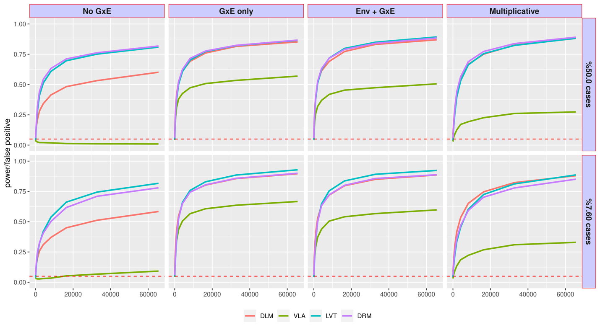
The above picture shows the power and type 1 error from the simulation studies for binary phenotypes, when the p-value threshold is set at 0.05.
- The Genotype main effect is fixed at 0.1 (weak but non-zero)
- The Environmental main effect is 1.0 when not null (column 3)
- GxE effect is 8.0 (very strong) when not null (column 2-3)
In column 1, the GxE effect is null, the curves show false positive rate, or type 1 error, a type 1 error at 0.05 is optimal (higher means to liberal, lower means too conservative); in column 2-4, where the GxE is non-null, the curves show true positive rate, or power, higher means better.
In column 4, the GxE and environmental main effect is not distinguishable, because the phenotype is based on multiplicative modeling.
In row 1, the case/control are balanced, in row 2, there are only 7.6% cases (roughly the prevalence of type 2 diabetes)
When the case/control is balanced, VLA (green) controlled the type 1 error while others failed. When imbalanced, VLA (green) also inflated type 1 error a bit. This inflation will grow with genotype mean effect (currently 0.1).

New Plots with Net Positive Rate
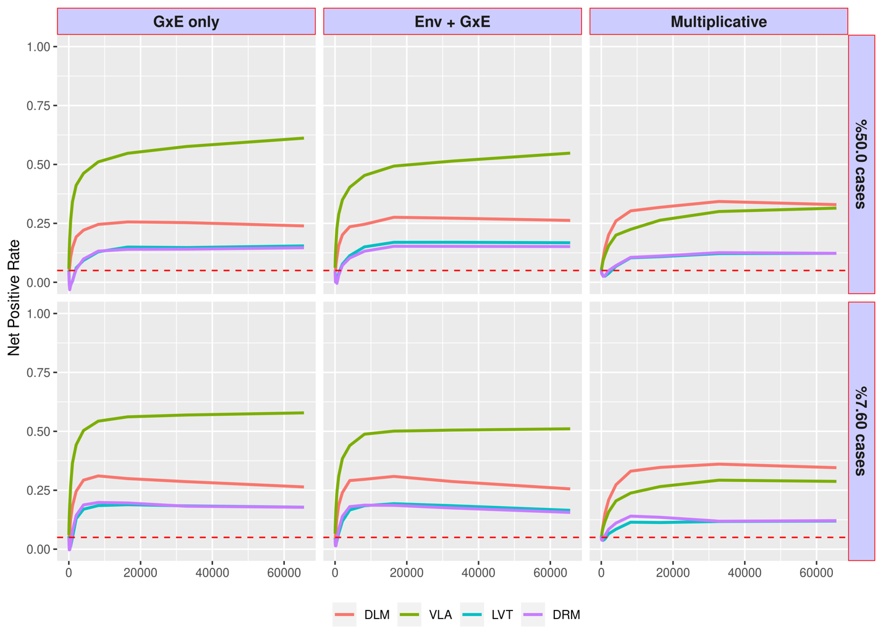
In this new picture, the type 1 error (false positive rate when GxE is null) is subtracted from the power (true positive rate when GxE is 8.0), to produce a “net positive rate”.
Because the type 1 error is subtracted, the new plots no longer show the null (no GxE) scenario.
In this new metric, higher curve means better, and VLA is better for additive modeling, even for imbalanced case/control. Some methods show a declining curve, because their false positive rate (type 1 error) grow faster than true positive rate (power) when the sample size increases.

