Cataloging gene-environment interaction candidate SNPs for over 3,000 UK Biobank disease phenotypes through variance loci analysis
Xiaoran Tong, <authors>, Alison Motsinger-Reif

Abstract
Detecting gene by environment interactions (GxEs) for diseases enriches the ontology of genetic effects and helps identify environmental targets for interventions with the goal of improving health outcomes. However, combining the dimensions of the genome and exposome poses challenges in terms of both computational and statistical power. Both additive and multiplicative genome-wide variance quantitative trait loci (vQTL) analysis methods have recently received attention for their ability to find candidate single nucleotide polymorphisms (SNPs) for GxEs without actual environmental exposome profiling. The rationale is that unaccounted GxEs cause the residual variance of a quantitative trait to change across allele dosages—a non-uniformity that, when captured, suggests GxEs.
Based on the simplest additive vQTL approach, the double linear model (DLM), we propose variance loci analysis (VLA) by augmenting the DLM with squared allele dosage. We show that VLA maintains superior power to detect GxE candidates with weak direct environmental effects on the phenotype. We also demonstrate that multiplicative vQTL methods—the double generalized linear model (DGLM) and Levene’s test (LVT)—are overly generic with squared dosage or overly restrictive without squared dosage. More importantly, we demonstrate that by appropriately adjusting covariates, VLA can overcome the inability of DLM/DGLM/LVT to analyze thousands of non-quantitative phenotypes.
We performed VLA for 3,273 health- and disease-related phenotypes derived from the UK Biobank and ranked the potential involvement of each SNP in GxEs. We created and host the VLA Catalog (genelist.niehs.nih.gov) as an open resource of GWAS, vQTL, and VLA mapping for these traits, along with the metadata required for reproducibility and independent applications. Using environmental exposome data collected in the Personalized Environmental Genetic Study (PEGS), we found that high-ranking genome variants selected by VLA enriched the detection of genome-exposome-wide significant GxE SNPs for cardiovascular disease, type 2 diabetes, and body mass index.

Introduction

Background and motivation
Most human traits have a complex etiology and are affected by both genetic and environmental factors and their interactions. Because environmental exposures can regulate the biological processes underlying a phenotype , unaccounted-for gene by environment (GxE) effects are recognized as part of the heritability “missed” by variants selected by genome-wide association studies (GWAS)(1, 2). While research in agricultural genetics, model organisms, and cell culture has consistently found that genetic effects are context-dependent (9-13), there has been limited success in identifying GxEs in humans. Among the reasons for this are the difficulty of measuring many environmental exposures and insufficient sample sizes (9–11).
In large cohorts with comprehensive exposome and genome data, a genome-exposome wide association study (GxE-WAS) can test for interactions between genome variants and environmental exposures. However, due to the overwhelming number of crossovers between exposures and genome variants, the burden of multiple testing and computation time are severe challenges. More practically, candidate variants in or near genome features likely to affect the phenotype according to a priori biological knowledge, or variants reaching a certain significance level in GWAS, can be prioritized. These approaches, however, either hinder hypothesis generation due to the reliance on prior knowledge or are prone to false positives due to the assumption that strong interactions exert strong marginal effects , which is not necessarily true since genetic main effects can coexist with weak GxE interactions.
These issues have motivated the development of alternative approaches. A promising strategy is to perform a genome-wide scan for variance quantitative trait loci (vQTL) in a selection cohort rich in genome data and then use the vQTLs as candidates for GxE studies in a discovery cohort rich in exposome data. Exposome data is not required for the selection cohort if it shares the phenotype of interest in the discovery cohort. Analogous to classic QTLs from a GWAS that tests the allelic effect on the phenotypic mean, vQTLs test the allelic effect on phenotypic variance. However, vQTLs are superior candidates because the presence of strong GxEs causes heterogenous variation of a quantitative trait among individuals of different allele carriage (3-6).

Variance quantitative trait loci (vQTL) analysis
A vQTL can be induced by a GxE effect unaccounted for in a GWAS linear model, resulting in uneven variation around the mean regression line across genotypes (7). Such vQTLs can be detected by fitting the variation with the same genotype via a second linear model. Recent high-profile work proposes a vQTL test that is a double linear model (DLM), where the first stage is a de facto GWAS, and the second stage treats the squared residual as a new phenotype. When a variant is not involved in a GxE (Figure 1a), the phenotypic variation, now measured by squared residuals, is nearly uniform across dosage, resulting in a flat regression line in stage 2. Conversely, when the variant is involved in a GxE (Figure 1b), the phenotypic variation changes with dosage, resulting in a non-zero slope in stage 2. Because DLM assumes each allele adds a certain quantity to the phenotypic variance, we intuitively call it an additive vQTL model.
More traditionally, modeling the mean and variance of a quantitative phenotype with shared genotype predictors (i.e., SNPs) is done by double generalized linear modeling (DGLM)(8) and double hierarchical generalized linear model (DHGLM)(9). Although the original intent of these approaches was to exclude vQTLs and prioritize select variants resistant to environmental changes (10, 11), DGLM/DHGLM is a common benchmark for comparing power to identify GxE candidates (12, 13). DGLM also involves two-stage modeling but allows link functions to accommodate non-normal outcomes and assumes that the squared residual deviance of a stage-1 model follows not a Gaussian but a Gamma distribution. Because DGLM uses log-linked Gamma regression in stage 2, it essentially models the phenotypic variance in log scale with allele dosage, thus capturing multiplicative vQTLs. A multiplicative vQTL test such as a DGLM assumes each allele multiplies the phenotypic variance by a factor.
Figure 1: Variance trait quantitative loci (vQTL) to suggest GxE
(a) In the absence of a GxE (left), residual variations are even across genotypes (right), and variant A/a is not a vQTL; based on GWAS, the variant would be erroneously identified as a GxE candidate. (b) In the presence of a GxE (left), residual variations are uneven across genotypes (right), and variant A/a is a vQTL. Teal/red dashes: environment-specific effect; blue solid lines: marginal effect. Red and teal points indicate samples experiencing different environments.

(a)
(b)
Although DLM and DGLM are designed to capture additive and multiplicative vQTLs, respectively, they cannot control type 1 errors when the quantitative phenotype is non-Gaussian and the genotype main effect is non-zero (14, 15). More robust methods have been successfully applied with varying results regarding their power. A deviation regression model (DRM), a modified DLM that replaces the squared distance between a phenotype and the group mean (i.e., the squared residuals of the stage-1 linear model) with the absolute distance between phenotype and the group median, is recommended to capture additive vQTLs (12), and the Levene’s test (LVT) of heterogeneous variance is recommended to capture multiplicative vQTLs (13, 15). In simulation studies where phenotypes are the sum of covariate effects, main genotype effects, main environmental effects, and GxE interactions, DRM as an additive vQTL test outperformed multiplicative vQTL tests such as DGLM and LVT (12). In another simulation, where phenotypes were drawn from a Gaussian distribution and variance was the exponent of allele dosage, which was then distorted into a quantitative non-Gaussian variable, LVT was the optimal choice.

Issues with vQTL analysis
Despite its usefulness, vQTL analysis is not recommended for binary case/control outcomes (7, 12, 13). This is an important limitation, as much of the work in disease genetics relies on binary phenotype definitions. Both additive and multiplicative vQTLs assume homogeneous variation among individuals with the same genotype. For non-Gaussian phenotypes, a QTL affecting the phenotypic mean also affects the variance, thus violating the assumption of within-group homogeneous variance and positively biasing the vQTL test. For quantitative phenotypes, false positives can still be countered by DRM (12) and LVT (13) while maintaining the power to detect true vQTLs. Binary phenotypes, however, cause uncontrolled type 1 errors (see Figure 2a) for DLM, DRM, and LVT and unpredictable behavior for DGLM. In addition, additive vQTL tests such as DLM and DRM lack the power to detect a true GxE candidate when the environmental main effect is weak, even if the phenotype is Gaussian (see Figure 2b).
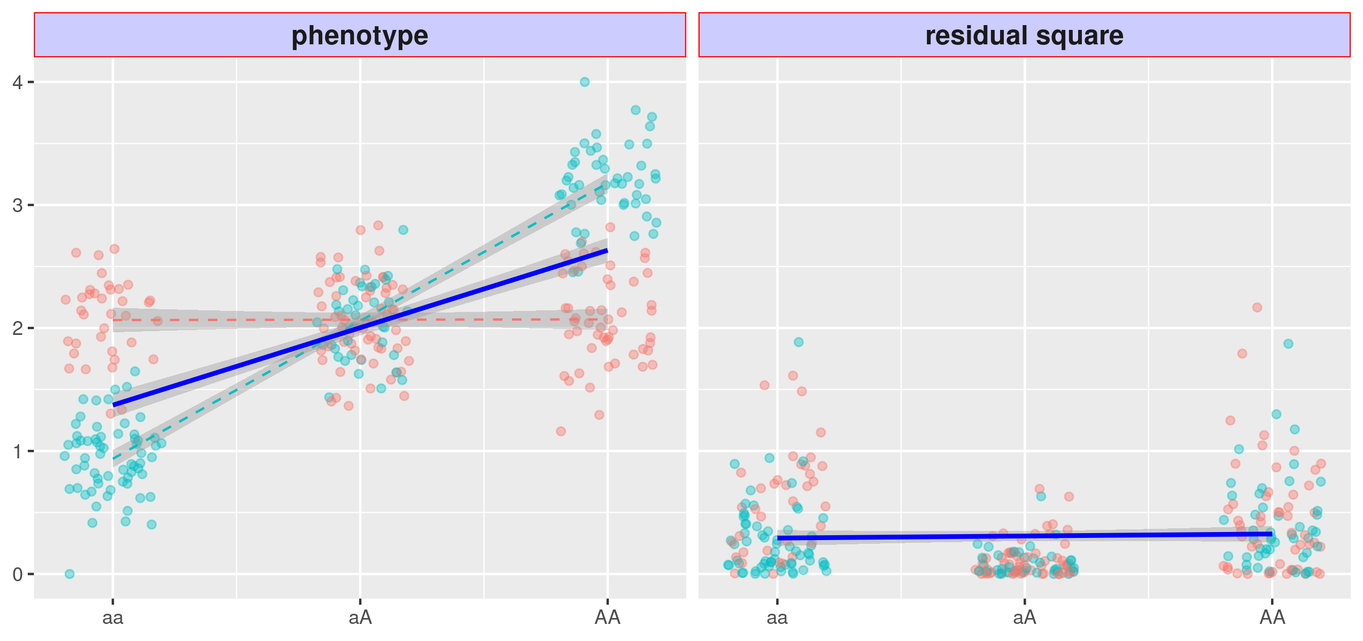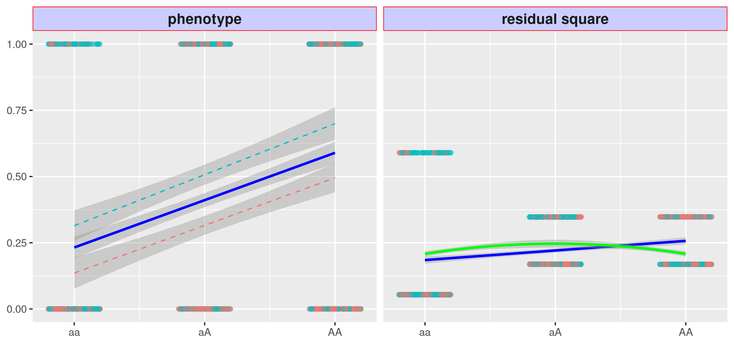
Figure 2: Issues with variance quantitative loci (vQTL)
(a) left: A binary phenotype with a non-null marginal genotype main effect, shown by the solid blue line, but null GxE effect, shown by the parallel dashed red and teal lines (left). (a) right: The squared residual changes with genotype, shown by the blue solid line, and the variant thus become a false vQTL. The VLA fits a downwards curve, shown by the solid green line, thus controlling type 1 errors. (b) left: A Gaussian phenotype with a strong GxE effect but a weak environmental main effect (i.e., a pure GxE), shown by the dashed red and teal lines with distinct slopes that cross at the center. (b) right: The squared residual changes with genotype but non-linearly. The linear model thus misses the true GxE candidate (i.e., DLM and DRM), shown by the flat regression line. Red and teal points indicate samples experiencing different environments.
(a)
(b)

Variance loci analysis (VLA)
To address issues with vQTL analysis, we propose variance locus analysis (VLA) to select GxE candidates for both Gaussian and binary phenotypes. VLA takes the additive perspective, assuming that a phenotype is composed of GxE effects along with the genotype, covariate, and environmental main effects, plus white noise. While existing additive vQTL statistics test the non-zero slope of the stage-2 regression line, VLA fits a curve and tests its upwardness. For Gaussian phenotypes, VLA overcomes the lack of power with low environmental main effects (see the solid green line in Figure 3b). Importantly, VLA also controls type 1 errors for binary phenotypes (see the solid green line in Figure 2b).
However, while it controls type 1 errors, the upwardness test lacks power for detecting GxE candidates (Figure 3a) for binary traits because the dichotomized phenotype glosses over the underlying quantitative risk leading up to the binary event. The underlying risk can be reconstructed to some extent as residuals by regressing the binary phenotype on a covariate such as age. The covariate residual is a quantitative representation of the underlying risk contributed by the genome, exposome, and GxEs.
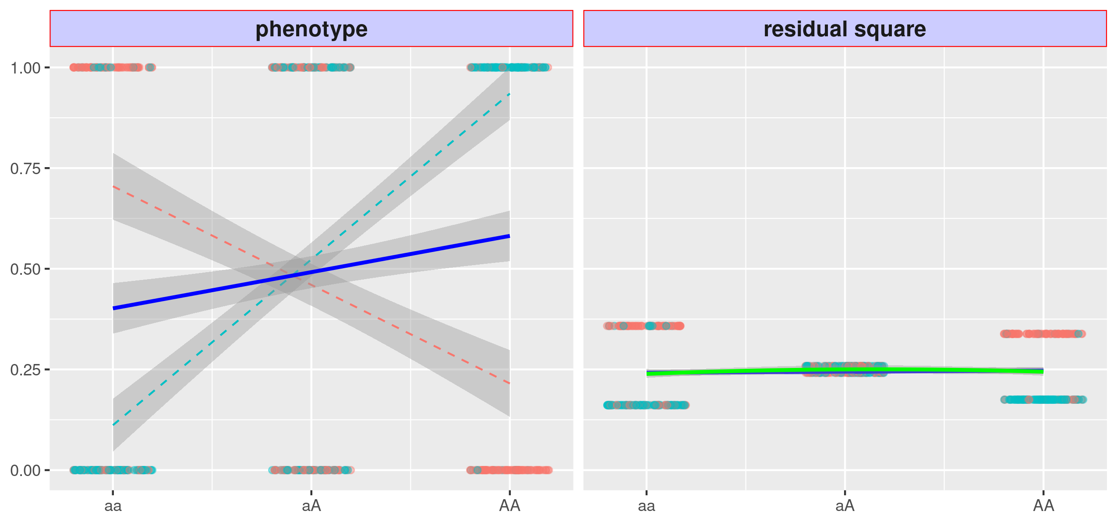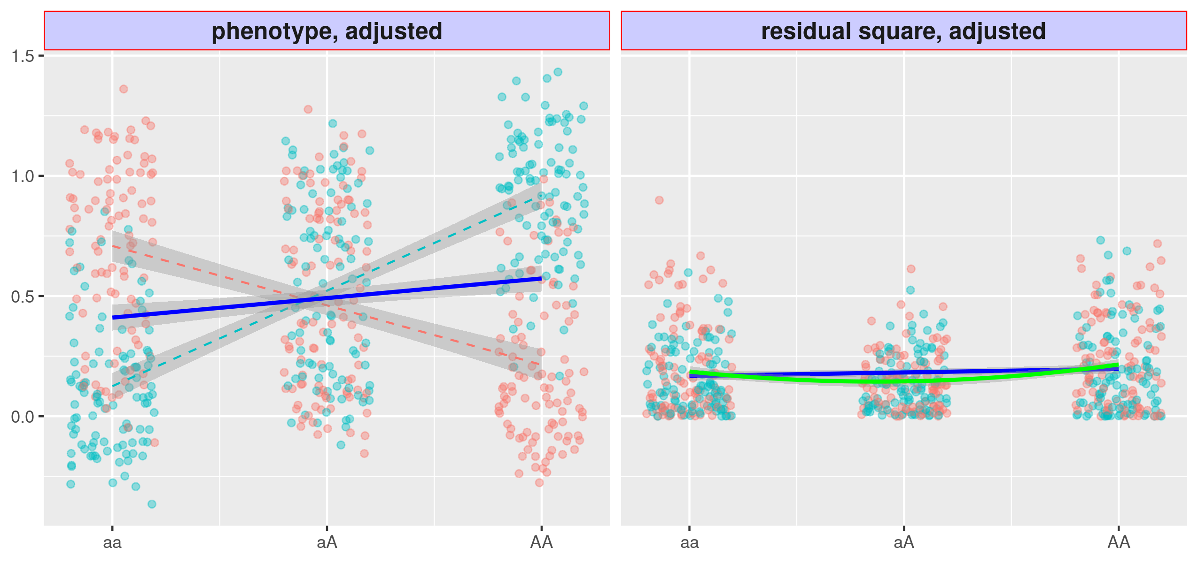
Figure 3: Variance loci analysis (VLA) with innate risk score
(a) Variant A/a has strong GxEs, but the VLA upwardness (green solid) test is as powerless as the slope-based vQTL (blue); (b) If the binary phenotype is replaced by the innate risk score as a covariate residual close to Gaussian, the upwardness of the VLA curve (green solid) detects the variance loci A/a. Red and teal points indicate samples experiencing different environments.
(a)
(b)
With high-quality covariates, the residuals are nearly Gaussian. By replacing a binary phenotype with its residualized risk, the upwardness test can detect variance loci involved in GxEs (see Figure 3b). In this case, “high-quality” indicates covariates that are non-confounding predictors such as age and sex, not heritable, and not determined by the exposome (i.e., non-confounding) yet predictive of disease risk. Importantly, confounding covariates bias the genome and exposome effects towards null (Aschard et al., 2015), and non-predictive covariates do not help recover the fine gradient of underlying risk.

Application of VLA
To demonstrate the potential of the approach to detect and prioritize variants involved in GXE and compare its performance to previously established methods, we performed genome-wide VLA for discovery for a handful of representative, well-studied diseases and clinical traits and then empirically tested significant loci from GxE in a second population. Given its large sample size (n=353,605) and availability of rich phenome and imputed genotype data, we conducted genome-wide VLA in the UKBB White British population for type 2 diabetes (T2D) (16, 17) and body mass index (BMI). Details of the analysis are found in the Supplement. Figure X. shows the results of both GWAS mapping and VLA mapping for T2D. At a genome-wide significant cutoff of XX, XX genes were significant in GWAS, and XX were in VLA. Table X summarizes the top hits from both analyses.
To test whether the highly-ranked variants in the VLA discovery analysis are more likely to be empirically involved in GxE in a sample with both genotype and exposure data. We used the White British population analyses as a discovery cohort, and used an independent set of samples for gene-environment interaction analysis (25,481 UKBB non-British Whites with imputed genotypes and a limited exposome of 16 environmental exposures). Using a range of thresholds for statistical significant in the discovery analysis, ADD HOW MODEL WAS FIT. we followed up with a two-way GxE-WAS analysis for each trait in a sample comprising. We compared the variant ranking given by VLA for UKBB White British to the ranking summarized from the two-way GxE-WAS analysis for 25,481 UKBB non-British Whites with imputed genotypes and 16 environmental exposures. We found strong positive correlations between the two rankings. NEED TO EXPLAIN THIS MORE. SO EACH VLA COULD BE ASSOCIATED WITH 0-16 GXE. IS A SIGNIFICANCE CUTOFF USED? ALSO NEED TO DO SOME SORT OF MORE TRADITIONAL OVER REPRESENTATION APPROACH. NEED A SUNSET PLOT FOR T2D IN UKBB. ALSO, HOW MANY WERE SIGNIFICANT AT GWAS CUTOFF.
We then used the genome-wide VLA results in the UKBB as candidate variants for GxE analysis in an independent cohort with extensive environmental exposure data, at a variety of p-value cutoffs. The North Carolina-based Personalized Gene and Environment Study (PEGS) is a cohort of 19,672 participants of varying age, race, socioeconomic status, and education level. PEGS includes extensive survey data on 365 environmental exposure items for 9,765 individuals and whole-genome sequencing data for 4,610 individuals. Details of the cohort and genotyping are found in the supplement. In the PEGS cohort, there was again a positive correlation between the rankings for T2D, CAD, and BMI. We also investigated the functional enrichment of variance loci, which were overrepresented in the intergenic and intronic regions compared to GWAS loci, which are concentrated within or near genes. The results and methods sections detail the findings and the preparation of phenome, genome, and exposome data.
The high number of significant GxEs discovered in PEGS for T2D motivated a further search for corroboration/functional validation of the top results. We replicated the VLA with UKBB White British in UKBB non-British Whites and subsequently preformed testing to determine interactions for all exposures in PEGS. We tested variants that were statistically significant variant loci in the UKBB White British population (p<X.XX) (XX,XXX number of SNPs) for replication in the UKBB Irish population. We replicated XX,XXX SNPs and then tested these for GxEs in PEGS. We tested all pairwise comparisons of the XXX questionnaire-based exposures from the three surveys that comprise PEGS as well as SNPs. We found XXXX GxEs at FDR<XXX. We mapped SNPs to the nearest gene with XXX. Need to see what the top ones actually were. NEED TO UPDATE HERE, one of the top exposures involved in multiple GxEs was “exposure to dyes and inks – inkjet printer”. The top genes were: LINC02552, LINC02812, SLC25A3P1, LINC02812, SLC25A3P1, RNU6-61P, HNRNPA1P31, LINC01508, ABCB7, BUD31P2. CHECK IF TOP SNPS ARE eQTLS according to Gtex.
To test whether expression in these top genes was modified by this exposure (GEO number GSE142351), we used gene expression data from a study that examined changes in gene expression with occupational printer exposure. In this study, blood was collected from female office workers in three groups: a control group (n=2), those exposed to inkjet printers (n=2), and those exposed to laser printers (n=7) at four time points, on each Monday and Friday of two subsequent weeks, and sequenced to determine mRNA expression. Samples from Mondays and sample from Fridays were each grouped together, with the assumptions that all participants worked a typical Monday-Friday workweek and that the same effects would be observable for any genes with expression changes on all Mondays or all Fridays.
Building on QC completed in Tuxedo, we removed geneIDs with less than two counts in five or more of the 33 samples (from nine participants at four time points) and used DESeq2 to obtain normalized gene counts, treating repeated measures for each subject as replicates. We performed filtering based on the gene list and conducted repeated measures linear regression for the 10 genes of interest. ABCB7 was the only gene expressed in this dataset, which is expected given that the others are pseudogenes or non-coding regions. Because there were no male controls, we used data only on females. Details of the QC and analysis are included in the Supplement. MAKE A STATEMENT OF SIGNIFICANCE BETWEEN EXPOSED AND UNEXPOSESD
The expression of ABCB7 is an interesting key finding.. ABCB7 is involved in metabolism and multi-drug resistance and is related to transport pathways of glucose and other sugars, bile salts and organic acids, metal ions, and amine compounds. Notably, the gene encodes a half-transporter involved in the transport of heme from the mitochondria to the cytosol. ABCB7 is also an ATP-dependent mitochondrial transporter implicated in Fe–S cluster assembly. Inherited mutations in ABCB7 have been linked to inherited and acquired sideroblastic anemia with cerebellar ataxia (18, 19), and the absence of ABCB7 impairs the maturation of cytosolic iron–sulfur proteins and induces iron accumulation in mitochondria. Further, knockdown of ABCB7 in HEK293T cells causes mitochondrial iron accumulation and the activation of SOD enzymes. This is important because iron and iron-regulatory proteins and cadmium alter ABCB7 expression, and some pigments in printer ink dyes, such as potash blue or soda blue pigments, contain iron based on ferro and ferric cyanides. Printer inks may also contain cadmium (20). Also of interest is the association of ABCB7 with fatty liver disease. This is notable because T2D is a major risk factor for fatty liver disease and could have common pathways (21, 22).

We created and host a catalog of VLA statistics on the NIEHS website (https://genelist.niehs.nih.gov/vla) for the entire genome and phenome of the UKBB, including compound phenotypes based on the most recent PHECODE mapping table (28, 29). The catalog is similar to the Pan-UK Biobank GWAS catalog (https://www.pan.ukbb.broadinstitute.org) and the EBI GWAS catalog (https://www.ebi.ac.uk/gwas/). The resource summarizes the interaction potential for each variant given phenotypes of interest and can be used to prioritize GxE candidates in future research. PREVIOUS WORK ONLY 13ish TRAITS.

Results
We implemented VLA as a self-contained vla R package, which simultaneously scans multiple phenotypes and genome variants, given adequate system memory. The vla R package is platform- and compiler-independent if the R Base package is installed. As the number of phenotypes increases, the vla R package is more efficient than routine genome-wide analysis implemented in C/C++, such as PLINK (30, 31). To traverse out-of-memory allele-dosage genotype data condensed in PLINK 1 binary biallelic genotype tables, we created plinkFile, another self-contained R package (32). We used these two packages for analyses based on UKBB and PEGS data.

Simulation
We consider a continuous phenotype as the sum of strong covariate effects, non-zero genotype main effects, optional environmental main effects, optional GxE effects, and Gaussian white noise. We consider four scenarios of how the environment affects a phenotype: 1) directly through the main effect (ENV + NUL); 2) no impact (NUL + NUL); 3) through the GxE effect (NUL + GxE); and 4) both directly and through the GxE effect (ENV + GxE). In the first two scenarios, there are no GxE effects, and rejecting the primary null hypothesis contributes to the false discovery rate (FDR). An out-of-control FDR invalidates a method. In the last two scenarios, there are GxE effects, and rejecting the null hypothesis adds to the true discovery rate (TDR). A high TDR means a method is more powerful, as long as the FDR is controlled in the first place.
We compare five methods, namely the proposed variance locus analysis (VLA), double linear model (DLM), deviation regression model (DRM), double generalized linear model (DGLM), and Levene’s test (LVT). We conducted 20,000 trials for each scenario. In each trial, we randomly picked a variant with MAF≥0.01 in region 17q3 (chromosome 17: 10700001-16000000) of the 1000 Genomes Project Phase 3 (33, 34) and drew 10,000 dosage values from that variant as the genotype.
Figure 4a presents the performance for Gaussian phenotypes. In scenarios 1 and 2, where GxE effects are null, the FDR was controlled for all methods (Figure 4a, left), thus making them eligible for TDR assessment. In scenarios 3 and 4, where GxE effects are present (Figure 4a, right), VLA had the highest TDR. This advantage was more pronounced in scenario 4, where there were GxE effects with null environmental main effects, because VLA is meant to prioritize pure GxEs. DGL and LVT had poorer performance than VLA and DLM. This is because DGL and LVT are meant to capture multiplicative vQTLs, but we simulated additive variance loci. DRM captured additive vQTLs, and its FDR was the closest to the 5% cut-off (Figure 4a, left panel, blue bar). However, its TDR is not optimal (Figure 4a, right panel, blue) when the phenotype is Gaussian.
(a)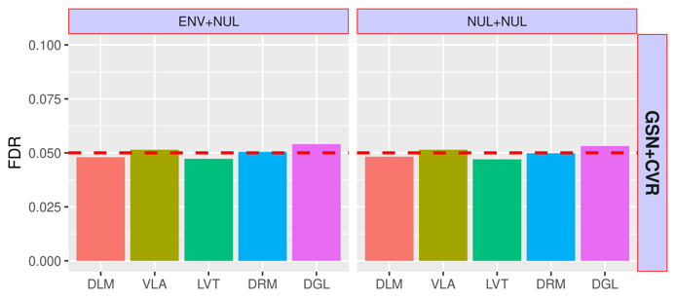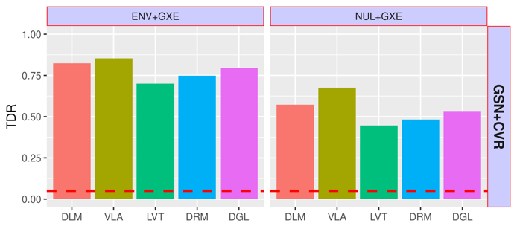
(b)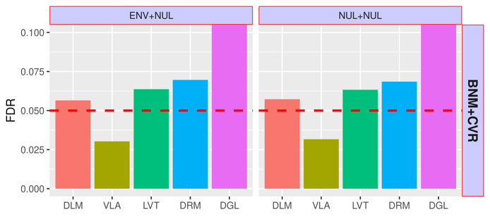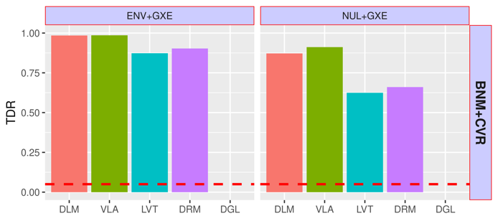

Figure 4: Simulation Studies
Top to bottom: (a) Gaussian phenotype; (b) binary phenotype. Left: For scenarios 1 and 2, with null GxE, the y-axis shows the FDR. Right: For scenarios 3 (direct environment effect and GxE) and 4 (pure GxE effect only), the y-axis shows the TDR.
DLM=double linear model; VLA = variance locus/curve upwardness test; LVT=Levene’s test; DRM=deviation regression model; DGL=double generalized linear model (DGLM).

Figure 5b compares the performance of the five approaches for a binary phenotype. To simulate a binary phenotype, we converted the Gaussian phenotype $y$ to probabilities with a logistic function, $π={\left(1+e^{-y}\right)}^{-1},$ then drew 1 = case and 0 = control from this probability. In scenarios 1 and 2 (Figure 5b, left), where the GxE effects are null, the FDR of DLM, LVT, and DRM was higher than but close to the expected 5%, remaining somewhat under control. The FDR of DGL substantially exceeded 5% and thus DGL was not included in the TDR comparison. The FDR of VLA was below the expected 5%, but this is acceptable if false positives are considered more harmful than being conservative. In scenarios 3 and 4 (Figure 5b, right), where there are GxE effects, the performance was similar to a Gaussian phenotype. VLA had better performance regarding the TDR, especially with pure GxE effects as in scenario 4.

GxE enrichment
GxE enrichment measures the likelihood that significant variance loci in a selection population are involved in significant GxE interactions in a discovery population. Positive enrichment means criteria such as VLA can be used to select GxE candidates. We compared the enrichment performance of proposed VLA loci, GWAS loci, and DLM-based vQTL analysis.
We first conducted VLA, GWAS, and vQTL analysis on a selection population of 35,3605 unrelated British Whites in the UKBB, with a genome of 11,425,831 variants across 22 autosomes. The phenome includes two binary traits, CAD and T2D, and two quantitative traits, BMI and GLU. The covariates were age, sex, age², age×sex, age²×sex, the first 20 genetic principal components, and the genotyping array. We ranked the variants from the least to the most significant according to each criterion.
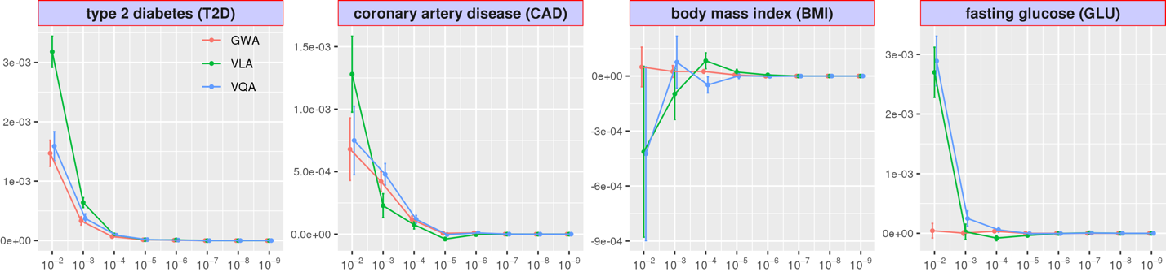
Figure 6: UKBB Internal GxE Enrichment
Given a p-value cut-off, we counted the number of significant GxE tests for each genome variant for UKBB non-British Whites and regressed the counts on variant rankings according to GWAS (red), VLA (green), and vQTL analysis (blue) based on UKBB British Whites. The regression coefficients (y-axis) at eight p-value cut-offs (x-axis) are shown, with higher coefficients indicating better enrichment. The error bar shows 2× standard error.

UKBB internal GxE enrichment
We performed a two-way GxE-WAS on a discovery population of 25,481 unrelated non-British Whites in the UKBB, with an exposome with lifestyle (drinking, smoking, and physical activity), neighborhood (green space, water, noise, air quality), and family (i.e., siblings) variables. The discovery analysis covers the same genome, phenome, and covariates as the selection analysis. For each variant, we counted the number of significant GxEs involved for a series of p-value cut-offs from 10⁻² to 10⁻⁹, with a higher count (up to 16) meaning a variant is more actively involved in GxEs given a p-value cut-off.
We then regressed the counts on the variant rankings according to GWAS, vQTL, and VLA, so the regression coefficient became a measure of enrichment. Figure 6 shows the GxE enrichment regression coefficients (y-axis) for GWAS, vQTL analysis, and VLA at several p-value cut-offs (x-axis), where a higher value means better GxE selection performance. For T2D, VLA outperformed GWAS and vQTL analysis for all GxE significance thresholds. For CAD, VLA had the best performance at more relaxed p-values cut-offs. For BMI, GWAS had no power, and VLA had better performance than vQTL analysis at medium to more stringent p-values cut-offs. For GLU, which is nearly Gaussian, GWAS had no power, and vQTL analysis had the best enrichment, followed by VLA. For binary phenotypes, VLA performed better in general, while the performance of vQTL analysis was nearly the same as that of GWAS, since a mean locus is also a variance locus in these cases. For continuous outcomes, GWAS had the worst performance, while the performance of VLA was nearly the same as for vQTL analysis.

PEGS external GxE enrichment
We next performed a two-way GxE-WAS on an external discovery population in PEGS of 4,603 unrelated individuals with whole-genome sequencing for the three exemplar traits: T2D, BMI, and CAD (35). PEGS participants complete extensive questionnaires measuring a rich exposome of 365 items on daily life, home environment, and workplace hazards. We again counted the number of significant GxEs at a series of p-value cut-offs for each variant and regressed the counts on the rankings given by GWAS, vQTL analysis, and VLA, based on 6,450,592 variants shared between UKBB imputed genotype and PEGS whole-genome sequencing. We used variant rankings for GLU in the UKBB to enrich T2D in PEGS. In this way, we assessed the usage of variance loci for a quantitative surrogate phenotype (i.e., GLU) to select GxE candidates for a binary outcome (i.e., T2D), an idea based on the assumption that significant vQTLs of a quantitative mediator are likely GxE candidates of a downstream binary phenotype (12). Figure 7 shows the enrichment regression coefficients. For T2D and CAD, VLA outperformed GWAS and vQTL analysis at all GxE significance thresholds. For BMI, GWAS had better performance at more relaxed p-value cut-offs, vQTL analysis had better performance at more stringent p-value cut-offs, and VLA had performance that ranged between the two. When using GLU in UKBB as a surrogate for T2D in PEGS, GWAS had the best performance. This indicates that VLA is better suited for binary phenotypes, followed by vQTL analysis and GWAS, which had nearly overlapping performance due to the link between phenotypic mean and variance.
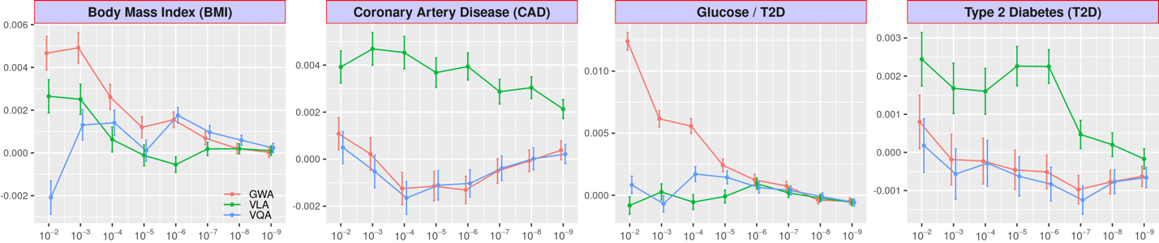
Figure 7: GxE enrichment on PEGS
Enrichment analysis counts the number of significant GxEs for a series of p-value cut-offs and tests each genome variant score in PEGS. It also regresses the count on variant rankings according to GWAS (red), VLA (green), and vQTL analysis (blue) based on British Whites in the UKBB. The regression coefficients (y-axis) at several p-value cut-offs (x-axis) are shown here, with a higher coefficient value indicating better enrichment. The error bar shows 2× standard error.

Investigation of functional enrichment
If VLA, GWAS, or vQTL loci are linked to genome functions, significant variants should reside unevenly in different regions. For example, the loci within or near genes may be more abundant than those between genes. We used the ANNOVAR package (36) to assign a functional class to each variant, such as intergenic or intronic variants. We also calculated the combined annotation dependent depletion (CADD) score (37, 38) for each variant as a continuous measure of pathogenic tendency and regressed the function class and CADD scores on the variant rankings given by VLA, GWAS, and vQTL analysis. If the loci are enriched in certain regions, the corresponding regression coefficients should be positive; conversely, if the loci are depleted, the coefficient should be negative. Table 1 shows the functional enrichment coefficients for BMI and T2D. For BMI and T2D, VLA loci were highly enriched in intergenic regions while GWAS and vQTL loci were highly concentrated within or near genes. As with CADD scores, VLA loci were depleted in regions with high CADD scores, indicating their low, direct pathogenic tendency. Although there were more GWAS and vQTL loci within or near genes, they were more concentrated in non-protein coding segments (i.e., upstream, intronic, and downstream). The distribution of the few VLA loci located within or near genes was relatively flat. Overall, the results indicate that VLA loci likely play an indirect, regulatory role in genome molecule biology while GWAS and vQTL loci play a more direct role in the production of proteins.
For a binary trait such as T2D, the functional distribution of GWAS and vQTL loci was nearly identical due to the high correlation between rankings from GWAS and vQTL. This is also shown by the overlapping performance of GWAS and vQTL regarding GxE enrichment. For quantitative traits such as BMI, GWAS and vQTL ranked the variants differently. For CADD scores, the concentration of GWAS and vQTL loci also differed. For both binary and quantitative traits, the pattern of VLA loci was distinct from the pattern of GWAS and vQTL loci. Accordingly, VLA provides a new perspective on the relative importance of each variant in terms of GxEs.
Body Mass Index |  | GWA | VQA | VLA |  | GWA | VQA | VLA |  | Type 2 Diabetes |  | GWA | VQA | VLA |  | GWA | VQA | VLA
Intergenic |  | --- | --- | ++ | CADD | --- | +++ | - |  | Intergenic |  | --- | --- | +++ | CADD | ++ | ++ | --
Genes | Upstream | ++ | ++ | + |  |  |  |  |  | Genes | Upstream | +++ | +++ | ++
Genes | Intronic | +++ | +++ |  |  |  |  |  |  | Genes | Intronic | +++ | +++ | +
Genes | Exonic |  |  |  |  |  |  |  |  | Genes | Exonic
Genes | Downstream | + | + | - |  |  |  |  |  | Genes | Downstream | +++ | +++ | ++
Table 1: Variant Function Enrichment
The functional enrichment analysis regresses the region type and CADD score of each variant on rankings given by GWAS (red), VLA (green), and vQTL analysis (blue) based on UKBB British Whites. Significant positive and negative regression coefficients are shown by + or -, respectively; the number of symbols denotes the level of significance. Non-significant coefficients are displayed as blank space.

UKBB variance loci catalog
Inspired by the Pan-UK Biobank GWAS catalog at pan.ukbb.broadinstitute.org, we created and host a catalog of variance loci statistics for UKBB phenotypes and variants on the NIEHS website (genelist.niehs.nih.gov). The catalog is a public resource that can be queried by phenotype, enabling researchers to prioritize candidate variants most likely to invoke significant GxEs. Figure 8 illustrates the workflow of creating the catalog and the query process.
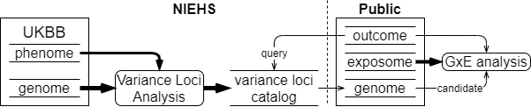
Figure 8: UKBB variance loci catalog workflow
We summarized 1,580 health-relevant phenotypes chosen from UKBB data fields accessible to NIEHS plus an additional 1,693 diseases derived from hospital records using PHECODE, a codebook for extrapolating diseases using ICD9/10 records (www.phewascatalog.org) (39, 40) for a phenome comprising 3,273 items. We distinguished the selected UKBB phenotypes into binomial, multinomial, ordinal, and continuous variables and subsequently recoded and normalized them. For the genome, we limited the variants to those with an overall minor allele frequency of at least 0.005, for a final number of 11,841,785 variants after quality control measures. The materials section provides details of these processes.
For each of the four main racial/ethnic groups in the UKBB (British Whites, Irish, Blacks, and Asian), we performed VLA for the whole phenome and genome to archive variant statistics. We used the plinkFile and vla R packages to traverse the genome by window while scanning variance loci for thousands of phenotypes and variants. We divided the genome into approximately 1,200 groups of 10,000 variants each and summarized the VLA statistics for British Whites, which is the largest group in the UKBB, with a working sample size of 384,000 in 12 hours, using the NIH HPC Biowulf cluster (hpc.nih.gov).

Methods
We investigated additive vQTLs, which are captured by DLM and DRM, and multiplicative vQTLs, which are captured by DGLM and Levene’s test. While the two types of vQTL are related, they represent different perspectives on the origin of GxE effects. In this study, we prefer the additive perspective over the multiplicative perspective as the basis of improvement because we rely on a linear model to capture significant GxEs in a discovery database. The construct of additive vQTL is a natural consequence of unaccounted GxE effects in this linear model (Equation 1 (1) in the supplement). Multiplicative vQTLs, on the other hand, do not depend on the parameterization of environmental and GxE effects and thus multiplicative vQTLs do not necessarily select GxE candidates in the linear model.
When a phenotype is not quantitative but binary, a locus of phenotypic mean is automatically a locus of phenotypic variance because the mean $μ$ and variance $v$ of a binary variable are related by $v=μ(1-μ)$. Thus, a GWAS significant variant would be a DLM significant variant in the absence of interaction, causing uncontrolled type 1 errors if GxE candidates are selected via variance loci. When a phenotype deviates from a Gaussian distribution, a DLM may inflate type 1 errors when the variant is a GWAS QTL. These type 1 errors cannot be resolved by using DRM or a multiplicative model such as Levene’s test or DGLM, despite the fact that DGLM supposedly handles binary phenotypes with the logit link. Therefore, current variance heterogeneity-based approaches are limited to quantitative trait loci.
VLA counters the inflated type 1 errors encountered with null GxEs because the curve fit by the stage 2 model (10) through the squared residual of stage 1 (i.e., the GWAS) is either flat, when the variant has no effect on the phenotypic mean, or bends downwards, when the variant does affect the mean. However, VLA is conservative because the curve would not bend upwards in the presence of a GxE. It is essential to use well-chosen covariates to recover innate risk. With covariates that are non-heritable (i.e., non-confounding) but highly predictive of the binary phenotype, the recovered risk (i.e., the covariate residuals) acts as a numerical phenotype, giving VLA the power to detect GxE candidates while controlling type 1 errors. Because the recovered risk is represented by quantitative traits, this improves the performance of DLM, DRM, and multiplicative vQTL methods with binary phenotypes. However, these methods do not guarantee full control of type 1 errors.

Materials

UK Biobank (UKBB) data

We used UKBB data to evaluate the performance of VLA is selecting GxE candidates and compare it with other methods. The UK Biobank is a large-scale resource consisting of genetic and health information for over half a million participants (Application ID: 57849, version 2) collected via questionnaires, electronic health records, biological samples, oral interviews, imaging, and genotype data. Details of this resource are included in the Supplement.

Genotype data

Using the imputed genotype, we created a comprehensive catalog of the whole genome. Beginning with 97,059,328 imputed variants from 487,411 individuals, we performed a series of quality control measures, after which 405,432 individuals with high-quality micro-array genotyping remained. We divided the remaining samples into five major ancestry groups—African (afr), non-Chinese Asian (asi), White British (bri), Irish (iri), and White but non-British (wnb)—and subsequently removed 29,440 individuals belonging to ethnic groups with a small sample size (e.g., Chinese with a sample size of 1574) or unclear ancestry, leaving 375,992 individuals from the original total (77.1% of 487,411 with imputed genotypes and 74.8% of the total 502,505). The afr, asi, bri, and iri groups serve as the basis of the NIEHS VLA Catalog, and the bri and wnb groups serve as training and testing datasets, respectively, for comparison of the performance of methods. Details of the quality control steps are provided in the Supplement.

Phenotype data
We manually compiled several phenotypes from baseline data collected at UKBB participants’ first visit, as summarized in Table 2. These phenotypes are type 2 diabetes, coronary artery disease, body mass index, and fasting glucose level. Details of how we compiled these phenotypes, including criteria and the UKBB data fields used, are included in the Supplement.

Environmental data
To compare the performance of enriching GxE discovery by GWAS, VLA, and vQTL, we conducted GxE analysis for various environmental variables in UKBB, namely number of siblings (SIB), physical activity in metabolic equivalent minutes (MET), smoking (SMK), alcohol intake (ALC), neighborhood traffic (TRF), nitrogen oxide (NO1), nitrogen dioxide (NO2), particulate matter air pollution, 10μm (P10), particulate matter air pollution, 2.5μm (P25), and noise pollution (NOI). We also included several neighborhood exposures in a 1000-m buffer around an individual’s home address, namely green space percentage (GSP), domestic garden percentage (DGP), water percentage (WTP), and natural environment percentage (NEP) and distance to the coast (SEA). Table 3 outlines the environmental variables, and the Supplement provides details on the methods and fields used to calculate the variables.

Phecodes
We derived phecodes for our analysis using phenotypes and disease diagnoses from electronic health record (EHR) data for UKBB participants recorded as International Classification of Diseases (ICD) codes. ICD codes are used to record medical diagnoses, signs and symptoms, abnormal findings, and injuries. Although more than 100 countries use ICD codes to track morbidity and mortality (41), they do not provide an appropriate level of granularity for phenotypes relevant for genetic association studies. Phecodes are manually curated groups of ICD codes aggregated into a distinct medical concept, disease, or phenotype intended to capture clinically meaningful concepts for research (40). Phecodes provide embedded case-control definitions based on exclusion criteria for controls, enabling the rapid characterization of large numbers of phenotypes. They are widely used for phenotyping participants with EHR data, especially for genetic association studies (40, 42). The use of phecodes in such studies produces superior results compared to ICD and Clinical Classification Software (CCS) codes. The Supplement provides details of our phecode mapping.

 | Description | N | Min | Median | Mean | Max | Histogram
BMI | Body mass index | 489955 | 18.0 | 26.7 | 27.4 | 48.0 | 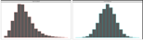
CAD | Coronary artery disease | 502505 | 0.0 | 0.0 | 0.0 | 1.0 | 
GLU | Blood fasting glucose | 429567 | 1.0 | 4.9 | 5.1 | 36.8 | 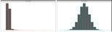
T2D | Type 2 diabetes | 493619 | 0.0 | 0.0 | 0.1 | 1.0 | 
Table 2. UK Biobank Phenotypes Used
Note: While the histogram shows distributions before and after normalization, only the latter were included in the analysis.

 | Description | N | Min | Med | Mean | Max | 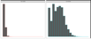  Histogram
ALC | Weekly alcohol intake | 427697 | 0.0 | 8.0 | 11.9 | 603.0
DGP | Domestic garden percentage | 440874 | 0.1 | 24.3 | 24.3 | 66.1 | 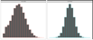  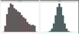
GSP | Green space percentage | 440874 | 4.4 | 41.5 | 45.0 | 99.2
MET | Metabolic equivalent minutes | 498628 | 0.0 | 1386.0 | 2553.7 | 125118.0 | 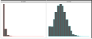
NEP | Nature environment percentage | 497542 | 0.0 | 36.6 | 40.5 | 100.0 | 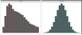
NO1 | Nitrogen oxide | 495124 | 19.7 | 42.4 | 44.1 | 265.9 | 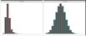  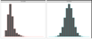
NO2 | Nitrogen dioxide | 495124 | 5.1 | 21.3 | 22.4 | 98.6 | 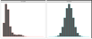
NOI | Noise | 495124 | 46.7 | 50.1 | 51.2 | 88.5
PM1 | Air pollution, PM10 | 495113 | 5.9 | 19.0 | 18.6 | 30.5 | 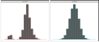
PM2 | Air pollution, PM2.5 | 461201 | 8.2 | 9.9 | 10.0 | 21.3 | 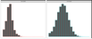
SDN | Sedentary behavior | 500967 | 0.0 | 4.0 | 4.5 | 48.0 | 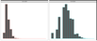
SEA | Distance to coast | 497542 | 0.0 | 44.0 | 41.6 | 108.0 | 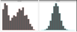  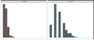
SIB | Number of siblings | 493402 | 0.0 | 2.0 | 2.2 | 44.0 | 
SMK | Ever smoke | 499620 | 0.0 | 1.0 | 0.6 | 1.0
TRF | Traffic intensity | 495124 | 0.8 | 78.2 | 172.6 | 100810.0 | 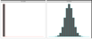  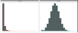
WTP | Water percentage | 440874 | 0.0 | 0.5 | 1.3 | 59.4
Table 3. UK Biobank Environmental Variables
Note: While the histograms show distributions before and after normalization, only the latter were included in the analysis.

PEGS

Exposome data
We used exposome data from self-administered surveys completed by PEGS participants. The Health and Exposure Survey requests general health, lifestyle, and occupational exposure information as well as individual and family medical histories (n=9,414). Part A of the Exposome Survey requests information on exogenous exposures throughout life, including but not limited to chemical and environmental exposures at home and work (n=3,519), and Part B requests information on endogenous exposures such as medication as well as lifestyle factors, including sleep patterns, stress, physical activity, and diet (n=2,962). The Supplement provides information on how the surveys were formulated.

Phenotype data
We used data on CAD and T2D for PEGS participants. The Supplement provides information on how we defined cases for each phenotype.

Whole-genome sequencing
The Broad Institute sequenced all samples and conducted quality control. In addition to the quality control steps, we compared the number of variants identified for each PEGS participant to the number determined in a parallel analysis of the same data based on the hg19 genome assembly. The Supplement provides further details on all the sequencing and filtering steps.

Principal Components Analysis
The UKBB performed the principal components analysis for all genotyped individuals. Data field 22009 provides the first 40 principal components. For PEGS, we performed PCA using the pca command in PLINK2. Before removing any variants or samples as part of QC, we performed PCA with the original whole genome sequencing (WGS) data for 40,123,943 variants (38,528,374 in the autosomes) in 4,610 individuals.

Gene-Environment Interaction Analysis
For each environment e, genome variant g, outcome y, and some covariates X, we fitted model y = g + e + ge + X. We tested the significance of the coefficient on ge and kept the p-value. The term ge is the product of g and e. For the UKBB, g is one of the imputed variants, and e is one of the 16 environment exposures described in the Materials section. The covariates X are age, sex, the top 40 PCs, and the genotyping array used (i.e., BiLEVE or Axiom). Because the GxE analysis was conducted for non-British whites only, ethnicity is not included among the covariates. For PEGS, g is one of the WGS variants after quality control, e is one the 766 available environment exposures, and the covariates X are age, sex, self-identified ethnicity, and the top 20 PCs. The proportion of each self-identified ethnicity is: 2.19% Asian, 27.46% Black, 62.34 White, and 2.21% other, coded as 3 dummy variables in X.

Discussion
Using VLA, we scanned more than 11 million SNPs in the UKBB White British population and selected the top 1% most significantly associated with the variance of T2D status as candidates for GxEs. By querying the VLA catalog for T2D status in the UKBB Irish population, we narrowed down the candidates to fewer than 10,000 variants. Due to the compactness of candidate variants, it was statistically practical to search for significant GxEs for T2D among the more than 700 environmental exposures for which PEGS collected information. The significant GxEs pointed to genes associated with fatty liver disease and differentially expressed among individuals with ink, paint, and pesticide exposures, suggesting targets for intervention in the identified genes and in workplaces containing these materials. Considering ABCB7 as an exemplar gene, we validated our GxE analysis in the PEGS cohort.
GxE enrichment analysis results in both the internal discovery population of UKBB non-British Whites (Figure 6) and the external discovery population of PEGS participants (Figure 7) demonstrate the advantages of VLA in prioritizing GxE candidates for binary phenotypes such as T2D and CAD. The advantage is more pronounced for PEGS, as it contains a much wider range of involved environmental exposures (728 vs. 16 in the UKBB). The link between the phenotypic mean and variance of binary phenotypes renders the vQTL statistics obtained from DLM redundant to the QTL statistics obtained from GWAS, as demonstrated by the nearly overlapping enrichment curves of GWAS and vQTL for binary phenotypes (Figures 6 and 7, T2D and CAD, red and blue). For quantitative phenotypes, vQTL statistics indicate the method has greater power than GWAS to select GxE candidates, as demonstrated by varying enrichment curves for vQTL and GWAS (Figures 6 and 7, BMI and GLU, red and blue). vQTL is ideal for phenotypes that are nearly perfectly Gaussian, such as GLU. In this scenario, GWAS lacks power to select GxE candidates, as demonstrated by separation of the phenotypic mean and variance. For quantitative phenotypes that are not fully Gaussian, such as BMI, GWAS has some demonstrated ability to select GxE candidates because vQTL and QTL are somewhat related.
When treating GLU as a quantitative surrogate of T2D, the GWAS provided the best overall GxE candidate ranking based on statistics (Figure 7, panel 3, GLU/T2D). For T2D without a surrogate, GWAS provided better enrichment coefficients (e.g., 0.0125 at 10⁻²) than VLA (e.g., 0.0025 at 10⁻², Figure 7, panel 1, T2D). However, the choice of GLU as a surrogate for T2D depends on prior knowledge and subjective judgement (e.g., BMI is also a potential surrogate of T2D) and thus such a technique is unsuitable for automated GxE hypothesis exploration before weighting and choosing surrogates, which is also an automated process. Despite these limitations, we provide the GWAS p-values in addition to VLA p-values for each phenotype in the VLA catalog to allow surrogate GxE candidate rankings based on subjective knowledge of disease etiology.
VLA was initially proposed as an additive vQTL scanner that prioritizes pure GxE effects and improves on existing two-stage methods such as DLM, DRM and LVT concerning the quality of GxE candidates selected for quantitative traits. However, after transforming simulated Gaussian phenotypes to case/control status via a logistic function and Bernoulli sampling, VLA was consistently conservative while DLM, DRM, and LVT resulted in uncontrolled type 1 errors with non-zero genetic effects on the original Gaussian phenotypic mean. To address this, we scanned variance loci for binary phenotypes using VLA in conjunction with covariates. This approach is based on the concept that the adjusted binary phenotypes of covariates can be treated as new phenotypes that more clearly represent combined genotype and environment effects. vQTL scanners can be used with high-quality, quantitative covariates. To ensure control of type 1 errors with lower-quality covariates, we used the curve upwardness test for VLA. A combined DLM and VLA test for statistical power to detect variance loci was unable to control type 1 errors unless the covariates were perfect.
The best covariates are non-confounding predictors, which, in essence, are variables unaffected by the genotype or environment yet associated with the outcome. Such covariates have been shown to improve statistical power in GWAS and epidemiology studies (Aschard et al., 2015). If covariates are non-confounding, adjusting them neither removes the genetic or environmental effect on the phenotype nor creates spurious associations between the genotype/environment and the phenotype. For a covariate to be predictive, after removing the effect of the covariate, the adjusted phenotype becomes closer to the combined genotype/environment effect than the original phenotype. Recommend covariates are age and age², or more than three age bins (e.g., <20, 20-40, 40-60, >60 years), because age is unaffected by the genotype or environment but predictive of most diseases. Sex, age × sex, and age² × sex can also be used if a disease affects both sexes and the analysis is limited to autosomes.
If the genotype and the environment (e.g., pollution and climate) are considered precursors of all phenotypes, confounding predictors are either mediators or colliders linking the precursors and the outcomes. Adjusting either attenuates (for mediators) or inflates (for colliders) the genetic and environmental effects (Hernán et al., 2002). However, some confounding predictors are useful, including genetic principal components. Although the components are the weighted sum of common genome variants, the association between a component and a single variant is typically insignificant. A contrasting example is the use of BMI and socioeconomic status (SES) variables (e.g., income and education) as adjusted covariates in T2D studies. BMI can be both a mediator and a collider because it is both heritable and an indicator of T2D risk, and T2D onset can reversely affect BMI through changes in lifestyle. Accordingly, we did not include BMI and SES in the VLA scan in the UKBB White British population.
Using VLA as a GxE candidate scanner for binary phenotypes enables analysis of a large number of case/control outcomes collected in a sizable cohort such as the UKBB. Archive VLA statistics as a reference for research on the environmental genetic effects on health motivated creation of the NIEHS-hosted VLA Catalog. For binary phenotypes, a logit linked, iteratively optimized binomial linear model is typically chosen for association analysis due to its befitting interpretation of the odds ratio per additional allele and predicted probability, which never exceeds the range of the phenotype (i.e., 0=control, 1=case). In contrast, plain linear models optimizable in close form are adopted for two-stage VLA (i.e., ordinary least squares) because the priority is not interpretating odds ratios and predicting binomial probability but quickly ranking variants’ potential to invoke GxE effects for a phenotype. Additionally, the logit link function $f\left(x\right)={\left[exp\left(1+x\right)\right]}^{-1}$ is monotonic and closely approximated by the trivial identity link function $f\left(x\right)=x$ near $x=0$. Therefore, the significance and direction of a variant effect identified by a logit linked binomial linear model can also be recognized by a plain linear model. The simplicity of VLA allows the rapid ranking of variants for multiple phenotypes en masse, facilitating creation of the VLA Catalog based on rich phenome (3,237 phenotypes, of which 1,693 are binary) and genome data from the UKBB.
Despite the use of VLA to select candidate variants for GxEs, type 1 errors are still inflated in simulations with highly imbalanced case/control ratios and large allele effects on the phenotypic mean. In this scenario, VLA performs similar to GWAS based on statistics. Specifically, effects on the phenotypic mean become indistinguishable from effects on phenotypic variance, causing VLA to identify variants not involved in a GxE as variance loci. In practice, however, this issue is mitigated by the fact that for complex diseases like T2D and CAD, few if any variants exert clinically noticeable marginal effects, but tens of thousands of variants exert clinically weak but statistically significant effects. To demonstrate this phenomenon, we used GWAS to select the top 1% most significant autosome variants (p <0.01) and inspected the correlations between the p-values given by GWAS, VLA, and additive vQTL analysis (although vQTL is intended for quantitative phenotypes only). For T2D in the UKBB White British population, the correlation between GWAS and VLA was nearly 0 but 0.79 between GWA and vQTL analysis. For CAD, the correlation between GWAS and VLA was again nearly 0 but 0.85 between GWAS and vQTL analysis. The unrelatedness between GWAS and VLA statistics means the latter ranks variants differently from the former and thus offers a unique perspective in selecting GxE candidates. Conversely, the high correlation between GWAS and vQTL statistics means the latter is redundant concerning binary phenotypes. For quantitative phenotypes such as BMI, the correlation between GWAS and VLA is 0, and the correlation between GWAS and vQTL analysis is as low as 0.04, reflecting the fact that vQTL analysis is appropriate for quantitative traits only. Because the p-values for additive vQTL are close to p-values for GWAS, we set the latter to NaN for all 1,698 binary phenotypes in the VLA Catalog.
Besides serving as a reference database for gene-by-environment analysis, the VLA Catalog can also aid summary statistics-based analysis. In polygenic risk score (PRS)-based prediction, PRS is the sum of allele dosage in a discovery cohort weighted by GWAS statistics from a training cohort. Because VLA statistics are sufficiently distinct from GWAS statistics yet relevant to the phenotype of interest, they can be considered an alternative weight vector for calculating PRS. A discovery model can improve overall fit and subsequent prediction by using two PRS vectors based on GWAS and VLA, respectively, or better, by including additional vector products between VLA-based PRS and environments of interest. Since VLA-significant variants are more evenly distributed in the entire genome compared to GWAS-significant variants, using VLA for variant weights can enable pathway analysis to identify alternative sets of regions affecting a disease phenotype.
A next step is better countering type 1 errors caused by imbalanced outcomes (e.g., case/control outcomes) in a prospective cohort and Poisson-distributed phenotypes, where it is difficult to separate the allele effect on the mean and variance. In a simulation study, we dropped the intercept term in stage-1 VLA model, forcing it to recognize 0.5 as the mean of an imbalanced binary phenotype (i.e., 0=control, 1=case). Type 1 errors were controlled when the simulated GxE effect was null, but statistical power substantially decreased when the GxE effect was non-null. Another approach is including additional non-confounding predictive covariates to break up the underlying risk of a discrete trait into a finer gradient closely resembling a Gaussian variable. However, besides age and sex, there are few covariates universally collected by cohort studies guaranteed to be free of genetic and environment effects yet predictive of outcomes. In the future, however, we anticipate that GWAS, vQTL (for quantitative phenotypes), and VLA statistics will be included for genotyped cohorts as a common practice to facilitate science on genetic and environmental effects on health.

References
1. Eichler EE, Flint J, Gibson G, Kong A, Leal SM, Moore JH, et al. Missing heritability and strategies for finding the underlying causes of complex disease. Nat Rev Genet. 2010;11(6):446-50.
2. van Ijzendoorn MH, Bakermans-Kranenburg MJ, Belsky J, Beach S, Brody G, Dodge KA, et al. Gene-by-environment experiments: a new approach to finding the missing heritability. Nat Rev Genet. 2011;12(12):881; author reply
3. Cao Y, Wei P, Bailey M, Kauwe JSK, Maxwell TJ. A versatile omnibus test for detecting mean and variance heterogeneity. Genet Epidemiol. 2014;38(1):51-9.
4. Deng WQ, Asma S, Paré G. Meta-analysis of SNPs involved in variance heterogeneity using Levene's test for equal variances. Eur J Hum Genet. 2014;22(3):427-30.
5. Struchalin MV, Amin N, Eilers PH, van Duijn CM, Aulchenko YS. An R package "VariABEL" for genome-wide searching of potentially interacting loci by testing genotypic variance heterogeneity. BMC Genet. 2012;13:4.
6. Yang J, Loos RJ, Powell JE, Medland SE, Speliotes EK, Chasman DI, et al. FTO genotype is associated with phenotypic variability of body mass index. Nature. 2012;490(7419):267-72.
7. Paré G, Cook NR, Ridker PM, Chasman DI. On the use of variance per genotype as a tool to identify quantitative trait interaction effects: a report from the Women's Genome Health Study. PLoS Genet. 2010;6(6):e1000981.
8. Smyth GK. Generalized linear models with varying dispersion. Journal of the Royal Statistical Society: Series B (Methodological). 1989;51(1):47-60.
9. Lee Y, Nelder JA. Double hierarchical generalized linear models (with discussion). Journal of the Royal Statistical Society: Series C (Applied Statistics). 2006;55(2):139-85.
10. Rönnegård L, Felleki M, Fikse F, Mulder HA, Strandberg E. Genetic heterogeneity of residual variance - estimation of variance components using double hierarchical generalized linear models. Genet Sel Evol. 2010;42(1):8.
11. Rönnegård L, Valdar W. Detecting major genetic loci controlling phenotypic variability in experimental crosses. Genetics. 2011;188(2):435-47.
12. Marderstein AR, Davenport ER, Kulm S, Van Hout CV, Elemento O, Clark AG. Leveraging phenotypic variability to identify genetic interactions in human phenotypes. Am J Hum Genet. 2021;108(1):49-67.
13. Wang H, Zhang F, Zeng J, Wu Y, Kemper KE, Xue A, et al. Genotype-by-environment interactions inferred from genetic effects on phenotypic variability in the UK Biobank. Sci Adv. 2019;5(8):eaaw3538.
14. Brown MB, Forsythe AB. Robust tests for the equality of variances. Journal of the American Statistical Association. 1974;69(346):364-7.
15. Levene H. Robust tests for equality of variances. Contributions to probability and statistics Essays in honor of Harold Hotelling. 1961:279-92.
16. Bycroft C, Freeman C, Petkova D, Band G, Elliott LT, Sharp K, et al. The UK Biobank resource with deep phenotyping and genomic data. Nature. 2018;562(7726):203-9.
17. Sudlow C, Gallacher J, Allen N, Beral V, Burton P, Danesh J, et al. UK biobank: an open access resource for identifying the causes of a wide range of complex diseases of middle and old age. PLoS Med. 2015;12(3):e1001779.
18. Pain D, Dancis A. Roles of Fe-S proteins: from cofactor synthesis to iron homeostasis to protein synthesis. Curr Opin Genet Dev. 2016;38:45-51.
19. Allikmets R, Raskind WH, Hutchinson A, Schueck ND, Dean M, Koeller DM. Mutation of a putative mitochondrial iron transporter gene (ABC7) in X-linked sideroblastic anemia and ataxia (XLSA/A). Hum Mol Genet. 1999;8(5):743-9.
20. Podhajny RM. A Brief Chemistry Lesson On Printing Ink Pigments. Paper, Film & Foil Converter Magazine [Internet]. 2001. Available from: https://www.pffc-online.com/magazine/782-paper-brief-chemistry-lesson.
21. Silaghi CA, Silaghi H, Colosi HA, Craciun AE, Farcas A, Cosma DT, et al. Prevalence and predictors of non-alcoholic fatty liver disease as defined by the fatty liver index in a type 2 diabetes population. Clujul Med. 2016;89(1):82-8.
22. Lonardo A, Lugari S, Ballestri S, Nascimbeni F, Baldelli E, Maurantonio M. A round trip from nonalcoholic fatty liver disease to diabetes: molecular targets to the rescue? Acta Diabetol. 2019;56(4):385-96.
23. Xiao L, Shi XY, Li ZL, Li M, Zhang MM, Yan SJ, et al. Downregulation of LINC01508 contributes to cisplatin resistance in ovarian cancer via the regulation of the Hippo-YAP pathway. J Gynecol Oncol. 2021;32(5):e77.
24. Gui W, Zhu WF, Zhu Y, Tang S, Zheng F, Yin X, et al. LncRNAH19 improves insulin resistance in skeletal muscle by regulating heterogeneous nuclear ribonucleoprotein A1. Cell Commun Signal. 2020;18(1):173.
25. Wang J, Yang W, Chen Z, Chen J, Meng Y, Feng B, et al. Long Noncoding RNA lncSHGL Recruits hnRNPA1 to Suppress Hepatic Gluconeogenesis and Lipogenesis. Diabetes. 2018;67(4):581-93.
26. Liu D, Liu F, Li Z, Pan S, Xie J, Zhao Z, et al. HNRNPA1-mediated exosomal sorting of miR-483-5p out of renal tubular epithelial cells promotes the progression of diabetic nephropathy-induced renal interstitial fibrosis. Cell Death Dis. 2021;12(3):255.
27. Zhao M, Shen L, Ouyang Z, Li M, Deng G, Yang C, et al. Loss of hnRNP A1 in murine skeletal muscle exacerbates high-fat diet-induced onset of insulin resistance and hepatic steatosis. J Mol Cell Biol. 2020;12(4):277-90.
28. Wei WQ, Bastarache LA, Carroll RJ, Marlo JE, Osterman TJ, Gamazon ER, et al. Evaluating phecodes, clinical classification software, and ICD-9-CM codes for phenome-wide association studies in the electronic health record. PLoS One. 2017;12(7):e0175508.
29. Wu P, Gifford A, Meng X, Li X, Campbell H, Varley T, et al. Mapping ICD-10 and ICD-10-CM Codes to Phecodes: Workflow Development and Initial Evaluation. JMIR Med Inform. 2019;7(4):e14325.
30. Chang CC, Chow CC, Tellier LC, Vattikuti S, Purcell SM, Lee JJ. Second-generation PLINK: rising to the challenge of larger and richer datasets. Gigascience. 2015;4(1):s13742-015-0047-8.
31. Purcell S, Neale B, Todd-Brown K, Thomas L, Ferreira MA, Bender D, et al. PLINK: a tool set for whole-genome association and population-based linkage analyses. Am J Hum Genet. 2007;81(3):559-75.
32. Chang CC. Plink binary biallelic genotype table 2021 [Available from: https://www.cog-genomics.org/plink/1.9/formats#bed.
33. Abecasis GR, Auton A, Brooks LD, DePristo MA, Durbin RM, Handsaker RE, et al. An integrated map of genetic variation from 1,092 human genomes. Nature. 2012;491(7422):56-65.
34. Auton A, Brooks LD, Durbin RM, Garrison EP, Kang HM, Korbel JO, et al. A global reference for human genetic variation. Nature. 2015;526(7571):68-74.
35. National Institute of Environmental Health Sciences. Personalized Environment and Genes Study Data Freeze 1.1. 2021.
36. Wang K, Li M, Hakonarson H. ANNOVAR: functional annotation of genetic variants from high-throughput sequencing data. Nucleic Acids Res. 2010;38(16):e164.
37. Kircher M, Witten DM, Jain P, O'Roak BJ, Cooper GM, Shendure J. A general framework for estimating the relative pathogenicity of human genetic variants. Nat Genet. 2014;46(3):310-5.
38. Rentzsch P, Witten D, Cooper GM, Shendure J, Kircher M. CADD: predicting the deleteriousness of variants throughout the human genome. Nucleic Acids Res. 2019;47(D1):D886-d94.
39. Wei W-Q, Bastarache LA, Carroll RJ, Marlo JE, Osterman TJ, Gamazon ER, et al. Evaluating phecodes, clinical classification software, and ICD-9-CM codes for phenome-wide association studies in the electronic health record. PLOS ONE. 2017;12(7):e0175508.
40. Wu P, Gifford A, Meng X, Li X, Campbell H, Varley T, et al. Developing and Evaluating Mappings of ICD-10 and ICD-10-CM codes to Phecodes. BioRxiv. 2019;
:462077.
41. World Health Organization. International Statistical Classification of Diseases and Related Health Problems (ICD) 2021 [Available from: https://www.who.int/standards/classifications/classification-of-diseases.
42. Bastarache L. Using Phecodes for Research with the Electronic Health Record: From PheWAS to PheRS. Annual Review of Biomedical Data Science. 2021;4(1):1-19.

