Cataloging gene-environment interaction candidate SNPs for over 3,000 UK Biobank disease phenotypes through variance loci analysis
Xiaoran Tong, <authors>, Alison Motsinger-Reif
September 7, 2021

Abstract
Detecting gene by environment interactions (GxEs) for diseases enriches the ontology of genetic effects and helps identify environmental targets for interventions with the goal of improving health outcomes. However, combining the dimensions of the genome and exposome poses challenges in terms of both computational and statistical power.
Variance quantitative trait loci (vQTL) analysis, which is based on a double linear model (DLM) or double generalized linear model (DGLM), has recently received attention for its ability to find candidate single nucleotide polymorphisms (SNPs) for GxEs without actual environmental exposome profiling. The rationale is that GxEs unaccounted for by a genome-wide association study (GWAS) can bring about the residual variance of a quantitative phenotype that changes across allele dosages—a non-uniformity that can be captured by a second GWAS treating the squared residual as a new phenotype.
We propose variance loci analysis (VLA) based on a DLM augmented by squared SNP dosage. We show that VLA maintains superior power to detect GxE candidates with weak direct environmental effects on the phenotype. We also demonstrate that DGLM is overly generic with squared dosage and overly restrictive when the squared dosage is not used. More importantly, we demonstrate that by appropriately adjusting covariates, VLA can overcome the inability of DLM/DGLM to analyze thousands of non-quantitative phenotypes.
We performed VLA for 3,273 health- and disease-related phenotypes derived from the UK Biobank and ranked the potential involvement of each SNP in GxEs. We present the VLA Catalog (genelist.niehs.nih.gov) an open resource of GWAS, vQTL, and VLA mapping for these traits, along with consistently curated metadata required for reproducibility and independent applications. Using environmental exposome data collected in the Personalized Environmental Genetic Study (PEGS), we found that high-ranking genome variants selected by VLA enriched the detection of genome-exposome-wide significant GxE SNPs for cardiovascular disease (CVD), type 2 diabetes (T2D), and body mass index (BMI).

Introduction

Background and motivation
Most human traits have a complex etiology and are affected by both genetic and environmental factors and their interactions. Because environmental exposures can regulate the biological processes underlying a phenotype^{1–4}, unaccounted-for GxE effects are recognized as part of the heritability “missed” by variants selected by genome-wide association studies (GWAS)^{5,6}. While research in agricultural genetics, model organisms, and cell culture has consistently found that genetic effects are context-dependent (9-13), there has been limited success in identifying GxEs in humans for several reasons. First, many environmental exposures are unknown or difficult to record. Second, due to the polygenic nature of most human traits (9-11), GxE effect sizes are small, (9–11), and the sample sizes of most previous studies have not been large enough to detect small GxE effects.
In larger cohorts with comprehensive information on environmental exposures (i.e., the exposome), along with genome-wide data, a two-way genome-exposome wide association study (GxEWAS) can test all possible single nucleotide polymorphism (SNP)-by-environment interactions. However, the burden of multiple testing and computation due to the overwhelming number of two-way crossovers between exposome items and whole genome variants limits the power of this approach (REFS). An unbiased genome-wide interrogation also restricts hypothesis generation. Accordingly, instead of looking at the whole genome, candidate genes for testing GxE interactions are frequently selected based on previous biological knowledge or results from other GWAS, based on the assumption that strong interactions are likely to exert strong marginal effects^{7,8}. While this approach increases power, candidate gene selection is limited by existing biological knowledge. Further, significant GWAS results do not necessarily equate to GxE interactions since substantial SNP main effects can coexist with weak GxE interactions.
These limitations motivated the development of alternative methods to identify candidate SNPs. GxE interactions with large effect sizes can be revealed as heterogeneity in the variance of a quantitative trait among groups of individuals with different genotypes^{9–12}. A promising strategy is screening for variance quantitative trait loci (vQTL) in a selection cohort rich in genome data and then using significant vQTLs as candidate SNPs to conduct GxE studies in a discovery cohort rich in exposome data. Unlike classical QTL analysis, which tests the allelic substitution effect of a variant on the phenotypic mean, vQTL analysis tests the allelic substitution effect on phenotypic variance. Therefore, vQTLs are superior GxE candidates compared to GWAS QTLs due to the link between GxEs and changes in phenotypic variance. vQTLs also retain one of the benefits of GWAS QTLs, namely that exposome data are not required for the selection cohort if it shares a phenotype of interest with the discovery cohort. Accordingly, vQTL-based candidate SNPs can mitigate the multiple testing burden without the requirement of prior biological knowledge.

Overview of variance quantitative trait loci (vQTL)
A phenotype, aside from noise and covariate effects (i.e., age and sex), is the sum of the genotype main effect, environmental main effect, and GxE interaction effect, where a GxE is expressed as the product of the genotype and an environmental exposure. A vQTL can be induced by a GxE interaction effect unaccounted for in a GWAS linear model, resulting in uneven variation around the mean regression line across genotypes. An intuitive approach to capture such a vQTL is to fit the phenotypic variance with the same genotype via a second linear model. Figure 1 conceptually illustrates vQTL analysis. Because two-stage linear regressions are used, the vQTL scan essentially acts as a double linear model (DLM), where the first stage is a de facto GWAS, and the second stage treats the squared residual as a new phenotype. If a variant is not involved in a GxE (Figure 1a), the second stage results in a flat regression line because the phenotypic variation, measured by squared residuals, is nearly uniform across the genotypes. If a variant is involved in a GxE, (Figure 1b), the regression line has a non-zero slope due to the monotonic increase of phenotypic variation across the genotypes.

Figure 1: Variance trait quantitative loci (vQTL) to suggest GxE
(a) In the absence of a GxE (left), residual variations are even across genotypes (right), and variant A/a is not a vQTL; based on GWAS, the variant would be erroneously identified as a GxE candidate. (b) In the presence of a GxE (left), residual variations are uneven across genotypes (right), and variant A/a is a vQTL. Teal/red dashes: environment-specific effect; blue solid lines: marginal effect.

(a)
(b)
In a DLM, the slope of the second linear model can be used to detect vQTLs (e.g., by t-test). It is important to note that vQTLs induced by missed GxE interactions are additive vQTLs. This is because each allele directly adds its effect to the phenotypic variance on a linear scale. In contrast, for multiplicative vQTLs, each allele multiplies the phenotypic variance by a factor, and its effect is added to the phenotypic variance in log scale. In contract, by GWAS alone, the variant in Figure 1a not involved in a GxE would be erroneously classified as a GxE candidate, so we see GWAS is not optimal in selecting GxE candidates.
Before the development of DLM and the concept of additive vQTL, modeling both the mean and dispersion of a quantitative phenotype with shared genotype predictors (i.e., SNPs) was achieved via double generalized linear modeling (DGLM)¹³ and double hierarchical generalized linear modeling (DHGLM)¹⁴, which allows random effects. Like DLM, DGLM involves a two-stage model but allows standard link functions to accommodate non-normal outcomes and assumes that the squared residual deviance (i.e., squared residual generalized) of a stage-1 model follows not a Gaussian, but a Gamma, distribution. Therefore, by default, DGLM uses log-linked Gamma regression for stage-2 models, which, for a Gaussian phenotype, essentially models the phenotypic variance in log scale. DGLM thus captures multiplicative vQTLs. The intent of DGLM and DHGLM is to prioritize genome variants that are resistant to environmental changes (i.e., non-vQTL), allowing the selection of non-interaction candidates¹⁵. DGLM is also a common benchmark for comparing power to identify GxE candidates^{16,17}.
Methods to capture additive or multiplicative vQTLs have been successfully applied with varying results regarding their power performance. Comparing the results of several studies (Guillame et al., Andrew et al., Huanwei et al.), DRM is recommended to capture additive vQTLs, and Levene’s test is recommended to capture multiplicative vQTLs. Although DGLM and DLM are motivated by multiplicative and additive vQTLs, respectively, they cannot control type 1 errors when the quantitative phenotype is non-Gaussian and the genotype main effect is non-zero^{18,19}.
In an application in the Women’s Genome Health Study, Guillaume et al., derived the additive vQTL and DLM from unaccounted GxE interaction. The proposed method however, did not use DLM’s t-test but Levene’s test^{18,19} for equality of variance across genotype groups, which captures multiplicative vQTLs²⁰. The authors identified three novel GxE interactions involving body mass index (BMI) and smoking that were significantly associated with C-reactive protein and soluble ICAM-1 levels on a whole-genome scale.
In an application of vQTL in UKBB genotype and BMI phenotype data, Andrew et al. used the deviation regression model (DRM), which is a modified DLM²¹ that replaces the typical squared distance between phenotype values and the group mean (i.e., the squared residuals of the stage-1 linear model) with the absolute distance between phenotype values and the group median. The study simulated Gaussian phenotypes as the sum of the covariate, main genotype effects, main environmental effects, and GxE interactions, the induced vQTLs were additive. As a result, DRM as an additive vQTL scanner outperformed multiplicative vQTL scanners such as DGLM and Levene’s Test. The authors identified variants that demonstrably improved the likelihood of detecting genome-wide significant GxE interactions with age, sex, smoking, drinking, physical activity, sedentary behavior, and diet as well as for related phenotypes such as diabetes.
In a comprehensive simulation, Huanwei et al.¹⁷ compared the performance of popular vQTL test statistics, including Bartlett’s test, Levene’s test, the Fligner-Killeen test, and DGLM for a variety of quantitative phenotypes [17]. The basic phenotype was drawn from a Gaussian distribution where the variance was a linear combination of allele dosages passed to the exponential function. In other words, the genotype determined the phenotypic variance in log scale, thus introducing multiplicative vQTLs. In this case, Levene’s test was the optimal choice for both power and type 1 error control when the phenotype was transformed into a quantitative non-Gaussian phenotype. Levene’s test was applied to scan vQTLs for 13 quantitative traits in a UKBB training dataset to enrich genome-wide discovery of significant GxEs in a validation dataset with exposome data, based on sex, age, physical activity, sedentary behavior, and smoking.

Issues with vQTL analysis
Despite its successful application in some contexts, vQTL analysis is limited by several issues, the most serious being its unsuitability for binary case/control outcomes such as type 2 diabetes (T2D) and cardiovascular disease (CVD). Both additive and multiplicative vQTL attempt to capture the heterogeneity of phenotypic variance between individuals with a different genotype while assuming homogeneous variance among individuals of the same genotype. When a phenotype is non-Gaussian, the phenotypic mean and variance within a group is related, so a significant QTL affecting the phenotypic mean is likely to affect the variance as well, which violates the assumption of within-group homogeneous variance, biasing the vQTL test towards positive. If the phenotype is quantitative, false positives are still somewhat, if not completely, countered by DRM²¹ and Levene’s test^{17,19}, and the power to detect true vQTLs is maintained.
However, this presents a serious issue for binary phenotypes because the binary mean µ and variance v are related by v = 2µ (1 - µ) and because the binary phenotype conceals the gradient of underlying risk. As a result, there are uncontrolled type 1 errors for both additive and multiplicative vQTL tests. Figure 2a illustrates a false positive vQTL that occurs when a DLM is applied for a binary phenotype. The GxE is null (parallel slopes for two environments, red and teal, left side of Figure 2a) yet the stage-2 linear regression still fits a non-zero slope through the squared residual (right side of Figure 2a). Type 1 errors cannot be controlled by simply replacing DLM with DRM or Levene’s test. Further, DGLM becomes overly conservative for binary phenotypes, in contrast to the uncontrolled type 1 errors reported by Andrew et al. and Huanwei et al. for non-Gaussian but quantitative phenotypes.

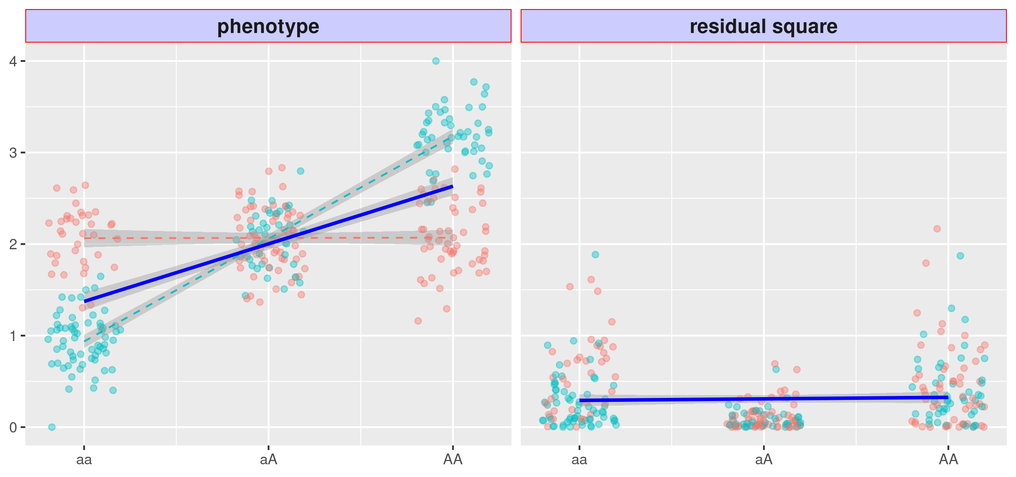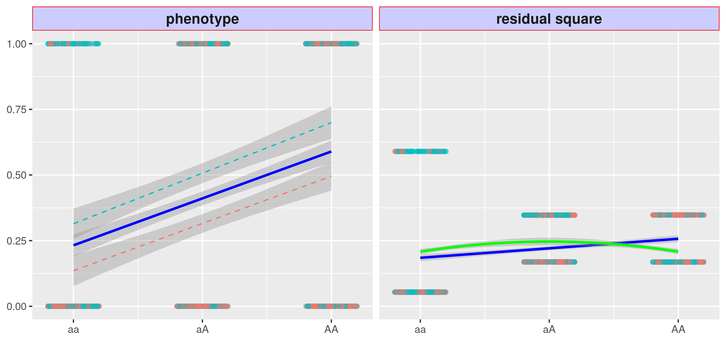
Figure 2: Issues with variance quantitative loci (vQTL)
The red and teal points represent samples experiencing two environments.
(a) left: a binary phenotype with non-null marginal genotype main effect, shown by the blue sloid slope, but null GxE effect, shown by dashed red and teal slope in paralleled (a) right: the squared residuals changes with genotype, shown by the blue solid slope, the variant thus become a false vQTL; the VLA fits a downwards curve, shown as green solid, thus control the type 1 error.
(b) left: a Gaussian phenotype with strong GxE effect but weak environmental main effect (i.e., pure GxE), shown by the dashed red and teal with distinct slopes but cross the center. (b) right: the squared residuals changes with genotype but non-linearly, the linear model misses the true GxE candidate (i.e., DLM and DRM), shown by the flat regression line.
(a)
(b)
Simulation studies^{17,21} have advised against applying vQTL analysis for binary phenotypes. Andrew et al. suggested the use of surrogates based on the assumption that significant vQTLs of a quantitative mediator are likely GxE candidates of a downstream binary phenotype. For example, significant GxE interactions for type 2 diabetes would likely be found among vQTLs of BMI²¹. However, the use of surrogate vQTLs has not been widely explored, and we report the evaluation of such a strategy later in the paper. Additionally, additive vQTL methods such as DLM and DRM lack the power to detect a true GxE candidate when the environmental main effect is weak, even if the phenotype is Gaussian. Figure 2b illustrates this issue.
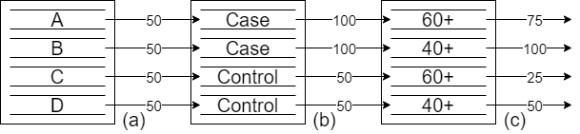
Figure 3: Assigning innate risk scores using covariates
(a) Without prior knowledge, four people are assigned a median innate risk score; (b) Given their disease status, an individual may be assigned a higher innate risk score; (c) Given their age, the innate risk score may be decreased for older individuals. VLA results in a downwards regression curve (green solid line) and controls type 1 errors.

Variance loci analysis (VLA)
To address the issues with vQTL analysis, we propose variance locus analysis (VLA) to select GxE candidates for both Gaussian and binary phenotypes. VLA takes the additive perspective of variance loci, based on the assumption that GxE effects adds to a phenotype, along with the genotype, covariate, and environmental main effects, plus some noise. VLA differ from existing additive vQTL methods that, instead of testing the non-zero slope of the stage-2 regression line, a curve is fit and its upwardness is tested. For Gaussian phenotypes, VLA overcomes the lack of power under low environmental main effects, this is illustrated by the solid green line in Figure 4b. Importantly, VLA also controls the type 1 errors for binary phenotypes, as illustrated by the solid green line in Figure 2b. While it controls the type 1 error, the upwardness test results in a lack of power for detecting GxE candidates (Figure 4a) because the binary event still glosses over the underlying risk leading up to the event.
However, the underlying risk can be reconstructed to some extent with covariates. Figure 3 demonstrates this process with a hypothetical situation. Given four individuals–A, B, C, and D–without any additional information, it is reasonable to assign all four an innate risk score of 50 for a particular disease, which is the median of a 100-point scale. A and B have been diagnosed with the disease, so their innate risk scores are increased to 100. Because A is in his 60s, his innate risk score is lowered to 75; because B is in his 40s, his innate risk score remains at 100. The logic behind this adjustment is that for an older person, a high innate risk score is not required to develop the disease. Because C and D have not been diagnosed with the disease, their innate risk scores remain at the default 50. However, because C is in his 60s, his risk score is lowered to 25. The logic behind this adjustment is that since he has not been diagnosed with the disease, given his age, he has a lower inherent risk score. Through this process, innate risk scores can be assigned that are distinct for those with and without the condition. In this scenario, the innate risk score has four levels, which is smoother and more informative than the original, binary phenotype. The risk score is the residual of the disease fitted by age, which is the combined effect of the genome and exposome; in other words, a finer gradient of risk is revealed by removing the effect of age.
With additional covariates, a risk score can resemble a smooth Gaussian variable. After replacing the binary phenotype with the recovered innate risk score, upward curve-based VLA can be used to select variance loci involved in GxE. Figure 4b conceptually demonstrates this. The best covariates are non-confounding predictors, such as age and sex, which are not heritable and not determined by the exposome (non-confounding) yet are predictive of the risk of disease. The risk score resulted from confounding covariate biases the genome and exposome effects towards null [20], and the risk score resulted from non-predictive covariates does not restore the fine gradient of risk.
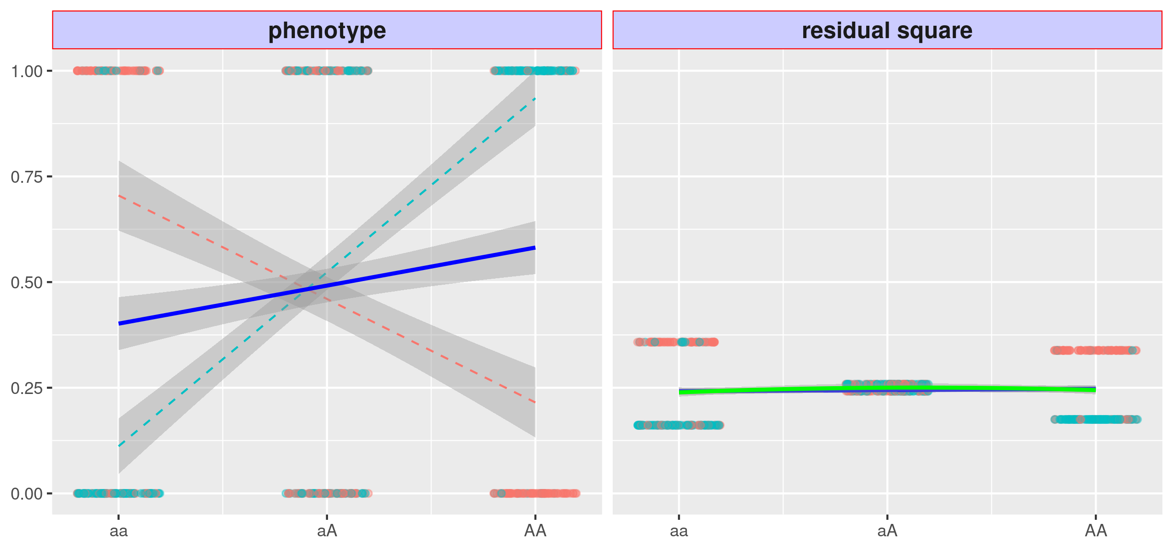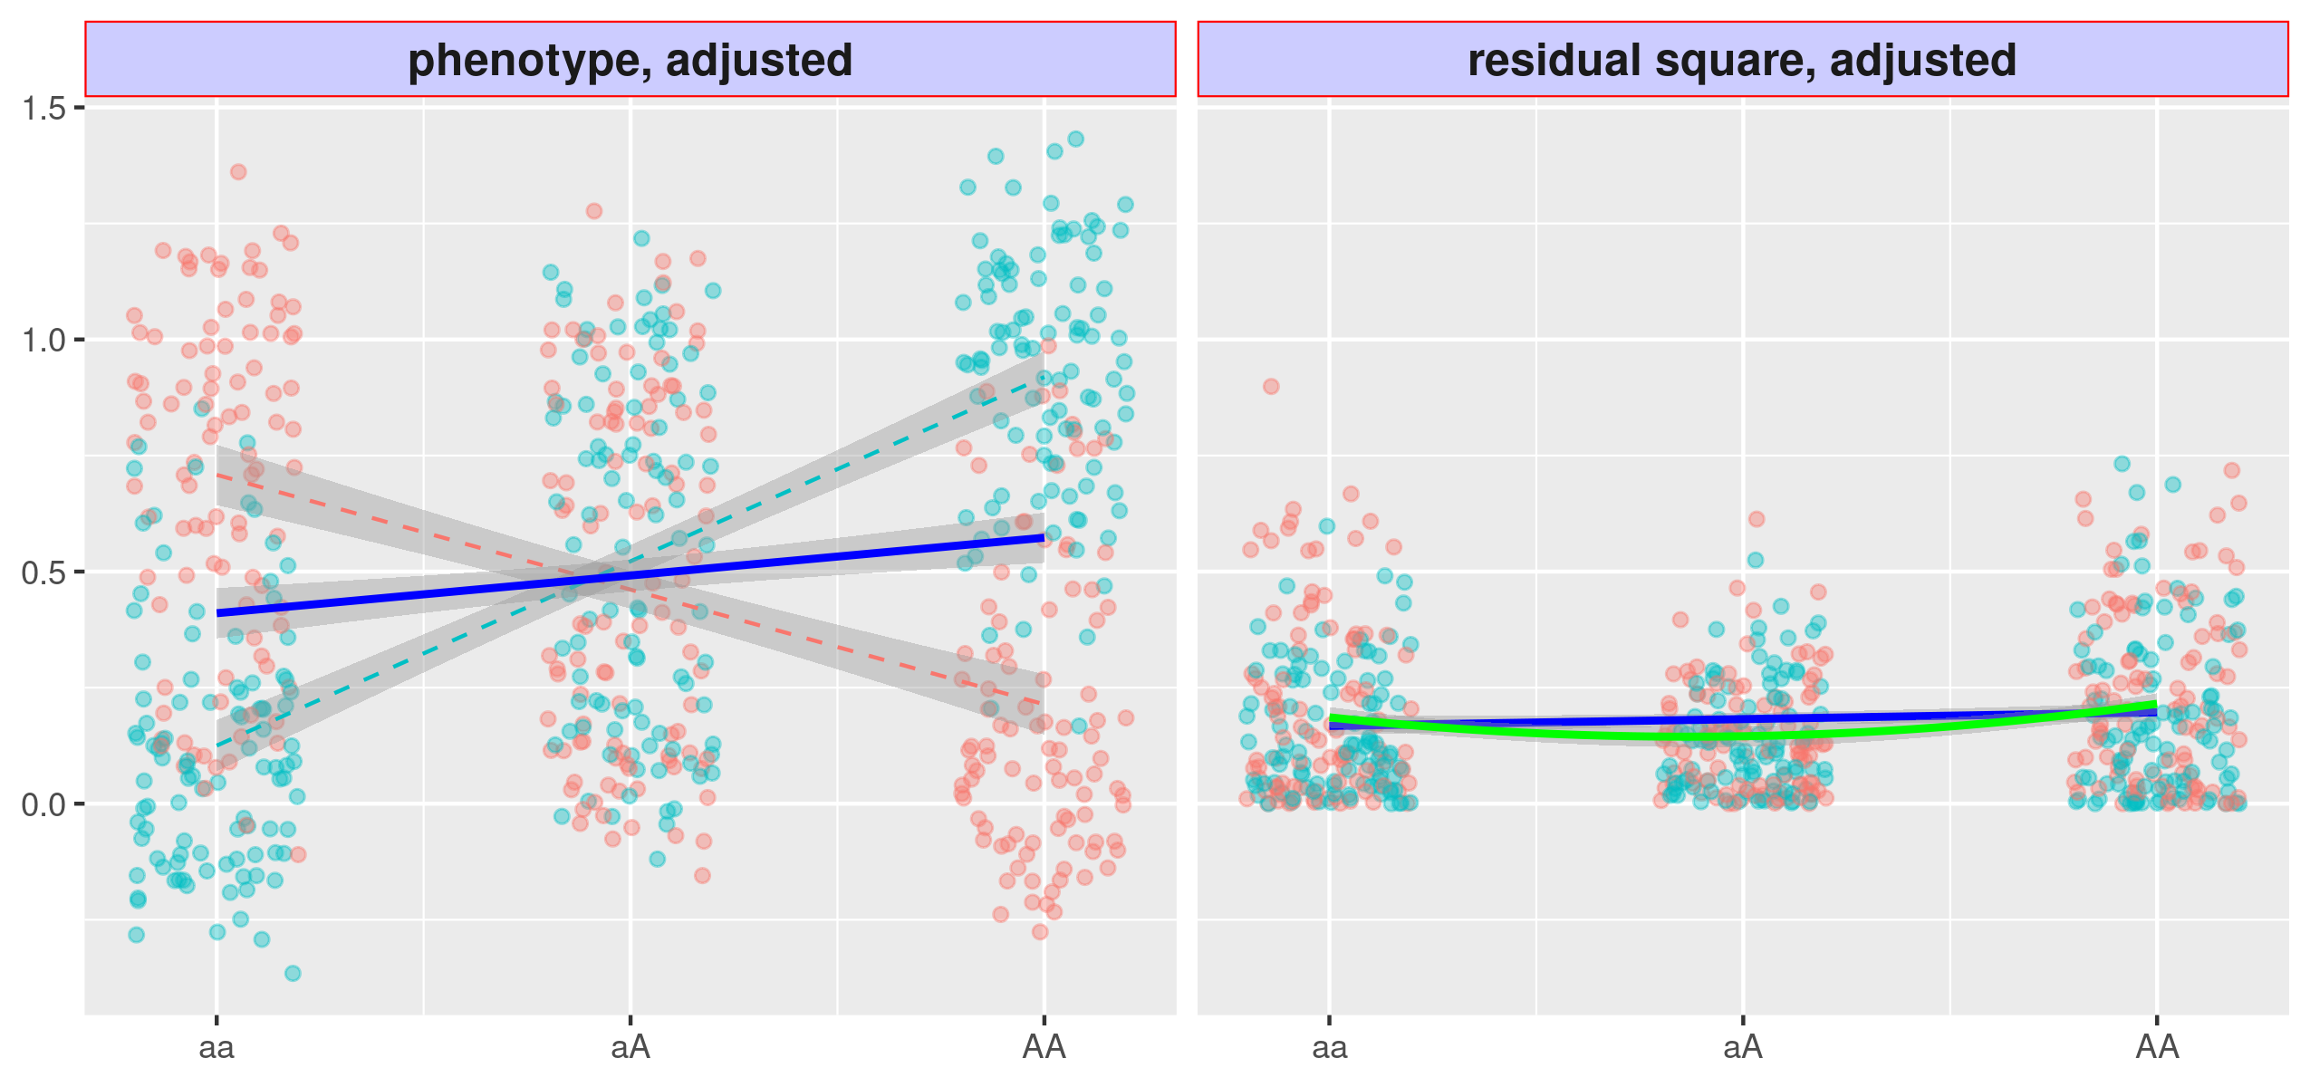
Figure 4: Variance loci analysis (VLA) with innate risk score
(a) Variant A/a is strong in GxE, but the VLA curve upwardness (green solid) test is as powerless as the slope-based vQTL(blue); (b) If the binary phenotype is replaced by the innate risk score as a covariate residual close to Gaussian, the upwardness of the VLA curve (green solid) detects the variance loci A/a.
(a)
(b)

Application of VLA in the UK Biobank
VLA can be used to examine the genome a range of phenotypes in cohorts with unprecedented sample sizes using data from large biobank-based GWAS (26, 27). We conducted whole-genome VLA scans across all relevant phenotypes in the UK Biobank (UKBB). We applied VLA to select GxE candidates for both binary and quantitative traits and created a catalog of VLA statistics hosted by NIEHS (https://genelist.niehs.nih.gov/vla) for the entire genome and phenome of the UKBB, which was expanded with compound phenotypes derived from hospital diagnoses recorded in ICD9/10 format, based on the most recent PHECODE mapping table (v1.2) [24,25]. The catalog is similar to the Pan-UK Biobank GWAS catalog (https://www.pan.ukbb.broadinstitute.org) and the EBI GWAS catalog (https://www.ebi.ac.uk/gwas/). The resource summarizes the interaction potential for phenotypes of interest for each variant and can be used in future GxE research to prioritize top-ranked candidates.

Validation of VLA
We demonstrate our method through simulation and application in the UK Biobank, focusing on three traits for which genomics mapping has been successfully conducted. The UK Biobank is an excellent source for discovery but contains limited data on external environmental exposures. We used UK Biobank data to prescreen candidates for GxE testing in the independent NIEHS Personalized Gene and Environment Study (PEGS). PEGS (16) is a diverse North Carolina-based cohort with 19,672 participants of varying age, race, socioeconomic status, and education level and has collected extensive self-reported survey data on more than 600 environmental exposures and health outcomes as well as whole genome sequencing data for multiple phenotypes.
ADD DEMOGRAPHIC TABLE.

Validation Process
We assessed annotation details of VLA results and compared them to GWAS results in UKBB British Whites for a selected phenome using the plinkFile and vla R packages to determine whether variance loci with greater significance can identify more significant GxEs detected in other populations, such as UKBB non-British Whites (who are mainly Irish). We also investigated whether variance loci are overrepresented in genome types (i.e., intronic and intergenic), just as GWAS loci are more concentrated within or near certain gene regions. The results section details the findings, and the methods section outlines the preparation of phenome, genome, and exposome data.
We also demonstrate that VLA analysis can identify/enrich for previously known GXEs. CardioGXE is a manually curated resource cataloging gene-environment interactions from the literature on blood lipids, glycemic traits, obesity anthropometrics, vascular measures, inflammation, and metabolic syndrome. CardioGXE catalogs the results of manual mining and curation from 386 publications that report gene-environment interactions. They demonstrated that the reported GxE SNPs showed little overlap with variants identified by main effect GWAS. For the cardiometabolic traits (DEFINE), we tested for enrichment of the significant VLA SNP with these previously reported GXE interaction. ADD DETAILS.

Results
We implemented VLA as a self-contained “vla” pure R package that simultaneously scans multiple phenotypes and genome variants, given adequate system memory. Because it is self-contained and pure R means that “vla” is platform- and compiler-independent as long as the R Base package is installed. As the number of phenotypes increases, the vla R package is more efficient than routine genome-wide analysis implemented in C/C++, such as PLINK [21, 22]. To traverse out-of-memory allele-count genotype data condensed in PLINK 1 binary biallelic genotype tables, we created “plinkFile”, another self-contained R package [23]. We used these two packages to run analysis based on UKBB and PEGS data, as detailed in later sections.

Simulation
We view the continuous phenotype as the sum of strong covariates effect, non-zero genotype main effect, optional environmental main effect, optional GxE effect, and Gaussian white noise. We consider four scenarios of how the environment impact the phenotype: 1. directly through main effect (ENV + NUL); 2. no impact at all (NUL + NUL); 3. though GxE effect (NUL + GXE); 4. both directly and through GxE (ENV + GXE). The first two scenarios have no GxE effect, thus, when a method rejects its stated primary null hypothesis, it contribute to the false discovery rate (FDR). An out-of-control FDR invalidates a method. The later two scenarios have GxE effect, and, rejecting the null add to the true discovery rate (TDR). A higher TDR means a method is more powerful, if it controls the FDR first.
We compare 6 methods, including the proposed variance locus analysis (VLA), double linear model (DLM), deviation regression model (DRM), double generalized linear model (DGL), and Levene’s test (LVT).
We repeated 20,000 trials for each scenario. In each trial, we randomly pick a variant with MAF≥0.01 in region 17q3 (chromosome 17: 10700001 - 16000000) of 1000 Genome Project Data Phase 3^{22,23}, and draw 10,000 dosages values from that variant as genotype.

We present the performance for Gaussian phenotypes in Figure 8a.
In scenarios 1 and 2 where GxE effect is null, all methods controlled the FDR (Figure 8a, left), and are thus eligible for TDR assessment. In scenario 3 and 4 where GxE exists (Figure 8a, right), VLA attained the highest TDR, and the advantage is more pronounced in scenario 4 where GxE exists with null environment main effect, because VLA is meant to prioritize pure GxE; the performance of DGL and LVT fell behind VLA and DLM because DGL and LVT are meant to captures multiplicative vQTL, but the variance loci we simulated were additive; DRM captures additive vQTL but also emphasize robustness, its FDR was indeed the closest to 5% (Figure 8a, left panel, blue bar), but its TDR is not optimal (Figure 8a, right panel, blue) when the phenotype is Gaussian.
To simulate binary phenotype, we convert the Gaussian phenotype $y$ to probabilities with logistic function, $π={\left(1+e^{-y}\right)}^{-1},$ then draw 1 = case and 0 = control from that probability.

(a)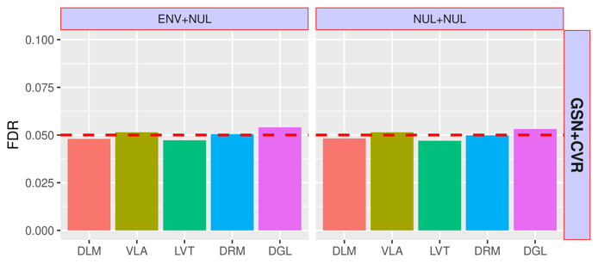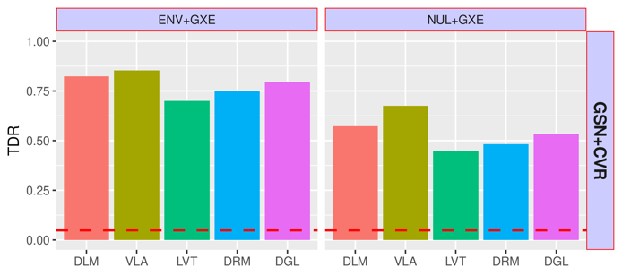
(b)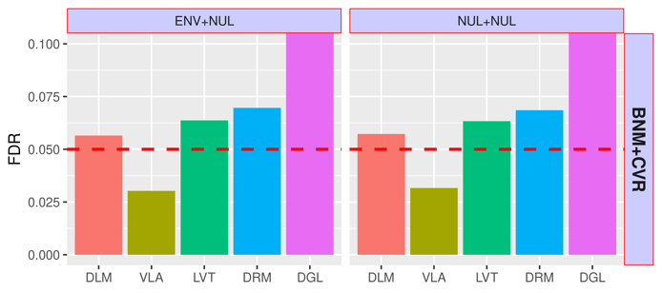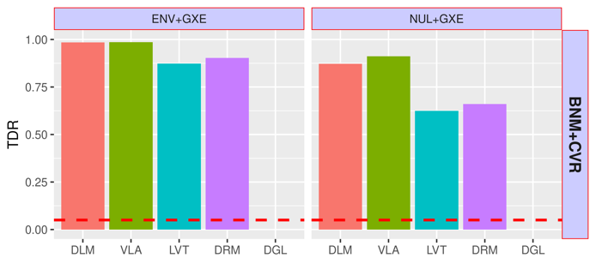
Figure 8: Simulation Studies
Top to bottom: (a) Gaussian phenotype; (b) Binary phenotype.
Left: scenario 1 and 2, with null GxE, the y-axis shows false discovery rate (FDR).
Right: scenario 3 (direct environment effect and GxE) and 4 (pure GxE effect only), the y-axis shows true discovery rate (TDR).
X-axis: DLM=double linear model; VLA = variance locus / curve upwardness test; LVT=Levene’s test; DRM=Deviation Regression Model, a modified DLM; DGL=double generalized linear model (DGLM).
In Figure 8b we compare the performance on binary phenotype. In scenario 1 and 2 (Figure 8b, left) of null GxE, the FDR of DLM, LVT, and DRM went above the expected 5%, but we still consider them somewhat under control; the FDR of DGL went far beyond 5%, thus we do not include DGL in the comparison of TDR; VLA was conservative, but is considered a safe method. In scenario 3 and 4 (Figure 8b, right) where GxE exists, the performance resembles the Gaussian phenotype and VLA achieved higher TDR performance, especially when the GxE effect is pure (scenario 4, NUL+GXE).

Benchmark GxE Enrichment
GxE enrichment measures the likelihood of significant variance loci in a selection population invoking significant GxE interactions in a discovery population. A positive enrichment enables the use of a criterion such as VLA to help select GxE candidates. The benchmark compares the enrichment performance of the proposed variance locus analysis (VLA), the GWAS (GWA), and vQTL analysis (VQA) with DLM.
We first ran GWAS (GWA), variance QTL scan (VQA), and the proposed variance locus analysis (VLA) on a selection population of 35,3605 unrelated British Whites in the UKBB, with a gnome of 11,425,831 autosome variants across 22 autosomes. We ranked the variants from the least to the most significant (i.e., negative log p-value) for each method. The phenome includes two binary traits, coronary artery disease (CAD) and type 2 diabetes (T2D), and two quantitative traits, body mass index (BMI) and fasting glucose (GLU). The covariates include age, sex, age², age×sex, age²×sex, the first 20 genetic principal components, and the genotyping array. For comparison, we performed GWAS and vQTL scans and then ranked the genome variants accordingly.

UKBB Internal GxE Enrichment
We perform two-way GxE scan on a discovery population of 25,481 unrelated non-British Whites in the UKBB, with an exposome of lifestyle (i.e., drinking, smoking, and activeness), neighborhood (i.e., green space, water, noise, air quality), and families (i.e., siblings). The GxE analysis covers the same genome, phenotype, and covariate the selection analysis based on.

For each variant, we counted the number of significant GxEs given a series of p-value thresholds from 10⁻² to 10⁻⁹, so higher count means a variant being more active in GxE.
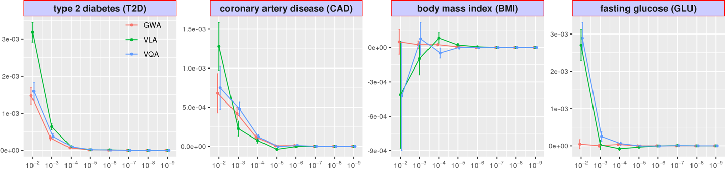We then regressed the counts on the variant rankings according to GWA, VQA, and VLA, so the regression coefficient becomes a measure of enrichment. Figure 5 shows the GxE enrichment regression coefficients for GWA, VQA, and VLA at several p-value thresholds, where a higher value means better GxE selection performance. For T2D, VLA outperformed GWA and VQA at all GxE significance threshold. For CAD, VLA selected most candidates for lower threshold. For BMI, GWA is powerless, and VLA did better than VQA at medium to high threshold. For GLU, which is nearly Gaussian, GWA is again powerless, VQA achieved the best enrichment, followed by VLA. For binary phenotypes, VLA in general performs better, while VQA nearly overlaps with GWA, since a mean locus is also a variance locus in these cases. For continuous outcomes, GWA gives the worst performance, while VLA nearly overlaps with VQA.
Figure 5: UKBB Internal GxE Enrichment
Given a p-value cut-off, we count the number of significant GxE tests for each genome variant on UKBB non-British Whites, and regresses the counts on variant rankings according to GWA (red), VLA (green), and VQA (blue) based on UKBB British Whites. The regression coefficients (y-axis) at 8 p-value cut-offs (x-axis) are shown, with higher coefficients indicating better enrichment. The error bar shows 2 × standard error.

PEGS External GxE Enrichment
Next, we perform two-way GxE scan on an external discovery population of 4,603 unrelated individuals with whole-genome sequencing profile in the personalized environment and gene study (PEGS)²⁴. The PEGS phenome covers T2D, BMI, and CAD. The rich exposome survey covers 365 parent items concerning daily life, neighborhood environment, and workplace hazards. We again count the number of significant GxEs each variant involves and regress the counts on the rankings given by GWA, VQA, and VLA, based on 6,450,592 semi-common variants shared between UKBB British Whites and the PEGS. Because PEGS does not collect blood assay, we use the ranking based on fasting glucose level (GLU) in the UKBB to enrich type 2 diabetes (T2D) in the PEGS, this way, we can also assess the usage of quantitative surrogate variance loci to select GxE candidates of a binary outcome T2D. Figure 6 shows the enrichment regression coefficients. For T2D and CAD, VLA outperformed GWA and VQA at all GxE significance thresholds. For BMI, GWA is better at lower thresholds, VQA is better at higher thresholds, and VLA performed somewhat in between. For the use of GLU in UKBB as a surrogate to T2D in PEGS, GWA gives the best performances. Again, we see VLA is better suited for binary phenotypes, while the performance VQA nearly overlap with GWA.
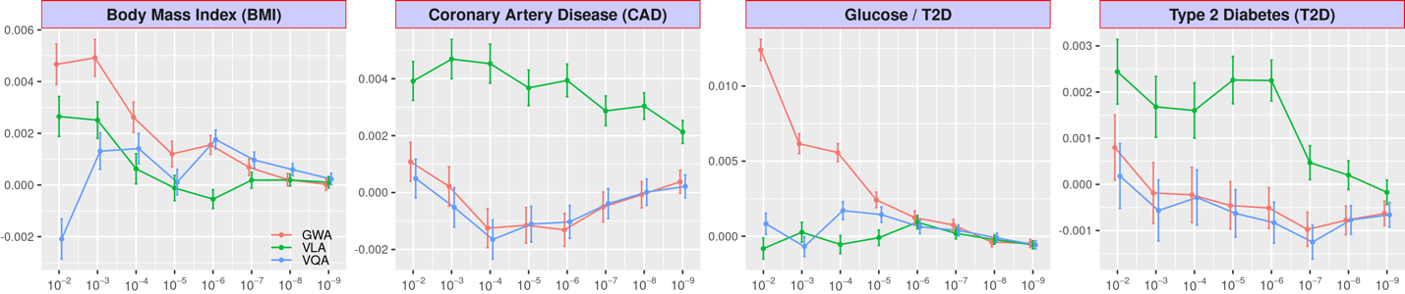
Figure 6: GxE enrichment on PEGS
Given a p-value cut-off, the enrichment analysis counts the number of significant GxEs and tests each genome variant score in PEGS. It also regresses the count on variant rankings according to GWAS (red), VLA (green), and vQTL (blue) based on British Whites in the UKBB. The regression coefficients (y-axis) at several p-value cut-offs (x-axis) are shown here, with a higher coefficient value indicating better enrichment. The error bar shows 2×standard error.

Investigation of functional enrichment
If VLA, GWAS, or vQTL loci are linked to genome functions, significant variants should reside unevenly in different regions. For example, the loci within or near genes may be more abundant than those between genes. We used the ANNOVAR package [26] to assign a functional class to each variant, such as intergenic or intronic variants. We also calculated the combined annotation dependent depletion (CADD) score [27] for each variant as a continuous measure of pathogenic tendency. We regressed the function class and CADD scores on the variant rankings from VLA, GWAS, and vQTL. If the loci are enriched in certain regions, the corresponding regression coefficients should be positive; conversely, if the loci are depleted, the coefficient should be negative. Table 1 shows the functional enrichment coefficients for BMI and T2D. For BMI and T2D, variance loci (from VLA) were highly enriched in intergenic regions while GWAS and vQTL loci were highly concentrated within or near genes. As with CADD scores, variance loci were depleted in regions with high CADD scores, indicating their high pathogenic tendency. Although there were more GWAS and vQTL loci within or near genes, they were more concentrated in non-protein coding segments (i.e., upstream, intronic, and downstream). For the few variance loci located within or near genes, the distribution was relatively flat. Overall, the results indicate that variance loci are likely to take indirect, regulatory roles in genome molecule biology while GWAS and vQTL loci are likely to be more directly involved in producing protein molecules.
For a binary trait such as T2D, the functional distribution of GWAS and vQTL loci was nearly identical due to the high correlation between rankings from GWAS and vQTL. This is also the reason for the overlapping performance of GWAS and vQTL regarding GxE enrichment benchmarks. For the continuous outcome of BMI, GWAS and vQTL ranked the variants differently. The concentration of GWAS and vQTL loci also differs for CADD scores. For both binary and continuous outcomes, the pattern of variance loci is distinct from the pattern of GWAS and vQTL loci, providing a new perspective on the relative importance of each variant in terms of potential interaction.
Body Mass Index |  | GWA | VQA | VLA |  | GWA | VQA | VLA |  | Type 2 Diabetes |  | GWA | VQA | VLA |  | GWA | VQA | VLA
Intergenic |  | --- | --- | ++ | CADD | --- | +++ | - |  | Intergenic |  | --- | --- | +++ | CADD | ++ | ++ | --
Genes | Upstream | ++ | ++ | + |  |  |  |  |  | Genes | Upstream | +++ | +++ | ++
Genes | Intronic | +++ | +++ |  |  |  |  |  |  | Genes | Intronic | +++ | +++ | +
Genes | Exonic |  |  |  |  |  |  |  |  | Genes | Exonic
Genes | Downstream | + | + | - |  |  |  |  |  | Genes | Downstream | +++ | +++ | ++
Table 1: Variant Function Enrichment
The functional enrichment analysis regresses the region type and CADD score of each variant on rankings given by GWAS (red), VLA (green), and vQTL (blue) based on UKBB British Whites. Significant positive and negative regression coefficients are shown by + or -, respectively; the number of symbols denotes the level of significance. Non-significant coefficients are displayed as blank space.

UKBB variance loci catalog
Inspired by the Pan-UK Biobank GWAS catalog at pan.ukbb.broadinstitute.org, one of our research aims is to catalog variance loci statistics for the health and disease phenotypes and variants in the UKBB. The catalog will serve as a public reference that researchers interested in GxEs can query by phenotype, enabling them to prioritize the candidate variants most likely to invoke significant GxEs. Figure 7 illustrates the workflow of the cataloging process.
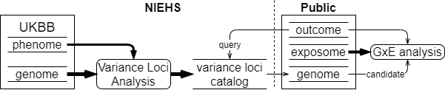
Figure 7: UKBB variance loci catalog
As described in detail in the Materials section, we summarized 1,580 health-relevant phenotypes chosen from UKBB data fields accessible to NIEHS plus another 1,693 diseases derived from hospital records. We distinguished the selected UKBB phenotypes into binomial, multinomial, ordinal, and continuous variables and subsequently recoded and normalized them. The methods section provides details of this process. We derived the 1,693 diseases using PHECODE, a codebook used to extrapolate diseases using ICD9/10 records. PHECODE is available at www.phewascatalog.org [24,25]. Thomas et al. (cite paper) implemented the codebook to transform NIEHS’s copy of ICD9/10 fields. In total, the phenome data comprise 3,273 items. For the genome, we limited the variants to those with an overall minor allele frequency of at least 0.005, for a final number of 11,841,785 after other quality control measures.
For each of the four main racial/ethnic groups in the UKBB (British White, non-British White, Black, and Asian), we performed VLA for the whole phenome and genome to archive variant statistics. We used two R packages specialized in traversing genome data and testing variance loci between thousands of phenotypes and variants. We divided the genome into approximately 1,200 groups of 1,000 variants each and summarized the VLA statistics for British Whites, the largest group by far with a working sample size of 384,000, in less than 12 hours, utilizing the computational resources of the NIH HPC Biowulf cluster (hpc.nih.gov). The variance loci catalog provides compressed files for the four main racial/ethnic groups and 3,273 phenotypes on (URL). A list of phenotypes and links to the files is available at (URL).

Methods
In this section, we review the two types of vQTL—additive vQTL captured by DLM and DRM and multiplicative vQTL captured by DGLM and Levene’s test. While the two types of vQTL are related, they represent different perspectives on the origin of GxE effects.
In a discovery cohort in which both exposome variable $u$ and genome variant $g$ are visible, GxE interaction effects are typically captured by adding the two-way product term $ug$ in a linear model,
$y=m_{0}+ag+bug+cu+dx+ e, Var\left(u_{i}\right)=σ_{u}^{2}, e_{i}\sim N\left(0, σ_{e}^{2}\right)$, (1)
where $e$ is the size $σ_{e}^{2}$ of Gaussian noise and $x$ is a non-confounding covariate. The phenotype $y$ remains Gaussian, the environment $u$ is a centered variable with variance $σ_{e}^{2}$, and $u⊥ g$. Model (1) is considered the ground truth of GxE interaction effects.
In an ideal selection cohort in which the joint distribution of all variables is identical to the discovery cohort, the sample size is sufficient, and the environment $u$ is either unobserved or ignored, a typical GWAS can be conducted as:
$y=m_{0}+ag+dx+r$ or $E\left(y | g\right)=m_{0}+ag+dx$. (2)
The unattended part, $bug+cu+e$, becomes the GWAS residual $r$. As a result, the squared residual $r^{2}$ is associated with genotype $g$ because
$r^{2}=b^{2}u^{2}g^{2}+2bcu^{2}g+c^{2}u^{2}+2\left(bug+cu\right)e+e^{2}$, (3)
and $Var\left(y | g\right)=E(r^{2}|g)=b^{2}σ_{u}^{2}g^{2}+2bcσ_{u}^{2}g+c^{2}σ_{u}^{2}+σ_{e}^{2}$. (4)
In (4), variant $g$ models the phenotypic variance, hence the description of $g$ as a “vQTL”. This type of vQTL is an artifact of modeling the additive allele effect (i.e., GWAS) without exposome data, with the assumption that model (1) is the ground truth of GxE effects. Because a variant causes heterogeneity of variance on a linear scale, it can be called an additive vQTL or GxE-induced vQTL.
On the other hand, it can be directly stated that the allele affects the phenotypic variance,
$y\sim N\left(m_{0}+αg,e^{μ+αg+βg^{2}}\right)$ or $\log{Var\left(y | g\right)}=μ+αg+βg^{2}.$ (5)
The exponential ensures variance will never be negative for real values $(μ,α,β)$. Variant $g$ is already a vQTL because each additional allele multiplies the variance by a factor of $e^{α^{'}+{(2g+1)β}^{'}}$ and thus it is called a multiplicative vQTL. Unlike the additive vQTL in (4), the multiplicative vQTL does not depend on a specific construct of GxE interaction as in (1).
The most straightforward way to capture a vQTL is with a DLM, with a stage-1 model identical to (2), that is, a GWAS. The stage-2 model treats the squared residual $r^{2}$ as a phenotype and fits it with the allele dosage, as if it was another GWAS:
$E(r^{2}|g)=a'g+m_{0}^{'}$. (6)
The DLM approximates the full additive vQTL model in (4), omitting the second-order term $b^{2}σ_{u}^{2}g^{2}$ and essentially fitting a straight line through the squared GWAS residual $r^{2}$ across allele dosage $g$. In an ideal situation, where $g{⊥g}^{2}$ holds, the estimated DLM coefficient $a'$ identifies the first-order coefficient $2bcσ_{u}^{2}$ in the full vQTL model (4). Rejecting $h_{0}: α^{'}=2bcσ_{u}^{2}=0,$ the coefficient reveals a GxE candidate because $2bcσ_{u}^{2}≠0$ implies the true GxE effect $b≠0$. In reality, $g$ and $g^{2}$ are correlated, especially when the MAF of $g$ is low. Therefore, the estimated DLM coefficient $a'$ in (5) is a mixture of $b^{2}σ_{u}^{2}$ and $2bcσ_{u}^{2}$ in (4) and runs the risk of mutual attenuation when the true GxE effect $b$ and environmental main effect $c$ have opposite signs. Nonetheless, when $b≠0$ and $g$ is an additive vQTL, the estimated $a'$ is likely to be non-zero and detectable via a t-test.
When the phenotype $y$ deviates from a Gaussian distribution, DLM may inflate type 1 errors when the variant is a GWAS QTL. Because a non-Gaussian distribution’s mean and variance are related, a QTL affecting the phenotypic mean is also a vQTL affecting the variance. It is important to note that the squared residual $r^{2}$ in stage-2 models (5) and (6) is a measurement of the sample variation per genotype group, replacing the genotype variation with the absolute distance from the group median results in DRM. While the DRM method is more robust than DLM for non-Gaussian phenotypes, its use is limited to discrete genotypes because a “group” cannot be clearly defined for a continuous genotype.
A double generalized linear model (DGLM) can capture a multiplicative vQTL. A DGLM is a two-stage model that fits both the mean and variance of a phenotype by genotype,
$μ=E\left(y | g\right)=h\left(m_{0}'+a^{'}g\right), Var\left(y | g\right)=ϕV\left(μ\right), ϕ=k(μ^{'}+α^{'}g)$. (7)
Here, $ϕ$ is the dispersion determined by allele dosage; function $V$ is, to some extent, relates the phenotypic mean $μ$ to the variance, for example, $V\left(μ\right)=μ(1-μ)$ for a binary phenotype; and $h$ and $k$ are the inverse link function of the mean and dispersion, respectively. Stage 1 of a DGLM fits the phenotypic mean with allele dosage, where the phenotype is the response variable and the link function is chosen according to the determined phenotypic distribution. Stage 2 models the dispersion, where the unit deviance from stage 1 is treated as the response variable following a Gamma distribution of a fixed shape and scale equal to the log-linked dispersion,
$D(y,μ)\sim Γ\left(1,ϕ \right)$, $ϕ=e^{μ^{'}+α^{'}g}$, or $logϕ=μ^{'}+α^{'}g$. (8)
When the phenotype is Gaussian, the variance function degenerates to a constant $V\left(μ\right)≡1$ and the unit deviance is the residual square $D\left(y,μ\right)=r^{2}={\left(y-μ\right)}^{2}$. In this special case, stage 2 of the DGLM does fit the logged phenotypic variance with the allele dosage,
$r^{2}\sim Γ\left(1,e^{μ^{'}+α^{'}g}\right), logE\left(r^{2} | g\right)=logVar\left(y | g\right)=μ^{'}+α^{'}g$, (9)
which approximates the multiplicative vQTL model in (5), omitting the second-order term $β^{'}g^{2}$. We consider Levene’s test a multiplicative vQTL scan because the formation of Levene’s test statistic does not depend on a specific parameterization of GxE.
In this study, we prefer the additive perspective (4) over the multiplicative perspective (5) as the basis of improvement because we rely on model (1) to capture significant GxEs in a discovery dataset. The construct of additive vQTL is a natural consequence of unaccounted GxE effects in model (1) and thus additive vQTLs are used to select GxE candidates specifically in model (1). Multiplicative vQTLs, on the other hand, do not depend on the parameterization of environmental and GxE effects and thus multiplicative vQTLs do not necessarily select GxE candidates in model (1). Forcibly viewing this from an additive vQTL perspective demonstrates the lack of specificity of multiplicative vQTLs on GxEs for a Gaussian phenotype, as shown in model (5),
$Var\left(y | g\right)=\exp\left(μ+αg+βg^{2}\right) =\left(σ_{\tilde{e}}^{2}+{\tilde{c}}^{2}σ_{\tilde{u}}^{2}\right)+2\tilde{b}\tilde{c}σ_{\tilde{u}}^{2}g+{\tilde{b}}^{2}σ_{\tilde{u}}^{2}g^{2}$,
where the left side is the multiplicative vQTL model for Gaussian distribution (5), the right side is the full additive vQTL model (4); $\tilde{u}$ and $\tilde{e}$ are latent noise and environmental effects with variance $σ_{\tilde{u}}^{2}$ and $σ_{\tilde{e}}^{2}$, respectively; and $\tilde{b}$ and $\tilde{c}$ are the effect sizes of latent GxE interactions and environmental main effects, respectively. Expanding the left-hand side at $g=0$, we acquire an approximated additive vQTL model,
$\left(σ_{\tilde{e}}^{2}+{\tilde{c}}^{2}σ_{\tilde{u}}^{2}\right)≈e^{μ}$, $2\tilde{b}\tilde{c}σ_{\tilde{u}}^{2}≈αe^{μ}$, ${\tilde{b}}^{2}σ_{\tilde{u}}^{2}≈0.5\left(α^{2}+2β\right)e^{μ}$,
where $\left(σ_{\tilde{e}}^{2}+{\tilde{c}}^{2}σ_{\tilde{u}}^{2}\right)≈e^{μ}$ is the part of phenotypic variance not affected by allele dosage. Because the construct of Gaussian multiplicative vQTLs in (5) requires only $\left(μ,α,β\right)∈R^{3}$, it is possible to encounter a situation in which ${\tilde{b}}^{2}σ_{\tilde{u}}^{2}≈0.5\left(α^{2}+2β\right)e^{μ}<0$. In this case, the latent GxE interaction effect $\tilde{b}$ is non-real, as well as the latent environmental main effect $\tilde{c}$, because $2\tilde{b}\tilde{c}σ_{\tilde{u}}^{2}$ produces the real value $αe^{μ}$. Multiplicative vQTL capture a broader class of GxE effects that are not fully representable by the common discovery model (1) in real space. Selecting GxE candidates for (1) with multiplicative vQTL in (5) would inflate type 1 errors. In practice, multiplicative modeling typically omits the second-order term $βg^{2}$ (i.e., DGLM). In this case, we fix $β≡0$ and, as a result,
${\tilde{b}}^{2}σ_{\tilde{u}}^{2}≈0.5α^{2}e^{μ}$,
which avoids unreal GxE effects size $b$. However,
$\frac{{\tilde{b}}^{2}σ_{\tilde{u}}^{2}}{2\tilde{b}\tilde{c}σ_{\tilde{u}}^{2}}=\frac{\tilde{b}}{2\tilde{c}}=\frac{0.5α^{2}e^{μ}}{αe^{μ}}=\frac{α}{2}$ or $\frac{\tilde{b}}{\tilde{c}}=α$.
An implicit constraint is that the ratio between latent GxE and environmental main effects must be $α$ — the coefficient of the first-order multiplicative vQTL effect, which means the solution space of $\left(b,c\right)$ cannot be fully accounted for in the common GxE discovery model (1). Using the restricted multiplicative vQTL model (9) to select GxE candidates for model (1) would result in a loss of power.
We choose the DLM as the basis for improvement. Under the ideal circumstance of $g{⊥g}^{2}$, the allele dosage term $α'g$ in stage 2 of the DLM (6) maps to the equivalent term $2bcσ_{u}^{2}g$ in the full additive vQTL model (4). The DLM identifies $b≠0$, that is, a GxE candidate, when $h_{0}: α^{'}=2bcσ_{u}^{2}=0$ is rejected. Replacing the allele dosage term with squared allele dosage results in:
$E(r^{2}|g)=β^{'}g^{2}+m_{0}^{'}$. (10)
The term $β^{'}g^{2}$ maps to the equivalent term $b^{2}σ_{u}^{2}g^{2}$ in the full additive vQTL model (4), and a GxE candidate is detected when $h_{0}: β^{'}=b^{2}σ_{u}^{2}≤0$ is rejected. A single-tailed test is used because $b^{2}σ_{u}^{2}$ should be non-negative. The proposed method is known as variance locus analysis (VLA). It is immediately clear that the VLA test statistic $β^{'}=b^{2}σ_{u}^{2}$ relies on the actual GxE effect size $b$ alone, but the DLM test statistic $α^{'}=2bcσ_{u}^{2}$ is determined by both GxE effect $b$ and environmental main effect $c$. As a result, DLM lacks power under weak environmental main effects, that is, $α^{'}=2bcσ_{u}^{2}→0$ when $c→0$, but VLA is unaffected. In other words, VLA is more sensitive to pure GxE effects. Model (10) essentially fits a curve through the squared GWAS residual $r^{2}$ across allele dosage $g$, and the null $h_{0}: β^{'}=b^{2}σ_{u}^{2}≤0$ tests the upwardness of the curve (Figure 2). This is accomplished by taking the derivative on both sides of (10) with respect to allele dosage,
${∂E(r^{2}|g)}/{∂g} =2β^{'}g$. (10)
When $β^{'}≤0$ is rejected, the curve fit through squared GWAS residual $r^{2}$ bends upwards with each additional allele.
In practice, allele dosage $g$ is rarely perpendicular to squared dosage $g^{2}$. In cases of extremely low MAF, $g$ and $g^{2}$ can be colinear. As a result, the expected DLM coefficient $α^{'}=2bcσ_{u}^{2}$ and the expected VLA coefficient $β^{'}=b^{2}σ_{u}^{2}$ blend into each other, either boosting or diminishing power to detect $b≠0$ when $b$ and $c$ have the same or the opposite signs. However, DLM still has power to select GxE candidates with null environmental main effects ($c=0$). To ensure the reliability of VLA, we limit the analysis to variants with MAF > 0.01.
When the phenotype is not quantitative but binary, a locus of phenotypic mean is automatically a locus of phenotypic variance because the mean $μ$ and variance $v$ of a binary variable are related by $v=μ(1-μ)$. Thus, a GWAS significant variant would be a DLM significant variant in the absence of interaction, causing uncontrolled type 1 errors if GxE candidates are selected via variance loci. These type 1 error cannot be resolved by using DRM or a multiplicative model such as DGLM, despite the fact that DGLM supposedly handles binary phenotypes with the logit link. Therefore, the current variance heterogeneity-based approaches are limited to quantitative trait loci, hence the name vQTL.
VLA counters the inflated type 1 errors encountered with null GxEs because the curve fit by the stage 2 model (10) through the squared residual of stage 1 (i.e., the GWAS) is either flat, when the variant has no effect on the phenotypic mean, or bends downwards, when the variant doesaffect the mean. However, VLA is conservative because the curve would not bend upwards in the presence of a GxE. It is essential to have well-chosen covariates that recover innate risk scores. With covariates that are non-heritable (i.e., non-confounding) but highly predictive of the binary phenotype, the recovered risk scores (i.e., the covariate residuals) act as a numerical phenotype, giving VLA the power to detect GxE candidates while controlling type 1 errors. Because the recovered risk scores can be seen as quantitative traits, they improve the performance of DLM, DRM, and multiplicative vQTL methods with binary phenotypes. However, these methods do not guarantee full control of type 1 errors.

Material

UK Biobank (UKBB)
We used data from the UKBB participants to evaluate the performance of VLA in selecting GxE candidates and compare it with other methods. The UK Biobank²⁵ is a large-scale resource consisting of genetic and health information for over half a million participants. The UKBB data we use consist of 502,505 participants (Application ID: 57849, version 2). Participant health data were collected via questionnaires, electronic health records, biological samples, verbal interviews, and imaging along with participant genotype data.
Of the 502,505 participants, 488,366 (97.2%) were genotyped with the UK BiLEVE or Axiom micro-array, covering of 805,426 autosomal, X/Y, and mitochondrial variants, and 487,411 (97.0%) had imputed whole-genome sequencing (WGS) genotype covering 97,059,328 autosomal and X variants, based on the Haplotype Reference Consortium (HRC) panel for mixed ancestry²⁶.

Genotype
We used the imputed genotype to create a comprehensive catalog of the whole genome. Beginning with 97,059,328 imputed variants, we applied basic quality control for 487,411 individuals. The quality control steps comprised the following:
- Drop variants with an imputation information score lower than 0.3.
- Drop variants with overall minor allele frequency less than 0.005.
- Drop variants with duplicated ID, that is, multi-allele variants.
After quality control, 11,939,376 (12.8%) variants remained with no excluded individuals. The imputation information score and minor allele frequency were precalculated metadata downloadable as UKBB resource 1671 (https://biobank.ctsu.ox.ac.uk/crystal/refer.cgi?id=1671). The imputation information score ranges from 0 to 1 and represents the posterior probability of observing an imputed genotype. The closer a score is to 1, the higher the likelihood of observing an imputed genotype. Of the removed variants, 87.2% were due to low MAF. While a stringent lower-bound MAF ≥ 0.01 is recommended to ensure the validity of VLA, a more relaxed MAF ≥ 0.005 helps buffering the fluctuation in MAF due to the subsequent removal of samples and the variation of working sample sizes across analyses. We excluded individuals with poor genotyping due to abnormal heterozygosity and high missing rates, indicated by UKBB field 22027. The kinship pairs were identified from the micro-array genotypes using the KINGSOFT and are available in a table downloadable using UKBB’s gfetch tool with parameter “rel”. The detail of gfetch is available as UKBB resource 668 (https://biobank.ctsu.ox.ac.uk/crystal/refer.cgi?id=668). Additional details about the genotypes are available from UKBB category 263 (https://biobank.ctsu.ox.ac.uk/crystal/label.cgi?id=263). We removed one individual from each pair of related individuals to break up kinships. Of 487,411 individuals with imputed genotype, 405,432 (83.2% and 80.1% of 502,505 in total) remained, representing unrelated individuals with high-quality microarray genotyping.
We divided the remaining samples into four major ancestry groups based on UKBB data field 21000, as summarized below:
- afr: African (3,100, code 4002)
- asi: non-Chinese Asian (8,668, code 3001, 3002, 3003, and 3004)
- bri: White British (35,3605, code 1001)
- iri: Irish (10,619, code 1002)
- wnb: White, but non-British (25,481, code 1002, and 1003 - any other white background)
After ancestry division, we removed 29,440 individuals who belonged to an ethnic group with a small sample size (e.g., Chinese, coded by 5, with a sample size of 1,574) or had an unclear background. This left 375,992 individuals (77.1% of 487,411 with imputed genotypes and 74.8% of 502,505 in total).
The first 4 groups (afr, asi, bri, and iri) are the bases of NIEHS VLA-catalog; the white British (bri) and white non-British (wnb) serves as training and testing data, respectively, to compare the performance of different methods.

Phenotype
Our study relies on the baseline data collect at the first visit. We manually compiled a handful of phenotypes, shown here.

Type 2 diabetes (T2D)
We define T2D cases as individuals who selected 1223 (type 2 diabetes) in "non-cancer illness touch screen" (field 20002), or having any of E111 -- 119 (various non-insulin-dependent diabetes) in "ICD 10 diagnosis" (field 41270), or any of 25000, 25010, 25020, 25090 (various diabetes of adult-onset type) in "ICD 9 diagnosis" (field 41271). The rest are controls by default. Among the controls, we assign missing values to type 1 diabetes and unspecified diabetes cases, defined as answering "yes" to the question "has a doctor ever told you that you have diabetes?" (field 2443), or chosen any of 1220, 1221, and 1222 in "non-cancer illnesses touch screen" (field 20002), or having any of E101 -- 109 (various insulin-dependent diabetes) in "ICD 10 diagnosis" (field 41270), or any of 25001, 25011, 25021 and 25091 (various diabetes of juvenile type) in "ICD 9 diagnosis" (field 41271). The results are 30,164 T2D cases, 462,983 controls, and 9,358 missing values.

Coronary artery disease (CAD)
Our definition of CAD follows Karin et.al.²⁷, where the cases are defined as individuals who selected 1075 (heart attack / myocardial infarction) for "non-cancer illnesses touch screen" (field 20002), or having any of I211, I212, I214, and I219 (types of acute myocardial infarction) in "ICD10 diagnosis" (field 41270), or any of K401-404, K411-414, K451-454, K491, K492, K498, K499, and K751-754 (operations to treat CAD) in "OPCS4 operative procedures" (field 41272). The rest are controls. The results are 24,907 CAD cases and 477,598 controls. This is no missing values because field 20002 is available for all participants.

Body mass index (BMI)
The BMI is taken from body composition estimation by impedance measurement (field 23104). A BMI less than 18 or greater than 48 is considered an outlier, where the two cut-offs are 0.25 and 99.75 percentiles rounded to the nearest integer. The results are 489,955 samples with a mean of 27.41 and a standard deviation of 4.63; among the 12,550 missing values, 2,413 are outliers.

Fasting Glucose Level (GLU)
The GLU is directly taken from the UKBB field 30740 without any transformation, excluding individuals with any reportability issues according to field 30746 (with a value unequal to 1). This results in 429,567 samples available, with a mean of 4.93 and a standard deviation of 1.24.

Environment
To compare the performance of enriching GxE discovery by GWA, VLA, and VQA, we ran GxE analysis for the following environments in UKBB.

Number of Siblings (SIB)
The SIB is the sum of brother (field 1873) and sisters (field 1883), if either is unreported, the other is taken as the sum and assigned to SIB, if both are unreported, a missing value is assigned to SIB.

Physical activities in Metabolic Equivalent Minutes (MET)
The MET is the weighted sum three sets of UKBB variables, calculated MET = 3.3 × days/week walked 10+ minutes (field 864) × duration of walks (field 874) + 4.0 × days/week of moderate physical activities 10+ minutes (field 884) × duration of moderate activities (field 894) + 8.0 × days/week of vigorous physical activities for more than ten minutes (field 904) × duration of vigorous activities (field 914). ²¹ If an activity is less than 10 minutes, that activity is given a duration of 0. If any of the activities is missing, the MET is treated as missing.

Sedentary lifestyle (SDN)
The SDN is the sum of hours spent watching TV per day (field 1070), hours spent using computer per day (field 1080), and hours spent driving per day (field 1090)²¹. If a time is less than one hour per day, that time is set to 0. If any of the three times is missing, the SDN is treated as missing.

Smoking (SMK)
The SMK is directly taken from UKBB variable “ever smoking” (field 20160).

Alcohol Drinking (ALC)
ALC is the combined per week alcohol consumption (units/week) at baseline. We begin with alcohol intake frequency (field 1558), those who chose 1=daily or almost daily, 2=three or four times a week, or 3=once or twice a week, are assigned a combined weekly frequency of 1 × red wine (field 1568) + 1 × champagne plus white wine (field 1578) + 2 × beer plus cider (field 1588) + 1 × spirits (field 1598) + 1 × fortified wine (field 1608), that is, beer plus cider is considered 2 units/week; in a similar manner, those who reported 4=one to three times a month or 5=special occasions only for alcohol intake frequency (field 1558), are given a combined monthly frequency of 1 × red wine (field 4407) + 1 × champagne plus white wine (field 4418) + 2 × beer plus cider (field 4429) + 1 × spirits (field 4440) + 1 × fortified wine (field 4451), followed by the weekly frequency derived as units/week = units/month × 12 months/year ÷ 52 weeks/year; lastly, those who chose 6=never for alcohol intake frequency (field 1558) are assigned 0 to ALC; those did not report alcohol intake frequency (field 1558), or those who reported weekly or monthly intake but did not give any of the five specific alcohol products, are treated as missing for ALC.

Neighborhood Traffic (TRF)
The TRF is defined as: traffic intensity on the nearest road (field 24009) × inverse distance to the nearest road (field 24010) + traffic intensity on the nearest road (field 24011) × inverse distance to the nearest major road (field 24012). If any of the basic values are missing, the TRF is treated as missing.

Nitrogen oxides (NO1)
The NO1 level is taken from residential nitrogen oxides air pollution of year 2010 in micro-g/m³ (field 24004).

Nitrogen dioxides (NO2)
The NO2 level is the average of residential nitrogen dioxides air pollution of year 2005 (field 24016), 2006 (field 24017), 2007 (field 24018), and 2010 (field 24003). If any of the four years is missing, the averaged NO2 is treated as missing.

Particulate matter air pollution, 10μm (P10)
The P10 level is the average residential PM10 of year 2007 (field 24019) and 2010 (field 24005) measured in micro-g/m³. If any of the two years is missing, the averaged P10 is treated as missing.

Particulate matter air pollution, 2.5μm (P25)
The P25 level is taken from residential PM2.5 of year 2010 (field 24006) measured in micro-g/m³.

Noise pollution (NOI)
The NOI level is the sum of average daytime, evening, and night-time sound level of noise pollution (field 24020, 24021, and 24022) measured in DB.

Neighborhood exposures
Several variables are included: green space percentage (GSP) buffer 1000m (field 24500), domestic garden percentage (DGP) buffer 1000m (field 24501), water percentage (WTP) buffer 1000m (field 24502), natural environment percentage buffer 1000m (field 24506), and distance to the coast (SEA) in kilometers (field 24508).
 | description | N | min | median | mean | max | histogram
BMI | Body Mass Index | 489955 | 18.0 | 26.7 | 27.4 | 48.0 | 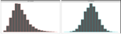
CAD | Coronary Artery Disease | 502505 | 0.0 | 0.0 | 0.0 | 1.0 | 
GLU | Blood Fasting Glucose | 429567 | 1.0 | 4.9 | 5.1 | 36.8 | 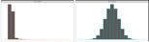
T2D | Type 2 Diabetes | 493619 | 0.0 | 0.0 | 0.1 | 1.0 | 

Table 2 UK-Biobank Phenotypes

PHECODEs
We used the various phenotypes recorded in the UK Biobank data in multiple fields for our analyses. These phenotypes included integer, continuous, unordered categorical and dummy-encoded categorical variables. Additionally, we used the phenotype or disease diagnostic codes from electronic health record (EHR) data in the UKB recorded as ICD9 and/or ICD10 codes to derive phecodes. International Classification of Diseases (ICD) codes are a list of codes for diseases, signs and symptoms, abnormal findings, injuries, diagnostics, and billing. ICD codes are used globally by to track morbidity and mortality data in more than 100 countries³. However, ICD codes do not provide an appropriate level of granularity for phenotypes relevant for genetic association studies. Phecodes are manually curated groups of International Classification of Diseases (ICD) codes that aggregate one or more related ICD codes into a distinct medical concept, disease or phenotype intended to capture clinically meaningful concepts for research⁴. Additionally, phecodes provide embedded case-control definitions based on exclusion criteria for controls. Phecodes enable the rapid characterization of large number of phenotypes and are widely used in phenotyping participants with EHR data, especially for genetic association studies^{4,5}. Studies have shown that using phecodes for genetic association studies produces superior results compared to ICD and Clinical Classification Software (CCS) codes⁶⁻⁸.
Hence, we mapped the ICD9 and ICD10 codes in the UKB to phecodes using the phecode mapping from the PheWAS catalog^{6,9}. We used the createUKBphenome scripts (https://github.com/umich-cphds/createUKBphenome) to create this mapping. A brief description of this process follows. First, we created a mapping of ICD9/10 codes to phecodes using Phecode Map v1.2 along with the inclusion/exclusion criteria for each phecode. Next, we collected and harmonized the ICD codes in the UKB following which we extracted all participant ICD codes from the multiple fields in the UKB data. Finally, the harmonized ICD codes were mapped to phecodes using Phecode Map 1.2 to create a phenome consisting of binary case-control data for each phecode. Only participants whose genetic sex matched their self-reported sex were retained. 162 ICD9 codes and 2,294 ICD10 codes could not be mapped to phecodes. This mapping produced a binary case-control phenome dataset with 1,694 phecodes for 487,891 UKB participants. We used these phecodes for our subsequent VLA analyses.
PHE | description | N | min | median | mean | max | histogram
BMI | Body Mass Index | 489955 | 18.0 | 26.7 | 27.4 | 48.0 | 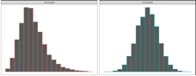
CAD | Coronoary Artery Disease | 502505 | 0.0 | 0.0 | 0.0 | 1.0 | 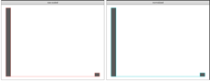
GLU | Blood Fasting Glucose | 429567 | 1.0 | 4.9 | 5.1 | 36.8 | 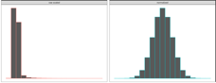
T2D | Type 2 Diabetes | 493619 | 0.0 | 0.0 | 0.1 | 1.0 | 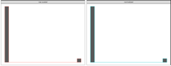

PEGS

Exposome data
PEGS participants complete the self-administered Health and Exposure Survey and a two-part Exposome Survey that request health and exposure information. The Health and Exposure Survey requests general health, lifestyle, and occupational exposure information as well as individual and family medical histories (n=9,414). The Exposome Survey comprises Part A, which requests information on exogenous exposures throughout life, including but not limited to chemical and environmental exposures at home and work (n=3,519), and Part B, which requests information on endogenous exposures such as medication as well as lifestyle factors, which include sleep patterns, stress, physical activity, and diet (n=2,962).
To formulate the surveys, previously validated surveys were used, including the National Health Information Survey and the National Health and Nutrition Examination Survey (NHANES) for the Health and Exposure Survey and the PhenX Toolkit, NHANES questionnaire, validated scales such as Cohen’s Perceived Stress Scale, and forms from NIEHS, NIH, CDC, and the Agency for Toxic Substances and Disease Registry for the Exposome Survey. The questionnaires administered to the PEGS participants are available online at https://www.niehs.nih.gov/research/clinical/studies/pegs/about/data/index.cfm.

Phenotypes

Coronary Artery Disease (CAD)
The Health and Exposure Survey asks participants if they have experienced a heart attack or myocardial infarction. CVD cases are participants who have experienced a heart attack or myocardial infarction. By default, controls are participants who did not report a heart attack or myocardial infarction. Participants with any of the following conditions are excluded from both the case and control groups: hypertension, high cholesterol, atherosclerosis, cardiac arrhythmia, angina, coronary artery disease (CAD), congestive heart failure, poor blood flow, blood clots, angioplasty, and stroke.

Type 2 Diabetes (T2D)
While the Health and Exposure Survey asks participants whether they have been diagnosed with diabetes, their age at diagnosis, and current and past treatments but does not ask about diabetes type. To define type 2 diabetes cases in the PEGS cohort, we used a cutoff of 20 years at age of diagnosis to differentiate between type 1 and type 2 diabetes, with the assumption that most individuals with type 1 diabetes are diagnosed before this age. We also excluded participants who indicated they had been diagnosed with gestational diabetes.

Whole Genome Sequencing
The Broad Institute sequenced all samples on the NovaSeq 6000 platform with a target genome-wide read depth of 30x (24 samples per flow cell) and processed reads with its gatk4-genome-processing-pipeline version 1.0.0 (github.com/gatk-workflows/gatk4-genome-processing-pipeline) [1]. Reads were aligned to the hg38 reference genome with bwa mem 0.7.15-r1140 [2], Picard Tool MarkDuplicates 2.20.4 was used to flag duplicate fragments, and GATK 4.0.10.1 ApplyBQSR was used to perform base quality score recalibration.
GATK 3.5.0 HaplotypeCaller was employed for variant calling for each sample, with output in g.vcf format. GATK 4.1.4.0 GenotypeGvcfs was used for joint genotyping, and GATK 4.1.1.0 VariantFiltration was subsequently used for applying filtering flags. Following this, GATK 4.1.1.0 ApplyVQSR was used for variant quality score recalibration. A “PASS” filter label was assigned to variants with an excess heterozygosity phred score ≤ 54.69 and a VQSLOD score exceeding the threshold of retaining 99.0% of true positive indels and 99.7% of true positive SNPs.

Quality control analysis
samtools flagstats was used to determine the total read count and proportion of duplicate fragments [3]. samtools idxstats was employed to determine the percentages of reads mapping to the mitochondrial genome and chrY, along with the ratio of reads mapped to chrX per bp relative to the genome-wide rate. FastQC 0.11.9 was used to determine the aggregate %GC, separately for mate 1 and mate 2 reads. The maximum deviation of mean per-cycle sequence content from genomic background rates of 20% for G/C and 30% for A/T was determined from the FastQC output. The first nine cycles were excluded because of anticipated large deviations. Percentages of reads with mapping quality below 5 and 10 were directly derived for each sample from the MAPQ field of sample CRAM files. Preliminary unfiltered GATK joint genotypes were called in batches of samples sequenced and processed in tandem. SNP counts, indel variants, the mean and standard deviation of variant genotype qualities, and major allele frequencies (calculated separately for homozygous and heterozygous genotypes) were derived from these preliminary calls.
Estimates of genomic proportions derived from Asian, Amerindian, European, and African ancestors were determined using ancestry informative markers and the genotypes of individuals with known ancestry (reported in Table S6) in Kosoy et al. [4]. Using Plink 1.90b4.3, genotypes called at these loci for each sample were extracted and independently merged with individuals of known ancestry using [5]. The genotypes were subsequently analyzed using fastStruture version 1.0 [6] with four specified ancestral populations (-K 4). fastStructure estimates genome proportions derived from unlabeled ancestral populations inferred from given data. For each estimated population, continental associations were determined by separately calculating mean proportions for individuals of known ancestry and pairing proportions ≥ 0.9. The analysis was repeated for rare cases in which fastStructure’s non-deterministic algorithm did not separate individuals with known ancestry in a way that a known population could be assigned as described to an inferred population.
Table SX provides the quality analysis results. For some individual samples, the GC-content and fractions of reads mapped to chrY were higher than expected. For a small proportion of the genome, the target of 30x coverage was surpassed. Because these features were not associated with increased novel variant calls or reduced genotype quality estimates, no individual samples were excluded from further analysis. Manually comparing estimated ancestral genome proportions with self-reported race and ethnicity and examining ratios of chrX to genomic coverage and fractions of reads mapped to chrY in the context of self-reported sex indicated no mislabeling or swapping of samples.

Genotype calling
Variant calling was performed separately with DeepVariant 0.9.0 [7] using default parameters for confirmation of the Broad Institute’s joint genotype calls. As part of the analysis, reads with unmodified, instrument-assigned base quality scores were mapped to the hg38 reference genome using bwa mem version 0.7.17. Duplicate fragments were flagged using Picard tools MarkDuplicates 2.21.2. For 89 samples in the pilot sequencing run, unmodified quality scores were unavailable. DeepVariant analyses were performed with hg38 alignments provided by the Broad Institute. Using Illumina hap.py version 0.3.7, genotypes called with the GATK pipeline were compared to DeepVariant calls, with GATK results as the “truth” set and DeepVariant results as the “query” set. For the final genotypes, any GATK genotype confirmed by DeepVariant was accepted regardless of filter status. Additionally, all unconfirmed GATK homozygous reference genotypes with “PASS” filter status and all unconfirmed GATK variant genotypes with “PASS” filter status and a GQ score ≥ 70 were accepted. A filtering step removed variants with cohort allele frequency < 0.001. The remaining variants were annotated with WGSA pipeline [8] version 0.8 based on the tool’s precomputed hg38 resource catalog. Ensembl gene annotations were employed for this annotation. Table SX outlines the full set of annotations.

Participant Filtering
In addition to the QC steps, the number of variants identified for each PEGS participant was compared to the number determined in a parallel analysis of the same data based on the hg19 genome assembly. Three samples were excluded from downstream analysis because they displayed very low hg38-based variant counts and average to very high hg19-based variant counts and, within the QC data, the samples were outliers in terms of the variability of the observed allelic fractions at loci with heterozygous genotype calls. This indicates the WGS results may have been derived from a mixture of DNA from two individuals.
The QC process included a visual inspection of the relationship between the percentage of total reads mapping to chrY and the ratio of mean chrX coverage to the genomic mean to infer sex chromosome copy numbers. Most participants fell into clusters indicative of an XX or XY karyotype that matched the expected copy number given their self-reported sex. A self-reported male with Klinefelter syndrome fell close to the XX cluster as anticipated but displayed a higher than expected %chrY. Additionally, one self-identified male’s %chrY value was more than double that of most falling in the XY cluster, and two self-identified female’s chrX ratios were close to 1.5. These observations were interpreted to indicate XYY and XXX karyotypes, respectively. Due to the indication of a sex chromosome aneuploidy, these four samples were excluded from downstream analyses.
To mitigate confounding effects of undisclosed or unknown relatedness among participants in the PEGS cohort, KING 2.2.5 [2] was used to generate a matrix of pairwise kinship coefficients to analyze individual genotypes. To ensure the cohort contained no third-degree or closer relatives (kinship coefficient threshold = 0.0884), the “relatednessFilter” function in the plinkQC R package 0.3.3 was then utilized to identify a parsimonious set of 120 individuals who were excluded from downstream analyses.

Principal Components Analysis
WILL NEED A BRIEF DESCRIPTION HERE

Gene-Environment Interaction Analysis
WILL NEED TEXT HERE

Discussion
Comparisons of risk allele frequencies across diverse populations have established appreciable directional differentiation for blood lipid and T2DM risk allele frequencies [55,56]. The decreasing frequencies of some T2DM risk alleles seen along an eastward arc from Africa to eastern Asia supplement disparities in predicted genetic risk, such that a portion of T2DM genetic risk is consistently elevated for individuals in African populations and lower in Asian populations [56], but this is somewhat controversial [57]. Accordingly, and considering that geography and climate strongly influence available foodstuffs, seasonally directed energy expenditures and other nutrition-centric human activity [13], we sought to identify those GxE SNPs that show evidence for positive selection.
Three resources were used to investigate relationships between cardiometabolic GxEs and adaptation to climate and geography. First, two genome-wide studies have examined associations between genetic variants and climatic and geographical characteristics, including latitude, seasonality, precipitation, solar radiation and temperature [58,59]. Second, a collection of genes was identified as under selection in different human populations with roles in cultural practices, often with rationales pertinent to agriculture, diet and societal behaviors [60]. Third, a number of other studies have assessed adaptation at candidate loci for specific phenotypes and we chose to examine those germane to cardiometabolic traits. From these reports, we found that 25 of 189 different genes supporting cardiometabolic GxE interactions show adaptation to climatic and geographical characteristics (Table 1). Just 23 of 453 loci participating in main effect associations for these cardiometabolic traits, as mined from the GWAS catalog [45], show adaptation to climate and geography features, indicating significant enrichment in the GxE dataset (p <0.001, two sample z-test).
  - How does the level of over-representation across any category compare to overrepresentation of that category from results from mQTL GWAS (either our own, or the GWAS catelogue)
  - Tissue based e-QTLs
  - Epigenetics: how many vQTLs create or destroy a CpG dinucleotide, compared to random SNPs
- Compare to CardioGXE, CTD as manually curated vs computationally driven, SNPXE from GWAS catalogue
- Check for phantom vQTL effects like in the Visscher paper

Notes to ourselves:
- Compare our vQTLs to those found by Visscher for 13 traits?
- https://advances.sciencemag.org/content/5/8/eaaw3538
- Functional categories/annotations
  - Clinical genomic catalogue?
  - GWAS catalogue (SNPs in LD to things in the GWAS catalogue?)
  - PheGenI phenotype-genotype integrator?
  - Test for GxE variants under positive selection

Points for Discussion:
While it certainly may be stated that a person’s ‘genometype’ could indeed prove the most useful for individualized medicine (including individualized nutrition) and personal genetics [89], the impact of environmental interactions on a person’s panel of alleles cannot be overstated. In this regard, an interaction between an obesity genetic risk score based on 63 variants and saturated fat intake has been demonstrated in two distinct populations [90]. We have not in this analysis coalesced the genetic variants cataloged in CardioGxE around a given phenotype-environmental factor pair and processed data for a global or genometype GxE interaction, but such research could proceed with the aid of this GxE resource. Indeed, the lack of overlap between our CardioGxE dataset and published GWAS for comparable phenotypes makes evident the utility of incorporating GxEs into assessment of disease risk in two important ways. One, a GxE catalog provides the means to develop a better strategy of intervention because genetic and environmental factors combined can equip the physician for more accurate prediction of future disease risk and hence disease prevention. Two, genetic variation alone is not just diagnostic of disease risk, but is a component of and should be considered in epistatic and GxE interactions to better inform the individual of potential disease risk. Altogether, the numerous examples presented here add to the emerging view that GxEs are widespread and significant contributors to phenotypic variance [91]. Although we have highlighted instances for which more data are needed, especially taken under conditions mimicking the environmental factor of the GxE equation, the insight thus far garnered from analysis of a large GxE catalog emphasizes the influential roles of environmental factors in the genetics of complex traits, particularly those of a metabolic nature.
Talk about the impact of unbalanced case / control ratio on power and type 1 error, and solutions.
Talk about why GWAS still works as a selector.

References
[1] Claude Bouchard and Tuomo Rankinen. Individual differences in response to regular physical activity. Medicine and science in sports and exercise, 33(6; SUPP):S446–S451, 2001.
[2] Jose M Ordovas and Jian Shen. Gene–environment interactions and susceptibility to metabolic syndrome and other chronic diseases. Journal of Periodontology, 79:1508–1513, 2008.
[3] Aseel Eid, Isha Mhatre, and Jason R Richardson. Gene-environment interactions in Alzheimer’s disease: a potential path to precision medicine. Pharmacology & Therapeutics, 199:173–187,2019.
[4] Nabodita Kaul and Sher Ali. Genes, genetics, and environment in type 2 diabetes: implication in personalized medicine. DNA and cell biology, 35(1):1–12, 2016.
[5] David J Hunter. Gene–environment interactions in human diseases. Nature Reviews Genetics,6(4):287–298, 2005.
[6] Avshalom Caspi and Terrie E Moffitt. Gene–environment interactions in psychiatry: joining forces with neuroscience. Nature Reviews Neuroscience, 7(7):583–590, 2006.
[7] Evan E Eichler, Jonathan Flint, Greg Gibson, Augustine Kong, Suzanne M Leal, Jason H Moore, and Joseph H Nadeau. Missing heritability and strategies for finding the underlying causes of complex disease. Nature Reviews Genetics, 11(6):446–450, 2010.
[8] Marinus H Van Ijzendoorn, Marian J Bakermans-Kranenburg, Jay Belsky, Steven Beach, Gene Brody, Kenneth A Dodge, Mark Greenberg, Michael Posner, and Stephen Scott. Gene-by-environment experiments: a new approach to finding the missing heritability. Nature Reviews Genetics, 12(12):881–881, 2011.
[9] Cathie Sudlow, John Gallacher, Naomi Allen, Valerie Beral, Paul Burton, John Danesh, Paul Downey, Paul Elliott, Jane Green, Martin Landray, et al. Uk Biobank: an open access resource for identifying the causes of a wide range of complex diseases of middle and old age. PLoSmedicine, 12(3):e1001779, 2015.
[10] Janet E Hall, Alison A Motsinger-Reif, David C Fargo, and Charles S Schmitt. PEGS: Personalized environment and genes study. https://www.niehs.nih.gov/research/clinical/studies/pegs/index.cfm, 2020. Last Reviewed: 09-01-2021.15
[11] Jonathan Marchini, Peter Donnelly, and Lon R Cardon. Genome-wide strategies for detecting multiple loci that influence complex diseases. Nature genetics, 37(4):413–417, 2005.
[12] Joshua Millstein, David V Conti, Frank D Gilliland, and W James Gauderman. A testing framework for identifying susceptibility genes in the presence of epistasis. The American Journal of Human Genetics, 78(1):15–27, 2006.
[13] Youngjo Lee and John A Nelder. Double hierarchical generalized linear models (with discussion). Journal of the Royal Statistical Society: Series C (Applied Statistics), 55(2):139–185,2006.
[14] Gordon K Smyth. Generalized linear models with varying dispersion. Journal of the Royal Statistical Society: Series B (Methodological), 51(1):47–60, 1989.
[15] Lars Rönnegård, Majbritt Felleki, Freddy Fikse, Herman A Mulder, and Erling Strandberg. Genetic heterogeneity of residual variance-estimation of variance components using double hierarchical generalized linear models. Genetics Selection Evolution, 42(1):8, 2010.
[16] Lars Rönnegård and William Valdar. Detecting major genetic loci controlling phenotypic variability in experimental crosses. Genetics, 188(2):435–447, 2011.
[17] Huanwei Wang, Futao Zhang, Jian Zeng, Yang Wu, Kathryn E Kemper, Angli Xue, Min Zhang, Joseph E Powell, Michael E Goddard, Naomi R Wray, et al. Genotype-by-environment interactions inferred from genetic effects on phenotypic variability in the UK Biobank. Science advances, 5(8):eaaw3538, 2019.
[18] Guillaume Paré, Nancy R Cook, Paul M Ridker, and Daniel I Chasman. On the use of variance per genotype as a tool to identify quantitative trait interaction effects: a report from the women’s genome health study. PLoS Genet, 6(6):e1000981, 2010.
[19] Andrew R Marderstein, Emily R Davenport, Scott Kulm, Cristopher V Van Hout, Olivier Elemento, and Andrew G Clark. Leveraging phenotypic variability to identify genetic interactions in human phenotypes. The American Journal of Human Genetics, 2020.
[20] Hugues Aschard, Bjarni J Vilhjálmsson, Amit D Joshi, Alkes L Price, and Peter Kraft. Adjusting for heritable covariates can bias effect estimates in genome-wide association studies. The American Journal of Human Genetics, 96(2):329–339, 2015.
[21] Shaun Purcell, Benjamin Neale, Kathe Todd-Brown, Lori Thomas, Manuel AR Ferreira, David Bender, Julian Maller, Pamela Sklar, Paul IW De Bakker, Mark J Daly, et al. Plink: a tool set for whole-genome association and population-based linkage analyses. The American journal of human genetics, 81(3):559–575, 2007.16
[22] Christopher C Chang, Carson C Chow, Laurent CAM Tellier, Shashaank Vattikuti, Shaun M Purcell, and James J Lee. Second-generation plink: rising to the challenge of larger and richer datasets. Gigascience, 4(1):s13742–015, 2015.
[23] Christopher Chang. Plink binary biallelic genotype table. https://www.cog-genomics.org/plink/1.9/formats#bed, Jun 2021.
[24] Wei-Qi Wei, Lisa A Bastarache, Robert J Carroll, Joy E Marlo, Travis J Osterman, Eric R Gamazon, Nancy J Cox, Dan M Roden, and Joshua C Denny. Evaluating phecodes, clinical classification software, and icd-9-cm codes for phenome-wide association studies in the electronic health record. PloS one, 12(7):e0175508, 2017.
[25] Patrick Wu, Aliya Gifford, Xiangrui Meng, Xue Li, Harry Campbell, Tim Varley, Juan Zhao, Robert Carroll, Lisa Bastarache, Joshua C Denny, et al. Mapping icd-10 and icd-10-cmcodes to phecodes: workflow development and initial evaluation. JMIR medical informatics,7(4):e14325, 2019.
[26] Kai Wang, Mingyao Li, and Hakon Hakonarson. Annovar: functional annotation of genetic variants from high-throughput sequencing data. Nucleic acids research, 38(16):e164–e164,2010.
[27] Martin Kircher, Daniela M Witten, Preti Jain, Brian J O’roak, Gregory M Cooper, and Jay Shendure. A general framework for estimating the relative pathogenicity of human genetic variants. Nature genetics, 46(3):310–315, 2014.
[28] Jacqueline MacArthur, Emily Bowler, Maria Cerezo, Laurent Gil, Peggy Hall, Emma Hastings, Heather Junkins, Aoife McMahon, Annalisa Milano, Joannella Morales, Zoe May Pendlington, Danielle Welter, Tony Burdett, Lucia Hindorff, Paul Flicek, Fiona Cunningham, and Helen Parkinson. The new NHGRI-EBI Catalog of published genome-wide association studies(GWAS Catalog). Nucleic Acids Research, 45(D1):D896–D901, 11 2016.

