Cataloging gene-environment interaction candidate SNPs for over 3,000 UK Biobank disease phenotypes through variance loci analysis
Xiaoran Tong, <authors>, Alison Motsinger-Reif
September 7, 2021

Abstract
Detecting gene by environment interactions (GxEs) for diseases enriches the ontology of genetic effects and helps identify environmental targets for interventions with the goal of improving health outcomes. However, combining the dimensions of the genome and exposome poses challenges in terms of both computational and statistical power.
Variance quantitative trait loci (vQTL) analysis, which is based on a double linear model (DLM) or double generalized linear model (DGLM), has recently received attention for its ability to find candidate single nucleotide polymorphisms (SNPs) for GxEs without actual environmental exposome profiling. The rationale is that GxEs unaccounted for by a genome-wide association study (GWAS) can bring about the residual variance of a quantitative phenotype that changes across allele dosages—a non-uniformity that can be captured by a second GWAS treating the squared residual as a new phenotype.
We propose variance loci analysis (VLA) based on a DLM augmented by squared SNP dosage. We show that VLA maintains superior power to detect GxE candidates with weak direct environmental effects on the phenotype. We also demonstrate that DGLM is overly generic with squared dosage and overly restrictive when the squared dosage is not used. More importantly, we demonstrate that by appropriately adjusting covariates, VLA can overcome the inability of DLM/DGLM to analyze thousands of non-quantitative phenotypes.
We performed VLA for 3,273 health- and disease-related phenotypes derived from the UK Biobank and ranked the potential involvement of each SNP in GxEs. We present the VLA Catalog (genelist.niehs.nih.gov) an open resource of GWAS, vQTL, and VLA mapping for these traits, along with consistently curated metadata required for reproducibility and independent applications. Using environmental exposome data collected in the Personalized Environmental Genetic Study (PEGS), we found that high-ranking genome variants selected by VLA enriched the detection of genome-exposome-wide significant GxE SNPs for cardiovascular disease (CVD), type 2 diabetes (T2D), and body mass index (BMI).

Introduction

Background and motivation
Most human traits have a complex etiology and are affected by both genetic and environmental factors and their interactions. Because environmental exposures can regulate the biological processes underlying a phenotype (1-4), unaccounted-for GxE effects are recognized as part of the heritability “missed” by variants selected by genome-wide association studies (GWAS)(5, 6). While research in agricultural genetics, model organisms, and cell culture has consistently found that genetic effects are context-dependent (9-13), there has been limited success in identifying GxEs in humans. Among the reasons for this are the difficulty of measuring many environmental exposures and the insufficient sample sizes of most previous studies for detecting GxE effects, which are often small (9–11).
In large cohorts with comprehensive exposome and genome data, a genome-exposome wide association study (GWAS) can test for single nucleotide polymorphism (SNP)-by-environment interactions. This approach, however, has limited power due to multiple testing and computational burdens because of the overwhelming number of crossovers between exposures and genome variants. Unbiased GWAS can also restrict hypothesis generation. To address these issues, candidate genes for GxE interactions are often selected based on prior biological knowledge, which limits this approach, or the results of other GWAS. Despite the assumption that strong interactions will likely exert strong marginal effects (7, 8), significant GWAS results do not necessarily equate to GxE interactions since SNP main effects can coexist with weak GxE interactions.
These issues have motivated the development of
alternative methods to identify candidate SNPs. A promising strategy is screening for variance quantitative trait loci (vQTL) in a selection cohort rich in genome data for use as candidate SNPs for GxE studies in a discovery cohort rich in exposome data. GxE interactions with large effect sizes can be revealed as heterogeneity in the variance of a quantitative trait among groups of individuals (9-12). Unlike classical QTL analysis, which tests the allelic substitution effect of a variant on the phenotypic mean, vQTL analysis tests the allelic substitution effect on phenotypic variance. vQTLs are superior GxE candidates because exposome data for the selection cohort are not required if it shares a phenotype of interest with the discovery cohort. vQTL-based candidate SNPs can thus mitigate the multiple testing burden without the requirement of prior biological knowledge.

Overview of variance quantitative trait loci (vQTL)
A vQTL can be induced by a GxE interaction effect unaccounted for in a GWAS linear model, resulting in uneven variation around the mean regression line across genotypes. Such vQTLs can be captured by fitting the phenotypic variance with the same genotype via a second linear model. vQTL analysis thus acts as a double linear model (DLM) because two-stage linear regressions are used, where the first stage is a de facto GWAS, and the second stage treats the squared residual as a new phenotype. The slope of the second linear model is used to detect vQTLs. A flat regression line indicates a variant is not involved in a GxE (Figure 1a) because the phenotypic variation, measured by squared residuals, is nearly uniform across genotypes. A non-zero slope indicates a variant is involved in a GxE (Figure 1b) due to the monotonic increase of phenotypic variation across the genotypes.

Figure 1: Variance trait quantitative loci (vQTL) to suggest GxE
(a) In the absence of a GxE (left), residual variations are even across genotypes (right), and variant A/a is not a vQTL; based on GWAS, the variant would be erroneously identified as a GxE candidate. (b) In the presence of a GxE (left), residual variations are uneven across genotypes (right), and variant A/a is a vQTL. Teal/red dashes: environment-specific effect; blue solid lines: marginal effect.

(a)
(b)

Before DLM and the concept of additive vQTLs were developed, modeling the mean and dispersion of a quantitative phenotype with shared genotype predictors (i.e., SNPs) was achieved via double generalized linear modeling (DGLM) (Smyth, 1989) and double hierarchical generalized linear modeling (DHGLM) (13). Additive vQTLs are induced by missed GxE interactions, with the effect of each allele added to the phenotypic variance on a linear scale. In contrast, multiplicative vQTLs are those for which the effect of each allele is added to the phenotypic variance in a log scale and multiplies the phenotypic variance. The intent of DGLM and DHGLM is to prioritize genome variants that are resistant to environmental changes (i.e., non-vQTL), allowing the selection of non-interaction candidates (14). DGLM is also a common benchmark for comparing power to identify GxE candidates (15, 16). Like DLM, DGLM involves a two-stage model but allows standard link functions to accommodate non-normal outcomes and assumes that the squared residual deviance of a stage-1 model follows not a Gaussian, but a Gamma, distribution. For a Gaussian phenotype, DGLM essentially models the phenotypic variance in log scale since it uses log-linked Gamma regression for stage-2 models, thus capturing multiplicative vQTLs.

Although DGLM and DLM are designed to capture multiplicative and additive vQTLs, respectively, they cannot control type 1 errors when the quantitative phenotype is non-Gaussian and the genotype main effect is non-zero (17, 18). Other methods to capture additive or multiplicative vQTLs have been successfully applied with varying results regarding their power. Deviation regression modeling (DRM), a modified DLM (19) that replaces the typical squared distance between phenotype values and the group mean (i.e., the squared residuals of the stage-1 linear model) with the absolute distance between phenotype values and the group median, is recommended to capture additive vQTLs, and Levene’s test is recommended to capture multiplicative vQTLs (16, 19, 20).
In a study simulating Gaussian phenotypes as the sum of the covariate, main genotype effects, main environmental effects, and GxE interactions, DRM, as a scan for additive vQTLs, outperformed DGLM and Levene’s test as scans for multiplicative vQTLs. DLM has also been used to discover additive vQTLs from unaccounted-for GxE interactions with Levene’s test, which typically reveals equality of variance across genotype groups to capture multiplicative vQTLs (20).

In a comprehensive simulation comparing the performance of vQTL test statistics (16), a basic phenotype was drawn from a Gaussian distribution where variance was a linear combination of allele dosages passed to the exponential function. In other words, the genotype determined the phenotypic variance in log scale, thus inducing multiplicative vQTLs. In this case, Levene’s test was the optimal choice for both power and type 1 error control when the phenotype was transformed into a quantitative non-Gaussian phenotype.

Issues with vQTL analysis
Despite its successful application in some contexts, vQTL analysis is not recommended for binary case/control outcomes such as type 2 diabetes (T2D) and cardiovascular disease (CVD)(16, 19). Both additive and multiplicative vQTLs capture the heterogeneity of phenotypic variance among individuals with a different genotype while assuming homogeneous variance among those with the same genotype. For non-Gaussian phenotypes, a QTL affecting the phenotypic mean will likely affect the variance as well, violating the assumption of within-group homogeneous variance and biasing the vQTL test towards positive. For quantitative phenotypes, false positives can generally be countered by DRM (19) and Levene’s test (16, 17), maintaining the power to detect true vQTLs.
Binary phenotypes, however, conceal the gradient of underlying risk, resulting in type 1 errors for both additive and multiplicative vQTL tests (see Figure 2a) that cannot be controlled by simply replacing DLM with DRM or Levene’s test. In contrast, DGLM is not advised because it is overly conservative for binary phenotypes (16, 20). Additionally, additive vQTL methods such as DLM and DRM lack the power to detect a true GxE candidate when the environmental main effect is weak, even if the phenotype is Gaussian (see Figure 2b).

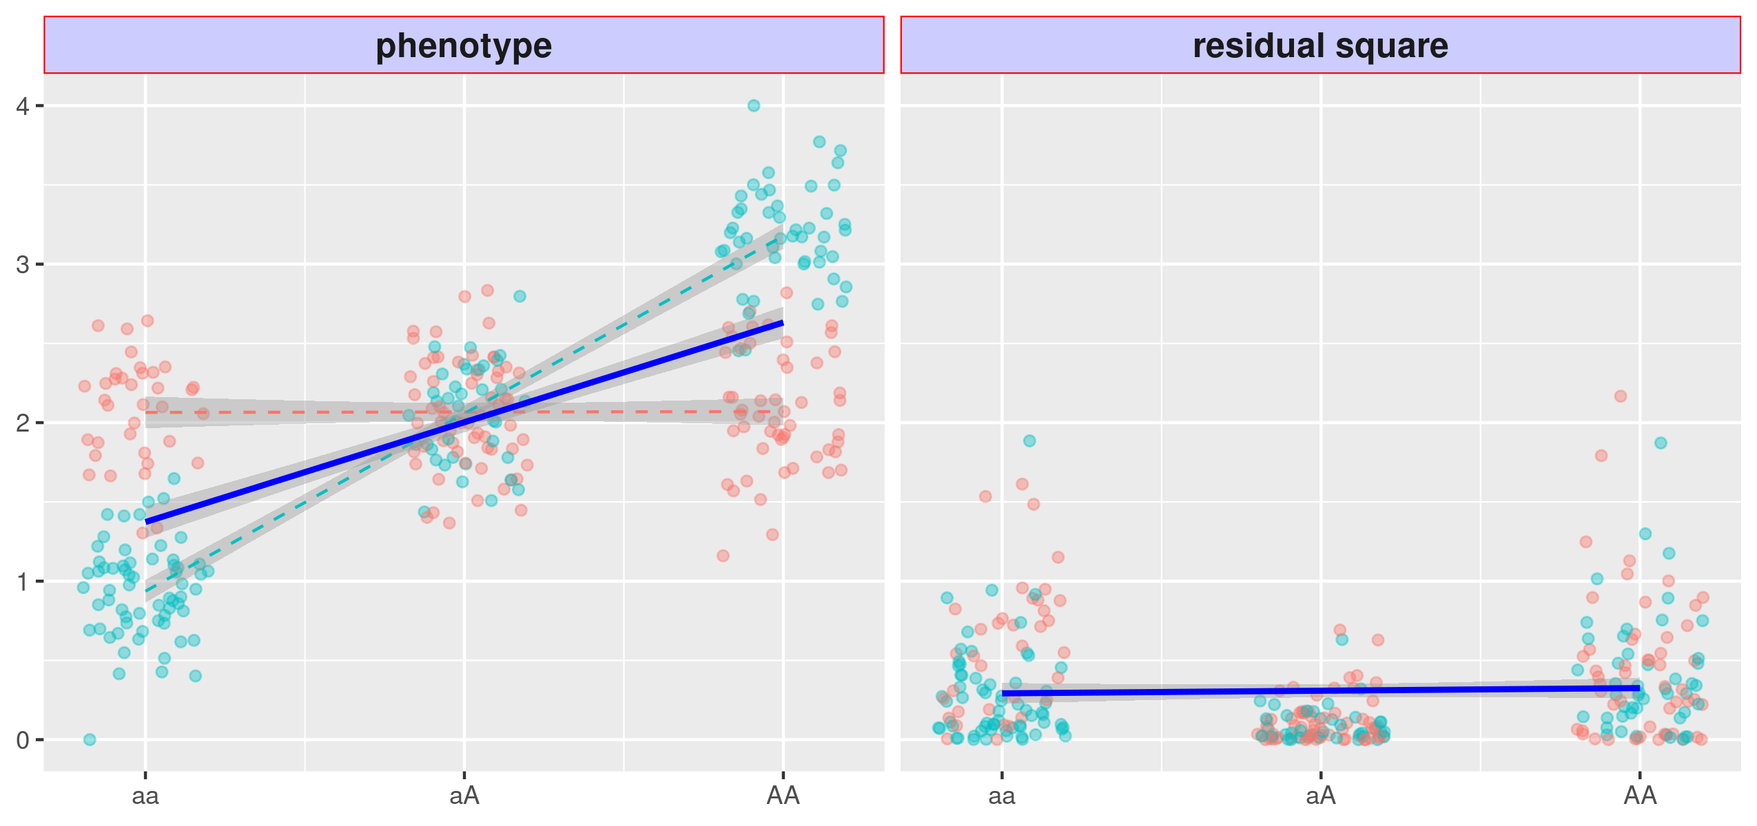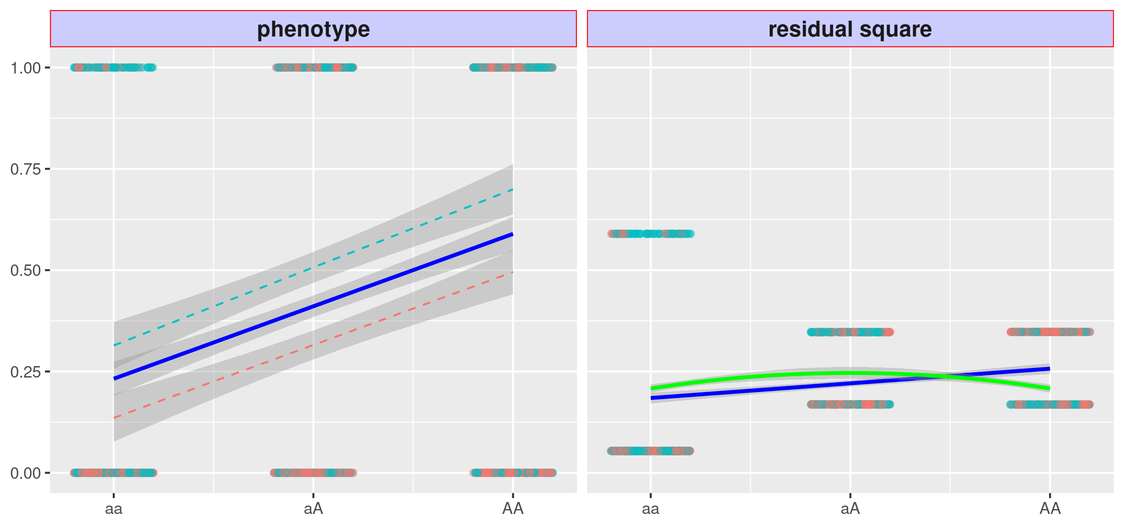
Figure 2: Issues with variance quantitative loci (vQTL)

(a) left: A binary phenotype with non-null marginal genotype main effect, shown by the solid blue line, but null GxE effect, shown by the parallel dashed red and teal lines (left). (a) right: The squared residual changes with genotype, shown by the blue solid line, and the variant thus become a false vQTL. The VLA fits a downwards curve, shown by the solid green line, thus controlling type 1 errors.
(b) left: A Gaussian phenotype with a strong GxE effect but a weak environmental main effect (i.e., a pure GxE), shown by the dashed red and teal lines with distinct slopes that cross at the center. (b) right: The squared residual changes with genotype but non-linearly. The linear model thus misses the true GxE candidate (i.e., DLM and DRM), shown by the flat regression line.
*The red and teal points represent samples experiencing two environments.

(a)
(b)

Variance loci analysis (VLA)
To address issues with vQTL analysis, we propose variance locus analysis (VLA) to select GxE candidates for both Gaussian and binary phenotypes. VLA takes the additive perspective of variance loci, based on the assumption that a phenotype is composed of GxE effects along with the genotype, covariate, and environmental main effects, plus noise. While existing additive vQTL methods test the non-zero slope of the stage-2 regression line, VLA fits a curve and tests its upwardness. For Gaussian phenotypes, VLA overcomes the lack of power with low environmental main effects (see the solid green line in Figure 4b). Importantly, VLA also controls type 1 errors for binary phenotypes (see the solid green line in Figure 2b).
However, the upwardness test results in a lack of power for detecting GxE candidates (Figure 4a) in the case of binary traits. Discretizing phenotypes into binary disease diagnoses still glosses over the underlying risk leading up to the event. To mitigate this, t
he underlying risk can be reconstructed to some extent with covariates. The residual from a regression model using a covariate such as age represents the underlying risk that is the combined effect of the genome and exposome.

With multiple covariates, these residuals become a smooth Gaussian variable. After replacing a binary phenotype with the residualized risk, upward curve-based VLA can be used to select variance loci involved in GxE (see Figure 4b). The best covariates are non-confounding predictors, such as age and sex, which are not heritable and not determined by the exposome (non-confounding) yet are predictive of risk of the disease. The use of confounding covariates can bias the genome and exposome effects towards null (21) while risk scores resulting from non-predictive covariates do not represent the fine gradient of risk.
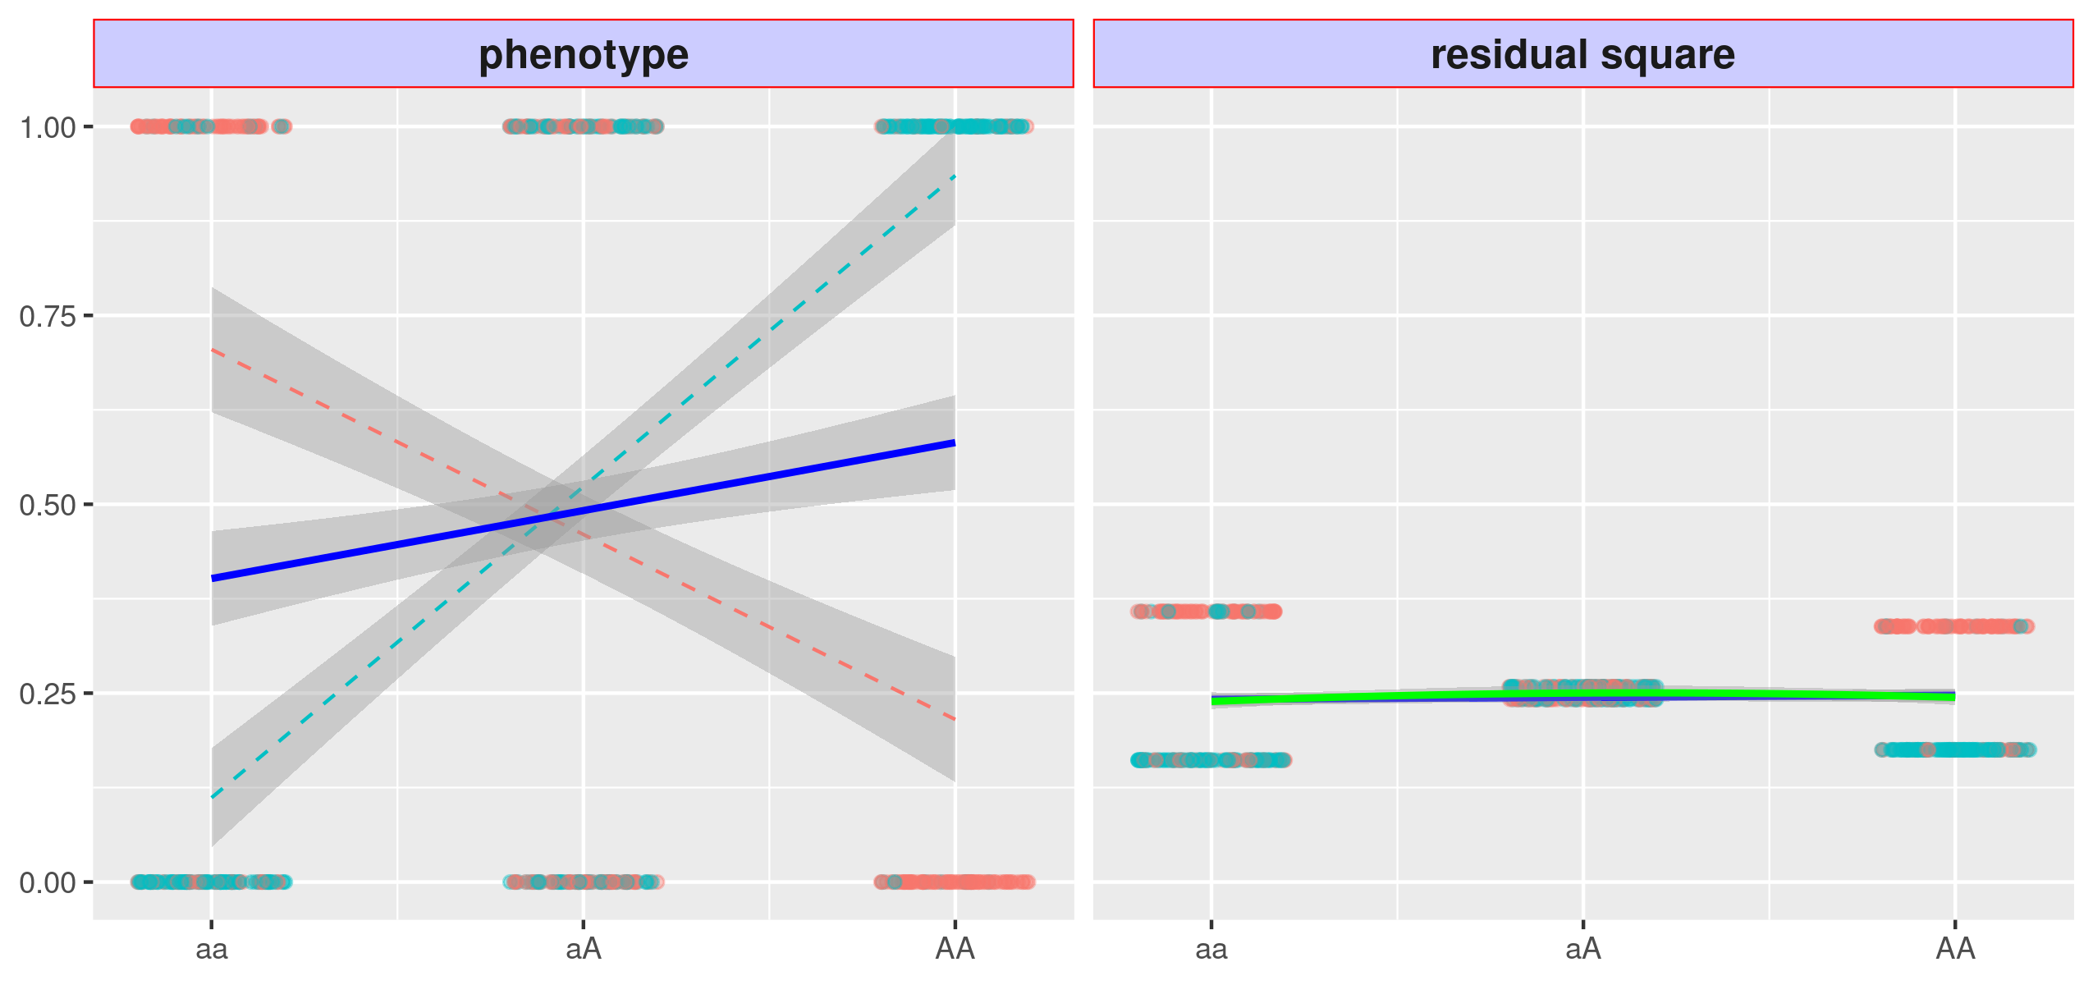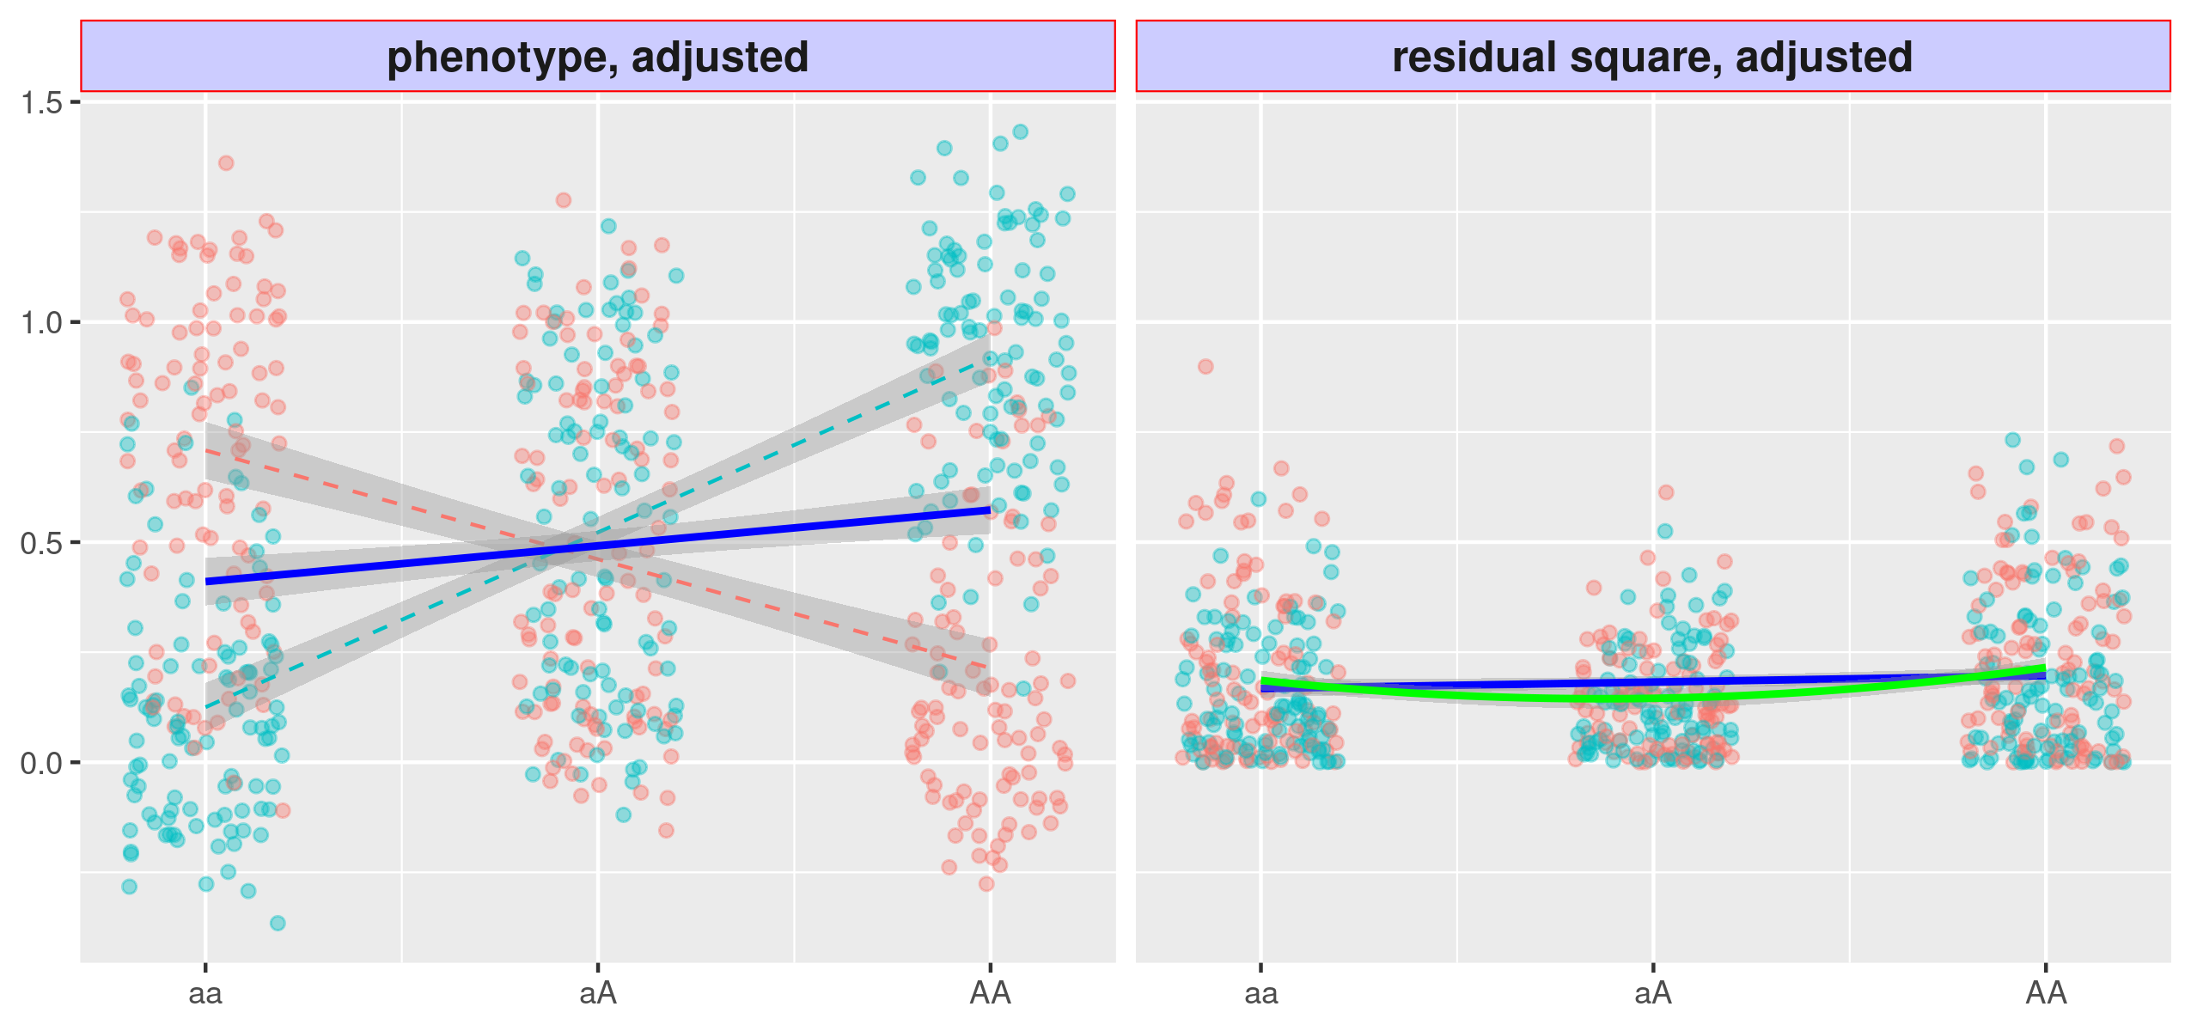
Figure 4: Variance loci analysis (VLA) with innate risk score
(a) Variant A/a is strong in GxE, but the VLA curve upwardness (green solid) test is as powerless as the slope-based vQTL (blue); (b) If the binary phenotype is replaced by the innate risk score as a covariate residual close to Gaussian, the upwardness of the VLA curve (green solid) detects the variance loci A/a.
(a)
(b)

Application of VLA in the UK Biobank
We demonstrated VLA with whole-genome scans across phenotypes in the UK Biobank (UKBB). The UKBB has large sample sizes and is an excellent discovery resource but contains limited data on external environmental exposures (22, 23). Using UKBB data, we applied VLA to prescreen candidates for GxE testing for binary and quantitative traits in the Personalized Gene and Environment Study (PEGS) (24). PEGS is a diverse North Carolina-based cohort of varying age, race, socioeconomic status, and education level and extensive self-reported survey data on more than 600 environmental exposures and health outcomes (ADD CORRECT Ns HERE) as well as whole-genome sequencing data for multiple phenotypes (ADD CORRECT Ns HERE).
With the results, we created a catalog of VLA statistics hosted by NIEHS (https://genelist.niehs.nih.gov/vla) for the entire genome and phenome of the UKBB, which was expanded with compound phenotypes based on the most recent PHECODE mapping table (25, 26). The catalog is similar to the Pan-UK Biobank GWAS catalog (https://www.pan.ukbb.broadinstitute.org) and the EBI GWAS catalog (https://www.ebi.ac.uk/gwas/). The resource summarizes the interaction potential for phenotypes of interest for each variant and can be used to prioritize GxE candidates in future research.

Validation process
To determine whether statistically significant variance loci can identify additional significant GxEs for measured environmental exposures compared to other populations (e.g., non-British Whites, who are mainly Irish), we compared the annotation details of VLA results with those of GWAS results in UKBB British Whites for a selected phenome using the plinkFile and vla R packages. We also investigated whether variance loci are overrepresented in genome types (i.e., intronic and intergenic), just as GWAS loci are more concentrated within or near certain gene regions. The results section details the findings, and the methods section outlines the preparation of phenome, genome, and exposome data.
Our results indicate that VLA analysis can identify/enrich for previously known GxEs. CardioGXE is a manually curated resource cataloging gene-environment interactions from the literature on blood lipids, glycemic traits, obesity anthropometrics, vascular measures, inflammation, and metabolic syndrome. CardioGXE catalogs the results of manual mining and curation from 386 publications that report gene-environment interactions. The reported GxE SNPs showed little overlap with variants identified by main effect GWAS. For the cardiometabolic traits (DEFINE), we tested for enrichment of the significant VLA SNP with these previously reported GxE interaction. ADD DETAILS.

Results
We implemented VLA as a self-contained “vla” pure R package that simultaneously scans multiple phenotypes and genome variants, given adequate system memory. “vla” is platform- and compiler-independent if the R Base package is installed. As the number of phenotypes increases, the vla R package is more efficient than routine genome-wide analysis implemented in C/C++, such as PLINK (27, 28). To traverse out-of-memory allele-count genotype data condensed in PLINK 1 binary biallelic genotype tables, we created “plinkFile”, another self-contained R package (29). We used these two packages for analyses based on UKBB and PEGS data.

Simulation
We consider a continuous phenotype as the sum of strong covariate effects, non-zero genotype main effects, optional environmental main effects, optional GxE effects, and Gaussian white noise. We consider four scenarios of how the environment affects a phenotype: 1) directly through the main effect (ENV + NUL); 2) no impact (NUL + NUL); 3) through the GxE effect (NUL + GXE); and 4) both directly and through the GxE effect (ENV + GXE). The first two scenarios have no GxE effects, and rejecting the primary null hypothesis contributes to the false discovery rate (FDR). An out-of-control FDR invalidates a method. The second two scenarios do have GxE effects, and rejecting the null adds to the true discovery rate (TDR). A higher TDR means a method is more powerful, if the FDR is controlled. If the FDR is not controlled, the TDR is not valid.
We compare five methods, namely the proposed variance locus analysis (VLA), double linear model (DLM), deviation regression model (DRM), double generalized linear model (DGLM), and Levene’s test (LVT).
We conducted 20,000 trials for each scenario. In each trial, we randomly picked a variant with MAF≥0.01 in region 17q3 (chromosome 17: 10700001 - 16000000) of the 1000 Genomes Project Phase 3 (Consortium, 2012; Consortium & others, 2015) and drew 10,000 dosage values from that variant as the genotype.

Figure 5a presents the performance for Gaussian phenotypes.
In scenarios 1 and 2, where GxE effects are null, the FDR was controlled for all methods (Figure 5a, left), thus making them eligible for TDR assessment. In scenarios 3 and 4, where there are GxE effects (Figure 5a, right), VLA had the highest TDR. This advantage was more pronounced in scenario 4, where there were GxE effects with null environment main effects because VLA is meant to prioritize pure GxE. DGL and LVT had worse performance than VLA and DLM. This is because DGL and LVT are meant to capture multiplicative vQTLs, but we simulated additive variance loci were. DRM captured additive vQTLs, and its FDR was the closest to the 5% cutoff (Figure 5a, left panel, blue bar), but its TDR is not optimal (Figure 5a, right panel, blue) when the phenotype is Gaussian.
yπ=1+e-y-1,

(a)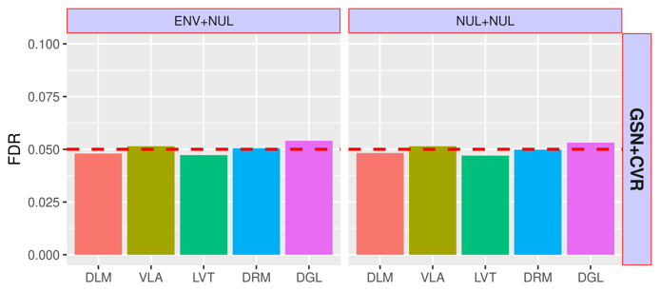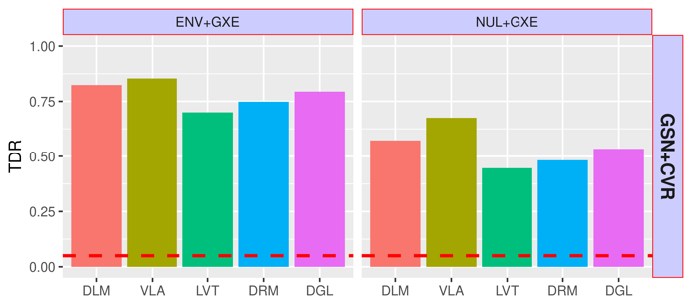
(b)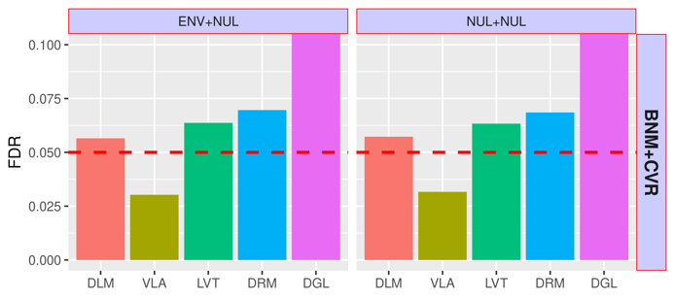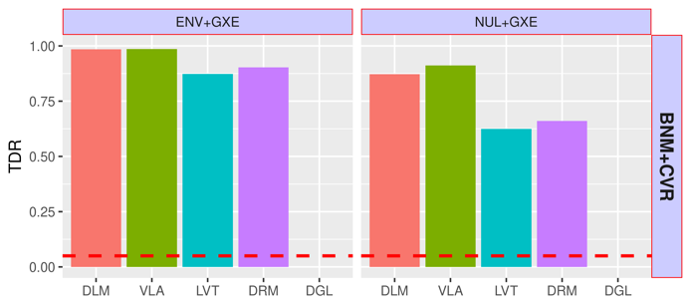
Figure 5: Simulation Studies
Top to bottom: (a) Gaussian phenotype; (b) binary phenotype.
Left: Scenarios 1 and 2, with null GxE, the y-axis shows the FDR.
Right: Scenarios 3 (direct environment effect and GxE) and 4 (pure GxE effect only) .The y-axis shows the TDR.
X-axis: DLM=double linear model; VLA = variance locus/curve upwardness test; LVT=Levene’s test; DRM=deviation regression model; DGL=double generalized linear model.

Figure 5b compares the performance of the five approaches for a binary phenotype. To simulate a binary phenotype, we converted the Gaussian phenotype y to probabilities with a logistic function, π=1+e-y-1, then drew 1 = case and 0 = control from this probability. In scenarios 1 and 2 (Figure 5b, left), where the GxE effects are null, the FDR of DLM, LVT, and DRM was higher than but close to the expected 5%, remaining somewhat under control. The FDR of DGL substantially exceeded 5% and thus DGL was not included in the TDR comparison. The FDR of VLA was conservative but is considered a safe method. In scenarios 3 and 4 (Figure 5b, right), where there are GxE effects, the performance was similar that for a Gaussian phenotype. VLA had better performance concerning the FDR, especially with pure GxE effects as in scenario 4.

Benchmark GxE Enrichment
GxE enrichment measures the likelihood that significant variance loci in a selection population will invoke significant GxE interactions in a discovery population. A positive enrichment enables the use of criteria such as VLA to select GxE candidates. The benchmark is used to compare the enrichment performance of the proposed VLA, the GWAS, and vQTL analysis with DLM.
We first ran GWAS, a variance QTL scan, and VLA on a selection population of 35,3605 unrelated British Whites in the UKBB, with a genome of 11,425,831 autosome variants across 22 autosomes. The phenome includes two binary traits, coronary artery disease (CAD) and type 2 diabetes (T2D), and two quantitative traits, body mass index (BMI) and fasting glucose (GLU). The covariates are age, sex, age², age×sex, age²×sex, the first 20 genetic principal components, and the genotyping array. For comparison, we performed GWAS and vQTL analysis and then ranked the genome variants from the least to the most significant (by log p-value).

UKBB internal GxE enrichment
We performed a two-way GxE scan on a discovery population of 25,481 unrelated non-British Whites in the UKBB, with an exposome with lifestyle (drinking, smoking, and physical activity), neighborhood (green space, water, noise, air quality), and family (i.e., siblings) variables. The GxE analysis covers the same genome, phenotype, and covariate as the selection analysis.

For each variant, we counted the number of significant GxEs for each as a series of p-value thresholds from 10⁻² to 10⁻⁹, with a higher count meaning a variant is involved in more GxEs.
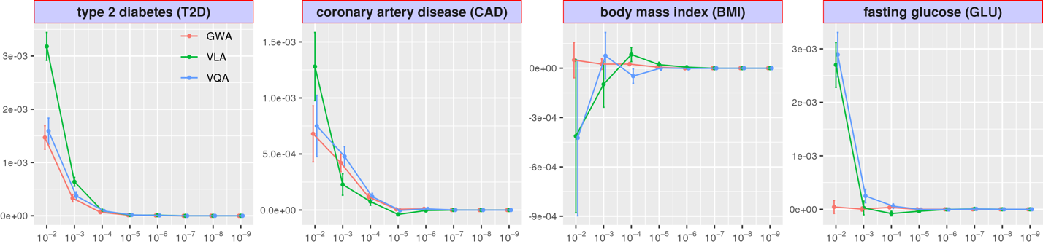We then regressed the counts on the variant rankings according to GWAS, vQTL analysis, and VLA, so the regression coefficient becomes a measure of enrichment. Figure 6 shows the GxE enrichment regression coefficients for GWAS, vQTL analysis, and VLA at several p-value thresholds, where a higher value means better GxE selection performance. For T2D, VLA outperformed GWAS and vQTL analysis for all GxE significance thresholds. For CAD, VLA had the pest performance at the lower thresholds. For BMI, GWAS had no power, and VLA had better performance than vQTL analysis at the medium to high thresholds. For GLU, which is nearly Gaussian, GWAS had no power, and vQTL analysis had the best enrichment, followed by VLA. For binary phenotypes, VLA performed better in general, while the performance of vQTL analysis was nearly the same as that of GWAS, since a mean locus is also a variance locus in these cases. For continuous outcomes, GWAS had the worst performance, while the performance of VLA was nearly the same as for vQTL analysis.
Figure 6: UKBB Internal GxE Enrichment
Given a p-value cut-off, we count the number of significant GxE tests for each genome variant on UKBB non-British Whites and regresses the counts on variant rankings according to GWAS (red), VLA (green), and vQTL analysis (blue) based on UKBB British Whites. The regression coefficients (y-axis) at eight p-value cut-offs (x-axis) are shown, with higher coefficients indicating better enrichment. The error bar shows 2 × standard error.

PEGS External GxE Enrichment
We next performed a two-way GxE scan on an external discovery population of 4,603 unrelated individuals with whole-genome sequencing in PEGS for the three exemplar traits discussed previously: T2D, BMI and CAD. (30). As previously described in (REF OR SUPPLEMENT), participants in PEGS answered extensive questionnaires measuring rich exposome survey data available for 365 parent items on daily life, home environment, and workplace hazards. We again counted the number of significant GxEs at different significance cut-offs for variants and regressed the counts on the rankings given by GWAS, vQTL analysis, and VLA, based on 6,450,592 semi-common variants shared between UKBB British Whites and the PEGS cohort. Because PEGS does not include blood assay data, we used rankings based on GLU in the UKBB to enrich T2D in PEGS. In this way, we were able to assess the usage of quantitative surrogate variance loci to select GxE candidates of T2D, a binary outcome. The use of surrogates has been suggested based on the assumption that significant vQTLs of a quantitative mediator are likely GxE candidates of a downstream binary phenotype (19). Figure 7 shows the enrichment regression coefficients. For T2D and CAD, VLA outperformed GWAS and vQTL analysis at all GxE significance thresholds. For BMI, GWAS had better performance at lower thresholds, vQTL analysis had better performance at higher thresholds, and VLA performed somewhat in between. When using GLU in UKBB as a surrogate for T2D in PEGS, GWAS had the best performance. This indicates that VLA is better suited for binary phenotypes, followed by vQTL analysis and GWAS, which had similar performance.

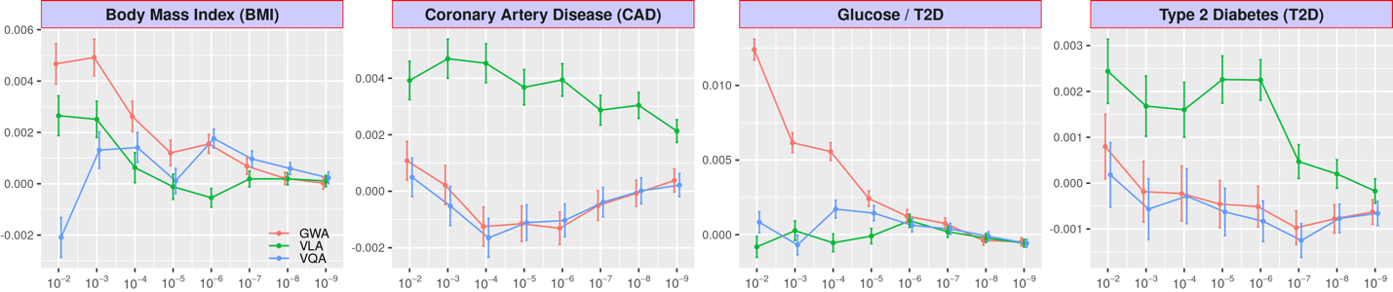
Figure 7: GxE enrichment on PEGS
Enrichment analysis counts the number of significant GxEs for a series of p-value cut-offs and tests each genome variant score in PEGS. It also regresses the count on variant rankings according to GWAS (red), VLA (green), and vQTL analysis (blue) based on British Whites in the UKBB. The regression coefficients (y-axis) at several p-value cut-offs (x-axis) are shown here, with a higher coefficient value indicating better enrichment. The error bar shows 2×standard error.

Investigation of functional enrichment
If VLA, GWAS, or vQTL loci are linked to genome functions, significant variants should reside unevenly in different regions. For example, the loci within or near genes may be more abundant than those between genes. We used the ANNOVAR package (31) to assign a functional class to each variant, such as intergenic or intronic variants. We also calculated the combined annotation dependent depletion (CADD) score (32) for each variant as a continuous measure of pathogenic tendency and regressed the function class and CADD scores on the variant rankings from VLA, GWAS, and vQTL. If the loci are enriched in certain regions, the corresponding regression coefficients should be positive; conversely, if the loci are depleted, the coefficient should be negative. Table 1 shows the functional enrichment coefficients for BMI and T2D. For BMI and T2D, variance loci (from VLA) were highly enriched in intergenic regions while GWAS and vQTL loci were highly concentrated within or near genes. As with CADD scores, variance loci were depleted in regions with high CADD scores, indicating their high pathogenic tendency. Although there were more GWAS and vQTL loci within or near genes, they were more concentrated in non-protein coding segments (i.e., upstream, intronic, and downstream). For the few variance loci located within or near genes, the distribution was relatively flat. Overall, the results indicate that variance loci are likely to take indirect, regulatory roles in genome molecule biology while GWAS and vQTL loci are likely to be more directly involved in producing protein molecules.
For a binary trait such as T2D, the functional distribution of GWAS and vQTL loci was nearly identical due to the high correlation between rankings from GWAS and vQTL. This is also the reason that GWAS and vQTL have overlapping performance regarding GxE enrichment benchmarks. For the continuous outcome of BMI, GWAS and vQTL ranked the variants differently. For CADD scores, the concentration of GWAS and vQTL loci also differs. For both binary and continuous outcomes, the pattern of variance loci is distinct from the pattern of GWAS and vQTL loci, providing a new perspective on the relative importance of each variant in terms of potential interaction.
Body Mass Index |  | GWA | VQA | VLA |  | GWA | VQA | VLA |  | Type 2 Diabetes |  | GWA | VQA | VLA |  | GWA | VQA | VLA
Intergenic |  | --- | --- | ++ | CADD | --- | +++ | - |  | Intergenic |  | --- | --- | +++ | CADD | ++ | ++ | --
Genes | Upstream | ++ | ++ | + |  |  |  |  |  | Genes | Upstream | +++ | +++ | ++
Genes | Intronic | +++ | +++ |  |  |  |  |  |  | Genes | Intronic | +++ | +++ | +
Genes | Exonic |  |  |  |  |  |  |  |  | Genes | Exonic
Genes | Downstream | + | + | - |  |  |  |  |  | Genes | Downstream | +++ | +++ | ++
Table 1: Variant Function Enrichment
The functional enrichment analysis regresses the region type and CADD score of each variant on rankings given by GWAS (red), VLA (green), and vQTL (blue) based on UKBB British Whites. Significant positive and negative regression coefficients are shown by + or -, respectively; the number of symbols denotes the level of significance. Non-significant coefficients are displayed as blank space.

UKBB variance loci catalog
Inspired by the Pan-UK Biobank GWAS catalog at pan.ukbb.broadinstitute.org, we created a catalog of variance loci statistics for UKBB phenotypes and variants. The catalog is a public reference that can be queried by phenotype, enabling the prioritization of candidate variants most likely to invoke significant GxEs. Figure 8 illustrates the workflow of the cataloging process.
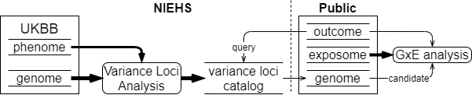
Figure 8: UKBB variance loci catalog workflow
As described in detail in the materials section, we summarized 1,580 health-relevant phenotypes chosen from UKBB data fields accessible to NIEHS plus an additional 1,693 diseases derived from hospital records using PHECODE, a codebook for extrapolating diseases using ICD9/10 records (www.phewascatalog.org) (25, 26) for a phenome comprising 3,273 items. We distinguished the selected UKBB phenotypes into binomial, multinomial, ordinal, and continuous variables and subsequently recoded and normalized them. For the genome, we limited the variants to those with an overall minor allele frequency of at least 0.005, for a final number of 11,841,785 after quality control measures. The methods section provides details of these processes.
For each of the four main racial/ethnic groups in the UKBB (British White, non-British White, Black, and Asian), we performed VLA for the whole phenome and genome to archive variant statistics. We used two R packages designed to traverse genome data and test variance loci for thousands of phenotypes and variants. We divided the genome into approximately 1,200 groups of 1,000 variants each and summarized the VLA statistics for British Whites, the largest group in the UKBB with a working sample size of 384,000, in less than 12 hours, utilizing the computational resources of the NIH HPC Biowulf cluster (hpc.nih.gov). The variance loci catalog provides compressed files for the four main racial/ethnic groups and 3,273 phenotypes on (genelist.niehs.nih.gov).

Methods
We investigated two types of vQTL—additive vQTL captured by DLM and DRM and multiplicative vQTL captured by DGLM and Levene’s test. While the two types of vQTL are related, they represent different perspectives on the origin of GxE effects.
In a discovery cohort in which both exposome variable $u$ and genome variant $g$ are visible, GxE interaction effects are typically captured by adding the two-way product term $ug$ in a linear model,
$y=m_{0}+ag+bug+cu+dx+ e, Var\left(u_{i}\right)=σ_{u}^{2}, e_{i}\sim N\left(0, σ_{e}^{2}\right)$, (1)
where $e$ is the size $σ_{e}^{2}$ of Gaussian noise and $x$ is a non-confounding covariate. The phenotype $y$ remains Gaussian, the environment $u$ is a centered variable with variance $σ_{e}^{2}$, and $u⊥ g$. Model (1) is considered the ground truth of GxE interaction effects.
In an ideal selection cohort in which the joint distribution of all variables is identical to the discovery cohort, the sample size is sufficient, and the environment $u$ is either unobserved or ignored, a typical GWAS can be conducted as:
$y=m_{0}+ag+dx+r$ or $E\left(y | g\right)=m_{0}+ag+dx$. (2)
The unattended part, $bug+cu+e$, becomes the GWAS residual $r$. As a result, the squared residual $r^{2}$ is associated with genotype $g$ because
$r^{2}=b^{2}u^{2}g^{2}+2bcu^{2}g+c^{2}u^{2}+2\left(bug+cu\right)e+e^{2}$, (3)
and $Var\left(y | g\right)=E(r^{2}|g)=b^{2}σ_{u}^{2}g^{2}+2bcσ_{u}^{2}g+c^{2}σ_{u}^{2}+σ_{e}^{2}$. (4)
In (4), variant $g$ models the phenotypic variance, hence the description of $g$ as a “vQTL”. This type of vQTL is an artifact of modeling the additive allele effect (i.e., GWAS) without exposome data, with the assumption that model (1) is the ground truth of GxE effects. Because a variant causes heterogeneity of variance on a linear scale, it can be called an additive vQTL or GxE-induced vQTL.
On the other hand, it can be directly stated that the allele affects the phenotypic variance,
$y\sim N\left(m_{0}+αg,e^{μ+αg+βg^{2}}\right)$ or $\log{Var\left(y | g\right)}=μ+αg+βg^{2}.$ (5)
The exponential ensures variance will never be negative for real values $(μ,α,β)$. Variant $g$ is already a vQTL because each additional allele multiplies the variance by a factor of $e^{α^{'}+{(2g+1)β}^{'}}$ and thus it is called a multiplicative vQTL. Unlike the additive vQTL in (4), the multiplicative vQTL does not depend on a specific construct of GxE interaction as in (1).
The most straightforward way to capture a vQTL is with a DLM, with a stage-1 model identical to (2), that is, a GWAS. The stage-2 model treats the squared residual $r^{2}$ as a phenotype and fits it with the allele dosage, as if it was another GWAS:
$E(r^{2}|g)=a'g+m_{0}^{'}$. (6)
The DLM approximates the full additive vQTL model in (4), omitting the second-order term $b^{2}σ_{u}^{2}g^{2}$ and essentially fitting a straight line through the squared GWAS residual $r^{2}$ across allele dosage $g$. In an ideal situation, where $g{⊥g}^{2}$ holds, the estimated DLM coefficient $a'$ identifies the first-order coefficient $2bcσ_{u}^{2}$ in the full vQTL model (4). Rejecting $h_{0}: α^{'}=2bcσ_{u}^{2}=0,$ the coefficient reveals a GxE candidate because $2bcσ_{u}^{2}≠0$ implies the true GxE effect $b≠0$. In reality, $g$ and $g^{2}$ are correlated, especially when the MAF of $g$ is low. Therefore, the estimated DLM coefficient $a'$ in (5) is a mixture of $b^{2}σ_{u}^{2}$ and $2bcσ_{u}^{2}$ in (4) and runs the risk of mutual attenuation when the true GxE effect $b$ and environmental main effect $c$ have opposite signs. Nonetheless, when $b≠0$ and $g$ is an additive vQTL, the estimated $a'$ is likely to be non-zero and detectable via t-test.
When the phenotype $y$ deviates from a Gaussian distribution, DLM may inflate type 1 errors when the variant is a GWAS QTL. Because a non-Gaussian distribution’s mean and variance are related, a QTL affecting the phenotypic mean is also a vQTL affecting the variance. It is important to note that the squared residual $r^{2}$ in stage-2 models (5) and (6) is a measurement of the sample variation per genotype group, and replacing the genotype variation with the absolute distance from the group median results in DRM. While the DRM method is more robust than DLM for non-Gaussian phenotypes, its use is limited to discrete genotypes because a “group” cannot be clearly defined for a continuous genotype.
A double generalized linear model (DGLM) can capture multiplicative vQTLs. A DGLM is a two-stage model that fits both the mean and variance of a phenotype by genotype,
$μ=E\left(y | g\right)=h\left(m_{0}'+a^{'}g\right), Var\left(y | g\right)=ϕV\left(μ\right), ϕ=k(μ^{'}+α^{'}g)$. (7)
Here, $ϕ$ is the dispersion determined by allele dosage; function $V$ relates the phenotypic mean $μ$ to the variance, for example, $V\left(μ\right)=μ(1-μ)$ for a binary phenotype; and $h$ and $k$ are the inverse link function of the mean and dispersion, respectively. Stage 1 of a DGLM fits the phenotypic mean with allele dosage, where the phenotype is the response variable and the link function is chosen according to the determined phenotypic distribution. Stage 2 models the dispersion, where the unit deviance from stage 1 is treated as the response variable, following a Gamma distribution of a fixed shape and scale equal to the log-linked dispersion,
$D(y,μ)\sim Γ\left(1,ϕ \right)$, $ϕ=e^{μ^{'}+α^{'}g}$, or $logϕ=μ^{'}+α^{'}g$. (8)
When the phenotype is Gaussian, the variance function degenerates to a constant $V\left(μ\right)≡1$, and the unit deviance is the residual square $D\left(y,μ\right)=r^{2}={\left(y-μ\right)}^{2}$. In this special case, stage 2 of the DGLM does fit the logged phenotypic variance with the allele dosage,
$r^{2}\sim Γ\left(1,e^{μ^{'}+α^{'}g}\right), logE\left(r^{2} | g\right)=logVar\left(y | g\right)=μ^{'}+α^{'}g$, (9)
which approximates the multiplicative vQTL model in (5), omitting the second-order term $β^{'}g^{2}$. We consider Levene’s test a multiplicative vQTL scan because the formation of Levene’s test statistic does not depend on a specific parameterization of GxE.
In this study, we prefer the additive perspective (4) over the multiplicative perspective (5) as the basis of improvement because we rely on model (1) to capture significant GxEs in a discovery dataset. The construct of additive vQTL is a natural consequence of unaccounted GxE effects in model (1) and thus additive vQTLs are used to select GxE candidates specifically in model (1). Multiplicative vQTLs, on the other hand, do not depend on the parameterization of environmental and GxE effects and thus multiplicative vQTLs do not necessarily select GxE candidates in model (1). Forcibly viewing this from an additive vQTL perspective demonstrates the lack of specificity of multiplicative vQTLs on GxEs for a Gaussian phenotype, as shown in model (5),
$Var\left(y | g\right)=\exp\left(μ+αg+βg^{2}\right) =\left(σ_{\tilde{e}}^{2}+{\tilde{c}}^{2}σ_{\tilde{u}}^{2}\right)+2\tilde{b}\tilde{c}σ_{\tilde{u}}^{2}g+{\tilde{b}}^{2}σ_{\tilde{u}}^{2}g^{2}$,
where the left side is the multiplicative vQTL model for Gaussian distribution (5), the right side is the full additive vQTL model (4); $\tilde{u}$ and $\tilde{e}$ are latent noise and environmental effects with variance $σ_{\tilde{u}}^{2}$ and $σ_{\tilde{e}}^{2}$, respectively; and $\tilde{b}$ and $\tilde{c}$ are the effect sizes of latent GxE interactions and environmental main effects, respectively. Expanding the left-hand side at $g=0$, we acquire an approximated additive vQTL model,
$\left(σ_{\tilde{e}}^{2}+{\tilde{c}}^{2}σ_{\tilde{u}}^{2}\right)≈e^{μ}$, $2\tilde{b}\tilde{c}σ_{\tilde{u}}^{2}≈αe^{μ}$, ${\tilde{b}}^{2}σ_{\tilde{u}}^{2}≈0.5\left(α^{2}+2β\right)e^{μ}$,
where $\left(σ_{\tilde{e}}^{2}+{\tilde{c}}^{2}σ_{\tilde{u}}^{2}\right)≈e^{μ}$ is the part of phenotypic variance not affected by allele dosage. Because the construct of Gaussian multiplicative vQTLs in (5) requires only $\left(μ,α,β\right)∈R^{3}$, it is possible to encounter a situation in which ${\tilde{b}}^{2}σ_{\tilde{u}}^{2}≈0.5\left(α^{2}+2β\right)e^{μ}<0$. In this case, the latent GxE interaction effect $\tilde{b}$, as well as the latent environmental main effect $\tilde{c}$, are non-real because $2\tilde{b}\tilde{c}σ_{\tilde{u}}^{2}$ produces the real value $αe^{μ}$. Multiplicative vQTL captures a broader class of GxE effects that are cannot be fully represented by the common discovery model (1) in real space. Selecting GxE candidates for (1) with multiplicative vQTL in (5) would inflate type 1 errors. In practice, multiplicative modeling typically omits the second-order term $βg^{2}$ (i.e., DGLM). In this case, we fix $β≡0$ and, as a result,
${\tilde{b}}^{2}σ_{\tilde{u}}^{2}≈0.5α^{2}e^{μ}$,
which avoids unreal GxE effects size $b$. However,
$\frac{{\tilde{b}}^{2}σ_{\tilde{u}}^{2}}{2\tilde{b}\tilde{c}σ_{\tilde{u}}^{2}}=\frac{\tilde{b}}{2\tilde{c}}=\frac{0.5α^{2}e^{μ}}{αe^{μ}}=\frac{α}{2}$ or $\frac{\tilde{b}}{\tilde{c}}=α$.
An implicit constraint is that the ratio between latent GxE and environmental main effects must be $α$—the coefficient of the first-order multiplicative vQTL effect, which means the solution space of $\left(b,c\right)$ cannot be fully accounted for in the common GxE discovery model (1). Using the restricted multiplicative vQTL model (9) to select GxE candidates for model (1) would result in a loss of power.
We chose DLM as the basis for improvement. Under the ideal circumstance of $g{⊥g}^{2}$, the allele dosage term $α'g$ in stage 2 of the DLM (6) maps to the equivalent term $2bcσ_{u}^{2}g$ in the full additive vQTL model (4). The DLM identifies $b≠0$, that is, a GxE candidate, when $h_{0}: α^{'}=2bcσ_{u}^{2}=0$ is rejected. Replacing the allele dosage term with squared allele dosage results in:
$E(r^{2}|g)=β^{'}g^{2}+m_{0}^{'}$. (10)
The term $β^{'}g^{2}$ maps to the equivalent term $b^{2}σ_{u}^{2}g^{2}$ in the full additive vQTL model (4), and a GxE candidate is detected when $h_{0}: β^{'}=b^{2}σ_{u}^{2}≤0$ is rejected. A single-tailed test is used because $b^{2}σ_{u}^{2}$ should be non-negative. The proposed method is VLA. It is immediately clear that the VLA test statistic $β^{'}=b^{2}σ_{u}^{2}$ relies on the actual GxE effect size $b$ alone, but the DLM test statistic $α^{'}=2bcσ_{u}^{2}$ is determined by both GxE effect $b$ and environmental main effect $c$. As a result, DLM lacks power under weak environmental main effects, that is, $α^{'}=2bcσ_{u}^{2}→0$ when $c→0$, but VLA is unaffected. In other words, VLA is more sensitive to pure GxE effects. Model (10) essentially fits a curve through the squared GWAS residual $r^{2}$ across allele dosage $g$, and the null $h_{0}: β^{'}=b^{2}σ_{u}^{2}≤0$ tests the upwardness of the curve (Figure 2). This is accomplished by taking the derivative on both sides of (10) with respect to allele dosage,
${∂E(r^{2}|g)}/{∂g} =2β^{'}g$. (10)
When $β^{'}≤0$ is rejected, the curve fit through squared GWAS residual $r^{2}$ bends upwards with each additional allele.
In practice, allele dosage $g$ is rarely perpendicular to squared dosage $g^{2}$. In cases of extremely low MAF, $g$ and $g^{2}$ can be colinear. As a result, the expected DLM coefficient $α^{'}=2bcσ_{u}^{2}$ and the expected VLA coefficient $β^{'}=b^{2}σ_{u}^{2}$ blend into each other, either boosting or diminishing power to detect $b≠0$ when $b$ and $c$ have the same or opposite signs. However, DLM still has power to select GxE candidates with null environmental main effects ($c=0$). To ensure the reliability of VLA, we limit the analysis to variants with MAF > 0.01.
When the phenotype is not quantitative but binary, a locus of phenotypic mean is automatically a locus of phenotypic variance because the mean $μ$ and variance $v$ of a binary variable are related by $v=μ(1-μ)$. Thus, a GWAS significant variant would be a DLM significant variant in the absence of interaction, causing uncontrolled type 1 errors if GxE candidates are selected via variance loci. These type 1 error cannot be resolved by using DRM or a multiplicative model such as Leven’s test or DGLM, despite the fact that DGLM supposedly handles binary phenotypes with the logit link. Therefore, current variance heterogeneity-based approaches are limited to quantitative trait loci, hence the term quantitative trait loci.
VLA counters the inflated type 1 errors encountered with null GxEs because the curve fit by the stage 2 model (10) through the squared residual of stage 1 (i.e., the GWAS) is either flat, when the variant has no effect on the phenotypic mean, or bends downwards, when the variant does affect the mean. However, VLA is conservative because the curve would not bend upwards in the presence of a GxE. It is essential to use well-chosen covariates to recover innate risk. With covariates that are non-heritable (i.e., non-confounding) but highly predictive of the binary phenotype, the recovered risk (i.e., the covariate residuals) act as a numerical phenotype, giving VLA the power to detect GxE candidates while controlling type 1 errors. Because the recovered risk can be seen as quantitative traits, they improve the performance of DLM, DRM, and multiplicative vQTL methods with binary phenotypes. However, these methods do not guarantee full control of type 1 errors.

Material

UK Biobank (UKBB)
We used UKBB data to evaluate the performance of VLA in selecting GxE candidates and compare it with other methods. The UK Biobank (33) is a large-scale resource consisting of genetic and health information for over half a million participants (Application ID: 57849, version 2) collected via questionnaires, electronic health records, biological samples, oral interviews, imaging, and genotype data.
Of the 502,505 participants, 488,366 (97.2%) were genotyped with the UK BiLEVE or Axiom micro-array, covering 805,426 autosomal, X/Y, and mitochondrial variants, and 487,411 (97.0%) had imputed whole-genome sequencing (WGS) genotype covering 97,059,328 autosomal and X variants, based on the Haplotype Reference Consortium (HRC) panel for mixed ancestry (22).

Genotype
We created a comprehensive catalog of the whole genome using the imputed genotype. We began with 97,059,328 imputed variants and applied the following quality control steps for 487,411 individuals: 1)
dropped variants with an imputation information score < 0.3; dropped variants with overall minor allele frequency < 0.005; and d

ropped variants with duplicated IDs, or multi-allele variants.
After these quality control steps, 11,939,376 (12.8%) variants remained with no excluded individuals. The imputation information score and minor allele frequency are precalculated metadata downloadable as UKBB resource 1671 (https://biobank.ctsu.ox.ac.uk/crystal/refer.cgi?id=1671). The imputation information score ranges from 0 to 1 and represents the posterior probability of observing an imputed genotype. The closer a score is to 1, the higher the likelihood of observing an imputed genotype. Of the removed variants, 87.2% were due to low MAF. While a stringent lower-bound MAF ≥ 0.01 is recommended to ensure the validity of VLA, a more relaxed MAF ≥ 0.005 helps buffer the fluctuation in MAF due to the subsequent removal of samples and variation in working sample sizes across analyses.
We excluded individuals with poor genotyping due to abnormal heterozygosity and high missing rates, indicated by UKBB field 22027. The kinship pairs were identified from the micro-array genotypes using KINGSOFT and are available in a table downloadable using UKBB’s gfetch tool with parameter “rel”. Details on gfetch are available as UKBB resource 668 (https://biobank.ctsu.ox.ac.uk/crystal/refer.cgi?id=668). Additional details about the genotypes are available from UKBB category 263 (https://biobank.ctsu.ox.ac.uk/crystal/label.cgi?id=263). To break up kinship pairs, we removed one individual from each pair of related individuals. Of 487,411 individuals with an imputed genotype, 405,432 (83.2% and 80.1% of the total 502,505) remained, representing unrelated individuals with high-quality micro-array genotyping.
We divided the remaining samples into four major ancestry groups based on UKBB data field 21000, as summarized below:
- afr: African (3,100, code 4002)
- asi: non-Chinese Asian (8,668, code 3001, 3002, 3003, and 3004)
- bri: White British (35,3605, code 1001)
- iri: Irish (10,619, code 1002)
- wnb: White, but non-British (25,481, code 1002, and 1003 - any other white background)
After ancestry division, we removed 29,440 individuals who belonged to an ethnic group with a small sample size (e.g., Chinese, with a sample size of 1,574) or had an unclear background. This left 375,992 individuals (77.1% of 487,411 with imputed genotypes and 74.8% of the total 502,505). The afr, asi, bri, and iri groups serve as the basis of the NIEHS VLA Catalog, and the bri and wnb groups serve as training and testing datasets, respectively, to enable comparison of the performance of methods.

Phenotype
Our study relies on the baseline data collected at UKBB participants’ first visit. We manually compiled several phenotypes, summarized in table 2.

Type 2 diabetes (T2D)
We defined T2D cases as individuals who selected 1223 (type 2 diabetes) in the “self-reported non-cancer illness” field (field 20002); had E111–119 (various non-insulin-dependent diabetes) in “ICD 10 diagnosis” (field 41270); or had 25000, 25010, 25020, or 25090 (types of adult-onset diabetes) in “ICD 9 diagnosis” (field 41271). We assigned the rest to the control group by default. Among the controls, we assigned missing values to type 1 diabetes and unspecified diabetes cases, defined as those who answered “yes” to the question, “Has a doctor ever told you that you have diabetes?” (field 2443); chose 1220, 1221, or 1222 in the “self-reported non-cancer illnesses” field (field 20002); had E101–109 (types of insulin-dependent diabetes) in “ICD 10 diagnosis” (field 41270); or had 25001, 25011, 25021, or 25091 (types of juvenile diabetes) in “ICD 9 diagnosis” (field 41271).

Coronary artery disease (CAD)
Following Klarin et.al.(Klarin et al., 2017), we defined CAD cases as individuals who selected 1075 (heart attack/myocardial infarction) in the "non-cancer illnesses" field (field 20002); had I211, I212, I214, or I219 (types of acute myocardial infarction) in "ICD10 diagnosis" (field 41270); or had K401-404, K411-414, K451-454, K491, K492, K498, K499, or K751-754 (procedures to treat CAD) in "OPCS4 operative procedures" (field 41272). We assigned the rest to the control group by default. There were 24,907 CAD cases and 477,598 controls. There were no missing values because field 20002 is available for all participants.

Body mass index (BMI)
We took BMI from the body composition estimation by impedance measurement (field 23104). We considered values < 18 or > 48 outliers, with the two cut-off points the 0.25 and 99.75 percentiles rounded to the nearest integer. There were 12,550 missing values, among which 2,413 were outliers.

Fasting glucose level (GLU)
We took GLU from UKBB field 30740 without transformation and excluded individuals with reportability issues according to field 30746 (i.e., a value unequal to 1). This resulted in 429,567 measurements, with a mean of 4.93 and a standard deviation of 1.24.
 | description | N | min | median | mean | max | histogram
BMI | Body Mass Index | 489955 | 18.0 | 26.7 | 27.4 | 48.0 | 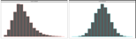
CAD | Coronary Artery Disease | 502505 | 0.0 | 0.0 | 0.0 | 1.0 | 
GLU | Blood Fasting Glucose | 429567 | 1.0 | 4.9 | 5.1 | 36.8 | 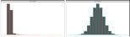
T2D | Type 2 Diabetes | 493619 | 0.0 | 0.0 | 0.1 | 1.0 | 
Table 2. UK Biobank Phenotypes Used
Note: the histogram shows distributions prior and after normalization, only the latter enters analysis.

Environment
To compare the performance of enriching GxE discovery by GWA, VLA, and VQA, we prepared GxE analysis for several environments in UKBB, summarized in table 3.

Number of Siblings (SIB)
The SIB is the sum of brother (field 1873) and sisters (field 1883), if either is unreported, the other is taken as the sum and assigned to SIB, if both are unreported, a missing value is assigned to SIB.

Physical activities in Metabolic Equivalent Minutes (MET)
The MET is the weighted sum three sets of UKBB variables, calculated MET = 3.3 × days/week walked 10+ minutes (field 864) × duration of walks (field 874) + 4.0 × days/week of moderate physical activities 10+ minutes (field 884) × duration of moderate activities (field 894) + 8.0 × days/week of vigorous physical activities for more than ten minutes (field 904) × duration of vigorous activities (field 914). (Marderstein et al., 2021) If an activity is less than 10 minutes, that activity is given a duration of 0. If any of the activities is missing, the MET is treated as missing.

Sedentary lifestyle (SDN)
The SDN is the sum of hours spent watching TV per day (field 1070), hours spent using computer per day (field 1080), and hours spent driving per day (field 1090)(Marderstein et al., 2021). If a time is less than one hour per day, that time is set to 0. If any of the three times is missing, the SDN is treated as missing.

Smoking (SMK)
The SMK is directly taken from UKBB variable “ever smoking” (field 20160).

Alcohol Drinking (ALC)
ALC is the combined per week alcohol consumption (units/week) at baseline. We begin with alcohol intake frequency (field 1558), those who chose 1=daily or almost daily, 2=three or four times a week, or 3=once or twice a week, are assigned a combined weekly frequency of 1 × red wine (field 1568) + 1 × champagne plus white wine (field 1578) + 2 × beer plus cider (field 1588) + 1 × spirits (field 1598) + 1 × fortified wine (field 1608), that is, beer plus cider is considered 2 units/week; in a similar manner, those who reported 4=one to three times a month or 5=special occasions only for alcohol intake frequency (field 1558), are given a combined monthly frequency of 1 × red wine (field 4407) + 1 × champagne plus white wine (field 4418) + 2 × beer plus cider (field 4429) + 1 × spirits (field 4440) + 1 × fortified wine (field 4451), followed by the weekly frequency derived as units/week = units/month × 12 months/year ÷ 52 weeks/year; lastly, those who chose 6=never for alcohol intake frequency (field 1558) are assigned 0 to ALC; those did not report alcohol intake frequency (field 1558), or those who reported weekly or monthly intake but did not give any of the five specific alcohol products, are treated as missing for ALC. The unit per each type of alcohol product is based on Table 1 of the survey guidelines released by the UK Office for National Statistics(Goddard, 2007).

Neighborhood Traffic (TRF)
The TRF is defined as: traffic intensity on the nearest road (field 24009) × inverse distance to the nearest road (field 24010) + traffic intensity on the nearest road (field 24011) × inverse distance to the nearest major road (field 24012). If any of the basic values are missing, the TRF is treated as missing.

Nitrogen oxides (NO1)
The NO1 level is taken from residential nitrogen oxides air pollution of year 2010 in micro-g/m³ (field 24004).

Nitrogen dioxides (NO2)
The NO2 level is the average of residential nitrogen dioxides air pollution of year 2005 (field 24016), 2006 (field 24017), 2007 (field 24018), and 2010 (field 24003). If any of the four years is missing, the averaged NO2 is treated as missing.

Particulate matter air pollution, 10μm (P10)
The P10 level is the average residential PM10 of year 2007 (field 24019) and 2010 (field 24005) measured in micro-g/m³. If any of the two years is missing, the averaged P10 is treated as missing.

Particulate matter air pollution, 2.5μm (P25)
The P25 level is taken from residential PM2.5 of year 2010 (field 24006) measured in micro-g/m³.

Noise pollution (NOI)
The NOI level is the sum of average daytime, evening, and night-time sound level of noise pollution (field 24020, 24021, and 24022) measured in DB.

Neighborhood exposures
Several variables are included: green space percentage (GSP) buffer 1000m (field 24500), domestic garden percentage (DGP) buffer 1000m (field 24501), water percentage (WTP) buffer 1000m (field 24502), natural environment percentage buffer 1000m (field 24506), and distance to the coast (SEA) in kilometers (field 24508).
 | description | N | min | med | mean | max | 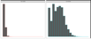  histogram
alc | Weekly alcohol intake | 427697 | 0.0 | 8.0 | 11.9 | 603.0
dgp | Domestic Garden percentage | 440874 | 0.1 | 24.3 | 24.3 | 66.1 | 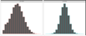  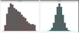
gsp | Green Space percentage | 440874 | 4.4 | 41.5 | 45.0 | 99.2
met | Metabolic Equivalents Minute | 498628 | 0.0 | 1386.0 | 2553.7 | 125118.0 | 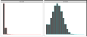
nep | Nature Environment percentage | 497542 | 0.0 | 36.6 | 40.5 | 100.0 | 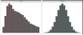
no1 | Nitrogen Oxides | 495124 | 19.7 | 42.4 | 44.1 | 265.9 | 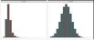  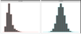
no2 | Nitrogen Dioxide | 495124 | 5.1 | 21.3 | 22.4 | 98.6 | 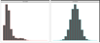
noi | Noise | 495124 | 46.7 | 50.1 | 51.2 | 88.5
pm1 | Air pollution, PM10 | 495113 | 5.9 | 19.0 | 18.6 | 30.5 | 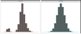
pm2 | Air pollution, PM2.5 | 461201 | 8.2 | 9.9 | 10.0 | 21.3 | 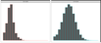
sdn | Sedentary behaviors | 500967 | 0.0 | 4.0 | 4.5 | 48.0 | 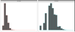
sea | Closeness to sea | 497542 | 0.0 | 44.0 | 41.6 | 108.0 | 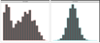  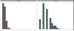
sib | Number of siblings | 493402 | 0.0 | 2.0 | 2.2 | 44.0 | 
smk | Ever smoke | 499620 | 0.0 | 1.0 | 0.6 | 1.0
trf | Traffic intensity | 495124 | 0.8 | 78.2 | 172.6 | 100810.0 | 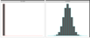  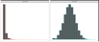
wtp | Water percentage | 440874 | 0.0 | 0.5 | 1.3 | 59.4
Table 3. UK Biobank Environments
Note: the histogram shows distributions prior and after normalization, only the latter enters analysis.

Phecodes
We used UKBB phenotype data recorded in multiple fields for our analyses. These phenotypes include integer, continuous, unordered categorical, and dummy-encoded categorical variables. We also used phenotype and disease diagnostic codes from electronic health record (EHR) data in the UKBB recorded as ICD9 and/or ICD10 codes to derive phecodes. International Classification of Diseases (ICD) codes are used to record diagnoses, signs and symptoms, abnormal findings, and injuries. ICD codes are used globally by to track morbidity and mortality data in more than 100 countries (34) but do not provide an appropriate level of granularity for phenotypes relevant for genetic association studies. Phecodes are manually curated groups of ICD codes aggregated into a distinct medical concept, disease, or phenotype intended to capture clinically meaningful concepts for research (35). Phecodes provide embedded case-control definitions based on exclusion criteria for controls and enable the rapid characterization of large numbers of phenotypes. They are widely used for phenotyping participants with EHR data, especially for genetic association studies(35, 36). Studies have shown that using phecodes for genetic association studies produces superior results compared to ICD and Clinical Classification Software (CCS) codes (37-39).
WE mapped the ICD9 and ICD10 codes in the UKB to phecodes using the phecode mapping from the PheWAS catalog (37, 40). We used the createUKBphenome scripts (https://github.com/umich-cphds/createUKBphenome) to create this mapping. First, we mapped ICD9/10 codes to phecodes using Phecode Map v1.2 and the inclusion/exclusion criteria for each phecode. We subsequently collected and harmonized the ICD codes in the UKBB and extracted all participant ICD codes. Finally, we mapped the harmonized ICD codes to phecodes using Phecode Map 1.2 to create a phenome consisting of binary case-control data for each phecode. We excluded participants whose genetic sex did not match their self-reported sex. We were unable to map 162 ICD9 codes and 2,294 ICD10 codes to phecodes. This mapping produced a binary case-control phenome dataset with 1,694 phecodes for 487,891 UKB participants, which we used for our subsequent VLA analyses.

PEGS

Exposome data
PEGS participants complete a self-administered Health and Exposure Survey and a two-part Exposome Survey. The Health and Exposure Survey requests general health, lifestyle, and occupational exposure information as well as individual and family medical histories (n=9,414). Part A of the Exposome Survey requests information on exogenous exposures throughout life, including but not limited to chemical and environmental exposures at home and work (n=3,519), and Part B requests information on endogenous exposures such as medication as well as lifestyle factors, including sleep patterns, stress, physical activity, and diet (n=2,962).
Previously validated surveys were used to formulate the surveys, including the National Health Information Survey and the National Health and Nutrition Examination Survey (NHANES) for the Health and Exposure Survey and the PhenX Toolkit, NHANES questionnaire, validated scales such as Cohen’s Perceived Stress Scale, and forms from NIEHS, NIH, CDC, and the Agency for Toxic Substances and Disease Registry for the Exposome Survey. The questionnaires administered to PEGS participants are available online at https://www.niehs.nih.gov/research/clinical/studies/pegs/about/data/index.cfm.

Phenotypes

Coronary artery disease (CAD)
We defined CAD cases as participants who indicated on the Health and Exposure Survey that they have experienced a heart attack or myocardial infarction or told by a doctor that they have CAD. We assigned rest of the participants to the control group by default. We then excluded participants with any of the following conditions from the control group: hypertension, high cholesterol, atherosclerosis, cardiac arrhythmia, angina, congestive heart failure, poor blood flow, blood clots, angioplasty, and stroke.

Type 2 diabetes (T2D)
While the Health and Exposure Survey asks participants whether they have been diagnosed with diabetes, their age at diagnosis, and current and past treatments, it does not ask about diabetes type. To define type 2 diabetes cases in the PEGS cohort, we used a cut-off of 20 years at age of diagnosis to differentiate between type 1 and type 2 diabetes, with the assumption that most individuals with type 1 diabetes are diagnosed before this age. We excluded participants who indicated they had been diagnosed with gestational diabetes.

Whole-genome sequencing
The Broad Institute sequenced all samples on the NovaSeq 6000 platform with a target genome-wide read depth of 30x (24 samples per flow cell) and processed reads with its gatk4-genome-processing-pipeline version 1.0.0 (github.com/gatk-workflows/gatk4-genome-processing-pipeline) (41). Reads were aligned to the hg38 reference genome with bwa mem 0.7.15-r1140 [2], Picard Tool MarkDuplicates 2.20.4 was used to flag duplicate fragments, and GATK 4.0.10.1 ApplyBQSR was used to perform base quality score recalibration.
GATK 3.5.0 HaplotypeCaller was employed for variant calling for each sample, with output in g.vcf format. GATK 4.1.4.0 GenotypeGvcfs was used for joint genotyping, and GATK 4.1.1.0 VariantFiltration was subsequently used for applying filtering flags. Following this, GATK 4.1.1.0 ApplyVQSR was used for variant quality score recalibration. A “PASS” filter label was assigned to variants with an excess heterozygosity phred score ≤ 54.69 and a VQSLOD score exceeding the threshold of retaining 99.0% of true positive indels and 99.7% of true positive SNPs.

Quality control analysis
samtools flagstats was used to determine the total read count and proportion of duplicate fragments (42). samtools idxstats was employed to determine the percentages of reads mapping to the mitochondrial genome and chrY, along with the ratio of reads mapped to chrX per bp relative to the genome-wide rate. FastQC 0.11.9 was used to determine the aggregate %GC, separately for mate 1 and mate 2 reads. The maximum deviation of mean per-cycle sequence content from genomic background rates of 20% for G/C and 30% for A/T was determined from the FastQC output. The first nine cycles were excluded because of anticipated large deviations. Percentages of reads with mapping quality below 5 and 10 were directly derived for each sample from the MAPQ field of sample CRAM files. Preliminary unfiltered GATK joint genotypes were called in batches of samples sequenced and processed in tandem. SNP counts, indel variants, the mean and standard deviation of variant genotype qualities, and major allele frequencies (calculated separately for homozygous and heterozygous genotypes) were derived from these preliminary calls.
Estimates of genomic proportions derived from Asian, Amerindian, European, and African ancestors were determined using ancestry informative markers and the genotypes of individuals with known ancestry (reported in Table S6) in Kosoy et al. (43). Using Plink 1.90b4.3, genotypes called at these loci for each sample were extracted and independently merged with individuals of known ancestry (28). The genotypes were subsequently analyzed using fastStruture version 1.0 (44) with four specified ancestral populations (-K 4). fastStructure estimates genome proportions derived from unlabeled ancestral populations were inferred from the given data. For each estimated population, continental associations were determined by separately calculating mean proportions for individuals of known ancestry and pairing proportions ≥ 0.9. The analysis was repeated for rare cases in which fastStructure’s non-deterministic algorithm did not separate individuals with known ancestry in a way that a known population could be assigned as described to an inferred population.
Table SX provides the quality analysis results. For some individual samples, the GC-content and fractions of reads mapped to chrY were higher than expected. For a small proportion of the genome, the target of 30x coverage was surpassed. Because these features were not associated with increased novel variant calls or reduced genotype quality estimates, no individual samples were excluded from further analysis. Manually comparing estimated ancestral genome proportions with self-reported race and ethnicity and examining ratios of chrX to genomic coverage and fractions of reads mapped to chrY in the context of self-reported sex indicated no mislabeling or swapping of samples.

Genotype calling
Variant calling was performed separately with DeepVariant 0.9.0 (41) using default parameters for confirmation of the Broad Institute’s joint genotype calls. As part of the analysis, reads with unmodified, instrument-assigned base quality scores were mapped to the hg38 reference genome using bwa mem version 0.7.17. Duplicate fragments were flagged using Picard tools MarkDuplicates 2.21.2. For 89 samples in the pilot sequencing run, unmodified quality scores were unavailable. DeepVariant analyses were performed with hg38 alignments provided by the Broad Institute. Using Illumina hap.py version 0.3.7, genotypes called with the GATK pipeline were compared to DeepVariant calls, with GATK results as the “truth” set and DeepVariant results as the “query” set. For the final genotypes, any GATK genotype confirmed by DeepVariant was accepted regardless of filter status. Additionally, all unconfirmed GATK homozygous reference genotypes with “PASS” filter status and all unconfirmed GATK variant genotypes with “PASS” filter status and a GQ score ≥ 70 were accepted. A filtering step removed variants with cohort allele frequency < 0.001. The remaining variants were annotated with WGSA pipeline version 0.8 (45) based on the tool’s precomputed hg38 resource catalog. Ensembl gene annotations were employed for this annotation. Table SX outlines the full set of annotations.

Participant filtering
In addition to the quality control steps, we compared the number of variants identified for each PEGS participant to the number determined in a parallel analysis of the same data based on the hg19 genome assembly. We excluded three samples from downstream analysis because they displayed very low hg38-based variant counts and average to very high hg19-based variant counts and, within the QC data, were outliers in terms of the variability of the observed allelic fractions at loci with heterozygous genotype calls. This indicates the WGS results may have been derived from a mixture of DNA from two individuals.
The quality control process included a visual inspection of the relationship between the percentage of total reads mapping to chrY and the ratio of mean chrX coverage to the genomic mean to infer sex chromosome copy numbers. Most participants fell into clusters indicative of an XX or XY karyotype that matched the expected copy number given their self-reported sex. A self-reported male with Klinefelter syndrome fell close to the XX cluster as anticipated but displayed a higher than expected %chrY. Additionally, one self-identified male’s %chrY value was more than double that of most falling in the XY cluster, and two self-identified female’s chrX ratios were close to 1.5. These observations were interpreted to indicate XYY and XXX karyotypes, respectively. Due to the indication of a sex chromosome aneuploidy, these four samples were excluded from downstream analyses.
To mitigate confounding effects of undisclosed or unknown relatedness among participants in the PEGS cohort, KING 2.2.5 [2] was used to generate a matrix of pairwise kinship coefficients to analyze individual genotypes. To ensure the cohort contained no third-degree or closer relatives (kinship coefficient threshold = 0.0884), the “relatednessFilter” function in the plinkQC R package 0.3.3 was then utilized to identify a parsimonious set of 120 individuals who were excluded from downstream analyses.

Principal Components Analysis
WILL NEED A BRIEF DESCRIPTION HERE

Gene-Environment Interaction Analysis
WILL NEED TEXT HERE

Discussion
Comparisons of risk allele frequencies across diverse populations have established appreciable directional differentiation for blood lipid and T2DM risk allele frequencies [55,56]. The decreasing frequencies of some T2DM risk alleles seen along an eastward arc from Africa to eastern Asia supplement disparities in predicted genetic risk, such that a portion of T2DM genetic risk is consistently elevated for individuals in African populations and lower in Asian populations [56], but this is somewhat controversial [57]. Accordingly, and considering that geography and climate strongly influence available foodstuffs, seasonally directed energy expenditures and other nutrition-centric human activity [13], we sought to identify those GxE SNPs that show evidence for positive selection.
Three resources were used to investigate relationships between cardiometabolic GxEs and adaptation to climate and geography. First, two genome-wide studies have examined associations between genetic variants and climatic and geographical characteristics, including latitude, seasonality, precipitation, solar radiation and temperature [58,59]. Second, a collection of genes was identified as under selection in different human populations with roles in cultural practices, often with rationales pertinent to agriculture, diet and societal behaviors [60]. Third, a number of other studies have assessed adaptation at candidate loci for specific phenotypes and we chose to examine those germane to cardiometabolic traits. From these reports, we found that 25 of 189 different genes supporting cardiometabolic GxE interactions show adaptation to climatic and geographical characteristics (Table 1). Just 23 of 453 loci participating in main effect associations for these cardiometabolic traits, as mined from the GWAS catalog [45], show adaptation to climate and geography features, indicating significant enrichment in the GxE dataset (p <0.001, two sample z-test).
  - How does the level of over-representation across any category compare to over-representation of that category from results from mQTL GWAS (either our own, or the GWAS catelogue)
  - Tissue based e-QTLs
  - Epigenetics: how many vQTLs create or destroy a CpG dinucleotide, compared to random SNPs
- Compare to CardioGXE, CTD as manually curated vs computationally driven, SNPXE from GWAS catalogue
- Check for phantom vQTL effects like in the Visscher paper

Notes to ourselves:
- Compare our vQTLs to those found by Visscher for 13 traits?
- https://advances.sciencemag.org/content/5/8/eaaw3538
- Functional categories/annotations
  - Clinical genomic catalogue?
  - GWAS catalogue (SNPs in LD to things in the GWAS catalogue?)
  - PheGenI phenotype-genotype integrator?
  - Test for GxE variants under positive selection

Points for Discussion:
While it certainly may be stated that a person’s ‘genometype’ could indeed prove the most useful for individualized medicine (including individualized nutrition) and personal genetics [89], the impact of environmental interactions on a person’s panel of alleles cannot be overstated. In this regard, an interaction between an obesity genetic risk score based on 63 variants and saturated fat intake has been demonstrated in two distinct populations [90]. We have not in this analysis coalesced the genetic variants cataloged in CardioGxE around a given phenotype-environmental factor pair and processed data for a global or genometype GxE interaction, but such research could proceed with the aid of this GxE resource. Indeed, the lack of overlap between our CardioGxE dataset and published GWAS for comparable phenotypes makes evident the utility of incorporating GxEs into assessment of disease risk in two important ways. One, a GxE catalog provides the means to develop a better strategy of intervention because genetic and environmental factors combined can equip the physician for more accurate prediction of future disease risk and hence disease prevention. Two, genetic variation alone is not just diagnostic of disease risk, but is a component of and should be considered in epistatic and GxE interactions to better inform the individual of potential disease risk. Altogether, the numerous examples presented here add to the emerging view that GxEs are widespread and significant contributors to phenotypic variance [91]. Although we have highlighted instances for which more data are needed, especially taken under conditions mimicking the environmental factor of the GxE equation, the insight thus far garnered from analysis of a large GxE catalog emphasizes the influential roles of environmental factors in the genetics of complex traits, particularly those of a metabolic nature.
Talk about the impact of unbalanced case / control ratio on power and type 1 error, and solutions.
Talk about why GWAS still works as a selector.

References

1. Bouchard C, Rankinen T. Individual differences in response to regular physical activity. Med Sci Sports Exerc. 2001;33(6 Suppl):S446-51; discussion S52-3.
2. Eid A, Mhatre I, Richardson JR. Gene-environment interactions in Alzheimer's disease: A potential path to precision medicine. Pharmacol Ther. 2019;199:173-87.
3. Kaul N, Ali S. Genes, Genetics, and Environment in Type 2 Diabetes: Implication in Personalized Medicine. DNA Cell Biol. 2016;35(1):1-12.
4. Ordovas JM, Shen J. Gene-environment interactions and susceptibility to metabolic syndrome and other chronic diseases. J Periodontol. 2008;79(8 Suppl):1508-13.
5. Eichler EE, Flint J, Gibson G, Kong A, Leal SM, Moore JH, et al. Missing heritability and strategies for finding the underlying causes of complex disease. Nat Rev Genet. 2010;11(6):446-50.
6. van Ijzendoorn MH, Bakermans-Kranenburg MJ, Belsky J, Beach S, Brody G, Dodge KA, et al. Gene-by-environment experiments: a new approach to finding the missing heritability. Nat Rev Genet. 2011;12(12):881; author reply
7. Marchini J, Donnelly P, Cardon LR. Genome-wide strategies for detecting multiple loci that influence complex diseases. Nat Genet. 2005;37(4):413-7.
8. Millstein J, Conti DV, Gilliland FD, Gauderman WJ. A testing framework for identifying susceptibility genes in the presence of epistasis. Am J Hum Genet. 2006;78(1):15-27.
9. Cao Y, Wei P, Bailey M, Kauwe JSK, Maxwell TJ. A versatile omnibus test for detecting mean and variance heterogeneity. Genet Epidemiol. 2014;38(1):51-9.
10. Deng WQ, Asma S, Paré G. Meta-analysis of SNPs involved in variance heterogeneity using Levene's test for equal variances. Eur J Hum Genet. 2014;22(3):427-30.
11. Struchalin MV, Amin N, Eilers PH, van Duijn CM, Aulchenko YS. An R package "VariABEL" for genome-wide searching of potentially interacting loci by testing genotypic variance heterogeneity. BMC Genet. 2012;13:4.
12. Yang J, Loos RJ, Powell JE, Medland SE, Speliotes EK, Chasman DI, et al. FTO genotype is associated with phenotypic variability of body mass index. Nature. 2012;490(7419):267-72.
13. Lee Y, Nelder JA. Double hierarchical generalized linear models (with discussion). Journal of the Royal Statistical Society: Series C (Applied Statistics). 2006;55(2):139-85.
14. Rönnegård L, Felleki M, Fikse F, Mulder HA, Strandberg E. Genetic heterogeneity of residual variance - estimation of variance components using double hierarchical generalized linear models. Genet Sel Evol. 2010;42(1):8.
15. Rönnegård L, Valdar W. Detecting major genetic loci controlling phenotypic variability in experimental crosses. Genetics. 2011;188(2):435-47.
16. Wang H, Zhang F, Zeng J, Wu Y, Kemper KE, Xue A, et al. Genotype-by-environment interactions inferred from genetic effects on phenotypic variability in the UK Biobank. Sci Adv. 2019;5(8):eaaw3538.
17. Brown MB, Forsythe AB. Robust tests for the equality of variances. Journal of the American Statistical Association. 1974;69(346):364-7.
18. Levene H. Robust tests for equality of variances. Contributions to probability and statistics Essays in honor of Harold Hotelling. 1961:279-92.
19. Marderstein AR, Davenport ER, Kulm S, Van Hout CV, Elemento O, Clark AG. Leveraging phenotypic variability to identify genetic interactions in human phenotypes. Am J Hum Genet. 2021;108(1):49-67.
20. Paré G, Cook NR, Ridker PM, Chasman DI. On the use of variance per genotype as a tool to identify quantitative trait interaction effects: a report from the Women's Genome Health Study. PLoS Genet. 2010;6(6):e1000981.
21. Aschard H, Vilhjálmsson BJ, Joshi AD, Price AL, Kraft P. Adjusting for heritable covariates can bias effect estimates in genome-wide association studies. Am J Hum Genet. 2015;96(2):329-39.
22. Bycroft C, Freeman C, Petkova D, Band G, Elliott LT, Sharp K, et al. The UK Biobank resource with deep phenotyping and genomic data. Nature. 2018;562(7726):203-9.
23. Klarin D, Zhu QM, Emdin CA, Chaffin M, Horner S, McMillan BJ, et al. Genetic analysis in UK Biobank links insulin resistance and transendothelial migration pathways to coronary artery disease. Nat Genet. 2017;49(9):1392-7.
24. NIEHS. PEGS: Personalized Environment and Genes Study: NIEHS; 2021 [Available from: https://www.niehs.nih.gov/research/clinical/studies/pegs/index.cfm.
25. Wei WQ, Bastarache LA, Carroll RJ, Marlo JE, Osterman TJ, Gamazon ER, et al. Evaluating phecodes, clinical classification software, and ICD-9-CM codes for phenome-wide association studies in the electronic health record. PLoS One. 2017;12(7):e0175508.
26. Wu P, Gifford A, Meng X, Li X, Campbell H, Varley T, et al. Mapping ICD-10 and ICD-10-CM Codes to Phecodes: Workflow Development and Initial Evaluation. JMIR Med Inform. 2019;7(4):e14325.
27. Chang CC, Chow CC, Tellier LC, Vattikuti S, Purcell SM, Lee JJ. Second-generation PLINK: rising to the challenge of larger and richer datasets. Gigascience. 2015;4(1):s13742-015-0047-8.
28. Purcell S, Neale B, Todd-Brown K, Thomas L, Ferreira MA, Bender D, et al. PLINK: a tool set for whole-genome association and population-based linkage analyses. Am J Hum Genet. 2007;81(3):559-75.
29. Chang CC. Plink binary biallelic genotype table 2021 [Available from: https://www.cog-genomics.org/plink/1.9/formats#bed.
30. National Institute of Environmental Health Sciences. Personalized Environment and Genes Study Data Freeze 1.1. 2021.
31. Wang K, Li M, Hakonarson H. ANNOVAR: functional annotation of genetic variants from high-throughput sequencing data. Nucleic Acids Res. 2010;38(16):e164.
32. Kircher M, Witten DM, Jain P, O'Roak BJ, Cooper GM, Shendure J. A general framework for estimating the relative pathogenicity of human genetic variants. Nat Genet. 2014;46(3):310-5.
33. Sudlow C, Gallacher J, Allen N, Beral V, Burton P, Danesh J, et al. UK biobank: an open access resource for identifying the causes of a wide range of complex diseases of middle and old age. PLoS Med. 2015;12(3):e1001779.
34. World Health Organization. International Statistical Classification of Diseases and Related Health Problems (ICD) 2021 [Available from: https://www.who.int/standards/classifications/classification-of-diseases.
35. Wu P, Gifford A, Meng X, Li X, Campbell H, Varley T, et al. Developing and Evaluating Mappings of ICD-10 and ICD-10-CM codes to Phecodes. BioRxiv. 2019:462077.
36. Bastarache L. Using Phecodes for Research with the Electronic Health Record: From PheWAS to PheRS. Annual Review of Biomedical Data Science. 2021;4(1):1-19.
37. Denny JC, Bastarache L, Ritchie MD, Carroll RJ, Zink R, Mosley JD, et al. Systematic comparison of phenome-wide association study of electronic medical record data and genome-wide association study data. Nature Biotechnology. 2013;31(12):1102-11.
38. Leader JB, Pendergrass SA, Verma A, Carey DJ, Hartzel DN, Ritchie MD, et al., editors. Contrasting association results between existing PheWAS phenotype definition methods and five validated electronic phenotypes. AMIA Annual Symposium Proceedings; 2015: American Medical Informatics Association.
39. Wei W-Q, Bastarache LA, Carroll RJ, Marlo JE, Osterman TJ, Gamazon ER, et al. Evaluating phecodes, clinical classification software, and ICD-9-CM codes for phenome-wide association studies in the electronic health record. PLOS ONE. 2017;12(7):e0175508.
40. PheWAS (Phenome Wide Association Studies) Catalog 2021 [Available from: https://www.phewascatalog.org/phecodes.
41. Poplin R, Chang PC, Alexander D, Schwartz S, Colthurst T, Ku A, et al. A universal SNP and small-indel variant caller using deep neural networks. Nat Biotechnol. 2018;36(10):983-7.
42. Li H, Handsaker B, Wysoker A, Fennell T, Ruan J, Homer N, et al. The Sequence Alignment/Map format and SAMtools. Bioinformatics. 2009;25(16):2078-9.
43. Kosoy R, Nassir R, Tian C, White PA, Butler LM, Silva G, et al. Ancestry informative marker sets for determining continental origin and admixture proportions in common populations in America. Hum Mutat. 2009;30(1):69-78.
44. Raj A, Stephens M, Pritchard JK. fastSTRUCTURE: variational inference of population structure in large SNP data sets. Genetics. 2014;197(2):573-89.
45. Liu X, White S, Peng B, Johnson AD, Brody JA, Li AH, et al. WGSA: an annotation pipeline for human genome sequencing studies. J Med Genet. 2016;53(2):111-2.

