Cataloging gene-environment interaction candidate variants for over 3,000 UK Biobank phenotypes through variance locus analysis
Xiaoran Tong, <authors>, Alison Motsinger-Reif
September 7, 2021

Abstract
Detecting gene by environment interaction (GxE) on diseases enriches the ontology of genetic effect and provides environmental targets of intervention for better health. However, the combined dimension of genome and exposome poses a challenge on both computational and statistical powers.
Recently, the variance quantitative trait loci (vQTL) analysis, based on a double linear model (DLM) or double generalized linear model (DGLM), gained attention due to the ability to track down GxE SNPs without the need for actual environmental exposome profiling. The rationale is that GxE unaccounted by a GWAS can result in the residual variance of a quantitative phenotype changing across allele dosages – a non-uniformity capturable by a second GWAS treating squared residual as a new phenotype.
We propose variance loci analysis (VLA) based on a DLM augmented by squared SNP dosage. We show that VLA maintained superior power to detect GxE candidates when the direct environmental effect on phenotype is weak; we also show that DGLM is either too generic with squared dosage or too restrictive without it. More importantly, we demonstrate that, by appropriately adjusting covariates, VLA overcome the inability of DLM/DGLM to analyze thousands of non-quantitative phenotypes.
We performed VLA for 3,273 health and disease-related phenotypes derived from the UK Biobank and ranked the potential of each SNP involving in GxE. With environmental exposome collected by the Personalized Environmental Genetic Study (PEGS), we show that high-ranking genome variants selected by the VLA indeed enriched the detection of genome-exposome-wide significant GxE for cardiovascular disease (CVD), type 2 diabetes (T2D), and BMI.

Introduction
Epidemiology and genetics have long noted the interplay of environmental and genetic factors affecting health. For example, the cardio-respiratory benefits due to physical exercises are more similar between family members than between unrelated individuals, supporting the theory that genotypes modulate the effect of lifestyle [1]. For examples, the efficacy of the Mediterranean diet in lowering the risk of cardiovascular disease is modified by the genetic predisposition score summarized from 11 single nucleotide polymorphism (SNP) [2]. The APOE genotype modified the prognosis of Alzheimer’s disease (AD) cases under dietary and physical activity intervention and the association between levels of pesticides/air pollutants and the odds of AD [3]. There are mixed reports on the risk of type 2 diabetes (T2D) attributed to the interaction between diet and polymorphism of gene PPARG and TCF7L2 [4].
These past experiences compel us to consider environmental exposure a potential regulator of biological processes leading to multifactorial diseases [5, 6]. Unaccounted gene by environment interactions (GxE) has been recognized as part of "missed" heritability due to the GWAS (genome wide association study) fixating on marginal genetic effects alone [7, 8]. Therefore, identifying the two-dimensional GxE variants associated with health outcomes will complement the biology behind complex diseases. Significant GxE variants can suggest intervention strategy at a personal level according to the specific environment a person experiences and at a population level for measures designed to alter the environment.
Contemporary prospective cohorts usually collect exposure profiles through questionnaires on life, work, and the local environment surrounding members of the study population. As an analogy of "genome," the array of phenotypes and exposures can be dubbed "phenome" and "exposome," respectively. One example is the UK Biobank (UKBB) - a longitudinal study with more than 500,000 baseline samples recruited between 2006 and 2010, with near-complete micro-array genotyping and a questionnaire of a few dozen items on the exposome [9]. Another example is the NIEHS Personalized Gene and Environment Study (PEGS), based in North Carolina, with more than 10,000 active participants, nearly half of which with whole-genome sequencing (WGS), and a comprehensive exposome of more than 600 items collected [10].
Despite the prospect of enriching the knowledge of GxE interaction and diseases, the response rate to an exposome questionnaire is typically lower than disease events which are easier to recall or passively collected as hospital records and cancer registry, and the streamlined genotyping. Therefore, the number of data points with complete phenome, genome, and exposome profiles are limited, even if the size of a study is substantial.
Nonetheless, when all three profiles are available, a straightforward approach is to exhaust the 3-way combinations of phenome, genome, and exposome while testing the significance of the coefficient on the GxE term. Compare to a GWAS that attacks the 2-way combinations between phenome and genome, the 3-way GxE scan, in the worst case, increases the effective number of hypothesis testing by the number of exposome items. Therefore, significant criteria more stringent than GWAS (i.e., p-value < 1 x 10⁻⁸) are required to control the false positives as exposome profiling improves. For example, the PEGS cohort has more than 620 after collapsing the questionnaire into main items, and it is thus ill-advised to directly attack the GxE search space with brute force.

Variance quantitative trait loci (vQTL)
For each trait, a countermeasure to the curse of dimensionality and inflated type 1 error is to limit the genome variants to candidates most likely to interact with the environment before introducing the exposome. A common practice is only to retain GWAS significant variants, assuming strong interaction is likely to exert a marginal effect [11, 12, 13]. Recently, attention has been given to a new approach called "variance quantitative trait loci (vQTL)." The vQTL scan put forward variants associated with conditional phenotypic variance (hence the prefix "v"). Significant vQTL prioritizes interactive variants since the interaction effect unaccounted by a GWAS linear model would flood into the residual, resulting in uneven variation around the regression line across the genotypes. The unevenness, in essence, is the lack of fit of the GWAS linear model, which is detectable by a second linear model regressing squared residual on the genotype. We illustrate the phenomenon of vQTL in Figure 1 The vQTL scan is essentially a double linear model (DLM) since two-stage linear regressions are used, where the first stage is de-facto a GWAS, and the second stage treats the squared residual as a new phenotype.
Figure 1: variance trait quantitative loci (vQTL) suggest GxE
(a) in the absence of GxE (left), residual variations are even across genotypes (right), variant A/a is not a vQTL; (b) in the presence of GxE (left), residual variations are uneven across genotype (right), and variant A/a is a vQTL. teal/red dashed: environment specific effect; blue solid: marginal effect.

(a)
(b)
Before DLM and the notion of vQTL, the idea of modeling both the mean and variance of a dependent variable with the same predictors (i.e., SNPs) has long been realized as double generalized linear models (DGLM) [14] and double hierarchical generalized linear models (DHGLM) [13] that allows random effects. DGLM, in essence, is also a 2-stage model, yet allows standard link functions to accommodate non-normal, non-continuous outcomes, and realizes that the squared deviance (i.e., residual) of stage-1 model does not follow Gaussian, but Gamma distribution, therefore by default, uses log linked Gamma regression for stage-2. However, DGLM and DHGLM were initially introduced by breeding analysis to prioritize variants with allele effects resistant to environmental changes, that is, to select non-interaction candidates [15]. Nonetheless, DGLM is now widely suggested as a robust and statistically powerful approach to identity vQTLs as GxE candidates [16,17].
For those interested in gene-by-environment interaction, vQTL or GWAS-based pre-screening have the advantage of not requiring the exposome collected, thus enable the reuse of existing cohort rich in genome and phenome to select GxE candidates. For example, one can prioritize top variants ranked by the significance in vQTL or GWAS analysis based on the UKBB, then perform a limited GxE scan between candidate variants and a rich exposome collected by a cohort specialized in environmental exposures, such as the PEGS.
Compare to GWAS-based selection, vQTL is more specific in targeting GxE candidates. Indeed, both DLM and DGLM based vQTL scans have seen some success. Guillaume et al. explained the DLM in detail, though it did not rely on the typical t-test come with stage-2 linear regression coefficients but used Levene’s test for equality of variance to identity vQTL [18]. The method was applied to Women’s Genome Health Study to select SNPs, which included three novel GxE interactions involving body mass index (BMI) and smoking and were significantly associated with C-reactive protein level and soluble ICAM-1 levels on a whole-genome scale.
Andrew et al. proposed a modified DLM called "deviation regression model (DRM).[19]”. Typically, variation within each genotype group is measured by the squared distance between phenotype values
and the group mean, that is, the squared residuals of the stage-1 linear model. The DRM, however, replaced it with the absolute distance between phenotype values and the group medium. In the simulation, DRM was statistically more powerful than Levene’s test in general and more potent than DGLM in selecting actual GxE candidates when the phenotype is skewed. When applied to the UK Biobank genotype and BMI phenotype, variants picked up by DRM demonstrably improved the chance to detect genome wide significant GxE with age, gender, smoking, drinking, physical activity, sedentary behavior, and diet. The study also reported that vQTL selected according to BMI enriched GxE detection for binary phenotypes such as diabetes.
Huanwei et al. conducted a comprehensive simulation to compare the performance of popular vQTL test statistics, including Bartlett’s test, Levene’s test, Fligner-Killeen test, and DGLM, with a wide variety of phenotypes, such as heavy-tailed, skewed, chi-square, and count numbers [17]. The study suggested DGLM as the optimal choice for vQTL modeling and applied DGLM to 13 quantitative traits in a UK-Biobank training dataset. By comparing the enrichment of genome-wide discovery on significant GxE in the validation dataset with an exposome composed of gender-age groups, physical activity, sedentary behavior, and smoking, the study showed that candidates selected by DGLM vQTL scan significantly out-perform variants selected by GWAS.
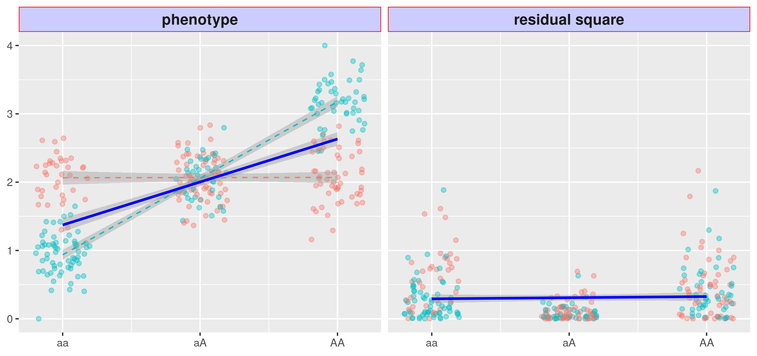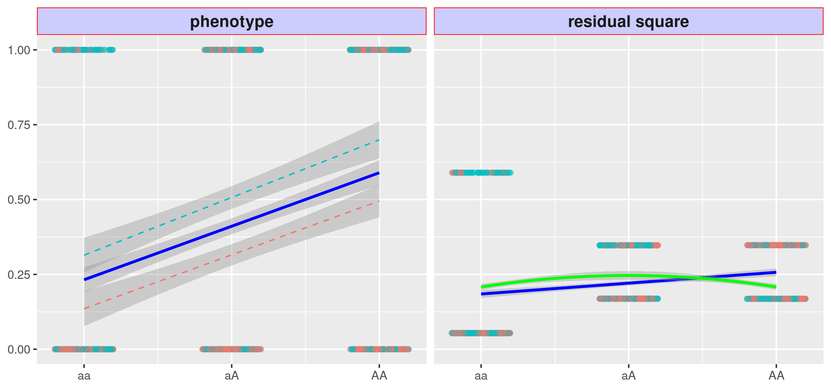
Figure 2: issues with variance quantitative loci (vQTL)
(a) with strong GxE but weak environmental main effect (left), DLM gives flat regression line, variant A/a fail to become a vQTL. (b) with binary phenotype and strong main effect (left), DLM gives non-flat regression line (blue solid), the variant become a false vQTL in the absence of GxE.
the VLA gives downwards regression curve (green solid), the type 1 error is controlled.
(a)
(b)

Issues with vQTL
We will show in the method section that DLM is powerless when the marginal environment effect is small, even in the substantial presence of GxE interaction. In other words, a vQTL scan is incapable of detecting a pure GxE. A severe limitation of vQTL lies with the term "quantitative," meaning that vQTL scan is only suitable for quantitative traits such as blood pressure and body mass index (BMI) but not able to handle binary case/control outcomes such as type 2 diabetes (T2D) and cardiovascular diseases (CVD). The DLM/DGLM essentially models the heteroscedasticity of phenotype variances across allele carriage. When proposing the DLM, Guillaume et al. also argued that "heteroscedasticity depends on the assumption of homogeneity of variances within a genotype, which could be violated if variances tend to be proportional to means" [19]. This assumption is violated for binary phenotypes since the mean - and variance v for individuals carrying a particular allele count are related by v = 2µ (1 - µ). In other words, the mean and variance for individuals in each genotype group are mutually predictive. As a result, the statistics (i.e., p-values) of stage-1 and stage-2 in a DLM are highly collinear. In other words, a significant QTL is also a significant vQTL, regardless of the GxE, which leads to out-of-control type 1 error when it comes to case/control phenotypes. We illustrate the above issues in Figure 2. This issue is not resolved by simply replacing DLM with DGLM/HDGLM despite the generalized linear models supposedly accommodate non-Gaussian phenotypes. As the simulation studies from Huanwei et al. and Andrew et al. conclude, both advised against attempted vQTL scan on binary phenotype [19, 17]. Some suggested using surrogates, assuming that significant vQTLs of a quantitative mediator are likely GxE candidates of a downstream binary phenotype. For example, more significant GxE on type 2 diabetes is likely found among vQTLs of body mass index [19]. The use of surrogate vQTL, however, is not widely explored. We report the evaluation of such a strategy in the later section.
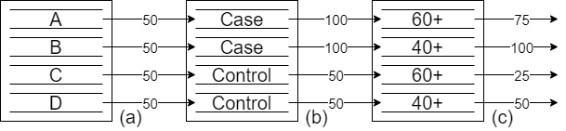
Figure 3: Recover innate risk score using covariates
(a) without any knowledge, the four persons are assigned medium innate risk score; (b) given their disease status, cases are given higher innate risks; (c) given their age, elderly people’s innate risks are adjusted downwards. The VLA gives downwards regression curve (green solid), the type 1 error is controlled.

Variance loci analysis (VLA)
We propose variance loci analysis (VLA) to select GxE candidates in the genome quantitative and binary phenotypes alike and overcome vQTL’s lack of power with a low marginal environment effect. Instead of testing the non-zero slope of the stage-2 regression line, we fit a curve and test its upwardness; this would first and foremost control the type 1 error for binary phenotypes, illustrated by the solid green line in Figure (2.b).
While controlling the type 1 error, the upwardness test lacks the power to detect a candidate knowingly involved in a GxE (Figure 4.a) because the binary event glossed over the underlying risk leading up to that event.
We can reconstruct the underlying risk to some extent with covariates. Taking cardiovascular disease (CVD) as a hypothetical example, given four men A, B, C, and D, without any further information, it is reasonable to assign an innate risk score of 50 to all four, right in the middle of a 1 to 100 scale. We saw records that A and B had had CVD events, we raise their innate risk score to 100; later, we learned that A was in his 60s, and B was in his 40s, thus lower the innate risk score to 75 for A, while keeping B at 100, since an older person does not require a high innate risk to develop CVD. For C and D who have never had CVD incidents so far, it is appropriate to maintain their innate risk scores at the default 50, but when we learn that C is in his 60s and D in the 40s, we lower the risk score for C to 25, since he needs a lower inherent risk to remain healthy given his older age. At this point, we have recovered the innate risk scores of CVD that are distinct between the cases and controls and distinct within each group. The innate risk score so recovered has four levels, which is smoother and more informative than the original, two-level phenotype, shown in Figure (3). The risk score is the residual of CVD fitted by age, which is the combined effect of the genome, exposome, and noise reduced due to the removal of the age effect. With more such covariates, the risk score can resemble a smooth Gaussian variable. The best covariates are non-confounding predictors, such as age and sex, which are not determined by genome or exposome (non-confounding) yet determine the risk of major diseases (predictors). Confounding covariates can still carve out of the raw, black/raw white disease traits a smooth gradient of risk score but also biases the genome and exposome effects [20]. Non-predictive covariates cannot extract helpful information from the original phenotype if not adding useless noise.
After replacing the binary phenotype with an innate risk score so recovered, the upward curve based VLA can select variance loci involved in GxE. We show this in Figure (4.b).
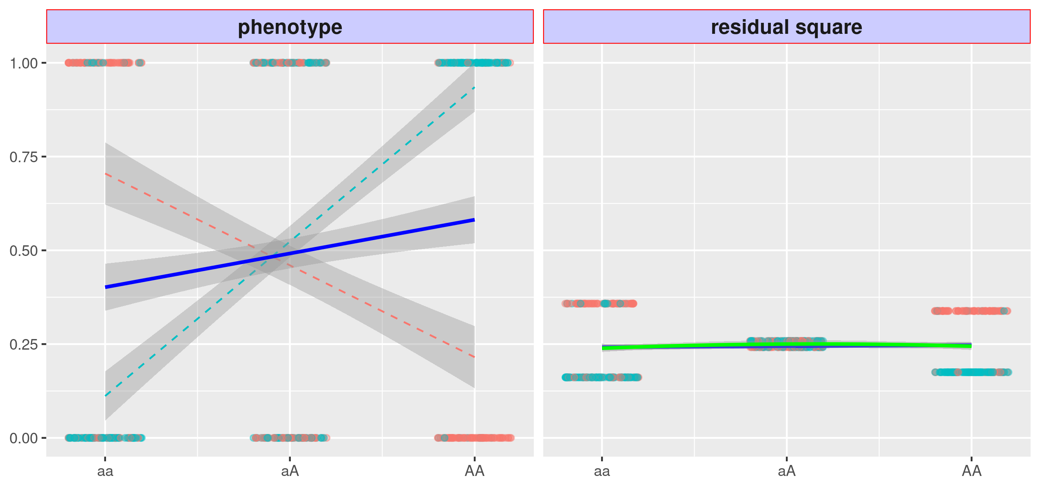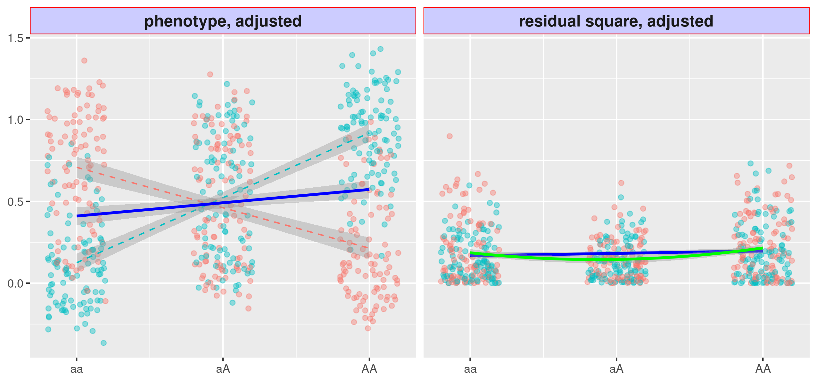
Figure 4: variance loci analysis (VLA) with innate risk score
(a) variant A/a is strong in GxE, but the VLA curve upwardness (green solid) test is as powerless as the slop (blue) based vQTL; (b) replace binary phenotype with innate risk score as covariate residual, the VLA curve upwardness (green solid) detects the variance loci A/a.
(a)
(b)
We implemented the variance loci analysis (VLA) as a self-contained purely R package "vla" that simultaneously scans many phenotypes and genome variants, given adequate system memory. Being self-contained and pure R means "vla" is platform and compiler independent as long as R-base is installed. It turned out to be more efficient than genome-wide analysis routine implemented in C/C++ such as PLINK [21, 22], as the number of phenotypes grew. We created another self-contained R package, "plinkFile," to help to traverse out-of-memory allele count genotype data condensed in PLINK 1 binary biallelic genotype tables [23]. We used these two packages together to run analysis based on UKBB and PEGS data, detailed in the later sections.
We perform the whole genome VLA scan on British Whites in the UKBB for a selected phenom using the software packages. We intend to validate that more significant variance loci can see more significant GxE detected in other populations, such as the White non-British (i.e., mainly Irish) in the UKBB with a dozen exposure related questionnaire items or the North Carolinian PEGS population with hundreds of such items. We also investigate if the variance loci are over-represented in a specific genome type (i.e., intronic and intergenic), just like GWAS loci being more concentrated in or near gene regions. We detail the findings in the results. The preparation of phenome, genome, and exposome is in the method section.
Since the variance loci analysis (VLA) can select GxE candidates for binary and quantitative traits alike, we can create a catalog of VLA statistics for the entire genome and phenome of UK Biobank, similar to the Pan-UK Biobank GWAS catalog at pan.ukbb.broadinstitute.org. The original UKBB phenome was expanded with compounded phenotypes derived from hospital diagnoses recorded in ICD9/10 format (international code of diseases), based on the latest PHECODE mapping table (v1.2) handcrafted by experts [24, 25]. The catalog summarizes the potential of interaction affecting any phenotype of interest for each variant, so future research in GxE could prioritize top-ranking candidates. We host the VLA catalog on the NIEHS (URL here).

Results
We ran variance loci analysis (VLA) on 35,3605 UKBB White British with 11,841,786 variants across the entire genome and ranked the variants from the least to the most significant. The phenome includes two binary traits, Coronary Artery Disease (CAD) and Type 2 Diabetes (T2D), and two quantitative traits, Body Mass Index (BMI) and Fasting Glucose. The covariates include age, sex, age2, age _ sex, age 2_ sex, the first 20 genetic principal components, and the genotyping array. We rank the genome variants according to their VLA significance (i.e., 1 - p-value). For comparison, we performed GWAS and vQTL scans, then ranked the genome variants accordingly.

benchmark GxE enrichment
The GxE enrichment measures the likelihood of significant variance loci invoking significant GxE (gene by environment) interaction. A positive enrichment means a criterion such as VLA helps to select GxE.
We screen for GxE with White, non-British in the UKBB who are mainly Irish, and the same choices of phenome, genome, and covariates used for VLA. The exposome we gathered from UKBB contains lifestyle (alcohol, smoking, physical activities, inactivity), neighborhood environment (garden space, water, coast, noise, nitrite oxide, nitrite dioxide, PM10, PM2.5, traffics), and family structure (siblings). For each variant, we count the number of significant GxE tests given a series of p-value thresholds from 10⁻². 10⁻³ to 10⁻⁹.
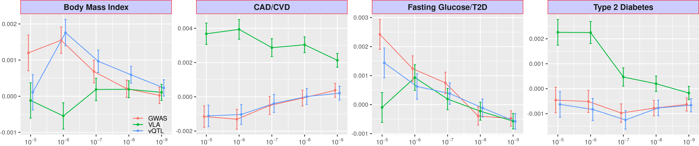We then regress the counts on the variant ranking according to 1 - p-values of VLA. Should VLA truly enriches GxE, a higher-ranking variant should appear more frequently among significant GxE tests, that is, the regression coefficient being significantly positive. For compression, we also regress the counts on variant rankings according to GWAS and vQTL, summarized from White British in the UKBB. We show the GxE enrichment regression coefficient for VLA, GWAS, and vQTL at several p-value thresholds in Figure (5), where the higher a curve climbs (or descends slower), the better GxE selection criteria it represents. VLA, in general, boosted the detection of significant GxE for type 2 diabetes (T2D), which is shown by the positive mean enrichment coefficients for thresholds stricter than 10⁻⁶. For CAD, GWAS and vQTL enriched the detection of GxE when p-value cut-offs were less strict but did the opposite under more stringent thresholds. For body mass index (BMI), VLA achieved mean positive enrichment of GxE, when GWAS and vQTL did the opposite - significantly deplete the selection. VLA outperformed the other two criteria for fasting glucose level by a significant margin on all p-value thresholds. Also, notice that GWAS and vQTL were nearly tied for the two binary traits, T2D and CAD.
Figure 5: GxE enrichment on UKBB White non-British
Given a p-value cut-off, the enrichment analysis counts the number of significant GxE tests each genome variant scores in the UKBB White non-British (up to 16 exposome items) and regress the count on variant rankings according to GWAS (red), VLA (green), or vQTL (blue) on British Whites in the UKBB. The regression coefficient (y-axis) at several p-value cut-offs (x-axis) is shown here - higher means better enrichment. The error bar shows2 × standard error.
Next, we screen for GxE on T2D, BMI, and cardiovascular disease (CVD) in the PEGS. The cohort provides whole-genome sequencing (WGS) profiles for 4,603 out of 19,673 of its current participants. The PEGS exposome survey covers 365 parent items concerning daily life, neighborhood, and workplace hazards. Of the four UKBB White British phenotypes we put through VLA, GWAS, or vQTL, we use the variant rankings to enrich the detection of the GxE on T2D and BMI - the two phenotypes directly available in PEGS. We let the variant rankings for CAD in the UKBB to enrich the detection of GxE on CVD in the PEGS since CAD is a major component of CVD. Lastly, we use the variant rankings for fasting glucose level in the UKBB to enrich the T2D in the PEGS, considering glucose level a strong indicator of T2D. We counted the significant GxE in the PEGS (up to 365 exposome items) at several p-value thresholds. We show the enrichment regression coefficient in Figure (6). For binary outcomes T2D and CVD in the PEGS matched byT2D and CAD in UKBB, respectively, VLA outperformed GWAS and vQTL in terms of enriching GxE detection at various thresholds; again, the pattern of vQTL mostly overlaps with GWAS, so vQTL does not provide additional information over GWAS if the trait severing variant ranking is binary. For well-behaved continuous variables such as BMI, vQTL selected better GxE candidates in the PEGS, although the three criteria converge under stricter thresholds of significant GxE. When using the ranking based on fasting glucose level in UKBB to enrich GxE on T2D, the performance of three criteria are indistinguishable beyond thresholds stricter than 10−5.
Figure 6: GxE enrichment on PEGS
Given a p-value cut-off, the enrichment analysis counts the number of significant GxE tests each genomevariant scores in the PEGS (up to 365 exposome items), and regress the count on variant rankings according toGWAS (red), VLA (green), or vQTL (blue) based on British Whites in the UKBB. The regression coefficient(y-axis) at several p-value cut-offs (x-axis) is shown here - higher means better enrichment. The error barshows2×standard error.

Investigate functional enrichment
If VLA, GWAS, or vQTL loci are linked to genome functions, significant variants should reside unevenly in regions of different classes. For example, the loci may be more abundant within or near genes than those in between genes. We use package ANNOVAR [26] to assign a functional class of each variant, such as intergenic or intronic variants. We also calculated the CADD score (Combined Annotation Dependent Depletion) [27] for each variant as a continuous measure of pathogenic tendency. We regressed the function class memberships and CADD scores on the variant rankings given by VLA, GWAS, and vQTL. If the loci are enriched in certain regions, the corresponding regression coefficients should be positive, and conversely, if the loci are depleted, the coefficient should be negative. We show the functional enrichment coefficient for BMI and T2D in table (1). Obviously, for BMI and T2D, variance loci (by VLA) are highly enriched in intergenic regions, while GWAS and vQTL loci are highly concentrated near or inside genes. As with the CADD scores, variance loci are depleted in high CADD score regions - regions of high pathogenic tendency. Although more GWAS and vQTL loci are near or within genes, they are more concentrated in non-protein coding segments (i.e., upstream, intronic, and downstream). For the fewer variance loci that are near or in genes, the distribution is relatively flat. Overall, variance loci are likely to take indirect, regulatory roles in genome molecule biology, while GWAS and vQTL loci are more directly involved in producing protein molecules. For a binary trait such as T2D, the functional distribution of GWAS and vQTL loci are nearly identical due to the high correlation between the rankings given by GWAS and vQTL, which is also why the overlapping performance in GxE enrichment benchmarks shown previously. When it comes to a continuous outcome such as BMI, where GWAS and vQTL rank the variants differently, the concentration of GWAS and vQTL loci differ regarding the CADD scores. In either case, the pattern of variance loci is distinct from GWAS and vQTL loci, providing a new perspective on the relative importance of each variant in terms of the potential in interaction.
Body Mass Index |  | GWA | VQA | VLA |  | GWA | VQA | VLA |  | Type 2 Diabetes |  | GWA | VQA | VLA |  | GWA | VQA | VLA
Intergenic |  | --- | --- | ++ | CADD | --- | +++ | - |  | Intergenic |  | --- | --- | +++ | CADD | ++ | ++ | --
Genes | Upstream | ++ | ++ | + |  |  |  |  |  | Genes | Upstream | +++ | +++ | ++
Genes | Intronic | +++ | +++ |  |  |  |  |  |  | Genes | Intronic | +++ | +++ | +
Genes | Exonic |  |  |  |  |  |  |  |  | Genes | Exonic
Genes | Downstream | + | + | - |  |  |  |  |  | Genes | Downstream | +++ | +++ | ++
Table 1: Variant Function Enrichment
the functional enrichment analysis regresses the region type and CADD score of each variant on rankings given by GWAS (red), VLA (green), or vQTL (blue) based on UKBB British Whites. A significant positive or negative regression coefficient are shown as "+" or "-" symbol, respectively; the number of repetitive symbols denote the level of significance. Insignificant coefficients are displayed as blanks.

UKBB variance loci catalog
Inspired by the Pan-UK Biobank GWAS catalog at pan.ukbb.broadinstitute.org, we aim to catalog variance loci statistics for all health and disease phenotypes and variants in the UKBB. The catalog serves as a public reference for the researcher interested in gene-by-environment interaction who could query the catalog by the name of a phenotype and prioritize candidate variants most likely to invoke significant GxE interactions. We illustrate this workflow in Figure (7).
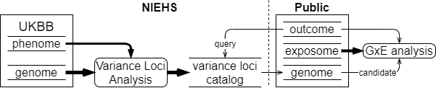
Figure 7: UKBB variance loci catalog
We summarize the UKBB phenome that includes 1,580 health-relevant phenotypes picked from the UKBB data fields accessible to the NIEHS plus another 1,693 diseases derived from hospital records in ICD9/10 format. Among those 1,580UKBBdata fields picked, we distinguished binomial, multinomial, ordinal, and continuous variables, re-coded and normalized accordingly (detailed in method). The derivation of 1,693 diseases was based on PHECODE - a codebook manually crafted by groups that excelled in extrapolating diseases from ICD9/10 records, currently hosted on www.phewascatalog.org [24, 25]. The implementation of the codebook to transform NIEHS’s copy of ICD9/10 fields was done by Thomas et al. (cite Thomas’ paper). In total, the phenome contains 3,273 items. As for the genome, we limited the variants to those with an overall MAF (minor allele frequency) no less than 0.005, making a final number of 11,841,785 after other quality control measures.
For each of the four main racial, ethnic groups (British White, White non-British, Blacks, and Asians), we performed variance loci analysis (VLA) for the whole phenom and genome to archive variant statistics. We rely on two R-packages specialized in traversing genome data and testing variance loci between thousands of phenotypes and variants. By dividing the genome into nearly 1,200 chunks of 1,000 variants each, we can summarize the VLA statistics for British Whites – the largest group by far with a working sample size of 384,000, in less than 12 hours, utilizing the computational resources of the NIH HPC Biowulf cluster (hpc.nih.gov). The variance loci catalog provides compressed files for all four groups and 3,273 phenotypes on (URL). A manifest of phenotypes and links to the files is available at (URL).

Methods

References
[1] Claude Bouchard and Tuomo Rankinen. Individual differences in response to regular physicalactivity.Medicine and science in sports and exercise, 33(6; SUPP):S446–S451, 2001.
[2] Jose M Ordovas and Jian Shen. Gene–environment interactions and susceptibility to metabolicsyndrome and other chronic diseases.Journal of periodontology, 79:1508–1513, 2008.
[3] Aseel Eid, Isha Mhatre, and Jason R Richardson. Gene-environment interactions in alzheimer’sdisease: a potential path to precision medicine.Pharmacology & Therapeutics, 199:173–187,2019.
[4] Nabodita Kaul and Sher Ali. Genes, genetics, and environment in type 2 diabetes: implicationin personalized medicine.DNA and cell biology, 35(1):1–12, 2016.
[5] David J Hunter. Gene–environment interactions in human diseases.Nature Reviews Genetics,6(4):287–298, 2005.
[6] Avshalom Caspi and Terrie E Moffitt. Gene–environment interactions in psychiatry: joiningforces with neuroscience.Nature Reviews Neuroscience, 7(7):583–590, 2006.
[7] Evan E Eichler, Jonathan Flint, Greg Gibson, Augustine Kong, Suzanne M Leal, Jason HMoore, and Joseph H Nadeau. Missing heritability and strategies for finding the underlyingcauses of complex disease. Nature Reviews Genetics, 11(6):446–450, 2010.
[8] Marinus H Van Ijzendoorn, Marian J Bakermans-Kranenburg, Jay Belsky, Steven Beach, GeneBrody, Kenneth A Dodge, Mark Greenberg, Michael Posner, and Stephen Scott. Gene-by-environment experiments: a new approach to finding the missing heritability.Nature ReviewsGenetics, 12(12):881–881, 2011.
[9] Cathie Sudlow, John Gallacher, Naomi Allen, Valerie Beral, Paul Burton, John Danesh, PaulDowney, Paul Elliott, Jane Green, Martin Landray, et al. Uk biobank: an open access resourcefor identifying the causes of a wide range of complex diseases of middle and old age.PLoSmedicine, 12(3):e1001779, 2015.
[10] Janet E Hall, Alison A Motsinger-Reif, David C Fargo, and Charles S Schmitt. PEGS: Personal-ized environment and genes study. https://www.niehs.nih.gov/research/clinical/studies/pegs/index.cfm, 2020. Last Reviewed: 09-01-2021.15
[11] Jonathan Marchini, Peter Donnelly, and Lon R Cardon. Genome-wide strategies for detectingmultiple loci that influence complex diseases.Nature genetics, 37(4):413–417, 2005.
[12] Joshua Millstein, David V Conti, Frank D Gilliland, and W James Gauderman. A testingframework for identifying susceptibility genes in the presence of epistasis.The AmericanJournal of Human Genetics, 78(1):15–27, 2006.
[13] Youngjo Lee and John A Nelder. Double hierarchical generalized linear models (with discus-sion).Journal of the Royal Statistical Society: Series C (Applied Statistics), 55(2):139–185,2006.
[14] Gordon K Smyth. Generalized linear models with varying dispersion.Journal of the RoyalStatistical Society: Series B (Methodological), 51(1):47–60, 1989.
[15] Lars Rönnegård, Majbritt Felleki, Freddy Fikse, Herman A Mulder, and Erling Strandberg.Genetic heterogeneity of residual variance-estimation of variance components using doublehierarchical generalized linear models.Genetics Selection Evolution, 42(1):8, 2010.
[16] Lars Rönnegård and William Valdar. Detecting major genetic loci controlling phenotypicvariability in experimental crosses.Genetics, 188(2):435–447, 2011.
[17] Huanwei Wang, Futao Zhang, Jian Zeng, Yang Wu, Kathryn E Kemper, Angli Xue, MinZhang, Joseph E Powell, Michael E Goddard, Naomi R Wray, et al. Genotype-by-environmentinteractions inferred from genetic effects on phenotypic variability in the uk biobank.Scienceadvances, 5(8):eaaw3538, 2019.
[18] Guillaume Paré, Nancy R Cook, Paul M Ridker, and Daniel I Chasman. On the use of varianceper genotype as a tool to identify quantitative trait interaction effects: a report from the women’sgenome health study.PLoS Genet, 6(6):e1000981, 2010.
[19] Andrew R Marderstein, Emily R Davenport, Scott Kulm, Cristopher V Van Hout, Olivier Ele-mento, and Andrew G Clark. Leveraging phenotypic variability to identify genetic interactionsin human phenotypes.The American Journal of Human Genetics, 2020.
[20] Hugues Aschard, Bjarni J Vilhjálmsson, Amit D Joshi, Alkes L Price, and Peter Kraft. Adjustingfor heritable covariates can bias effect estimates in genome-wide association studies.TheAmerican Journal of Human Genetics, 96(2):329–339, 2015.
[21] Shaun Purcell, Benjamin Neale, Kathe Todd-Brown, Lori Thomas, Manuel AR Ferreira, DavidBender, Julian Maller, Pamela Sklar, Paul IW De Bakker, Mark J Daly, et al. Plink: a tool setfor whole-genome association and population-based linkage analyses.The American journalof human genetics, 81(3):559–575, 2007.16
[22] Christopher C Chang, Carson C Chow, Laurent CAM Tellier, Shashaank Vattikuti, Shaun MPurcell, and James J Lee. Second-generation plink: rising to the challenge of larger and richerdatasets.Gigascience, 4(1):s13742–015, 2015.
[23] Christopher Chang. Plink binary biallelic genotype table.https://www.cog-genomics.org/plink/1.9/formats#bed, Jun 2021.
[24] Wei-Qi Wei, Lisa A Bastarache, Robert J Carroll, Joy E Marlo, Travis J Osterman, Eric RGamazon, Nancy J Cox, Dan M Roden, and Joshua C Denny. Evaluating phecodes, clini-cal classification software, and icd-9-cm codes for phenome-wide association studies in theelectronic health record.PloS one, 12(7):e0175508, 2017.
[25] Patrick Wu, Aliya Gifford, Xiangrui Meng, Xue Li, Harry Campbell, Tim Varley, Juan Zhao,Robert Carroll, Lisa Bastarache, Joshua C Denny, et al. Mapping icd-10 and icd-10-cmcodes to phecodes: workflow development and initial evaluation.JMIR medical informatics,7(4):e14325, 2019.
[26] Kai Wang, Mingyao Li, and Hakon Hakonarson. Annovar: functional annotation of geneticvariants from high-throughput sequencing data.Nucleic acids research, 38(16):e164–e164,2010.
[27] Martin Kircher, Daniela M Witten, Preti Jain, Brian J O’roak, Gregory M Cooper, and JayShendure. A general framework for estimating the relative pathogenicity of human geneticvariants.Nature genetics, 46(3):310–315, 2014.
[28] Jacqueline MacArthur, Emily Bowler, Maria Cerezo, Laurent Gil, Peggy Hall, Emma Hastings,Heather Junkins, Aoife McMahon, Annalisa Milano, Joannella Morales, Zoe May Pendlington,Danielle Welter, Tony Burdett, Lucia Hindorff, Paul Flicek, Fiona Cunningham, and HelenParkinson. The new NHGRI-EBI Catalog of published genome-wide association studies(GWAS Catalog).Nucleic Acids Research, 45(D1):D896–D901, 11 2016.

