Cataloging gene-environment interaction candidate SNPs for over 3,000 UK Biobank disease phenotypes through variance loci analysis
Xiaoran Tong, <authors>, Alison Motsinger-Reif
September 7, 2021

Abstract
Detecting gene by environment interactions (GxEs) in diseases enriches the ontology of genetic effects and helps identify environmental targets for interventions with the goal of improving health outcomes. However, combining the dimensions of the genome and exposome poses challenges in terms of both computational and statistical power.
Variance quantitative trait loci (vQTL) analysis, which is based on a double linear model (DLM) or double generalized linear model (DGLM), has recently received attention for its ability to find candidate single nucleotide polymorphisms (SNPs) for GxEs without actual environmental exposome profiling. The rationale is that GxEs unaccounted for by a genome-wide association study (GWAS) can bring about the residual variance of a quantitative phenotype that changes across allele dosages—a non-uniformity that can be captured by a second GWAS treating the squared residual as a new phenotype.
We propose variance loci analysis (VLA) based on a DLM augmented by squared SNP dosage. We show that VLA maintains superior power to detect GxE candidates with weak direct environmental effects on the phenotype. We also demonstrate that DGLM is overly generic with squared dosage and overly restrictive when the squared dosage is not used. More importantly, we demonstrate that by appropriately adjusting covariates, VLA can overcome the inability of DLM/DGLM to analyze thousands of non-quantitative phenotypes.
We performed VLA for 3,273 health- and disease-related phenotypes derived from the UK Biobank and ranked the potential involvement of each SNP in GxEs. Using environmental exposome data collected in the Personalized Environmental Genetic Study (PEGS), we found that high-ranking genome variants selected by VLA enriched the detection of genome-exposome-wide significant GxE SNPs for cardiovascular disease (CVD), type 2 diabetes (T2D), and body mass index (BMI).

Introduction
Most human traits have a complex etiology and are affected by both genetic and environmental factors and their interactions. The genotype has been found to modulate the effects of lifestyle factors such as exercise and diet on traits such as disease status. For example, family members receive more similar cardio-respiratory benefits of exercise compared to unrelated individuals¹. Further, the risk-lowering effects of diet on diseases that include cardiovascular disease (CVD), and type 2 diabetes are modified by the presence of certain SNPs^{2,3}. For Alzheimer’s disease, the genotype has been shown to affect the prognosis of diagnosed individuals undergoing diet- and exercise-related interventions as well as the association between pesticide and air pollutant levels and risk of the disease⁴.
Because environmental exposures can regulate the biological processes underlying a phenotype^{1,2,5,6}, unaccounted-for GxE effects are recognized as part of the heritability “missed” by variants selected by genome-wide association studies (GWAS)^{7,8}. Research in agricultural genetics, model organisms, and cell culture has consistently found that genetic effects are context-dependent (9-13). However, there has been limited success in identifying GxEs in humans for several reasons. First, many environmental exposures are unknown or difficult to record. Second, due to the polygenic nature of most human traits (9-11), GxE effect sizes are small, (9–11), and the sample sizes of most previous studies have not been large enough to detect small GxE effects.
Within larger cohorts for which environmental exposure items are comprehensively surveyed and termed “exposome” along with the commonly seen whole genome data, a 2-way GxEWAS (genome exposome wide association study) can be conducted to test all possible SNP-by-environment interactions. However, the burden of multiple testing and computation due to the overwhelming number of 2-way crossovers between the exposome items and whole genome variants limits the power of this approach (REFS), and an unbiased genome-wide interrogation restricts hypothesis generation. More commonly, instead of the whole genome, candidate genes for testing GxE interactions are selected based on previous biological knowledge or results from other GWAS, assuming strong interactions are likely to exert strong marginal effects^{9,10}. While this approach increases power, candidate gene selection is limited by existing biological knowledge, and GWAS significance does not necessarily suggest GxEs since significant SNP main effect can coexist with weak GxE. The limitations of using prior knowledge and GWAS results to identify candidate SNPs motivated the development of alternative methods. There is a growing appreciation of the observation that GxEs with large effect sizes can be revealed as a change in the variance of a quantitative trait among groups of individuals with different variant genotypes. As a result, a promising strategy is to screen for the so called “Variance Quantitative Trait Loci (vQTL)” in a selection cohort rich in genome data, then treat the most significant vQTLs as candidate SNPs to conducted GxE studies in a discovery cohort rich in exposome data. Unlike classical QTL, which tests the allelic substitution effect of a variant on the phenotypic mean, variance QTL (vQTL) tests the allelic substitution effect on the phenotypic variance. Therefore, vQTLs are superior GxE candidates in comparison to GWAS QTLs due to the link between GxEs and changes in the phenotypic variance. On the other hand, vQTLs retain the benefit of GWAS QTLs that the selection cohort does not require an exposome, as long as it shares the phenotype of interest with the discovery cohort. In turn, the vQTL based candidate SNPs mitigate the multiple testing burden without requiring prior biological knowledge.

Variance quantitative trait loci (vQTL)
A vQTL scan identifies variants associated with conditional phenotypic variance (hence the “v”). The vQTL approach prioritizes variants with interactions because the interaction effect unaccounted for in a GWAS linear model affects the residual, resulting in uneven variation when fitting a regression line across genotypes. The aforementioned link between large GxEs and the changes in phenotypic variance among groups individuals of different genotypes, is essentially the lack of fit of the GWAS linear model, which is detectable by a second linear model regressing the squared residual on the genotype. Figure 1 conceptually illustrates the vQTL approach. In this figure, the vQTL scan is essentially a double linear model (DLM) since two-stage linear regressions are used, where the first stage is a de facto GWAS, and the second stage treats the squared residual as a new phenotype.
Figure 1: Variance trait quantitative loci (vQTL) to suggest GxE
(a) In the absence of GxE (left), residual variations are even across genotypes (right), and variant A/a is not a vQTL; by GWAS significance, the variant will be erroneously seen as a GxE candidate; (b) In the presence of GxE (left), residual variations are uneven across genotypes (right), and variant A/a is a vQTL. Teal/red dashes: environment-specific effect; blue solid lines: marginal effect.

(a)
(b)
Before the development of DLM and vQTL, modeling both mean and variance of a dependent variable with the same predictors (i.e., SNPs) have been achieved using double generalized linear models (DGLM)¹¹ and double hierarchical generalized linear models (DHGLM)¹², which allows random effects. Like DLM, DGLM is also a two-stage model but allows standard link functions to accommodate non-normal, non-continuous outcomes and assumes that the squared deviance (i.e., residual) of a stage-1 model follows not Gaussian, but Gamma, distribution. Therefore, by default, DGLM uses log-linked Gamma regression for stage-2 models. DGLM and DHGLM were developed by combining analyses to prioritize variants with allele effects that are resistant to environmental changes, allowing the selection of non-interaction candidates¹³. DGLM is widely recommended as a robust and statistically powerful approach to identity vQTLs as GxE candidates^{14,15}.
Compared to GWAS-based selection, vQTL specifically targets GxE candidates, this is illustrated in Figure 1a, where, by GWAS significance, a variant not involved in GxE would be erroneously select as candidate. Indeed, both DLM- and DGLM-based vQTL scans have seen some success. Guillaume et al. explained DLM in detail, relying not on the typical t-test come with stage-2 linear regression coefficients but rather Levene’s test for equality of variance to identity vQTLs¹⁶. The DLM-based method was applied to the Women’s Genome Health Study to select SNPs, which included three novel GxE interactions involving body mass index (BMI) and smoking and were significantly associated with C-reactive protein level and soluble ICAM-1 levels on a whole-genome scale.
Recently, Andrew et al. proposed the deviation regression model (DRM), a modified DLM¹⁷. Typically, variation within each genotype group is measured by the squared distance between phenotype values and the group mean, that is, the squared residuals of the stage-1 linear model. The DRM, however, replaces this with the absolute distance between phenotype values and the group median. The results of simulation experiments indicate that DRM is statistically more powerful than Levene’s test in general and more potent than DGLM for selecting actual GxE candidates when the phenotype is skewed. When applied to UKBB genotype and BMI phenotype data, variants identified by DRM demonstrably improved the likelihood of detecting genome-wide significant GxE interactions with age, sex, smoking, drinking, physical activity, sedentary behavior, and diet. The study also reported that vQTL selected according to BMI enriched GxE detection for binary phenotypes such as diabetes.
In a comprehensive simulation, Huanwei et al. compared the performance of popular vQTL test statistics, including Bartlett’s test, Levene’s test, Fligner-Killeen test, and DGLM, challenged by a wide variety of phenotypes [17]. The study suggested DGLM as the optimal choice for vQTL modeling and applied the method to 13 quantitative traits in a UKBB training datasetfor the enrichment of genome-wide discovery of significant GxE in a validation dataset with exposome groups based on sex and age, physical activity, sedentary behavior, and smoking, DGLM vQTL significantly outperformed GWAS for candidate variant selection.
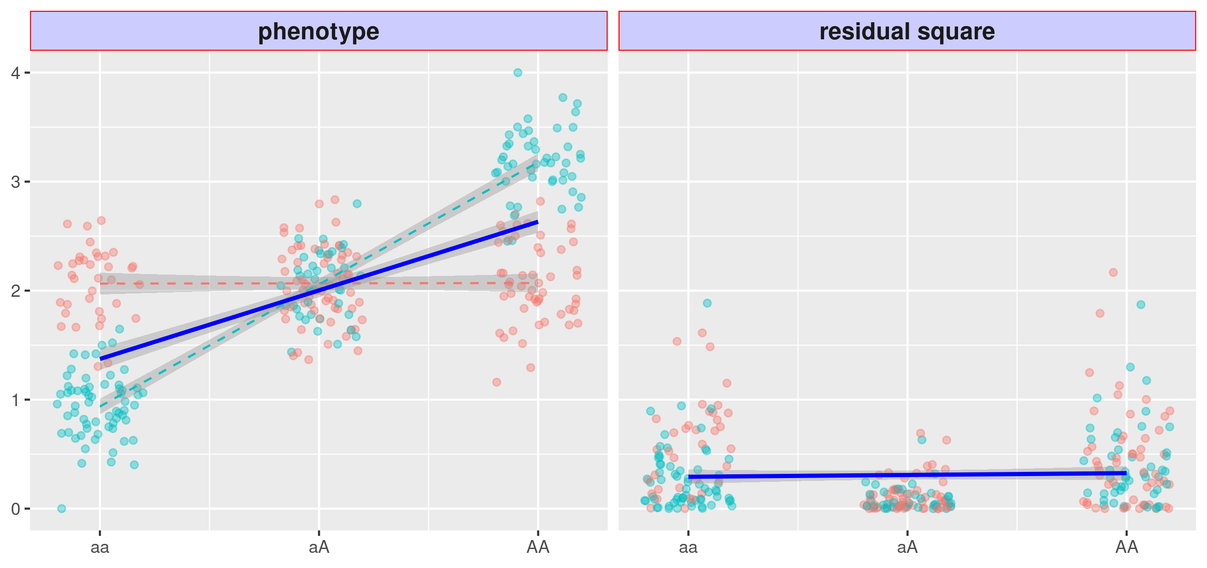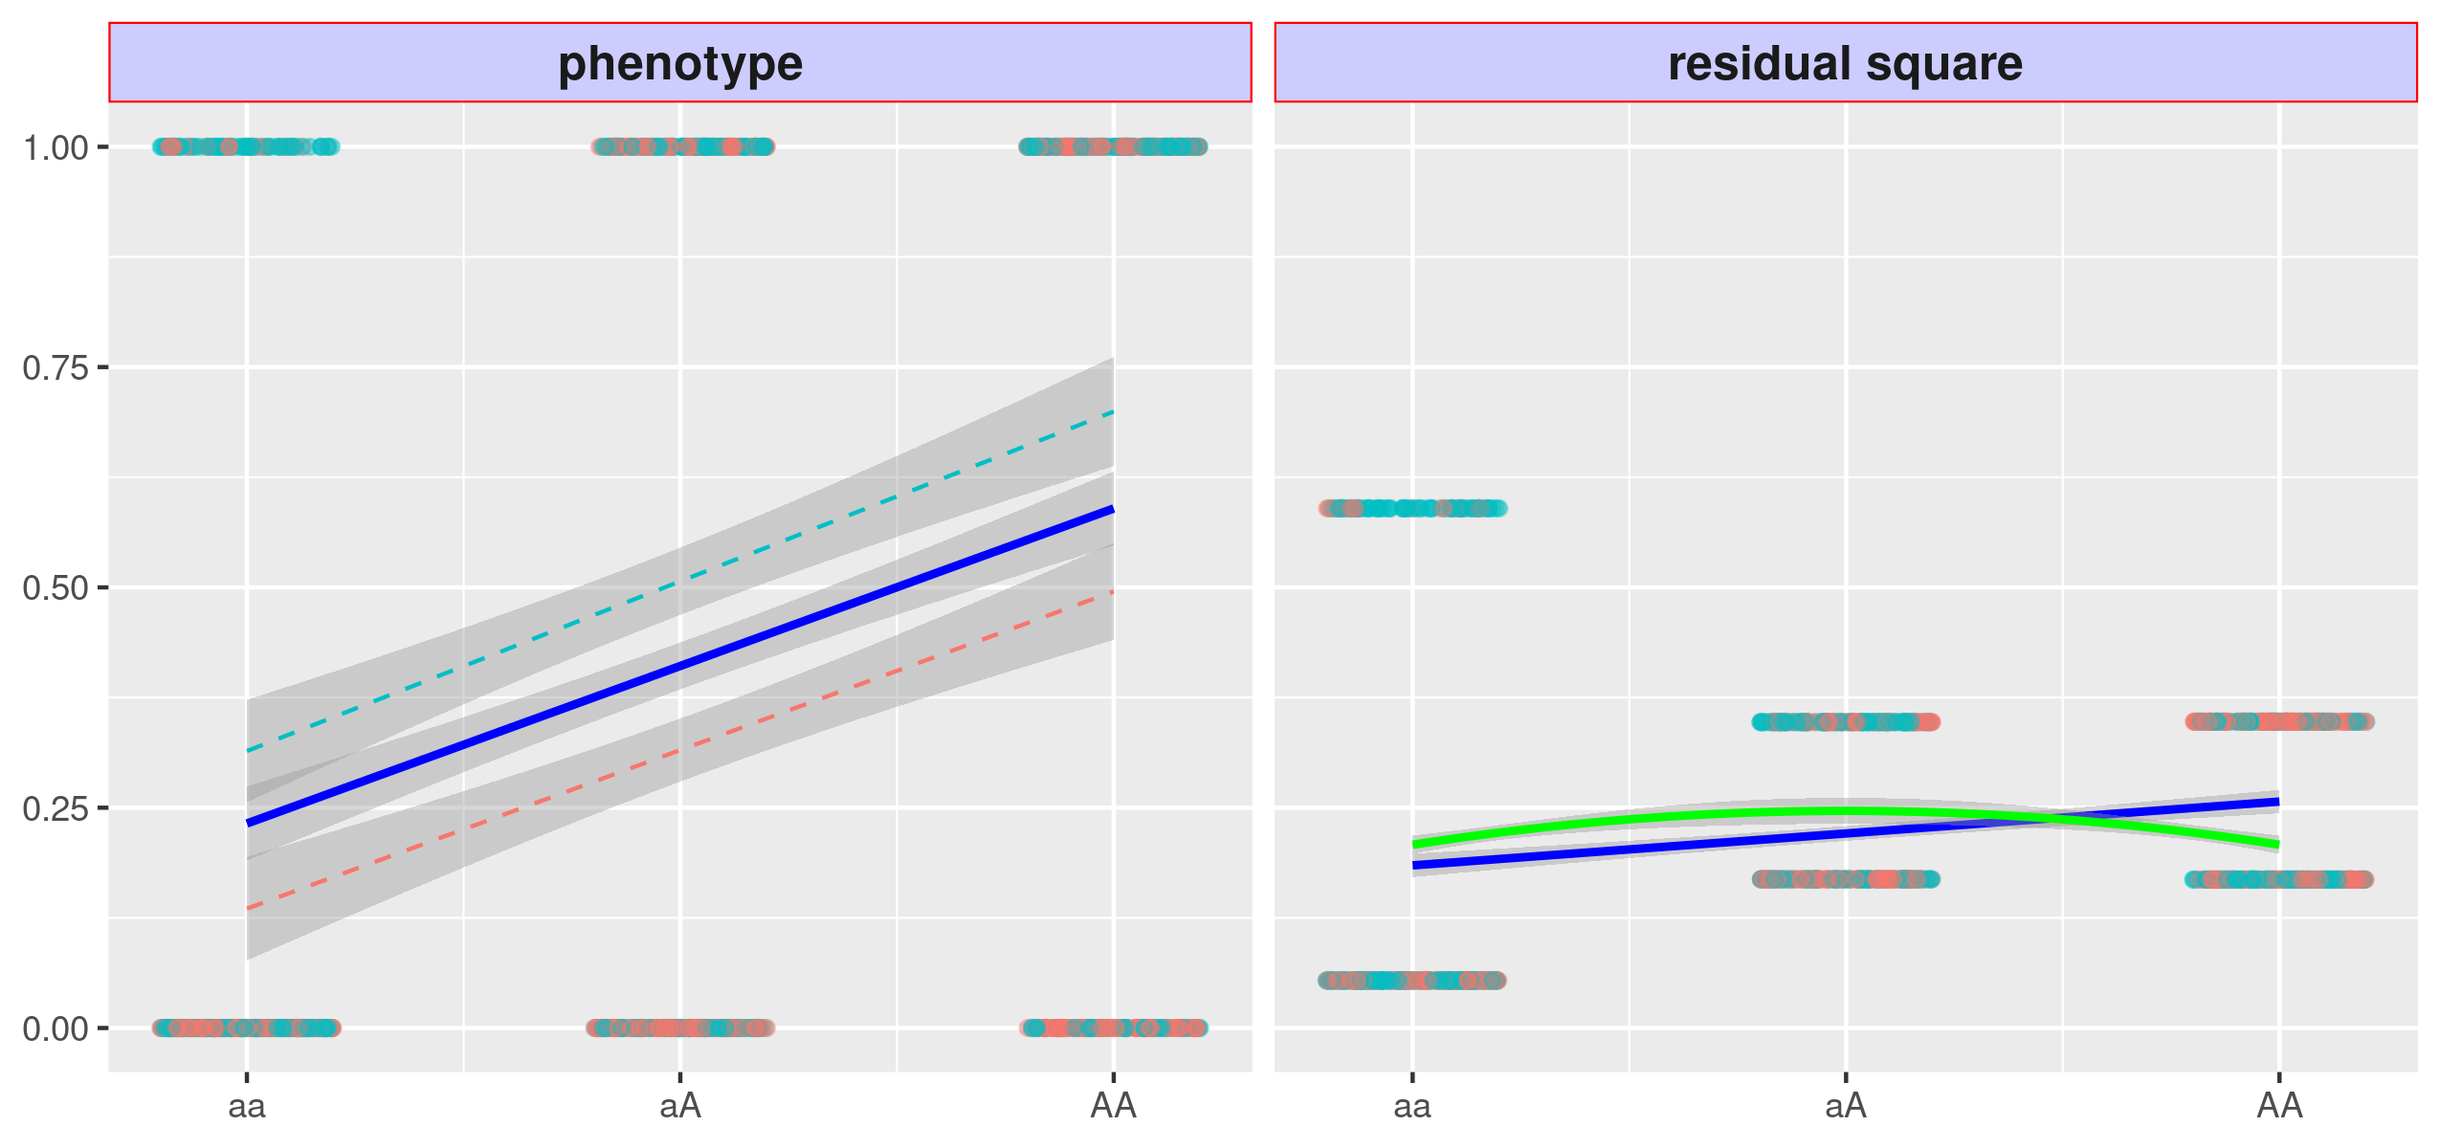
Figure 2: Issues with variance quantitative loci (vQTL)
(a) With strong GxE but weak environmental main effects (left), DLM results in a flat regression line, and variant A/a fails to become a vQTL. (b) With a binary phenotype and strong main effect (left), DLM results in a non-flat regression line (blue solid), and the variant become a false vQTL in the absence of GxE.
the VLA gives downwards regression curve (green solid), the type 1 error is controlled.
(a)
(b)

Issues with vQTL
While these methods have discovered exciting results, there are important limitations that we address in the current study.
A severe limitation is that a vQTL scan is suitable only for quantitative traits such as blood pressure and BMI and cannot handle binary case/control outcomes such as type 2 diabetes (T2D) and cardiovascular disease (CVD). DLM and DGLM essentially model the heteroscedasticity of phenotype variance across allele carriage. DLM was developed based on the proposition that heteroscedasticity relies on the assumption of the homogeneity of variances within the genotype, which may not occur if variances are proportional to means [19]. This assumption is violated for binary phenotypes since the relationship between the mean µ and variance v for individuals carrying a particular allele count is v = 2µ (1 - µ). In other words, the mean and variance for individuals in each genotype group are mutually predictive. As a result, the statistics (i.e., p-values) of stage-1 and stage-2 models in a DLM are highly collinear. Hence, a significant QTL is also a significant vQTL, regardless of the GxE, which leads to out-of-control type 1 errors regarding binary phenotypes. Simply replacing DLM with DGLM/HDGLM does not resolve this issue despite the supposed ability of generalized linear models to accommodate non-Gaussian phenotypes. Figure 2 illustrates the above issues.
From the results of simulation studies, Huanwei et al. [19] and Andrew et al. [17] advised against attempting a vQTL scan on binary phenotypes. Some studies have suggested using surrogates, assuming that significant vQTLs of a quantitative mediator are likely GxE candidates of a downstream binary phenotype. For example, significant GxE interactions for type 2 diabetes would likely be found among vQTLs of BMI [19]. The use of surrogate vQTL has not been widely explored, and we report the evaluation of such a strategy later in the paper. Additionally, as discussed in detail in the methods section, DLM lacks power with small marginal environment effects, even in the substantial presence of GxEs. In other words, a vQTL scan is incapable of detecting a pure GxE.

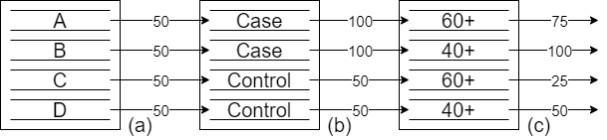
Figure 3: Assigning innate risk scores using covariates
(a) Without prior knowledge, four people are assigned a median innate risk score; (b) Given their disease status, an individual may be assigned a higher innate risk score; (c) Given their age, the innate risk score may be decreased for older individuals. VLA results in a downwards regression curve (green solid line) and controls type 1 errors.

Variance loci analysis (VLA)
We propose variance loci analysis (VLA) to select GxE candidates from both quantitative and binary phenotypes. This approach overcomes vQTL’s lack of power with low and marginal environmental effects. In VLA, instead of testing the non-zero slope of the stage-2 regression line, a curve is fit and its upwardness is tested; importantly, this controls the type 1 errors for binary phenotypes, as illustrated by the solid green line in Figure 2b.
While it controls the type 1 error, the upwardness test results in a lack of power to detect GxE candidates (Figure 4a) because the binary event glosses over the underlying risk leading up to the event.
However, the underlying risk can be reconstructed to some extent with covariates. Figure 3 demonstrates this process with a hypothetical situation. Given four individuals–A, B, C, and D–without any additional information, it is reasonable to assign all four an innate risk score of 50, which is the median of a 100-point scale. If A and B have been diagnosed with the disease, their innate risk scores are increased to 100. Because A is in his 60s, his innate risk score is lowered to 75; because B is in his 40s, his innate risk score remains at 100. The logic behind this adjustment is that for an older person, a high innate risk score is not required to develop the disease. Because C and D have not been diagnosed with the disease, their innate risk scores remain at the default 50. However, because C is in his 60s, his risk score is lowered to 25. The logic behind this adjustment is that since he has not been diagnosed with the disease, given his age, he has a lower inherent risk score.
Through this process, innate risk scores for a disease can be assigned that are distinct for those with and without the condition and as well as within each group. In this scenario, the innate risk score has four levels, which is smoother and more informative than the original, two-level phenotype, shown in Figure 3. The risk score is the residual of the disease fitted by age, which is the combined effect of the genome and exposome, in other words, a finer gradient of risk is revealed by removing the effect of age..
With additional covariates, the risk score can resemble a smooth Gaussian variable. After replacing the binary phenotype with the recovered innate risk score, upward curve-based VLA can be used to select variance loci involved in GxE. Figure 4b conceptually demonstrates this. The best covariates are non-confounding predictors, such as age and sex, which are not heritable and not determined by the genome or exposome (non-confounding) yet determine the risk of major diseases (predictors). Using raw, case/control disease traits to carve out a smooth gradient of risk score biases the genome and exposome effects [20]. Non-predictive covariates cannot extract helpful information from the original phenotype without adding useless noise.
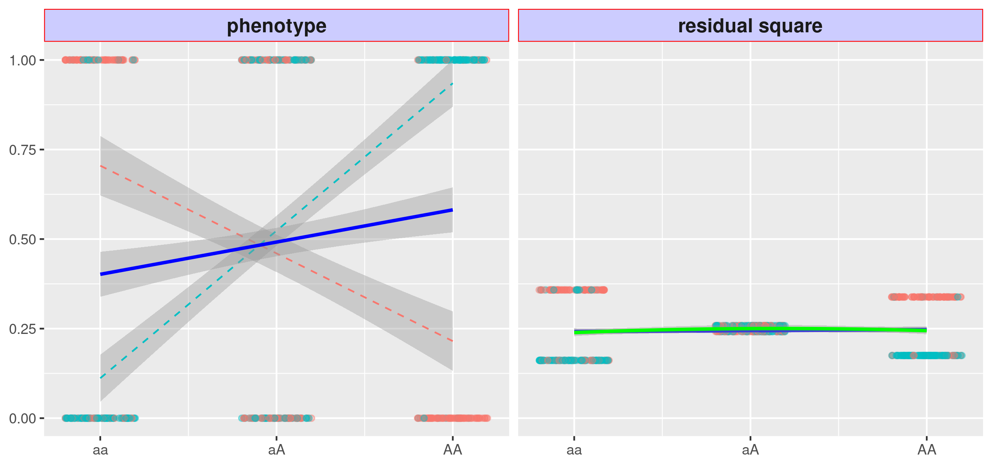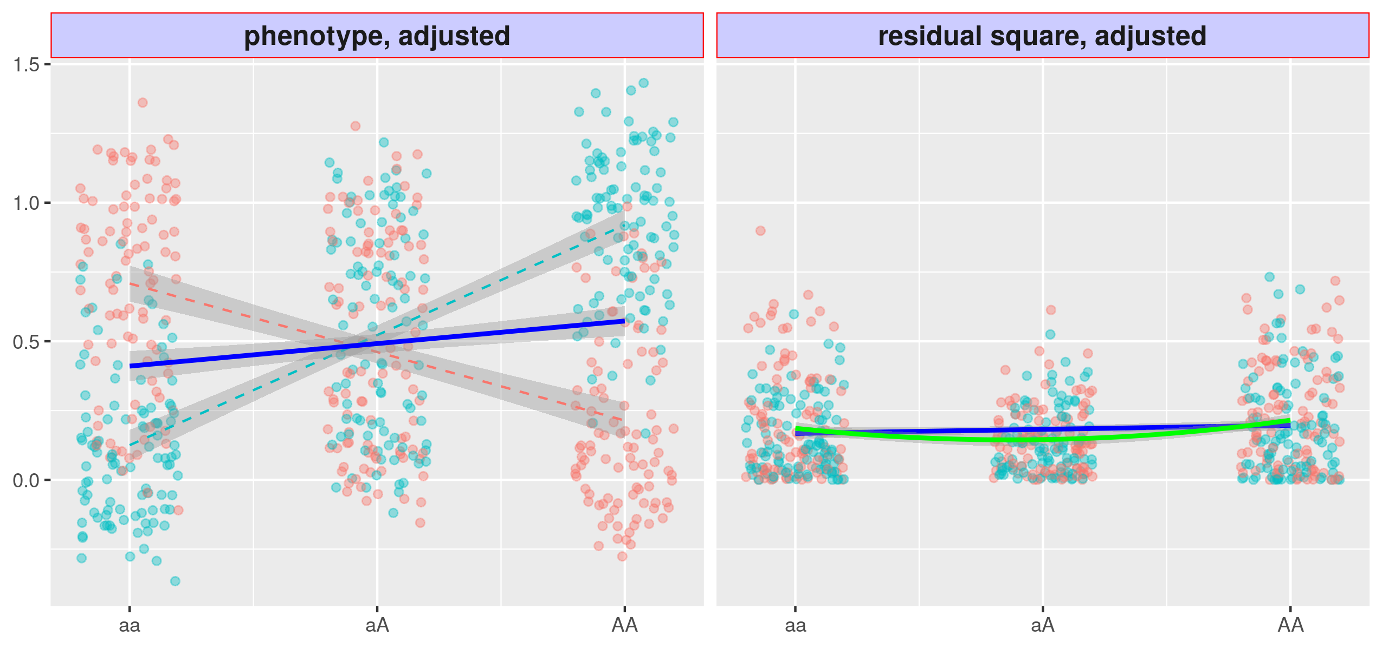
Figure 4: Variance loci analysis (VLA) with innate risk score
(a) Variant A/a is strong in GxE, but the VLA curve upwardness (green solid) test is as powerless as the slope-based vQTL(blue); (b) If the binary phenotype is replaced by the innate risk score as a covariate residual, the upwardness of the VLA curve (green solid) detects the variance loci A/a.
(a)
(b)

Application in the UK Biobank
Because data from large biobank-based GWAS (26, 27) is available, the genome can be examined using VLA for a range of phenotypes in cohorts with unprecedented sample sizes. In this work, we conducted whole-genome VLA scans across all relevant phenotypes in the UK Biobank (UKBB).
VLA can select GxE candidates for both binary and quantitative traits, enabling the creation of a catalog of VLA statistics for the entire genome and phenome of the UKBB, similar to the Pan-UK Biobank GWAS catalog at pan.ukbb.broadinstitute.org or the EBI GWAS catalog. The original UKBB phenome was expanded with compound phenotypes derived from hospital diagnoses recorded in ICD9/10 format, based on the most recent PHECODE mapping table (v1.2) [24,25]. The catalog summarizes the interaction potential for phenotypes of interest for each variant and can be used in future GxE research to prioritize top-ranking candidates. The VLA catalog is hosted by NIEHS (https://genelist.niehs.nih.gov/vla).

Validation
We demonstrate our method through simulation and application in the UK Biobank, focusing on three traits for which genomics mapping has been successfully conducted. The UK Biobank is an excellent source for discovery but contains limited data on external environmental exposures.
We used UK Biobank data to prescreen candidates for GxE testing in the independent, NIEHS Personalized Gene and Environment Study (PEGS) cohort. The results provide excellent proof of principle. The PEGS is based in North Carolina, with more than 10,000 active participants, nearly half of which with whole-genome sequencing (WGS), and a comprehensive exposome of more than 600 items collected [10].
Now add back the brief description of PEGS and how top VLA results from UKBB were used to test for GXE in PEGS with its extensive exposome data for LIST TRAITS.
Much is known about the functional characteristics of GWAS signals (over-represented for eQTLs, etc.) Performed a similar assessment of annotation details of VLA results. Compare it to GWAS results. on UKBB British Whites for a selected phenome using the plinkFile and vla R packages to determine whether variance loci with greater significance can identify more significant GxEs detected in other populations, such as UKBB non-British Whites (i.e., mainly Irish). We also investigated whether variance loci are over-represented in specific genome types (i.e., intronic and intergenic), just as GWAS loci are more concentrated within or near certain gene regions. The results section details the findings, and the methods section outlines the preparation of phenome, genome, and exposome data.
Also, we demonstrate that the VLA analysis can identify/enrich for previously known GXEs. CardioGXE is a manually curated resource cataloging gene-environment interactions from the literature on blood lipids, glycemic traits, obesity anthropometrics, vascular measures, inflammation, and metabolic syndrome.

Results
NEED TO ADD IN A BRIEF DISCUSSION OF THE SIMULATION AND METHODS COMPARISON WORK HERE.
We implemented VLA as a self-contained “vla” pure R package that simultaneously scans multiple phenotypes and genome variants, given adequate system memory. Because it is self-contained and pure R means that “vla” is platform- and compiler-independent as long as the R Base package is installed. As the number of phenotypes increases, the vla R package is more efficient than routine genome-wide analysis implemented in C/C++, such as PLINK [21, 22]. To traverse out-of-memory allele-count genotype data condensed in PLINK 1 binary biallelic genotype tables, we created “plinkFile”, another self-contained R package [23]. We used these two packages to run analysis based on UKBB and PEGS data, as detailed in later sections.
We ran VLA on 35,3605 UKBB British Whites with 11,841,786 variants across the genome and ranked the variants from the least to the most significant. The phenome includes two binary traits—coronary artery disease (CAD) and type 2 diabetes (T2D)—and two quantitative traits—BMI and fasting glucose. The covariates include age, sex, age², age_sex, age²_sex, the first 20 genetic principal components, and the genotyping array. We rank the genome variants according to their VLA significance (i.e., 1–p-value). For comparison, we performed GWAS and vQTL scans and then ranked the genome variants accordingly.

Benchmark GxE enrichment
GxE enrichment measures the likelihood of significant variance loci invoking a significant GxE interaction. Positive enrichment enables the use of a criterion such as VLA to help select GxE candidates.
We screened for GxE in UKBB non-British Whites and the same phenome and genome data and covariates used for VLA. The UKBB includes exposome data on lifestyle factors (alcohol use, smoking, physical activity, sedentary lifestyle), environment (green space, water, coast, noise, nitrite oxide, nitrite dioxide, PM10, PM2.5, traffic), and family structure (siblings). For each variant, we counted the number of significant GxEs given a series of p-value thresholds from 10⁻² to 10⁻⁹.
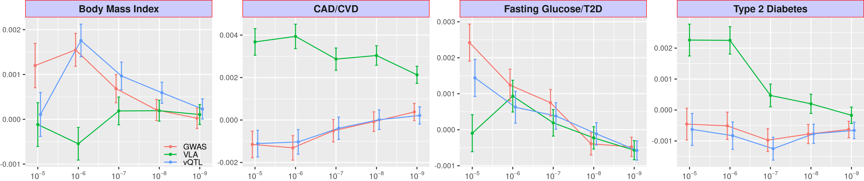We then regressed the counts on the variant ranking according to 1–p-value of VLA. If VLA enriches GxE, a higher-ranking variant should appear more frequently among significant GxE tests, with a significantly positive regression coefficient. For compression, we also regressed the counts on variant rankings from GWAS and vQTL, summarized from UKBB British Whites. Figure 5 shows the GxE enrichment regression coefficients for VLA, GWAS, and vQTL at several p-value thresholds, where the higher the value , the better the GxE selection criteria it represents. In general, VLA boosted the detection of significant GxEs for T2D, shown by the positive mean enrichment coefficients for thresholds stricter than 10⁻⁶. For CAD, GWAS and vQTL enriched GxE detection for less strict p-value cut-offs; the opposite was true for more stringent thresholds. For BMI, VLA achieved mean positive enrichment of GxE while GWAS and vQTL did the opposite—significantly degraded the selection. VLA outperformed the other two criteria for fasting glucose level by a significant margin for all p-value thresholds. Notably, GWAS and vQTL had similar performance for the two binary traits, T2D and CAD.
Figure 5: GxE enrichment for UKBB non-British Whites
Given a p-value cut-off, the enrichment analysis counts the number of significant GxE tests for each genome variant for UKBB non-British Whites (up to 16 exposome items) and regresses the count on variant rankings according to GWAS (red), VLA (green), and vQTL (blue) for UKBB British Whites. The regression coefficients (y-axis) at several p-value cut-offs (x-axis) are shown here, with higher coefficients indicating better enrichment. The error bar shows 2 × standard error.
We next screened for GxEs for T2D, BMI, and CVD in the PEGS cohort, which provides whole-genome sequencing profiles for 4,603 of 19,673 participants. The PEGS exposome survey covers 365 parent items concerning daily life, household exposures, and workplace hazards. We used the variant rankings of the four UKBB British White phenotypes analyzed with VLA, GWAS, or vQTL to enrich GxE detection for T2D and BMI—the two phenotypes directly available in PEGS. Because CAD is a major component of CVD, we used the variant rankings for CAD in the UKBB to enrich GxE detection for CVD in PEGS. Because glucose level is a strong indicator of T2D, we used the variant rankings for fasting glucose level in the UKBB to enrich T2D in PEGS. We counted the significant GxE interactions in PEGS at several p-value thresholds. Figure 6 shows the enrichment regression coefficients. For the binary outcomes, T2D and CVD in PEGS matched with T2D and CAD in UKBB, respectively, VLA outperformed GWAS and vQTL at enriching GxE detection at various thresholds. Again, the results for vQTL substantially overlapped with those for GWAS. Accordingly, vQTL provided no additional information compared to GWAS if the trait severing variant ranking is binary. For continuous variables with predictable behavior, such as BMI, vQTL is better at selecting GxE candidates in PEGS, although the three approaches converge under stricter significance thresholds for GxE candidates. When using the ranking for fasting glucose level in UKBB to enrich GxE for T2D, the performance of the three criteria was indistinguishable beyond thresholds stricter than 10⁻⁵.
Figure 6: GxE enrichment on PEGS
Given a p-value cut-off, the enrichment analysis counts the number of significant GxEs and tests each genome variant score in PEGS. It also regresses the count on variant rankings according to GWAS (red), VLA (green), and vQTL (blue) based on British Whites in the UKBB. The regression coefficients (y-axis) at several p-value cut-offs (x-axis) are shown here, with a higher coefficient value indicating better enrichment. The error bar shows 2×standard error.

Investigation of functional enrichment
If VLA, GWAS, or vQTL loci are linked to genome functions, significant variants should reside unevenly in different regions. For example, the loci within or near genes may be more abundant than those between genes. We used the ANNOVAR package [26] to assign a functional class to each variant, such as intergenic or intronic variants. We also calculated the combined annotation dependent depletion (CADD) score [27] for each variant as a continuous measure of pathogenic tendency. We regressed the function class and CADD scores on the variant rankings from VLA, GWAS, and vQTL. If the loci are enriched in certain regions, the corresponding regression coefficients should be positive; conversely, if the loci are depleted, the coefficient should be negative. Table 1 shows the functional enrichment coefficients for BMI and T2D. For BMI and T2D, variance loci (from VLA) were highly enriched in intergenic regions while GWAS and vQTL loci were highly concentrated within or near genes. As with CADD scores, variance loci were depleted in regions with high CADD scores, indicating their high pathogenic tendency. Although there were more GWAS and vQTL loci within or near genes, they were more concentrated in non-protein coding segments (i.e., upstream, intronic, and downstream). For the few variance loci located within or near genes, the distribution was relatively flat. Overall, the results indicate that variance loci are likely to take indirect, regulatory roles in genome molecule biology while GWAS and vQTL loci are likely to be more directly involved in producing protein molecules.
For a binary trait such as T2D, the functional distribution of GWAS and vQTL loci was nearly identical due to the high correlation between rankings from GWAS and vQTL. This is also the reason for the overlapping performance of GWAS and vQTL regarding GxE enrichment benchmarks. For the continuous outcome of BMI, GWAS and vQTL ranked the variants differently. The concentration of GWAS and vQTL loci also differs for CADD scores. For both binary and continuous outcomes, the pattern of variance loci is distinct from the pattern of GWAS and vQTL loci, providing a new perspective on the relative importance of each variant in terms of potential interaction.
Body Mass Index |  | GWA | VQA | VLA |  | GWA | VQA | VLA |  | Type 2 Diabetes |  | GWA | VQA | VLA |  | GWA | VQA | VLA
Intergenic |  | --- | --- | ++ | CADD | --- | +++ | - |  | Intergenic |  | --- | --- | +++ | CADD | ++ | ++ | --
Genes | Upstream | ++ | ++ | + |  |  |  |  |  | Genes | Upstream | +++ | +++ | ++
Genes | Intronic | +++ | +++ |  |  |  |  |  |  | Genes | Intronic | +++ | +++ | +
Genes | Exonic |  |  |  |  |  |  |  |  | Genes | Exonic
Genes | Downstream | + | + | - |  |  |  |  |  | Genes | Downstream | +++ | +++ | ++
Table 1: Variant Function Enrichment
The functional enrichment analysis regresses the region type and CADD score of each variant on rankings given by GWAS (red), VLA (green), and vQTL (blue) based on UKBB British Whites. Significant positive and negative regression coefficients are shown by + or -, respectively; the number of symbols denotes the level of significance. Non-significant coefficients are displayed as blank space.

UKBB variance loci catalog
Inspired by the Pan-UK Biobank GWAS catalog at pan.ukbb.broadinstitute.org, one of our research aims is to catalog variance loci statistics for the health and disease phenotypes and variants in the UKBB. The catalog will serve as a public reference that researchers interested in GxEs can query by phenotype, enabling them to prioritize the candidate variants most likely to invoke significant GxEs. Figure 7 illustrates the workflow of the cataloging process.
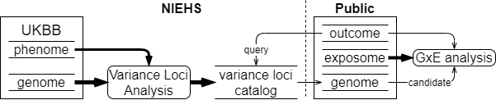
Figure 7: UKBB variance loci catalog
We summarized 1,580 health-relevant phenotypes chosen from UKBB data fields accessible to NIEHS plus another 1,693 diseases derived from hospital records. We distinguished the selected UKBB phenotypes into binomial, multinomial, ordinal, and continuous variables and subsequently recoded and normalized them. The methods section provides details of this process. We derived the 1,693 diseases using PHECODE, a codebook used to extrapolate diseases using ICD9/10 records. PHECODE is available at www.phewascatalog.org [24,25]. Thomas et al. (cite paper) implemented the codebook to transform NIEHS’s copy of ICD9/10 fields. In total, the phenome data comprise 3,273 items. For the genome, we limited the variants to those with an overall minor allele frequency of at least 0.005, for a final number of 11,841,785 after other quality control measures.
For each of the four main racial/ethnic groups in the UKBB (British White, non-British White, Black, and Asian), we performed VLA for the whole phenome and genome to archive variant statistics. We used two R packages specialized in traversing genome data and testing variance loci between thousands of phenotypes and variants. We divided the genome into approximately 1,200 groups of 1,000 variants each and summarized the VLA statistics for British Whites, the largest group by far with a working sample size of 384,000, in less than 12 hours, utilizing the computational resources of the NIH HPC Biowulf cluster (hpc.nih.gov). The variance loci catalog provides compressed files for the four main racial/ethnic groups and 3,273 phenotypes on (URL). A list of phenotypes and links to the files is available at (URL).

Methods

Notes to ourselves:
- Compare our vQTLs to those found by Visscher for 13 traits?
- https://advances.sciencemag.org/content/5/8/eaaw3538
- Functional categories/annotations
  - Clinical genomic catalogue?
  - GWAS catalogue (SNPs in LD to things in the GWAS catalogue?)
  - PheGenI phenotype-genotype integrator?
  - Test for GxE variants under positive selection

- Comparisons of risk allele frequencies across diverse populations have established appreciable directional differentiation for blood lipid and T2DM risk allele frequencies [55,56]. The decreasing frequencies of some T2DM risk alleles seen along an eastward arc from Africa to eastern Asia supplement disparities in predicted genetic risk, such that a portion of T2DM genetic risk is consistently elevated for individuals in African populations and lower in Asian populations [56], but this is somewhat controversial [57]. Accordingly, and considering that geography and climate strongly influence available foodstuffs, seasonally directed energy expenditures and other nutrition-centric human activity [13], we sought to identify those GxE SNPs that show evidence for positive selection.
- Three resources were used to investigate relationships between cardiometabolic GxEs and adaptation to climate and geography. First, two genome-wide studies have examined associations between genetic variants and climatic and geographical characteristics, including latitude, seasonality, precipitation, solar radiation and temperature [58,59]. Second, a collection of genes was identified as under selection in different human populations with roles in cultural practices, often with rationales pertinent to agriculture, diet and societal behaviors [60]. Third, a number of other studies have assessed adaptation at candidate loci for specific phenotypes and we chose to examine those germane to cardiometabolic traits. From these reports, we found that 25 of 189 different genes supporting cardiometabolic GxE interactions show adaptation to climatic and geographical characteristics (Table 1). Just 23 of 453 loci participating in main effect associations for these cardiometabolic traits, as mined from the GWAS catalog [45], show adaptation to climate and geography features, indicating significant enrichment in the GxE dataset (p <0.001, two sample z-test).
  - How does the level of over-representation across any category compare to overrepresentation of that category from results from mQTL GWAS (either our own, or the GWAS catelogue)
  - Tissue based e-QTLs
  - Epigenetics: how many vQTLs create or destroy a CpG dinucleotide, compared to random SNPs
- Compare to CardioGXE, CTD as manually curated vs computationally driven, SNPXE from GWAS catalogue
- Check for phantom vQTL effects like in the Visscher paper

Points for Discussion:
While it certainly may be stated that a person’s ‘genometype’ could indeed prove the most useful for individualized medicine (including individualized nutrition) and personal genetics [89], the impact of environmental interactions on a person’s panel of alleles cannot be overstated. In this regard, an interaction between an obesity genetic risk score based on 63 variants and saturated fat intake has been demonstrated in two distinct populations [90]. We have not in this analysis coalesced the genetic variants cataloged in CardioGxE around a given phenotype-environmental factor pair and processed data for a global or genometype GxE interaction, but such research could proceed with the aid of this GxE resource. Indeed, the lack of overlap between our CardioGxE dataset and published GWAS for comparable phenotypes makes evident the utility of incorporating GxEs into assessment of disease risk in two important ways. One, a GxE catalog provides the means to develop a better strategy of intervention because genetic and environmental factors combined can equip the physician for more accurate prediction of future disease risk and hence disease prevention. Two, genetic variation alone is not just diagnostic of disease risk, but is a component of and should be considered in epistatic and GxE interactions to better inform the individual of potential disease risk. Altogether, the numerous examples presented here add to the emerging view that GxEs are widespread and significant contributors to phenotypic variance [91]. Although we have highlighted instances for which more data are needed, especially taken under conditions mimicking the environmental factor of the GxE equation, the insight thus far garnered from analysis of a large GxE catalog emphasizes the influential roles of environmental factors in the genetics of complex traits, particularly those of a metabolic nature.

References
[1] Claude Bouchard and Tuomo Rankinen. Individual differences in response to regular physical activity. Medicine and science in sports and exercise, 33(6; SUPP):S446–S451, 2001.
[2] Jose M Ordovas and Jian Shen. Gene–environment interactions and susceptibility to metabolic syndrome and other chronic diseases. Journal of Periodontology, 79:1508–1513, 2008.
[3] Aseel Eid, Isha Mhatre, and Jason R Richardson. Gene-environment interactions in Alzheimer’s disease: a potential path to precision medicine. Pharmacology & Therapeutics, 199:173–187,2019.
[4] Nabodita Kaul and Sher Ali. Genes, genetics, and environment in type 2 diabetes: implication in personalized medicine. DNA and cell biology, 35(1):1–12, 2016.
[5] David J Hunter. Gene–environment interactions in human diseases. Nature Reviews Genetics,6(4):287–298, 2005.
[6] Avshalom Caspi and Terrie E Moffitt. Gene–environment interactions in psychiatry: joining forces with neuroscience. Nature Reviews Neuroscience, 7(7):583–590, 2006.
[7] Evan E Eichler, Jonathan Flint, Greg Gibson, Augustine Kong, Suzanne M Leal, Jason H Moore, and Joseph H Nadeau. Missing heritability and strategies for finding the underlying causes of complex disease. Nature Reviews Genetics, 11(6):446–450, 2010.
[8] Marinus H Van Ijzendoorn, Marian J Bakermans-Kranenburg, Jay Belsky, Steven Beach, Gene Brody, Kenneth A Dodge, Mark Greenberg, Michael Posner, and Stephen Scott. Gene-by-environment experiments: a new approach to finding the missing heritability. Nature Reviews Genetics, 12(12):881–881, 2011.
[9] Cathie Sudlow, John Gallacher, Naomi Allen, Valerie Beral, Paul Burton, John Danesh, Paul Downey, Paul Elliott, Jane Green, Martin Landray, et al. Uk Biobank: an open access resource for identifying the causes of a wide range of complex diseases of middle and old age. PLoSmedicine, 12(3):e1001779, 2015.
[10] Janet E Hall, Alison A Motsinger-Reif, David C Fargo, and Charles S Schmitt. PEGS: Personalized environment and genes study. https://www.niehs.nih.gov/research/clinical/studies/pegs/index.cfm, 2020. Last Reviewed: 09-01-2021.15
[11] Jonathan Marchini, Peter Donnelly, and Lon R Cardon. Genome-wide strategies for detecting multiple loci that influence complex diseases. Nature genetics, 37(4):413–417, 2005.
[12] Joshua Millstein, David V Conti, Frank D Gilliland, and W James Gauderman. A testing framework for identifying susceptibility genes in the presence of epistasis. The American Journal of Human Genetics, 78(1):15–27, 2006.
[13] Youngjo Lee and John A Nelder. Double hierarchical generalized linear models (with discussion). Journal of the Royal Statistical Society: Series C (Applied Statistics), 55(2):139–185,2006.
[14] Gordon K Smyth. Generalized linear models with varying dispersion. Journal of the Royal Statistical Society: Series B (Methodological), 51(1):47–60, 1989.
[15] Lars Rönnegård, Majbritt Felleki, Freddy Fikse, Herman A Mulder, and Erling Strandberg. Genetic heterogeneity of residual variance-estimation of variance components using double hierarchical generalized linear models. Genetics Selection Evolution, 42(1):8, 2010.
[16] Lars Rönnegård and William Valdar. Detecting major genetic loci controlling phenotypic variability in experimental crosses. Genetics, 188(2):435–447, 2011.
[17] Huanwei Wang, Futao Zhang, Jian Zeng, Yang Wu, Kathryn E Kemper, Angli Xue, Min Zhang, Joseph E Powell, Michael E Goddard, Naomi R Wray, et al. Genotype-by-environment interactions inferred from genetic effects on phenotypic variability in the UK Biobank. Science advances, 5(8):eaaw3538, 2019.
[18] Guillaume Paré, Nancy R Cook, Paul M Ridker, and Daniel I Chasman. On the use of variance per genotype as a tool to identify quantitative trait interaction effects: a report from the women’s genome health study. PLoS Genet, 6(6):e1000981, 2010.
[19] Andrew R Marderstein, Emily R Davenport, Scott Kulm, Cristopher V Van Hout, Olivier Elemento, and Andrew G Clark. Leveraging phenotypic variability to identify genetic interactions in human phenotypes. The American Journal of Human Genetics, 2020.
[20] Hugues Aschard, Bjarni J Vilhjálmsson, Amit D Joshi, Alkes L Price, and Peter Kraft. Adjusting for heritable covariates can bias effect estimates in genome-wide association studies. The American Journal of Human Genetics, 96(2):329–339, 2015.
[21] Shaun Purcell, Benjamin Neale, Kathe Todd-Brown, Lori Thomas, Manuel AR Ferreira, David Bender, Julian Maller, Pamela Sklar, Paul IW De Bakker, Mark J Daly, et al. Plink: a tool set for whole-genome association and population-based linkage analyses. The American journal of human genetics, 81(3):559–575, 2007.16
[22] Christopher C Chang, Carson C Chow, Laurent CAM Tellier, Shashaank Vattikuti, Shaun M Purcell, and James J Lee. Second-generation plink: rising to the challenge of larger and richer datasets. Gigascience, 4(1):s13742–015, 2015.
[23] Christopher Chang. Plink binary biallelic genotype table. https://www.cog-genomics.org/plink/1.9/formats#bed, Jun 2021.
[24] Wei-Qi Wei, Lisa A Bastarache, Robert J Carroll, Joy E Marlo, Travis J Osterman, Eric R Gamazon, Nancy J Cox, Dan M Roden, and Joshua C Denny. Evaluating phecodes, clinical classification software, and icd-9-cm codes for phenome-wide association studies in the electronic health record. PloS one, 12(7):e0175508, 2017.
[25] Patrick Wu, Aliya Gifford, Xiangrui Meng, Xue Li, Harry Campbell, Tim Varley, Juan Zhao, Robert Carroll, Lisa Bastarache, Joshua C Denny, et al. Mapping icd-10 and icd-10-cmcodes to phecodes: workflow development and initial evaluation. JMIR medical informatics,7(4):e14325, 2019.
[26] Kai Wang, Mingyao Li, and Hakon Hakonarson. Annovar: functional annotation of genetic variants from high-throughput sequencing data. Nucleic acids research, 38(16):e164–e164,2010.
[27] Martin Kircher, Daniela M Witten, Preti Jain, Brian J O’roak, Gregory M Cooper, and Jay Shendure. A general framework for estimating the relative pathogenicity of human genetic variants. Nature genetics, 46(3):310–315, 2014.
[28] Jacqueline MacArthur, Emily Bowler, Maria Cerezo, Laurent Gil, Peggy Hall, Emma Hastings, Heather Junkins, Aoife McMahon, Annalisa Milano, Joannella Morales, Zoe May Pendlington, Danielle Welter, Tony Burdett, Lucia Hindorff, Paul Flicek, Fiona Cunningham, and Helen Parkinson. The new NHGRI-EBI Catalog of published genome-wide association studies(GWAS Catalog). Nucleic Acids Research, 45(D1):D896–D901, 11 2016.

