Cataloging gene-environment interaction candidate SNPs for over 3,000 UK Biobank disease phenotypes through variance loci analysis
Xiaoran Tong, <authors>, Alison Motsinger-Reif
September 7, 2021

Abstract
Detecting gene by environment interactions (GxEs) in diseases enriches the ontology of genetic effects and helps identify environmental targets for interventions with the goal of improving health outcomes. However, combining the dimensions of the genome and exposome poses challenges in terms of both computational and statistical power.
Variance quantitative trait loci (vQTL) analysis, which is based on a double linear model (DLM) or double generalized linear model (DGLM), has recently received attention for its ability to find candidate single nucleotide polymorphisms (SNPs) for GxEs without actual environmental exposome profiling. The rationale is that GxEs unaccounted for by a genome-wide association study (GWAS) can bring about the residual variance of a quantitative phenotype that changes across allele dosages—a non-uniformity that can be captured by a second GWAS treating the squared residual as a new phenotype.
We propose variance loci analysis (VLA) based on a DLM augmented by squared SNP dosage. We show that VLA maintains superior power to detect GxE candidates with weak direct environmental effects on the phenotype. We also demonstrate that DGLM is overly generic with squared dosage and overly restrictive when the squared dosage is not used. More importantly, we demonstrate that by appropriately adjusting covariates, VLA can overcome the inability of DLM/DGLM to analyze thousands of non-quantitative phenotypes.
We performed VLA for 3,273 health- and disease-related phenotypes derived from the UK Biobank and ranked the potential involvement of each SNP in GxEs. Using environmental exposome data collected in the Personalized Environmental Genetic Study (PEGS), we found that high-ranking genome variants selected by VLA enriched the detection of genome-exposome-wide significant GxE SNPs for cardiovascular disease (CVD), type 2 diabetes (T2D), and body mass index (BMI).

Introduction
Most human traits have a complex etiology and are affected by both genetic and environmental factors and their interactions. The genotype has been found to modulate the effects of lifestyle factors such as exercise and diet on traits such as disease status. For example, family members receive more similar cardio-respiratory benefits of exercise compared to unrelated individuals¹. Further, the risk-lowering effects of diet on diseases that include cardiovascular disease (CVD), and type 2 diabetes are modified by the presence of certain SNPs^{2,3}. For Alzheimer’s disease, the genotype has been shown to affect the prognosis of diagnosed individuals undergoing diet- and exercise-related interventions as well as the association between pesticide and air pollutant levels and risk of the disease⁴.
Because environmental exposures can regulate the biological processes underlying a phenotype^{1,2,5,6}, unaccounted-for GxE effects are recognized as part of the heritability “missed” by variants selected by genome-wide association studies (GWAS)^{7,8}. Research in agricultural genetics, model organisms, and cell culture has consistently found that genetic effects are context-dependent (9-13). However, there has been limited success in identifying GxEs in humans for several reasons. First, many environmental exposures are unknown or difficult to record. Second, due to the polygenic nature of most human traits (9-11), GxE effect sizes are small, (9–11), and the sample sizes of most previous studies have not been large enough to detect small GxE effects.
Within larger cohorts for which environmental exposure items are comprehensively surveyed and termed “exposome” along with the commonly seen whole genome data, a 2-way GxEWAS (genome exposome wide association study) can be conducted to test all possible SNP-by-environment interactions. However, the burden of multiple testing and computation due to the overwhelming number of 2-way crossovers between the exposome items and whole genome variants limits the power of this approach (REFS), and an unbiased genome-wide interrogation restricts hypothesis generation. More commonly, instead of the whole genome, candidate genes for testing GxE interactions are selected based on previous biological knowledge or results from other GWAS, assuming strong interactions are likely to exert strong marginal effects^{9,10}. While this approach increases power, candidate gene selection is limited by existing biological knowledge, and GWAS significance does not necessarily suggest GxEs since significant SNP main effect can coexist with weak GxE. The limitations of using prior knowledge and GWAS results to identify candidate SNPs motivated the development of alternative methods. There is a growing appreciation of the observation that GxEs with large effect sizes can be revealed as heterogeneity in the variance of a quantitative trait among groups of individuals with different variant genotypes^{11–14}. As a result, a promising strategy is to screen for the so called “Variance Quantitative Trait Loci (vQTL)” in a selection cohort rich in genome data, then treat the most significant vQTLs as candidate SNPs to conducted GxE studies in a discovery cohort rich in exposome data. Unlike classical QTL, which tests the allelic substitution effect of a variant on the phenotypic mean, variance QTL (vQTL) tests the allelic substitution effect on the phenotypic variance. Therefore, vQTLs are superior GxE candidates in comparison to GWAS QTLs due to the link between GxEs and changes in the phenotypic variance. On the other hand, vQTLs retain the benefit of GWAS QTLs that the selection cohort does not require an exposome, as long as it shares the phenotype of interest with the discovery cohort. In turn, the vQTL based candidate SNPs should mitigate the multiple testing burden without requiring prior biological knowledge.

Variance quantitative trait loci (vQTL)
To begin, we adopt the common perspective that a phenotype, aside from noise and covariate effects (i.e., age and sex), is the sum of genotype main effect, environmental main effect, and the GxE interaction effect, where the GxE interaction is express by the product between genotype and environmental exposure. A vQTL can be induced by a GxE interaction effect unaccounted for in a GWAS linear model, resulting in uneven variation around the mean regression line across genotypes. Therefore, an intuitive approach to capture such a vQTL is to fit the phenotypic variance with the same genotype via a second linear model. Figure 1 conceptually illustrates the genesis of vQTL and its capture. In this figure, the vQTL scan is essentially a double linear model (DLM) since two-stage linear regressions are used, where the first stage is a de facto GWAS, and the second stage treats the squared residual as a new phenotype. When the variant is not involved in GxE (Figure 1a), the second stage results in a flat regression line because the phenotypic variation, measured by squared residuals, are nearly uniform across the genotypes; otherwise, (Figure 1b), the regression line has a non-zero slope due to the monotonic increase of phenotypic variation across the genotypes.
Figure 1: Variance trait quantitative loci (vQTL) to suggest GxE
(a) In the absence of GxE (left), residual variations are even across genotypes (right), and variant A/a is not a vQTL; by GWAS significance, the variant will be erroneously seen as a GxE candidate; (b) In the presence of GxE (left), residual variations are uneven across genotypes (right), and variant A/a is a vQTL. Teal/red dashes: environment-specific effect; blue solid lines: marginal effect.

(a)
(b)

Thus, the DLM can detect vQTLs by checking the slope of the second linear model, for example, by a t-test. Also obvious is that GWAS, by design, is not meant to select GxE candidates, which is illustrated in the left panel in Figure 1a, where, by GWAS significance, the variant not involved in GxE would be erroneously classified as a GxE candidate.
Here, we must emphasize the vQTLs included by missed GxE interaction are additive vQTLs, because each allele directly adds its effect to the phenotypic variance in linear scale. The DLM is one way to capture additive vQTLs. In contrast, there is also the so called multiplicative vQTLs where each allele multiplies the phenotypic variance by a factor, in other words, adds its effect to the phenotypic the variance in log scale.
Before the development of DLM and additive vQTL, modeling both the mean and dispersion of a quantitative phenotype with shared genotype predictors (i.e., SNPs) have been achieved via double generalized linear models (DGLM)¹⁵ and double hierarchical generalized linear models (DHGLM)¹⁶, which allows random effects. Like DLM, DGLM is also a two-stage model but allows standard link functions to accommodate non-normal outcomes and assumes that the squared residual deviance (i.e., squared residual generalized) of a stage-1 model follows not Gaussian, but Gamma, distribution. Therefore, by default, DGLM uses log-linked Gamma regression for stage-2 models. When the phenotype is Gaussian, the log linked Gamma regression in stage-2 essentially models the phenotypic variance in log scale, thus the DGLM is one way to capture multiplicative vQTLs. The intent of DGLM and DHGLM was to prioritize genome variants that are resistant to environmental changes, allowing the selection of non-interaction candidates¹⁷. DGLM is a common benchmark to compare the power to identify GxE candidates^{18,19}.
Indeed, methods that capture either additive or multiplicative vQTLs have seen some success, but also seen confusions when comparing the power performance due to the difference in the two perspectives. Guillaume et al. explained in detail how the second stage of a DLM fits the heterogeneous residual variance with the allele dosage, which is an additive vQTL, yet the proposed method relied not on linear regression and t-test in stage-2, but rather Levene’s test^{20,21} for equality of variance across genotype groups, which captures multiplicative vQTLs²². Nonetheless, the method was applied to the Women’s Genome Health Study to select SNPs, which included three novel GxE interactions involving body mass index (BMI) and smoking and were significantly associated with C-reactive protein level and soluble ICAM-1 levels on a whole-genome scale.
Recently, Andrew et al. proposed the deviation regression model (DRM), a modified DLM²³. Typically, variation within each genotype group is measured by the squared distance between phenotype values and the group mean, that is, the squared residuals of the stage-1 linear model. The DRM, however, replaces this with the absolute distance between phenotype values and the group median. We notice that the simulation generated normal phenotype as the sum of covariate, genotype main, environmental main, and GxE interaction. The vQTLs were induced by the GWAS under the presence of GxE effect and were thus additive vQTLs. The DRM is statistically more powerful than Levene’s test^{20,21}. When the quantitative phenotype was made non-Gaussian and the genotype main effect is non-zero, the DRM managed to controlled the type 1 error while DGLM and TSSR (two-step squared residual, essentially the DLM) failed to. DRM was then applied to UKBB genotype and BMI phenotype data, variants identified by DRM demonstrably improved the likelihood of detecting genome-wide significant GxE interactions with age, sex, smoking, drinking, physical activity, sedentary behavior, and diet. The study also reported that vQTL selected according to BMI enriched GxE detection for binary phenotypes such as diabetes.
In a comprehensive simulation, Huanwei et al.¹⁸ compared the performance of popular vQTL test statistics, including Bartlett’s test, robust Levene’s test, Fligner-Killeen test, and DGLM, challenged by a wide variety of quantitative phenotypes [17]. In this study, the basic phenotype was drawn from a normal distribution with the variance being a linear combination of allele dosages passed to the exponential function, that is, the genotype determined the phenotypic variance in log scale, and the vQTLs thus created were multiplicative vQTL. In this case, the study found Levene’s robust test being the optimal choice for both power and type 1 error control when the phenotype was transformed into quantitative non-Gaussian. The study then applied Levene’s test to scan vQTLs for 13 quantitative traits in a UKBB training dataset for the enrichment of genome-wide discovery of significant GxE in a validation dataset with exposome based on sex, age, physical activity, sedentary behavior, and smoking.
To summarize, it is recommended to use Levene’s test to capture multiplicative vQTL, and DRM to capture additive vQTL; although DGLM and DLM are motivated by multiplicative and additive vQTLs, respectively, but they cannot control the type 1 errors when the quantitative phenotype is not close to Gaussian.

Issues with vQTL

The most severe limitation is that vQTL approaches are not suitable for binary case/control outcomes such as type 2 diabetes (T2D) and cardiovascular disease (CVD). Both additive and multiplicative vQTL try to capture the heterogeneity of phenotypic variance between individuals of different genotypes while assuming homogeneous variance among individuals of the same genotype. When the phenotype is non-Gaussian, the phenotypic mean and variance within a group is related, so a significant QTL affecting the phenotypic mean is likely to affect the variance as well, which violates the assumption of within group homogeneous variance bias the vQTL test towards positive. If the phenotype is quantitative, false positives are still somewhat, if not completely, countered by DRM²³ and Levene’s test^{18,21} while maintaining the power to detect true vQTL. For binary phenotypes however, this issue has become extreme not only due to the binary mean µ and variance v being related by v = 2µ (1 - µ), but also because the binary phenotype concealing the gradient of underlying risk. As a result, the type 1 errors is out of control for both vQTL tests. Figure 2a illustrates the false positive vQTL when we fit a DLM for binary phenotype, where the GxE is null (parallel slopes for two environments, red and teal, figure 2b left), yet the stage-2 linear regression still fits a non-zero slope through the squared residual (2b right).
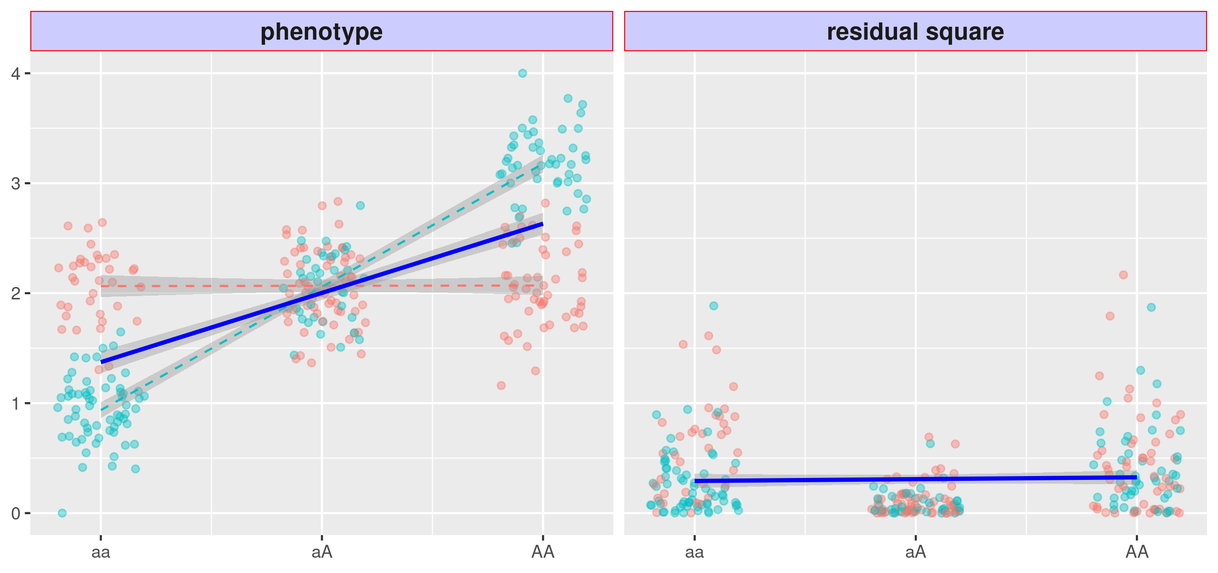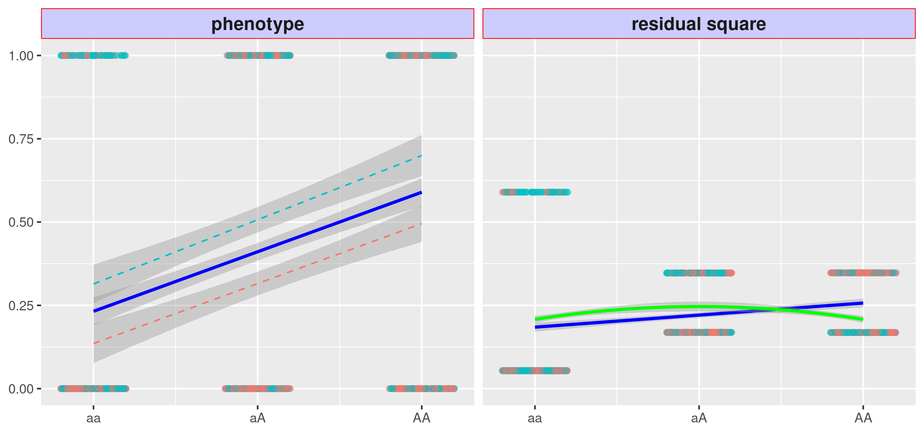
Figure 2: Issues with variance quantitative loci (vQTL)
The red and teal points represent samples experiencing two environments.
(a) left: a binary phenotype with non-null marginal genotype main effect, shown by the blue sloid slope, but null GxE effect, shown by dashed red and teal slope in paralleled (a) right: the squared residuals changes with genotype, shown by the blue solid slope, the variant thus become a false vQTL; the VLA fits a downwards curve, shown as green solid, thus control the type 1 error.
(b) left: a Gaussian phenotype with strong GxE effect but weak environmental main effect (i.e., pure GxE), shown by the dashed red and teal with distinct slopes but cross the center. (b) right: the squared residuals changes with genotype but non-linearly, the linear model misses the true GxE candidate (i.e., DLM and DRM), shown by the flat regression line.
(a)
(b)
The type 1 error is not controlled by simplify replacing DLM with DRM or Levene’s test. DGLM becomes overly conservative for binary phenotypes, which is different from the uncontrolled type 1 error reported by Andrew et al. and and Huanwei et al. for non-Gaussian but quantitative phenotypes.
From the results of simulation studies, Huanwei et al.¹⁸ and Andrew et al.²³ advised against vQTL scan on binary phenotypes. The later also suggested using surrogates, assuming that significant vQTLs of a quantitative mediator are likely GxE candidates of a downstream binary phenotype. For example, significant GxE interactions for type 2 diabetes would likely be found among vQTLs of BMI²³. However, the use of surrogate vQTL has not been widely explored, and we report the evaluation of such a strategy later in the paper. Additionally, additive vQTL methods such as DLM and DRM lack the power to detect a true GxE candidate when the environment main effect is weak, even if the phenotype is Gaussian. Figure 2a illustrate This issue is

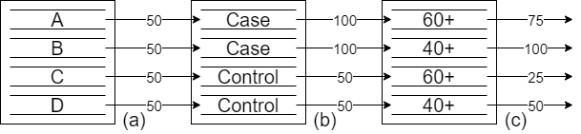
Figure 3: Assigning innate risk scores using covariates
(a) Without prior knowledge, four people are assigned a median innate risk score; (b) Given their disease status, an individual may be assigned a higher innate risk score; (c) Given their age, the innate risk score may be decreased for older individuals. VLA results in a downwards regression curve (green solid line) and controls type 1 errors.

Variance loci analysis (VLA)
We propose variance locus analysis (VLA) to select GxE candidates for both Gaussian and binary phenotypes. First, between additive and multiplicative perspective on the genesis of variance locus, we choose the additive perspective as the basis for improvement, because the GxE effect will eventually be discovered with the most common additive model, that is, phenotype being the sum of genotype main effect, covariate main effect, environmental main effect, GxE interaction main effect, plus some noise.
This approach overcomes additive vQTL scanner’s lack of power under low environmental main effects. In VLA, instead of testing the non-zero slope of the stage-2 regression line, a curve is fit and its upwardness is tested; importantly, this controls the type 1 errors for binary phenotypes, as illustrated by the solid green line in Figure 2b.
While it controls the type 1 error, the upwardness test results in a lack of power to detect GxE candidates (Figure 4a) because the binary event glosses over the underlying risk leading up to the event.
However, the underlying risk can be reconstructed to some extent with covariates. Figure 3 demonstrates this process with a hypothetical situation. Given four individuals–A, B, C, and D–without any additional information, it is reasonable to assign all four an innate risk score of 50, which is the median of a 100-point scale. If A and B have been diagnosed with the disease, their innate risk scores are increased to 100. Because A is in his 60s, his innate risk score is lowered to 75; because B is in his 40s, his innate risk score remains at 100. The logic behind this adjustment is that for an older person, a high innate risk score is not required to develop the disease. Because C and D have not been diagnosed with the disease, their innate risk scores remain at the default 50. However, because C is in his 60s, his risk score is lowered to 25. The logic behind this adjustment is that since he has not been diagnosed with the disease, given his age, he has a lower inherent risk score.
Through this process, innate risk scores for a disease can be assigned that are distinct for those with and without the condition and as well as within each group. In this scenario, the innate risk score has four levels, which is smoother and more informative than the original, two-level phenotype, shown in Figure 3. The risk score is the residual of the disease fitted by age, which is the combined effect of the genome and exposome, in other words, a finer gradient of risk is revealed by removing the effect of age..
With additional covariates, the risk score can resemble a smooth Gaussian variable. After replacing the binary phenotype with the recovered innate risk score, upward curve-based VLA can be used to select variance loci involved in GxE. Figure 4b conceptually demonstrates this. The best covariates are non-confounding predictors, such as age and sex, which are not heritable and not determined by the genome or exposome (non-confounding) yet determine the risk of major diseases (predictors). Using raw, case/control disease traits to carve out a smooth gradient of risk score biases the genome and exposome effects [20]. Non-predictive covariates cannot extract helpful information from the original phenotype without adding useless noise.
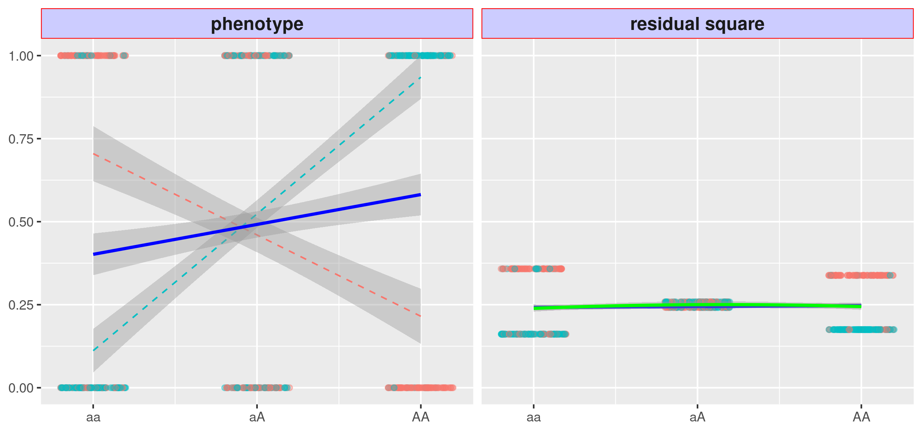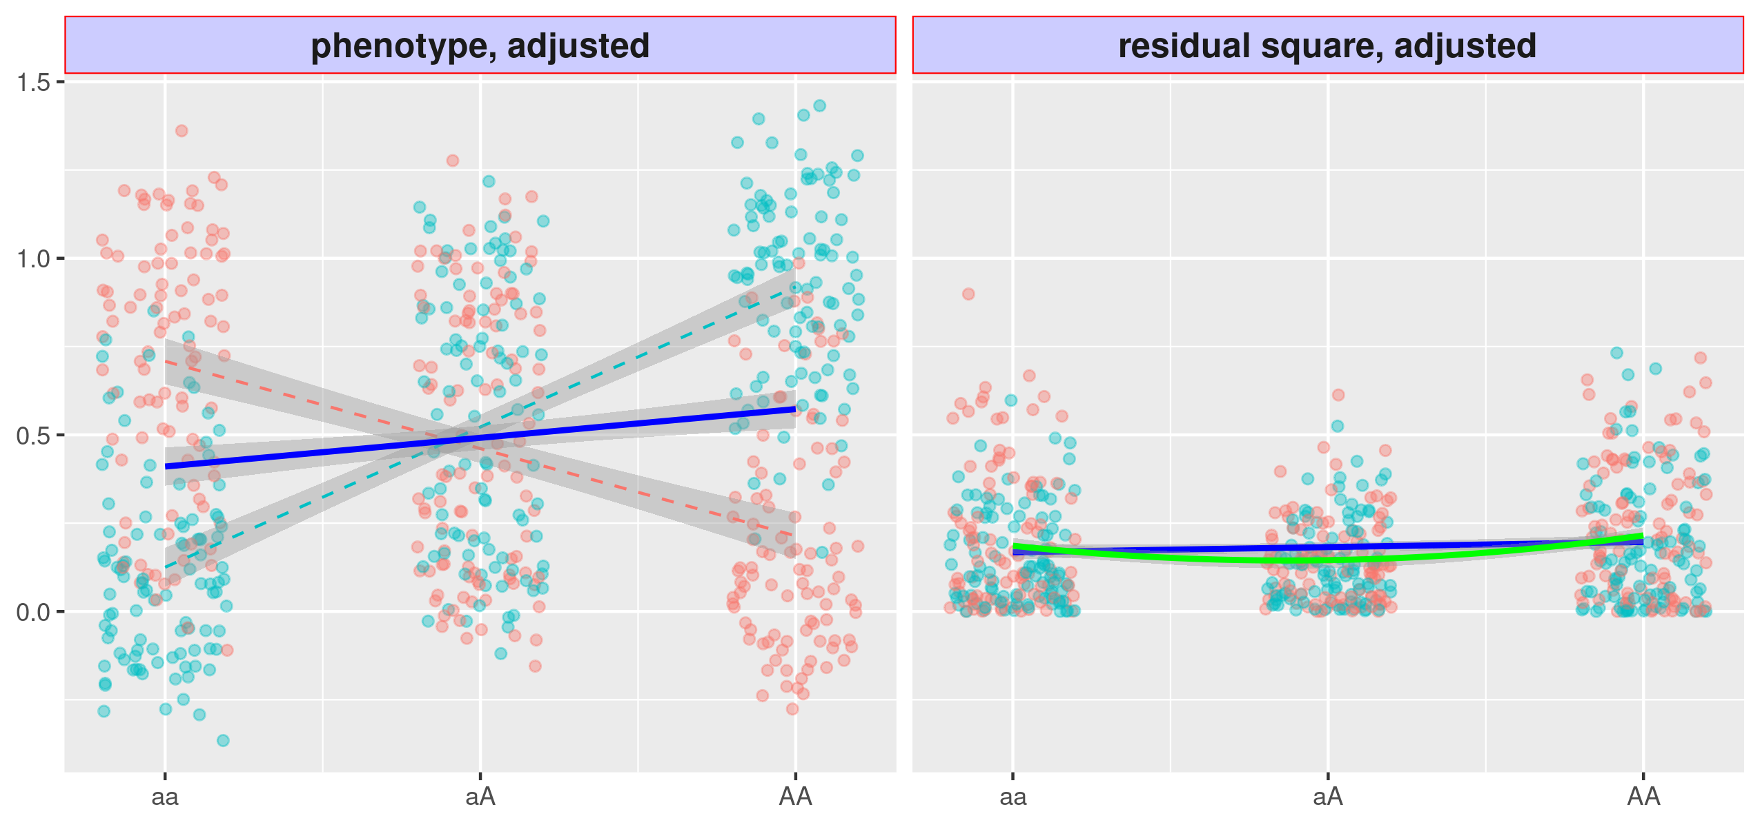
Figure 4: Variance loci analysis (VLA) with innate risk score
(a) Variant A/a is strong in GxE, but the VLA curve upwardness (green solid) test is as powerless as the slope-based vQTL(blue); (b) If the binary phenotype is replaced by the innate risk score as a covariate residual, the upwardness of the VLA curve (green solid) detects the variance loci A/a.
(a)
(b)

Application in the UK Biobank
Because data from large biobank-based GWAS (26, 27) is available, the genome can be examined using VLA for a range of phenotypes in cohorts with unprecedented sample sizes. In this work, we conducted whole-genome VLA scans across all relevant phenotypes in the UK Biobank (UKBB).
VLA can select GxE candidates for both binary and quantitative traits, enabling the creation of a catalog of VLA statistics for the entire genome and phenome of the UKBB, similar to the Pan-UK Biobank GWAS catalog at pan.ukbb.broadinstitute.org or the EBI GWAS catalog. The original UKBB phenome was expanded with compound phenotypes derived from hospital diagnoses recorded in ICD9/10 format, based on the most recent PHECODE mapping table (v1.2) [24,25]. The catalog summarizes the interaction potential for phenotypes of interest for each variant and can be used in future GxE research to prioritize top-ranking candidates. The VLA catalog is hosted by NIEHS (https://genelist.niehs.nih.gov/vla).

Validation
We demonstrate our method through simulation and application in the UK Biobank, focusing on three traits for which genomics mapping has been successfully conducted. The UK Biobank is an excellent source for discovery but contains limited data on external environmental exposures.
We used UK Biobank data to prescreen candidates for GxE testing in the independent, NIEHS Personalized Gene and Environment Study (PEGS) cohort. The results provide excellent proof of principle. The PEGS is based in North Carolina, with more than 10,000 active participants, nearly half of which with whole-genome sequencing (WGS), and a comprehensive exposome of more than 600 items collected [10].
Now add back the brief description of PEGS and how top VLA results from UKBB were used to test for GXE in PEGS with its extensive exposome data for LIST TRAITS.
Much is known about the functional characteristics of GWAS signals (over-represented for eQTLs, etc.) Performed a similar assessment of annotation details of VLA results. Compare it to GWAS results. on UKBB British Whites for a selected phenome using the plinkFile and vla R packages to determine whether variance loci with greater significance can identify more significant GxEs detected in other populations, such as UKBB non-British Whites (i.e., mainly Irish). We also investigated whether variance loci are over-represented in specific genome types (i.e., intronic and intergenic), just as GWAS loci are more concentrated within or near certain gene regions. The results section details the findings, and the methods section outlines the preparation of phenome, genome, and exposome data.
Also, we demonstrate that the VLA analysis can identify/enrich for previously known GXEs. CardioGXE is a manually curated resource cataloging gene-environment interactions from the literature on blood lipids, glycemic traits, obesity anthropometrics, vascular measures, inflammation, and metabolic syndrome.

Results
NEED TO ADD IN A BRIEF DISCUSSION OF THE SIMULATION AND METHODS COMPARISON WORK HERE.
We implemented VLA as a self-contained “vla” pure R package that simultaneously scans multiple phenotypes and genome variants, given adequate system memory. Because it is self-contained and pure R means that “vla” is platform- and compiler-independent as long as the R Base package is installed. As the number of phenotypes increases, the vla R package is more efficient than routine genome-wide analysis implemented in C/C++, such as PLINK [21, 22]. To traverse out-of-memory allele-count genotype data condensed in PLINK 1 binary biallelic genotype tables, we created “plinkFile”, another self-contained R package [23]. We used these two packages to run analysis based on UKBB and PEGS data, as detailed in later sections.

Simulation
We present the performances for normal phenotypes with covariate effect in Fig.8a. We omit the results with null covariate effect because the change of performances is hardly noticeable.
In scenario 1 and 2 where GxE effect and environmental main effect are both non-zero, and the expected effect of allele, VLA attained the best performance, especially in scenario 1 where GxE and environmental main effect (ENV) took the opposite sign, causing all methods to be less efficient due to the mutual attenuation between $g$ and $g^{2}$ under low MAF. In scenario 4 where a pure GxE effect exists with null environmental main effect, VLA out-perform DLM as expected since the former supposedly capturing $b^{2}$ with squared dosage $g^{2}$ is unaffected, while the latter capturing $2bc$ with linear dosage $g$ is nullified as $c→0$, however, all methods still achieved substantial power because, again, $g$ and $g^{2}$ cannot perfectly separate. In scenario 1, 2, and 4 with non-zero GxE, linear DGLM (DG1) and Levene’s Test (LVT) fell behind DLM and VLA as expected because we simulated additive variance loci according to (4), while DGLM and LVT are going after multiplicative variance loci. Augmented DGLM (DG2) not only fell behind in terms of power despite being more flexible but was also the only method inflated false discovery rate (FDR) above the expected 0.05 in scenario 3 and 5, which may be the result of exploring solutions of $(b,c)$ in unreal space.
To simulate binary phenotype $z$, we convert Gaussian phenotype $y$ to probabilities with logistic function, then draw 1 = case and 0 = control status from that probability, such that
$z\sim Bernulli\left(π\right), π=Pr(z=1)=\frac{1}{1+exp⁡(-y)}$. (?)

In Figure 8b we show the performance on binary phenotype with null covariate effect. The false discovery rate of DLM, Levene’t Test, and DRM went far beyond the expected 0.05 in scenario 3 and 5. The two DGLM methods with correctly specified logit link binomial model became overly conservative. VLA was also conservative, resulting in rates lower than 0.05 in scenario 3 and 5, and was powerless in scenario 1, 2, and 4 where GxE exists.
In Figure 8c we show the performance on binary phenotype with strong covariate effect. The results changed drastically because a non-confounding predictive covariate can recover the innate risk score (IRS) underlying the binary phenotype as a numeric variable, which is crucial in restoring the power to detect variance loci. In fact, the performances resemble the Gaussian phenotype shown in Fig.8a, except the two DGLM methods, which had been shown to be overly conservative in scenario 3 and 5 with null GxE, so their power are at greater disadvantages in scenario 1, 2, and 4 when GxE does exists.
(a)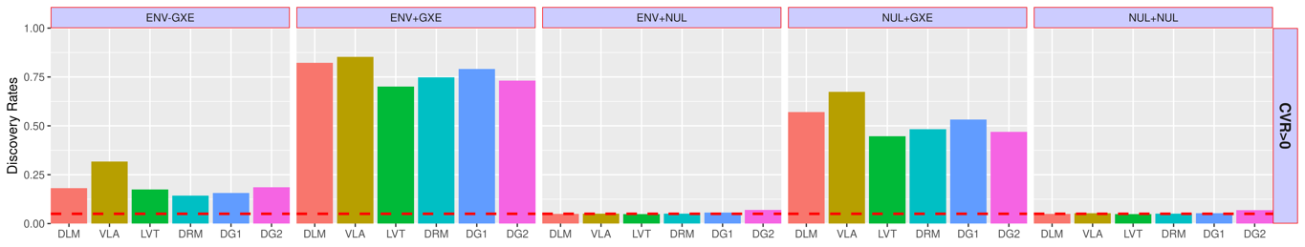
(b)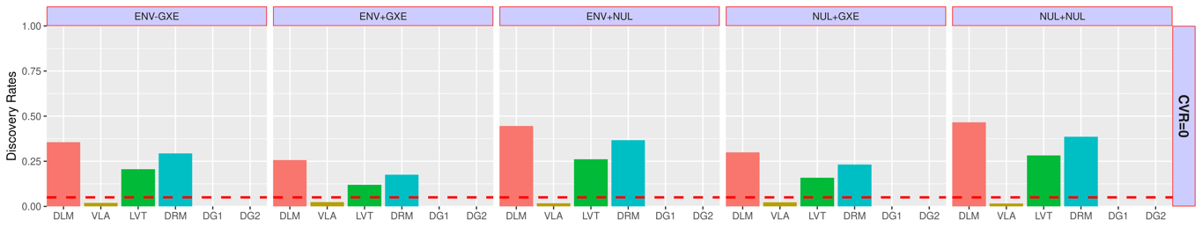
(c)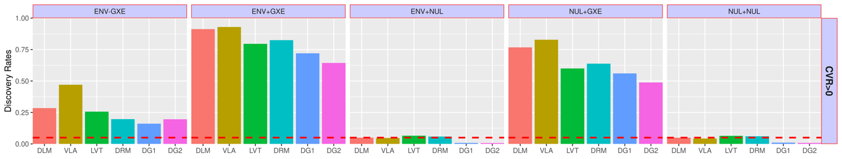
Figure 8: Performance for normal phenotypes
Top to bottom: (a) Gaussian phenotype with covariate effect (CVR>0); (b) Binary phenotype without covariate effect (CVR=0); (c) Binary phenotype with covariate effect (CVR>0)
Left to right: simulation scenario 1 – 5.
- ENV – GXE: GxE effect b and environmental main effect c took opposite sign, thus the linear and square dosage terms in model (4) mutually attenuate under low MAF. Since GxE is non-zero, higher discovery rate is better.
- ENV + GXE: GxE effect b and environmental main effect c took the same sign, thus the linear and square dosage terms in model (4) stacks under low MAF. Since GxE is non-zero, higher discovery rate is better.
- ENV + NUL: pure environmental main effect without GxE, a false discovery rate of 0.05 is good.
- NUL + GXE: pure GxE without environmental main effect, higher discovery rate is better.
- NUL + NUL, null environmental main effect, null GxE, a false discovery rate of 0.05 is good.
X-axis: competing methods. DLM=double linear model vQTL test; VLA = proposed variance locus / curve upwardness test; DG1=double generalized linear model (DGLM); DG2=augmented DGLM, with quadratic term; LVT=Levene’s test; DRM=Deviation Regression Model, the modified DLM.
Y-axis: GxE discovery rate. In panel 1,2, and 4, where GxE does exists, higher rates mean better, otherwise, the rates are false discovery rates expected to be 0.05, a rate higher than 0.05 means inflated type 1 error, lower than 0.05 means conservative. The red dash line marks the discovery rate of 0.05.

Pilot VLA scan on UKBB
We ran VLA on 35,3605 UKBB British Whites with 11,841,786 variants across the genome and ranked the variants from the least to the most significant. The phenome includes two binary traits—coronary artery disease (CAD) and type 2 diabetes (T2D)—and two quantitative traits—BMI and fasting glucose. The covariates include age, sex, age², age_sex, age²_sex, the first 20 genetic principal components, and the genotyping array. We rank the genome variants according to their VLA significance (i.e., 1–p-value). For comparison, we performed GWAS and vQTL scans and then ranked the genome variants accordingly.

Benchmark GxE enrichment
GxE enrichment measures the likelihood of significant variance loci invoking a significant GxE interaction. Positive enrichment enables the use of a criterion such as VLA to help select GxE candidates.
We screened for GxE in UKBB non-British Whites and the same phenome and genome data and covariates used for VLA. The UKBB includes exposome data on lifestyle factors (alcohol use, smoking, physical activity, sedentary lifestyle), environment (green space, water, coast, noise, nitrite oxide, nitrite dioxide, PM10, PM2.5, traffic), and family structure (siblings). For each variant, we counted the number of significant GxEs given a series of p-value thresholds from 10⁻² to 10⁻⁹.
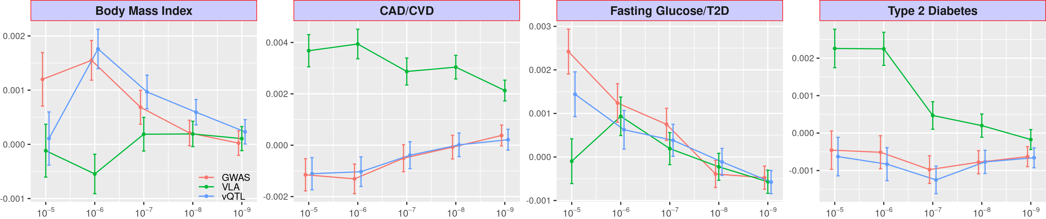We then regressed the counts on the variant ranking according to 1–p-value of VLA. If VLA enriches GxE, a higher-ranking variant should appear more frequently among significant GxE tests, with a significantly positive regression coefficient. For compression, we also regressed the counts on variant rankings from GWAS and vQTL, summarized from UKBB British Whites. Figure 5 shows the GxE enrichment regression coefficients for VLA, GWAS, and vQTL at several p-value thresholds, where the higher the value , the better the GxE selection criteria it represents. In general, VLA boosted the detection of significant GxEs for T2D, shown by the positive mean enrichment coefficients for thresholds stricter than 10⁻⁶. For CAD, GWAS and vQTL enriched GxE detection for less strict p-value cut-offs; the opposite was true for more stringent thresholds. For BMI, VLA achieved mean positive enrichment of GxE while GWAS and vQTL did the opposite—significantly degraded the selection. VLA outperformed the other two criteria for fasting glucose level by a significant margin for all p-value thresholds. Notably, GWAS and vQTL had similar performance for the two binary traits, T2D and CAD.
Figure 5: GxE enrichment for UKBB non-British Whites
Given a p-value cut-off, the enrichment analysis counts the number of significant GxE tests for each genome variant for UKBB non-British Whites (up to 16 exposome items) and regresses the count on variant rankings according to GWAS (red), VLA (green), and vQTL (blue) for UKBB British Whites. The regression coefficients (y-axis) at several p-value cut-offs (x-axis) are shown here, with higher coefficients indicating better enrichment. The error bar shows 2 × standard error.
We next screened for GxEs for T2D, BMI, and CVD in the PEGS cohort, which provides whole-genome sequencing profiles for 4,603 of 19,673 participants. The PEGS exposome survey covers 365 parent items concerning daily life, household exposures, and workplace hazards. We used the variant rankings of the four UKBB British White phenotypes analyzed with VLA, GWAS, or vQTL to enrich GxE detection for T2D and BMI—the two phenotypes directly available in PEGS. Because CAD is a major component of CVD, we used the variant rankings for CAD in the UKBB to enrich GxE detection for CVD in PEGS. Because glucose level is a strong indicator of T2D, we used the variant rankings for fasting glucose level in the UKBB to enrich T2D in PEGS. We counted the significant GxE interactions in PEGS at several p-value thresholds. Figure 6 shows the enrichment regression coefficients. For the binary outcomes, T2D and CVD in PEGS matched with T2D and CAD in UKBB, respectively, VLA outperformed GWAS and vQTL at enriching GxE detection at various thresholds. Again, the results for vQTL substantially overlapped with those for GWAS. Accordingly, vQTL provided no additional information compared to GWAS if the trait severing variant ranking is binary. For continuous variables with predictable behavior, such as BMI, vQTL is better at selecting GxE candidates in PEGS, although the three approaches converge under stricter significance thresholds for GxE candidates. When using the ranking for fasting glucose level in UKBB to enrich GxE for T2D, the performance of the three criteria was indistinguishable beyond thresholds stricter than 10⁻⁵.
Figure 6: GxE enrichment on PEGS
Given a p-value cut-off, the enrichment analysis counts the number of significant GxEs and tests each genome variant score in PEGS. It also regresses the count on variant rankings according to GWAS (red), VLA (green), and vQTL (blue) based on British Whites in the UKBB. The regression coefficients (y-axis) at several p-value cut-offs (x-axis) are shown here, with a higher coefficient value indicating better enrichment. The error bar shows 2×standard error.

Investigation of functional enrichment
If VLA, GWAS, or vQTL loci are linked to genome functions, significant variants should reside unevenly in different regions. For example, the loci within or near genes may be more abundant than those between genes. We used the ANNOVAR package [26] to assign a functional class to each variant, such as intergenic or intronic variants. We also calculated the combined annotation dependent depletion (CADD) score [27] for each variant as a continuous measure of pathogenic tendency. We regressed the function class and CADD scores on the variant rankings from VLA, GWAS, and vQTL. If the loci are enriched in certain regions, the corresponding regression coefficients should be positive; conversely, if the loci are depleted, the coefficient should be negative. Table 1 shows the functional enrichment coefficients for BMI and T2D. For BMI and T2D, variance loci (from VLA) were highly enriched in intergenic regions while GWAS and vQTL loci were highly concentrated within or near genes. As with CADD scores, variance loci were depleted in regions with high CADD scores, indicating their high pathogenic tendency. Although there were more GWAS and vQTL loci within or near genes, they were more concentrated in non-protein coding segments (i.e., upstream, intronic, and downstream). For the few variance loci located within or near genes, the distribution was relatively flat. Overall, the results indicate that variance loci are likely to take indirect, regulatory roles in genome molecule biology while GWAS and vQTL loci are likely to be more directly involved in producing protein molecules.
For a binary trait such as T2D, the functional distribution of GWAS and vQTL loci was nearly identical due to the high correlation between rankings from GWAS and vQTL. This is also the reason for the overlapping performance of GWAS and vQTL regarding GxE enrichment benchmarks. For the continuous outcome of BMI, GWAS and vQTL ranked the variants differently. The concentration of GWAS and vQTL loci also differs for CADD scores. For both binary and continuous outcomes, the pattern of variance loci is distinct from the pattern of GWAS and vQTL loci, providing a new perspective on the relative importance of each variant in terms of potential interaction.
Body Mass Index |  | GWA | VQA | VLA |  | GWA | VQA | VLA |  | Type 2 Diabetes |  | GWA | VQA | VLA |  | GWA | VQA | VLA
Intergenic |  | --- | --- | ++ | CADD | --- | +++ | - |  | Intergenic |  | --- | --- | +++ | CADD | ++ | ++ | --
Genes | Upstream | ++ | ++ | + |  |  |  |  |  | Genes | Upstream | +++ | +++ | ++
Genes | Intronic | +++ | +++ |  |  |  |  |  |  | Genes | Intronic | +++ | +++ | +
Genes | Exonic |  |  |  |  |  |  |  |  | Genes | Exonic
Genes | Downstream | + | + | - |  |  |  |  |  | Genes | Downstream | +++ | +++ | ++
Table 1: Variant Function Enrichment
The functional enrichment analysis regresses the region type and CADD score of each variant on rankings given by GWAS (red), VLA (green), and vQTL (blue) based on UKBB British Whites. Significant positive and negative regression coefficients are shown by + or -, respectively; the number of symbols denotes the level of significance. Non-significant coefficients are displayed as blank space.

UKBB variance loci catalog
Inspired by the Pan-UK Biobank GWAS catalog at pan.ukbb.broadinstitute.org, one of our research aims is to catalog variance loci statistics for the health and disease phenotypes and variants in the UKBB. The catalog will serve as a public reference that researchers interested in GxEs can query by phenotype, enabling them to prioritize the candidate variants most likely to invoke significant GxEs. Figure 7 illustrates the workflow of the cataloging process.
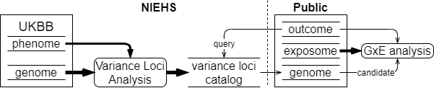
Figure 7: UKBB variance loci catalog
We summarized 1,580 health-relevant phenotypes chosen from UKBB data fields accessible to NIEHS plus another 1,693 diseases derived from hospital records. We distinguished the selected UKBB phenotypes into binomial, multinomial, ordinal, and continuous variables and subsequently recoded and normalized them. The methods section provides details of this process. We derived the 1,693 diseases using PHECODE, a codebook used to extrapolate diseases using ICD9/10 records. PHECODE is available at www.phewascatalog.org [24,25]. Thomas et al. (cite paper) implemented the codebook to transform NIEHS’s copy of ICD9/10 fields. In total, the phenome data comprise 3,273 items. For the genome, we limited the variants to those with an overall minor allele frequency of at least 0.005, for a final number of 11,841,785 after other quality control measures.
For each of the four main racial/ethnic groups in the UKBB (British White, non-British White, Black, and Asian), we performed VLA for the whole phenome and genome to archive variant statistics. We used two R packages specialized in traversing genome data and testing variance loci between thousands of phenotypes and variants. We divided the genome into approximately 1,200 groups of 1,000 variants each and summarized the VLA statistics for British Whites, the largest group by far with a working sample size of 384,000, in less than 12 hours, utilizing the computational resources of the NIH HPC Biowulf cluster (hpc.nih.gov). The variance loci catalog provides compressed files for the four main racial/ethnic groups and 3,273 phenotypes on (URL). A list of phenotypes and links to the files is available at (URL).

Methods
In this section we first review the two types of vQTL, the additive vQTL captured by DLM/DRM, and the multiplicative vQTL captured by DGLM and Levene’s test. The two are related yet represent different view on the origin of GxE effect.
In a discovery cohort where both exposome variable $u$ and genome variant $g$ are visible, we typically represent the GxE interaction effect by the 2-way product term $ug$ in a linear model, that is,
$y=m_{0}+ag+bug+cu+dx+ e, Var\left(u_{i}\right)=σ_{u}^{2}, e_{i}\sim N\left(0, σ_{e}^{2}\right)$, (1)
where $e$ is a size $σ_{e}^{2}$ Gaussian noise, and $x$ is a non-confounding covariate. For now, we let the phenotype $y$ remain Gaussian, the environment $u$ be a centered variable with variance $σ_{e}^{2}$, and $u⊥ g$. The model (1) is frequently considered the ground truth of GxE interaction effect.
In an ideal selection cohort where the joint distribution of all variables is identical to the discovery cohort and the sample size is sufficient, except the environment $u$ is either unobserved or ignored, one can conduct the typical GWAS as
$y=m_{0}+ag+dx+r$ or $E\left(y | g\right)=m_{0}+ag+dx$. (2)
The unattended part, $bug+cu+e$, would become the GWAS residual $r$. As a result, the squared residual $r^{2}$ is also associated with the genotype $g$, because,
$r^{2}=b^{2}u^{2}g^{2}+2bcu^{2}g+c^{2}u^{2}+2\left(bug+cu\right)e+e^{2}$, (3)
and $Var\left(y | g\right)=E(r^{2}|g)=b^{2}σ_{u}^{2}g^{2}+2bcσ_{u}^{2}g+c^{2}σ_{u}^{2}+σ_{e}^{2}$. (4)
From (4) we see variant $g$ is in fact modeling the phenotypic variance, hence the notion of $g$ being a “variance QTL”, or “vQTL”. This phenomenon had been shown in Figure 1. Since each additional allele adds $[b^{2}(2g+1)+2bc]σ_{u}^{2}$ to the variance in linear space, we call it an additive vQTL, and because such property relies on the premises of GxE interaction in (1), we may also call it an GxE induced vQTL.
On the other hand, one may directly state that the allele affects the phenotypic variance, that is,
$y\sim N(m_{0}+ag,e^{μ+α^{'}g+β^{'}g^{2}})$ or $\log\left[Var\left(y | g\right)\right]=μ+α^{'}g+β^{'}g^{2}.$ (5)
The exponential ensures variance will never be negative for real valued $(μ,α,β)$. The variant $g$ is a vQTL already since each additional allele multiplies the variance by a factor of $e^{α^{'}+{(2g+1)β}^{'}}$, and we call it a multiplicative vQTL. Unlike the additive vQTL in (4), the multiplicative vQTL does not depends on a specific construct of GxE interaction like (1).
The most straightforward way to capture additive vQTLs is via double linear model (DLM), where the stage-1 model is (2) exactly, that is, the orthodox GWAS; the stage-2 model treats squared residual $r^{2}$ as a “phenotype” and fit it with the allele dosage, as if conducting another GWAS,
$E(r^{2}|g)=a'g+m_{0}^{'}$. (6)
The DLM approximates the full additive vQTL model in (4), omitting the second order term $b^{2}σ_{u}^{2}g^{2}$. In a hypothetical world where $g{⊥g}^{2}$ holds, the estimated DLM coefficient $a'$ in (5) would identity the first order coefficient $2bcσ_{u}^{2}$ of the true vQTL model in (4). In reality, $g$ and $g^{2}$ are correlated, especially when the MAF of $g$ is low, therefore, the estimated DLM coefficient $a'$ in (5) is a mixture of $b^{2}σ_{u}^{2}$ and $2bcσ_{u}^{2}$ in (4) and runs the risk of mutual attenuation when the true GxE effect $b$ and environmental main effect $c$ take opposite signs. Nonetheless, when $b≠0$ and $g$ is an additive vQTL, the estimated $a'$ is likely to be non-zero and is detectable via a t-test.
When the phenotype $y$ deviates from Gaussian, DLM may inflate type 1 errors when the variant is a GWAS QTL, because a non-Gaussian distribution’s mean and variance are related, therefore, a QTL affecting the phenotypic mean is also a vQTL affecting the variance. Realize that the squared residual $r^{2}$ in stage-2 models (5) and (6) is in fact a measurement of sample variation per genotype group, replacing it with the absolute distance from the group median results in DRM. The DRM method is more robust than DLM under non-Gaussian but limited to discrete genotypes, since a continues genotype value does not offer a clear definition of “group”.
To capture a multiplicative vQTL, we can use the double generalized linear model (DGLM). DGLM is also a 2-stage model that fit both the mean and variance of a phenotype by genotype, that is,
$μ=E\left(y | g\right)=h\left(m_{0}+ag\right), Var\left(y | g\right)=ϕV\left(μ\right), ϕ=h'(m_{0}^{'}+α^{'}g)$. (7)
Here, $ϕ$ is the dispersion determined by allele dosage; function $V$ relates the phenotypic mean $μ$ and variance to some extent, with its form determined by the distribution of phenotype, for example, $V\left(μ\right)=μ(1-μ)$ for a binary phenotype; $h$ and $h'$ are the inverse link function of the mean and dispersion, respectively. The link function for the stage-1 mean model is chosen based on the phenotype; the stage-2 dispersion model typically uses a log link. DGLM assumes the unit deviance of the mean model follows a Gamma distribution of fixed shape and a scale parameter equals to the dispersion,
$D(y,μ)\sim Γ\left(1,ϕ \right)$, $ϕ=e^{m_{0}^{'}+α^{'}g}$, or $logϕ=m_{0}^{'}+α^{'}g$. (8)
When the phenotype is Gaussian, the variance function degenerates to a constant $V\left(μ\right)≡1$ and the unit deviance is the residual square $D\left(y,μ\right)=r^{2}={\left(y-μ\right)}^{2}$. In such a special case, the DGLM is in fact fitting the logged phenotypic variance with genotype, that is,
$r^{2}\sim Γ\left(1,e^{m_{0}^{'}+α^{'}g}\right), logE\left(r^{2} | g\right)=logVar\left(y | g\right)=m_{0}^{'}+α^{'}g$, (9)
which approximates the complete multiplicative vQTL model in (5), omitting the second order term $β^{'}g^{2}$.
In this study, we prefer the additive vQTL perspective (4) over the multiplicative perspective (5) as the basis of improvement, because, eventually, we will be relying on model (1) to capture significant GxE in a discovery dataset.

Material

UK Biobank (UKBB)
We use the UKBB to evaluate the performance of VLA in comparison with other methods in selecting GxE candidates. The UKBB is a national scale prospective cohort study funded by UK Medical17
Research Council and Welcome Trust [9]. Between 2006 to 2010, the study recruited more than half million individuals in the UK aged from 40 to 70. The UKBB collected health related information from all aspects of life, including demographics, physical measure, medication, lift-style, disease, and high-dimensional genotype profile [28].By the time of our study, the NIEHS is able to access 502,505 individuals in total, among which488,366 (97.2%) were genotyped with either UK BiLEVE or Axiom micro-array covering 805,426autosomal, X/Y, and Mitochondrial variants; 487,411 (97.0%) have imputed whole-genome sequencing (WGS) genotype covering 97,059,328 autosomal and X variants, based on the Haplotype Reference Consortium (HRC) panel [29] for mixed ancestry.

Genotype
We prefer the imputed genotype for a comprehensive catalog of the whole genome. Beginning with 97,059,328 imputed variants, we applied the basic quality control to the entirety of 87,411 individuals
- drop variants imputation information score lower than 0.3.
- drop variants with overall minor allele frequency less than 0.005.
- drop variants with duplicated ID, that is, multi-allele variants.
The quality control retained 11,939,376 (12.8%) variants without excluding any individual so far. The imputation information score and minor allele frequency were pre-calculated meta-data downloadable as UKBB resource 1671. The imputation information score between 0 and 1 is the posterior probability of observing imputed genotype, so a score closer to 1 means higher certainty. The removal of 87.2% of variants was mainly attributed to low MAF. Although a more stringent lower bound MAF≥0.01 is recommended to ensure the validity of VLA, a more relaxed MAF≥0.005helps to buffer the fluctuation of MAF due to the subsequent removal of samples and the variation of working sample sizes from analysis to analysis. We drop individuals classified as poor genotyping due to heterozygosity abnormally and high missing rates, listed by UKBB field 22027, we then remove one from each pair of related individuals to breakup kinship pairs. The kinship pairs were identified from the micro-array genotypes, available as a table to download using UKBB’s "gfetch" tool (resource 668) with parameter "rel". Also see UKBB category 263 for more details. Out of 487,411 individuals with imputed genotype, 405,432 (83.2%,80.1% out of 502,505 in total) remained, who are of high-quality microarray genotyping and are unrelated.
The UKBB is multi-ethical, thus we divided the remaining samples into 4 major ancestry groups based on data field 21000 and coding 1001, summarized below,
- afr: African (3,100, code 4002)
- asi: Asian (8,668, code 3001, 3002, 3003, and 3004, not including the Chinese)
- bri: British (35,3605, code 1001)
- iri: Irish (10,619, code 4002)
The ancestry division removed another 29,440 individuals who either belongs to ethnic groups of too few samples (e.g., the 1,574 Chinese coded by 5), or those with unclear background, which left us with 375,992 individuals (77.1% out of 487,411 imputed, 74.8 out of 502,505 in total). In this study we use actual phenotypes and genotype data in the UKBB to compare the performance variance locus analysis (VLA).
Notes to ourselves:
- Compare our vQTLs to those found by Visscher for 13 traits?
- https://advances.sciencemag.org/content/5/8/eaaw3538
- Functional categories/annotations
  - Clinical genomic catalogue?
  - GWAS catalogue (SNPs in LD to things in the GWAS catalogue?)
  - PheGenI phenotype-genotype integrator?
  - Test for GxE variants under positive selection

- Comparisons of risk allele frequencies across diverse populations have established appreciable directional differentiation for blood lipid and T2DM risk allele frequencies [55,56]. The decreasing frequencies of some T2DM risk alleles seen along an eastward arc from Africa to eastern Asia supplement disparities in predicted genetic risk, such that a portion of T2DM genetic risk is consistently elevated for individuals in African populations and lower in Asian populations [56], but this is somewhat controversial [57]. Accordingly, and considering that geography and climate strongly influence available foodstuffs, seasonally directed energy expenditures and other nutrition-centric human activity [13], we sought to identify those GxE SNPs that show evidence for positive selection.
- Three resources were used to investigate relationships between cardiometabolic GxEs and adaptation to climate and geography. First, two genome-wide studies have examined associations between genetic variants and climatic and geographical characteristics, including latitude, seasonality, precipitation, solar radiation and temperature [58,59]. Second, a collection of genes was identified as under selection in different human populations with roles in cultural practices, often with rationales pertinent to agriculture, diet and societal behaviors [60]. Third, a number of other studies have assessed adaptation at candidate loci for specific phenotypes and we chose to examine those germane to cardiometabolic traits. From these reports, we found that 25 of 189 different genes supporting cardiometabolic GxE interactions show adaptation to climatic and geographical characteristics (Table 1). Just 23 of 453 loci participating in main effect associations for these cardiometabolic traits, as mined from the GWAS catalog [45], show adaptation to climate and geography features, indicating significant enrichment in the GxE dataset (p <0.001, two sample z-test).
  - How does the level of over-representation across any category compare to overrepresentation of that category from results from mQTL GWAS (either our own, or the GWAS catelogue)
  - Tissue based e-QTLs
  - Epigenetics: how many vQTLs create or destroy a CpG dinucleotide, compared to random SNPs
- Compare to CardioGXE, CTD as manually curated vs computationally driven, SNPXE from GWAS catalogue
- Check for phantom vQTL effects like in the Visscher paper

Points for Discussion:
While it certainly may be stated that a person’s ‘genometype’ could indeed prove the most useful for individualized medicine (including individualized nutrition) and personal genetics [89], the impact of environmental interactions on a person’s panel of alleles cannot be overstated. In this regard, an interaction between an obesity genetic risk score based on 63 variants and saturated fat intake has been demonstrated in two distinct populations [90]. We have not in this analysis coalesced the genetic variants cataloged in CardioGxE around a given phenotype-environmental factor pair and processed data for a global or genometype GxE interaction, but such research could proceed with the aid of this GxE resource. Indeed, the lack of overlap between our CardioGxE dataset and published GWAS for comparable phenotypes makes evident the utility of incorporating GxEs into assessment of disease risk in two important ways. One, a GxE catalog provides the means to develop a better strategy of intervention because genetic and environmental factors combined can equip the physician for more accurate prediction of future disease risk and hence disease prevention. Two, genetic variation alone is not just diagnostic of disease risk, but is a component of and should be considered in epistatic and GxE interactions to better inform the individual of potential disease risk. Altogether, the numerous examples presented here add to the emerging view that GxEs are widespread and significant contributors to phenotypic variance [91]. Although we have highlighted instances for which more data are needed, especially taken under conditions mimicking the environmental factor of the GxE equation, the insight thus far garnered from analysis of a large GxE catalog emphasizes the influential roles of environmental factors in the genetics of complex traits, particularly those of a metabolic nature.

References
[1] Claude Bouchard and Tuomo Rankinen. Individual differences in response to regular physical activity. Medicine and science in sports and exercise, 33(6; SUPP):S446–S451, 2001.
[2] Jose M Ordovas and Jian Shen. Gene–environment interactions and susceptibility to metabolic syndrome and other chronic diseases. Journal of Periodontology, 79:1508–1513, 2008.
[3] Aseel Eid, Isha Mhatre, and Jason R Richardson. Gene-environment interactions in Alzheimer’s disease: a potential path to precision medicine. Pharmacology & Therapeutics, 199:173–187,2019.
[4] Nabodita Kaul and Sher Ali. Genes, genetics, and environment in type 2 diabetes: implication in personalized medicine. DNA and cell biology, 35(1):1–12, 2016.
[5] David J Hunter. Gene–environment interactions in human diseases. Nature Reviews Genetics,6(4):287–298, 2005.
[6] Avshalom Caspi and Terrie E Moffitt. Gene–environment interactions in psychiatry: joining forces with neuroscience. Nature Reviews Neuroscience, 7(7):583–590, 2006.
[7] Evan E Eichler, Jonathan Flint, Greg Gibson, Augustine Kong, Suzanne M Leal, Jason H Moore, and Joseph H Nadeau. Missing heritability and strategies for finding the underlying causes of complex disease. Nature Reviews Genetics, 11(6):446–450, 2010.
[8] Marinus H Van Ijzendoorn, Marian J Bakermans-Kranenburg, Jay Belsky, Steven Beach, Gene Brody, Kenneth A Dodge, Mark Greenberg, Michael Posner, and Stephen Scott. Gene-by-environment experiments: a new approach to finding the missing heritability. Nature Reviews Genetics, 12(12):881–881, 2011.
[9] Cathie Sudlow, John Gallacher, Naomi Allen, Valerie Beral, Paul Burton, John Danesh, Paul Downey, Paul Elliott, Jane Green, Martin Landray, et al. Uk Biobank: an open access resource for identifying the causes of a wide range of complex diseases of middle and old age. PLoSmedicine, 12(3):e1001779, 2015.
[10] Janet E Hall, Alison A Motsinger-Reif, David C Fargo, and Charles S Schmitt. PEGS: Personalized environment and genes study. https://www.niehs.nih.gov/research/clinical/studies/pegs/index.cfm, 2020. Last Reviewed: 09-01-2021.15
[11] Jonathan Marchini, Peter Donnelly, and Lon R Cardon. Genome-wide strategies for detecting multiple loci that influence complex diseases. Nature genetics, 37(4):413–417, 2005.
[12] Joshua Millstein, David V Conti, Frank D Gilliland, and W James Gauderman. A testing framework for identifying susceptibility genes in the presence of epistasis. The American Journal of Human Genetics, 78(1):15–27, 2006.
[13] Youngjo Lee and John A Nelder. Double hierarchical generalized linear models (with discussion). Journal of the Royal Statistical Society: Series C (Applied Statistics), 55(2):139–185,2006.
[14] Gordon K Smyth. Generalized linear models with varying dispersion. Journal of the Royal Statistical Society: Series B (Methodological), 51(1):47–60, 1989.
[15] Lars Rönnegård, Majbritt Felleki, Freddy Fikse, Herman A Mulder, and Erling Strandberg. Genetic heterogeneity of residual variance-estimation of variance components using double hierarchical generalized linear models. Genetics Selection Evolution, 42(1):8, 2010.
[16] Lars Rönnegård and William Valdar. Detecting major genetic loci controlling phenotypic variability in experimental crosses. Genetics, 188(2):435–447, 2011.
[17] Huanwei Wang, Futao Zhang, Jian Zeng, Yang Wu, Kathryn E Kemper, Angli Xue, Min Zhang, Joseph E Powell, Michael E Goddard, Naomi R Wray, et al. Genotype-by-environment interactions inferred from genetic effects on phenotypic variability in the UK Biobank. Science advances, 5(8):eaaw3538, 2019.
[18] Guillaume Paré, Nancy R Cook, Paul M Ridker, and Daniel I Chasman. On the use of variance per genotype as a tool to identify quantitative trait interaction effects: a report from the women’s genome health study. PLoS Genet, 6(6):e1000981, 2010.
[19] Andrew R Marderstein, Emily R Davenport, Scott Kulm, Cristopher V Van Hout, Olivier Elemento, and Andrew G Clark. Leveraging phenotypic variability to identify genetic interactions in human phenotypes. The American Journal of Human Genetics, 2020.
[20] Hugues Aschard, Bjarni J Vilhjálmsson, Amit D Joshi, Alkes L Price, and Peter Kraft. Adjusting for heritable covariates can bias effect estimates in genome-wide association studies. The American Journal of Human Genetics, 96(2):329–339, 2015.
[21] Shaun Purcell, Benjamin Neale, Kathe Todd-Brown, Lori Thomas, Manuel AR Ferreira, David Bender, Julian Maller, Pamela Sklar, Paul IW De Bakker, Mark J Daly, et al. Plink: a tool set for whole-genome association and population-based linkage analyses. The American journal of human genetics, 81(3):559–575, 2007.16
[22] Christopher C Chang, Carson C Chow, Laurent CAM Tellier, Shashaank Vattikuti, Shaun M Purcell, and James J Lee. Second-generation plink: rising to the challenge of larger and richer datasets. Gigascience, 4(1):s13742–015, 2015.
[23] Christopher Chang. Plink binary biallelic genotype table. https://www.cog-genomics.org/plink/1.9/formats#bed, Jun 2021.
[24] Wei-Qi Wei, Lisa A Bastarache, Robert J Carroll, Joy E Marlo, Travis J Osterman, Eric R Gamazon, Nancy J Cox, Dan M Roden, and Joshua C Denny. Evaluating phecodes, clinical classification software, and icd-9-cm codes for phenome-wide association studies in the electronic health record. PloS one, 12(7):e0175508, 2017.
[25] Patrick Wu, Aliya Gifford, Xiangrui Meng, Xue Li, Harry Campbell, Tim Varley, Juan Zhao, Robert Carroll, Lisa Bastarache, Joshua C Denny, et al. Mapping icd-10 and icd-10-cmcodes to phecodes: workflow development and initial evaluation. JMIR medical informatics,7(4):e14325, 2019.
[26] Kai Wang, Mingyao Li, and Hakon Hakonarson. Annovar: functional annotation of genetic variants from high-throughput sequencing data. Nucleic acids research, 38(16):e164–e164,2010.
[27] Martin Kircher, Daniela M Witten, Preti Jain, Brian J O’roak, Gregory M Cooper, and Jay Shendure. A general framework for estimating the relative pathogenicity of human genetic variants. Nature genetics, 46(3):310–315, 2014.
[28] Jacqueline MacArthur, Emily Bowler, Maria Cerezo, Laurent Gil, Peggy Hall, Emma Hastings, Heather Junkins, Aoife McMahon, Annalisa Milano, Joannella Morales, Zoe May Pendlington, Danielle Welter, Tony Burdett, Lucia Hindorff, Paul Flicek, Fiona Cunningham, and Helen Parkinson. The new NHGRI-EBI Catalog of published genome-wide association studies(GWAS Catalog). Nucleic Acids Research, 45(D1):D896–D901, 11 2016.

