Simulation

In each simulation repeat we generated vectors of environment and covariate with a normal, and drew genotype dosage values form an actual SNP randomly picked from the 1000 Genomes Project (Consortium 2012; Consortium and others 2015) with an MAF≥0.01 and a sample size between from 2⁴ to 2¹⁶.

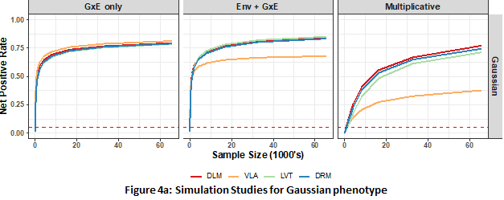
Figure 4a: Simulation studies with a Gaussian phenotype
Left: GxE-induced additive variance loci with no environmental main effect; Middle: GxE-induced additive variance loci with an environmental main effect; Right: multiplicative variance loci. DLM: double linear model; VLA: variance locus analysis/curve upwardness test; LVT: Levene’s test; DRM: deviation regression model

We first treat the phenotype additively, as the sum of strong covariate effect, weak genotype main effect, possible environmental main effect, and possible GxE effect. We consider scenarios of pure GxE effect or coexisting environmental and GxE effect. Both scenarios give rise to additive variance loci. Secondly, as a comparison, we let the genotype directly affect the phenotypic variance in log scale, giving rise to multiplicative variance loci. Rejecting the null (i.e., declaring an SNP significant) increased a method’s true positive rate, or power. Next, for each scenario, we simulate a corresponding null scenario by zeroing out either the GxE effect (additive variance loci) or the genetic effect on logged phenotypic variance (multiplicative variance loci), rejecting the null increased a method’s false positive rate.

We compared four methods, namely, the proposed variance locus analysis (VLA), double linear model (DLM), deviation regression model (DRM), and Levene’s robust test (LVT). We run 20,000 repeats for each scenario. In all scenarios, we fixed the alpha to 0.05. A method is superior if it had a high true positive rate (power) while controlling the false positive rate in the first place. We report the net positive rate, which is the true positive minus false positive rate.

Figure 4a compares the performance for Gaussian phenotype. For a pure GxE effect without environmental main effect, VLA had the best performance in identifying candidate SNPs (Figure 4a, left); with environmental main effect, other methods had better with larger sample sizes (Figure 4a, middle); with multiplicative variance loci, VLA underperformed as expected (explained in detail the simulation scenario of Gaussian phenotype, and Figure s1a in the Supplement provides a traditional display of false positive and true positive rates.
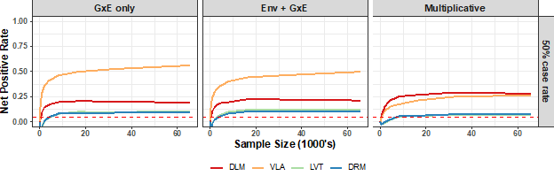
Figure 4b: Simulation studies for balanced binary phenotype
Left: GxE induced additive variance loci, no environmental main effect; Middle: GxE induced additive variance loci, no environmental main effect; Right: multiplicative variance loci. DLM=double linear model; VLA: variance locus analysis/curve upwardness test; LVT=Levene’s test; DRM=deviation regression model

Figure 4b compares the performance for balanced binary phenotypes (50% case rate). VLA was the best detector for additive GxE candidate SNPs, especially for variance loci by pure GxE (Figure 4b, middle); other methods had poor performance due to uncontrolled false positive dragging down the net positive rate. With larger sample sizes, the variance loci and genetic main effect become less distinguishable, attenuating instead of boosting the net positive rate. For multiplicative, VLA was not optimal as expected.
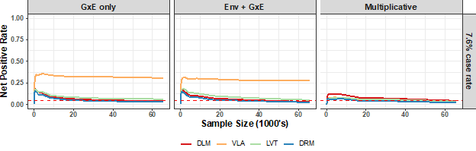
Figure 4c: Simulation studies for imbalanced binary phenotype
Left: GxE induced additive variance loci, no environmental main effect; Middle: GxE induced additive variance loci, no environmental main effect; Right: multiplicative variance loci. DLM=double linear model; VLA: variance locus analysis/curve upwardness test; LVT=Levene’s test; DRM=deviation regression model
Figure 4c compares the performance for imbalanced binary phenotypes (7.6% case rate). When the samples were imbalanced, a SNP main effect on phenotypical mean is automatically an effect on the phenotypic variance, causing an overall increase of false positives. Still, VLA maintained the ability to detect true GxE candidates while other methods did not. The Supplement describes in detail the simulation” in the supplement materials. For a display of false positive and true positive rates.

Overall, the simulations showed that VLA was more specialized in detecting variance loci induced by pure GxE effect and, overall more robust under the face of false positives due to imbalanced, non-Gaussian phenotype. As expected, VLA underperformed when the variance loci because when the allele effect on logged variance corresponds to a scenario where the squared GxE effect is negative, that is, a latent GxE with non-real-value effect size violates the assumption of VLA test (see “methods”). The acquisition of simulation materials (i.e., genotype), decisions on effect sizes, and the generation of phenotypes of various distributions and provides links to the R-scripts.

